What were the three main objectives of discussions held by NATO in 1968:

a) Dicsuss on the current trends of software and what are the new innovations in computer science

b) Discuss the process of Design, Production and Service of software and arrive on solutions for problems faced in each of the processes

c) To come up with a strong theoretical approach to developement of software

d) To showcase new software and to recruit people into various developement projects

Why was the term "Software Engineering" coined in the NATO confrence of 1968?

The term was coined as a provocative term to showcase the need for software manufacturing to be based on theoretical foundations and practical disciplines that were common in other branches of Engineering.

What was the analogy that Graham gave to the current state of Software Engineering and how was it similar to it?

Graham said that the current state of software development was analogus to that of building airplanes. He suggested that people invested in systems that they did not understand well enough to begin with and would face disappointment when it did not work as they anticipated it would. Like the Wright brothers, people would build software, push it off a cliff and if it crashed, started all over again.

What was one of the main problems faced by Software Engineers during that time?

a) The pressure from society to build even bigger and sophisticated systems that were not within the capabilities of todays software production and manufacturing process

b) The lack of resources and computing power to develop software that was of much significance to the society

c) The lack of population of software engineers required to build a sophisticated system of software

d) Less number of people with computers so as to be able to gain any profit from selling software products

Fill in the blanks in the arrows of the diagram that showcase the process of software developement according to Selig:

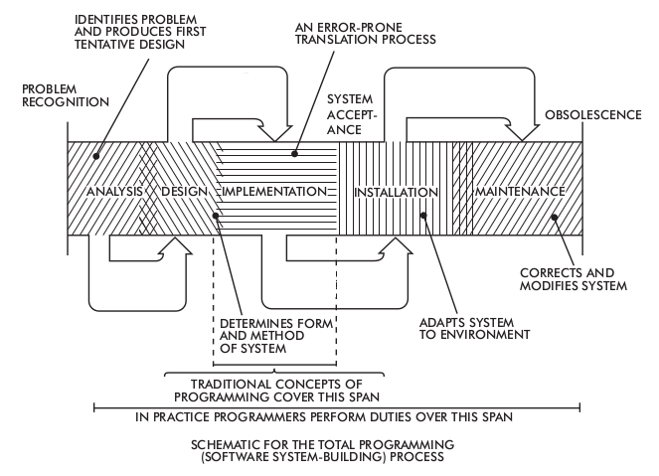

Answer:

