CPLPOS

MANUAL

Date : August 2005
Version : 1.5

CPL Computer Innovations Ltd.

Stock Control
For General Merchandising / Supermarkets

CONTENTS

CONTENTS 1
Introduction 4
Conventions 5
a. Keys 5
b. Menu navigation 5
c. Screen philosophy 6
d. Searching windows 7
1. Stock classification – General overview 8
2. Examples for stock classification 9
3. System menu 12
a. Managing Departments 12
b. Managing Categories 14
c. Managing Suppliers 14
4. Stock control – Transactions 16
4.1. Inputting new stock 17
a. Inventory in 17
Opening an invoice 17
Selecting a supplier 17
Selecting in-house number 18
Selecting PLU number 18
Selecting Department, Category, Unit, Tax 18
Cost calculation 18
Price calculation 19
Price level formula 19
Closing the invoice 20
b. Check inventory in Error! Bookmark not defined.
c. Posting 22
4.2. Modifying stock 23
a. Quantity adjustments 23
b. Items file 24
c. Posting 27
4.3. Wholesale invoicing 28
a. Wholesale customers 28
b. Sales transactions – wholesale invoicing 29
c. Customer payments 33
d. Price level formulas 34
e. Posting documents / payments 34
f. Wholesale reports 35
Customer statements 36
Customer balances 37
Sales report 37
Payments report 38
Document list 38
Document reprint 39
Balance recalculation 39
4.4. Posting 40
5. Promotions set-up Error! Bookmark not defined.
Introduction Error! Bookmark not defined.
5.1. Promotions Error! Bookmark not defined.
5.2. Quantity promotions Error! Bookmark not defined.
5.3. Specials Error! Bookmark not defined.
5.4. Promotions for selected Client Error! Bookmark not defined.
5.5. Markdowns/Mark-ups 42
6. Loyalty set-up 43
Introduction 43
6.1. Points per department 46
6.2. Points per item 47
6.3. Customer points adjustments 48
6.4. Loyalty reports 49
Points from customer purchases 50
Points from adjustments 50
6.5. Loyalty discount table 50
6.6. Gift Items set-up 52
6.7. Loyalty points adjustment reason 53
6.8. Posting 53
7. Stock taking – Inventory check 54
7.1. Blank inventory sheet – manual stock taking 55
By Item Number 55
By Category Error! Bookmark not defined.
By Department - Price Error! Bookmark not defined.
By Supplier Error! Bookmark not defined.
7.2. Physical inventory in 56
Data collector file 56
Manual stock taking 57
List data collection 58
7.3. Stock variance report Error! Bookmark not defined.
7.4. Automatic stock adjustments Error! Bookmark not defined.
7.5. Delete collections file Error! Bookmark not defined.
8. Inventory reports 59
8.1. Brief Report 60
By Item Number 60
By Category 61
By Department 61
By Supplier 61
8.2. Detail Report 63
By Item Number 63
By Category 64
By Department 64
By Supplier 64
By Selection 65
8.3. Price catalogue 66
By Item Number 67
By Category 68
By Department 68
By Supplier 69
8.5. Low stock list 69
By Item Number 70
By Category 70
By Department 70
By Supplier 71
8.6. Supplier purchase list 71
By Invoice 73
By Date Error! Bookmark not defined.
8.7. Purchase / Sales Details 74
By Item Number 74
By Department 75
By Supplier 75
8.8. Expiration date report 75
9. Analysis reports 78
9.1. Sales reports 78
9.1.1 Items sales reports 79
By Item 79
By Category 79
By Department 80
By supplier 80
By selection 80
9.1.2. Customer purchases 82
9.1.2.1. Credit purchases 83
9.1.2.2. Credit balances 83
9.1.2.3. Customer statement 84
9.1.2.4. Detailed purchases 84
9.1.2.5. Best buyers list 84
9.1.3. Period total net sales 85
9.1.4. Period clerk sales 85
9.1.5. POS Z-reports 86
9.2. Returned goods report 87
9.3. Profit Reports 88
By Item Error! Bookmark not defined.
By Department Error! Bookmark not defined.
9.4. Best selling list 88
By Quantity 88
By Amount 89
9.5. Worst selling list 89
9.6. Slow sales stock 89
9.7. Detail sales report 90
9.8. Sales / Purchases tax report 91
9.9. Stock adjustments 92

Introduction

Retail Management starts around a classic till machine, designed for a fast transaction taking and ease of use by any cashier without special training.

We realized this is a system that nobody is afraid of and they can easily use, therefore we built our Cash module system around that philosophy and we make a use of a programmable keyboard to emulate it.

Once our system gets into the shop the cashier within 5 minutes familiarization (and we do not exaggerate) can start crunching numbers within the same cash register style selling, making everyone feel right at home.

How good is a complicated system if it is cumbersome and difficult to learn? Cashiers and managers alike want it simple - and we deliver.

Conventions

For a better understanding, now we will have a look at some conventions used all over this manual.

Keys

Whenever a key or a combination of keys should be pressed for some actions, they will be written between “<” and “>” signs (ex: <ESC>). If a combination of keys has to be pressed, it will be written between “<” and “>” signs, and each key will be delimited by a dash (“-”) sign (ex: <ALT-F8> or <CTRL-ESC>).

Menu navigation

To perform menu navigation, you can choose the following:
  - Positioning on the desired option with arrow keys (<ARROW UP ↑ > and <ARROW DOWN ↓ >), and pressing <ENTER>.
  - Using the mouse.
  - Typing the number written in the front of the desired option (ex: if the desired option is “4. System data” you can press <4>)

Note: You can easily access any menu option in any menu and submenu, using the access path number, which consist of corresponding number from the menus or submenus that compose the path. We will call this method “Direct access” or “Expert mode”.

These are the corresponding numbers of each menu option, which can be used in Direct Access mode
These are the menu options. You can highlight one by positioning with arrow keys (↓↑) and select it by pressing <ENTER>, or you can use the mouse for this.
Highlighted option

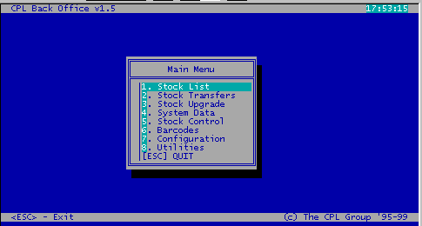

Sample Menu Navigator
5-1-1 means from the main menu, option “5.Stock Control” which will open the Stock control menu; from this menu, option “1.Transactions”, which will open the Transactions submenu; from this last submenu the option “1.Inventory In”, which will open the Inventory In screen. This means that we can address the Inventory In screen with the sequence 5-1-1.

The Direct access method is the most efficient from all presented methods.
First, because it’s faster to have two or three keystrokes to access a menu or a screen, than to use the mouse or to use arrows for positioning and <ENTER> for selection.
Second, because for some particular users, is more easier to remember two or three numbers, than to remember all the menus and all options from that menus.
Third, because anyway after a few days, or weeks of working with the software, they will remember only these numbers for Direct Access, they will become “experts” for their part of work.

For example, in one supermarket we have three different categories of users:
- Cashiers, which just use the Cash Register screen;
- Managers which can access Daily Reports and perform Z-Total
- Stock clerks, which are just entering items and invoices from suppliers into the system;
- Owner or supervisor, which will be able to access any option from any menu, and to manage data in any screen.

For all users within these categories of users, it’s easier to use the Direct Access method, practically to remember few combinations of numbers that leads to the most frequently used screen or option. The cashier has to remember only 1 for entering the Cash Register screen; the stock clerks have to remember only 5-1-1 to access the Inventory In screen and 5-1-4 to access the Items file screen; the manager has to remember for example that for ending the day they have to press 3-1, or for seeing an Instant account they have to press 2-5, and so on.

Screen philosophy

As you will see in following chapters, all screens in the CPLPOS are made with the same concept. The only part that effectively differs from one screen to another is the contents.
The screen menu options you will find on the bottom of each screen and it’s the same for all screens, with some minor exceptions. To select one option from a screen menu options, you can apply methods presented for menu navigation. You can position on the desired option using the arrow keys <ARROW LEFT ← > and <ARROW RIGHT → >, and select the option with <ENTER> key. Also you can press the number of each option.
On any screen you are if you press <ESC> you will exit the screen. Also, by pressing <F1> you will see all the content of the database table related with that screen.

On any field that is a code, if you press the <ARROW DOWN ↓ > key, a searching window containing a list of all codes applicable for that field will appear, allowing you to select one from the list (see next paragraph).

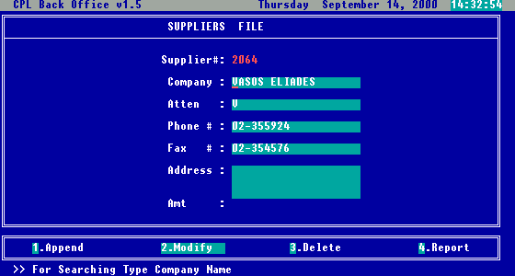
Screen options
Informational field – cannot be modified
Data entry fields – here you can enter or modify data
Name of the screen
Labels – usually these are the names of the fields
Screen components

In some specific screens (like Inventory In screen), if you are about to enter data in some specific fields (like Department, Category, Units of Measurement, etc.), if you enter the sign “*” and press <ENTER>, the screen that manages that specific item will be brought up allowing you to add a new entry, that you can afterwards use it for entering in the field. With this facility, is no need to exit the current screen, to add a new record in a system data screen.

Select windows

Usually after pressing the <ARROW DOWN ↓ > key, a selecting window will appear. From this widow, you will be able to select an item by positioning on it with arrow keys, and by selecting it with <ENTER> key. In the moment you press <ENTER>, the select window will close, and the selected item will be automatically taken to the current field.
You will see that one of the columns presented in the select window is alphabetically ordered. By typing the beginning characters of the searched item, you will be positioned on the first item which start with typed characters in the sorted column.

1. Stock classification – General overview

For a better administration of stock, as well as for obtaining different types of useful stock / sales reports, it is recommended to classified all items in the stock in groups and subgroups. Usually main classification is by: departments, categories (called also groups or sub-departments) and suppliers.

- Department – is the most wide grouping criteria. It’s situated on the highest level within the grouping pyramid. Usually, one department could contain many categories.

- Category – is the next level of grouping criteria, situated exactly under the department level within the grouping pyramid. Usually, one category contain many items.

On the ground level within the grouping pyramid, are situated all the items existing in stock.

Departments

Categories / Groups / Sub departments

Items in stock

Fig.1 – Grouping pyramid

- Suppliers – Tracking the supplier for each item all stock can be classified by the supplier where items were bought in quantity and value.

Having in mind the usage of the criteria presented above, the nature of your activity and the structure of your stock, you can choose a method to organize the stock, in a manner which will best fit your requirements and your profile.

For a better understanding, in next chapter you can see few examples.

2. Stock classification example

Sample 1

Department | Category | Item
1. Bakery | 11. Bread | White bread ½ kg
1. Bakery | 11. Bread | Black bread ½ kg
1. Bakery | 11. Bread | Sliced bread for toast
1. Bakery | 12. Cakes | Cocoa cake
1. Bakery | 12. Cakes | Simple cake
1. Bakery | 12. Cakes | Raisins cake
1. Bakery | 13. Croissants | Mini Croissants
1. Bakery | 13. Croissants | Chocolate Croissants
1. Bakery | 13. Croissants | Butter Croissants
2. Dairy products | 21. Milk | Regular milk
2. Dairy products | 21. Milk | Fat free milk
2. Dairy products | 22. Cheese | Feta cheese
2. Dairy products | 22. Cheese | Halloumi cheese

Sample 2

Department | Category | Item
1. Bakery | 11. Full bread | White bread ½ kg
1. Bakery | 11. Full bread | Black bread ½ kg
1. Bakery | 12. Sliced bread | Sliced bread for toast
1. Bakery | 13. Sweet cakes | Cocoa cake
1. Bakery | 13. Sweet cakes | Simple cake
1. Bakery | 13. Sweet cakes | Raisins cake
1. Bakery | 14. Salty cakes | Salt cheese pie
1. Bakery | 15. Croissants | Mini Croissants
1. Bakery | 15. Croissants | Chocolate Croissants
1. Bakery | 16. Others | Butter Croissants
2. Dairy Products | 21. Milk 1L pack | Regular milk
2. Dairy Products | 21. Milk 1L pack | Fat free milk
2. Dairy Products | 22. Milk 1/2 L pack | Regular milk
2. Dairy Products | 22. Milk 1/2 L pack | Fat free milk
2. Dairy Products | 23. Cheese | Feta cheese
2. Dairy Products | 23. Cheese | Halloumi cheese

Sample 3

Department | Item
1. Bakery | White bread ½ kg
1. Bakery | Black bread ½ kg
1. Bakery | Sliced bread for toast
1. Bakery | Cocoa cake
1. Bakery | Simple cake
1. Bakery | Raisins cake
1. Bakery | Salt cheese pie
1. Bakery | Mini Croissants
1. Bakery | Chocolate Croissants
1. Bakery | Butter Croissants
2. Dairy Products | Regular milk
2. Dairy Products | Fat free milk
2. Dairy Products | Regular milk
2. Dairy Products | Fat free milk
2. Dairy Products | Feta cheese
2. Dairy Products | Halloumi cheese

As you can see from the examples above, (the same items are used on purpose), each sample has a different classification. The deepest is Sample 2, and the shallowest is Sample 3, which has only departments.

Following are different ways of grouping stock items.

Sample 4

Department | Category | Item
1. Bread | 11. Bread | White bread ½ kg
1. Bread | 11. Bread | Black bread ½ kg
1. Bread | 11. Bread | Sliced bread for toast
2. Snacks | 21. Cakes | Cocoa cake
2. Snacks | 21. Cakes | Simple cake
2. Snacks | 21. Cakes | Raisins cake
2. Snacks | 22. Croissants | Mini Croissants
2. Snacks | 22. Croissants | Chocolate Croissants
2. Snacks | 22. Croissants | Butter Croissants
3. Milk | 31. Milk | Regular milk
3. Milk | 31. Milk | Fat free milk
4. Cheese | 41. Cheese | Feta cheese
4. Cheese | 41. Cheese | Halloumi cheese

Sample 5

Department | Item
1. Bread | White bread ½ kg
1. Bread | Black bread ½ kg
1. Bread | Sliced bread for toast
2. Snacks | Cocoa cake
2. Snacks | Simple cake
2. Snacks | Raisins cake
2. Snacks | Salt cheese pie
2. Snacks | Mini Croissants
2. Snacks | Chocolate Croissants
2. Snacks | Butter Croissants
3. Milk | Regular milk
3. Milk | Fat free milk
3. Milk | Regular milk
3. Milk | Fat free milk
4. Cheese | Feta cheese
4. Cheese | Halloumi cheese

Practically you should choose departments and categories to reflect on the best way your stock organization and reporting features later on.

3. System menu
Once you decided how you would like to classify items in the stock, you can start entering departments, categories and suppliers. All these settings are grouped in a menu called SYSTEM MENU (number 4 from Main Menu). There are some more settings in this Menu option but this time we will focus only on setting up the stock.

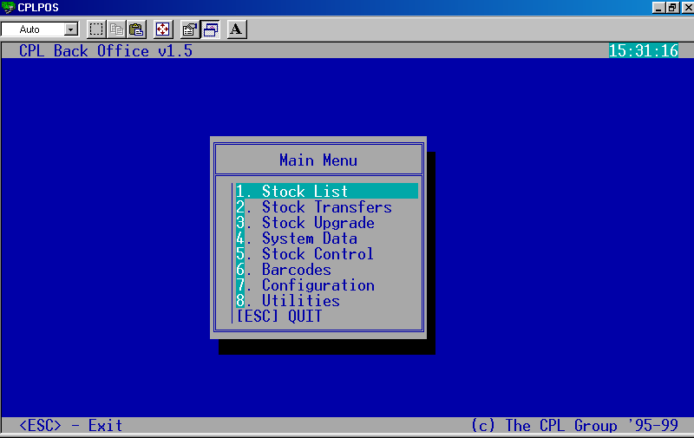

Fig 2. Main Menu

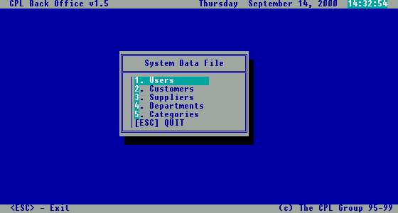
Fig 3. System Data Menu for Supermarket

Managing Departments

Here you can see prompts leading to the screens that manage suppliers, departments, and categories. For entering in departments screen, just press <4> from the Main menu, or select the prompt end press <ENTER>.

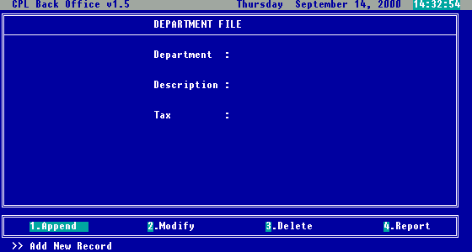
Fig 4. Departments Screen

On this screen you can manage information about department. The department code is automatically sequential generated, but you can replace it with your own, just to have in mind that one code can be used only once. Also you must complete a description for the new department, and you can select a tax code for the specific department by typing directly code or pressing <ARROW DOWN> button for selection.

You will notice that the option bar from the bottom of the screen, is mostly the same in all screens (with small differences). If you want to add a new department, just select 1. Append, and you are in the proper mode for entering new data.

If you want to modify a department that already exists in your database, select 2.Modify. After this, you will see a window containing all departments, alphabetically ordered, from which you can select the department you want to modify (see Fig.5).

If you want to delete from the database a department that no longer exists, or is useless, you should select option 3. Delete. Exactly after that, the same window with all the departments, from Fig.5, will open, and after selecting one department, you will be asked to confirm deletion.

Any time you can see a report with all departments inputted, by selecting the option 4. Report.

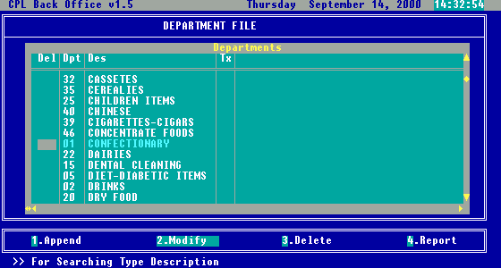
Fig 5. Search window for Modify/Delete

Managing Categories

For entering on categories screen, just press <5> from the Main menu, or select the prompt end press <ENTER>.

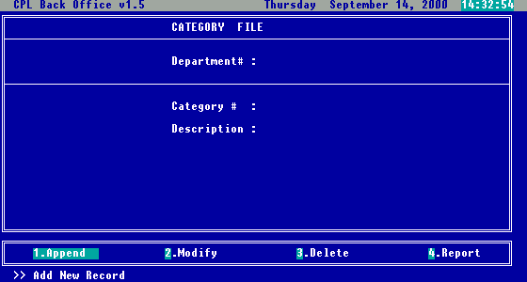
Fig 6. Category screen

On this screen you can enter categories within a specified department. In department code field, during data entering you can type the code or if you press <ARROW DOWN>, a window with department selection will appear, making the department code selection process easier. Category code will be also automatically generated (sequential numbers), and you have to complete the description. The functionality of the options from the bottom of the screen is the same as from the previously presented screen.

Managing Suppliers

From System Data Menu, press <3>, or select Suppliers and press <ENTER>.

Fig 7. Suppliers screen

On this screen you can enter and manage information related to your suppliers. The supplier code will be automatically generated, you need to fill the company name, and you can also fill the rest of details.

4. Stock control – Transactions

From the main menu you can access the Stock Control <5> and then Transactions option <1>. This could be accomplished by highlighting the “Stock Control” option and then pressing enter or by pressing the number <5> corresponding to the menu option.

After the selection is made this screen will appear:

Fig 8. Stock control menu

After the first choice “1. Transactions” is selected, the Transaction menu appears. This could be seen below:

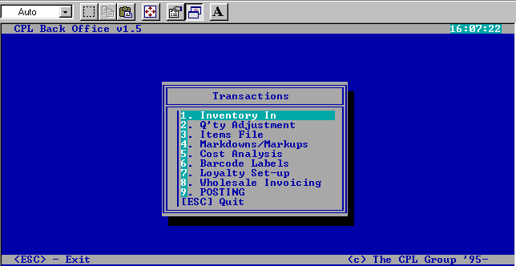
Fig 9. Transactions menu

4.1. Inputting new stock

Inventory in

After goods are purchased from the supplier and purchase invoice received it has to be entered into the system as per purchase invoice. This can be done with the “1. Inventory in” option from the menu shown in Fig.8 that will bring up the following screen.

As you can see, on this screen the options from the bottom of the screen are not exactly the same as for previously discussed screens. The options this screen offers are:
- Append : Add a new line from the same purchase invoice.
- Modify : Change an existing “Inventory In” record (purchase invoice line)
- Delete : Erase an existing “Inventory In” record (purchase invoice line)
- Search : Search the existing records (lines already inputted).
- Report : Do a report on the existing records (print purchase invoice).
- Exit : Exits the “Inventory In” screen (finishes purchase invoice).

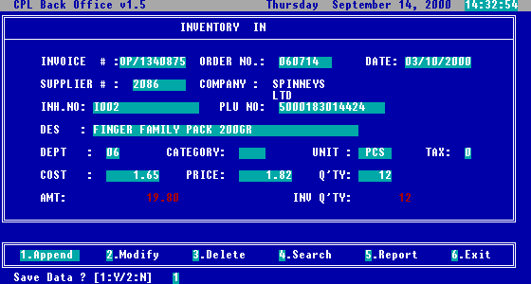
Fig 10. Inventory in screen

Opening an invoice

In the moment you entered this screen, and selected for the first time 1. Append, you are opening a new purchase invoice. You will see that information entered for the first record for Invoice #, Order # and Date will be kept for all records entered until selecting the option 6. Exit, which functionally means closing the invoice.

Selecting a supplier

When you are about to complete the field Supplier #, by pressing <ARROW DOWN>, you will see a supplier selection list, from which you can select the right one, if you don’t remember its code. After selection, the COMPANY name will be automatically displayed.

Selecting in-house number

If you would like to input a purchase invoice received from your regular supplier, and you want to keep also their internal coding of items, for keeping track later on, you can fill this field with the item code existing on the purchase invoice for that item (called also: Local code or In-house code)

Selecting PLU number

In PLU number field, you can scan the item’s barcode, or if you don’t have a scanner, you can enter the code manually. If during previous invoice processing, the Inhouse# was entered, then automatically a window with all barcodes associated with this In-house no. will appear, and will allow you to select the right one.

Selecting Department, Category, Unit, Tax

As you can see from picture 9, next fields to be completed are Department, Category, Unit, Tax. In all of them, if you cannot remember the codes, you can press <ARROW DOWN>, and a window with selection of departments / categories / units of measure / tax codes, will appear and will allow you to select the desired one.

Cost calculation

When you are about to enter data in Cost field, you can enter directly the cost, or if you press <ARROW DOWN>, a cost calculator window will appear as shown in the picture below.

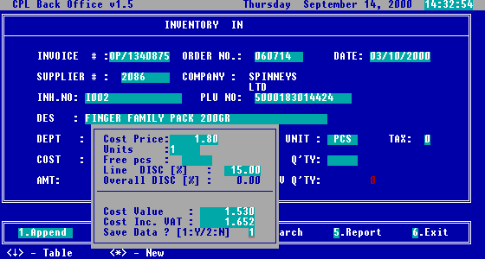
Fig 11. Cost calculator window

In this calculation window, in the field Cost price you have to enter the price shown in your purchase invoice, and for Units you should enter the quantity received for that amount. In Free pcs field, you can enter the quantity of free items received along with the payed ones. After entering data in Line DISC [%] the net cost, and the cost including VAT will be automatically calculated based on the information entered.

Overall discount amount will appear if overall discount is defined for that invoice at the beginning of screen et the field Invoice # (pressing <ARROW DOWN> you will get the window with Invoice No and overall discount)

On the question Save data ? [1:Y/2:N] if you answer Yes (1), the cost calculated in this window, will be transferred in the Inventory in window, if you answer No (2) you will be still staying in calculation window.

Note: The result of cost calculation is unit cost for selected item.

Price calculation

When you are about to enter data in Price field, you can enter directly the selling price, or if you press <ARROW DOWN>, a selling price calculator window will appear as shown in the picture below.

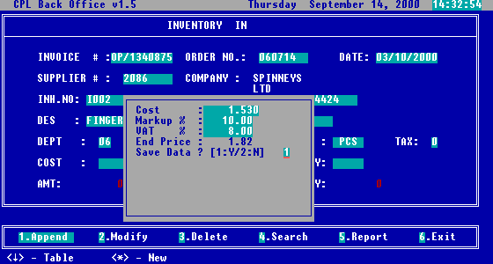
Fig 12. Selling price calculator window

The cost is automatically taken from the cost field (cost without VAT and discounts) . You can fill the Mark-up percent in the Markup % field, and to confirm the VAT %. After that, the End price will be calculated, and you will be asked if you want to save this value or not.

Price level formula

In the window presented above (Fig.12), after saving data, you can choose a price level formula to be applied for this item. A price level formula is used to calculate automatically different price level prices for wholesale customers. You can define up to 4 price levels, and the prices will be automatically calculated based on the already set-up formula, as in the picture below. The price level formula can be set up from the Main Menu – Stock Control – Transactions – Wholesale Invoicing – Price Levels Formula.
If you choose not to used price level formulas in this place you can directly define your wholesale prices for this item.
After you selected the formula from the window, the price will be updated as shown in the next picture. Even after automatic calculation you can still manually change your prices for wholesale customers.

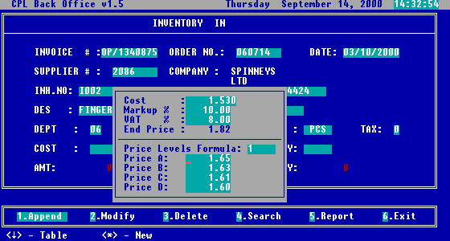
Fig 14. The price levels computed, based on chosen formula

Closing the invoice

After the price, next field to input is the quantity for the item received as per purchase invoice (do not forget to add also free pieces if applicable). After all data is entered, the screen will look like in the next picture.

Fig 15. The screen with all data completed, before saving
After visual inspection and if everything is OK the data can be saved (Save 1:Yes). If you have finished all items from the purchase invoice, you can proceed to close the invoice, but before this, is highly recommended to generate a report (Fig.16), print it out and compare with your purchase invoice.
If the total amount agrees, then you can safely close the invoice by choosing
6. Exit option, and exit the Inventory in screen. If the amount is wrong for specific item, you can still change it through option 2. Modify.

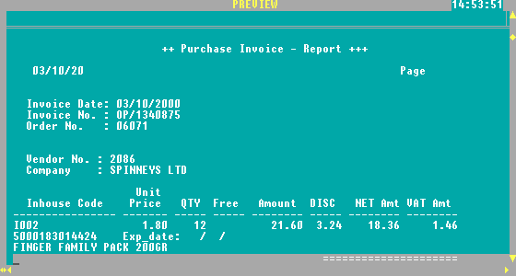
Fig 16. Report generated by Inventory in – Report option

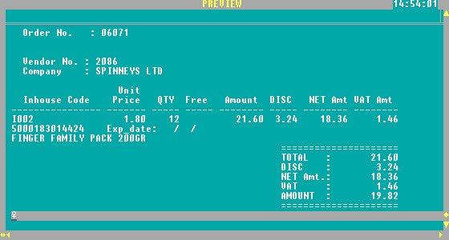
Fig 17. Same report as Fig.16, scrolled down for totals checking

Posting

This function finalizes the process of data entry by placing entered items in the Stock. From the Transaction menu, you can press the <7> or select the option 7.Posting and press <ENTER> to start the POSTING and answering YES to the 'POSTING' window (Fig.21).

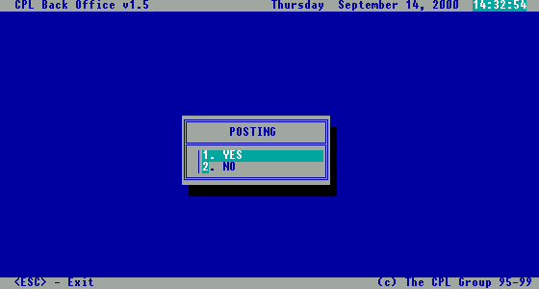
Fig 21. Posting

Note: Posting is very important function and has to be performed in order to create Stock items available for selling on POS machines.

As you will see after all operations involving Stock change (Inventory-In, Items File, QTY Adjustment,… you have to proceed with posting.

4.2. Modifying stock

In this paragraph, you will see how you can modify Stock content, other then Purchase or Sale.

Quantity adjustments

If the physical quantity of the item in stock does not agree with the quantity existing in the computer, then you can adjust the qty with option Quantity Adjustment.

For this goal you should select the “2.Q’ty adjustments” option from Transaction Menu, and the screen presented in next picture will be shown.

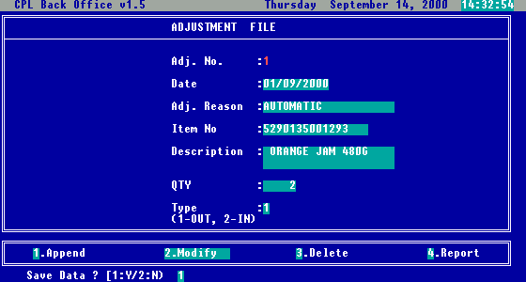
Fig 22. Quantity adjustment screen

The adjustment number will be automatically generated starting always from 1 (after posting is performed the number is reset to 1 again), and current date will be filled by default in field Date.
For Adj. Reason, you can choose one of the reasons, from the reason table (previously set-up) called with the <ARROW DOWN> key (Fig.23) or you can input any of the reasons you need.
In Item No field, you can enter directly, scan, or select from the list the correct barcode. Once a valid barcode is entered, the Description will be completed automatically.
In the Qty field, you can enter the number of items which will be adjusted from stock, and in Type, the type of adjustment: 1=Out (Minus), 2=In (Plus).

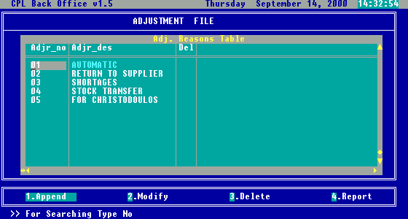

Fig 23. Reason selection window

Note: Adjustment reason table can be set-up using menu option Main menu – Configuration – Stock adjustments reasons.

Items file

If you need to modify any other details of the item, except quantity, then the option “4. Items file” from Transaction Menu, is the right one. After selecting this option, you will see the menu presented in the next picture.

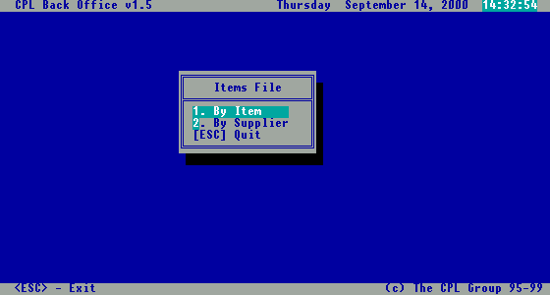
Fig 24. Filtering criteria for Items file screen

If you choose “1.By Item”, then you will see the following screen.

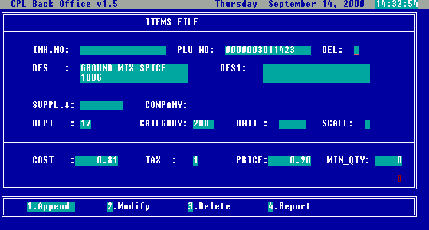
Fig 25. Items file screen by item

If you are on one of the code fields Inh.No, PLU No. Suppl.#, Dept, Category, Unit, Tax and you press <ARROW DOWN> key, the appropriate list for selection will be open in a small window, allowing you to select the desired one.

In the field Del if you enter the value “1” then that item, will be completely removed from the Stock database after posting.

The field Scale, is useful if you have an electronic scale connected to the POS machine, and you want to declare that item as scalable (weight measurable). In this case, in the moment of selling, the POS machine will read the weight automatically from the scale, and the price will be calculated accordingly. If it’s not applicable for your profile, please let this field empty.

In the field Min_Qty you can input a minimum level for the item in stock. When stock quantity for that item will reach the amount specified, this item will be reported in Low Stock List.

The options Append, Modify, Delete and Report have the same functionality as in previously discussed screens.

If you select option “2.By Supplier”, then you will see the dialog box, presented in Fig.26. You can enter codes in fields of Supplier #, Category, Department and Item_no, or you can select an appropriate values from the list opened after pressing the <ARROW DOWN> key. Filling this Dialog box you are making criteria in which items will be shown in table in Fig.27

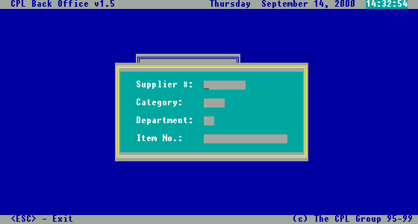

Fig 26. Selection criteria for Items file screen by supplier

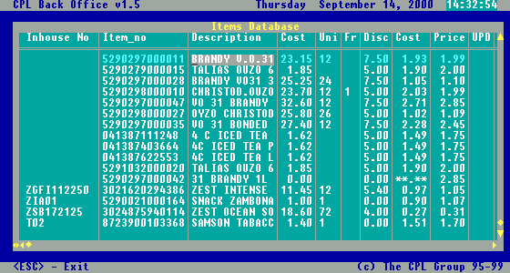
Fig 27. Items file screen by supplier

As you can see from the picture above, selected are all items that correspond with the selection criteria entered in the dialog box presented in Fig.26.

Here you can modify the characteristics of items presented as table columns. After modification, if you want the stock database to be changed, you need to mark this item typing any character in the UPD column (usually 1).

If you scroll right, you will see other fields also including Quantity, VAT percent, and price levels for wholesale, as in Fig.28. Once you are satisfied with the modifications made, you can exit this screen pressing <ESC>, and go to the next step.

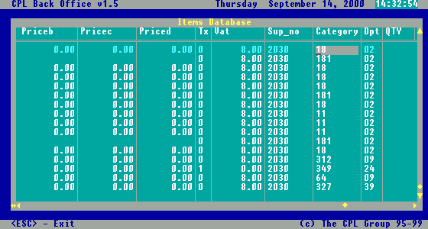
Fig 28. Items file screen by supplier scrolled right

Note: The screen is specially useful when you need to check up on Cost/Price for specific supplier and make quick changes. Inputting values in fields Cost, Unit, Free, Discount will calculate Unit cost in the next column.

Posting

Any modification made on the stock database, will not really affect the database until you will not do Posting. This option was already presented in this chapter, in paragraph 4.1.c.

4.3. Wholesale invoicing

If you have a wholesale customers and you wish to sell on wholesale way, in this chapter you will find explanations regarding whole selling.
To access wholesale options, from the Transactions menu you should select the “8.Wholesale invoicing” option. Right after you will see the menu presented in the following picture.

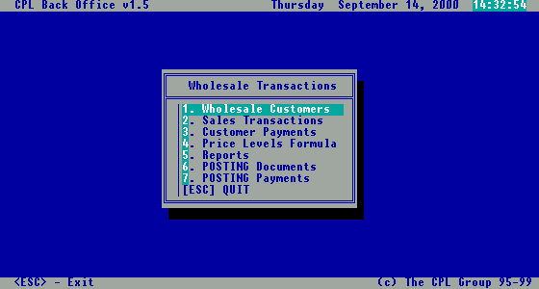

Fig 29. Wholesale transactions menu

Wholesale customers

Wholesale customers are completely separated from retail customers. You can input information about your wholesale customers filling the next screen.

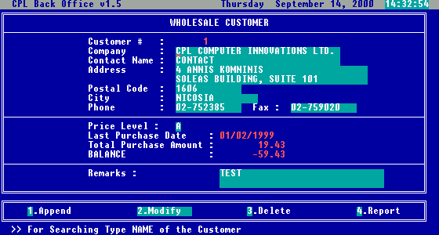
Fig 30. Wholesale customer screen
On this screen you can complete fields Company, Contact name, Address, Postal code, City, Phone and Remarks with real information regarding the wholesale customer.
Customer # is generated automatically by the system with unique sequential value, but you can overwrite this field with another code if needed. In Price Level field you can directly enter the code (A,B,C or D) or you can choose the level from the list opened after pressing <ARROW DOWN> key. Once you have chosen a price level for a wholesale customer, each time he buys something, the price according the selected price level will be used in calculations.
There are also few fields for informational purpose (you cannot enter or modify data in those fields), like Last purchase date, Total purchase amount (the amount of all purchases made by that customer from the beginning until now) and Balance (total purchase amount minus total payments amount) which are showing details automatically managed by the system, related to that customer.
Options Append, Modify, Delete, Report have the same functionality as in the other previously presented screens.

Sales transactions – wholesale invoicing

This is actually the Wholesale invoicing module. You can reach this screen if you select from the Wholesale menu option “2.Sales transactions”. Once you entered the screen, and selected Append, you can specify the document type, selecting the proper one from the list called with <ARROW DOWN> key, as in the next picture.

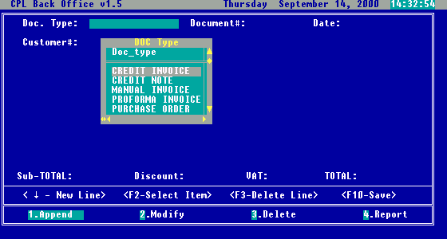
Fig 31. Sales Transactions screen – selecting document type

The Document # field is automatically generated, and as usual can be overwritten with different value, and the same with the field Date, which will show by default current date. After you complete or choose the value for the field Customer # in the empty space next this field, will be shown customer details like company name and address, and you can proceed to enter the content of the whole sale invoice, as in the picture below.

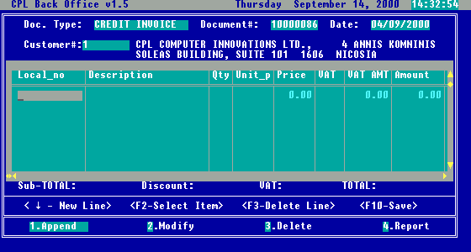
Fig 32. Sales Transactions screen – adding items on wholesale invoice

As you can see the info message below the window are:
- for item selection press <F2>;
- for deleting a wrong entered line press <F3>;
- to add new line press <ARROW DOWN> ;
- to save and close invoice content press <F10>.

If you press the <F2> key, you will see a dialog box as on the next picture, which allows you to select item to be sold.

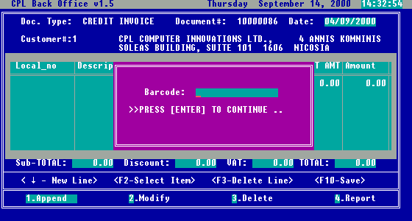
Fig 33. Sales Transactions screen – dialog box for selecting the item to be added

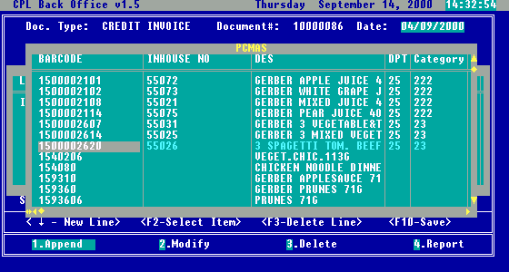
Fig 34. Sales Transactions screen – selecting the item to be added on wholesale invoice

Note: Item can be selected scanning or inputting Barcodes, Inhouse # or Description.

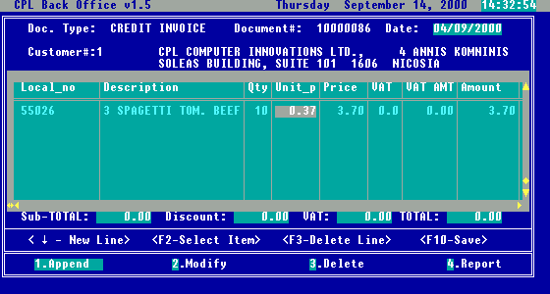
Fig 35. Sales Transactions screen – completing quantity and checking price for the item to be sold by wholesale invoice

After you have entered all items to be sold pressing <F10> key, the summary information regarding the invoice, like: Subtotal, VAT and Total, will be automatically completed, and you will be allowed to enter an overall discount for the invoice as amount. Once you entered a discount, the total of the invoice will be decreased with that amount, and after that you will be asked if you want to save the invoice (Fig.36).

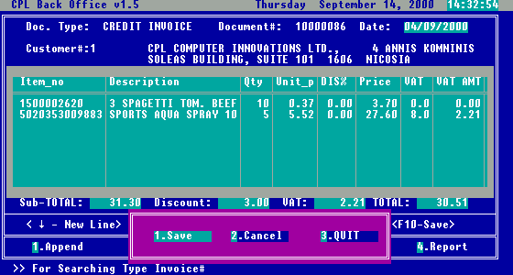
Fig 36. Sales Transactions screen – completing overall discount and saving the wholesale invoice

After saving the invoice, you can print it on your pre-printed invoice form. Be sure that invoice form is loaded and in the starting position on the printer.
Select the option “4.Report”, enter the wholesale invoice number in the dialog box that will appear , and after that, from the list of printing destinations choose “2.Invoice printer” as shown in the next picture.

Note: By default last entered invoice number is shown. Number of copies can be set-up from the Main menu – Configuration – System settings –
Wholesale invoicing set-up – General Parameters.

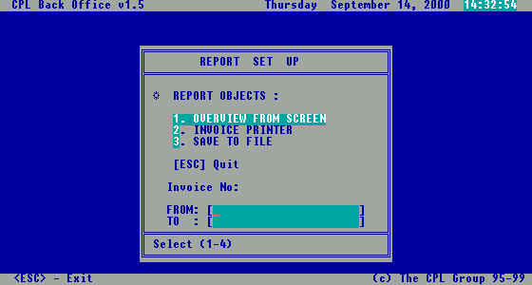
Fig 37. Sales Transactions screen – printing the wholesale invoice

Customer payments

Once you received payment from wholesale customers, towards invoices issue you can enter them into the system, in order to have correct customer balance, and the statement. This will allow you to track and monitor easy, payments for the issued invoices and keep correct debtors records.

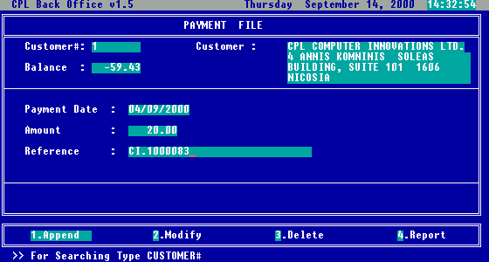
Fig 38. Payment file screen

As you can see from the above picture (Fig.38), first you can select the wholesale customer by entering its code, or by selecting it from the list called with <ARROW DOWN> key. After selection, in Customer and Balance fields you will see information related to the wholesale customer, like company name, address, and current balance.

Payment date is completed by default with current date, but you can overwrite this field with the desired date.
In the Amount field you can enter the amount paid , and in the Reference you can complete information regarding the document the payment (example: Settlement of Invoice No 30001, …) like you will do on manually issued receipt.

The options Append, Modify, Delete and Report have the same functionality as in the other screens presented.

Note: Reference you enter here will also appear on the customer statement.

Price level formulas

This is the screen where you can view, enter, modify and delete price level formulas. You can access this screen by selecting the option “4.Price levels formula” from the Wholesale Transactions menu. After selection you will see the screen presented in next picture.

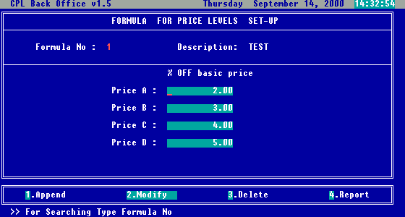
Fig 39. Price levels formulas screen

The field Formula No will be automatically completed by the system. In the field Description you have to complete a suggestive name for your formula (something that will remind you quickly on the pricing scheme you want to use)

After that you have to complete percents of discounts for each level. You can use maximum 4 levels (A,B,C and D). If you want to use less than 4 levels, skip unwanted levels (ex: if you’ll use only two levels, A and B, then A and B will have percents greater than zero, meanwhile C and D can stay empty).

The options Append, Modify, Delete and Report have the same functionality as in the rest of the screens already presented.

Posting documents / payments

As you know by now, just entering the data does not affect the Stock database.

To affect the Stock database with the wholesale data, you have to post data. In Wholesale Transactions menu you have two options referring posting :
“6.Posting Documents” and
“7.Posting Payments”.
As their names specify, the first one is used to post data entered in Sales transaction screen, meanwhile posting payments is used to post data entered in Customer payments screen. Once you choose one of these options you will be asked if you want to post, and you can select between Yes and No options. If you select yes, then the posting will be performed. You can see the dialog boxes in the pictures below.

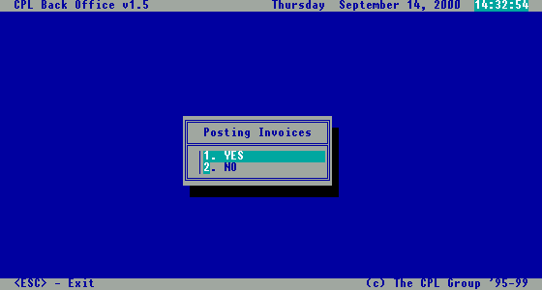
Fig 40. Posting invoices dialog box

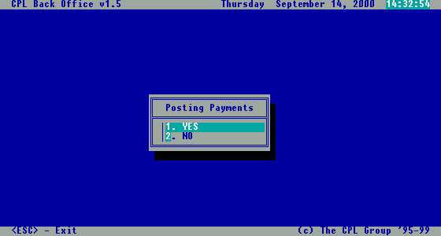
Fig 41. Posting payments dialog box

Wholesale reports

To reflect wholesale activity program is offering a different sets of reports. To access these reports, select the option “5.Reports” from the 8.Wholesale Invoicing menu. After selection, the menu presented in the next picture will be displayed.

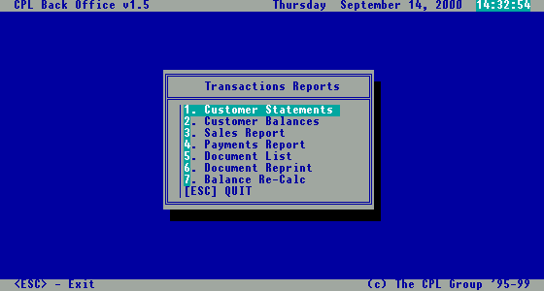
Fig 42. Wholesale reports menu

Now we will have a look at each of the reports from this menu.

Customer statements

After selecting the customer for which is the report to be generated, and a period (you must complete at least the end date), the generated report will look as in Fig.43, and after scrolling down as in Fig.44.
This report will not reflect reality if you didn’t post documents and payments previously.

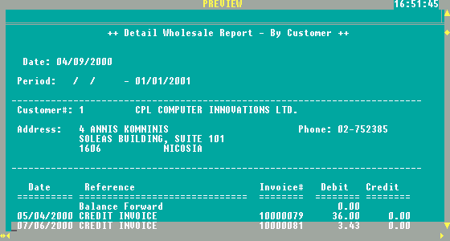

Fig 43. Customer statements report

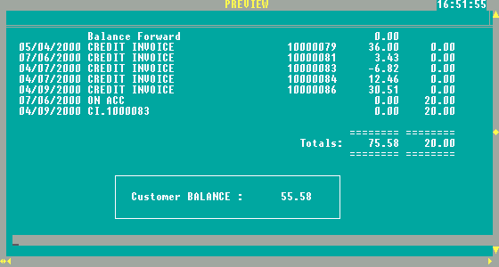
Fig 44. Customer statements report scrolled down

Customer balances

After selecting desired period, or at least the end date, you will see a report containing all the customers balances, as shown in the next picture.

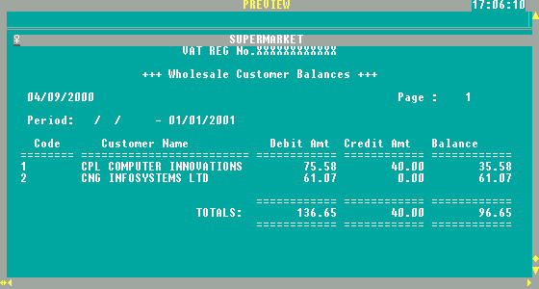

Fig 45. Customer balances report

Sales report

Once you entered the period and the customer, you will see all items sold, for the specific wholesale customer, as in the next picture.

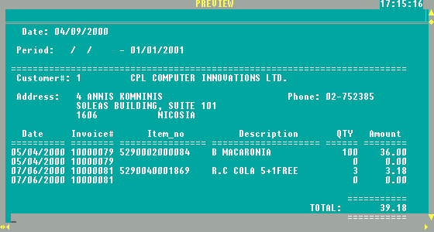

Fig 46. Sales report - wholesale

Payments report

This report will show you all payments made in a specified period of time, or until the end date specified for the selected wholesale customer. The report layout can be seen in the next picture.

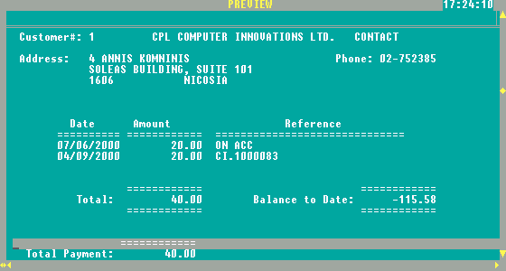
Fig 47. Payments report

Document list

This report will contain all documents from the specified period and wholesale customer as you can see in Fig.48.

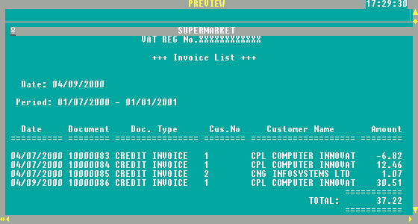
Fig 48. Document list report

Document reprint

This option is to be used in case you need to reprint a specific document already printed and posted. In the dialog box that will appear after the selection of this option, you have to enter the identification code of the document (Fig.49). After that, just select the printing destination for the desired document.

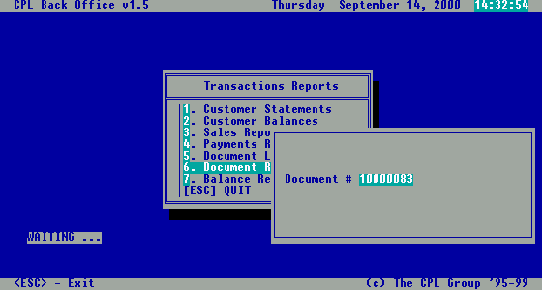

Fig 49. Document reprint dialog box

Balance recalculation

This option will not generate a report. It will just recalculate the balance of the customers, in case you will select this option after recent changes affecting the database

Note: Balance will be recalculated from the very beginning of wholesale activity – this can take a noticeable amount of time, so you will be prompted to wait.

Do not run this option unless there are serious mistakes in your Customer Statements.

4.4. Posting

As you already red about this option, is presented in large in paragraph 4.1.c. It’s very important to not forget to use this option after entering data that should immediately affect the stock database.

5.5. Markdowns/Mark-ups

As you probably noticed, this option is not in the Promotions Settings menu. This is part of the Transactions Menu, but because is referring to promotions, will be discussed in this chapter.

To access this option, you have to select from the Transactions menu, the option “5.Markdowns/Markups”. After you selected this option, the screen presented in the next picture will be displayed.

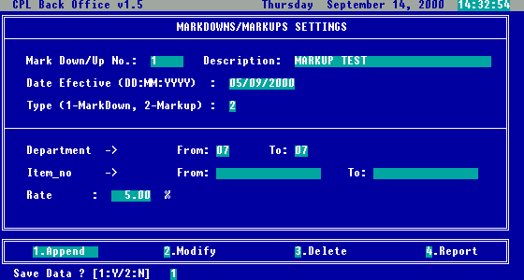
Fig 56. Markdowns/Markups Settings screen

On this screen you can increase or decrease prices for items, for specified departments or items, with specified percent. This will affect the price of the item in stock from a date on (effective date), not just for a period of time.

In the picture above (Fig.56), you can see how data was completed to obtain a price raise with 5%, for all items from department 7, starting with 5th September 2000.

Note: After Markdown/Mark-up has been set-up posting has to be performed. This will permanently change prices for specific items. If you decide later on to revert to original prices, after markdown a mark-up has to be performed and vice versa. This is the main difference between Markdown/Mark-up and set of promotions. In case of promotions, original price for selected items remains the same in the stock and the new (promoted) price is calculated in time of selling (“on the fly”).

6. Loyalty set-up

Introduction

Loyalty / frequency system rewards the customer for making repeated purchases on your location(s), depending on the total amount spent, and at the same time motivates the customer for future purchases.
The Purchase data is captured at the Point-Of-Sale system (POS) by swiping a magnetic stripe, bar code or smart card through the card reader integrated with the POS software. Points are awarded based on customer spending (previously set-up in the system), and awards can be:
- Special discounts for loyal customers (different discounts levels)
- Products on promotion.
- Points can be used instead of cash at the specific supplier’s shops.
- Random draw prizes
- Special “bonus gifts”
By choice some of the awards can be given instantly at the POS at the time of selling.

There are two ways to recognize a Customer and to store relative information about Customer:

Customer Card
- with Magnetic Stripe
- printed Barcode
All information about Customer is stored in the Database (on the Back Office computer and POS terminals). The size of database depends of amount of information collected for each customer and your total number of customers.

Smart card
- All Information about Customer is stored on the card. The card acts like portable database that can be accessed instantly at the POS, no need for the big, on-line database in the Back Office.

Setting up the Points Systems

- After swiping magnetic stripe, barcode or smart card, the POS system recognizes the customer and uses information from the customer records: name, address, sex, date of birth, card member group, card expiry date, current points and account balance. Also it can be date of last used, points-to-date, spend-to-date.

- Pointing structure can be previously set-up in the POS:
- System Point per each Pound spent.
- Different pointing structure for each product or group of products separately

Example:
- Promote individual Products – some items can bring more points for the same price.
- Buying certain quantities can bring more points.
- Items with better profit margin can bring more points.

Example:
This is good way to “get-rid-of” obsolete stock simply announcing that certain product have points value increased for a limited time, encouraging customers to buy specific brand or flavour. Gaining extra points, the customer can be located in better discount group or can buy promotional items, or receive a gift.

Rewarding structure

- Loyalty Discount system (Discount Card)

- Different Discounts groups are set-up previously in the POS system giving for different Number of points different % of overall discount.

Example:
For Number of points >=100 4% OFF
>=200 6% OFF
>=300 10% OFF
With automatic re-grouping upon the attainment of specified points level, the customers can increase their discount level simply by accumulating the required number of points.

How the system works?
- The POS recognizes customer and all items bought by client are check through pointing system. Total number of points is calculated per bill and adds on total points purchased in the certain period. Any discounts or points to which they are entitled are automatically applied to their purchase accordingly to the Discount group they are belonging to.
- At the end of bill you can show: Current number of points for the bill; Total number of points (cumulative); Message to encourage more spending in order to gain more points and more benefits (better discount group, better promotion etc…).

Example:
Message can be:
Congratulation you are in discount group A!
By gaining 10 extra points you will be located in discount group B.

2. Promotion system

Different products or groups (by choice) can be offered to the customer at the special promotion price depending of their point’s level in limited period of time. This can include also customers which total points-to-date is on the certain level.

Example:
Some attractive and expensive but slow moving items (set of plates or set of glasses of the certain brand) can be offered to loyal customers if they rich certain level
Level 1: No of points > 300 Promotional discount 35%
Level2: No of points > 500 Promotional discount 50%
Etc.

- Prepayment Cash Card

Customer can load the card with a certain value (approximate spending amount in certain period of time). Then, they simply present the card at time of purchase. And the sale value is deducted. At the same time any loyalty points associated with the purchase are added to the card and accordingly relevant discounts are applied. Advantage: less cash is in circulation and security is improved.

- Random Draw Prizes

Facility to automatically select one or a number of customer to receive prizes. Record of the customer transaction is stored within the POS so the more often a card is used, the better the chance the customer has to receive a prize.

- Birthday / name date Acknowledgment and “Bonus gifts”

- A special “Happy Birthday or Happy name date” message appears on the POS cashier display on their birthday customer will receive specially prepared gift.

- “Bonus gift” for customers after reaching certain points level.

We will explain in the following chapter how to set-up all different types of loyalties.

Loyalty set-up

Selecting from the Inventory File menu, option “6.Loyalty set-up”, Loyalty Set-up menu will be opened, as you can see from the following picture.

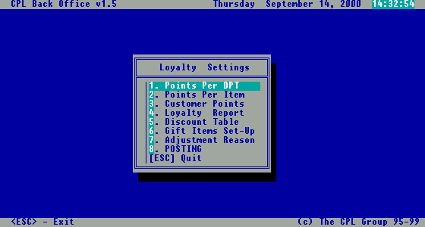
Fig 57. Loyalty Settings menu

6.1. Points per department

If you select the option “1.Points Per DPT”, the screen presented in the next picture (Fig.58) will be displayed.

In this screen you can declare a certain period of time, in which a number of points per CYP spent, will be granted.

In the picture below (Fig.58), shown is a setting for the items from food departments. Customer will gain 2 points for every CYP spent buying the food.

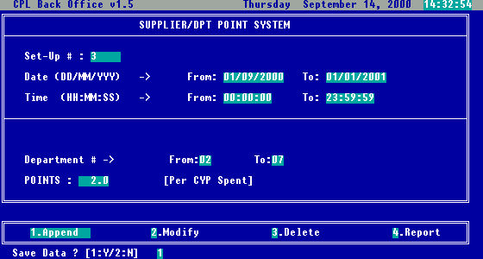
Fig 58. Points per Department screen

6.2. Points per item

If you need to be more specific, to promote only certain items, you need to select option “2.Points Per Item” from the Loyalty Settings menu. After selection a dialog box will appear (Fig.59) allowing you to be more specific, selecting from all items in the stock, only those which satisfy criteria entered below.

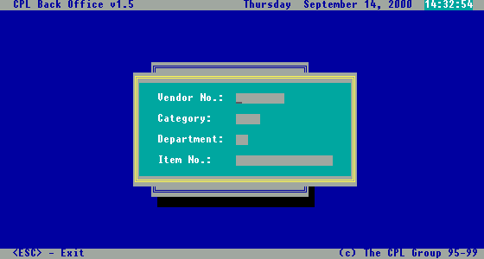
Fig 59. Points per Item dialog box

On this way you can select items from a certain supplier, category, department or directly one item, specifying the necessary codes. In this dialog box, you have to fill in at least one criterion, to proceed to the next step (Fig.60).

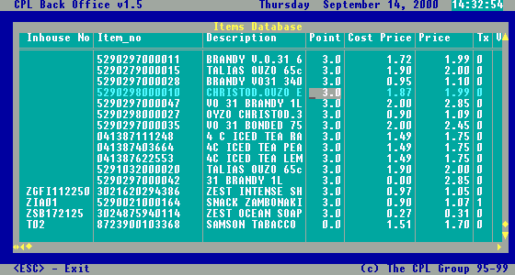
Fig 60. Points per Item screen

Once you entered criteria, all items that satisfy that criteria will be displayed in this screen accordingly. After that, you can go directly to the targeted item, and change the Point value.

6.3. Customer points adjustments

If the customer points have to be changed, you have the possibility to adjust them through the following menu option. Potential reasons for this, could be mistakes during selling process, the need for resetting some customer points, or if you choose to do it manually, redemption of points after taking some benefits in exchange (gifts or reduced price items, etc).

To reach this option, you need to select from the Loyalty Settings menu, the option “3.Customer Points”. Once you selected this option, you will be able to see the screen presented in the next picture (Fig.61).

When entering data on this screen, first you have to select the customer, the systems will complete automatically the Name and Current Points.

Then you need to enter the Date of adjustment, the number of Points Adjustment and the Reason of adjustments. In the Points Adjustment field you have to enter positive values if you want to add points to a customer, or negative if you want to subtract them.

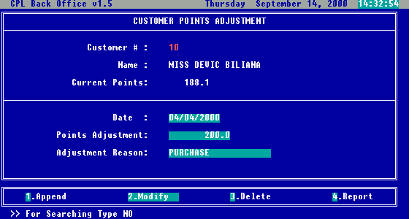
Fig 61. Customer’s Points adjustment screen

Related with Adjustment Reason field, you have the possibility to administrate a table of adjustment reasons, which will be presented later on in this chapter on subtitle 6.7.

Note: after completing the changes for the customer it is necessary to use “Posting” in order to affect Customer Record.

6.4. Loyalty reports

There is a set of reports in the system related to loyalty settings and loyalty usage. To use this reports (Fig.62), you need to select from Loyalty Settings menu option “4.Loyalty report”.

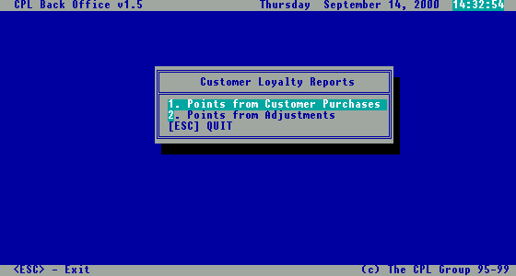
Fig 62. Customer loyalty reports menu

After selecting any of this options, a message box will appear on screen, that will allow you to enter manually client card number, or to select the customer from the alphabetically sorted list called with <ARROW DOWN> key (Fig.63).

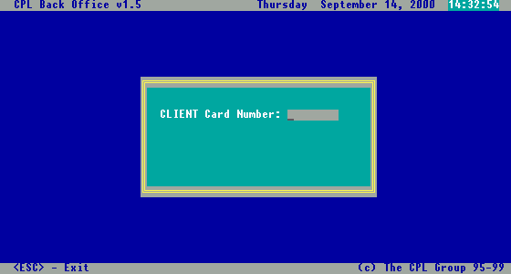
Fig 63. Client card number dialog box

Once client is selected, you need to specify the period of time for the reports, and the destination of the report (On Screen, On Report, On File).

Points from customer purchases

This report will show you the points earned by a specified customer, in a specified period of time by purchased invoice. The layout of this report can be seen in the next picture.

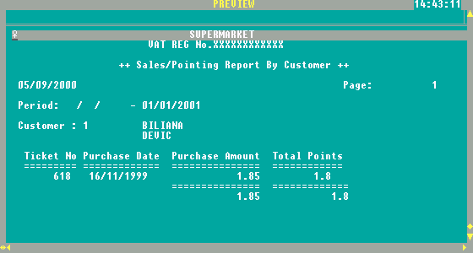
Fig 64. Points from customer purchases

Points from adjustments

This report will show you the points adjusted for a specified customer, in a specified period of time for every adjustment. The layout of this report can be seen in the next picture.

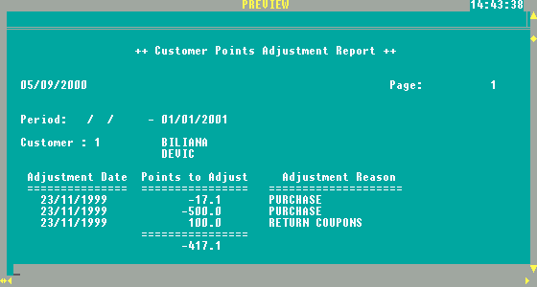
Fig 65. Points from customer adjustments

6.5. Loyalty discount table

If you want to apply policy that every customer with certain amount of points gets a discount for every purchase made in the certain period of time, you can automatically set-up this features through this option.

You can enter this screen, selecting option “5.Discount table” from the Loyalty Settings menu. On this screen, which can be seen in the next picture (Fig.66) you can declare periods and rates of discounts for customers who earned more points than a specified level.

On the picture, you can see how data was entered to declare that during the month of September, all customers with at least 500 points would benefit a discount of 10% for every purchase made.

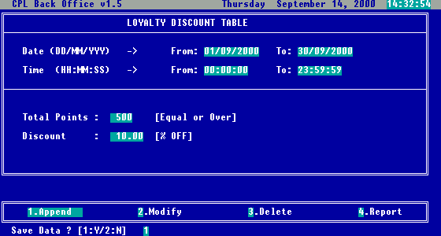
Fig 66. Loyalty discount table screen

6.6. Gift Items set-up

In general, purpose of Loyalty discount table settings is to allow you to set-up automatically gift or discounted items which can be purchase only from the customers reaching certain level of points. At the POS machine when selling this kind of items system will automatically check on points and sell the item on discounted price. Points will be redeemed automatically as well.

To access this screen, just select the option “6.Gift Items set-up” from the Loyalty settings menu. Once selected, you will see the screen presented in next picture.

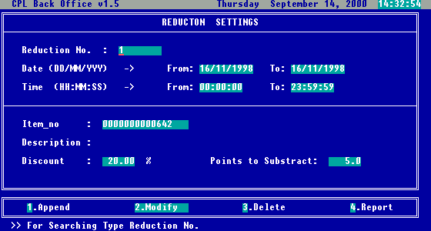
Fig 67. Gift items set-up screen

In this screen you can declare items, which in exchange of customer’s points will offer discounts for specific items.

Sample: If you want to offer in exchange of 200 points, one packet of ½ kg Jacobs coffee, during month of September 2000, you have to complete the following: Date From: 01/09/2000, Date To: 30/09/2000, Time From: 00:00:00, Time To: 23:59:59, Item no: 500000012563 (assuming this is the barcode for Jacobs coffee), Discount: 100, Points to Subtract: 200.

6.7. Loyalty points adjustment reason

This is the screen where you can administer the loyalty adjustment reasons table.

To access this screen, you have to select option “7.Adjustment Reason” from the Loyalty settings screen. This screen can be viewed below:

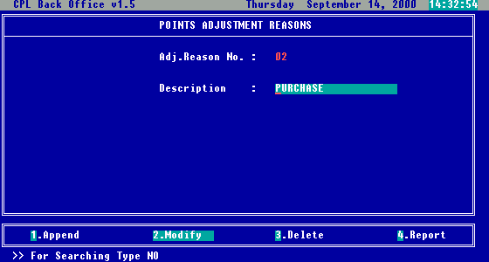
Fig 68. Adjustment reasons screen

All you have to do here is to enter all reasons possible for adjustments (which can be selected later on in the Options “Customer Points Adjustments” . The screen options Append, Modify, Delete and Report have the same functionality as in the rest of reports already discussed.

6.8. Posting

This option has the same functionality as the posting option from Transactions menu, with the difference that is related to loyalty settings.

7. Stock taking – Inventory check

It’s recommended periodically to check your stock (stock take) either manually, or with the help of the handheld data collector device.

Here we are starting to discuss how stock take is implemented in CPLPOS software.

Stock take can be:

- General – for all the stock items not found during stock take quantity will be 0

- Selective – only items found during stock take will be compared to the items in stock ; items not included in stock will not be compared.

This menu can be accessed if you select from the Inventory File menu, the option “4.Inventory check”. Once selected, you will see the menu, as in the next picture.

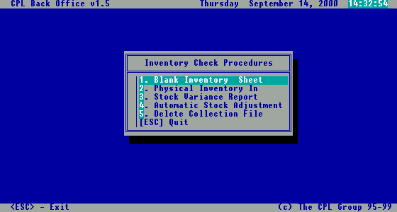
Fig 69. Inventory check menu

7.1. Blank inventory sheet – manual stock taking

Selecting this option from the menu presented in Fig.69, you will be able to print out four different types of stock list sheets, for manual stocktaking. You can select which one to be printed from the submenu that will appear after selecting the option “1.Blank inventory sheet” from the Inventory check menu (Fig.70). Each report will provide you all the stock items, organized in the manner you need (by item, category, department or supplier). As you can see from the report pictures (Fig.71 to Fig.74), the physical quantity is left empty to be filled manually during stock take.

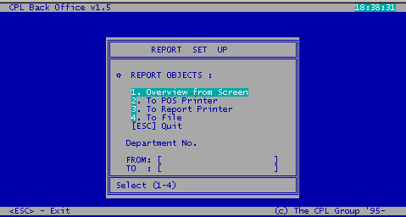
Fig 70. Blank inventory sheet menu

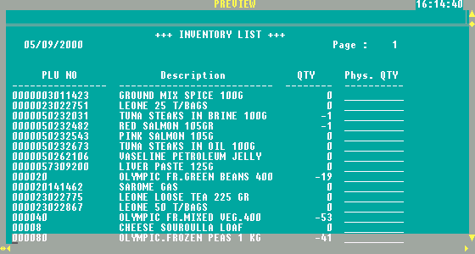
Fig 71. Blank inventory sheet report

7.2. Physical inventory in

If you choose from the Inventory check menu the option “2.Physical inventory in”, the submenu presented in the next picture will appear. The purpose is to form the file containing quantity of items found during stock take.

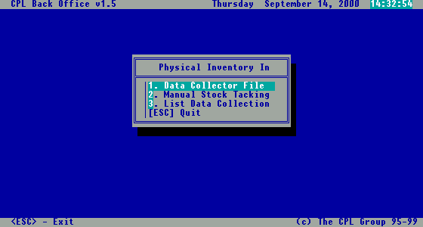
Fig 75. Physical inventory in menu

As you can see from the picture, here are grouped options that will allow you to input stocktaking results into the database.

Data collector file

This option is used, if you have a handheld data collector device compatible with the CPLPOS software. In this case, after you have downloaded the stock take file into the computer, you have to enter the name of the file in the dialog box presented in the next picture.

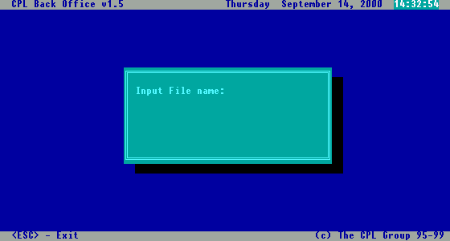
Fig 76. File name dialog box for data collector file

Once you have entered the correct file name in this dialog box, the program will automatically import all data, into the database. During the import procedure, items imported are verified if they exist in the database. If some items are not recognized (usually because of scanning errors), these items will be marked with “***” after the import. If later on you recognize some of them, you can modify them in the screen offered by next option “2.Manual stock taking”.

Manual stock taking

The selection of this option, will display the Maintain Physical Stock screen, presented in the next picture (Fig.77). This screen allows you to modify items imported wrong at previous step, or to manually enter the stock take results from the inventory sheets, into the database, in the case you don’t have a data collector device.

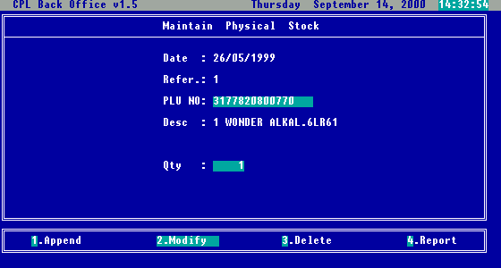
Fig 77. Maintain physical stock screen

List data collection

With this option you can see the results of stocktaking that are to be entered into the database (Fig.78).

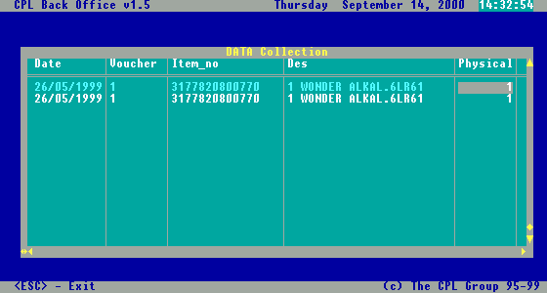

Fig 78. List data collection screen

8. Inventory reports

CPLPOS offers a set of inventory reports which are reflecting from many different views your current stock.

Selecting option “Stock Control” from the main menu, then option 2.Inventory reports”, you will get grouped all inventory reports offered by the CPLPOS. (Fig.86)

In the following chapters we will explain each one of them.

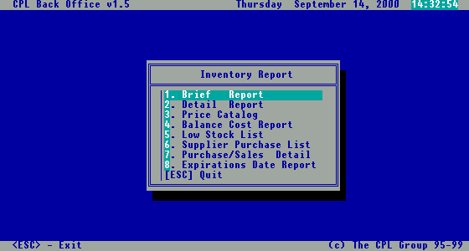
Fig 86. Inventory report menu

8.1. Brief Report

Selecting this option, a submenu will appear (Fig.87), allowing you to select the way you want to view stock data (By Item – Fig.88, By Category – Fig.89, By Department – Fig.90, By Supplier – Fig.91).

Brief reports shows the items, quantity in stock, cost and total value.

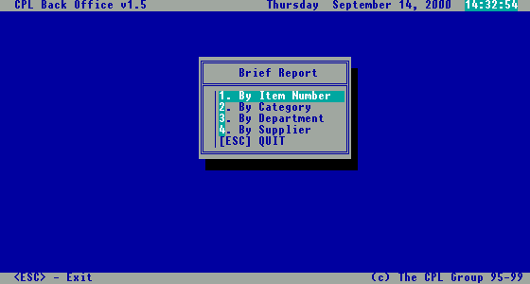
Fig 87. Brief report menu

By Item Number

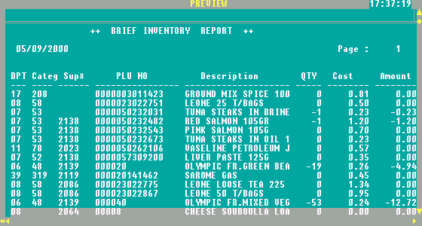
Fig 88. Brief report by item number

By Category

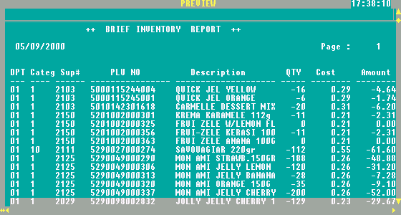
Fig 89. Brief report by category

By Department

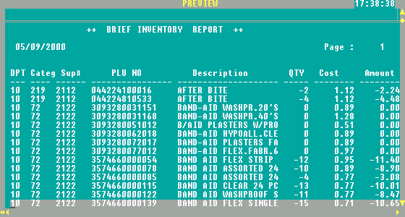

Fig 90. Brief report by department

By Supplier

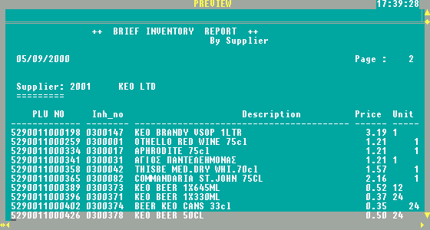
Fig 91. Brief report by supplier

8.2. Detail Report

Selecting this option, a submenu will appear (Fig.92), allowing you to select the way you want to view stock data (By Item – Fig.93, By Category – Fig.94, By Department – Fig.95, By Supplier – Fig.96, By Selection – Fig.98).

Detail reports are showing item, quantity in stock, cost and price.

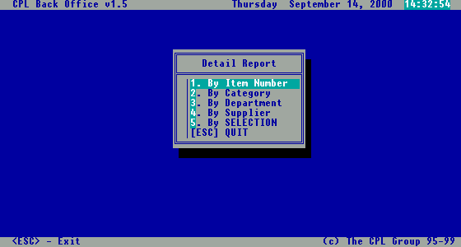
Fig 92. Detail report menu

By Item Number

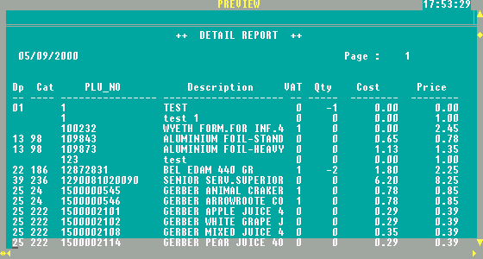
Fig 93. Detail report by item number

By Category

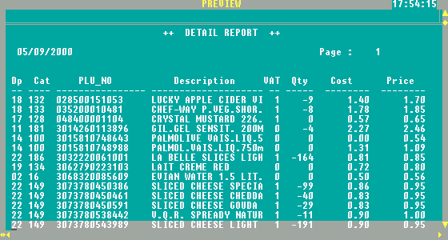
Fig 94. Detail report by category

By Department

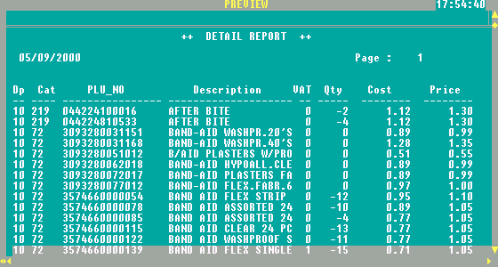

Fig 95. Detail report by department

By Supplier

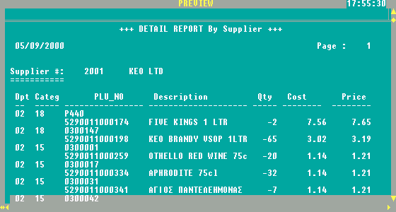

Fig 96. Detail report by supplier

By Selection

After choosing this report, a dialog box for specifying selection criteria will appear, as in Fig.97.
This allows you to define more complex criteria on which you want to view the stock (Fig.98).

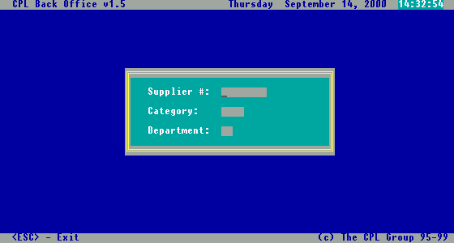

Fig 97. Selection criteria dialog box

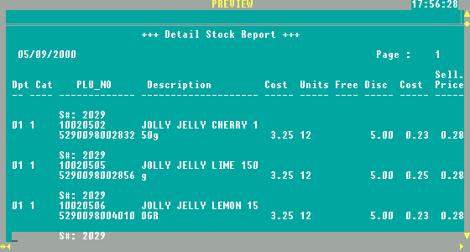
Fig 98. Detail report by selection

8.3. Price catalogue

The price catalogue report show items with their current prices, organized by department and category (Fig.99)
The purpose of this report is to provide staff with the clear list of items with current prices for checking.

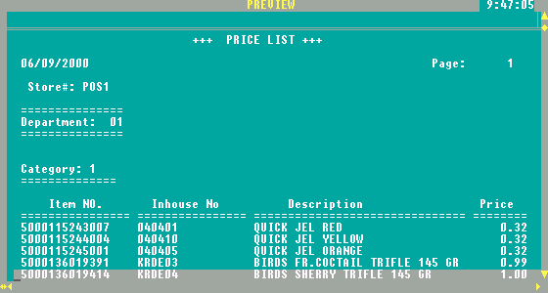
Fig 99. Price catalogue report
8.4. Balance cost report

The report shows current stock balance: purchased quantity against sold quantity, transferred in/out quantity, adjusted quantity and at the end current quantity in stock for each item.
It’s a quick way to check on movement and availability of specific item.

Note: the stock balance shows the stock levels at the moment of running report.

Once selected, you have the possibility to view stock data: by item, by category, by department and by supplier.
The menu that allows you to select appropriate view is shown in Fig.100, and the reports layouts in next four pictures (Fig. 101 - 104).

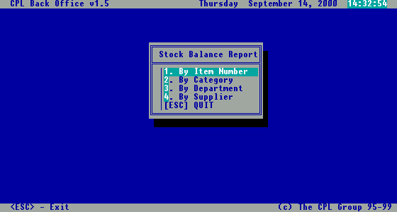
Fig 100. Stock balance report menu

By Item Number

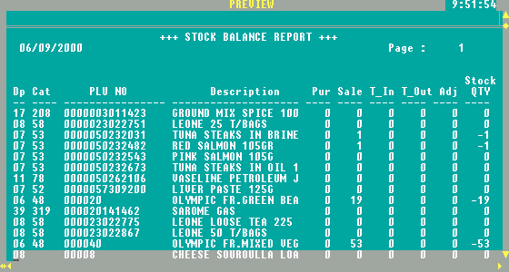
Fig 101. Stock balance report by item

By Category

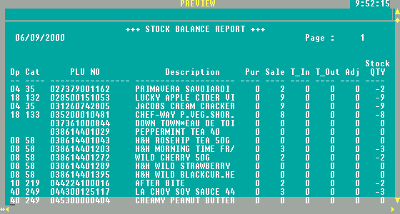
Fig 102. Stock balance report by category

By Department

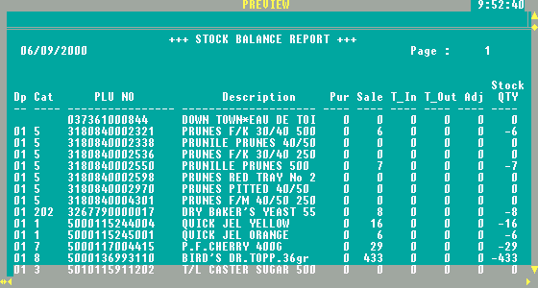
Fig 103. Stock balance report by department

By Supplier

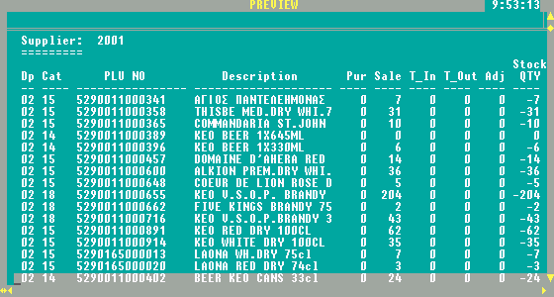
Fig 104. Stock balance report by supplier

8.5. Low stock list

The purpose of this reports is to “alarm” showing information, list of items running low on quantity (quantity less than minimum quantity specified in Items file).

Once selected this option, you can view the data: by item, by category, by department and by supplier, in the same manner as previous reports (Fig.105)

The reports layouts are shown in next four pictures (Fig. 106 - 109).

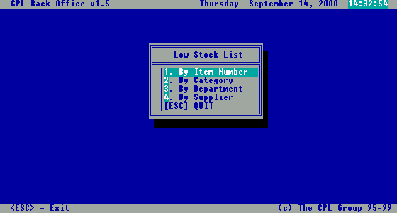
Fig 105. Low Stock List menu

By Item Number

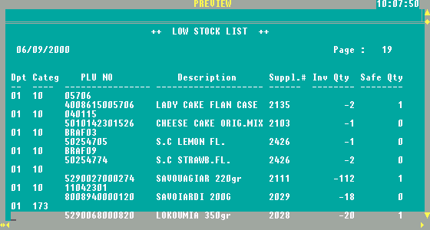
Fig 106. Low Stock List by item number

By Category

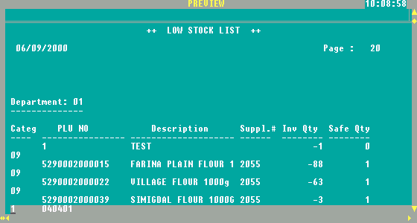
Fig 107. Low Stock List by category

By Department

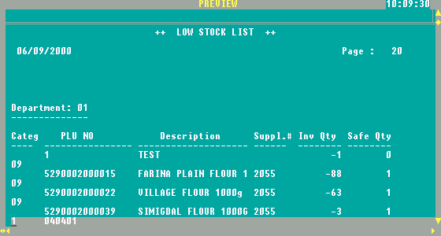
Fig 108. Low Stock List by department

By Supplier

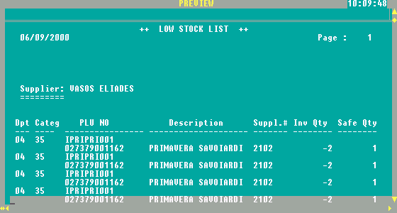
Fig 109. Low Stock List by supplier

8.6. Supplier purchase list

The purpose of the report is to reprint all the entries done from specified supplier.

After selecting this option, you have to choose de supplier code for which you want to see the report (Fig.110), to select the period of time, and to select the right report type (Fig.111.)

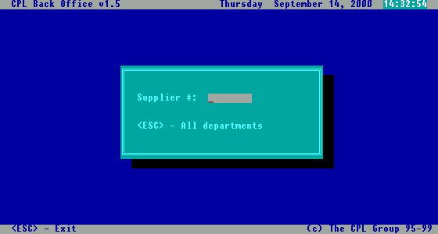
Fig 110. Supplier code dialog box

Fig 111. Purchase report menu

By Invoice

Report shows every purchase invoice, with all included items and total amount.

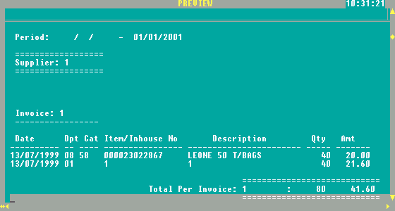

Fig 112. Purchase report Sheet

8.7. Purchase / Sales Details

The purpose of this report is tracking the movements of specific item(s).

After selecting this option, you can to select the view: By Item No, By Department, By Supplier (Fig.114)

Note: it is recommended to run this report for one specific item at the time.

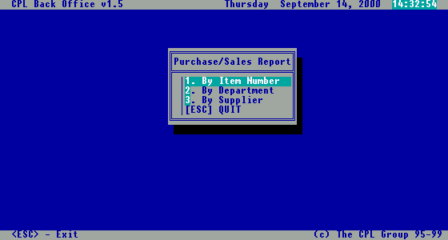
Fig 114. Purchase/Sale report menu

By Item Number

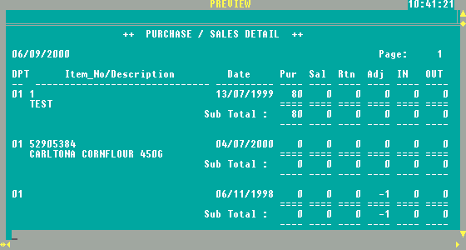
Fig 115. Purchase/Sale report by item number

By Department

Shows movement for all items under selected department.

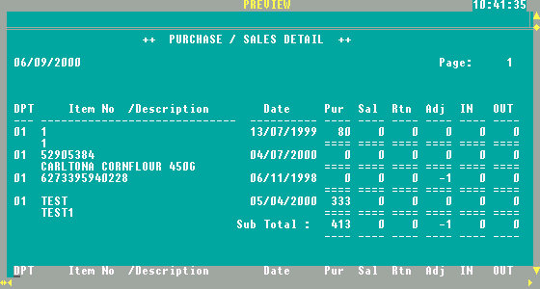
Fig 116. Purchase/Sale report by department

By Supplier

Shows movements for all items from selected supplier.

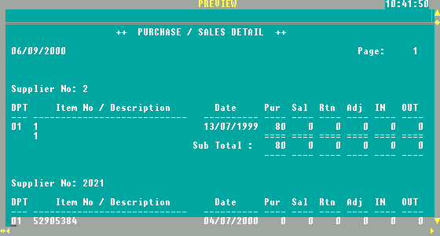
Fig 117. Purchase/Sale report by supplier

8.8. Expiration date report

If you have items with expiration date in your stock, during Inventory-In process you can specify expiration date for each one of them for later reporting purpose and control.

The “Expiration Date report” shows list of items which will expire in a selected period (30 days, 60 day, 90 days or over 90 days) as you can see in Fig.118.

After selecting this option, you need to select the supplier and the period of time,. Reports presented in Fig.119, 120 will be generated.

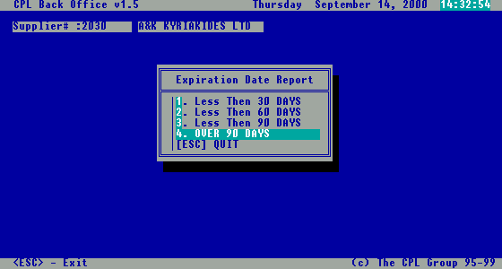
Fig 118. Period selection menu for expiration date report

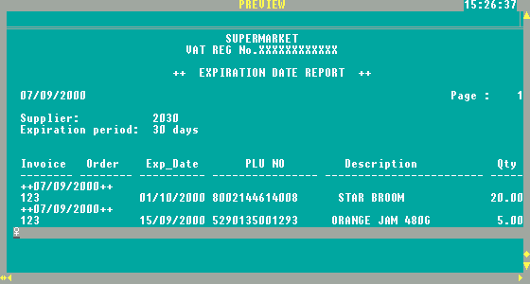
Fig 119. Expiration date report for 30 days period

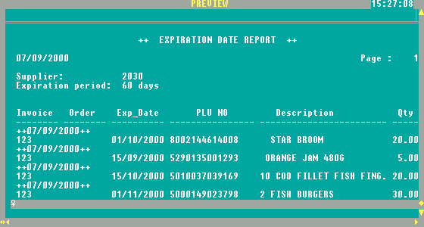

Fig 120. Expiration date report for 60 days period

9. Analysis reports

For the good control of your sale CPLPOS provides a set of Analysis reports related to Sales, VAT, Profit, Customer Purchases, etc.
All these reports are grouped into a menu that will be opened when you select the option “3.Analysis reports” within the Inventory File menu (Fig.121).

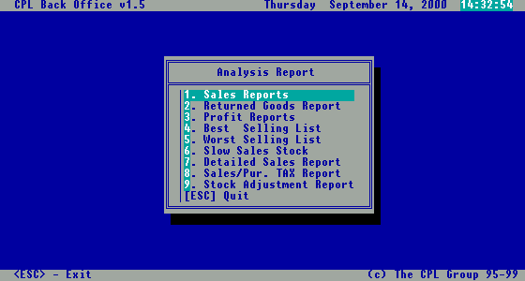

Fig 121. Analysis reports menu

9.1. Sales reports

If you select the option “1.Sales reports” from Analysis Reports menu, the following submenu will be displayed (Fig.122), containing reports related with sales activity.

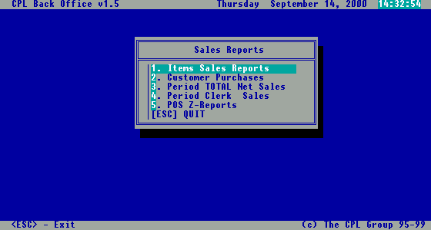
Fig 122. Sales reports menu

9.1.1 Items sales reports

The reports shows sales collected in a certain period of time viewed: by item (Fig.123), by category (Fig.124), by department (Fig.125), by supplier (Fig.126), by selection (Fig.127).

By Item

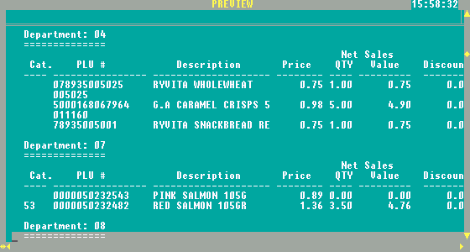
Fig 123. Item sales report by item

By Category

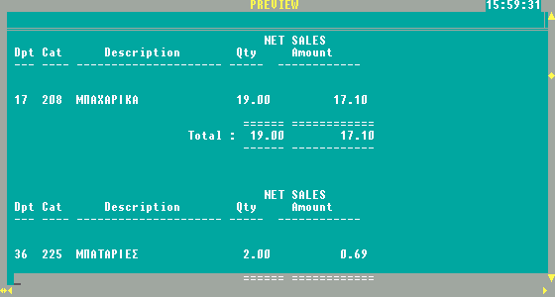
Fig 124. Item sales report by category

By Department

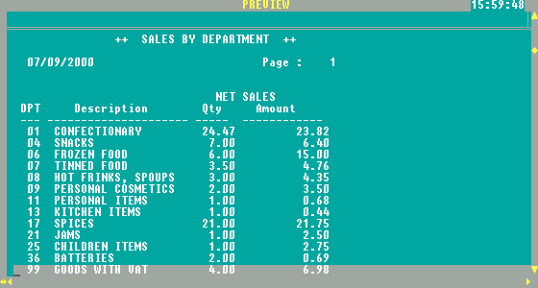
Fig 125. Item sales report by department

By supplier

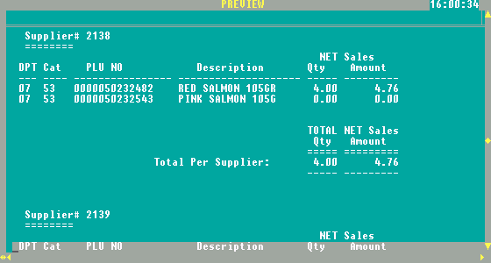
Fig 126. Item sales report by supplier

By selection

The initial selection screen let you make more complex criteria to view a sales data, as you can see from the picture below.

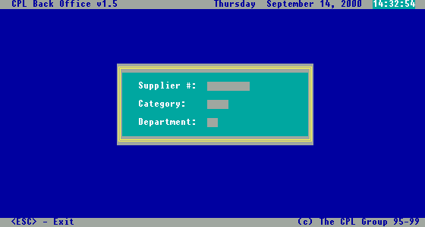
Fig . Item sales selection dialog box

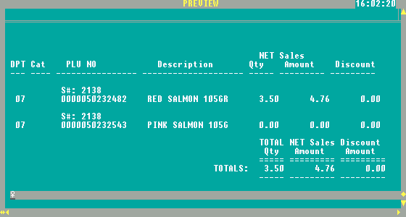
Fig 127. Item sales report by selection

9.1.2. Customer purchases

This set of reports are related to the purchases of regular customers tracked in your system. Selecting this option, submenu (Fig.128) will be open offering all the relevant reports like:
- Credit purchase: shows all the CREDIT purchase (itemized) by Specific Customer in selected period of time
- Credit Balance – Customer Credit Balance
- Customer Statement
- Detail Purchases
- Best Buyers List (list of customers buying specific product, style..)

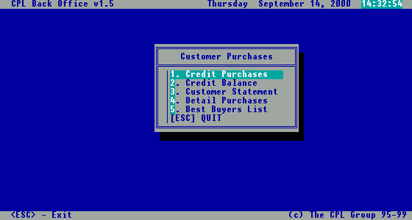
Fig 128. Customer purchases reports menu

9.1.2.1. Credit purchases

The report (Fig.129) shows all the purchase invoices done by selected client - on credit.

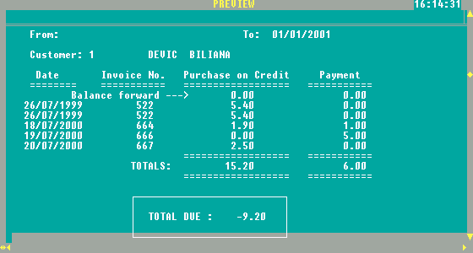
Fig 129. Credit purchases report

9.1.2.2. Credit balances

Shows the current balance amount for selected group of customers.

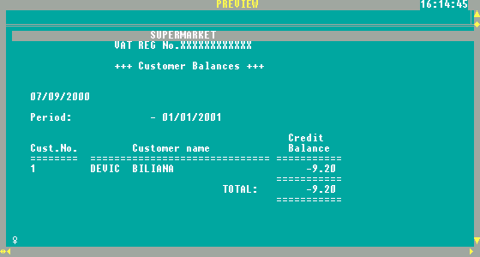
Fig 130. Customer balances report

9.1.2.3. Customer statement

After selecting a customer, current statement is shown for a selected period of time. The statement includes all purchases.

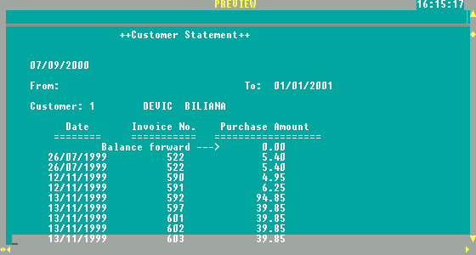
Fig 131. Customer statement report

9.1.2.4. Detailed purchases

This report shows total purchase amount from specified customer(s) for selected Item in selected period of time.

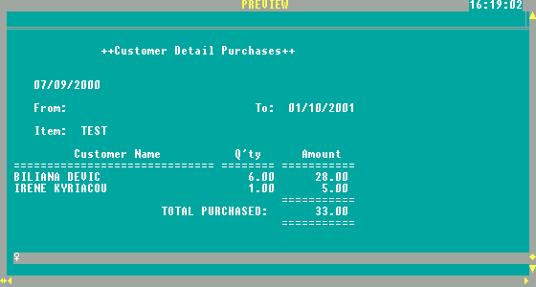
Fig 132. Customer detail purchases report

9.1.2.5. Best buyers list

After selecting number of customers you want to see (ex: 10 for Top 10, 100 for Top 100), the report from next picture will be generated, showing the best buyers list and total amount purchased.

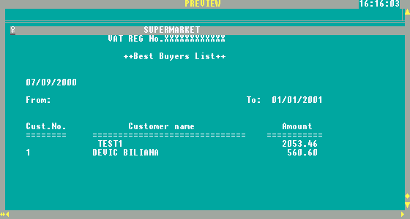
Fig 133. Best buyers list

9.1.3. Period total net sales

The report shows Total Daily Amounts collected from the POS machines with separated VAT amount.

The purpose is quick overview of the sales figures in selected period of time.

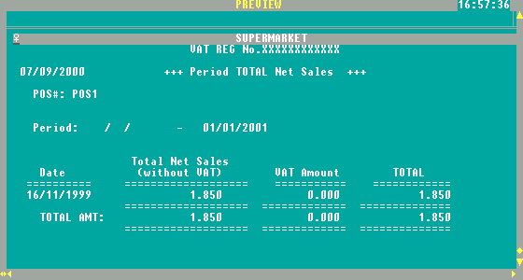
Fig 134. Period total net sales report

9.1.4. Period clerk sales

This report is very useful if you want to apply commission scheme to the sales personnel. In selected period of time reports show grouped by department sales done by specific Sales Person. Using this figure it is easy to apply commission scheme.

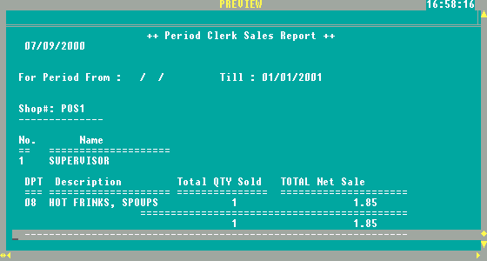
Fig 135. Period clerk sales report

9.1.5. POS Z-reports

The purpose of tis report is to allow Re-print of Z-Total reports, for every POS machine (selected) , and the period of time (which can be one specific day).

9.2. Returned goods report

This report shows all items returned during a sale in a specified period of time (Fig.136). It shows sales person that perform return and a supplier of the item.

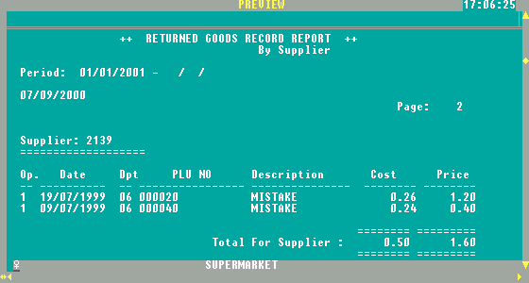
Fig 136. Returned goods report

9.3. Profit Reports

For the better control of current pricing, sales and profitability it is recommended to check on profitability reports and get the right information of profitability of items sold.

After selecting the period and the viewing method: By item – Fig.137 or
By department – Fig.138), you will be able to see information related with the cost of Sale , Sales Price and Profit.

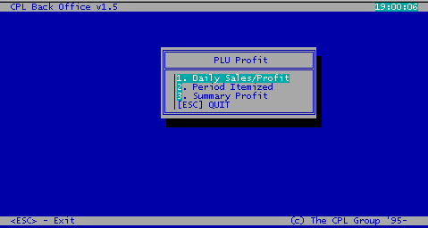
Fig 137. Profit report

9.4. Best selling list

The report shows the top list (best selling list) of items sold. You need to select the period of time, the number of items desired, and the criteria: By quantity – Fig.139 or By amount – Fig.140.

By Quantity

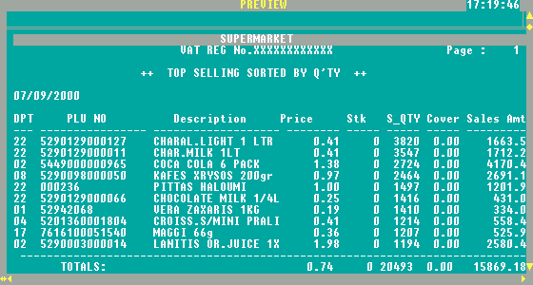
Fig 139. Best selling report by quantity

By Amount

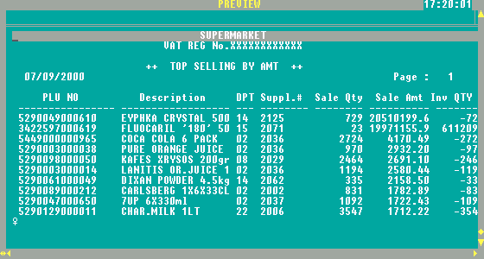
Fig 140. Best selling report by amount

9.5. Worst selling list

It’s exactly the same report as “9.4. Best selling list” with the difference, that instead of showing best selling, shows worst selling list of items.

9.6. Slow sales stock

After selecting the number of days of inactivity, and the viewing method: By item, By department, By supplier, this report shows all the stock items with slow selling.

Note: Date shown on report is the last date of sale.

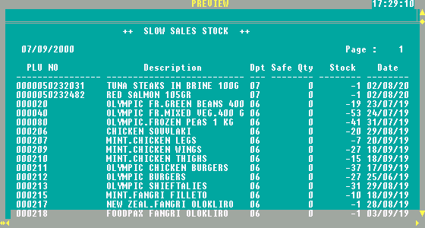
Fig 141. Slow sales report

9.7. Detail sales report

In order to check each individual invoice collected during selling (from specific POS machine), you can use detail sales report. This report (Fig, 141) shows you information about invoice printed, including method of payment.

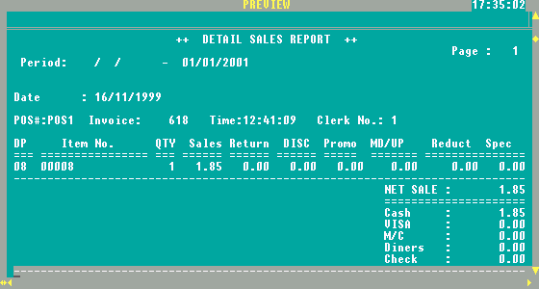
Fig 141. Detail sales report

9.8. Sales / Purchases tax report

For VAT purpose in order to submit right amount on your VAT forms, you can run VAT reports:

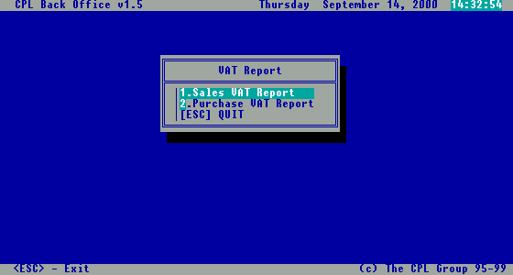
Fig 142. VAT report menu

As you can see from the picture above (Fig.142), you can select to calculate VAT Amount related with sales (Fig.143) or with purchases (Fig.144).

After selecting the period of time, the following reports will be generated (Fig. 143, Fig. 144) For the Retail and on the same way for the Wholesale Sales/Purchase.

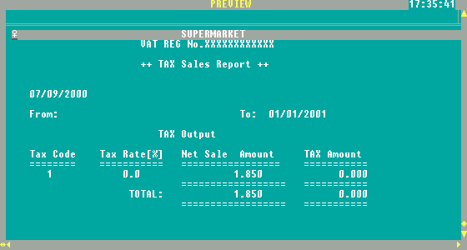
Fig 143. Tax sales report

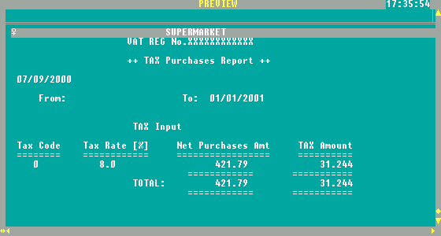
Fig 144. Tax purchases report

9.9. Stock adjustments

The report shows all stock adjustments made in a selected period of time.

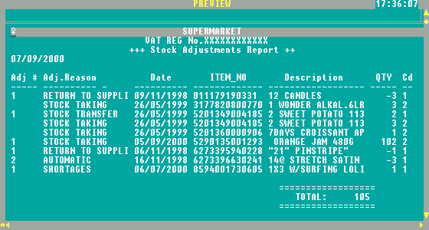
Fig 145. Stock adjustments report

