CPLPOS

MANUAL

Date : July 2005
Version : 1.5

CPL Computer Innovations Ltd.

Stock Control
For Shops

CONTENTS

CONTENTS 1
Introduction 5
Conventions 6
a. Keys 6
b. Menu navigation 6
c. Screen philosophy 7
d. Searching windows 8
1. Stock classification – General overview 9
2. Examples for stock classification 10
3. System menu 12
Managing Departments 13
Managing Categories 16
Managing Suppliers 16
Managing Seasons 17
Managing Colors 17
Managing Sizes 18
4. Stock control – Transactions 19
4.1. Inputting new stock 20
4.1.1. Locally purchased goods 22
A. Inventory-in option for locally purchased goods 22
Opening an invoice 22
Selecting a supplier 22
Selecting in-house number 23
Selecting PLU number 23
Selecting Department, Category, Unit, Tax 23
Cost calculation 23
Price calculation 24
Closing the invoice 24
B. Item Code Synthesizing 26
B.1. Inventory In with matrix color and size 26
(Descriptive item codes, barcodes: Code-39) 26
B.2. Inventory In with color and size 27
(Sequential item codes, barcodes: EAN-8) 27
Posting 28
4.1.2. Imported Goods 29
Cost Analysis 29
A. Inventory-in option for imported goods 29
Opening an invoice 30
Selecting an import #: 30
Selecting a supplier 30
Selecting in-house number 31
Selecting PLU number 31
Selecting Department, Category, Unit, Tax 31
Cost calculation 31
Price calculation 32
Closing the invoice 32
B. Item Code Synthesizing 34
B.1. Inventory In with matrix color and size 34
(Descriptive item codes, barcodes: Code-39) 34
B.2. Inventory In with color and size 35
(Sequential item codes, barcodes: EAN-8) 35
Posting 36
4.2. File importing 37
Import reports 38
Detail by PLU number report 39
Inventory check report 39
Summary by sub department 40
Inventory in report 40
Summary inventory 41
Summary imports 41
4.3. Label production 42
Create label 42
WinLabel 43
Re-print labels 44
4.4. Modifying stock 46
Quantity adjustments 46
Items file 47
Posting 49
4.5. Wholesale invoicing 50
Wholesale customers 50
Sales transactions 51
Customer payments 55
Price level formulas 55
Posting documents / payments 56
Wholesale reports 57
Customer statements 58
Customer balances 59
Sales report 60
Payments report 60
Document list 61
Document reprint 61
Balance recalculation 62
4.6. Posting 62
5. Promotions set-up 63
Introduction 63
5.1. Promotions 64
5.2. Quantity promotions 66
5.3. Specials 68
5.4. Promotions for selected Client 69
5.5. Markdowns/Mark-ups 70
6. Loyalty set-up 71
Introduction 71
6.1. Points per department 74
6.2. Points per item 75
6.3. Customer points adjustments 76
6.4. Loyalty reports 77
Points from customer purchases 78
Points from adjustments 78
6.5. Loyalty discount table 79
6.6. Gift Items set-up 80
6.7. Loyalty points adjustment reason 81
6.8. Posting 81
7. Stock taking – Inventory check 82
7.1. Blank inventory sheet – manual stock taking 83
By Item Number 83
By Category 84
By Department - Price 84
By Supplier 85
7.2. Physical inventory in 85
Data collector file 86
Manual stock taking 86
List data collection 87
7.3. Stock variance report 88
7.4. Automatic stock adjustments 89
7.5. Delete collections file 91
8. Inventory reports 92
8.1. Price catalogue 93
8.2. Detail Cost Report 93
By Item Number 94
By Sub Department 94
By Item Number 95
By Department 96
By Sub Department 96
By Style 97
8.4. Low stock list 97
By Item Number 98
By Department 98
By Supplier 99
8.5. Daily purchase list 99
By Item Number 100
By Style 100
8.6. Vendor purchase list 101
8.7. Purchase / Sales Details 101
By Item Number 102
By Department 102
By Vendor 103
8.8. Stores stock report 104
By Item number 104
By Style 104
9. Analysis reports 105
9.1. Sales reports 105
9.1.1 Items sales reports 106
By Item number 106
By Department 106
By style 107
9.1.2. Period MD/FP sales 107
By department 107
By Sub Department 108
9.1.3. Sales/Stock by season 108
9.1.4. Actual sales / Last week sales 109
By Department 109
By Sub Department 109
9.1.5. Period total net sales 110
9.1.6. Period total invoice number 110
9.1.7. Hourly sales 111
9.2. Returned goods report 111
9.3. Profit Reports 112
By Item 112
By Department 112
9.4. Best selling list 113
By Quantity 113
By Amount 113
9.5. Worst selling list 114
9.6. Slow sales stock 114
9.7. Detail sales report 114
9.8. Sales / Purchases tax report 115
9.9. Stock adjustments 117

Introduction

Retail Management starts around a classic till machine, designed for a fast transaction taking and ease of use by any cashier without special training.

We realized this is a system that nobody is afraid of and they can easily use, therefore we built our Cash module system around that philosophy and we make a use of a programmable keyboard to emulate it.

Once our system gets into the shop the cashier within 5 minutes familiarization (and we do not exaggerate) can start crunching numbers within the same cash register style selling, making everyone feel right at home.

How good is a complicated system if it is cumbersome and difficult to learn? Cashiers and managers alike want it simple - and we deliver.

Conventions

For a better understanding, now we will have a look at some conventions used all over this manual.

Keys

Whenever a key or a combination of keys could be pressed for some actions, they will be written between “<” and “>” signs (ex: <ESC>). If a combination of keys has to be pressed, it will be written between “<” and “>” signs, and each key will be delimited by a dash (“-”) sign (ex: <ALT-F8> or <CTRL-ESC>).

Menu navigation

To perform navigation, you can choose a method suitable for you from following:
  - Positioning on the desired option with arrow keys (<ARROW UP ↑ > and <ARROW DOWN ↓ >), and pressing <ENTER>.
  - Using the mouse.
  - Typing the number written in the front of the desired option (ex: if the desired option is “4. System data” you can press <4>)

Note: From the second method of navigation, can be created and used a rule of options referrals. You can access any option in any menu and submenu, using the access path number, which consist practically from each corresponding number of options from the menus and submenus that compose the path. We will call this method “Direct access” or “Expert mode”.

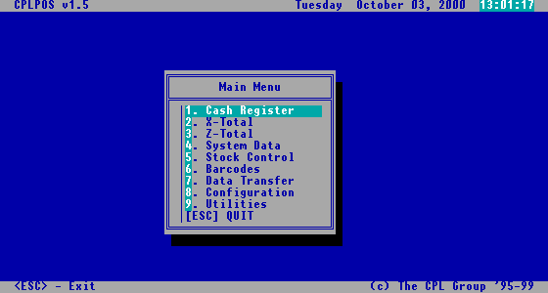
These are the corresponding numbers of each option, which can be used in Direct Access mode
These are the options of the menu. You can highlight one by positioning with arrow keys (↓↑) and select it by pressing <ENTER>, or you can use the mouse for this.
Highlighted option
Menu Navigation

Sample

5-1-1 means from the main menu, option “5.Stock Control” which will open the Stock control menu; from this menu, option “1.Transactions”, which will open the Transactions submenu; from this last submenu the option “1.Inventory In”, which will open the Inventory In screen. This means that we can address the Inventory In screen with the sequence 5-1-1.

The Direct access method is the most efficient from all presented methods.
First, because it’s faster to have two or three keystrokes to access a menu or a screen, than to use the mouse or to use arrows for positioning and <ENTER> for selection.
Second, because for some particular users, is more easier to remember two or three numbers, than to remember all the menus and all options from that menus.
Third, because anyway after few days, or weeks of working with the software, they will remember only these numbers for Direct Access, or said in another way they will all become “experts” for their part of work.

Sample

For example, in one supermarket we have three different categories of users:
- Normal clerks, which just use the Cash Register screen;
- Stock clerks, which are just entering items and invoices from vendors into the system;
- Supervisors, which can use the Cash Register screen, and also execute few reports and perform some daily actions;
- Owner or manager, which will be able to access any option from any menu, and to manage data in any screen.
For all users within these categories of users, it’s easier to use the Direct Access method, practically to remember few combinations of numbers that leads to the most used screen or option. The clerks have to remember only 1 for entering the Cash Register screen; the stock clerks have to remember only 5-1-1 to access the Inventory In screen and 5-1-4 to access the Items file screen; the supervisors have to remember for example that for ending the day they have to press 3-1, or for seeing an Instant account they have to press 2-5, and so on.

Screen philosophy

As you will see in following chapters, all the screens of the CPLPOS software are made in the same concept. The only part that effectively differs from one screen to another is the content.
The options menu you will find on the bottom of each screen has the same options in all screens, with some minor exceptions. To select one option from a screen option menu, you can apply methods presented for menu navigation. You can position on the desired option using the arrow keys <ARROW LEFT ← > and <ARROW RIGHT → >, and select the option with <ENTER> key. Also you can press the number of each option.
On any screen you are if you press <ESC> you will exit the screen. Also, by pressing <F1> you will see all the content of the database table related with that screen.
On any field that is a code, if you press the <ARROW DOWN ↓ > key, a searching window containing a list of all codes applicable for that field will appear, allowing you to select one from the list (see next paragraph).

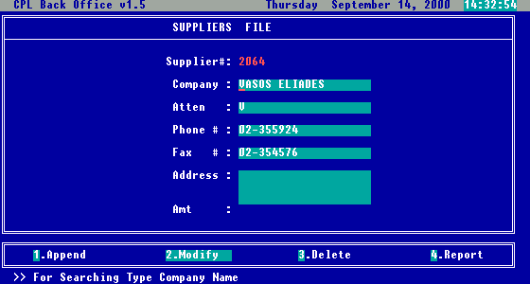
Screen options
Informational field – cannot be modified
Data entry fields – here you can enter or modify data
Name of the screen
Labels – usually these are the names of the fields
Screen components

In some specific screens (like Inventory In screen), if you are about to enter data in some specific fields (like Department, Category, Units of Measurement, etc.), if you enter the sign “*” and press <ENTER>, the screen that manages that specific item will be brought up allowing you to add a new entry, that you can afterwards use it for entering in the field. With this facility, is no need to exit the current screen, to add a new record in a system data screen.

Searching windows

Usually after pressing the <ARROW DOWN ↓ > key, a searching window will appear. From this widow, you will be able to select an item by positioning on it with arrow keys, and by selecting it with <ENTER> key. In the moment you press <ENTER>, the searching window will close, and the selected item will be automatically completed in the current field.
You will see that one of the columns presented in the search window is alphabetically ordered. By typing the beginning characters of the searched item, you will be positioned on the first item which start with typed characters in the sorted column.

1. Stock classification – General overview

For a better administration of stock, as well as for obtaining different types of useful stock/sales reports, it is recommended to classified all the items in the stock in groups and subgroups. Usually main classification is by: departments, categories (called also groups, sub-departments), suppliers, seasons, styles, colours and sizes.

- Suppliers – Tracking the supplier for each item all stock can be classified by the supplier where items were received from .

- Department – is the most wide grouping criteria. It’s situated on the highest level within the grouping pyramid. Usually, one department could contain many categories.

- Category (Group, Sub department) – is the next level of grouping criteria, situated exactly under the department level within the grouping pyramid. Usually, one category contain many items.

On the ground level within the grouping pyramid, are situated all the items existing in stock with assigns colours and sizes.

Departments

Categories / Groups / Sub departments

Styles

Items in stock

Fig.1 – Grouping pyramid

- Style – (or model) one style refers to a group of items with different colours and sizes.

- Colour – each item can have a specific colour. You can obtain statistical reports of items in stock organized and grouped by colour, where you can see customers preferences for colours.

- Size – each item can have a specific size. Obtaining sales reports by size, you can see which sizes are selling the most so you can tailor better your next order/

- Season – each item was purchased from supplier and is made for specific season.

Having in mind the usage of the criteria presented above, the nature of your activity and the structure of your stock, you can choose a method to organize the stock, in a manner which will best fit your requirements and your profile.
For a better understanding, in next chapter you can see few examples.

2. Examples for stock classification

Sample 1

Department | Category | Style | Item | Colour | Size
1. Women’s  ware | 11. Bags | BJVG12 | Plastic bag | Red | M
1. Women’s  ware | 11. Bags | JOJ22G | Leather bag | Black | M
1. Women’s  ware | 11. Bags | JOJ22G | Leather bag | Red | M
1. Women’s  ware | 12. Belts | BL021T | Leather belt | White | 48
1. Women’s  ware | 12. Belts | BL021T | Leather belt | Green | 52
1. Women’s  ware | 12. Belts | BL025T | Leather belt | White | 56
1. Women’s  ware | 13. Coats | RR2T4 | Plastic rain coat | Green | M
1. Women’s  ware | 13. Coats | RR2T4 | Plastic rain coat | Grey | L
1. Women’s  ware | 13. Coats | RR2T4 | Plastic rain coat | Blue | L
1. Women’s  ware | 14. Dresses | AR717D | Armani Dress | Grey | M
1. Women’s  ware | 14. Dresses | AR717D | Armani Dress | Blue | M
1. Women’s  ware | 14. Dresses | AR717D | Armani Dress | Black | L
2. Men’s ware | 21. Jackets | TRT67V | Velvet jacket | White | M
2. Men’s ware | 21. Jackets | TRT67V | Velvet jacket | Black | M
2. Men’s ware | 22. Pants | ST045W | Trousers | Red | L
2. Men’s ware | 22. Pants | ST045W | Trousers | White | L

Sample 2

Department | Category | Style | Item | Colour | Size
1. Bottoms | 11. Shorts | U20225 | Adidas shorts | Red | M
1. Bottoms | 11. Shorts | U20225 | Adidas shorts | Black | M
1. Bottoms | 11. Shorts | U20225 | Adidas shorts | Red | XXL
1. Bottoms | 11. Shorts | U17018 | Safari shorts | White | L
1. Bottoms | 11. Shorts | U17018 | Safari shorts | Green | L
1. Bottoms | 11. Shorts | U17018 | Safari shorts | White | XL
1. Bottoms | 12.Bermudes | U22020 | Fishing trousers | Green | M
1. Bottoms | 12.Bermudes | U22020 | Fishing trousers | Grey | L
1. Bottoms | 12.Bermudes | U22020 | Fishing trousers | Blue | L
1. Bottoms | 13. Jeans | U24111 | Casual jeans | Grey | M
1. Bottoms | 13. Jeans | U24111 | Casual jeans | Blue | M
1. Bottoms | 13. Jeans | U24111 | Casual jeans | Black | L
2. Tops | 21. Shirts | S00233 | Polo shirt | White | M
2. Tops | 21. Shirts | S00233 | Polo shirt | Black | M
2. Tops | 22. T-Shirts | S00545 | LaCoste | Red | L
2. Tops | 22. T-Shirts | S00545 | LaCoste | White | L

Sample 3

Department | Category | Style | Item | Colour | Size
1. Dresses | 11. Short Denim | 202IDJ25 | D/String Denim | 130 | 22
1. Dresses | 11. Short Denim | 202IGI24 | Empire Denim | 175 | 26
1. Dresses | 12. Mid Denim | 2CX02U | Classic | 175 | 33
1. Dresses | 12. Mid Denim | 2CX02F | Flower | 190 | 35
1. Dresses | 13. Jersey Club | 1702TY3 | Snake Skin Zip | 130 | 20
1. Dresses | 13. Jersey Club | 1702TY7 | Indian Zip | 190 | 28
2. Blouses | 21.Tunics | TU02C2 | Clipper tunic | 120 | 20
2. Blouses | 21.Tunics | TU02P2 | Poplin tunic | 175 | 22
2. Blouses | 21.Tunics | TU02P2 | Poplin tunic | 130 | 24
2. Blouses | 22. Club Tops | 3BT05Z | Zip boob tube | 120 | 26
2. Blouses | 22. Club Tops | 3BT05Z | Zip boob tube | 130 | 28
2. Blouses | 22. Club Tops | 3BT07D | Denim boob tube | 120 | 33
3. Cosmetics | 31. Lipstick | S21L2M | Mushroom lipst. | 125
3. Cosmetics | 31. Lipstick | S21L2I | Water ICE lipst. | 100
3. Cosmetics | 32. Eyeshadow | S00X545 | Sterling | 130
3. Cosmetics | 32. Eyeshadow | S00X507 | Hazelnut | 155

3. System menu

Once you have decided exactly how you would like to classify stock items, you can start entering suppliers, departments, categories, seasons, colours and sizes as per your system. All these settings are grouped in a menu called System Data Menu (number 4 from Main Menu).

Fig 2. Main Menu

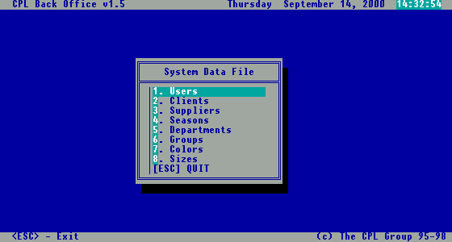
Fig 3. System Data Menu for Supermarket

Managing Departments

Here you can see prompts leading to the screens that manage suppliers, departments, and categories. For entering in departments screen, just press <4> from the Main menu, or select the prompt end press <ENTER>.

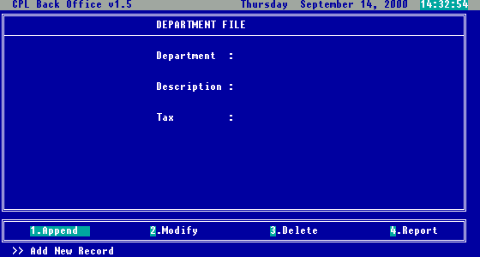
Fig 4. Departments Screen

On this screen you can manage information about department. The department code is automatically sequential generated, but you can replace it with your own, just to have in mind that one code can be used only once. Also you must complete a description for the new department, and you can select a tax code for the specific department by typing directly code or pressing <ARROW DOWN> button for selection.

You will notice that the option bar from the bottom of the screen, is mostly the same in all screens (with small differences). If you want to add a new department, just select 1. Append, and you are in the proper mode for entering new data.

If you want to modify a department that already exists in your database, select 2.Modify. After this, you will see a window containing all departments, alphabetically ordered, from which you can select the department you want to modify (see Fig.5).

If you want to delete from the database a department that no longer exists, or is useless, you should select option 3. Delete. Exactly after that, the same window with all the departments, from Fig.5, will open, and after selecting one department, you will be asked to confirm deletion.

Any time you can see a report with all departments inputted, by selecting the option 4. Report.

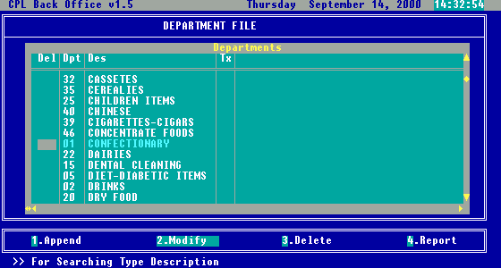
Fig 5. Search window for Modify/Delete

If you decided to use Descriptive barcodes and method of synthesize with Matrix Col/Size (see chapter 4.1), then after entering or modifying data for a department, you should choose YES as answer for the “Color/Size” question, as you can see in the next picture.

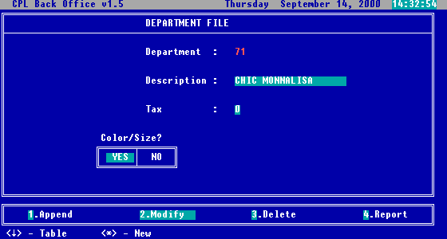
Fig 6. Colour and Size question

Proceeding like this, you will be allowed to enter all possible colours and sizes assign to each department, information that will be used for synthesize often codes (barcodes).
The actual input of colours and sizes can be done through small windows that will open right after you chose YES. In these windows, you will add all possible colours and sizes for each department (moving to the next available position with <ARROW DOWN> as you can see from the next two pictures.

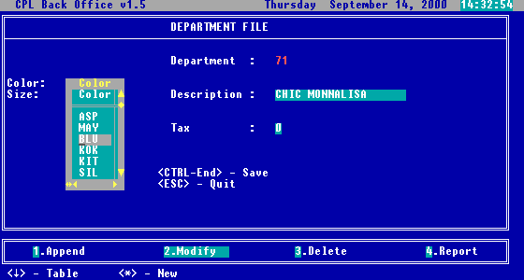
Fig 7. Colour window

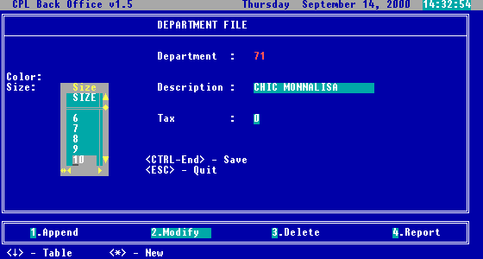
Fig 8. Size window

For saving all colours and sizes added in each corresponding window, you could press <CTRL-END> or <CTRL-W>, or moving to the first empty field and pressing <ESC>.

Managing Categories

For entering Categories option, just press <6>, or select the prompt end press <ENTER>.

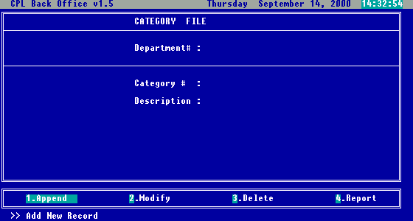
Fig 9. Category screen

On this screen you can enter categories within a specified department. In the department code field, during data entry, or if you press <ARROW DOWN> you can select one of the departments from the list.
Category code will be also automatically generated, and you have to complete the description. The functionality of the options from the bottom of the screen is the same as from the previously presented screen.

Managing Suppliers

From System Data Menu, press <3>, or select Suppliers and press <ENTER>.

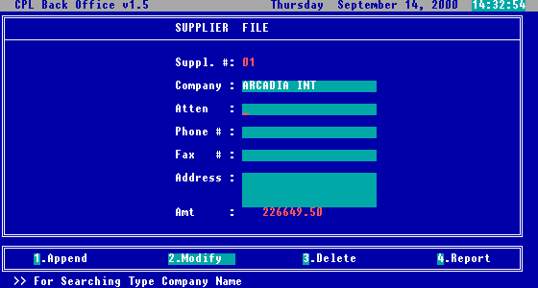
Fig 10. Suppliers screen
On this screen you can enter and manage information related with your suppliers. The supplier code will be automatically generated, you need to fill the company name, and you can fill also the rest of details.

Managing Seasons

From System Data Menu, press <4>, or select Seasons and press <ENTER>.

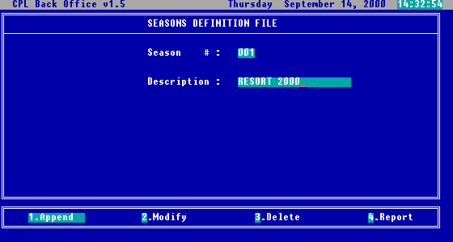
Fig 11. Seasons screen

On this screen you can enter and manage information related with your seasons. The season code will be automatically generated and you need to fill the description.

Managing Colors

If you choose to keep your colours and for synthesize of barcode with sequential numbers (EAN) you can enter them through the following screen. Otherwise you will specify them with the department definitions.

From System Data Menu, press <7>, or select Colours and press <ENTER>.

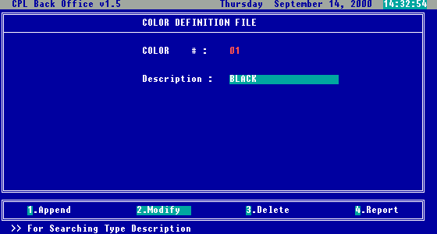
Fig 12. Colours screen

Managing Sizes

If you choose to keep your sizes and for synthesize of barcode with sequential numbers (EAN) you can enter them through the following screen. Otherwise you will specify them with the department definitions.

From System Data Menu, press <8>, or select Sizes and press <ENTER>.

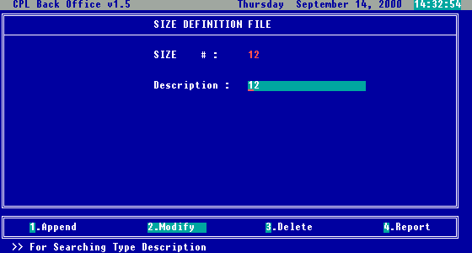
Fig 13. Sizes screen

Through this screen you can enter and manage information related with your sizes. The size code will be automatically generated and you must fill in the description.

Note: Styles will be entered during Inventory-In procedure and automatically during Posting save in a separate Style Database – you don’t need to enter them separately.

4. Stock control – Transactions

From the main menu you can access Stock Control – Transactions option. This could be accomplished by highlighting the “Stock Control” option and then pressing enter or by pressing the number corresponding to the option as seen on the screen above.

After the selection is made this screen will be brought up.

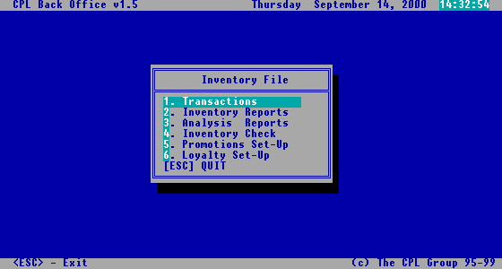
Fig 14. Stock control menu

After the first choice “1.Transactions” is selected, the Transaction menu appears. This could be seen below.

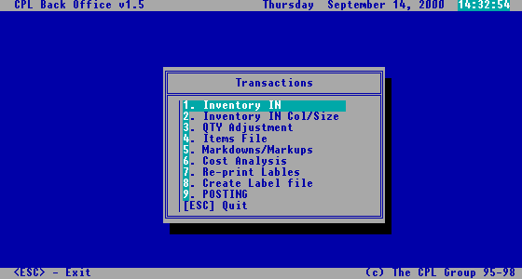
Fig 12. Transactions menu
Fig 15. Transaction menu

4.1. Inputting new stock

Entering stock items using CPLPOS can be done on several different ways, depending on the current stock organization.
First thing is to separate the local goods from the imported goods. But for both types of goods you will have the following options:

- Inventory-In option – used for inputting items that already have barcodes (like input from purchase invoice) or the item code (PLU) can be assigned manually.

- Inventory-In with Col/Size option – used when stock items do not have barcodes and there is a need to synthesize them. Provided are 2 methods:

B.1. Input with Matrix Colour/Size – Descriptive barcodes (Code-39)

In order to use this method it is important to set-up Colour and Size on the Departments Set-up screen (System Menu). Every department need to have assigned appropriate colors and sizes.

Sample:

Department: 01 Men trousers
Colours: BLK, BLU, RED, GRE, BEI, …
Sizes: 28, 30, 32, 34, 36, 38, 40, 42, 44, 46, 48

Department: 02 Men T-Shirts
Colours: WHI, BLU, BLK, GRE, …
Sizes: S, M, L, XL, XXL, …

So, on the Inventory-In with Col/Size screen, after inputting related data, barcodes are synthesized on the following way:

Department
Supplier
Style
Colour
Size
2 char
Ex: 07
2 char
Ex: 85
6 char
Ex: 100255
3 char
Ex: 307
3 char
Ex: 002
Barcode for the stock item
Ex: 0785100255307002

Maximum length for barcode is 16 characters and for this reason all the relevant fields must have exact length.
These item codes are possible to print as barcodes using Code-39. Code-39 is internationally recognized code for the local use.

Note: Code-128 can also be used.

B.2. Input with Matrix Color/Size – Sequential numbers (EAN-8)

In case when style need to be longer and color and sizes have to be more than 3 characters, and when barcode needs to be small, suggested is to synthesize barcodes with sequential numbers (7 digit number for code EAN-8, or 13 digit for code EAN-13)

In the following chapters we will explain in details how to implement each of the selected methods.

Note: Depending on your source of supply (local market or international) the options are provided for inputting local goods or imported ones.

4.1.1. Locally purchased goods

A. Inventory-in option for locally purchased goods

After goods are purchased from the supplier and purchase invoice received it has to be entered into the system as per purchase invoice. This can be done with the “1. Inventory in” option from the menu shown in Fig.8 that will bring up the following screen.

As you can see, on this screen the options from the bottom of the screen are not exactly the same as for previously discussed screens. The options this screen offers are:
- Append : Add a new line from the same purchase invoice.
- Modify : Change an existing “Inventory In” record (purchase invoice line)
- Delete : Erase an existing “Inventory In” record (purchase invoice line)
- Search : Search the existing records (lines already inputted).
- Report : Do a report on the existing records (print purchase invoice).
- Exit : Exits the “Inventory In” screen (finishes purchase invoice).

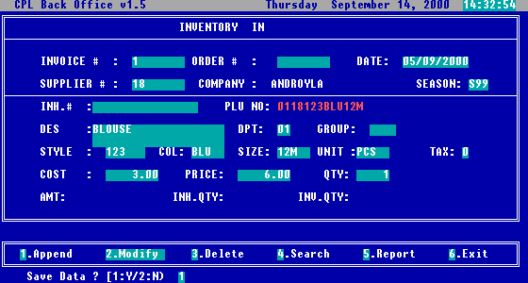
Fig 16. Inventory in screen

Opening an invoice

In the moment you entered this screen, and selected for the first time 1. Append, you are opening a new purchase invoice. You will see that information entered for the first record for Invoice #, Order # and Date will be kept for all records entered until selecting the option 6. Exit, which functionally means closing the invoice.

Selecting a supplier

When you are about to complete the field Supplier #, by pressing <ARROW DOWN>, you will see a supplier selection list, from which you can select the right one, if you don’t remember its code. After selection, the COMPANY name will be automatically displayed.

Selecting in-house number

If you would like to input a purchase invoice received from your regular supplier, and you want to keep also their internal coding of items (can be SKU Number), for keeping track later on, you can fill this field with the item code existing on the purchase invoice for that item (called also: Local code or In-house code)

Selecting PLU number

In PLU number field, you can scan the item’s barcode, or if you don’t have a scanner, you can enter the code manually. If during previous invoice processing, the Inhouse# was entered, then automatically a window with all barcodes associated with this In-house no. will appear, and will allow you to select the right one, as shown in the next picture.
For each Items then you need to fill the following fields: Description, Style, Colour and Size.

Selecting Department, Category, Unit, Tax

As you can see from picture 13, next fields to be completed are Department, Category, Unit, Tax. On all of them, if you cannot remember the codes, you can press <ARROW DOWN>, and a window with all departments / categories / units of measure / tax codes, will appear, and will allow you to choose the desired one.

Cost calculation

When you are about to enter data in Cost field, you can enter directly the cost, or if you press <ARROW DOWN>, a cost calculator window will appear as shown in the picture below.

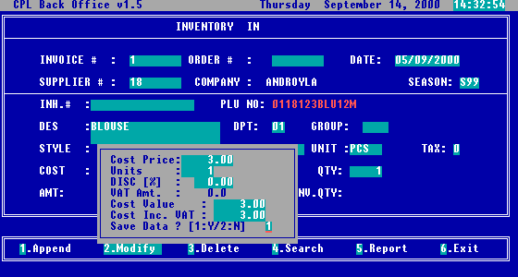
Fig 17. Cost calculator window

In this calculation window, in the field Cost price you have to enter the price shown in your purchase invoice, and for Units you should enter the quantity received for that amount. After entering data in DISC [%] the net cost, and the cost including VAT will be automatically calculated based on the information entered.
On the question Save data ? [1:Y/2:N] if you answer yes (1), the cost calculated in this window, will be transferred in the Inventory in window, if you answer no (2), the small window is closed, and the cost field from the Inventory in window will not be affected.

Price calculation

When you are about to enter data in Price field, you can enter directly the selling price, or if you press <ARROW DOWN>, a selling price calculator window will appear as shown in the picture below.

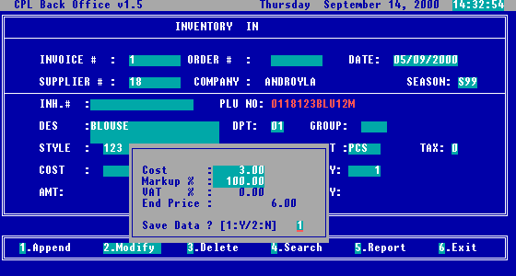
Fig 18. Selling price calculator window

The cost is automatically taken from the cost field (cost without VAT and discounts) . You can fill the Mark-up percent in the Markup % field, and to confirm the VAT %. After that, the End price will be calculated, and you will be asked if you want to save this value or not.

Closing the invoice

After price, you have to input the quantity for the item received, After all data is entered, the screen will look like in the next picture.

Fig 19. The screen with all data completed, before saving

At this step you can decide if the entered data is correct, and to save the record. If you finished all items from the invoice, you can proceed to close the invoice, but before this, is highly recommended to generate a report on screen (Fig.20), and to compare is the total of the invoice entered in the database, agrees with the amount from the paper invoice. If the amounts agree, then you can safely close the invoice by choosing Exit option, and exit the Inventory in screen.

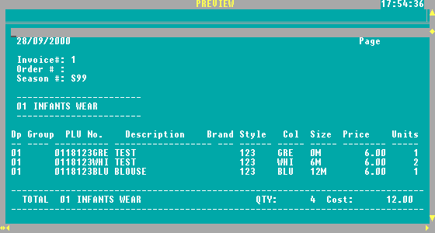
Fig 20. Report generated by Inventory in – Report option

B. Item Code Synthesizing

B.1. Inventory In with matrix color and size

(Descriptive item codes, barcodes: Code-39)

From the Transaction Menu, after the first choice “2.Inventory in with col/size” is selected, the following screen will appear, as you can see below:

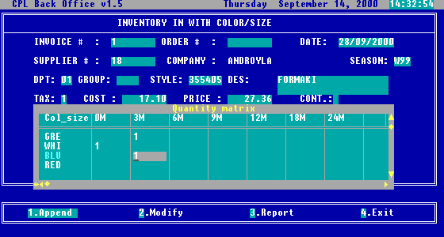
Fig 21. Inventory in with colour and size screen – descriptive barcodes

Before we start explaining how to actually fill table (matrix) with Col/Size let’s have a look on the basic concept.

Items are entered into the system selecting first department (colour and sizes are already assign to this department) following is a Style. For every Style you need to enter Description, Tax (VAT), Cost and Price. If the style was previously inputted and posted the description, Tax, Cost and Price will show automatically.

For the current Style and Department, matrix Col/Size will be created. In this table you need to position the cursor on the corresponding row for colour, and on the right column for size, and enter the quantity of stock item that have that colour and size.

After you finished entering all quantities, you can close the matrix with <CTRL-END> or <CTRL-W> or moving to the first empty cell press <ESC>.

After saving, for each item with different colour and size, will be generated a different descriptive code/barcode, and a different entry in inventory-in table will be added.
So, filling one screen you can synthesize all the barcodes belonging to the entered style.

B.2. Inventory In with color and size

(Sequential item codes, barcodes: EAN-8)

From the Transaction Menu, after the first choice “2.Inventory in with col/size” is selected, the following screen will appear, as you can see below:

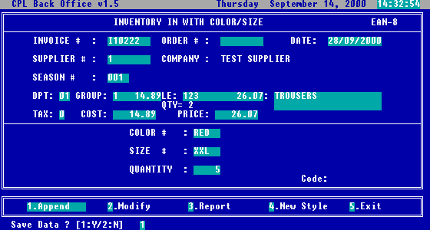
Fig 22. Inventory in with colour and size screen

This screen is used also for stock inputting, the only difference is that the codes generated for entered items are sequential, applicable for barcodes type EAN-8. With append option once style is inputted, the only information to input is colour, size and quantity. If you have to move to the next style, use option New Style.

Note: If style already exists, entering style it will show on the screen description, cost and price.

Posting

This function finalizes the process of data entry by effectively affecting stock database. From the Transaction menu, you can press the <7> key or select the option “9.Posting” and press <ENTER> to start the POSTING and answering YES to the 'POSTING' window (Fig.23).

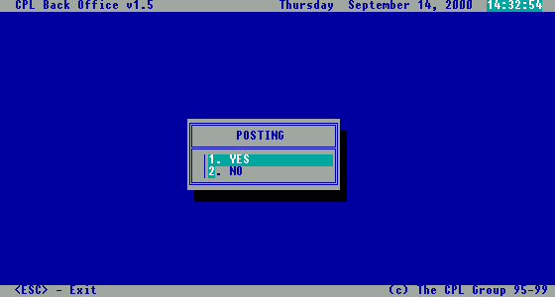
Fig 23. Posting

This step is very important. If you omit to post, practically all items you entered in stock, will not be available for further modifications, or selling. As you will see in the rest of this manual, after all operations involving stock change, or other major changes of the database, you have to proceed posting.

4.1.2. Imported Goods

Before we start explaining actual option for Inventory-In it is important for imported goods to go through Cost Analysis option and calculate the expenses. Result of Cost Analysis is percentage to be applied on the cost shown on the purchase invoice in order to know real cost of the items received.

Cost Analysis

The Cost analysis screen can be seen in the next picture.

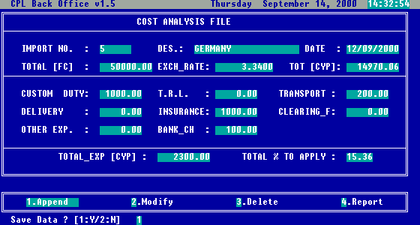
Fig 24. Cost analysis screen

Suggested is, that all the data should be inputted from clearing documents. As you can see, basically this is a cost calculator for imported goods. You have to complete the value of goods in foreign currency and exchange rate, and you will get amount in CYP. After that you ca input all the expanses, and the program will calculate for you the margin rate (mark-up rate) to cover all expenses.

A. Inventory-in option for imported goods

After goods are purchased from the supplier and purchase invoice received it has to be entered into the system as per purchase invoice. This can be done with the “1. Inventory in” option from the menu, option that will bring up the following screen.

As you can see, on this screen the options from the bottom of the screen are not exactly the same as for previously discussed screens. The options this screen offers are:
- Append : Add a new line from the same purchase invoice.
- Modify : Change an existing “Inventory In” record (purchase invoice line)
- Delete : Erase an existing “Inventory In” record (purchase invoice line)
- Search : Search the existing records (lines already inputted).
- Report : Do a report on the existing records (print purchase invoice).
- Exit : Exits the “Inventory In” screen (finishes purchase invoice).

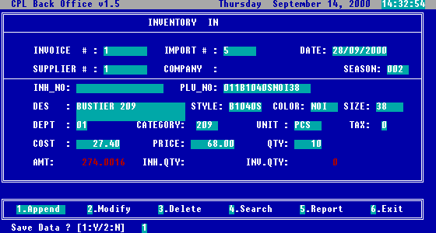
Fig 25. Inventory in screen

Opening an invoice

In the moment you entered this screen, and selected for the first time 1. Append, you are opening a new purchase invoice. You will see that information entered for the first record for Invoice #, Order # and Date will be kept for all records entered until selecting the option 6. Exit, which functionally means closing the invoice.

Selecting an import #:

When you are about to complete the field Import#, by pressing <ARROW DOWN>, you will see a list with all imports entered in Cost analysis screen. Selecting one from the list will affect all cost and price calculations, with the amount, exchange rate and mark-up percentage accordingly.

Selecting a supplier

When you are about to complete the field Supplier #, by pressing <ARROW DOWN>, you will see a supplier selection list, from which you can select the right one, if you don’t remember its code. After selection, the COMPANY name will be automatically displayed.

Selecting in-house number

If you would like to input a purchase invoice received from your regular supplier, and you want to keep also their internal coding of items (can be SKU Number), for keeping track later on, you can fill this field with the item code existing on the purchase invoice for that item (called also: Local code or In-house code)

Selecting PLU number

In PLU number field, you can scan the item’s barcode, or if you don’t have a scanner, you can enter the code manually. If during previous invoice processing, the Inhouse# was entered, then automatically a window with all barcodes associated with this In-house no. will appear, and will allow you to select the right one, as shown in the next picture.
For each Items then you need to fill the following fields: Description, Style, Colour and Size.

Selecting Department, Category, Unit, Tax

As you can see from picture 13, next fields to be completed are Department, Category, Unit, Tax. On all of them, if you cannot remember the codes, you can press <ARROW DOWN>, and a window with all departments / categories / units of measure / tax codes, will appear, and will allow you to choose the desired one.

Cost calculation

When you are about to enter data in Cost field, you can enter directly the cost, or if you press <ARROW DOWN>, a cost calculator window will appear as shown in the picture below.

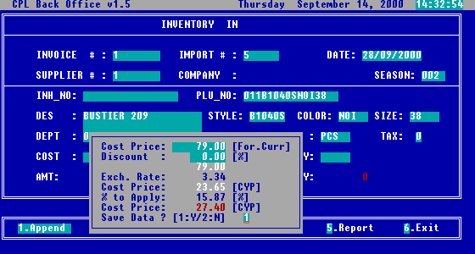
Fig 26. Cost calculator window

In this small window, for field Cost Price you have to enter the price shown for that item, and for Exchange rate and % to Apply the correct rates will be automatically completed accordingly to the chosen import settings. After entering data in Discount [%] the cost price will be automatically calculated.
On the question Save data ? [1:Y/2:N] if you answer yes (1), the cost calculated in this window, will be transferred in the Inventory in window, if you answer no (2), the small window is closed, and the cost field from the Inventory in window will not be affected.

Price calculation

When you are about to enter data in Price field, you can enter directly the selling price, or if you press <ARROW DOWN>, a selling price calculator window will appear as shown in the picture below.

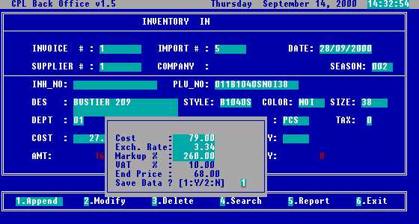
Fig 27. Selling price calculator window

The Cost and Exchange Rate are automatically taken from the chosen import settings. You have to fill the markup percent in the Markup % field. After that, the End price will be computed, and you will ask if you want to save this value or not.

Closing the invoice

After price, you have to input the quantity for the item received, After all data is entered, the screen will look like in the next picture.

Fig 28. The screen with all data completed, before saving

At this step you can decide if the entered data is correct, and to save the record. If you finished all items from the invoice, you can proceed to close the invoice, but before this, is highly recommended to generate a report on screen (Fig.29), and to compare is the total of the invoice entered in the database, agrees with the amount from the paper invoice. If the amounts agree, then you can safely close the invoice by choosing Exit option, and exit the Inventory in screen.

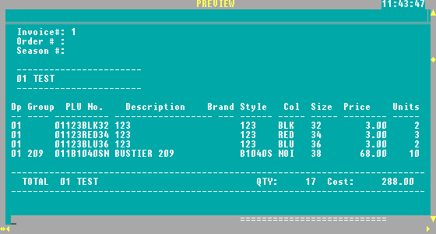
Fig 29. Report generated by Inventory in – Report option

Note: The example shown on Fig 28 is in case of imported goods and purchase invoice received in Foreign Currency.

B. Item Code Synthesizing

B.1. Inventory In with matrix color and size

(Descriptive item codes, barcodes: Code-39)

In this chapter we will explain methods of synthesizing item codes. Please, note that screen can be design for imported good as well as for locally purchased. In case of imported goods it is necessary to complete Cost Analysis (as we explain in previous chapter) and refer to the import number in the field Import#. In case of locally purchased goods the field Import# will be absent from the screen below, also Cost calculation will not have foreign currency and expense calculation.

From the Transaction Menu, after the first choice “2.Inventory in with col/size” is selected, the following screen will appear, as you can see below:

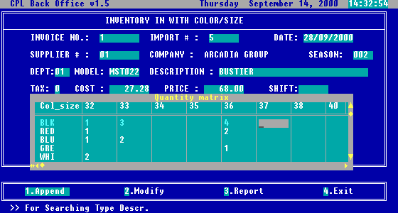
Fig 30. Inventory in with colour and size screen – descriptive barcodes

Before we start explaining how to actually fill table (matrix) with Col/Size let’s have a look on the basic concept.

Items are entered into the system selecting first department (colour and sizes are already assign to this department) following is a Style. For every Style you need to enter Description, Tax (VAT), Cost and Price. If the style was previously inputted and posted the description, Tax, Cost and Price will show automatically.

For the current Style and Department, matrix Col/Size will be created. In this table you need to position the cursor on the corresponding row for colour, and on the right column for size, and enter the quantity of stock item that have that colour and size.

After you finished entering all quantities, you can close the matrix with <CTRL-END> or <CTRL-W> or moving to the first empty cell press <ESC>.

After saving, for each item with different colour and size, will be generated a different descriptive code/barcode, and a different entry in inventory-in table will be added.
So, filling one screen you can synthesize all the barcodes belonging to the entered style.

B.2. Inventory In with color and size

(Sequential item codes, barcodes: EAN-8)

From the Transaction Menu, after the first choice “2.Inventory in with col/size” is selected, the following screen will appear, as you can see below:

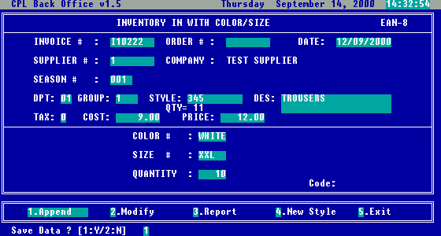
Fig 31. Inventory in with colour and size screen

This screen is used also for stock inputting, the only difference is that the codes generated for entered items are sequential, applicable for barcodes type EAN-8. With append option once style is inputted, the only information to input is colour, size and quantity. If you have to move to the next style, use option New Style.

Note: If style already exists, entering style it will show on the screen description, cost and price.

Posting

This function finalizes the process of data entry by effectively affecting stock database. From the Transaction menu, you can press the <7> key or select the option “9.Posting” and press <ENTER> to start the POSTING and answering YES to the 'POSTING' window (Fig.32).

Fig 32. Posting

This step is very important. If you omit to post, practically all items you entered in stock, will not be available for further modifications, or selling. As you will see in the rest of this manual, after all operations involving stock change, or other major changes of the database, you have to proceed posting.

4.2. File importing

Under this paragraph you will find grouped some particular options for franchises shops. We assume that your franchisee will provide a dispatch file, which correspond with the purchase invoice. This can be done by e-mail or Internet FTP site. Also we need detail description of the dispatch file structure to provide valid file import procedure.

Note: You must have always in mind that these files to be imported must exist in the C:\CPLPOS\IMPORT\ folder.

After selecting File import option, you will be asked for the name of the file to be imported, and you will be asked to confirm the import number from the costing analysis previously done.. After that a thermometer progress bar will be appear showing the status of the import process.

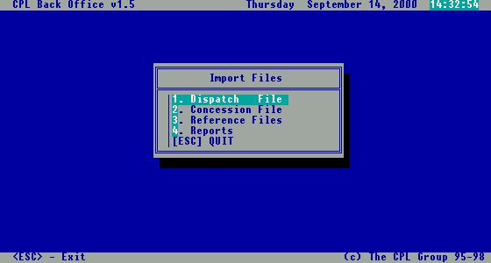
Fig 33. Import file menu

If you will select the Reference file option from the menu above, you have to select after what kind of reference file you want to import, as in the menu from the next picture.

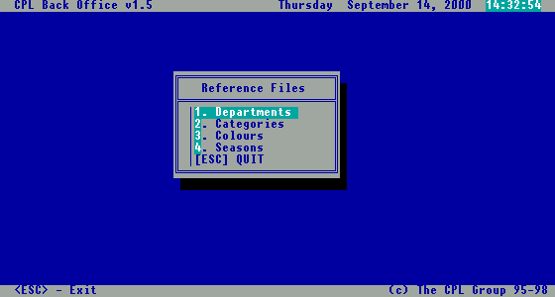
Fig 34. Reference files import menu

After the import process has finished, you can proceed for generating reports regarding import. The report menu is presented in the next picture, and the reports layouts after.

Import reports

After automatically import of dispatch file is done, in order to check it with the real invoices received from supplier, you can select one of the provided reports.

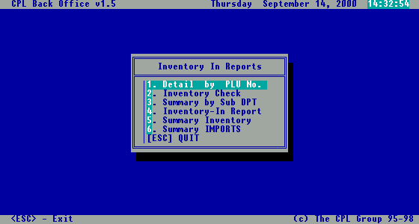
Fig 35. Inventory in import reports

Detail by PLU number report

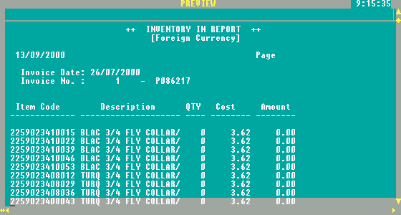
Fig 36. Detail by PLU number report

Inventory check report

The purpose of this report is to provide the form to check delivery.

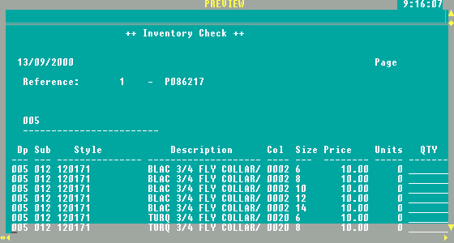

Fig 37. Inventory check report

Summary by sub department

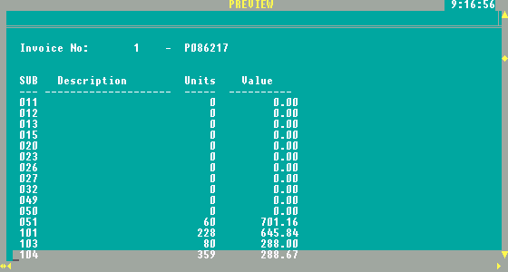
Fig 38. Summary by sub department

Inventory in report

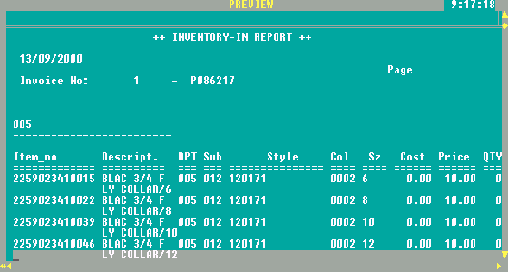
Fig 39. Inventory in report

Summary inventory

This report shows subtotal by department and total per invoice imported (the amount is in CYP)

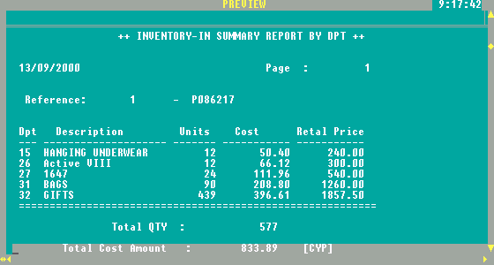

Fig 40. Summary inventory report

Summary imports

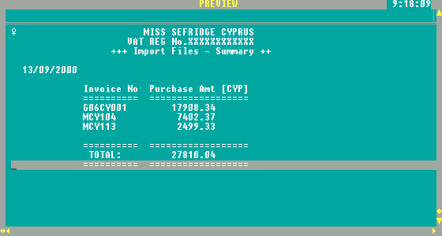
Fig 41. Summary imports report

The purpose of this report is to be able to check all the import files posted in the system and check if any of them are missing.

Note: During import, system is checking for invoice number and suppresses you to import many times the same invoice.

4.3. Label production

Create label

Once you decided about the barcode type you will use, you can go to the next step, which is barcode generation. For this purpose, you have to enter all stock items from the Inventory in with colour and size screen. After entering items, if you want to print the barcodes labels, you have to exit the inputting screen, and before Posting to select the option Create label file, which can be found in Transaction menu. If you select this option, you will be able to see the menu presented in next picture.

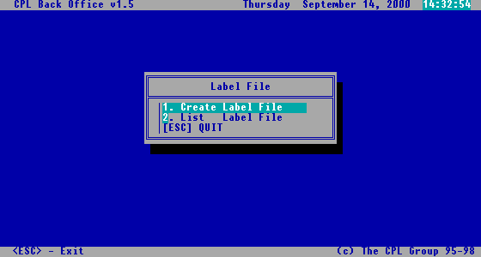
Fig 42. Label file menu

As you can see, you have here two options. Create label file option will generate the file required for label printing, without displaying anything. The second option List label file will show you the content of the label file generated by the first option, as you can see from the next picture.

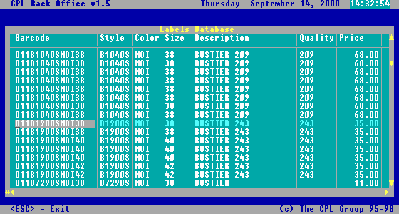
Fig 43. List label file screen

In the picture above, you can see how a descriptive barcode has been generated for each stock item.

WinLabel

After the generation of the label file, you can proceed to the next step, which is the printing of the labels. Basically you can use any external software that can read data from DBF files, and fulfils your needs. Preferable for the easiest use, for label standardization, and for the design facilities offered is WinLabel. This is an external software, for usage into a Windows environment, made by the Zweckform company. The main screen of WinLabel looks as in the next picture.

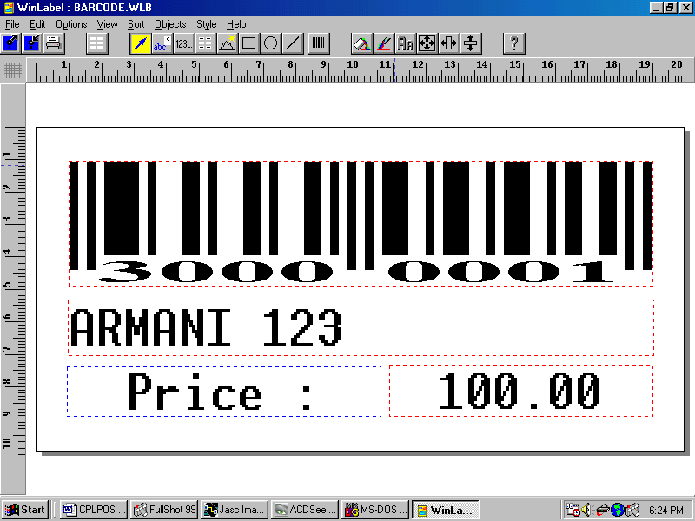
Fig 44. WinLabel 2.02 screen

With this software you can easily design, view and print barcodes, based on the items selected by the Create label file option. What you can see in the picture above is the design of labels for sequential barcodes (EAN-8).
After designing the labels, all you have to do is to print the labels out to a high quality printer (preferable a laser printer).

Re-print labels

If by mistake you already did Posting without generating the labels file, you will not able to print entered items, unless you choose the option Re-print labels from Transaction menu. In this case you will be asked to enter or select the styles you want to reprint, and after that it will show you a list with all items from that style with the quantity in stock. You can modify the quantity of items you want to re-print labels, and you have to enter something in the column UPD, usually “1”, to mark items you want to re-print. This is shown in next pictures.

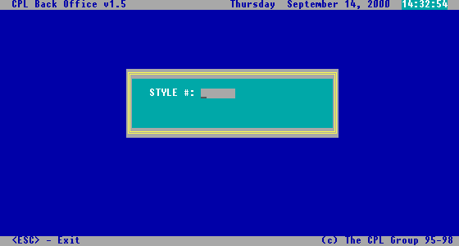
Fig 45. Style selection dialog box

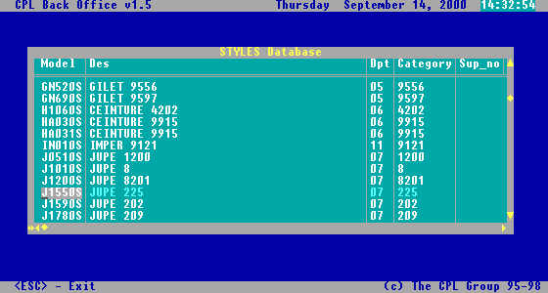
Fig 46. Model selection from specified style window

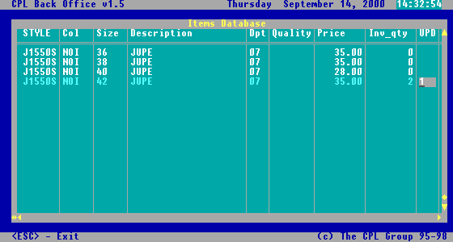
Fig 47. Selection of items you want to re-print

Once you have selected an item by entering a value in UPD column, you can exit the window presented above by one of the combinations <ESC>, <CTRL-W>, <CTRL-END>.
After this, you have to go again to select the Create label option, to regenerate the file including your selection made. Of course after that you can view the content of the file with the List labels file option, and effectively print out the labels via WinLabel software.

4.4. Modifying stock

In this paragraph, you will see how you can modify stock content, when the subject of modification is not purchasing or selling stock items.

Quantity adjustments

If for some reason the real quantity from the stock does not agree with the quantity existing in the database, then you can proceed for a quantity adjustment. For this goal you should select the “3.Q’ty adjustments” option from Transaction Menu, and the screen presented in next picture will be shown.

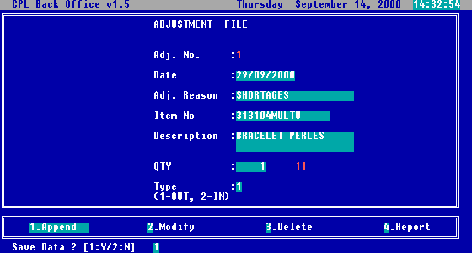
Fig 48. Quantity adjustment screen

The adjustment number will be automatically generated, and current date will be filled by default in field Date. For Adj. Reason, you must choose one reason, from the reason table called with the <ARROW DOWN> key (Fig.49). In Item No field, you can enter directly, scan, or choose from the list the correct barcode. Once a valid barcode is entered, the Description will be completed automatically. In Qty field, you have to enter the number of items which will be adjusted from stock, and in Type, the type of adjustment: 1=Out=Minus, 2=In=Plus.

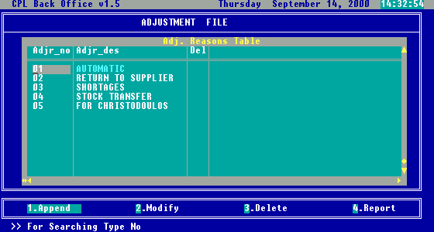

Fig 49. Reason selection window

Items file

If you need to modify any other details of the item, except quantity, then the option “4. Items file” from Transaction Menu, is the right one for you. After selecting this option, you will be asked to choose filtering criterion for the Items file screen, which is presented in the next picture.

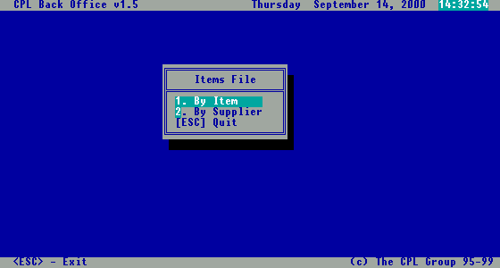
Fig 50. Filtering criteria for Items file screen

If you choose “1.By Item”, then you will see the screen presented in the next picture.

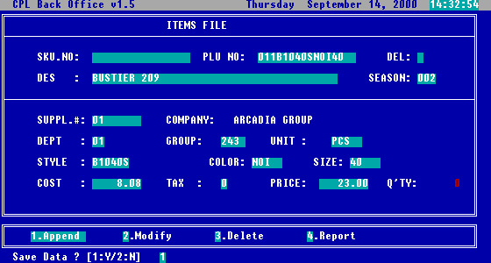
Fig 51. Items file screen by item

As you already know from the screens already presented, if you are on one of the code fields Inh.No, PLU No. Suppl.#, Dept, Category, Unit, Style, Colour, Size, Tax and you press <ARROW DOWN> key, the appropriate list for selection will be open in a small window, allowing you to select the desired one.
On field Del if you enter the value “1” then that item, will be completely removed from the stock database.
The options Append, Modify, Delete and Report have the same functionality as in previously discussed screens.
If you choose “2.Table mode”, then you will see the dialog box, presented in Fig.52. As you already know, you can enter codes in these fields, or you can choose an appropriate value from the list opened after pressing the <ARROW DOWN> key. If you will not complete any of these fields, then no records will be shown in the Items database screen, presented in Fig.53.

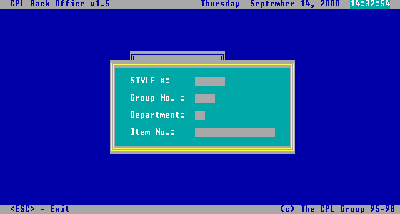
Fig 52. Selection criteria for Items file screen by supplier

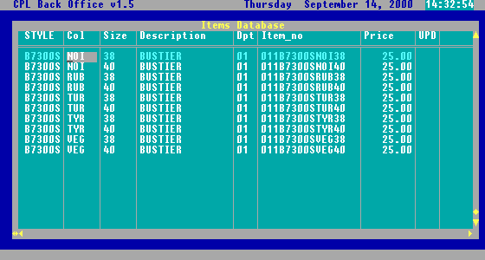
Fig 53. Items file screen by supplier

As you can see from the picture above, in this screen will be shown all items that correspond with the selection criteria entered in the dialog box presented in Fig.52. Here you can modify the characteristics of items represented as table columns. After you modified, if you want to affect the stock database, you have to put something in the UPD column for the modified item (usually 1). Once you are satisfied with the modifications made, you can exit this screen pressing <ESC>, and go to the next step.

Posting

Any modification made on the stock database, will not really affect the database until you will not do Posting. This option was already presented in this chapter.

4.5. Wholesale invoicing

If applicable for your profile, in this subchapter you will find explanations and particular details regarding whole selling. To access wholesale options, from the Transactions menu you have to select the “6.Wholesale invoicing” option. After that, you will see the menu presented in the following picture.

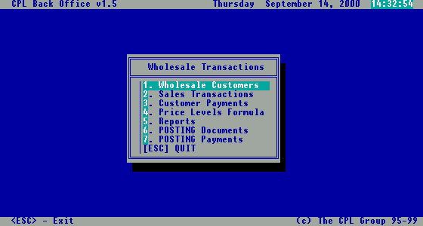
Fig 54. Wholesale transactions menu

Wholesale customers

Wholesale customers are completely different from the regular customers, and for this reason they are kept separately. They have their own particularities, and for this reason, if you want to have in your stock an image which reflects entirely the reality, you have to declare each constant wholesale customer using the following screen.

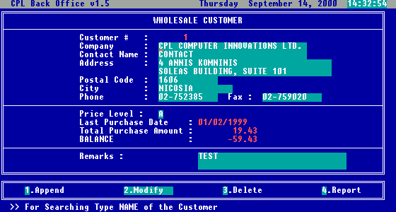
Fig 55. Wholesale customer screen

In this screen you have to complete the fields Company, Contact name, Address, Postal code, City, Phone and Remarks with real information regarding the wholesale customer. Customer # is generated automatically by the system with unique sequential value, but you can overwrite this field with another code if needed. In Price Level field you can directly enter the code (A,B,C or D) or you can choose the level from the list opened after pressing <ARROW DOWN> key. Once you have chosen a price level for a wholesale customer, each time he will buy something, the price according the selected price level will be used in calculations.
There are also few fields with informational purpose (you cannot enter or modify data in those fields), like Last purchase date, Total purchase amount (the amount of all purchases made by that customer from the beginning until now) and Balance (total purchase amount minus total payments amount) which are showing details automatically managed by the system, related with that customer.
The options Append, Modify, Delete, Report have the same functionality as in the other previously presented screens.

Sales transactions

In this screen you can enter and manage wholesales transactions. You can reach this screen if you select from the Wholesale menu the option “2.Sales transactions”. Once you entered in the screen, and selected Append option, you have to specify the document type, selecting the proper one from the list called with <ARROW DOWN> key, as in the next picture.

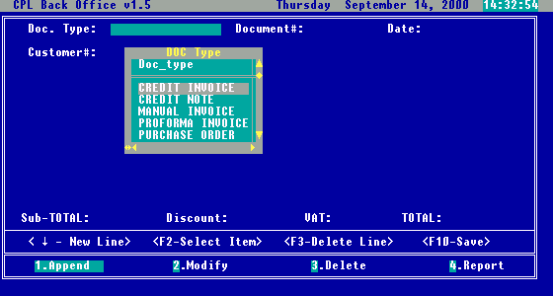
Fig 56. Sales Transactions screen – selecting document type

The Document # field is automatically generated, and as usual can be overwritten, and the same with the field Date, which will show by default current date. After you will complete or choose the value for the field Customer # in the empty space next this field, will be shown customer details like company name and address, and you can proceed to enter the content of the whole sale invoice, as in the picture below.

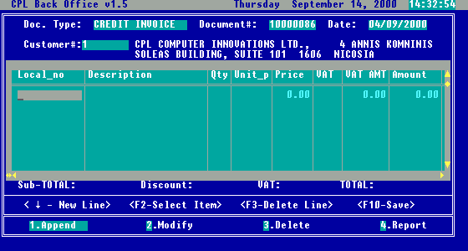
Fig 57. Sales Transactions screen – adding items on wholesale invoice

As you can see the info message below the window, for item selection press <F2>, for deleting a wrong entered line press <F3>, to add new line press <ARROW DOWN> and to save and close invoice content press <F10>. If you press the <F2> key, you will see a dialog box as in the next picture, which allows you to select the item to be sold.

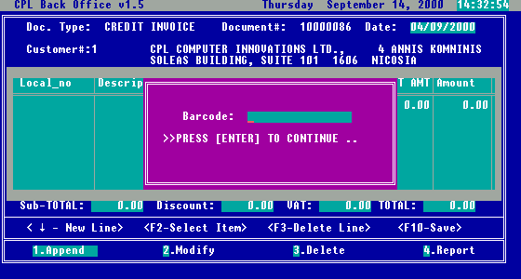
Fig 58. Sales Transactions screen – dialog box for selecting the item to be added

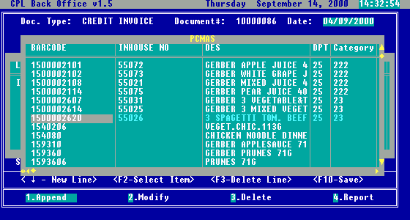
Fig 59. Sales Transactions screen – selecting the item to be added on wholesale invoice

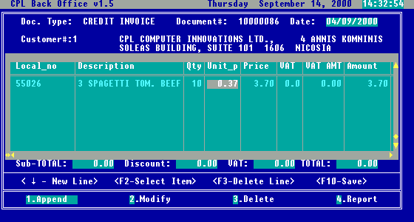
Fig 60. Sales Transactions screen – completing quantity and checking price for the item to be sold by wholesale invoice

After you have entered all items to be sold, and saving invoice content with <F10> key, the summary information regarding the invoice, like: Subtotal, VAT and Total, will be automatically completed, and you will be allowed to enter an overall discount for the invoice as amount. Once you entered a discount, the total of the invoice will be decreased with that amount, and after that you will be asked if you want to save the invoice (Fig.61).

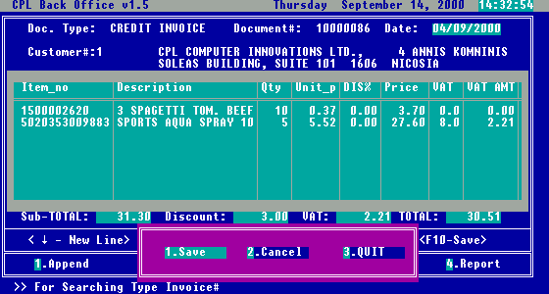
Fig 61. Sales Transactions screen – completing overall discount and saving the wholesale invoice

After saving the invoice, you have to print it on the invoice printer, but first be sure that you loaded into the printer pre-printed forms for invoicing. For this purpose, you can choose the option “4.Report”, enter the wholesale invoice number in the dialog box that will appear, and after that, from the list of printing destinations choose “2.Invoice printer” as shown in the next picture.

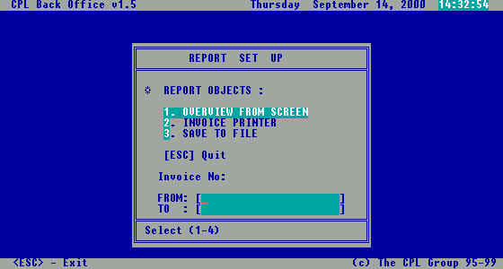
Fig 62. Sales Transactions screen – printing the wholesale invoice

Customer payments

Once you received cash or cheques from wholesale customers, in exchange of the sold items, you must enter them into the system, to have in this way the correct customer balance, and statement. In this way you can track and monitor easy, payments for the sold items, what are customer debts, etc.

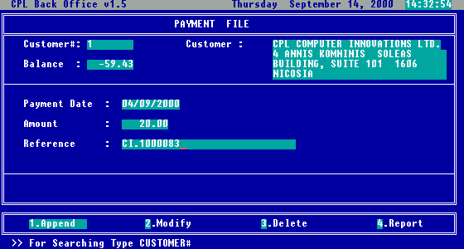
Fig 63. Payment file screen

As you can see from the above picture (Fig.63), first of all you have to select the wholesale customer who did the payment, by entering its code, or by selecting it from the list called with <ARROW DOWN> key. After selection, in Customer and Balance fields you will see information related with wholesale customer, like company name, address, and current balance. Payment date is completed by default with current date, but you can overwrite this field with the desired date. In the Amount field you have to enter the amount paid by the wholesale customer, and in the Reference you can complete information regarding the document that is being paid.
The options Append, Modify, Delete and Report have the same functionality as in the other screens presented.

Price level formulas

This is the screen where you can view, enter, modify and delete price level formulas. You can access this screen by selecting the option “4.Price levels formula” from the Wholesale Transactions menu. After selection you will see the screen presented in next picture.

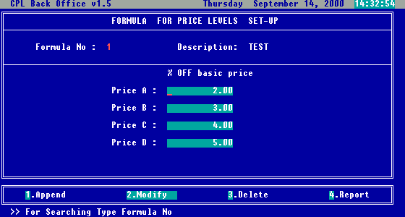
Fig 64. Price levels formulas screen

The field Formula No will be automatically completed by the system. In the field Description you have to complete a suggestive name for your formula. After that you have to complete percents of discounts for each level. You can use maximum 4 levels (A,B,C and D). If you want to use less than 4 levels, just put 0 as percent off for the unwanted levels (ex: if you’ll use only two levels, A and B, then A and B will have percents greater than zero, meanwhile C and D will be exactly zero).
The options Append, Modify, Delete and Report have the same functionality as in the rest of the screens already presented.

Posting documents / payments

As you know by now, just entering data in screen does not affect the stock database. To affect the stock database with the wholesale data, you have to post data. In Wholesale Transactions menu you have two options referring posting : “6.Posting Documents” and “7.Posting Payments”. As their names specify, the first one is used to post data entered in Sales transaction screen, meanwhile posting payments is used to post data entered in Customer payments screen. Once you choose one of these options you will be asked if you want to post, and you can select between Yes and No options. If you select yes, then the posting is to be done. You can see the dialog boxes in the pictures below.

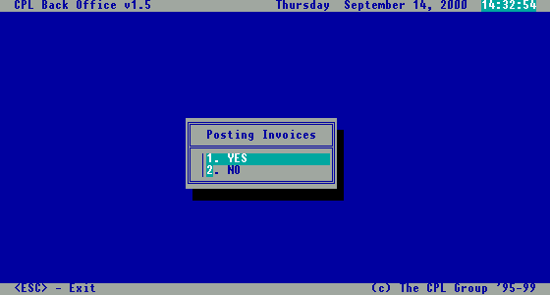

Fig 65. Posting invoices dialog box

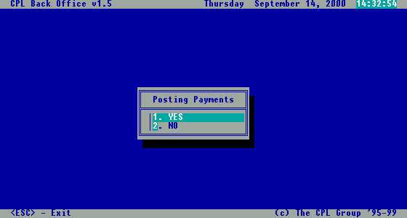
Fig 66. Posting payments dialog box

Wholesale reports

As you probably imagined, there is a distinct set of reports used only for wholesale activity. To access these reports, just select the option “5.Reports” from the Wholesale Transaction menu. After selection, the menu presented in the next picture will be displayed.

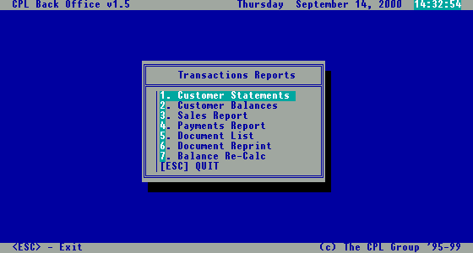
Fig 67. Wholesale reports menu

Now we will have a look at each of the reports from this menu.

Customer statements

After selecting the customer for which is the report to be generated, and completion of period (you must complete at least the end date), the generated report will look as in Fig.68, and after scrolling down as in Fig.69.
This report will not reflect reality if you didn’t post documents and payments before.

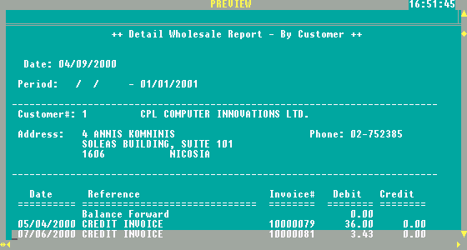
Fig 68. Customer statements report

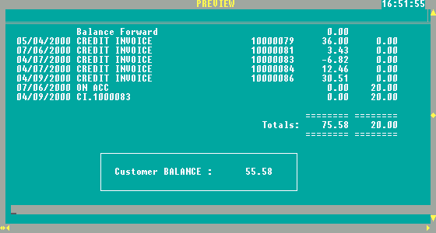
Fig 69. Customer statements report scrolled down

Customer balances

After completion of the desired period, or at least the end date, you will see a report containing all the customers balances, as shown in the next picture.

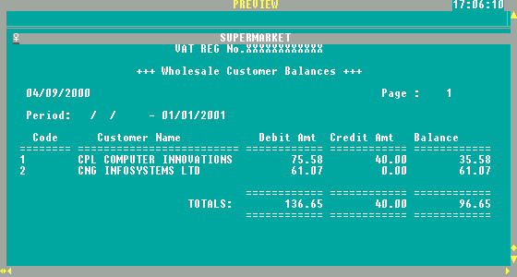

Fig 70. Customer balances report

Sales report

Once you entered the period and the destination for this report, you will see all items whole sold, grouped by wholesale customer, as in the next picture.

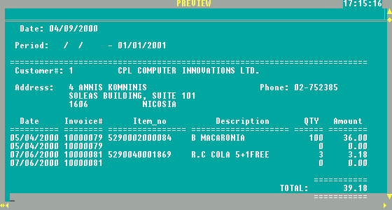

Fig 71. Sales report - wholesale

Payments report

This report will show you all payments made in a specified period of time, or until the end date specified. The report layout can be seen in the next picture.

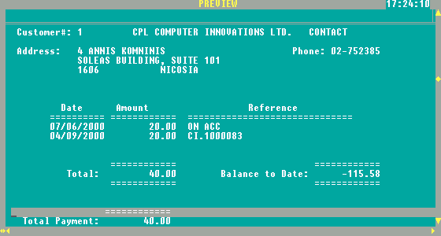
Fig 72. Payments report

Document list

This report will contain all documents from the specified period as you can see in Fig.73.

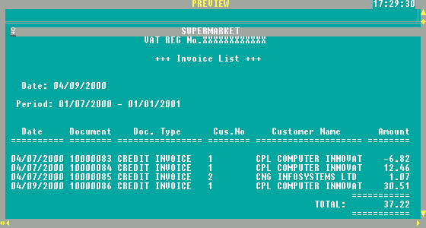
Fig 73. Document list report

Document reprint

This option is to be used in case you need to reprint a specific document already printed before. In the dialog box that will appear after the selection of this option, you have to enter the identification code of the document (Fig.74). After that, just select the printing destination for the desired document.

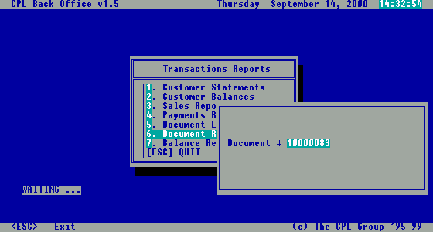

Fig 74. Document reprint dialog box

Balance recalculation

This option will not generate a report. It will just recalculate the balance of the customers, in case you will select this option after recent changes affecting the database

4.6. Posting

As you already red about this option, is presented in large in chapter 4. It’s very important to not forget to use this option after entering data that should immediately affect the stock database.

5. Promotions set-up

Introduction

With the general expression Promotion we will assume all kinds of reduction and discounts that can be automatically set-up in the system and applied in the selected period of time.

PROMOTION

Specific Item, or group of items (Departments or categories) can be associate with the specific Discount.

At the time of sales System is checking for period (Date and Time) and if promotional discount is set-up for the product automatically promotional pricing is applied.

Setting-up promotion the price of the item in stock is not affected. Promotional price is calculated “on the fly” during selling.

MARK-DOWN

Products can be selected for the automatic Mark-Down pricing for specific period of time. Automatic mark-down pricing is applied until next Mark-Up/Mark-Down.
This means that Markdown is affecting the price of item in the stock.

QUANTITY PROMOTION

Similar to promotion with addition that promotion is applied if customer is buying specific quantities of product. If QTY purchased are over the specific level the customer is entitled to the QTY discount. Price for the items are calculated during selling.

SPECIALS

Product can be set-up as special, free item(s) after specific quantities are purchased (on the same bill). Example: If customer purchase 10 pieces of product 11th is FREE of charge (specials).

We will explain in the following chapter how to set-up all different types of promotions.

Promotions settings Menu

To enter this menu, you must choose from the Inventory File menu, the option “5.Promotions set-up”. After this selection the menu presented in the picture below will appear on screen.

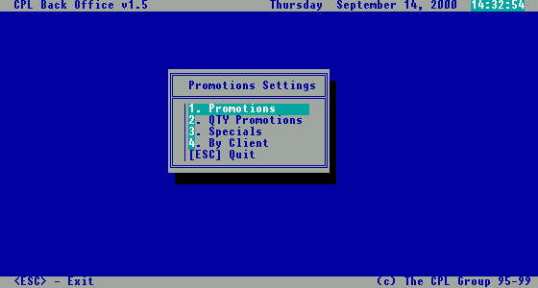
Fig 75. Promotions Settings menu

As you can see, here are grouped some options, which will allow you to promote items in different ways. We will discuss them one by one in following paragraphs.

5.1. Promotions

After selecting the option “1.Promotions” from the Promotion settings menu presented in Fig.75, the screen from Fig.76 will appear on screen.
On this screen you can declare sales periods, percent off, and items and/or departments affected.
In the field Promotion No you need to enter a unique number, usually generated automatically. Also you can complete a suggestive Description for the settings you want to declare. Follows the period declaration fields: Date From, Date To, Time From, Time To. Practically here you can do all the combination possible for a desired sale period.

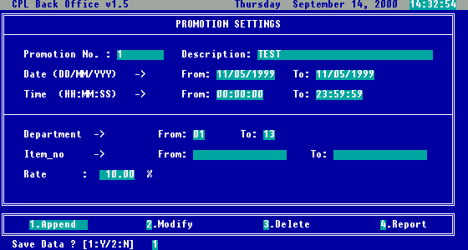
Fig 76. Promotions Settings screen

Sample 1: If you want to declare 1 month (August 2000) of sales.

You need to complete for this purpose Date From: 01/08/2000, Date To: 31/08/2000, Time From: 00:00:00 Time To: 23:59:59.

Sample 2: If you want to declare, sales during all summer time (June 2000 – August 2000), one hour per day (11.00 a.m. – 12.00 a.m.) sales period.

For this goal you need to complete Date From: 01/06/2000, Date To: 31/08/2000, Time From: 11:00:00, Time To: 12:00:00.

Sample 3: You want to declare one single day of sales (23 August 2000), then you will complete Date From: 23/08/2000, Date To: 23/08/2000, Time From: 00:00:00, Time To: 23:59:59.

After choosing the desired period of promotions, you have to enter which departments are affected (Department From, Department To), and/or which items (Item No From, Item No To), and the percent off (Rate). With departments and items, you have the same flexibility as seen for choosing the period.

Sample 1: You have the stock organized in 10 departments (from 1 to 10). If you want to include all departments except number 8, then you have to add two records with the same period, in the first complete Dept. From: 1, Dept To: 7, in the second Dept. From: 9, Dept To: 10.

Sample 2: You have the same situation as in the previous example, but you want to include only the department 8. For this goal you have to complete Dept. From: 8, Dept. To: 8.

The same “tricks” used in the examples above, could be used also for item number (Item No From, Item No To).

5.2. Quantity promotions

Choosing the option “2.QTY Promotions” from the Promotion Settings menu, a small submenu with two options will appear on screen, as in the following picture.

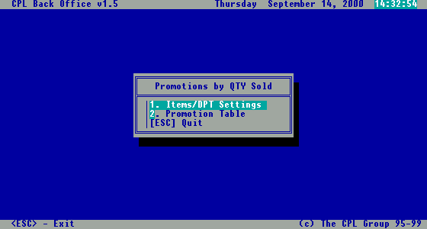

Fig 77. Promotions by QTY submenu

This two options act in conjunction as follows: in the first option “1.Items/DPT Settings” you can specify the period and the target items or departments for promotions, as in the Promotion Settings screen presented above at paragraph 5.1, and in the second option “2.Promotion table” you complete the declaration made in the first option with minimum required quantity to be sold and percentage off applied.

If you choose the first option, you will see a screen very similar with Promotion Settings screen presented above, with the difference that Rate field is missing (Fig.78).

The second option will show you a different screen, called Promotion Table Settings, screen that can be viewed in Fig.79. For the field Promotion No, you have to choose the promotion you want to complete, and after that to specify which is the minimum quantity required to be sold in the field After QTY sold, and the percent off to be applied in the field Mark-Down.

Sample 1: You have the stock organized in 10 departments (from 1 to 10), you want to declare 1 month (August 2000) of sales, after 5 items sold from department 8, to be applied 10% off.
Choose first option, and complete Promotion No: 1, Description: Summer sales, Date From: 01/08/2000, Date To: 31/08/2000, Time From: 00:00:00 Time To: 23:59:59, Dept. From: 8, Dept. To: 8.
Choose second option and complete Promotion No: 3, Description will be automatically completed with Summer sales, After QTY sold: 5 and Mark-Down: 10.

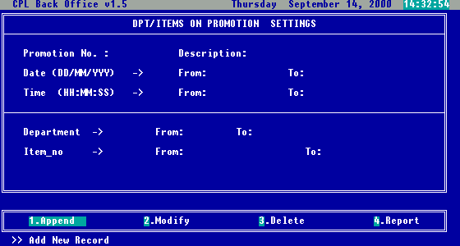
Fig 78. DPT/Item Promotions Settings screen

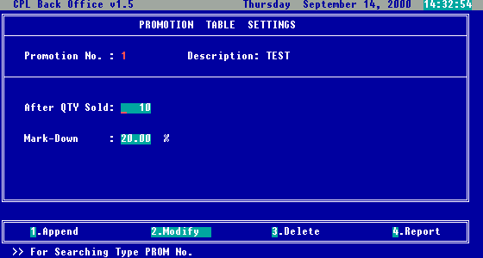
Fig 79. Promotions Table Settings screen

5.3. Specials

From the Promotions Settings menu, if you will choose the option “3.Specials”, the screen presented below will be displayed.

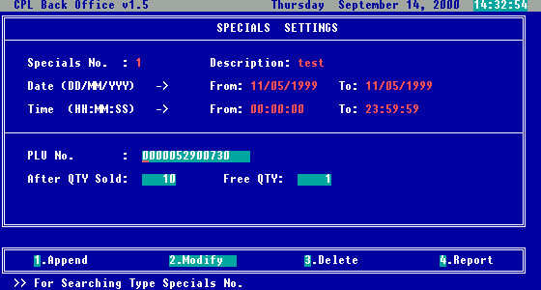
Fig 80. Specials Settings screen

As you can see from the picture, in this screen, you can declare special offers, which means that for a specified period of time, and a specified items, after a minimum required quantity to be purchased by the customer, he will receive another quantity of the same item as free.
In the picture, for the item with barcode 0000052900730, for that period, after 10 items sold, it will be offered one piece for free.

5.4. Promotions for selected Client

Choosing from the Promotion Settings menu, the option “4.By Client”, you will see the screen presented in Fig.81. Here you can set up promotions which will be applied only for a particular Client.

On this screen, in the field Client No, you have to select the client, and in the field Promotion #, the promotion to be applied for that client.

After inputting or selecting these codes, you will see that the fields Name and Description will be automatically completed according to the codes entered.

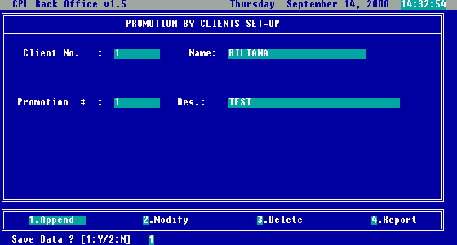
Fig 81. Promotions by client set-up screen

5.5. Markdowns/Mark-ups

As you probably noticed, this option is not in the Promotions Settings menu. This is part of the Transactions Menu, but because is referring to promotions, will be discussed in this chapter.

To access this option, you have to select from the Transactions menu, the option “5.Markdowns/Markups”. After you selected this option, the screen presented in the next picture will be displayed.

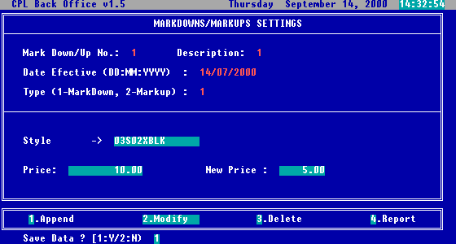
Fig 82. Markdowns/Mark-ups Settings screen

On this screen you can increase or decrease prices for items, for specified departments or items, with specified percent. This will affect the price of the item in stock from a date on (effective date), not just for a period of time.

In the picture above (Fig.82), you can see how data was completed to obtain a price lower from 10CYP to 5CYP, for all items from style 03S02XBLK, starting with 14th July 2000.

Note: After Markdown/Mark-up has been set-up posting has to be performed. This will permanently change prices for specific items. If you decide later on to revert to original prices, after markdown a mark-up has to be performed and vice versa. This is the main difference between Markdown/Mark-up and set of promotions. In case of promotions, original price for selected items remains the same in the stock and the new (promoted) price is calculated in time of selling (“on the fly”).

6. Loyalty set-up

Introduction

Loyalty / frequency system rewards the customer for making repeated purchases on your location(s), depending on the total amount spent, and at the same time motivates the customer for future purchases.
The Purchase data is captured at the Point-Of-Sale system (POS) by swiping a magnetic stripe, bar code or smart card through the card reader integrated with the POS software. Points are awarded based on customer spending (previously set-up in the system), and awards can be:
- Special discounts for loyal customers (different discounts levels)
- Products on promotion.
- Points can be used instead of cash at the specific supplier’s shops.
- Random draw prizes
- Special “bonus gifts”
By choice some of the awards can be given instantly at the POS at the time of selling.

There are two ways to recognize a Customer and to store relative information about Customer:

Customer Card
- with Magnetic Stripe
- printed Barcode
All information about Customer is stored in the Database (on the Back Office computer and POS terminals). The size of database depends of amount of information collected for each customer and your total number of customers.

Smart card
- All Information about Customer is stored on the card. The card acts like portable database that can be accessed instantly at the POS, no need for the big, on-line database in the Back Office.

Setting up the Points Systems

- After swiping magnetic stripe, barcode or smart card, the POS system recognizes the customer and uses information from the customer records: name, address, sex, date of birth, card member group, card expiry date, current points and account balance. Also it can be date of last used, points-to-date, spend-to-date.

- Pointing structure can be previously set-up in the POS:
- System Point per each Pound spent.
- Different pointing structure for each product or group of products separately

Example:
- Promote individual Products – some items can bring more points for the same price.
- Buying certain quantities can bring more points.
- Items with better profit margin can bring more points.

Example:
This is good way to “get-rid-of” obsolete stock simply announcing that certain product have points value increased for a limited time, encouraging customers to buy specific brand or flavour. Gaining extra points, the customer can be located in better discount group or can buy promotional items, or receive a gift.

Rewarding structure

- Loyalty Discount system (Discount Card)

- Different Discounts groups are set-up previously in the POS system giving for different Number of points different % of overall discount.

Example:
For Number of points >=100 4% OFF
>=200 6% OFF
>=300 10% OFF
With automatic re-grouping upon the attainment of specified points level, the customers can increase their discount level simply by accumulating the required number of points.

How the system works?
- The POS recognizes customer and all items bought by client are check through pointing system. Total number of points is calculated per bill and adds on total points purchased in the certain period. Any discounts or points to which they are entitled are automatically applied to their purchase accordingly to the Discount group they are belonging to.
- At the end of bill you can show: Current number of points for the bill; Total number of points (cumulative); Message to encourage more spending in order to gain more points and more benefits (better discount group, better promotion etc…).

Example:
Message can be:
Congratulation you are in discount group A!
By gaining 10 extra points you will be located in discount group B.

2. Promotion system

Different products or groups (by choice) can be offered to the customer at the special promotion price depending of their point’s level in limited period of time. This can include also customers which total points-to-date is on the certain level.

Example:
Some attractive and expensive but slow moving items (set of plates or set of glasses of the certain brand) can be offered to loyal customers if they rich certain level
Level 1: No of points > 300 Promotional discount 35%
Level2: No of points > 500 Promotional discount 50%
Etc.

- Prepayment Cash Card

Customer can load the card with a certain value (approximate spending amount in certain period of time). Then, they simply present the card at time of purchase. And the sale value is deducted. At the same time any loyalty points associated with the purchase are added to the card and accordingly relevant discounts are applied. Advantage: less cash is in circulation and security is improved.

- Random Draw Prizes

Facility to automatically select one or a number of customer to receive prizes. Record of the customer transaction is stored within the POS so the more often a card is used, the better the chance the customer has to receive a prize.

- Birthday / name date Acknowledgment and “Bonus gifts”

- A special “Happy Birthday or Happy name date” message appears on the POS cashier display on their birthday customer will receive specially prepared gift.

- “Bonus gift” for customers after reaching certain points level.

We will explain in the following chapter how to set-up all different types of loyalties.

Loyalty set-up

Selecting from the Inventory File menu, option “6.Loyalty set-up”, Loyalty Set-up menu will be opened, as you can see from the following picture.

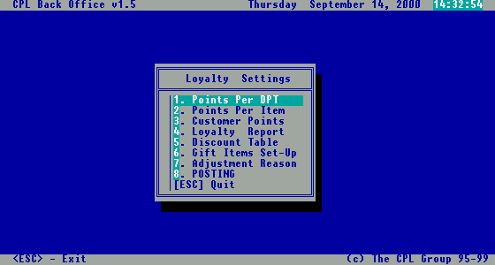
Fig 83. Loyalty Settings menu

6.1. Points per department

If you select the option “1.Points Per DPT”, the screen presented in the next picture (Fig.84) will be displayed.

In this screen you can declare a certain period of time, in which a number of points per CYP spent, will be granted.

In the picture below (Fig.84), shown is a setting for the items from food departments. Customer will gain 2 points for every CYP spent buying the food.

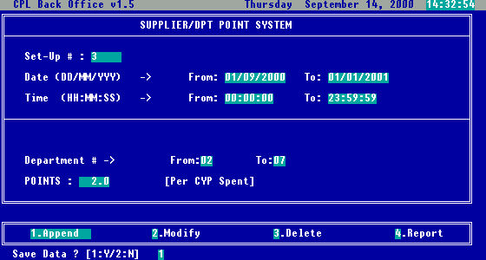
Fig 84. Points per Department screen

6.2. Points per item

If you need to be more specific, to promote only certain items, you need to select option “2.Points Per Item” from the Loyalty Settings menu. After selection a dialog box will appear (Fig.85) allowing you to be more specific, selecting from all items in the stock, only those which satisfy criteria entered below.

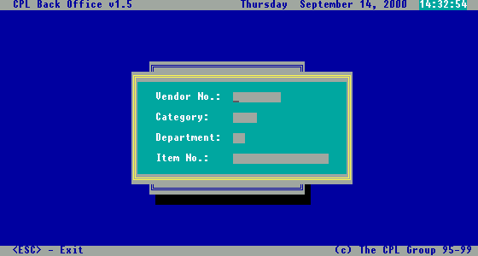
Fig 85. Points per Item dialog box

On this way you can select items from a certain supplier, category, department or directly one item, specifying the necessary codes. In this dialog box, you have to fill in at least one criterion, to proceed to the next step (Fig.86).

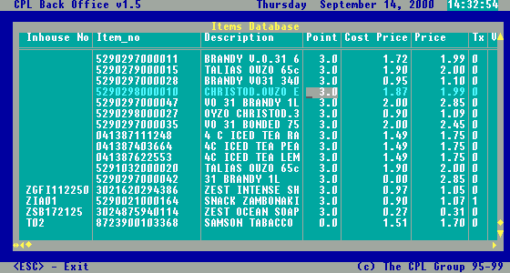
Fig 86. Points per Item screen

Once you entered criteria, all items that satisfy that criteria will be displayed in this screen accordingly. After that, you can go directly to the targeted item, and change the Point value.

6.3. Customer points adjustments

If the customer points have to be changed, you have the possibility to adjust them through the following menu option. Potential reasons for this, could be mistakes during selling process, the need for resetting some customer points, or if you choose to do it manually, redemption of points after taking some benefits in exchange (gifts or reduced price items, etc).

To reach this option, you need to select from the Loyalty Settings menu, the option “3.Customer Points”. Once you selected this option, you will be able to see the screen presented in the next picture (Fig.87).

When entering data on this screen, first you have to select the customer, the systems will complete automatically the Name and Current Points.

Then you need to enter the Date of adjustment, the number of Points Adjustment and the Reason of adjustments. In the Points Adjustment field you have to enter positive values if you want to add points to a customer, or negative if you want to subtract them.

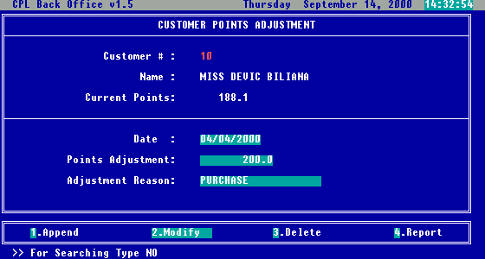
Fig 87. Customer’s Points adjustment screen

Related with Adjustment Reason field, you have the possibility to administrate a table of adjustment reasons, which will be presented later on in this chapter on subtitle 6.7.

Note: after completing the changes for the customer it is necessary to use “Posting” in order to affect Customer Record.

6.4. Loyalty reports

There is a set of reports in the system related to loyalty settings and loyalty usage. To use this reports, you need to select from Loyalty Settings menu option “4.Loyalty report”.

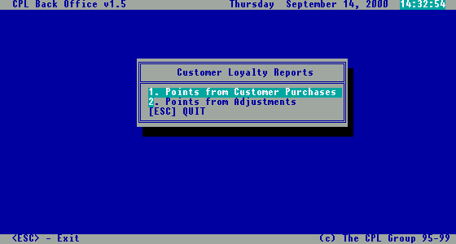
Fig 88. Customer loyalty reports menu

After selecting any of this options, a message box will appear on screen, that will allow you to enter manually client card number, or to select the customer from the alphabetically sorted list called with <ARROW DOWN> key (Fig.88).

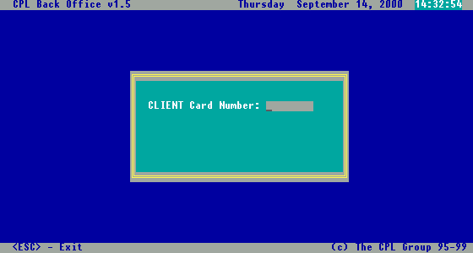
Fig 89. Client card number dialog box

Once client is selected, you need to specify the period of time for the reports, and the destination of the report (On Screen, On Report, On File).

Points from customer purchases

This report will show you the points earned by a specified customer, in a specified period of time by purchased invoice. The layout of this report can be seen in the next picture.

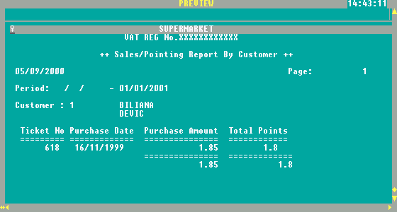
Fig 90. Points from customer purchases

Points from adjustments

This report will show you the points adjusted for a specified customer, in a specified period of time for every adjustment. The layout of this report can be seen in the next picture.

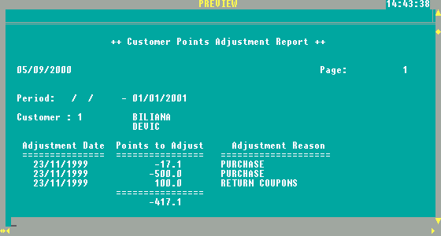
Fig 91. Points from customer adjustments

6.5. Loyalty discount table

If you want to apply policy that every customer with certain amount of points gets a discount for every purchase made in the certain period of time, you can automatically set-up this features through this option.

You can enter this screen, selecting option “5.Discount table” from the Loyalty Settings menu. On this screen, which can be seen in the next picture (Fig.92) you can declare periods and rates of discounts for customers who earned more points than a specified level.

On the picture, you can see how data was entered to declare that during the month of September, all customers with at least 500 points would benefit a discount of 10% for every purchase made.

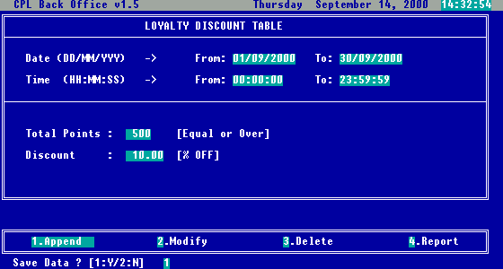
Fig 92. Loyalty discount table screen

6.6. Gift Items set-up

In general, purpose of Loyalty discount table settings is to allow you to set-up automatically gift or discounted items which can be purchase only from the customers reaching certain level of points. At the POS machine when selling this kind of items system will automatically check on points and sell the item on discounted price. Points will be redeemed automatically as well.

To access this screen, just select the option “6.Gift Items set-up” from the Loyalty settings menu. Once selected, you will see the screen presented in next picture.

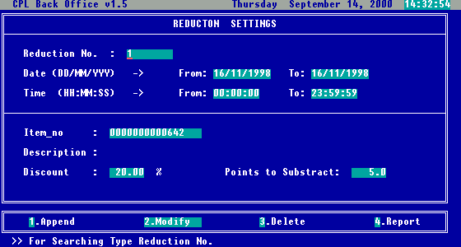
Fig 93. Gift items set-up screen

In this screen you can declare items, which in exchange of customer’s points will offer discounts for specific items.

Sample: If you want to offer in exchange of 200 points, one packet of ½ kg Jacobs coffee, during month of September 2000, you have to complete the following: Date From: 01/09/2000, Date To: 30/09/2000, Time From: 00:00:00, Time To: 23:59:59, Item no: 500000012563 (assuming this is the barcode for Jacobs coffee), Discount: 100, Points to Subtract: 200.

6.7. Loyalty points adjustment reason

This is the screen where you can administer the loyalty adjustment reasons table.

To access this screen, you have to select option “7.Adjustment Reason” from the Loyalty settings screen. This screen can be viewed below:

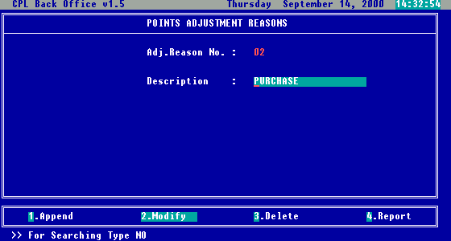
Fig 94. Adjustment reasons screen

All you have to do here is to enter all reasons possible for adjustments (which can be selected later on in the Options “Customer Points Adjustments” . The screen options Append, Modify, Delete and Report have the same functionality as in the rest of reports already discussed.

6.8. Posting

This option has the same functionality as the posting option from Transactions menu, with the difference that is related to loyalty settings.

7. Stock taking – Inventory check

It’s recommended periodically to check your stock (stock take) either manually, or with the help of the handheld data collector device.

Here we are starting to discuss how stock take is implemented in CPLPOS software.

Stock take can be:

- General – for all the stock items not found during stock take quantity will be 0

- Selective – only items found during stock take will be compared to the items in stock ; items not included in stock will not be compared.

This menu can be accessed if you select from the Inventory File menu, the option “4.Inventory check”. Once selected, you will see the menu, as in the next picture.

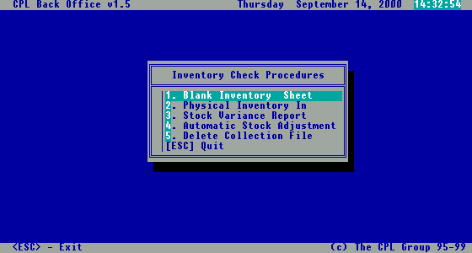
Fig 95. Inventory check menu

7.1. Blank inventory sheet – manual stock taking

Selecting this option from the menu presented in Fig.96, you will be able to print out four different types of stock list sheets, for manual stocktaking. You can select which one to be printed from the submenu that will appear after selecting the option “1.Blank inventory sheet” from the Inventory check menu (Fig.97). Each report will provide you all the stock items, organized in the manner you need (by item, category, department or supplier). As you can see from the report pictures (Fig.97 to Fig.100), the physical quantity is left empty to be filled manually during stock take.

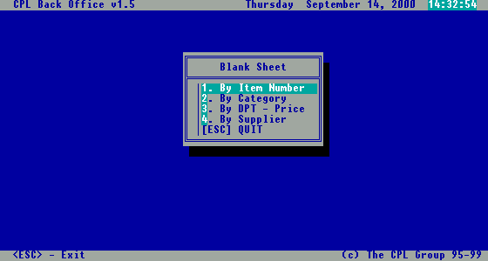
Fig 96. Blank inventory sheet menu

By Item Number

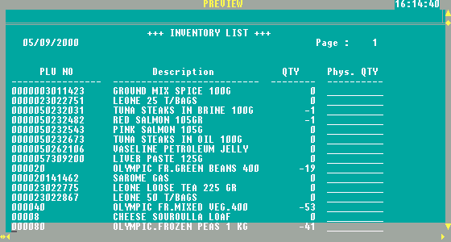
Fig 97. Blank inventory sheet by item number report

By Category

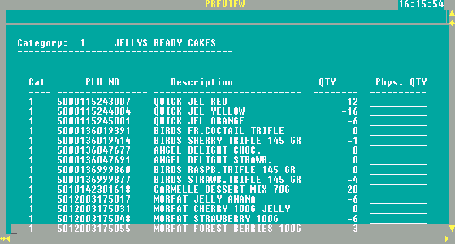
Fig 98. Blank inventory sheet by category report

By Department - Price

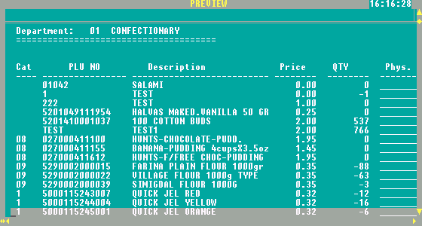

Fig 99. Blank inventory sheet by department report

By Supplier

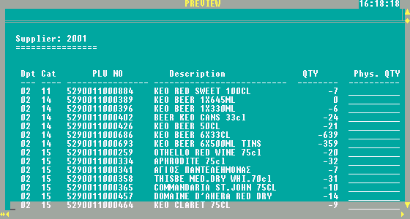
Fig 100. Blank inventory sheet by supplier report

7.2. Physical inventory in

If you choose from the Inventory check menu the option “2.Physical inventory in”, the submenu presented in the next picture will appear. The purpose is to form the file containing quantity of items found during stock take.

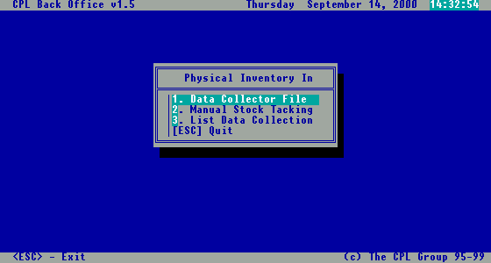
Fig 101. Physical inventory in menu

As you can see from the picture, here are grouped options that will allow you to input stocktaking results into the database.

Data collector file

This option is used, if you have a handheld data collector device compatible with the CPLPOS software. In this case, after you have downloaded the stock take file into the computer, you have to enter the name of the file in the dialog box presented in the next picture.

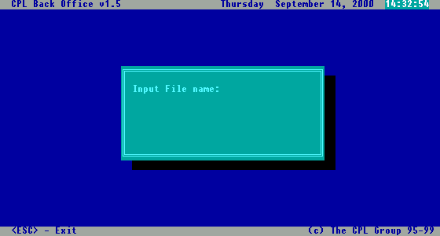
Fig 102. File name dialog box for data collector file

Once you have entered the correct file name in this dialog box, the program will automatically import all data, into the database. During the import procedure, items imported are verified if they exist in the database. If some items are not recognized (usually because of scanning errors), these items will be marked with “***” after the import. If later on you recognize some of them, you can modify them in the screen offered by next option “2.Manual stock taking”.

Manual stock taking

The selection of this option, will display the Maintain Physical Stock screen, presented in the next picture (Fig.103). This screen allows you to modify items imported wrong at previous step, or to manually enter the stock take results from the inventory sheets, into the database, in the case you don’t have a data collector device.

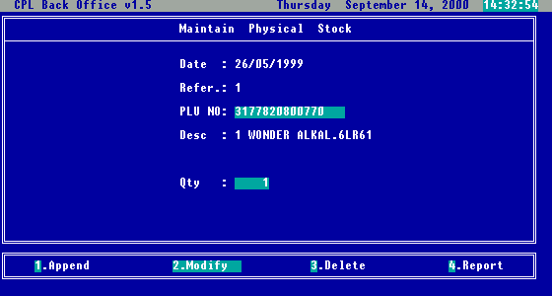
Fig 103. Maintain physical stock screen

List data collection

With this option you can see the results of stocktaking that are to be entered into the database (Fig.104).

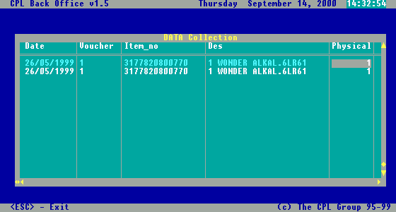

Fig 104. List data collection screen

7.3. Stock variance report

In order to get information about differences between your physical (real) stock and computer stock you can run “Stock variance report”.

To generate this report you have to select departments (Fig.105) and categories (Fig.106), for which the report is generated (Fig.107).

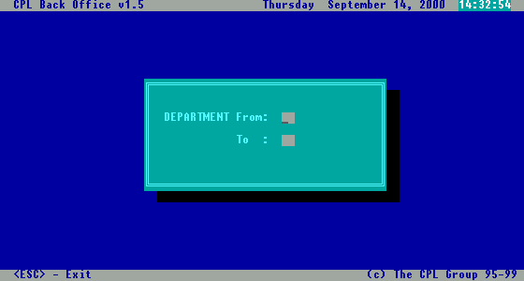

Fig 105. Choosing departments dialog box

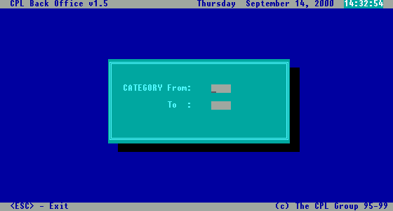
Fig 106. Choosing categories dialog box

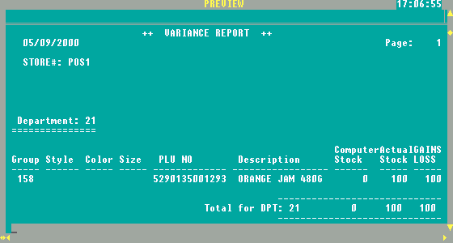
Fig 107. Stock variance report

7.4. Automatic stock adjustments

After “Stock variance report” is produced and full analysis and checking is done in order to know why real stock differ from the computer stock for each item, it is possible to adjust Stock automatically according to the recent stock take..

Hen you select this option you will be asked to confirm the action (Fig.108), a progress thermometer will be displayed (Fig.109) showing the status of the adjustment process, and after all that is finished you will be asked if you want to post the data into the main database (Fig.110). This is the last step, which changed effectively stock database.

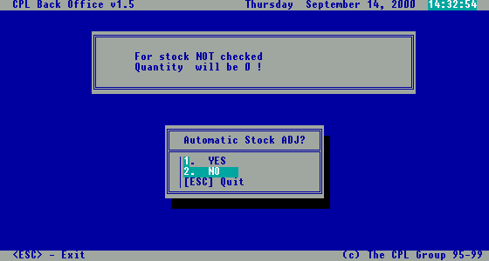
Fig 108. Confirm adjustments dialog box

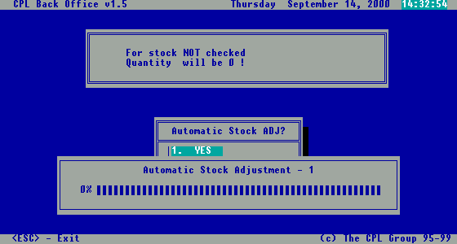
Fig 109. Process status thermometer

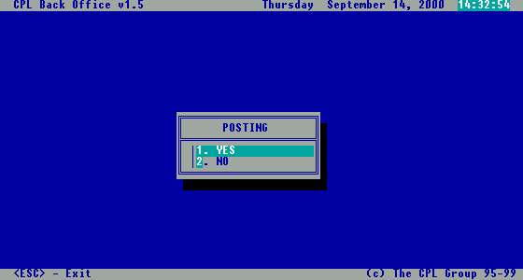
Fig 110. Confirm posting dialog box

7.5. Delete collections file

After finishing stock taking, it is important to delete the collection file, to be empty and ready for the next stock take.

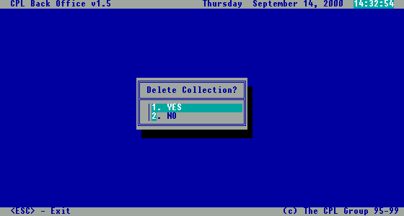
Fig 111. Confirm collection deletion dialog box

8. Inventory reports

CPLPOS offers a set of inventory reports which are reflecting from many different views your current stock.

Selecting option “Stock Control” from the main menu, then option 2.Inventory reports”, you will get grouped all inventory reports offered by the CPLPOS. (Fig.112)

In the following chapters we will explain each one of them.

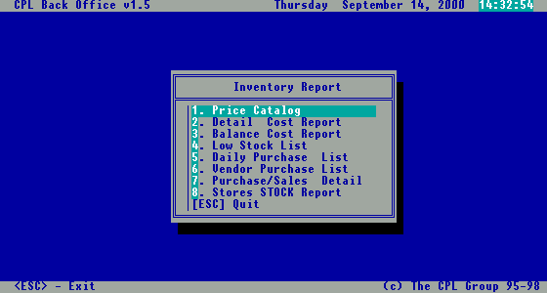
Fig 112. Inventory report menu

8.1. Price catalogue

The price catalogue report shows items with their current prices, organized by department and category (Fig.113)
The purpose of this report is to provide staff with the clear list of items with current prices for checking.

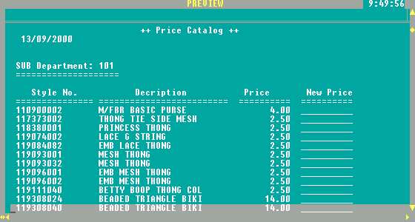
Fig 113. Price catalogue report

8.2. Detail Cost Report

Selecting this option, a submenu will appear (Fig.114), allowing you to select the way you want to view stock data (By Item – Fig.115, By Sub Department– Fig.116).
Detail reports are showing item, quantity in stock, cost and price.

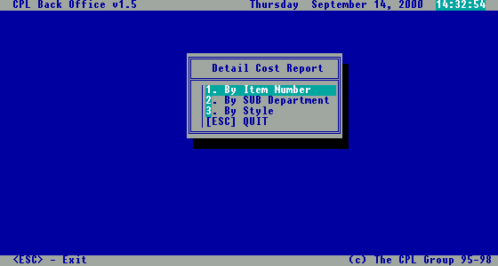
Fig 114. Detail report menu

By Item Number

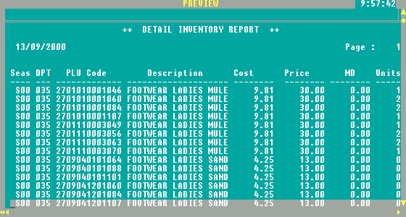
Fig 115. Detail report by item number

By Sub Department

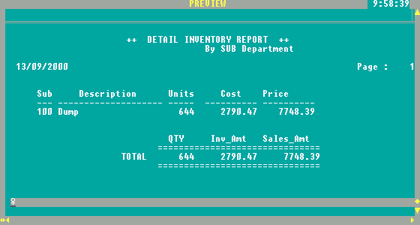

Fig 116. Detail report by department

8.3. Balance cost report

The report shows current stock balance: purchased quantity against sold quantity, transferred in/out quantity, adjusted quantity and at the end current quantity in stock for each item.
It’s a quick way to check on movement and availability of specific item.

Note: the stock balance shows the stock levels at the moment of running report.

Once selected, you have the possibility to view stock data: by item, by department, by sub department, and by style.
The menu that allows you to select appropriate view is shown in Fig.117, and the reports layouts in next four pictures (Fig. 118 - 121).

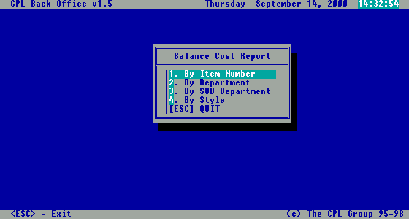
Fig 117. Stock balance report menu

By Item Number

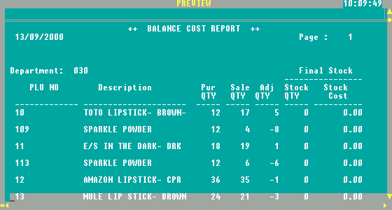
Fig 118. Stock balance report by item

By Department

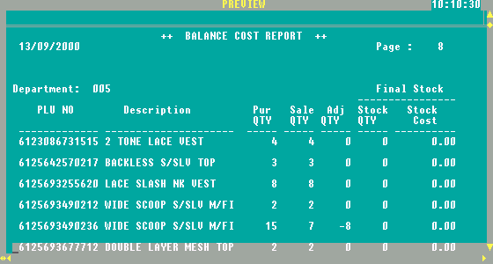
Fig 119. Stock balance report by category

By Sub Department

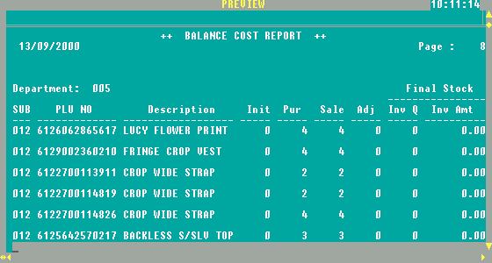
Fig 120. Stock balance report by department

By Style

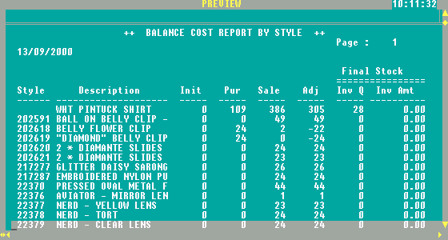
Fig 121. Stock balance report by supplier

8.4. Low stock list

The purpose of this report is to “alarm” showing information, list of items running low on quantity (quantity less than minimum quantity specified in Items file).

Once selected this option, you can view the data: by item, by department and by supplier, in the same manner as previous reports (Fig.122)

The reports layouts are shown in next three pictures (Fig. 123 - 125).

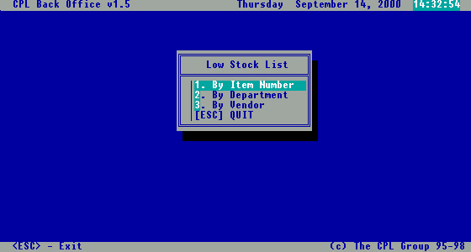
Fig 122. Low Stock List menu

By Item Number

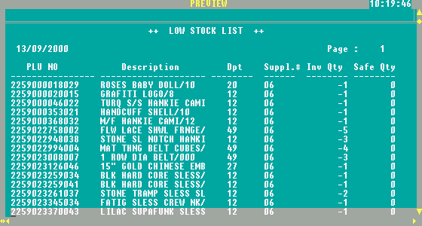
Fig 123. Low Stock List by item number

By Department

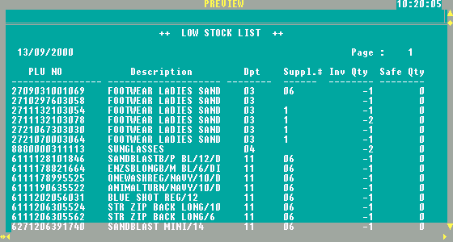
Fig 124. Low Stock List by department

By Supplier

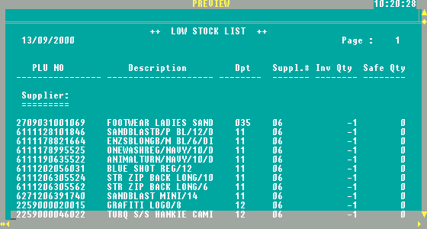
Fig 125. Low Stock List by supplier

8.5. Daily purchase list

The purpose of the report is to reprint all the purchases made within a certain period.

After selecting this option, you have to choose from the menu displayed on the screen, which report you want: by item or by style, as you can see from the next picture.

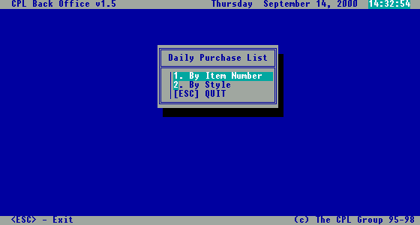
Fig 126. Daily purchase list menu

By Item Number

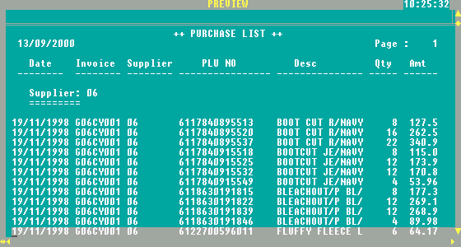
Fig 127. Daily purchase list by item number report

By Style

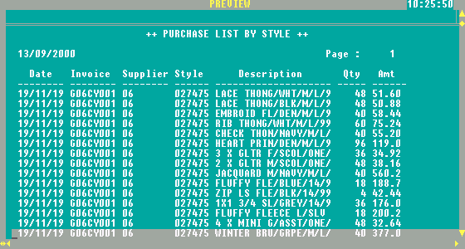
Fig 128. Daily purchase list by style report

8.6. Vendor purchase list

This report will contain all purchases made by you from your suppliers, organized by supplier, as you can see from the next picture.

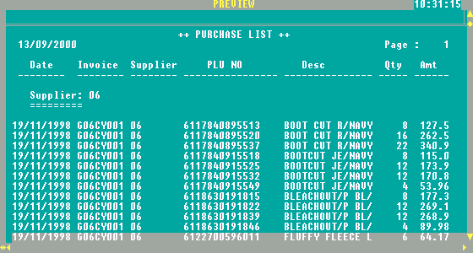

Fig 129. Vendor purchase report by date

8.7. Purchase / Sales Details

The purpose of this report is tracking the movements of specific item(s).
After selecting this option, you can to select the view: By Item No, By Department, By Vendor.

Note: it is recommended to run this report for one specific item at the time.

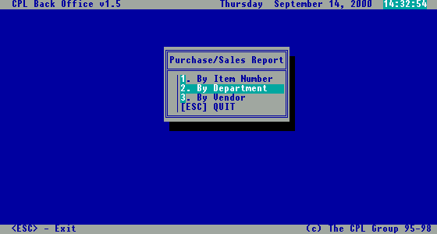
Fig 130. Purchase/Sale report menu

By Item Number

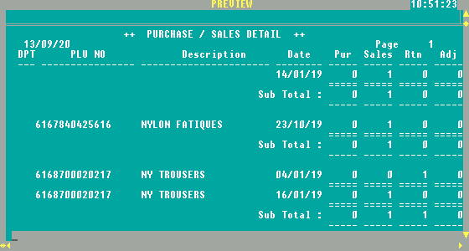
Fig 131. Purchase/Sale report by item number

By Department

Shows movement for all items under selected department.

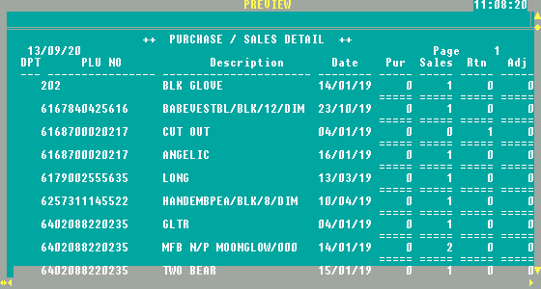
Fig 132. Purchase/Sale report by department

By Vendor

Shows movements for all items from selected supplier.

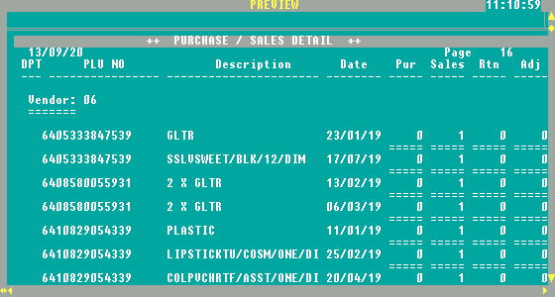
Fig 133. Purchase/Sale report by supplier

8.8. Stores stock report

These reports will show you items in stock from all stores. As you can see in the next picture, each store has one column for quantity in stock, and there is also a total column, with items from all stores summarized. This report can be obtained by item number, or by style.

By Item number

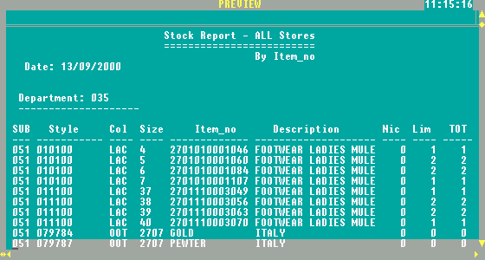
Fig 134. Stores stock by item number report

By Style

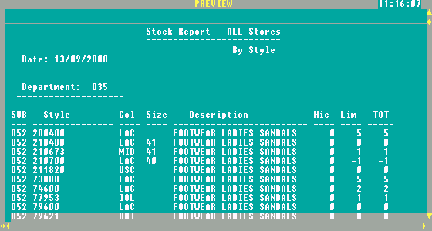
Fig 135. Stores stock by style report

9. Analysis reports

For the good control of your sale CPLPOS provides a set of Analysis reports related to Sales, VAT, Profit, Customer Purchases, etc.
All these reports are grouped into a menu that will be opened when you select the option “3.Analysis reports” within the Inventory File menu.

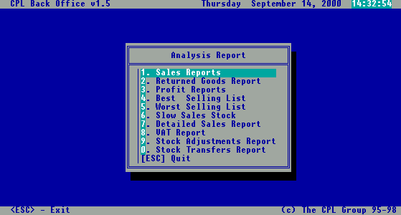

Fig 136. Analysis reports menu

9.1. Sales reports

If you select the option “1.Sales reports” from Analysis Reports menu, the following submenu will be displayed, containing reports related with sales activity.

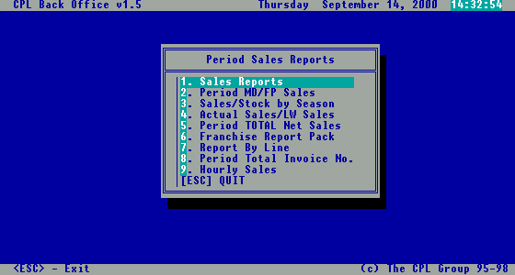
Fig 137. Sales reports menu

9.1.1 Items sales reports

The reports shows sales collected in a certain period of time viewed: by item, by department, by style.

By Item number

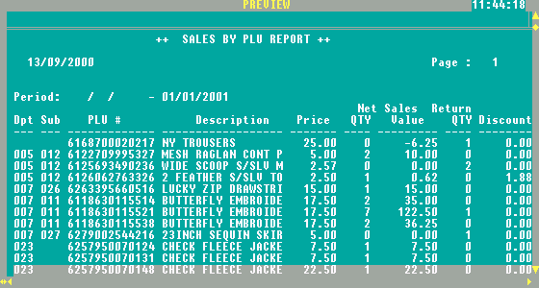
Fig 138. Item sales report by item

By Department

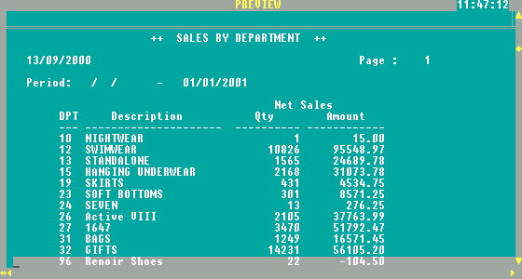
Fig 139. Item sales report by department

By style

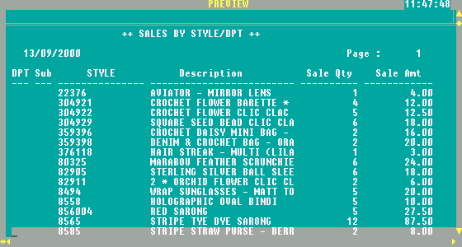
Fig 140. Item sales report by style

9.1.2. Period MD/FP sales

This report will show you sales amount of items sold with markdown price, and sales amount with full price. You can choose the report to be organized by department or by sub department.

By department

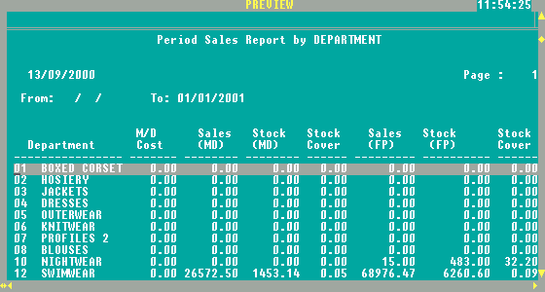
Fig 141. Period MD/FP sales by department report

By Sub Department

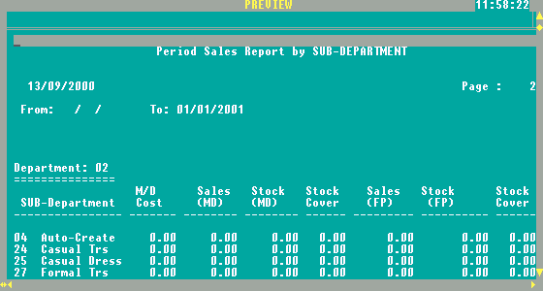
Fig 142. Period MD/FP sales by department report

Fig 133. Best buyers list

9.1.3. Sales/Stock by season

This report will show you sales and stock split by the specified seasons, for selected period of time.

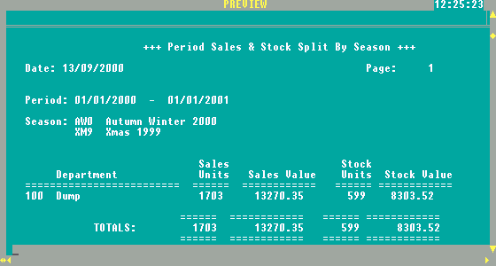
Fig 143. Period sales and stock by season report

9.1.4. Actual sales / Last week sales

This report will show you a statistical report about the current sales and last week sales. This report can be organized by departments or by sub departments.

By Department

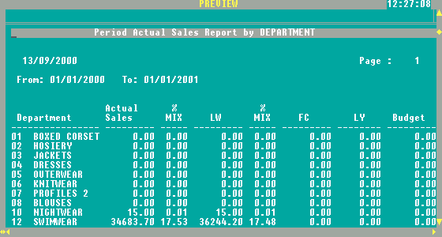
Fig 144. Actual sales / last week sales by department report

By Sub Department

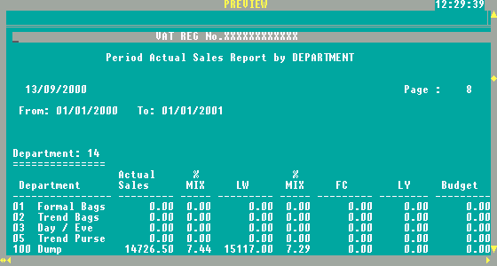
Fig 145. Actual sales / last week sales by sub department report

9.1.5. Period total net sales

This report shows you for a selected period of time total net daily sales, total tax and grand total of the period.

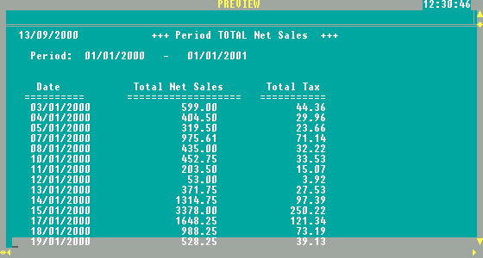
Fig 146. Actual sales / last week sales by sub department report

9.1.6. Period total invoice number

This report will show you how many invoices you issued during the specified period of time.

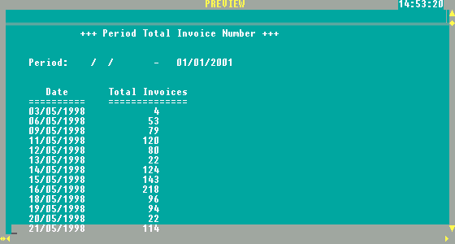
Fig 147. Period total invoice number report

9.1.7. Hourly sales

This report shows you how sales were doing hour by hour during specified period.

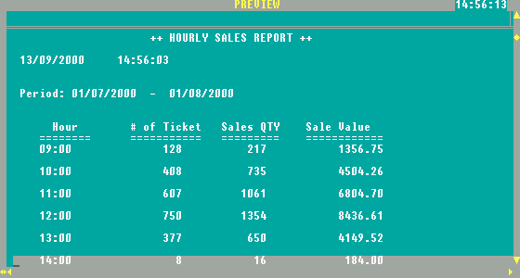
Fig 148. Hourly sales report

9.2. Returned goods report

This report shows all items returned during a sale in a specified period of time. It shows sales person that performs return and a supplier of the item.

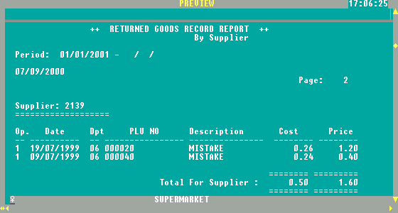
Fig 149. Returned goods report

9.3. Profit Reports

For the better control of current pricing, sales and profitability it is recommended to check on profitability reports and get the right information of profitability of items sold.

After selecting the period and the viewing method: by item or by department, you will be able to see information related with the cost of sale, sales price and profit.

By Item

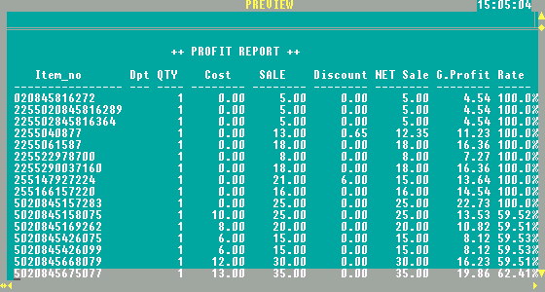
Fig 150. Profit by item report

By Department

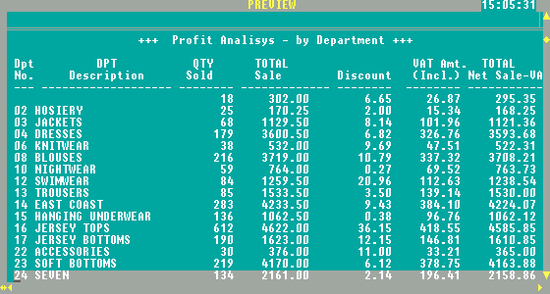
Fig 151. Profit by department report

9.4. Best selling list

The report shows the top list (best selling list) of items sold. You need to select the period of time, the number of items desired, and the criteria: by quantity or by amount.

By Quantity

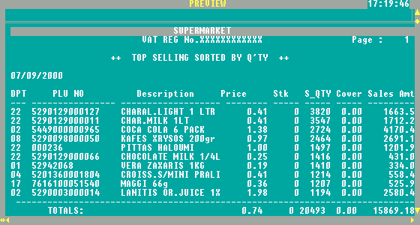
Fig 152. Best selling report by quantity

By Amount

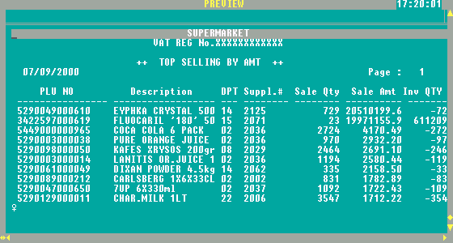
Fig 153. Best selling report by amount

9.5. Worst selling list

It’s exactly the same report as “9.4. Best selling list” with the difference, that instead of showing best selling, shows worst selling list of items.

9.6. Slow sales stock

After selecting the number of days of inactivity, and the viewing method: by item, by department, by supplier or by style, this report will show all the stock items with slow selling.

Note: Date shown on report is the last date of sale.

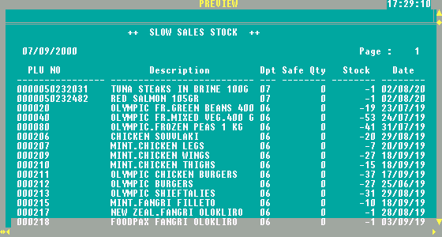
Fig 154. Slow sales report

9.7. Detail sales report

In order to check each individual invoice collected during selling (from specific POS machine), you can use detail sales report. This report (Fig, 155) shows you information about invoice printed, including method of payment.

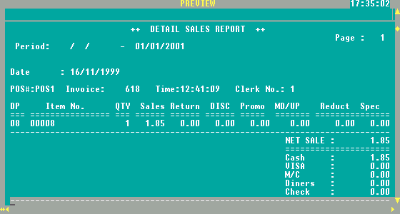
Fig 155. Detail sales report

9.8. Sales / Purchases tax report

For VAT purpose in order to submit right amount on your VAT forms, you can run VAT reports:

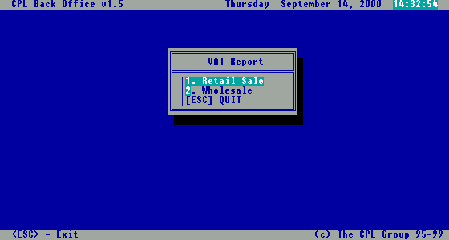
Fig 156. VAT activity selection menu

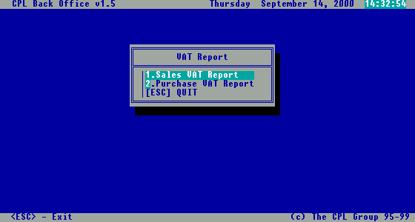
Fig 157. VAT report menu

As you can see from the picture above, you can select to calculate VAT Amount related with sales or with purchases.

After selecting the period of time, the following reports will be generated for the retail and on the same way for the wholesale sales/purchase.

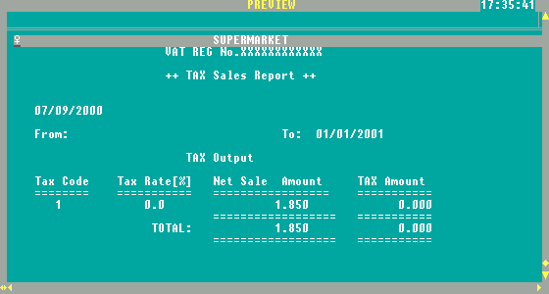
Fig 158. Tax sales report

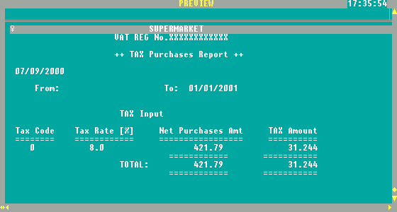
Fig 159. Tax purchases report

9.9. Stock adjustments

The report shows all stock adjustments made in a selected period of time.

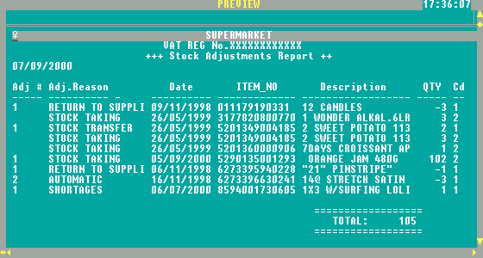
Fig 160. Stock adjustments report

