Syntra West

C# Fundamentals

# Building Block I : Variables

## DataTypes

[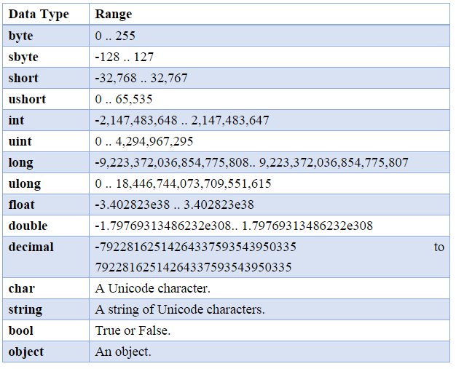](https://www.google.be/url?sa=i&rct=j&q=&esrc=s&source=images&cd=&ved=2ahUKEwjjopfgy53eAhUDI1AKHREzD4EQjRx6BAgBEAU&url=https%3A%2F%2Fstackoverflow.com%2Fquestions%2F5366730%2Fdatatypes-in-c-sharp&psig=AOvVaw2cmEeC-4zNvhLzdR0Q6Ahl&ust=1540419408896877)

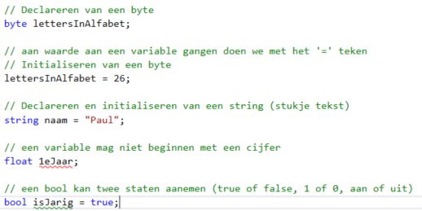

## 

## Input en output

