Vergleich verschiedener Deep-Learning-Modelle zur Klassifizierung von Fledermausrufen

Christian Müller
Gutenbergstraße 20
64342 Seeheim-Jugenheim
chrmue44@gmail.com

Einleitung
Ziel der Untersuchung ist es, einen automatischen Klassifizierer für Fledermausrufe zu entwickeln. Die Klassifizierung soll eine möglichst gute Vorhersage-Genauigkeit bei möglichst geringem Rechenaufwand liefern. Als Software-Plattform dienen das AI-Framework tensorflow 2.0 und diverse weitere Python-Bibliotheken. Die Klassifizierung in dieser Untersuchung beschränkt sich auf 9 Fledermausarten.
Als Testdaten wurden Aufnahmen vom Naturkundemuseum Berlin, von Rudolf Böhm und Christian Müller verwendet. Zum Vergleich verschiedener Deep-Learning Modell-Architekturen wurde immer der gleiche Testdatensatz verwendet.

Inhaltsverzeichnis
1 Einleitung 1
2 Verwendete Testdaten 2
3 Aufbereitung der Daten 4
4 Ergebnisse 5
5 Implementierung der untersuchten Modelle 6
5.1 Rnn1aModel 6
5.2 Rnn5Model 7
5.3 rnn6Model 8
5.4 rnn6aModel 9
5.5 ResNet34 10
6 Quellen 13

Verwendete Testdaten
Folgende Fledermausarten bzw. Klassen sollen detektiert werden:
Fledermausart | Quelle | Anzahl Rufe
Mopsfledermaus (Barbastella barbastellus) | Rudolf Böhm | 748
Breitflügelfledermaus (Eptesicus serotinus | Tierstimmenarchiv.de | 1069
Wasserfledermaus (Myotis daubentonii) | Tierstimmenarchiv.de | 3308
Großes Mausohr (Myotis myotis) | Tierstimmenarchiv.de | 999
Kleinabendsegler (Nyctalus leisleri) | Tierstimmenarchiv.de | 779
Großer Abendsegler (Nyctalus noctula) | Tierstimmenarchiv.de | 852
Rauhautfledermaus (Pipistrellus nathusii) | Tierstimmenarchiv.de | 1678
Zwergfledermaus (Pipistrellus pipistrellus) | Tierstimmenarchiv.de | 3579
Mückenfledermaus (Pipistrellus pygmaeus) | Rudolf, Böhm | 4450
Heuschrecken (nachfolgend als Cric bezeichnet) | Christian Müller, | 424
Sonstiges (incl. diverser Störgeräusche) | Christian Müller,  www.github.org/paddygoat | 4329
Die Testdaten werden in 3 Klassen aufgeteilt:
Name | Anzahl Rufe | Beschreibung
train | 17676 | Daten, mit denen das Modell trainiert wird
Dev | 2209 | Daten, mit denen das Modell während des Trainings überprüft wird
test | 2210 | Daten, mit denen das Modell am Ende des Trainings validiert wird

Aufbereitung der Daten
Bevor die Tonaufnahmen dem Training bzw. der Klassifizierung zugeführt werden, erfolgt eine Aufbereitung der Daten. Dazu werden die folgenden Schritte durchgeführt:
1. Resampling der WAV-Aufnahmen zu einer Abtastrate von 312500 Hz
2. Erkennung und Isolation von einzelnen Rufen in der jeweiligen Aufnahme. Hierzu wird das biocoustics package verwendet.
3. FFT: Die Aufnahme wird per FFT in den Frequenzbereich transformiert
4. Normierung: Die lauteste festgestellte Amplitude innerhalb eines Rufes wird auf den Wert 1.0 gesetzt. Sämtliche anderen Amplituden werden zu dieser Maximalamplitude ins Verhältnis gesetzt. Mit dieser Maßnahme werden die teilweise erheblichen Lautstärkeunterschiede zwischen den Aufnahmen ausgeglichen.
5. Die FFTs der einzelnen Rufe werden auf ein Format von 129 x 330 Punkten begrenzt. Kürzere Rufe werden mit 0 aufgefüllt, längere Rufe werden am Ende abgeschnitten.
6. Rauschunterdrückung: 2 verschiedene Methoden getestet:
- alle Amplituden im Spektrogramm unterhalb eines Schwellwertes auf 0 gesetzt
- nur die oberen 95% der Energie einer Spektrallinie werden berücksichtigt,
der Rest auf 0 gesetzt (Methode 1 funktioniert besser)

Ergebnisse
In der unten stehenden Tabelle sind die Ergebnisse für die einzelnen Arten aufgelistet. Berechnet ist jeweils die „precision“ für jede erkannte Klasse bzw. Fledermausart. Generell schneidet das resNet34 am besten ab. Für einzelne Arten liefern andere Modelle jedoch teilweise bessere Ergebnisse.
Das Training der Modelle dauert bei allen Modellen außer dem resNet34 60 … 90 Sekunden pro Epoche. Lediglich das Resnet34 braucht ca. 1,5 Stunden zum Training einer Epoche, ist also wesentlich ressourcenhungriger.

Modell  Art | Precision ( TP / (TP + FP)
Modell  Art | Resnet34 | rnn5 | rnn6a | flat | rnn1a
---- | 99.1% | 98.8% | 99.1% | 98.6% | 99.1%
Bbar | 96.4% | 95.2% | 91.7% | 88.1% | 94.0%
Cric | 97.5% | 97.3% | 97.3% | 94.7% | 100.0%
Eser | 80.4% | 81.4% | 81.4% | 76.2% | 81.4%
Mdau | 98.4% | 96.6% | 96.9% | 91.1% | 92.7%
Mmyo | 93.5% | 80.4% | 76.0% | 62.0% | 64.1%
Nlei | 66.7% | 74.7% | 76% | 56.0% | 65.3%
Nnoc | 78.4% | 79.5% | 76.1% | 76.1% | 84.1%
Pnat | 96.3% | 92.1% | 93.3% | 91.4% | 92.1%
Ppip | 98.5% | 96.2% | 95.0% | 94.4% | 96.8%
Ppyg | 99.8% | 99.1% | 98.6% | 99.5% | 99.8%

Da die Modelle zwischen 2 und über 20 Millionen Parameter haben, erscheinen die gut 20.000 Trainingsbeispiele etwas knapp bemessen. Hier würden mehr verlässliche Daten sicher noch zu einer Verbesserung des Ergebnisses beitragen.

Implementierung der untersuchten Modelle

FlatModel
Learning rate: 0.00002, accurracy: 0.91

Model: "flatModel"
_________________________________________________________________
Layer (type) Output Shape Param #
=================================================================
flatten (Flatten) (None, 42570) 0
dense (Dense) (None, 256) 10898176
dense_1 (Dense) (None, 256) 65792
dense_2 (Dense) (None, 128) 32896
dense_3 (Dense) (None, 11) 1419
=================================================================
Total params: 10,998,283
Trainable params: 10,998,283
Non-trainable params: 0
_________________________________________________________________

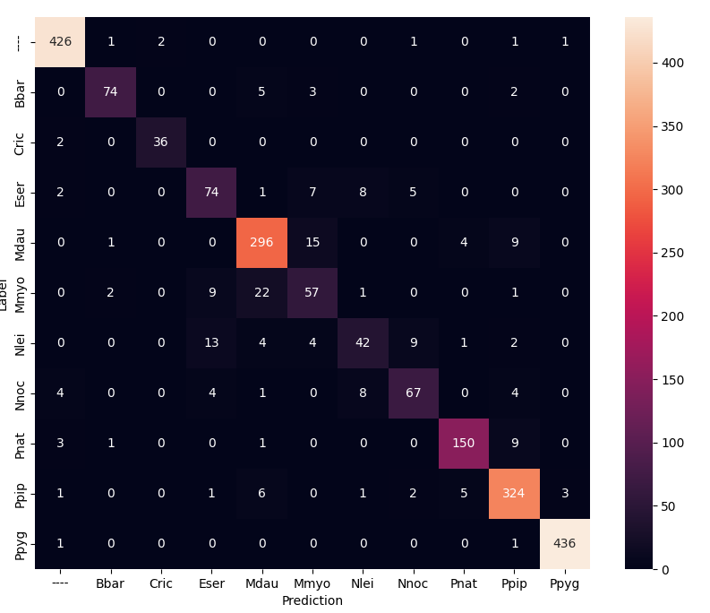

Rnn1aModel
Learning rate: 0.00002, Optimizer „Adam“, 95 Epochs, dropout 0,5
accuracy 0.93
Model: "rnn1aModel"
_________________________________________________________________
Layer (type) Output Shape Param #
=================================================================
gru (GRU) (None, 129, 128) 176640
flatten (Flatten) (None, 16512) 0
dropout (Dropout) (None, 16512) 0
dense (Dense) (None, 128) 2113664
dense_1 (Dense) (None, 11) 1419
=================================================================
Total params: 2,291,723
Trainable params: 2,291,723
Non-trainable params: 0

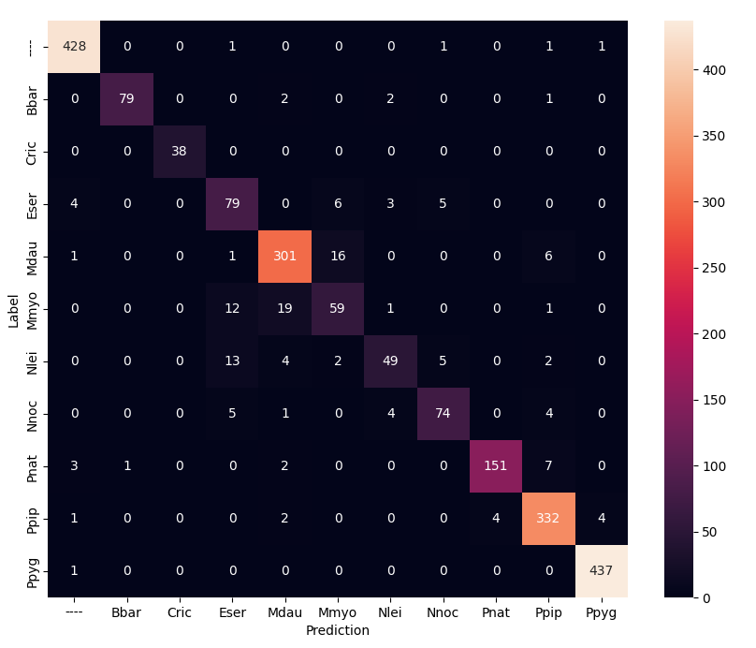

Rnn5Model
Learning rate: 0.00002, Optimizer „Adam“, 41 Epochs, dropout 0,5
accurracy 0.943
Model: "rnn5Model"
_________________________________________________________________
Layer (type) Output Shape Param #
=================================================================
conv1d (Conv1D) (None, 29, 196) 970396
batch_normalization (BatchNormalization) (None, 29, 196) 784
activation (Activation) (None, 29, 196) 0
dropout (Dropout) (None, 29, 196) 0
gru (GRU) (None, 29, 128) 125184
dropout_1 (Dropout) (None, 29, 128) 0
batch_normalization_1 (BatchNormalization) (None, 29, 128) 512
gru_1 (GRU) (None, 29, 128) 99072
dropout_2 (Dropout) (None, 29, 128) 0
flatten (Flatten) (None, 3712) 0
dense (Dense) (None, 128) 475264
dense_1 (Dense) (None, 11) 1419
=================================================================
Total params: 1,672,631
Trainable params: 1,671,983
Non-trainable params: 648

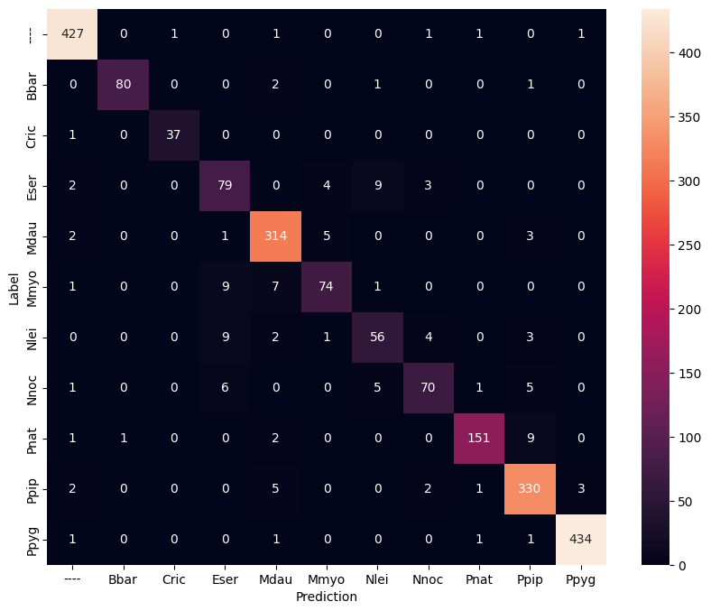

rnn6aModel
Learning rate: 0.00002, Epochs: 45, dropout 0.5, accuracy 93.8%
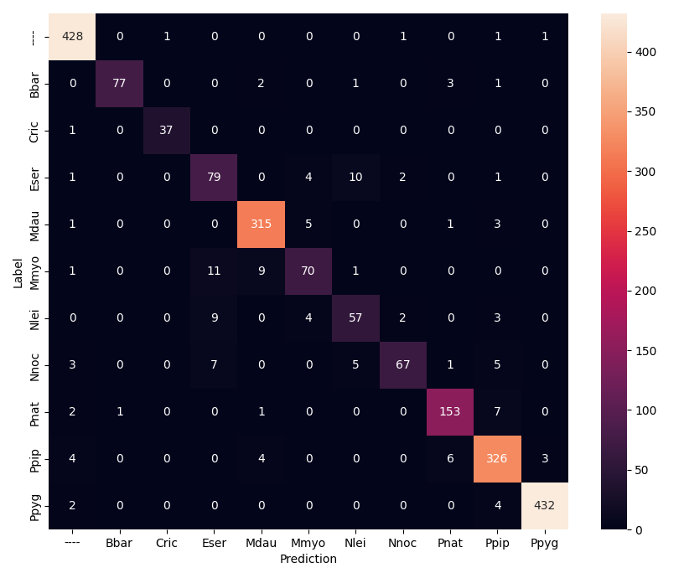
Model: "rnn6aModel"
_________________________________________________________________
Layer (type) Output Shape Param #
=================================================================
conv1d (Conv1D) (None, 29, 196) 970396
batch_normalization (BatchNormalization) (None, 29, 196) 784
activation (Activation) (None, 29, 196) 0
dropout (Dropout) (None, 29, 196) 0
gru (GRU) (None, 29, 128) 125184
dropout_1 (Dropout) (None, 29, 128) 0
batch_normalization_1 (BatchNormalization) (None, 29, 128) 512
gru_1 (GRU) (None, 29, 128) 99072
dropout_2 (Dropout) (None, 29, 128) 0
batch_normalization_2 (BatchNormalization) (None, 29, 128) 512
gru_2 (GRU) (None, 29, 128) 99072
dropout_3 (Dropout) (None, 29, 128) 0
flatten (Flatten) (None, 3712) 0
dense (Dense) (None, 128) 475264
dense_1 (Dense) (None, 11) 1419
=================================================================
Total params: 1,772,215
Trainable params: 1,771,311
Non-trainable params: 904

ResNet34
rows, timeSteps, classes: 129 330 11, 5 epochs, learning rate 0.00002
accurracy 0.956
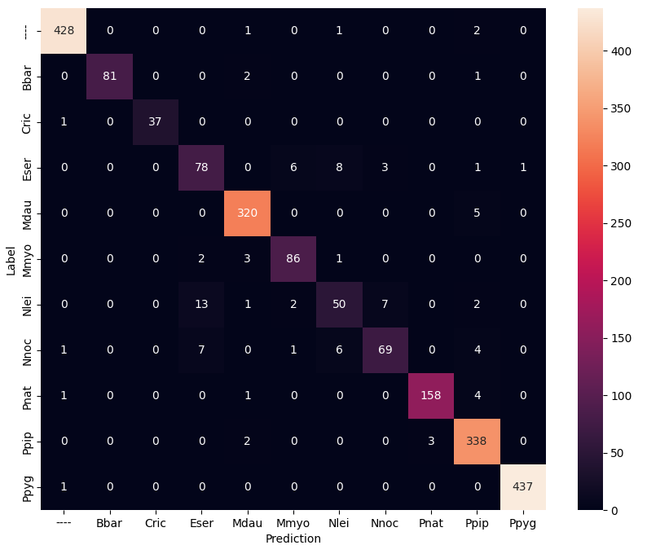
Model: "resNet34Model"
__________________________________________________________________________________________________
Layer (type) Output Shape Param # Connected to
==================================================================================================
input_1 (InputLayer) [(None, 129, 330)] 0 []
reshape (Reshape) (None, 129, 330, 1) 0 ['input_1[0][0]']
zero_padding2d (ZeroPadding2D) (None, 135, 336, 1) 0 ['reshape[0][0]']
conv2d (Conv2D) (None, 68, 168, 64) 3200 ['zero_padding2d[0][0]']
batch_normalization (BatchNorm alization) (None, 68, 168, 64) 256 ['conv2d[0][0]']
activation (Activation) (None, 68, 168, 64) 0 ['batch_normalization[0][0]']
max_pooling2d (MaxPooling2D) (None, 34, 84, 64) 0 ['activation[0][0]']
conv2d_1 (Conv2D) (None, 34, 84, 64) 36928 ['max_pooling2d[0][0]']
batch_normalization_1 (BatchNo rmalization) (None, 34, 84, 64) 256 ['conv2d_1[0][0]']
activation_1 (Activation) (None, 34, 84, 64) 0 ['batch_normalization_1[0][0]']
conv2d_2 (Conv2D) (None, 34, 84, 64) 36928 ['activation_1[0][0]']
batch_normalization_2 (BatchNormalization) (None, 34, 84, 64) 256 ['conv2d_2[0][0]']
add (Add) (None, 34, 84, 64) 0 ['batch_normalization_2[0][0]',
'max_pooling2d[0][0]']
activation_2 (Activation) (None, 34, 84, 64) 0 ['add[0][0]']
conv2d_3 (Conv2D) (None, 34, 84, 64) 36928 ['activation_2[0][0]']
batch_normalization_3 (BatchNormalization) (None, 34, 84, 64) 256 ['conv2d_3[0][0]']
activation_3 (Activation) (None, 34, 84, 64) 0 ['batch_normalization_3[0][0]']
conv2d_4 (Conv2D) (None, 34, 84, 64) 36928 ['activation_3[0][0]']
batch_normalization_4 (BatchNormalization) (None, 34, 84, 64) 256 ['conv2d_4[0][0]']
add_1 (Add) (None, 34, 84, 64) 0 ['batch_normalization_4[0][0]',
'activation_2[0][0]']
activation_4 (Activation) (None, 34, 84, 64) 0 ['add_1[0][0]']
conv2d_5 (Conv2D) (None, 34, 84, 64) 36928 ['activation_4[0][0]']
batch_normalization_5 (BatchNormalization) (None, 34, 84, 64) 256 ['conv2d_5[0][0]']
activation_5 (Activation) (None, 34, 84, 64) 0 ['batch_normalization_5[0][0]']
conv2d_6 (Conv2D) (None, 34, 84, 64) 36928 ['activation_5[0][0]']
batch_normalization_6 (BatchNo rmalization) (None, 34, 84, 64) 256 ['conv2d_6[0][0]']
add_2 (Add) (None, 34, 84, 64) 0 ['batch_normalization_6[0][0]',
'activation_4[0][0]']
activation_6 (Activation) (None, 34, 84, 64) 0 ['add_2[0][0]']
conv2d_7 (Conv2D) (None, 17, 42, 128) 73856 ['activation_6[0][0]']
batch_normalization_7 (BatchNormalization) (None, 17, 42, 128) 512 ['conv2d_7[0][0]']
activation_7 (Activation) (None, 17, 42, 128) 0 ['batch_normalization_7[0][0]']
conv2d_8 (Conv2D) (None, 17, 42, 128) 147584 ['activation_7[0][0]']
batch_normalization_8 (BatchNormalization) (None, 17, 42, 128) 512 ['conv2d_8[0][0]']
conv2d_9 (Conv2D) (None, 17, 42, 128) 8320 ['activation_6[0][0]']
add_3 (Add) (None, 17, 42, 128) 0 ['batch_normalization_8[0][0]',
'conv2d_9[0][0]']
activation_8 (Activation) (None, 17, 42, 128) 0 ['add_3[0][0]']
conv2d_10 (Conv2D) (None, 17, 42, 128) 147584 ['activation_8[0][0]']
batch_normalization_9 (BatchNormalization) (None, 17, 42, 128) 512 ['conv2d_10[0][0]']
activation_9 (Activation) (None, 17, 42, 128) 0 ['batch_normalization_9[0][0]']
conv2d_11 (Conv2D) (None, 17, 42, 128) 147584 ['activation_9[0][0]']
batch_normalization_10 (BatchNormalization) (None, 17, 42, 128) 512 ['conv2d_11[0][0]']
add_4 (Add) (None, 17, 42, 128) 0 ['batch_normalization_10[0][0]',
'activation_8[0][0]']
activation_10 (Activation) (None, 17, 42, 128) 0 ['add_4[0][0]']
conv2d_12 (Conv2D) (None, 17, 42, 128) 147584 ['activation_10[0][0]']
batch_normalization_11 (BatchN (None, 17, 42, 128) 512 ['conv2d_12[0][0]']
ormalization)
activation_11 (Activation) (None, 17, 42, 128) 0 ['batch_normalization_11[0][0]']
conv2d_13 (Conv2D) (None, 17, 42, 128) 147584 ['activation_11[0][0]']
batch_normalization_12 (BatchNormalization) (None, 17, 42, 128) 512 ['conv2d_13[0][0]']
add_5 (Add) (None, 17, 42, 128) 0 ['batch_normalization_12[0][0]',
'activation_10[0][0]']
activation_12 (Activation) (None, 17, 42, 128) 0 ['add_5[0][0]']
conv2d_14 (Conv2D) (None, 17, 42, 128) 147584 ['activation_12[0][0]']
batch_normalization_13 (BatchN ormalization) (None, 17, 42, 128) 512 ['conv2d_14[0][0]']
activation_13 (Activation) (None, 17, 42, 128) 0 ['batch_normalization_13[0][0]']
conv2d_15 (Conv2D) (None, 17, 42, 128) 147584 ['activation_13[0][0]']
batch_normalization_14 (BatchNormalization) (None, 17, 42, 128) 512 ['conv2d_15[0][0]']
add_6 (Add) (None, 17, 42, 128) 0 ['batch_normalization_14[0][0]',
'activation_12[0][0]']
activation_14 (Activation) (None, 17, 42, 128) 0 ['add_6[0][0]']
conv2d_16 (Conv2D) (None, 9, 21, 256) 295168 ['activation_14[0][0]']
batch_normalization_15 (BatchN ormalization) (None, 9, 21, 256) 1024 ['conv2d_16[0][0]']
activation_15 (Activation) (None, 9, 21, 256) 0 ['batch_normalization_15[0][0]']
conv2d_17 (Conv2D) (None, 9, 21, 256) 590080 ['activation_15[0][0]']
batch_normalization_16 (BatchNormalization) (None, 9, 21, 256) 1024 ['conv2d_17[0][0]']
conv2d_18 (Conv2D) (None, 9, 21, 256) 33024 ['activation_14[0][0]']
add_7 (Add) (None, 9, 21, 256) 0 ['batch_normalization_16[0][0]',
'conv2d_18[0][0]']
activation_16 (Activation) (None, 9, 21, 256) 0 ['add_7[0][0]']
conv2d_19 (Conv2D) (None, 9, 21, 256) 590080 ['activation_16[0][0]']
batch_normalization_17 (BatchNormalization) (None, 9, 21, 256) 1024 ['conv2d_19[0][0]']
activation_17 (Activation) (None, 9, 21, 256) 0 ['batch_normalization_17[0][0]']
conv2d_20 (Conv2D) (None, 9, 21, 256) 590080 ['activation_17[0][0]']
batch_normalization_18 (BatchNormalization) (None, 9, 21, 256) 1024 ['conv2d_20[0][0]']
add_8 (Add) (None, 9, 21, 256) 0 ['batch_normalization_18[0][0]',
'activation_16[0][0]']
activation_18 (Activation) (None, 9, 21, 256) 0 ['add_8[0][0]']
conv2d_21 (Conv2D) (None, 9, 21, 256) 590080 ['activation_18[0][0]']
batch_normalization_19 (BatchNormalization) (None, 9, 21, 256) 1024 ['conv2d_21[0][0]']
activation_19 (Activation) (None, 9, 21, 256) 0 ['batch_normalization_19[0][0]']
conv2d_22 (Conv2D) (None, 9, 21, 256) 590080 ['activation_19[0][0]']
batch_normalization_20 (BatchNormalization) (None, 9, 21, 256) 1024 ['conv2d_22[0][0]']
add_9 (Add) (None, 9, 21, 256) 0 ['batch_normalization_20[0][0]',
'activation_18[0][0]']
activation_20 (Activation) (None, 9, 21, 256) 0 ['add_9[0][0]']
conv2d_23 (Conv2D) (None, 9, 21, 256) 590080 ['activation_20[0][0]']
batch_normalization_21 (BatchNormalization) (None, 9, 21, 256) 1024 ['conv2d_23[0][0]']
activation_21 (Activation) (None, 9, 21, 256) 0 ['batch_normalization_21[0][0]']
conv2d_24 (Conv2D) (None, 9, 21, 256) 590080 ['activation_21[0][0]']
batch_normalization_22 (BatchNormalization) (None, 9, 21, 256) 1024 ['conv2d_24[0][0]']
add_10 (Add) (None, 9, 21, 256) 0 ['batch_normalization_22[0][0]',
'activation_20[0][0]']
activation_22 (Activation) (None, 9, 21, 256) 0 ['add_10[0][0]']
conv2d_25 (Conv2D) (None, 9, 21, 256) 590080 ['activation_22[0][0]']
batch_normalization_23 (BatchNormalization) (None, 9, 21, 256) 1024 ['conv2d_25[0][0]']
activation_23 (Activation) (None, 9, 21, 256) 0 ['batch_normalization_23[0][0]']
conv2d_26 (Conv2D) (None, 9, 21, 256) 590080 ['activation_23[0][0]']
batch_normalization_24 (BatchNormalization) (None, 9, 21, 256) 1024 ['conv2d_26[0][0]']
add_11 (Add) (None, 9, 21, 256) 0 ['batch_normalization_24[0][0]',
'activation_22[0][0]']
activation_24 (Activation) (None, 9, 21, 256) 0 ['add_11[0][0]']
conv2d_27 (Conv2D) (None, 9, 21, 256) 590080 ['activation_24[0][0]']
batch_normalization_25 (BatchNormalization) (None, 9, 21, 256) 1024 ['conv2d_27[0][0]']
activation_25 (Activation) (None, 9, 21, 256) 0 ['batch_normalization_25[0][0]']
conv2d_28 (Conv2D) (None, 9, 21, 256) 590080 ['activation_25[0][0]']
batch_normalization_26 (BatchNormalization) (None, 9, 21, 256) 1024 ['conv2d_28[0][0]']
add_12 (Add) (None, 9, 21, 256) 0 ['batch_normalization_26[0][0]',
'activation_24[0][0]']
activation_26 (Activation) (None, 9, 21, 256) 0 ['add_12[0][0]']
conv2d_29 (Conv2D) (None, 5, 11, 512) 1180160 ['activation_26[0][0]']
batch_normalization_27 (BatchNormalization) (None, 5, 11, 512) 2048 ['conv2d_29[0][0]']
activation_27 (Activation) (None, 5, 11, 512) 0 ['batch_normalization_27[0][0]']

conv2d_30 (Conv2D) (None, 5, 11, 512) 2359808 ['activation_27[0][0]']
batch_normalization_28 (BatchNormalization) (None, 5, 11, 512) 2048 ['conv2d_30[0][0]']
conv2d_31 (Conv2D) (None, 5, 11, 512) 131584 ['activation_26[0][0]']
add_13 (Add) (None, 5, 11, 512) 0 ['batch_normalization_28[0][0]',
'conv2d_31[0][0]']
activation_28 (Activation) (None, 5, 11, 512) 0 ['add_13[0][0]']
conv2d_32 (Conv2D) (None, 5, 11, 512) 2359808 ['activation_28[0][0]']
batch_normalization_29 (BatchNormalization) (None, 5, 11, 512) 2048 ['conv2d_32[0][0]']
activation_29 (Activation) (None, 5, 11, 512) 0 ['batch_normalization_29[0][0]']
conv2d_33 (Conv2D) (None, 5, 11, 512) 2359808 ['activation_29[0][0]']
batch_normalization_30 (BatchNormalization) (None, 5, 11, 512) 2048 ['conv2d_33[0][0]']
add_14 (Add) (None, 5, 11, 512) 0 ['batch_normalization_30[0][0]',
'activation_28[0][0]']
activation_30 (Activation) (None, 5, 11, 512) 0 ['add_14[0][0]']
conv2d_34 (Conv2D) (None, 5, 11, 512) 2359808 ['activation_30[0][0]']
batch_normalization_31 (BatchNormalization) (None, 5, 11, 512) 2048 ['conv2d_34[0][0]']
activation_31 (Activation) (None, 5, 11, 512) 0 ['batch_normalization_31[0][0]']
conv2d_35 (Conv2D) (None, 5, 11, 512) 2359808 ['activation_31[0][0]']
batch_normalization_32 (BatchNormalization) (None, 5, 11, 512) 2048 ['conv2d_35[0][0]']
add_15 (Add) (None, 5, 11, 512) 0 ['batch_normalization_32[0][0]',
'activation_30[0][0]']
activation_32 (Activation) (None, 5, 11, 512) 0 ['add_15[0][0]']
average_pooling2d (AveragePooling2D) (None, 3, 6, 512) 0 ['activation_32[0][0]']
flatten (Flatten) (None, 9216) 0 ['average_pooling2d[0][0]']
dense (Dense) (None, 512) 4719104 ['flatten[0][0]']
dense_1 (Dense) (None, 11) 5643 ['dense[0][0]']
==================================================================================================
Total params: 26,025,099
Trainable params: 26,009,867
Non-trainable params: 15,232
_______________________________

Quellen

www.tierstimmenarchiv.de
https://cran.r-project.org/web/packages/bioacoustics/index.html
https://www.tensorflow.org/
https://www.coursera.org/learn/neural-networks-deep-learning/home/
https://www.analyticsvidhya.com/blog/2021/08/how-to-code-your-resnet-from-scratch-in-tensorflow/
Gulli Anonio, Kapoor Amita, Oal Sujit; Deep Leraning with Tensorflow 2.0 and Keras; 2019; Birmingham
Rudolf Böhm, Alsbach
Kaiming He, Xiangyu Zhang, Shaoqing Ren, and Jian Sun in their paper – “Deep Residual Learning for Image Recognition”.
https://github.com/paddygoat/bioacoustics/blob/master/Train_and_deploy_bats/readme
https://en.wikipedia.org/wiki/Precision_and_recall

Www.tensorflow.org
www.tierstimmenarchiv.de
Rudolf Böhm, Alsbach-Hähnlein
https://github.com/paddygoat/bioacoustics/blob/master/Train_and_deploy_bats/readme (house_keys, Junk_A … Junk_F)
https://cran.r-project.org/web/packages/bioacoustics/index.html
https://en.wikipedia.org/wiki/Precision_and_recall

