User Manual BatInspector

SoftwareVersion: 0.2
Date: 23-05-30

BatInspector is a software to analyze and manage recordings of bat calls.
It supports Elekon BatCorder projects as well as plain WAV files.

Main Features:
- manage bat recordings
- Analyze bat calls:
-frequency max
- frequency min
- duration
- many more
- Waterfall diagrams:
- zoom in and out
- zoom to detected call
- play recordings in original and 10x stretched speed
- Automatic species detection (experimental)
- Manual species detection
- Powerful data filtering
- user defined filter expressions
- Generate reports

Index
1 Document History 3
2 Introduction 4
3 Installation and setup 5
3.1 Installation 5
4 The GUI 6
4.1 Basic Concepts 6
4.2 The Main Button Bar 7
4.3 The Project Selector 8
5 Basic Workflow 9
5.1 Copy Data from recorder to PC 9
5.1.1 Copy data from Elekon (or compatible) device 9
5.1.2 Copy data from random device 10
5.2 Open a Project 10
5.2.1 Format of the project file 11
5.2.2 Format of the Report File 12
5.3 Analyze calls automatically 13
5.4 Working with Filters 13
5.5 Analyze calls manually 13
6 Menues and Screens 13
7 Scripting Language 14
7.1 Syntax 14
7.2 Commands 14
7.2.1 SET 14
7.2.2 CALL 14
7.2.3 FOR … END 15
7.2.4 WHILE … END 15
7.2.5 BREAK 16
7.2.6 LOG 16
8 Expression Parser Syntax 17
8.1 Operators 17
8.2 Data Types of Expressions 18
8.3 Supported Functions 18
8.3.1 Trigonometrical Functions 18
8.3.2 Mathematical Functions 19
8.3.3 String functions 20
8.3.4 Miscellanous Functions 21
8.3.5 Functions to Handle CSV Files 22
8.3.6 Functions to deal with projects 23
8.3.7 Functions to deal with project informations 24
8.3.8 Functions to deal with WAV files 27

Document History
Date | Author | Changes
22-03-15 | CMU | Initial version

Introduction

The main purpose of the BatInspector software ist to manage and analyze bat call recordings in a convenient and time saving way.

It offers the following main features:

- create projects (set of files) from recordings of miscelaneous recording devices.
- Analyze the recordings automatically based on a AI model developed by the University of Edinborough
- Inspect WAV files in details (Sonograms, play back recordings (full speed, time stretched, heterodyne)
- powerful script language
- Manipulate files or projects with predefined or individually developed scripts
- creation of summarized reports across multiple projects
- sophisticated filter options for recordings

Installation and setup

Installation

- Install python 3.10
https://www.python.org/downloads/
It has to be installed in the location C:\Program Files\python310

- Install BatInspector:
TODO

The GUI

Basic Concepts
The screen is divided in several areas as shown in the picture below

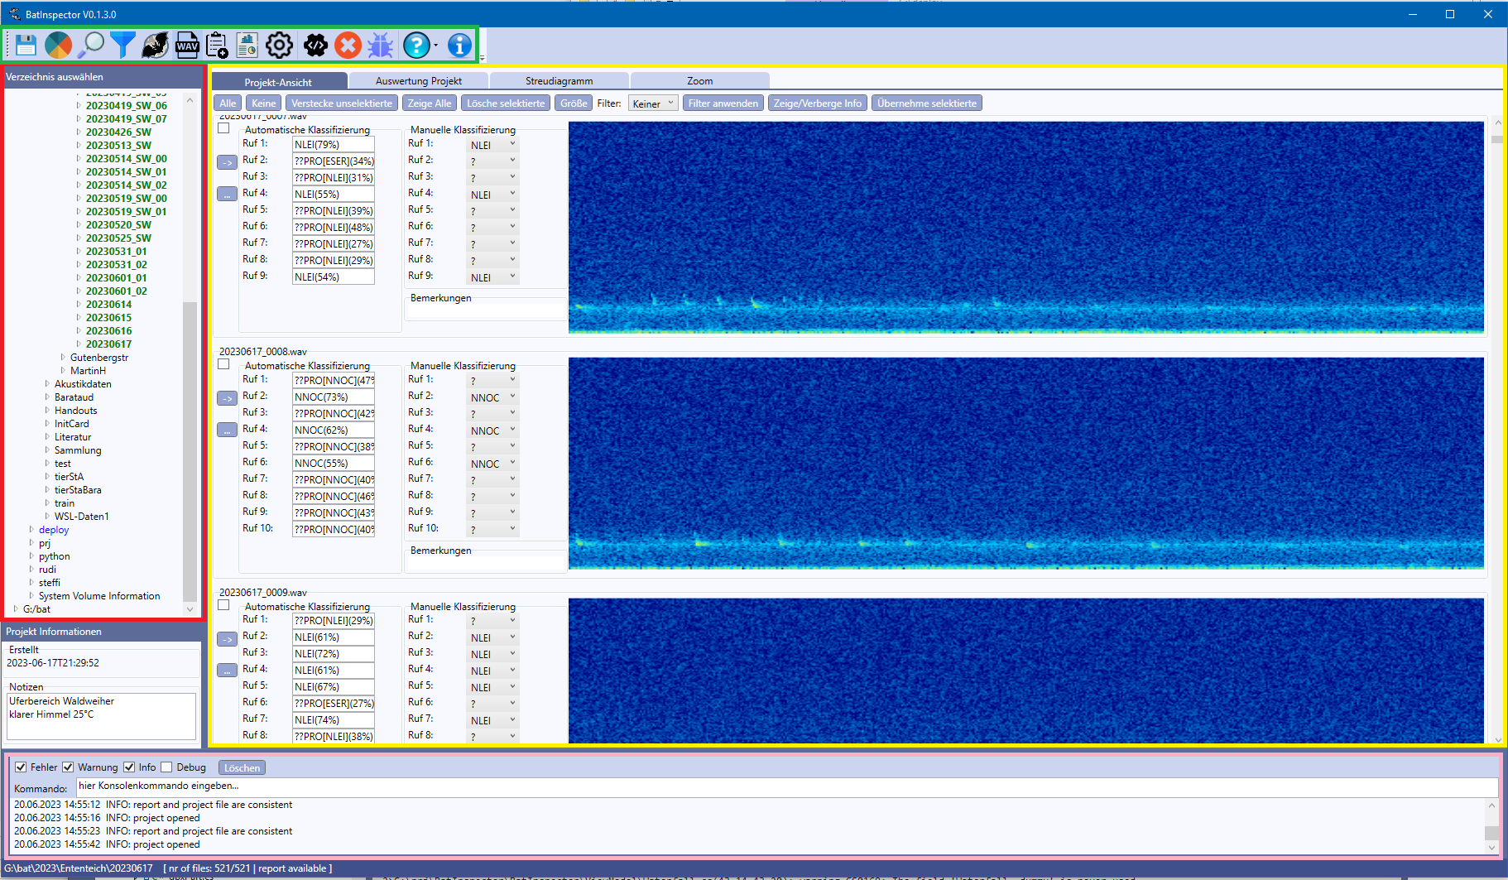

- The button bar (green) on top of the screen provides various high level functions. Hovering the mouse over the buttons shows a tool tip for each function
- The Project selector (red) on the left side shows the file system on the disk and allows to select a project to work with.
- The main area (yellow) shows detailed information of the selected project
- The log (pink) logs the activity of the program

The size of the project selector may be changed by dragging its right border. The size of the logger by dragging its top border. The size of the window may be changed like any other ‚Windows software.

The Main Button Bar
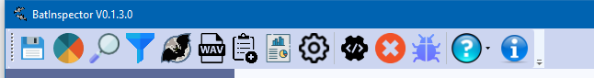

Save settings on disk
Specify color map for spectrograms
Analyze bat calls in currently active project
Manage data filters
Show characteristics of bat species
Show and manipulate wav file properties
Create projects on the disk of the PC from recorded files or projects on SD card
Edit settings
Manage, run and edit scripts
Stop currently running script
Debugging for scripts: Show variable table with current values
Show various help files about the software and bat species information from „Bayrischen Landesamt für Umwelt“
Version and licensing information about this software

The Project Selector
The project selector shows the file system of the computer as a tree structure with expandable and collapsable nodes. To expand or collapse a node click on the little arrows in front of the name of the tree node.
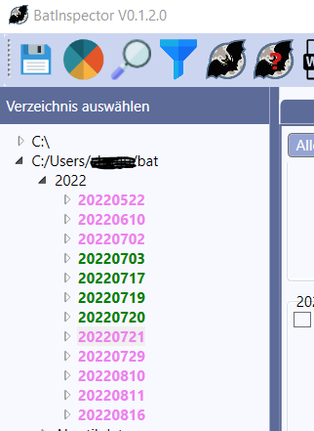

Folders containing fully evaluated projects are shown in green color. If the folder contains a not yet evaluated project it is depicted in pink. All other folders are shown in black.

Clicking on the name of a folder containing a project (green or pink) opens the project in the main screen area.

The Project Area

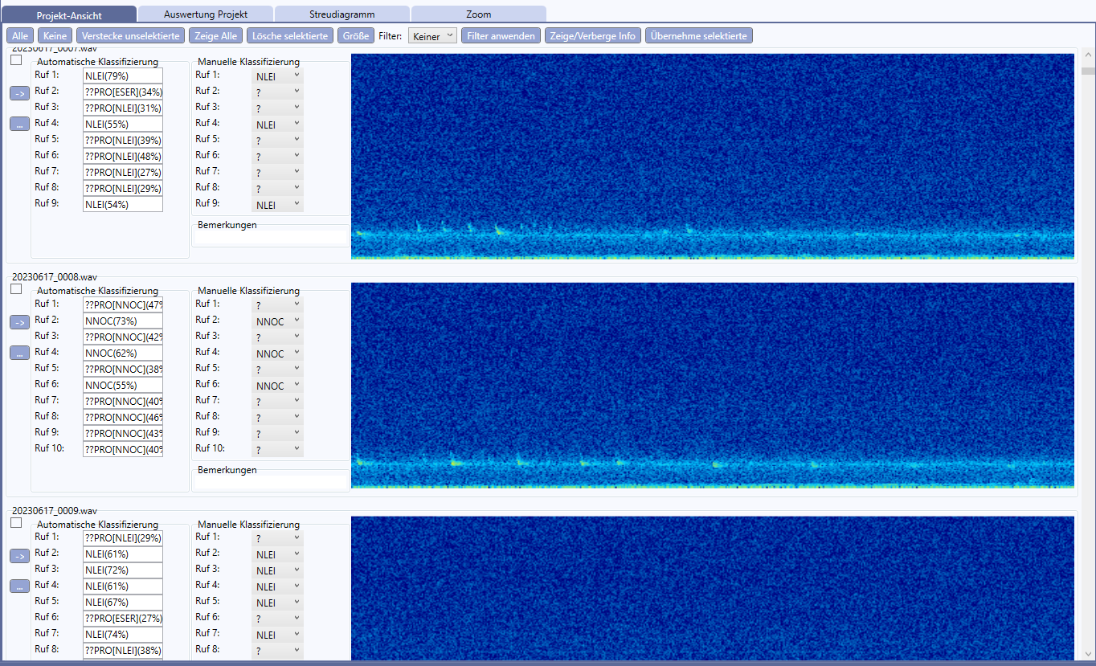

Basic Workflow

Copy Data from recorder to PC
In order to work with the recorded data, they must first be copied to the PC. If you are using an Elekon or compatible recording device follow chapter otherwise chapter

Copy data from Elekon (or compatible) device
- Press the button „Create Project“ in the main main menue:
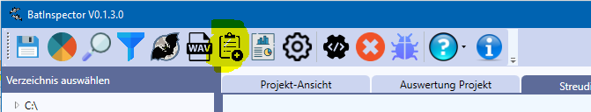

The following dialog appears:
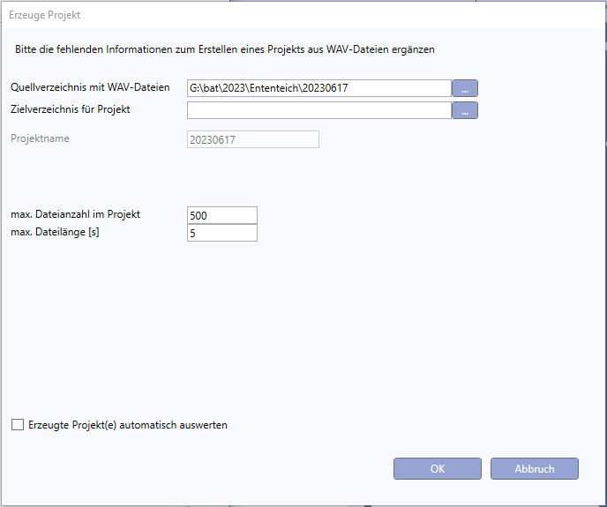
- Select the source directory where the project is stored on the SD card of your device.
- Select the destination directory whre the project directory shall be located on your PC
- Enter how much files you want to have as a maximum in one project. If the folder contains more than the specified number of files multiple projects will be created.
- Specify the maximum length of one recording file. If a file exceeds the specified length it will be split to multiple files.
- Tick checkbox to evaluate automatically the recorded bat species after creating the project (this may be a time consuming process)

Copy data from random device

Open a Project
Select a directory in the file browser on the left side of the main window and click the directory containing the project to open.

Directories containing projects with project files are marked in cyan or green color.

Format of the project file

BatInspector is able to read project files in the Elekon data format.
The project file must have the extension *.bpr and the recordings must be located in a subfolder named „Records“:
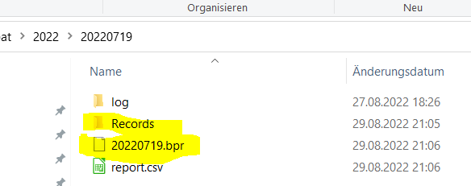
The project file has an XML format, containing a list with all the files and some additional information:
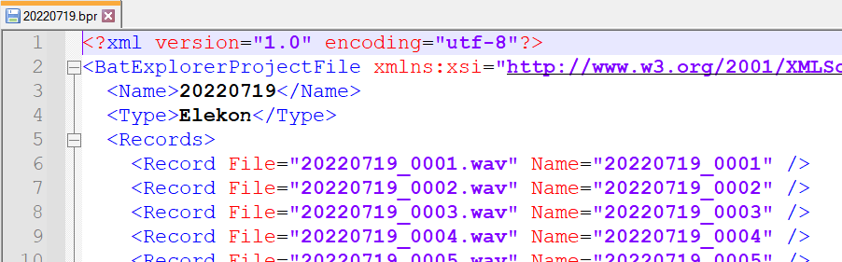

Format of the Report File

Analyze calls automatically

Working with Filters
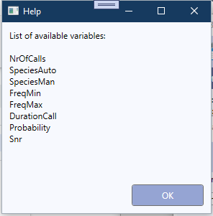

Analyze calls manually

Menues and Screens

Scripting Language

Syntax

The syntax of each script line is:
<command> <Par₁> <Par₂> … <Par_{n}>

Each line contains a command with parameters.
A parameter may be
- a fixed value: 22
- a string enclosed in „“: „this is a sample string“
- an expression: =(cos(a) + 5)

An expression is surrounded by the start character „=(„ and the end character „)“:
SET a =(cos(b) * 2)
A detailed description of the expression syntax is provided in chapter 8

Before and between command and parameters abitrary white space (space or tab) is allowed.

A line starting with the character ‚#‘ is considered as a comment
# this is a comment and will not be executed

Commands

SET
Function: Assigns a value to a variable. If the variable does not exist, it will be created
Syntax: SET <VarName> <Value>
Parameter: VarName: Name of the variable
Value: Value to assign the variable
Example: SET a 33
SET b =(a + 5)

CALL
Function: calls a script. All variables of the calling script are accessible in the called script.
Syntax: CALL <FileName>
Parameter: FileName: Name of the script file (full path or only name. If only the name is provided, the file must b located in the directory <ScriptDir> from the application settings.
Example: CALL C:\scripts\script1.scr
CALL script2.scr

FOR … END
Function: For Loop

Syntax: FOR <iteratorName> <start> <end>
# a block of code
:
END

Parameter: iteratorName: name of the iterating variable
start: start value for the iterator
end: end value for the iterator
Example:
FOR i 1 10
LOG i
END

WHILE … END
Function: While Loop

Syntax: WHILE <expression>
# a block of code
:
END

Parameter: expression: an expression with boolen result. As log the expressio is true, the loop will be executed
Example:
SET i 0
WHILE =(i < 10)
LOG i
SET i =(i + 1)
END

BREAK
Function: breaks the execution of a loop (applicable for FOR and WHILE loops
Syntax: BREAK
Parameter: none
Example:
WHILE =(a < 100)
LOG a
IF =((b >0) && ( a > 50)
BREAK
END
SET a =(a + 1)
END

LOG
Function: write a message to the log window
Syntax: LOG <message> <type>
Parameter: message: the message to log (fixed val. Or expression)
type: optional parameter for message type:
INFO (default)
ERROR
WARNING
DEBUG
Example:
LOG „this should never happen“ ERROR

Expression Parser Syntax
With the integrated formaula parser it is possible to express complex logic formulas or mathematical calculations.
This is useful to create filter expressions and scripts.

Operators
Operator | Description
+ | Addition
- | Subtraction
* | Multiplication
/ | Division
&& | Logical AND
|| | Logical OR
! | Logical NOT
< | Lesser than
<= | Lesser or equal than
> | Greater than
>= | Greater or equal than
== | Equal
!= | Not equal
() | Braces for math terms or function arguments
[] | Square braces for array index
„“ | Double quotes to enclose strings

Data Types of Expressions

Data Type | Range | Examples
RT_BOOL | True, False | (a <= 3.0)
RT_INT64 | - 2⁶³ … 2⁶³ | -236, 224
RT_UINT64 | 0 … 2⁶⁴ | 23456
RT_HEX | 0x0 …. 0xFFFFFFFFFFFFFFFF | 0xFA10
RT_FLOAT | 64 bit floating point number | -3.5, 66.8767, -3.23E-12
RT_COMPLEX | Complex numbers | 1+2.0i, -4.5 – 3i, 2.3 + 1i
RT_STR | String | „this is a string“, „1.0“

Supported Functions

Trigonometrical Functions
sin(x)
Function returns sinus of a number",
Params x: a number
Returns sinus of x
asin(x)
Function returns arcus sinus of a number
Params x: a number
Returns arcus sinus of x

sinh(x)
Function returns sinus hyperbolicus of a number",
Params x: a number
Returns sinus hyperbolicus of x

cos(x)
Function returns cosinus of a number",
Params x: a number
Returns cosinus of x

acos(x)
Function returns arcus cosinus of a number",
Params x: a number
Returns arcus cosinus of x

cosh(x)
Function returns cosinus hyperbolicus of a number",
Params x: a number
Returns cosinus hyperbolicus of x

tan(x)
Function returns tangens of a number",
Params x: a number
Returns tangens of x

atan(x)
Function returns arcus tangens of a number",
Params x: a number
Returns arcus tangens of x

Mathematical Functions

sqrt(x)
Function returns square root of a number
Params x: a number
Returns square root of x

pow(x, e)
Function calculate power of a number",
Params x: a number
e: exponent
Returns x^{e} (x to the power of e)

exp(x)
Function calculate power of e",
Params x: a number
Returns e^{x} (e to the power of x)

ln(x)
Function calculate the natural logarithm of a number
Params x: a number
Returns natural logarithm of x

abs(x)
Function calculate the absolute value of a number (real or complex)
Params x: a number
Returns absolute value of x

arg(x)
Function calculate the argument of a complex number
Params x: a complex number
Returns arg x

String functions

strlen(s)
Function calculate the length of a string
Params s: a string
Returns length of string s

strListCnt(str)
Function counts the number of items in a ‚;‘ separated list of strings
Params str: a string
Returns number of items in list

strListItem(str, item)
Function returns the selected item in a ‚;‘ separated list of strings
Params str: a string
item: index of selected item (0..n)
Returns selected item of list

substr(str, start, length)
Function calculate the substring of a string
Params str: a string
start: start character (0... <length of str – 1>)
length: length od substr (0... <length of str – 1 - start>)
Returns the sub string

toupper(str)
Function convert string to upper case
Params str: a string
Returns the string in upper case

Miscellanous Functions
cast(exp, type)
Function cast an expression to a specific type
Params exp: an expression
type: a type
(„RT_BOOL“, „RT_FLOAT“, „RT_INT64“, „RT_UIN64“, „RT_STR“, „RT_HEX“
„RT_COMPLEX“)
Returns length of string s

if(exp, argTrue, argFalse)
Function evaluate boolean expression and return corresponding argument
Params exp: a boolean expression
argTrue: an expression for exp == true
argFalse: an expression for exp == false
Returns argTrue or argFalse depending on result of exp

vars()
Function return a list of variables and their values
Params none
Returns list of all defined variables and their values

consts()
Function return a list of constants and their values
Params none
Returns list of all defined constants and their values

Functions to Handle CSV Files
openCsv(fileName,withHeader,separator)

Function: opens a csv file and reads it to memory
Parameter: fileName: Name of the script file (full path or only name. If only the name is provided, the file must b located in the directory <ScriptDir> from the application settings.name of the file (full path)
withHeader: (optional, default 0) 1: first row contains header with column names. The colums can be accessed via the names if opened in this mode.
Separator (optional, default=“;“) separation character in lines for the cells
Returns: >=0: a handle to access the file, <0: error opening the file

closeCsv(handle, write)

Function: closes a csv file and releases the memory"
Parameter: handle: file handle to access csv file
write: (optional, default:0) 1: write file to disk
Returns nothing

getCell(handle, row, col)

Function: get cell content of a previously opened file
Parameter: handle: file handle to access csv file
row row number (1..n)
col col name (if opened with option ‚withHeader‘) or col number(1..n)
Returns content of cell as string

setCell(handle, row, col, value)

Function: set a cell content of a previously opened csv file
Parameter: handle: file handle to access csv file
row row number (1..n)
col col name (if opened with option ‚withHeader‘) or col number(1..n)
value value to write to cell (string)

getRowCount(handle)

Function: get row count of a previously opened csv file (including header)
Parameter: handle: file handle to access csv file
Returns: number of rows in opened file

Functions to deal with projects

createPrjFromFiles(name, srcDir, destDir, maxFiles, maxFileLen,
latitude, longitude, landscape, weather)
Function: create a project from a list of WAV files. If the number of WAV files exceeds the specified maximum number of files the projects gets split into multiple projects. The name of the subprojects are supplemented with an index nr: <prjName_<nnn>. Files that exceed the specified maximum file length are split into several file names. The resulting file names are supplemented with index numbers: <fileName>_<nnn>.wav
Parameter: name: name of the project (without extension)
srcDir: source folder containing WAV files
destDir: destination folder containing project folders
maxFiles: maximum number of files per project
maxFileLen: maximum file length per WAV file [s] (float)
latitude: geographical position
longitude: geographical position
landscape: short description of the landscape of the recording location
weather: short description of weather conditions during recording
Returns: error code: 0=OK

inspectPrj()
Function: identify calls, parameters of calls and the species in the recordings of the currently opened project. The results of the inspection process are stored in a report file named „report.csv“. The result file is stored in a sub folder with the name of the selected modell and is located in the project folder.
Parameter: none
Returns: error code: 0=OK

openPrj(directory, name)
Function: open a project.
Parameter: directory: directory that contains the project
name: project name (*.bpr)
Returns: projectList: a list of ‚;‘ separated project names

Functions to deal with project informations
calcProbabilityRatios()
Function: calculate the ratio for the probabilities of classification for the 1st and 2nd rank for each call in the currently opened project.
Parameter: none
Returns: nothing

getCallCount(index)

Prerequisite: a record file must be generated first
Function: get number of calls for a specified file in currently opened project
Parameter: index: index of file (0..n)
Returns: number of calls

getCallInfo(fIndex, cIndex, infoType)

Prerequisite: a record file must be generated first
Function: get call information for a specified call in a specified file in currently opened project
Parameter: fIndex: index of file (0 … n)
cIndex: index of call (0 … m)
infoType: type of information
„SPEC_AUTO“: automatically detected species, classifier 1
„SPEC_MAN“: manually detected species
„PROB_RATIO“: ratio betw. 1St and 2nd rank of classification
„PROBABILITY“: probability for classified species
Returns: the requested information

getPrjFileCount()
Function: get nr of files in open project
Parameter: none
Returns: number of files in currently opened project

getFileName(index)

Function: get full path file name of file in project opened project
Parameter: index: index of file (0… n)
Returns: full path of wav file

getFileInfo(index, infoType)

Prerequisite: a record file must be generated first
Function: get file specific information in currently opened project
Parameter: index: index of file (0… n)
infoType: type of information to set
„NAME“: name of the file
„DURATION: duration of the recording [s]
„SAMPLE_RATE: sampling rate [Hz]
Returns: the specified data

setFileInfo(index, infoType, data)

Prerequisite: a record file must be generated first
Function: set file specific information in currently opened project
Parameter: index: index of file (0… n)
infoType: type of information to set
„SELECT“: set the state of the checkbox „Select“
(„TRUE“ or „FALSE“)
data: the data
Returns: error code

setCallInfo(fIndex, cIndex, infoType, data)

Prerequisite: a record file must be generated first
Function: set call information for a specified call in a specified file in currently opened project
Parameter: fIndex: index of file (0 … n)
cIndex: index of call (0 … m)
infoType: type of information
„SPEC_MAN“: manually detected species
data: the data
Returns: the requested information

getNrOfSpecies(fIndex)

Prerequisite: a record file must be generated first
Function: get number of auto detected species for spec. file in open project
Parameter: fIndex: index of file (0 … n)
Returns: nr of automatically detected species

getRankSpecies(fIndex, rank)

Prerequisite: a record file must be generated first
Function: get the species name for the specified rank in specified file in open project
Parameter: fIndex: index of file (0 … n)
rank: rank (1 … n, 1= most calls)
Returns: species name for specified rank

getRankCount(fIndex, rank)

Prerequisite: a record file must be generated first
Function: get the nr of calls of species for the specified rank in specified file in open project
Parameter: fIndex: index of file (0 … n)
rank: rank (1 … n, 1= most calls)
Returns: nr species in recording for specified rank

Functions to deal with WAV files

bandPass(file, fMin, fMax)

Function: sets the sampling rate of a file
Parameter: file: name of the file (full path) or alternatively file index of file in
currently open project
fMin: low frequency limit for band pass [Hz]
fMax: high frequency limit for band pass Hz]
Returns: error code

getSampleRate(fileName)

Function: returns the sampling rate of a file
Parameter: fileName: name of the file (full path)
Returns: the sampling rate

rescaleSampleRate(fileName, factor)

Function: multiplies the sampling rate of a file with a factor
Parameter: fileName: name of the file (full path)
factor: factor to multiply sampling rate
Returns: the new sampling rate

SetSampleRate(fileName, sampleRate)

Function: sets the sampling rate of a file
Parameter: fileName: name of the file (full path)
sampleRate: new value for sampling rate
Returns: nothing

