User Manual BatInspector

SoftwareVersion: 0.1
Date: 22-11-20

BatInspector is a software to analyze and manage recordings of bat calls.
It supports Elekon BatCorder projects as well as plain WAV files.

Main Features:
- manage bat recordings
- Analyze bat calls:
-frequency max
- frequency min
- duration
- many more
- Waterfall diagrams:
- zoom in and out
- zoom to detected call
- play recordings in original and 10x stretched speed
- Automatic species detection (experimental)
- Manual species detection
- Powerful data filtering
- user defined filter expressions
- Generate reports

Index
1 Document History 2
2 Introduction 3
3 Installation and setup 3
3.1 Installation 3
4 Basic Workflow 4
4.1 Copy Data to Workstation 4
4.2 Open a Project 4
4.3 Analyze calls automatically 4
4.4 Working with Filters 4
4.5 Analyze calls manually 4
5 Menues and Screens 4
6 Scripting Language 5
6.1 Syntax 5
6.2 Commands 5
6.2.1 SET 5
6.2.2 CALL 5
6.2.3 FOR … END 6
6.2.4 WHILE … END 6
6.2.5 BREAK 7
6.2.6 LOG 7
7 Expression Parser Syntax 8
7.1 Operators 8
7.2 Data Types of Expressions 9
7.3 Supported Functions 9
7.3.1 Trigonometrical Functions 9
7.3.2 Mathematical Functions 10
7.3.3 String functions 11
7.3.4 Miscellanous Functions 11
7.3.5 Functions to Handle CSV Files 12
7.3.6 Functions to deal with project informations 13
7.3.7 Functions to deal with WAV files 15

Document History
Date | Author | Changes
22-03-15 | CMU | Initial version

Introduction

Installation and setup

Installation

- Install python 3
https://www.python.org/downloads/
- Install tensorflow 2
https://www.tensorflow.org/install
- Install BatInspector:
call setup.exe and follow the instructions

Basic Workflow

Copy Data from recorder to PC
In order to work with the recorded data, they must first be copied to the PC. Copy the data to a folder in your hard disk. Each project or recording session should have its own directory.

Open a Project
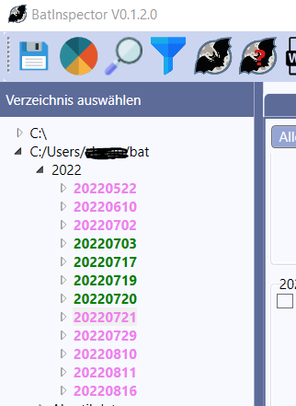 | Select a directory in the file browser on the left side of the main window and click the directory containing the project to open.  Directories containing projects with project files are marked in cyan or green color.

Format of the project file

BatInspector is able to read project files in the Elekon data format.
The project file must have the extension *.bpr and the recordings must be located in a subfolder named „Records“:
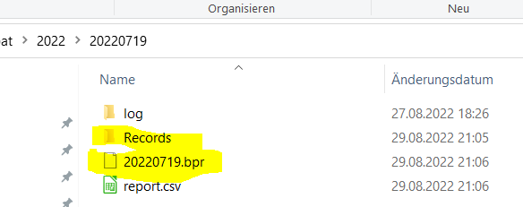
The project file has an XML format, containing a list with all the files and some additional information:
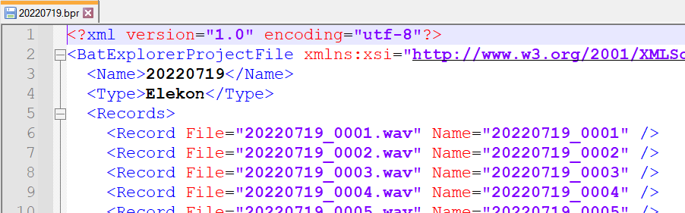

Format of the Report File

Analyze calls automatically

Working with Filters
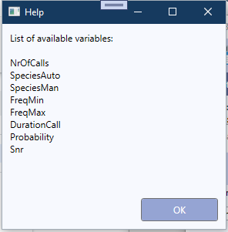

Analyze calls manually

Menues and Screens

Scripting Language

Syntax

The syntax of each script line is:
<command> <Par₁> <Par₂> … <Par_{n}>

Each line contains a command with parameters.
A parameter may be
- a fixed value: 22
- a string enclosed in „“: „this is a sample string“
- an expression: =(cos(a) + 5)

An expression is surrounded by the start character „=(„ and the end character „)“:
SET a =(cos(b) * 2)
A detailed description of the expression syntax is provided in chapter 7

Before and between command and parameters abitrary white space (space or tab) is allowed.

A line starting with the character ‚#‘ is considered as a comment
# this is a comment and will not be executed

Commands

SET
Function: Assigns a value to a variable. If the variable does not exist, it will be created
Syntax: SET <VarName> <Value>
Parameter: VarName: Name of the variable
Value: Value to assign the variable
Example: SET a 33
SET b =(a + 5)

CALL
Function: calls a script. All variables of the calling script are accessible in the called script.
Syntax: CALL <FileName>
Parameter: FileName: Name of the script file (full path or only name. If only the name is provided, the file must b located in the directory <ScriptDir> from the application settings.
Example: CALL C:\scripts\script1.scr
CALL script2.scr

FOR … END
Function: For Loop

Syntax: FOR <iteratorName> <start> <end>
# a block of code
:
END

Parameter: iteratorName: name of the iterating variable
start: start value for the iterator
end: end value for the iterator
Example:
FOR i 1 10
LOG i
END

WHILE … END
Function: While Loop

Syntax: WHILE <expression>
# a block of code
:
END

Parameter: expression: an expression with boolen result. As log the expressio is true, the loop will be executed
Example:
SET i 0
WHILE =(i < 10)
LOG i
SET i =(i + 1)
END

BREAK
Function: breaks the execution of a loop (applicable for FOR and WHILE loops
Syntax: BREAK
Parameter: none
Example:
WHILE =(a < 100)
LOG a
IF =((b >0) && ( a > 50)
BREAK
END
SET a =(a + 1)
END

LOG
Function: write a message to the log window
Syntax: LOG <message> <type>
Parameter: message: the message to log (fixed val. Or expression)
type: optional parameter for message type:
INFO (default)
ERROR
WARNING
DEBUG
Example:
LOG „this should never happen“ ERROR

Expression Parser Syntax
With the integrated formaula parser it is possible to express complex logic formulas or mathematical calculations.
This is useful to create filter expressions and scripts.

Operators
Operator | Description
+ | Addition
- | Subtraction
* | Multiplication
/ | Division
&& | Logical AND
|| | Logical OR
! | Logical NOT
< | Lesser than
<= | Lesser or equal than
> | Greater than
>= | Greater or equal than
== | Equal
!= | Not equal
() | Braces for math terms or function arguments
[] | Square braces for array index
„“ | Double quotes to enclose strings

Data Types of Expressions

Data Type | Range | Examples
RT_BOOL | True, False | (a <= 3.0)
RT_INT64 | - 2⁶³ … 2⁶³ | -236, 224
RT_UINT64 | 0 … 2⁶⁴ | 23456
RT_HEX | 0x0 …. 0xFFFFFFFFFFFFFFFF | 0xFA10
RT_FLOAT | 64 bit floating point number | -3.5, 66.8767, -3.23E-12
RT_COMPLEX | Complex numbers | 1+2.0i, -4.5 – 3i, 2.3 + 1i
RT_STR | String | „this is a string“, „1.0“

Supported Functions

Trigonometrical Functions
sin(x)
Function returns sinus of a number",
Params x: a number
Returns sinus of x
asin(x)
Function returns arcus sinus of a number
Params x: a number
Returns arcus sinus of x

sinh(x)
Function returns sinus hyperbolicus of a number",
Params x: a number
Returns sinus hyperbolicus of x

cos(x)
Function returns cosinus of a number",
Params x: a number
Returns cosinus of x

acos(x)
Function returns arcus cosinus of a number",
Params x: a number
Returns arcus cosinus of x

cosh(x)
Function returns cosinus hyperbolicus of a number",
Params x: a number
Returns cosinus hyperbolicus of x

tan(x)
Function returns tangens of a number",
Params x: a number
Returns tangens of x

atan(x)
Function returns arcus tangens of a number",
Params x: a number
Returns arcus tangens of x

Mathematical Functions

sqrt(x)
Function returns square root of a number
Params x: a number
Returns square root of x

pow(x, e)
Function calculate power of a number",
Params x: a number
e: exponent
Returns x^{e} (x to the power of e)

exp(x)
Function calculate power of e",
Params x: a number
Returns e^{x} (e to the power of x)

ln(x)
Function calculate the natural logarithm of a number
Params x: a number
Returns natural logarithm of x

abs(x)
Function calculate the absolute value of a number (real or complex)
Params x: a number
Returns absolute value of x

arg(x)
Function calculate the argument of a complex number
Params x: a complex number
Returns arg x

String functions

strlen(s)
Function calculate the length of a string
Params s: a string
Returns length of string s

substr(str, start, length)
Function calculate the substring of a string
Params str: a string
start: start character (0... <length of str – 1>)
length: length od substr (0... <length of str – 1 - start>)
Returns the sub string

toupper(str)
Function convert string to upper case
Params str: a string
Returns the string in upper case

Miscellanous Functions
cast(exp, type)
Function cast an expression to a specific type
Params exp: an expression
type: a type
(„RT_BOOL“, „RT_FLOAT“, „RT_INT64“, „RT_UIN64“, „RT_STR“, „RT_HEX“
„RT_COMPLEX“)
Returns length of string s

if(exp, argTrue, argFalse)
Function evaluate boolean expression and return corresponding argument
Params exp: a boolean expression
argTrue: an expression for exp == true
argFalse: an expression for exp == false
Returns argTrue or argFalse depending on result of exp

vars()
Function return a list of variables and their values
Params none
Returns list of all defined variables and their values

consts()
Function return a list of constants and their values
Params none
Returns list of all defined constants and their values

Functions to Handle CSV Files
openCsv(fileName,withHeader,separator)

Function: opens a csv file and reads it to memory
Parameter: fileName: Name of the script file (full path or only name. If only the name is provided, the file must b located in the directory <ScriptDir> from the application settings.name of the file (full path)
withHeader: (optional, default 0) 1: first row contains header with column names. The colums can be accessed via the names if opened in this mode.
Separator (optional, default=“;“) separation character in lines for the cells
Returns: >=0: a handle to access the file, <0: error opening the file

closeCsv(handle, write)

Function: closes a csv file and releases the memory"
Parameter: handle: file handle to access csv file
write: (optional, default:0) 1: write file to disk
Returns nothing

getCell(handle, row, col)

Function: get cell content of a previously opened file
Parameter: handle: file handle to access csv file
row row number (1..n)
col col name (if opened with option ‚withHeader‘) or col number(1..n)
Returns content of cell as string

setCell(handle, row, col, value)

Function: set a cell content of a previously opened csv file
Parameter: handle: file handle to access csv file
row row number (1..n)
col col name (if opened with option ‚withHeader‘) or col number(1..n)
value value to write to cell (string)

getRowCount(handle)

Function: get row count of a previously opened csv file (including header)
Parameter: handle: file handle to access csv file
Returns: number of rows in opened file

Functions to deal with project informations

calcProbabilityRatios()
Function: calculate the ratio for the probabilities of classification for the 1st and 2nd rank for each call in the currently opened project.
Parameter: none
Returns: nothing

getCallCount(index)

Prerequisite: a record file must be generated first
Function: get number of calls for a specified file in currently opened project
Parameter: index: index of file (0..n)
Returns: number of calls

getCallInfo(fIndex, cIndex, infoType)

Prerequisite: a record file must be generated first
Function: get call information for a specified call in a specified file in currently opened project
Parameter: fIndex: index of file (0 … n)
cIndex: index of call (0 … m)
infoType: type of information
„SPEC_AUTO“: automatically detected species, classifier 1
„SPEC_AUTO2“: automatically detected species, classifier 2
„SPEC_MAN“: manually detected species
„PROB_RTIO“: ratio betw. 1St and 2nd rank of classification
Returns: the requested information

getPrjFileCount()
Function: get nr of files in open project
Parameter: none
Returns: number of files in currently opened project

getFileName(index)

Function: get full path file name of file in project opened project
Parameter: index: index of file (0… n)
Returns: full path of wav file

getFileInfo(index, infoType)

Prerequisite: a record file must be generated first
Function: get file specific information in currently opened project
Parameter: index: index of file (0… n)
infoType: type of information to set
„NAME“: name of the file
„DURATION: duration of the recording [s]
„SAMPLE_RATE: sampling rate [Hz]
Returns: the specified data

setFileInfo(index, infoType, data)

Prerequisite: a record file must be generated first
Function: set file specific information in currently opened project
Parameter: index: index of file (0… n)
infoType: type of information to set
„SELECT“: set the state of the checkbox „Select“
(„TRUE“ or „FALSE“)
data: the data
Returns: error code

setCallInfo(fIndex, cIndex, infoType, data)

Prerequisite: a record file must be generated first
Function: set call information for a specified call in a specified file in currently opened project
Parameter: fIndex: index of file (0 … n)
cIndex: index of call (0 … m)
infoType: type of information
„SPEC_MAN“: manually detected species
data: the data
Returns: the requested information

getNrOfSpecies(fIndex)

Prerequisite: a record file must be generated first
Function: get number of auto detected species for spec. file in open project
Parameter: fIndex: index of file (0 … n)
Returns: nr of automatically detected species

getRankSpecies(fIndex, rank)

Prerequisite: a record file must be generated first
Function: get the species name for the specified rank in specified file in open project
Parameter: fIndex: index of file (0 … n)
rank: rank (1 … n, 1= most calls)
Returns: species name for specified rank

getRankCount(fIndex, rank)

Prerequisite: a record file must be generated first
Function: get the nr of calls of species for the specified rank in specified file in open project
Parameter: fIndex: index of file (0 … n)
rank: rank (1 … n, 1= most calls)
Returns: nr species in recording for specified rank

Functions to deal with WAV files

getSampleRate(fileName)

Function: returns the sampling rate of a file
Parameter: fileName: name of the file (full path)
Returns: the sampling rate

rescaleSampleRate(fileName, factor)

Function: multiplies the sampling rate of a file with a factor
Parameter: fileName: name of the file (full path)
factor: factor to multiply sampling rate
Returns: the new sampling rate

SetSampleRate(fileName, sampleRate)

Function: sets the sampling rate of a file
Parameter: fileName: name of the file (full path)
sampleRate: new value for sampling rate
Returns: nothing

