Brennan Cheatwood
CSD402
Link to repo: https://github.com/chromafella/csd-402
Screenshot of repo:
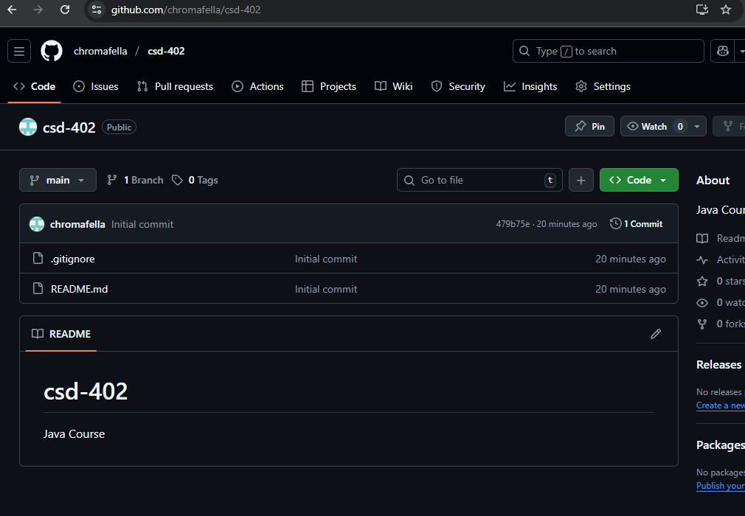
Screenshot of local directory: 