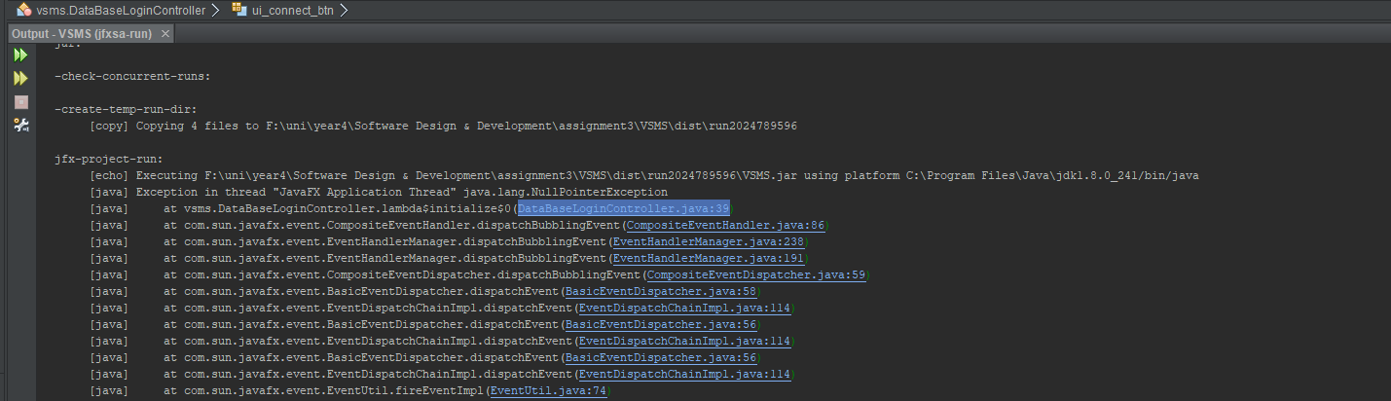

Error when creating the data base connection object. Had to add @FXML before every ui binding cannot group them under one @FXML

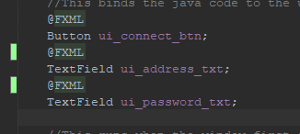

Test Search for customer

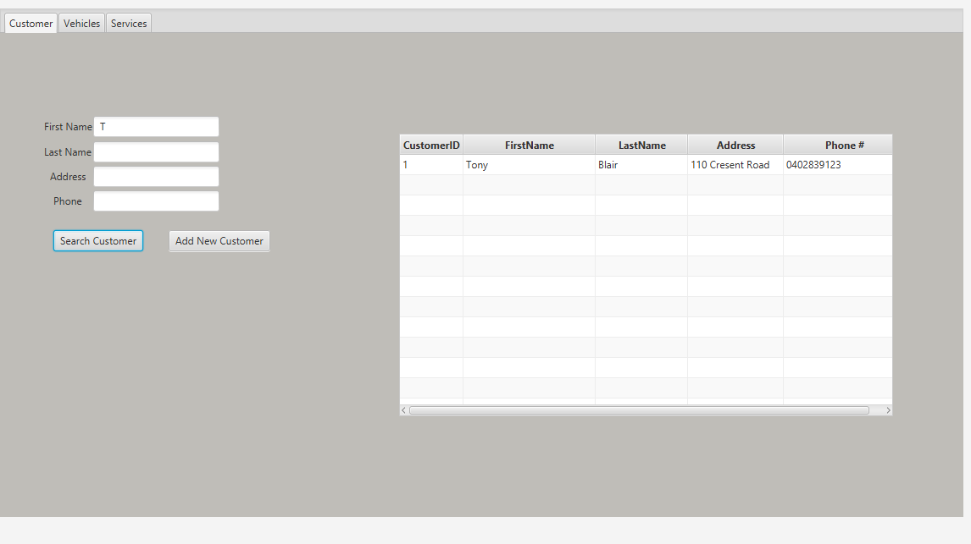

If no customer found

