Environment Setup Guide (EO2)

1. Install Node.js (version 18+ LTS): **https://nodejs.org/en**

2. Verify npm installation by running: **npm --version**

3. Install yarn by running: **npm install yarn --global**

4. Verify yarn installation by running: **yarn --version**

5. Install project dependencies by running: **yarn global add expo expo-cli**

6. Download Android Studio from: **https://developer.android.com/studio**

7. Install Java JDK (version 15+ LTS) from: **https://www.oracle.com/in/java/technologies/downloads/**

8. In Android Studio, download the required SDKs including ADB tools, Platform Tools, and Command Line Tools. React Native recommends API level 29.

9. After successful SDK installation, set the system environment variables:

ANDROID_HOME= C:\Users\Unique\AppData\Local\Android\Sdk

JAVA_HOME= C:\Program Files\Java\jdk-15

Add to Path: C:\Users\Unique\Downloads\platform-tools-latest-windows\platform-tools

10. After setting everything up, open the terminal and navigate to the EO2 root directory, then run:

yarn install

Next, go to EyeOrderMobile directory and run:

yarn install

Finally, go to packages/BillandReplace and run:

yarn dev:emulator

This will run the BillandReplace app using the Expo emulator.

11. Ensure you have the following installed based on your operating system:

* **Windows/Mac**: Docker Desktop
* **Linux**: Docker and Docker Compose

**EyeOrder 2 Local Setup Documentation**

**Setup Instructions**

1. **Navigate to the Root Directory** Open your terminal and go to the root directory of the EyeOrder 2 (EO2) project.
2. **Run Docker Compose** Execute the following command to set up the environment:

***yarn run docker***

Wait a few minutes as Docker Compose creates the necessary containers:

* + EO2-Core-API server container
  + Nginx reverse-proxy container
  + IDP/SAML container
  + PostgreSQL database container

• **Access the SAML Login** Once all containers are running, go to your web browser and enter:

[***http://localhost:5010***](http://localhost:5010)

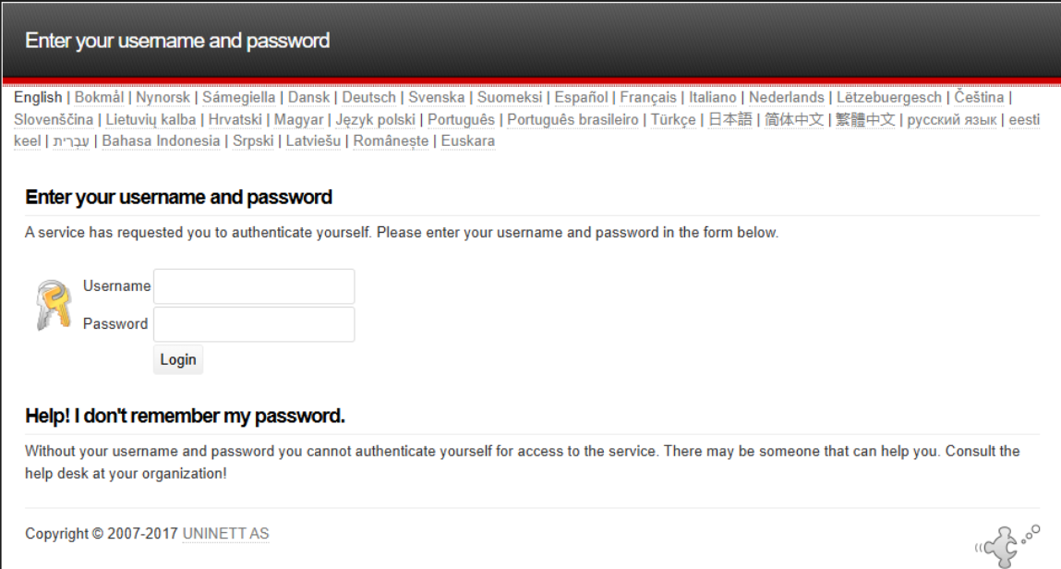

Log in with the following credentials:

* **Username**: admin
* **Password**: secret

Upon successful login, you will be redirected to the EyeOrder server's Admin Dashboard, which is the core of the application.

• **Enable Local/Emulator Functionality** To ensure the server functions fully on local machines and real-time devices, follow these steps:

* **Extract the Port-Forwarding Script** Extract the provided zip file containing the port-forwarding script.
* **Update Environment File** Open the .env file and replace the IP address with your current PC's IP address where the containers are running.
* **Start the Port-Forwarding Script (eo2-proxy)** Run the command:

***npm start***

Congratulations! Your port-forwarding script is now active. You can use this URL to set the following environment variables:

* + For the **Bill and Replace** Android app: set DEV_URL
  + For the **Cycle Count** iOS app: set DEV_URL

• **Launch the Bill and Replace App** Start the Bill and Replace app in Expo Go mode. You should see the app functioning with all screens, just like in production.

**The (eo2-proxy) port-forwarding script written in Node.js is crucial for redirecting emulator requests to the server API. It is mandatory to run this script on your local machine.**

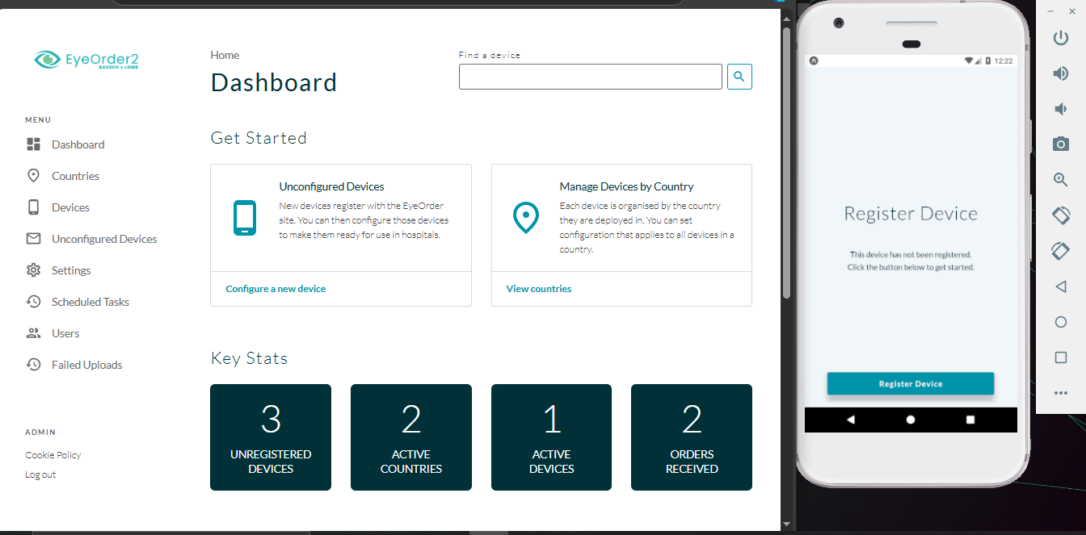

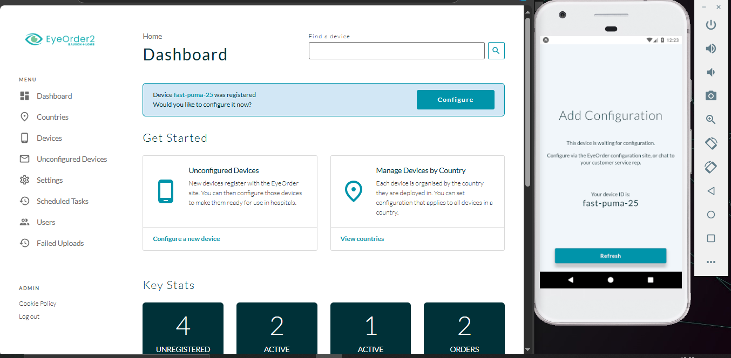

Once Every thing is done. Inorder to remove the containers from the root dir >> cd eyeOrderCore  
type the cmd: ***docker-compose down***  
And to turn off the running emulators gracefully just press the ***ctrl+c*** in the current front end shell.