

**Lodash is a JavaScript library that works on the top of underscore.js. It helps in working with arrays, strings, objects, numbers, etc. It provides us with various inbuilt functions and uses a functional programming approach which that coding in JavaScript easier to understand because instead of writing repetitive functions, tasks can be accomplished with a single line of code. It also makes it easier to work with objects in JavaScript if they require a lot of manipulation to be done upon them.**

Using CDN Link

We can directly use the file in the browser. Go to the official documentation and copy the lodash.min.js file CDN link and paste this link inside the head section.

<script type=”text/JavaScript” src = “https://cdn.jsdelivr.net/npm/lodash@4.17.20/lodash.min.js”></script>

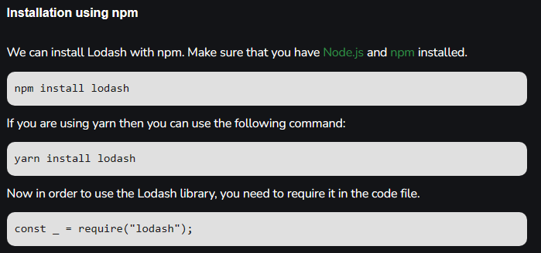

### Lodash Array Methods

Lodash _.chunk() function is used to break the array into small chunks. Each chunk is an array of sizes as given.

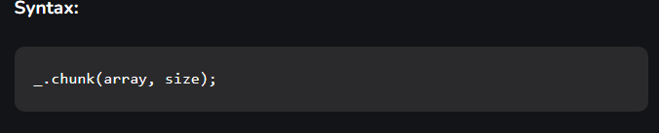

## // Requiring the lodash module

## // in the script

## const _ = require("lodash");

## let arr = [1, 2, 3, 4, 5, 6];

## // Making chunks of size 1

## console.log(_.chunk(arr, 1))



### Lodash _.fill() Method

Lodash _.fill() method is used to fill a set of values into the array in a given range.

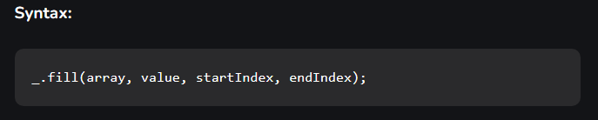

// Requiring the lodash library

let _ = require("lodash");

// Original array

let array = [2, 2, 3, 4, 5, 6]

// Printing original array

console.log("Before : ", array)

// Using fill() method to replace

// values in range (0, 4]

_.fill(array, 10, 0, 4)

// Printing original array again

console.log("After : ", array)

