OptoFidelity Touch And Test

TPPT Analysis Software

User Guide
Version 2.1

Contents
1 Introduction 6
1.1 Requirements 6
2 Installation 6
2.1 Hardware installation 6
2.2 Software installation 6
3 Starting and stopping the system 6
3.1 Starting the system 6
3.2 Stopping the system 8
4 Using the system 8
4.1 Main view 8
4.1.1 Most recent test sessions 9
4.1.2 Hierarchical view of test sessions 9
4.2 Settings view 9
4.3 Recalculate all 11
4.4 Test session overview 12
4.5 DUT settings view 13
4.6 Test session summary 14
5 Test analysis 15
5.1 Common items in test reports 15
5.2 One Finger Tap Test 16
5.2.1 Settings 16
5.2.2 Report contents 16
5.2.3 Preview images 17
5.3 One Finger Swipe Test 18
5.3.1 Settings 18
5.3.2 Report contents 19
5.3.3 Preview images 19
5.4 One Finger Stationary Jitter Test 20
5.4.1 Settings 20
5.4.2 Report contents 20
5.4.3 Preview images 21
5.5 One Finger Tap Repeatability Test 21
5.5.1 Settings 21
5.5.2 Report contents 21
5.5.3 Preview images 22
5.6 One Finger Stationary Reporting Rate Test 22
5.6.1 Settings 22
5.6.2 Report contents 23
5.6.3 Preview images 23
5.7 One Finger Non-Stationary Reporting Rate Test 23
5.7.1 Settings 24
5.7.2 Report contents 24
5.7.3 Preview images 24
5.8 One Finger Rotate Test 24
5.8.1 Settings 25
5.8.2 Report contents 25
5.8.3 Preview images 25
5.9 Multifinger Tap Test 26
5.9.1 Settings 26
5.9.2 Report contents 26
5.9.3 Preview images 27
5.10 Multifinger Swipe Test 29
5.10.1 Settings 30
5.10.2 Report contents 30
5.10.3 Preview images 30
5.11 Two Finger Separation Test 31
5.11.1 Settings 31
5.11.2 Report contents 32
5.11.3 Preview images 32
5.12 Two Finger Pinch and Zoom Test 34
5.12.1 Settings 34
5.12.2 Report contents 35
5.12.3 Preview images 35
5.13 Two Finger Swipe Test 36
5.13.1 Settings 36
5.13.2 Report contents 36
5.13.3 Preview images 37
5.14 Stylus Activation Force Test 38
5.14.1 Settings 38
5.14.2 Report contents 38
5.14.3 Preview images 39
5.15 Stylus Angled Height Sensing Test 40
5.15.1 Settings 40
5.15.2 Report contents 40
5.15.3 Preview images 41
5.16 Stylus Angled Swipe Test 43
5.16.1 Settings 43
5.16.2 Report contents 44
5.16.3 Preview images 44
5.17 Stylus Angled Tap Test 45
5.17.1 Settings 45
5.17.2 Report contents 46
5.17.3 Preview images 46
5.18 Stylus Force Swipe Test 47
5.18.1 Settings 47
5.18.2 Report contents 47
5.18.3 Preview images 48
5.19 Stylus Hover Angled Tap Test 49
5.19.1 Settings 49
5.19.2 Report contents 49
5.19.3 Preview images 50
5.20 Stylus Hover Stationary Jitter Test 51
5.20.1 Settings 51
5.20.2 Report contents 51
5.20.3 Preview images 51
5.21 Stylus Pressure Sensing Test 52
5.21.1 Settings 52
5.21.2 Report contents 52
5.21.3 Preview images 53
5.22 Stylus Stationary Jitter Test 54
5.22.1 Settings 54
5.22.2 Report contents 54
5.22.3 Preview images 55
6 Troubleshooting 55
7 Change history 56

Introduction
This Document describes how to use analysis software with OptoFidelity Touch Panel Performance Tester (TPPT). This guide is valid for analysis software version x.x.x.

Requirements
Software and hardware requirements are explained in document SoftwareInstallationGuide.pdf.

Installation

Hardware installation
Running tests on hardware is specified in document TnT_TPPT_Script_UserManual.pdf.

Software installation
Software installation is specified in document TPPT_Installer_User_Guide.pdf.

Starting and stopping the system

Starting the system
To start the analysis software, use shortcut located on desktop or navigate to C:\OptoFidelity\TPPT Analysis\ and click on the icon named Analysis.bat. This opens command line prompt and shows the status of the application and a web browser. The browser will show the main view.
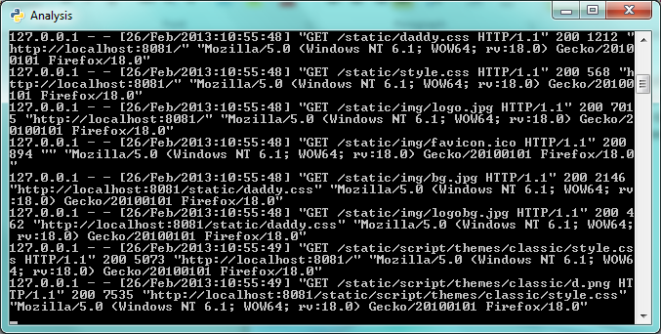
Figure 1 Command prompt window
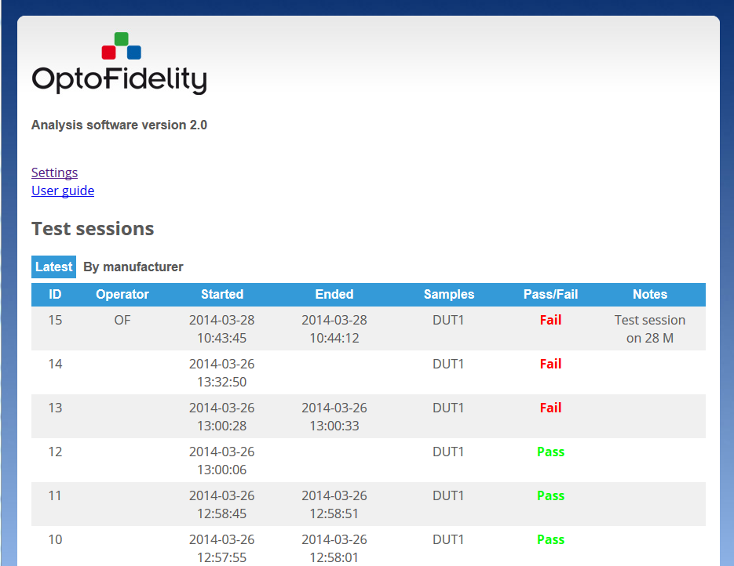
Figure 2 Analysis SW main view

Stopping the system
To stop the system, close command line prompt.
Figure 3 Closing analysis SW

Using the system

Main view
The main view shows the test sessions currently in the database. It has two different views:
- Most recent test sessions
- Hierarchical tree of test sessions
In addition the main view has links to global settings (see 4.2) and recalculate all –button.

Most recent test sessions
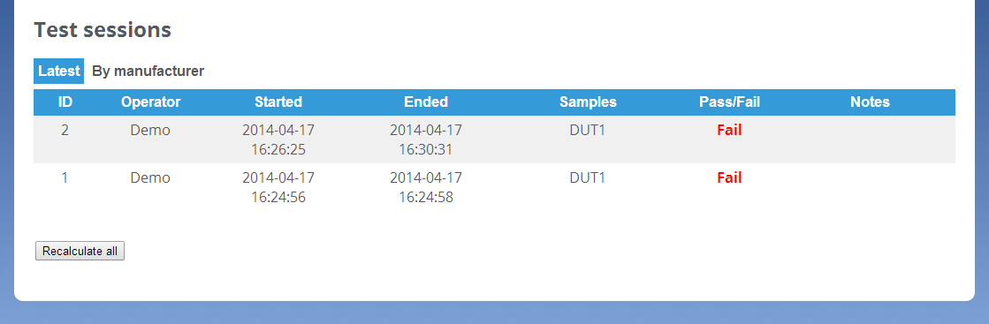
Figure 4 Most recent test sessions
The most recent test sessions view shows at most 10 most recent test sessions.

Hierarchical view of test sessions
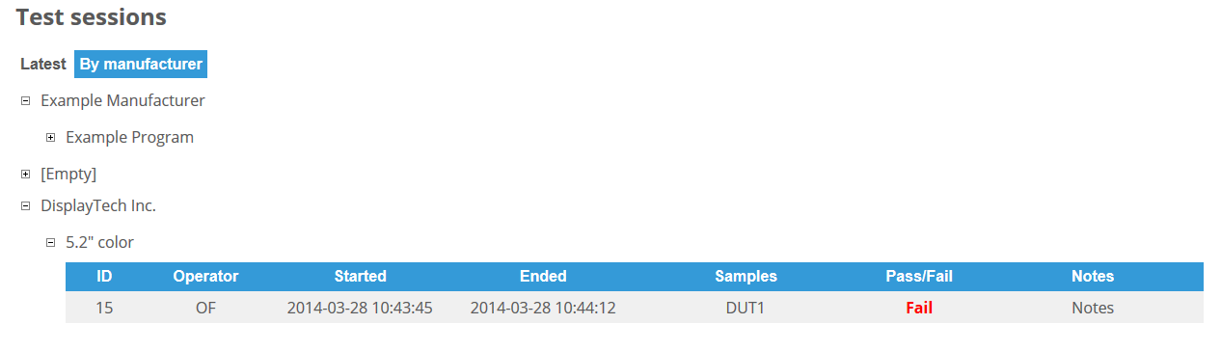
Figure 5 Hierarchical view of test sessions
The hierarchical view shows the test sessions categorized by DUT information: Manufacturer name and Program name. The showing of the contents can be toggled by clicking the manufacturer or program name.
If there’s incorrect information in the tree, like misspelled manufacturer name, that information can be corrected in DUT settings (see chapter 4.5).

Settings view
In the settings view the global acceptance limits of the tests can be changed. Changing a test limit results in re-calculation of all test verdicts.
The settings view can be accessed from the main view under the link ‘Settings’.
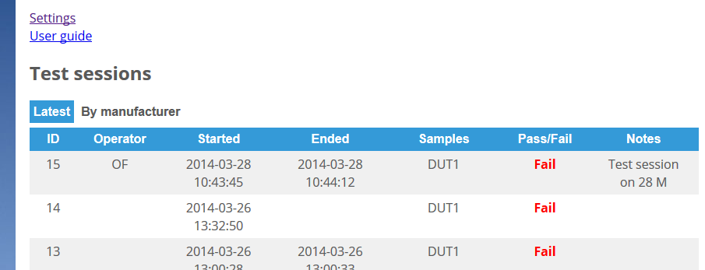
Figure 6: Settings view navigation
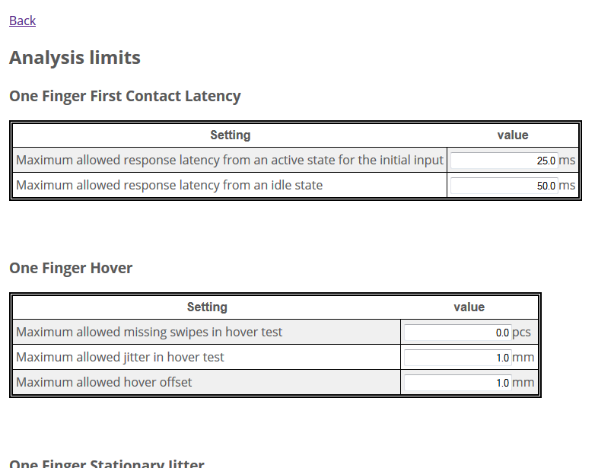
Figure 7 Settings view
The settings are divided to categories based on the tests they are used in. For each setting the description and the value is shown. The value can be changed by typing a new value to the field. Invalid values are marked with red field background.
The save button saves the values to the database. At that time all the analysis results are recalculated, which can be a lengthy operation if there are many measurements in the database.
The descriptions of the individual tests are given in the tests (see chapter 5).
Settings should not be changed when there is a test session running. In the worst case it can introduce errors to the TPPT test run.

Recalculate all
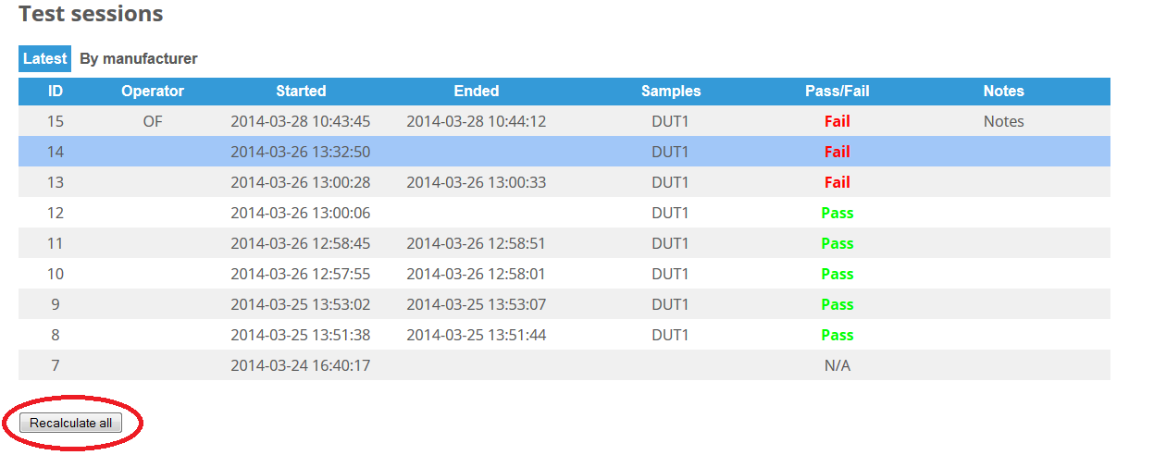
Figure 8: Recalculate all
The recalculate all button recalculates all the analysis results in the database. This can take some time if there are many test sessions in the database.
The recalculate all button can be used in situations where the analysis has been run while the test measurements are still active. In these situations the verdicts of the tests may be invalid. By recalculating all measurements with the current data the consistency of the results can be ensured.
Recalculate all should not be run when there is a test session running. In the worst case it can introduce errors to the TPPT test run.

Test session overview
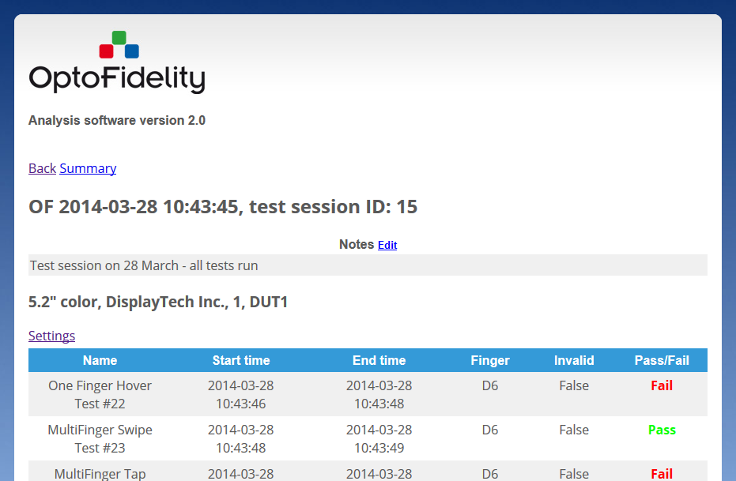
Figure 9: Test session overview
The test session page can be opened by clicking a test session in the main view. The test session view shows the individual test results in a single test run.
If multiple DUT functionality is enabled, the test results are grouped by DUT. Below the DUT information is link to the DUT settings (see 4.5)
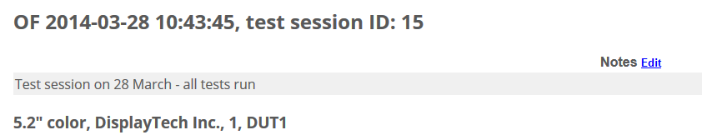
Figure 10: Session notes
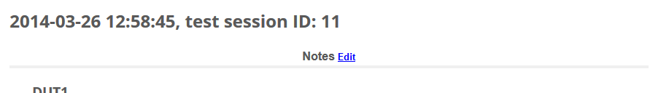
Figure 11: Empty session notes with edit button
At the top of the page the session notes are shown. The first words of the notes are shown also in the main page. The notes can be edited by selecting ‘edit’, after which the notes can be edited in the text field. The edited notes must be saved by selecting ‘save’.

DUT settings view
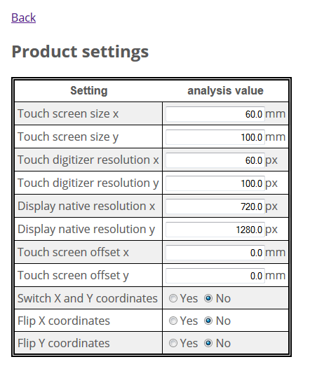
Figure 12 DUT settings view – DUT settings
The DUT settings control the characteristics of the DUT. The settings are separate for each DUT and test session. The different settings are the following:
Touch screen size x: width of the touch screen in millimeters.
Touch screen size y: height of the touch screen in millimeters.
Touch digitizer resolution x: touch digitizer resolution in direction of width of the screen in pixels.
Touch digitizer resolution y: touch digitizer resolution in direction of height of the screen in pixels.
Display native resolution x: display native resolution in direction of width of the screen in pixels.
Display native resolution y: display native resolution in direction of height of the screen in pixels.
Touch screen offset x: Offset of the actual panel top left from the taught top left corner of the panel in millimeters.
Touch screen offset x: Offset of the actual panel top left from the taught top left corner of the panel in millimeters.
Switch X and Y coordinates: If selected, the X and Y coordinates are exchanged. Switch X and Y-coordinates switch is used before Flip X and Y settings.
Flip X coordinates: Normally the positive X coordinate direction is right. If Flip X coordinates is selected, the direction is reversed (positive direction to left).
Flip Y coordinates: Normally the positive Y coordinate direction is down. If Flip Y coordinates is selected, the direction is reversed (positive direction up).
The Flip X, Flip Y, and Switch X and Y coordinates can be used to adjust to screen rotation. For example, if a typical display is rotated 90° clockwise (positive X direction down, positive Y direction left), this can be adjusted by selecting Switch X and Y coordinates (positive Y direction down, positive X direction left) and Flip X coordinates (positive X direction right).
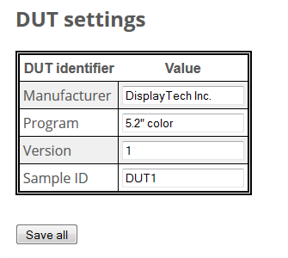
Figure 13 DUT settings view – DUT properties and save button
Below the test session related DUT settings are the DUT properties: Manufacturer name, program name, version, and Sample ID.
All the settings are saved by pressing “Save all”. After the settings have been changed, the measurements in the test session are re-calculated to accommodate new settings.

Test session summary
Summary page lists all results of tests run in test session. Test session overview is in the top of the page. From each test item the general test results are shown. In order to view the detailed results, use the individual test reports.

Test analysis

Common items in test reports
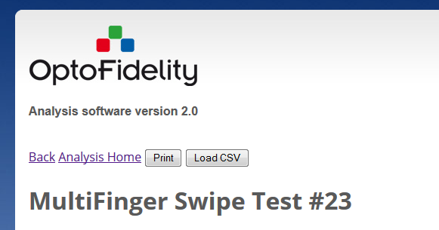
Figure 14: Common items
At the top of the test report page are the functions common to all test reports:
Back: Return to test session view.
Analysis Home: Return to main page
Print: Print the test report.
Load CSV: Load the test item raw data as a CSV file.
Note: use the print button in the test page rather than the browser’s print function. The print button is disables when all the images in the report are not yet loaded.
When detailed plots (pictures) are shown in test reports, they can be toggled by the toggle buttons:
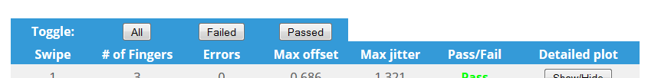
Figure 15: Toggle buttons
All: Toggles the state of all detailed plots.
Failed: Toggles the state of failed plots
Passed: Toggles the state of passed plots
If some of the plots are manually opened and then toggle button is pressed, the plots are all either opened or closed, depending on the state of the detailed plots. The desired state can be achieved with at most two presses of the toggle button.

One Finger Tap Test
One Finger Tap Test report shows the results of the tap test. The tap test is used to measure the tap accuracy performance of the DUT.

Settings
The settings (see 4.2 Settings view) related to the one finger tap test are:
Maximum allowed positional error: The distance from the point that the robot presses to the coordinates reported by the DUT.
Maximum allowed missing inputs: The maximum allowed amount of missing inputs in the test.
Edge area distance from edge in Tap test: The edge area width. The edge area can have different thresholds than rest of the DUT. If this setting is positive (larger than 0), the edge area analysis is enabled and the two following settings are in use:
Maximum allowed positional error in edge area: The maximum allowed positional error if the point that the robot presses resides in the edge area.
Maximum allowed missing edge inputs: The maximum allowed amount of missing inputs in the edge area in addition to the global value. Thus, if the global value is 1 and missing edge inputs value is 2, there can be at most 3 missing inputs in the edge area if none are missing in other parts of the DUT.

Report contents
The detailed results are:
Max accuracy error: Maximum accuracy error. If edge area analysis is enabled, this is reported for both the edge area and for the rest of the display (center).
Missing inputs: Missing inputs in the test. If edge area analysis is in use, this is reported separately for the edge area and for the rest of the display (center).

Preview images
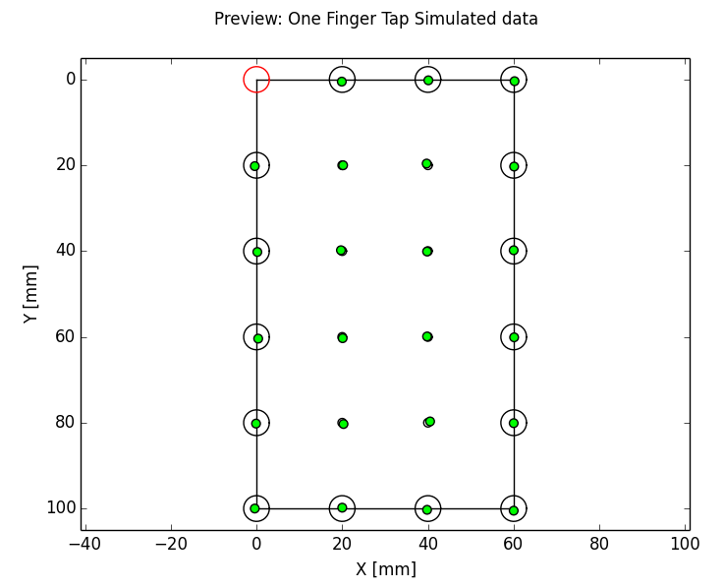
Figure 16: One finger tap preview
The first preview image shows the overview of the DUT. Circles represent the robot points and the size of the circle is the size of the allowed area given by accuracy error. If the input is missing, the circle is drawn red. If the input is outside the allowed area, the position of the input is shown with red marker, otherwise a green marker is used.
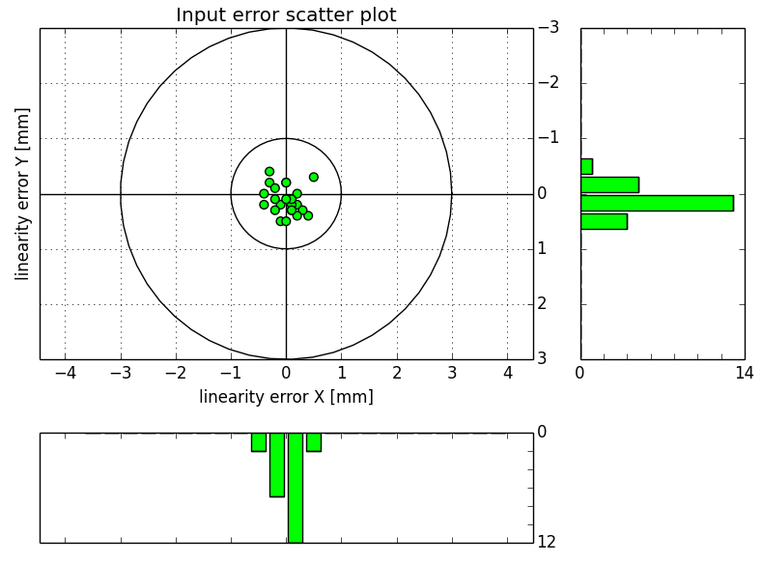
Figure 17: One finger tap scatter plot
The second image gives the scatter plot. It plots all the measurements in relation with the point that the robot has pressed (reference point). In the image the distribution of the tap error can be observed. The histograms on the sides show the distribution of the points on the axes. The unit in the histogram is one measured event, and the cumulative amount of events in each bar can be read from the scale of the respective histogram. If edge analysis is conducted, two acceptance circles are shown (see above).
The last image(s) give the same scatter information with limited display area. This is useful if there are erroneous measurements that are far from the reference point. With limited display area the points near the reference point can be viewed in more detail. If edge analysis is enabled,
All the preview images can be viewed in higher resolution by clicking the preview image.

One Finger Swipe Test
The one finger swipe test report shows the results of the swipe test. The swipe test is used to measure the accuracy of the DUT, when the touch is in linear motion.

Settings
Robot swipe
Offset
Jitter

Figure 18: Swipe parameters
The settings related to the one finger swipe test are:
Maximum allowed offset: The maximum allowed offset of swipe point perpendicular to the line that the robot has swiped (see Figure 18 above).
Maximum allowed jitter: Maximum allowed jitter in a swipe. Jitter is the peak-to-peak maximum movement perpendicular to the swipe line (see Figure 18 above).
Jitter search mask: The distance (or window) along the swipe line in which the jitter is calculated.
Maximum amount of missing swipes: A swipe is missing if no points are reported for a single swipe. If the number of missing swipes is more than the maximum amount, the test has failed.

Report contents
The report shows the maximum offset measured in the test, maximum jitter and the amount of missing swipes.
The second table shows the offset and jitter values for each swipe. The pass/fail value for the swipe is determined by the offset and jitter values. If no measurement values for a swipe are available the offset and jitter values are ‘N/A’. If there is only one measurement value, the jitter value is ‘N/A’, as jitter calculation requires at least two measurement values.

Preview images
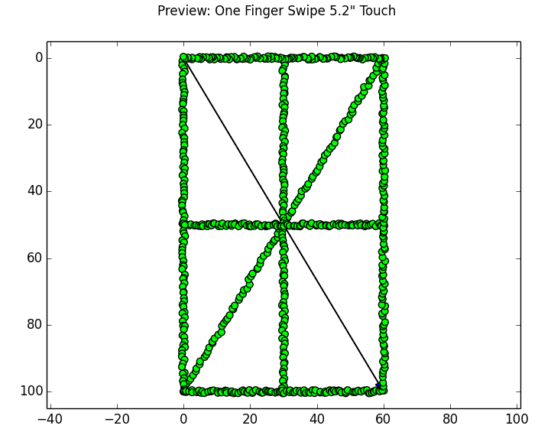
Figure 19: Main swipe test preview image
The main preview image shows the swipes and the measured points. The swipes are shown with gray arrows. The measured points are colored green or red based on their offset values – the values exceeding the offer are colored red. If maximum allowed jitter is exceeded, it is not shown on the preview image. A higher resolution version of the image is available by clicking the preview image on the report.
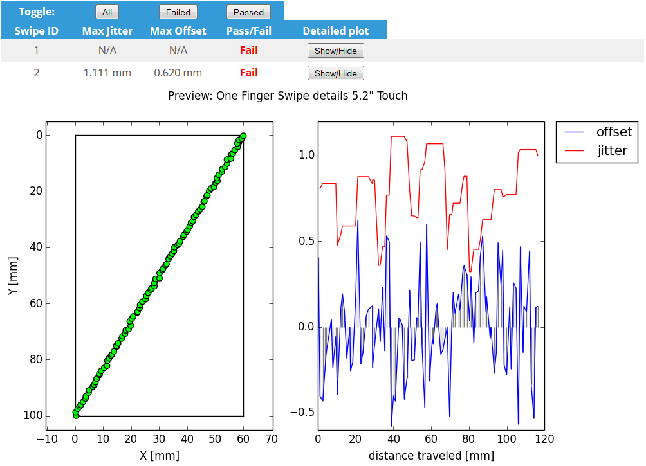
Figure 20: Swipe details
The individual swipe plot images show the measured swipe points on the left and the detailed analysis of the swipe on the right. The detailed analysis shows the offset for each point (blue) and the calculated jitter (red). The x-axis is measured along the robot swipe line. Vertical lines (gray) show the location of the measurement point in the X axis.

One Finger Stationary Jitter Test
One finger stationary jitter report reports the results of the stationary jitter test. It is used to test the performance of the DUT when a single point is pressed and hold. Optimally the DUT should report a single coordinate consistently.

Settings
The one finger stationary jitter test has the following settings:
Maximum allowed stationary jitter: The maximum amount of jitter allowed for a single point.

Report contents
The stationary jitter reports the maximum measured stationary jitter in the test. In addition, the results for individual points pressed are measured.
The jitter is calculated from the first coordinate reported by the DUT. The jitter for each successive measurement value is the distance from the first reported point. The jitter reported for an individual tap is the maximum of jitters for individual points.

Preview images
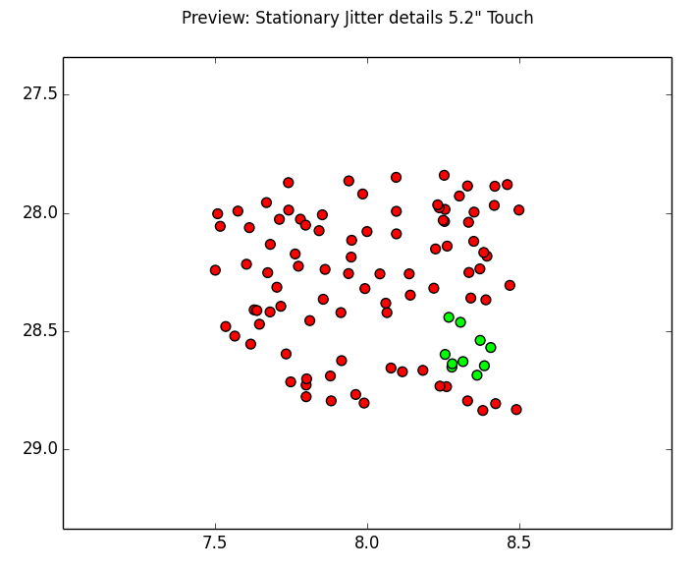
Figure 21: Stationary jitter details
The main preview image shows the different points measured related to the DUT. Passed points (jitter value not exceeding threshold) are marked green, failed points are marked with red color. Note that the passed points are determined by the first input from the panel – the analysis does not take robot touch point into account when determining the pass/failure limits.

One Finger Tap Repeatability Test
The one finger tap repeatability report shows the results of the repeatability test. The tap repeatability test is used to measure the panel’s ability to report consistent coordinates when the same location of the panel is pressed repeatedly with the robot.

Settings
The settings related to the tap repeatability test are:
Maximum tap repeatability error: The maximum distance of the reported points either in x- or y-direction.

Report contents
The report shows the maximum repeatability errors in both x- and y-directions. The maximum errors reported may be from different measurement points. Individual measurement points are reported in a table with respective errors in x- and y-directions.

Preview images
The main preview image shows the passed and failed points located in the DUT. The point is passed if errors in both the x- and y-directions are less than equal to the maximum repeatability error.
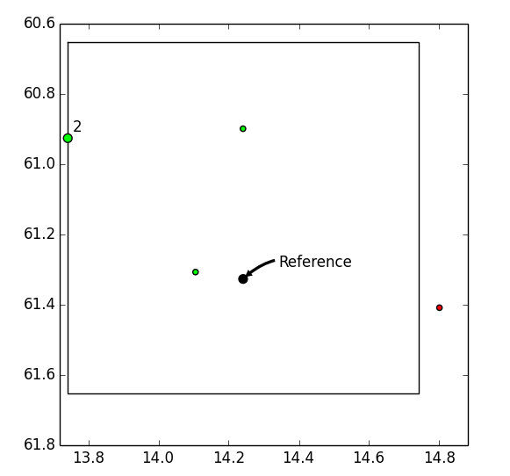
Figure 22: One finger tap repeatability details
The detailed images show the location of the taps. The reference point shows the location that the robot has tapped. The inner box in the image shows the acceptance area of the measurements. The measurements outside the acceptance area are marked failed with red color.
Note: the acceptance area is not an absolute definition, it is estimated from the measurement values. The pass/fail value is absolute, as it is calculated from peak-to-peak values of the measurements in both x- and y-directions.

One Finger Stationary Reporting Rate Test
The one finger stationary reporting rate test reports the results of the stationary reporting rate test. It measures the reporting frequency of the DUT.
Note: This test is platform-specific. Some platforms, like Android, do not report tap events if the tap is stationary. In those platforms the stationary reporting rate test is not applicable.

Settings
The settings related to the stationary reporting rate test are:
Minimum allowed reporting rate: The minimum reporting rate that is allowed. Measured in Herz (Hz).

Report contents
The report contains the minimum measured reporting rate for the test. The reporting rate is calculated from time intervals between reported coordinates from DUT.
The detailed table shows the measured minimum and maximum reporting rate for each measured point.

Preview images
The main preview image shows the measured points on the DUT, and marks the point passed (green) or failed (red) based on the minimum reporting rate for that specific point.
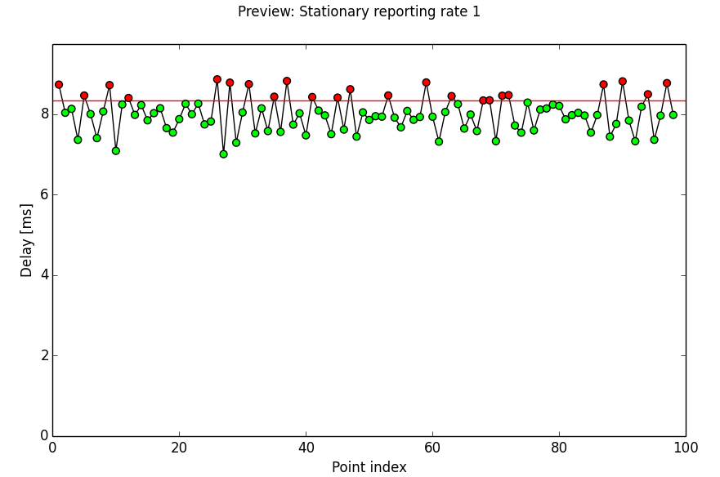
Figure 23: tap stationary reporting rate details
The detailed image shows the reporting rate for an individual tap. The X axis is the DUT event index, and the Y axis shows the delay from the previous event. The red line (if visible) shows the acceptance limit. Delays above the acceptance limit are considered failed. Note: the acceptance limit is the reciprocal of the minimum allowed reporting rate.

One Finger Non-Stationary Reporting Rate Test
The One finger non-stationary reporting rate test report shows the results for non-stationary reporting rate test.
Note: the applicability concerns for stationary reporting rate test do not apply for non-stationary reporting rate test.

Settings
The settings related to the stationary reporting rate test are:
Minimum allowed reporting rate: The minimum reporting rate that is allowed. Measured in Herz (Hz).

Report contents
The report contains the minimum measured reporting rate for the test. The reporting rate is calculated from time intervals between reported coordinates from DUT. Additionally the amount of missing lines (missing inputs) is reported.
The detailed table shows the measured minimum and maximum reporting rate for each measured point.

Preview images
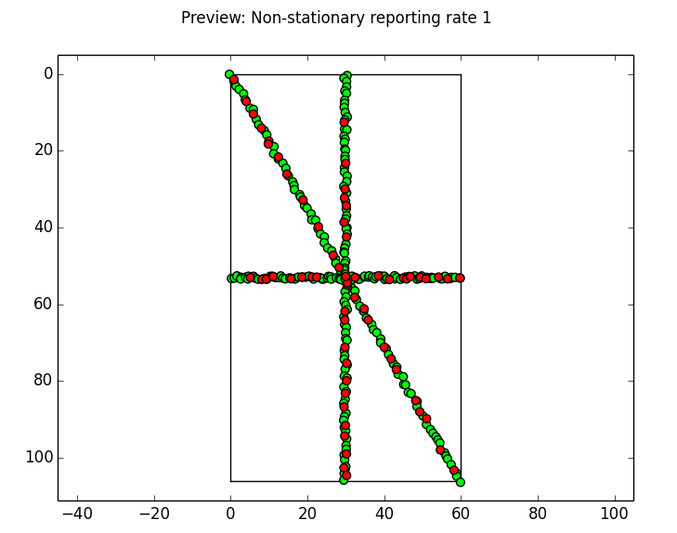
Figure 24: tap stationary reporting rate preview
The main preview image shows the measured points on the DUT, and marks the point passed (green) or failed (red) based on the minimum reporting rate for that specific point. The arrows show the location and direction of robot movement.
The detailed preview image is the same than in stationary reporting rate test (see above)

One Finger Rotate Test
The rotation test shows the results of rotation gestures performed on the DUT. Radius error, offset and jitter error are analyzed based on the measured data.

Settings
Maximum allowed non stationary jitter: Maximum allowed jitter in a swipe. Jitter is the peak-to-peak maximum movement perpendicular to the swipe line (see Figure 18).
Maximum allowed offset: The maximum allowed offset of swipe point perpendicular to the line that the robot has swiped (see Figure 18 above).
Non stationary jitter search mask: The distance (or window) along the swipe line in which the jitter is calculated.

Report contents
The main preview images show the clockwise and counterclockwise rotations and the measured points. The measured points are colored green or red based on their radius error values – the values exceeding the radius error limit are colored red. A higher resolution version of the image is available by clicking the preview image on the report.
The individual rotation plot images show the measured rotation points on the left and the detailed analysis of the rotation the right.

Preview images
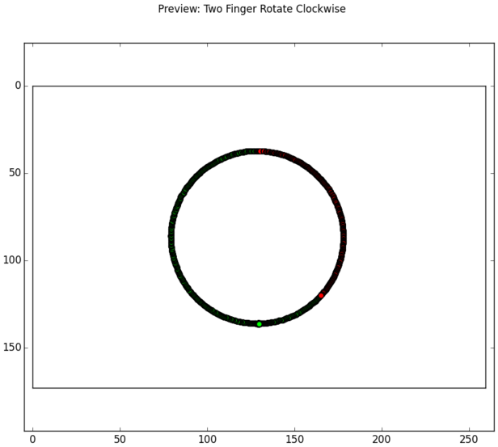
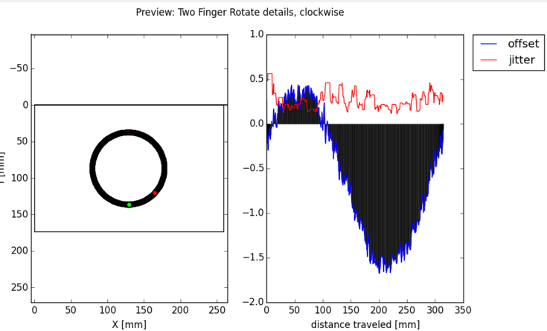

Multifinger Tap Test
Multifinger Tap Test report shows the results of the multifinger tap test. The multifinger tap test is used to measure the tap accuracy performance of the DUT when the DUT is operated with multiple fingers.

Settings
The settings related to the multifinger tap test are:
Maximum allowed positional error: The distance from the point that the robot presses to the coordinates reported by the DUT.
Maximum allowed missing inputs: The maximum allowed amount of missing inputs in the test.
Note: the edge area analysis is not supported in the current version of analysis software.

Report contents
The detailed results are:
Max accuracy error: Maximum accuracy error.
Missing inputs: Missing inputs in the test.
Errors: The errors detected while analyzing the images.
The detailed results table shows the results for individual taps. For each tap the number of fingers, errors, and maximum offset are reported. The individual test fails if the maximum offset is exceeded or there are errors in the test.

Preview images
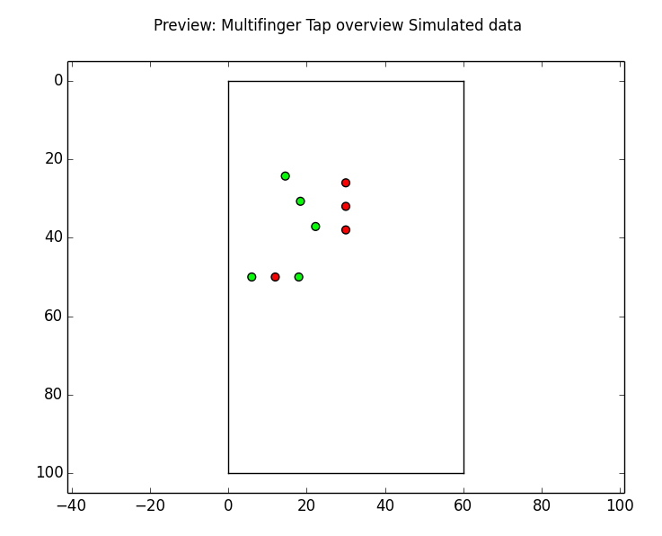
Figure 25: tap stationary reporting rate overview
The overview image shows the passed and failed mesurements on the DUT. Only the location of the first finger is reported. Thus, each point on the DUT corresponds to one tap with multifinger effector.
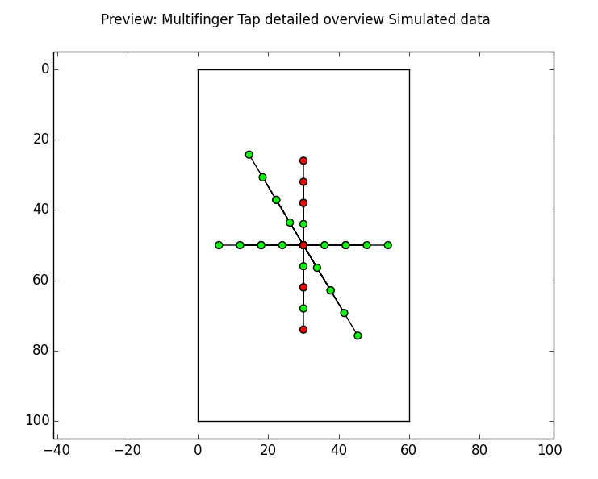
Figure 26: tap stationary reporting rate detailed overview
The detailed overview image is similar to the overview image, but it shows additionally the all the fingers in the multifinger effector connected by a line. If the effector lines overlap, the resulting image may be difficult to interpret (see above). In these cases the detailed locations of the effector can be seen in the detailed images (see below).
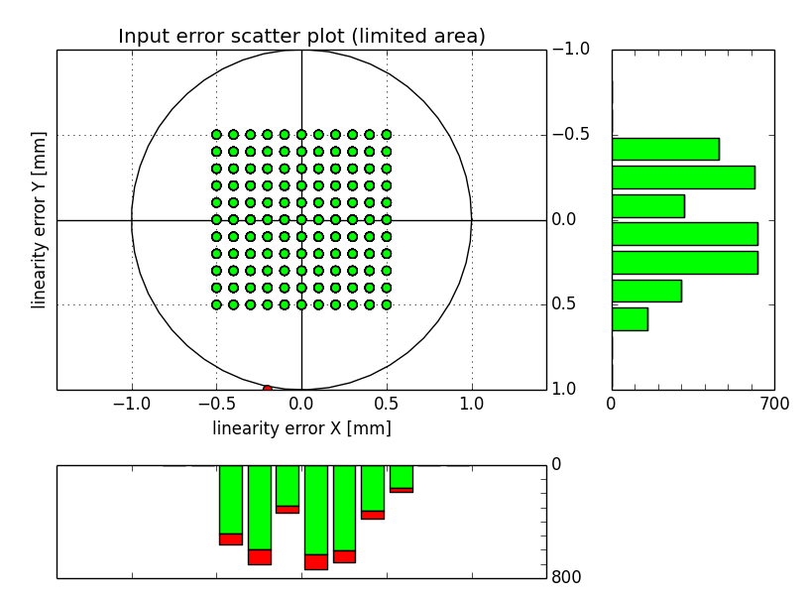
Figure 27: tap stationary reporting rate scatter plot
The scatter plot shows the tap locations for each of the taps and in each of the effector fingers. Only a limited version is shown, as the errors in the tap test quickly render the scatter plot non-usable.
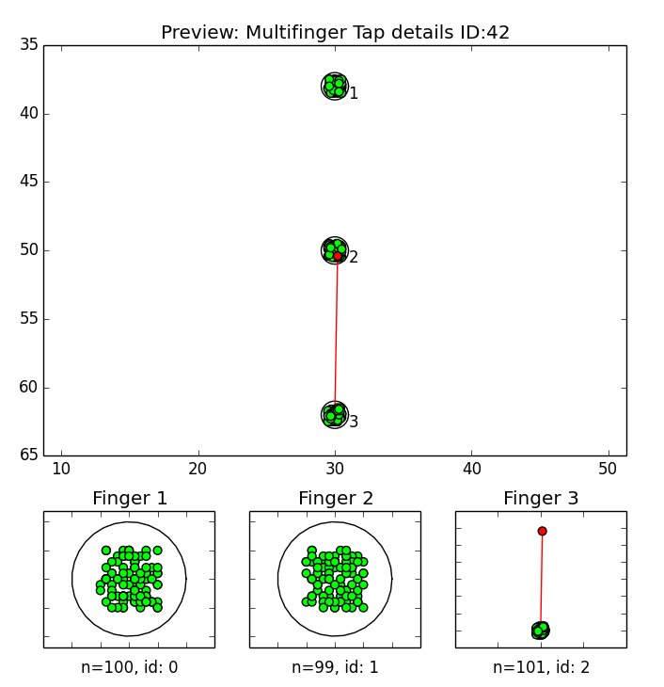
Figure 28: tap details image
The tap details image shows one tap with multifinger effector along with the measured events from the DUT. The upper portion of the image shows the general results of the tap. The circles give the maximum position error related to the effector positions. If a point is failed, a red line connects the point to the effector position (see above).
The small scatter diagrams show the individual finger results of the effector. For each finger, the amount of events is reported (n, e.g. for Finger 1 the amount of events is 100) and the finger id received in the event.
Note: the finger ids can be used to detect errors. Generally the finger ids are distributed randomly between different effector fingers, but there should always be exactly one finger id per effector finger.

Multifinger Swipe Test
The multifinger swipe test report shows the results for the multifinger swipe test that is used to measure the performance of the DUT when it is used with multiple fingers in a swiping motion.

Settings
The settings related to the multifinger swipe test are:
Maximum allowed offset: The maximum allowed offset of swipe point perpendicular to the line that the robot has swiped (see Figure 18 above).
Maximum allowed jitter: Maximum allowed jitter in a swipe. Jitter is the peak-to-peak maximum movement perpendicular to the swipe line (see Figure 18 above).
Jitter search mask: The distance (or window) along the swipe line in which the jitter is calculated.
Maximum amount of missing swipes: A swipe is missing if no points are reported for a single swipe. If the number of missing swipes is more than the maximum amount, the test has failed.
The values are the same than in the one finger swipe test.

Report contents
The first table reports the maximum offset and jitter in any of the swipes and the number of missing swipes. Additionally, the possible errors in the analysis are reported.
The detailed table gives the offset and jitter for each of the individual multifinger swipes.

Preview images
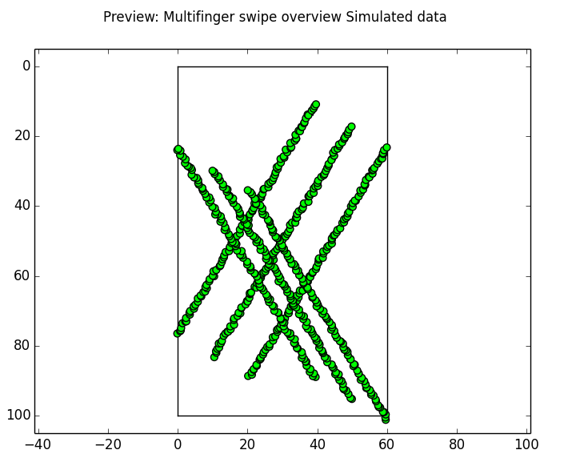
Figure 29: Multifinger swipe overview
The first preview image shows the multifinger swipes on the DUT. All the swipes and all the fingers are plotted. The received events are shown with markers, green (passed) and red (failed) depending on the offset value of the event. The robot swipes are shown with arrows (hidden behind the markers in the example figure above).
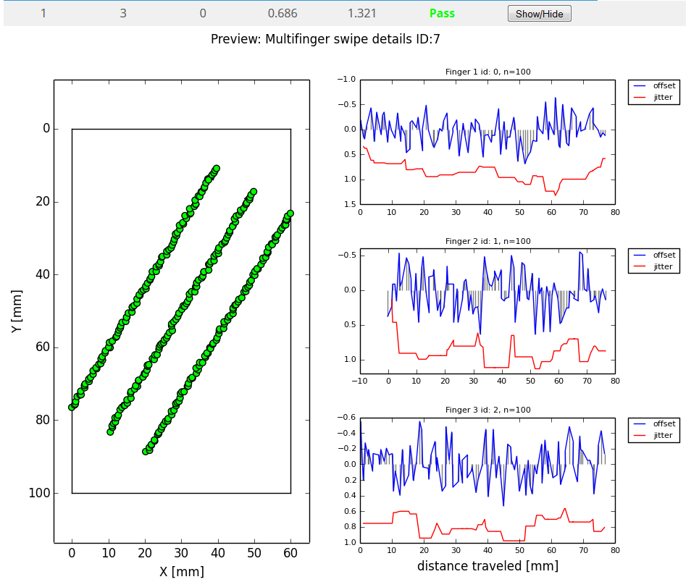
Figure 30: Multifinger swipe overview
The multifinger swipe details image gives the same information than the one finger swipe details image, but each of the fingers are plotted separately. For each of the fingers, the number of measurements and finger id received in the event is plotted.

Two Finger Separation Test
The separation test report shows the results for the separation test that is used to measure the DUTs ability to separate distinct fingers (effectors) based on their distance from each other.

Settings
The settings related to the separation test are:
Maximum allowed finger separation distance (vertical and horizontal): The maximum distance in which the fingers are allowed to be interpreted as one input. If the DUT cannot detect distinct fingers with larger separation distances than the setting, the result is fail. This setting is used for horizontal and vertical finger alignments.
Maximum allowed finger separation distance (diagonal): The maximum distance in which the fingers are allowed to be interpreted as one input in other directions than strictly horizontal or vertical.

Report contents
The first table lists the measured separation distances with the different separation angles. The distance measured is the first distance with which the different fingers are detected as separate fingers and all the successive tests with larger separation distances are also successful.
If the separation distance is larger than the maximum allowed setting for that angle, the measurement is marked as failed.
In the second table, all the different measurements with all angles and separation distances are listed. Individual measurement is marked as passed, if the different fingers could be detected. If an individual test fails with separation distance less or equal to maximum allowed setting, the failed test does not affect the overall result of the test.

Preview images
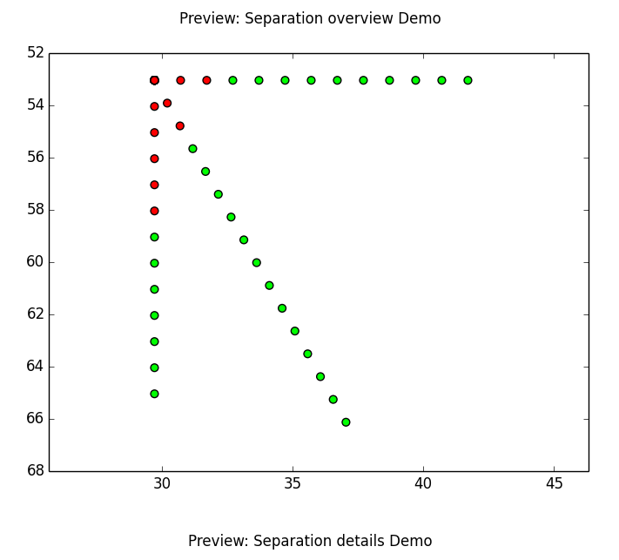
Figure 31: Separation overview
The first preview image of the separation test shows the overall results for the test. It shows the individual robot positions, in which the fingers have been pressed. Each position is marked as passed or failed depending on the individual separation result.
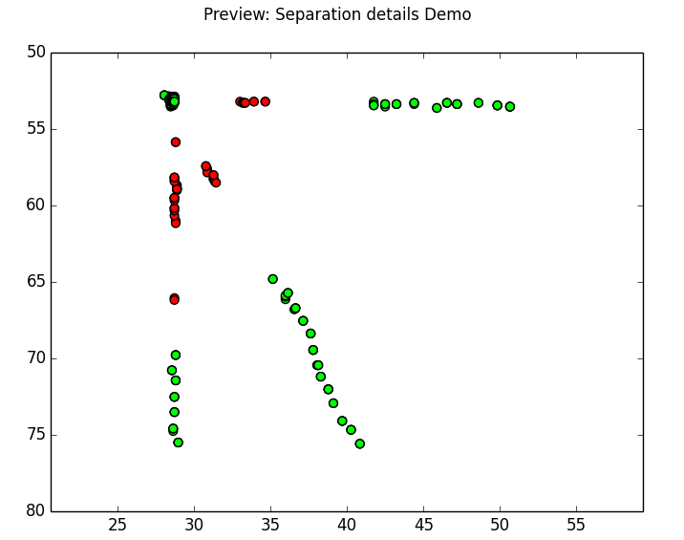
Figure 32: Separation detailed overview
The second figure shows the analysis of the test results based on the actual detected finger events. The event positions detected as separate are marked with green color. The event positions that show only one finger id (fingers are detected as one), are marked with red color.
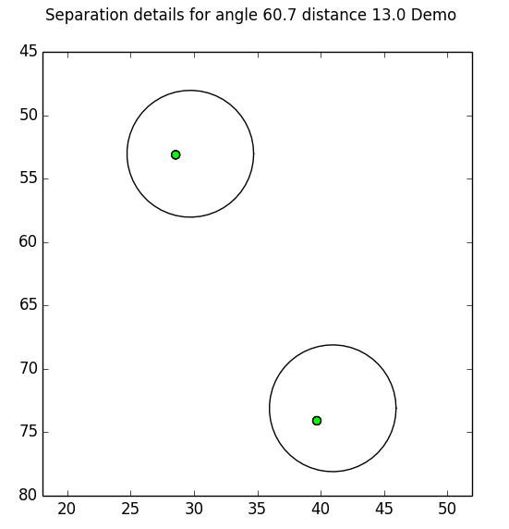
Figure 33: Separation test details
The details figure shows the received events from a single separation test with single angle and separation distance. The events are marked to the picture with red or green markers. The events having the same event id are connected by solid lines. The finger positions of the robot are marked with circles.

Two Finger Pinch and Zoom Test
Two Finger Pinch and Zoom Test report shows the results of the pinch and zoom test. The pinch and zoom test measures the accuracy of DUT when pinch and zoom gestures are used.

Settings
Maximum allowed non stationary jitter: Maximum allowed jitter in a swipe. Jitter is the peak-to-peak maximum movement perpendicular to the swipe line (see Figure 18).
Maximum allowed offset: The maximum allowed offset of swipe point perpendicular to the line that the robot has swiped (see Figure 18 above).
Non stationary jitter search mask: The distance (or window) along the swipe line in which the jitter is calculated.
Maximum allowed missing swipes in swipe test: A swipe is missing if no points are reported for a single swipe. If the number of missing swipes is more than the maximum amount, the test has failed.

Report contents
The report shows the maximum offset measured in the test, maximum jitter and the amount of missing swipes from gestures.

Preview images
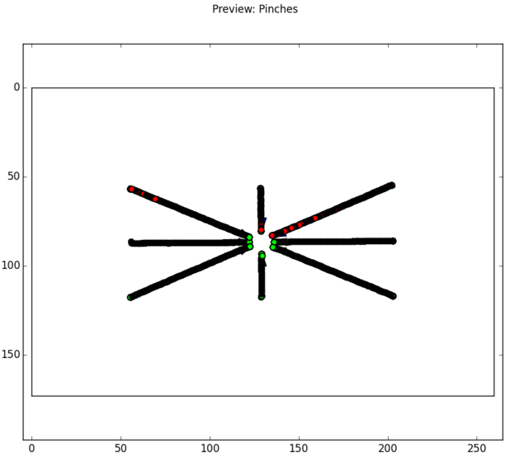
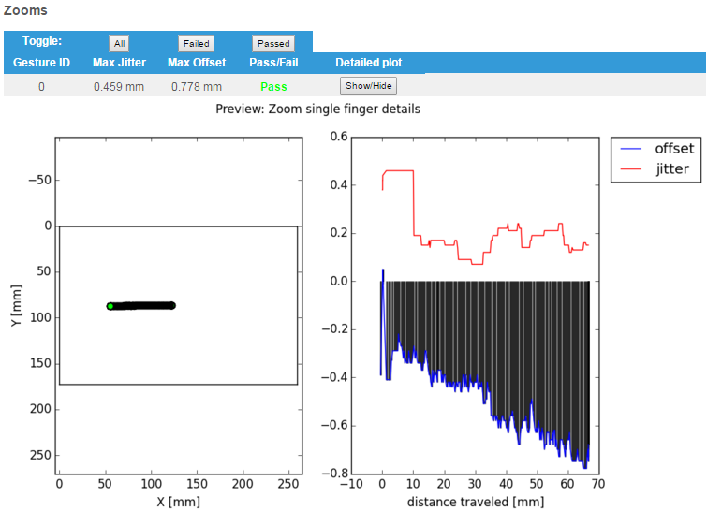

Two Finger Swipe Test
The two finger swipe test report shows the results of the two finger swipe test. The swipe test is used to measure the accuracy of the DUT, when the touch is in linear motion and two fingers are used.

Settings
Maximum allowed non stationary jitter: Maximum allowed jitter in a swipe. Jitter is the peak-to-peak maximum movement perpendicular to the swipe line (see Figure 18).
Maximum allowed offset: The maximum allowed offset of swipe point perpendicular to the line that the robot has swiped (see Figure 18 above).
Non stationary jitter search mask: The distance (or window) along the swipe line in which the jitter is calculated.
Maximum allowed missing swipes in swipe test: A swipe is missing if no points are reported for a single swipe. If the number of missing swipes is more than the maximum amount, the test has failed.

Report contents
The report shows the maximum offset measured in the test, maximum jitter and the amount of missing swipes.
The second table shows the offset and jitter values for each swipe. The pass/fail value for the swipe is determined by the offset and jitter values. If no measurement values for a swipe are available the offset and jitter values are ‘N/A’. If there is only one measurement value, the jitter value is ‘N/A’, as jitter calculation requires at least two measurement values.

Preview images
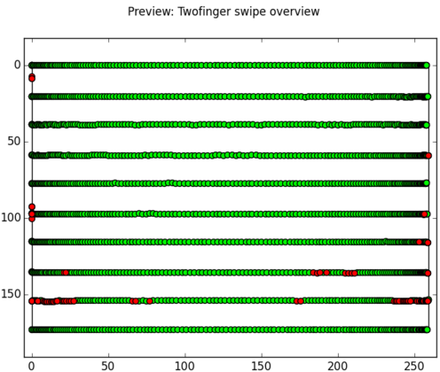

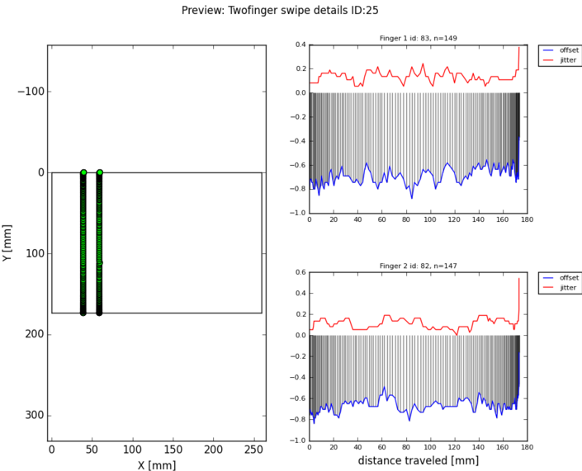

Stylus Activation Force Test
Stylus activation force test report shows the results of the activation force test. The activation force test is used to measure the force threshold for DUT to report sensitivity values. Force is increased step by step until threshold value is reached and DUT reports sensitivity value.

Settings
Target activation force: Activation force target value.
Max activation force error: Maximum allowed activation force error. If highest measured pressure value is within this value distance from the target value, test returns pass, otherwise fail.

Report contents
Test report shows lowest force values on which the panel starts to report sensitivity information. Activation force values are maximum overshoot values from force adjustment reported by force controller.

Preview images
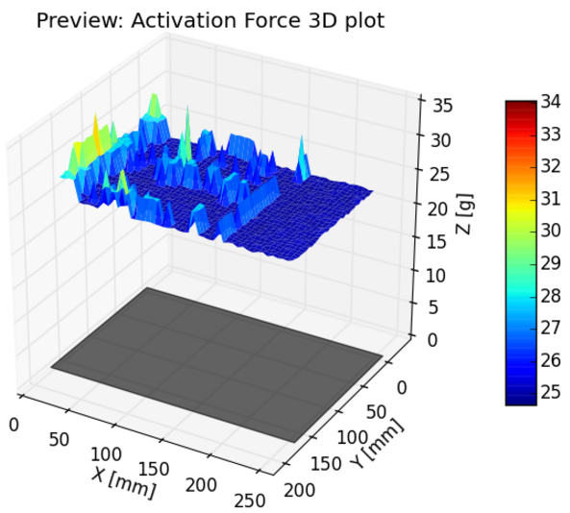
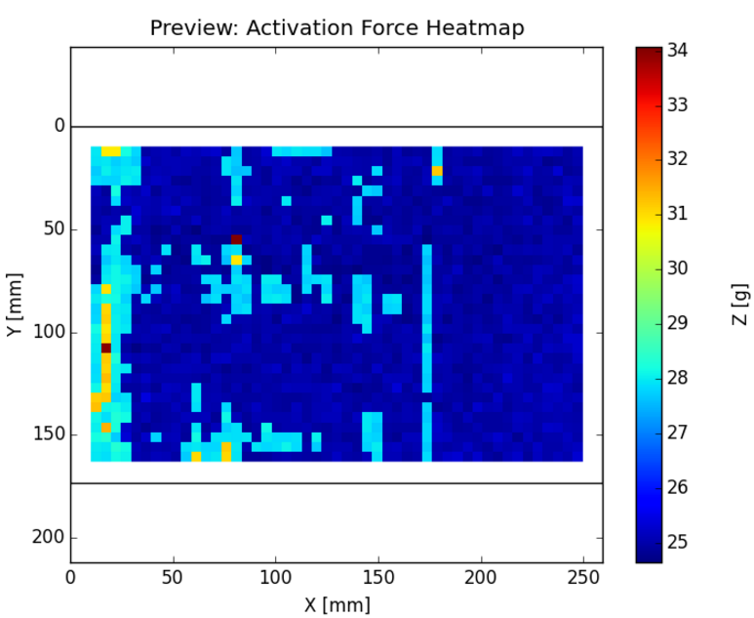
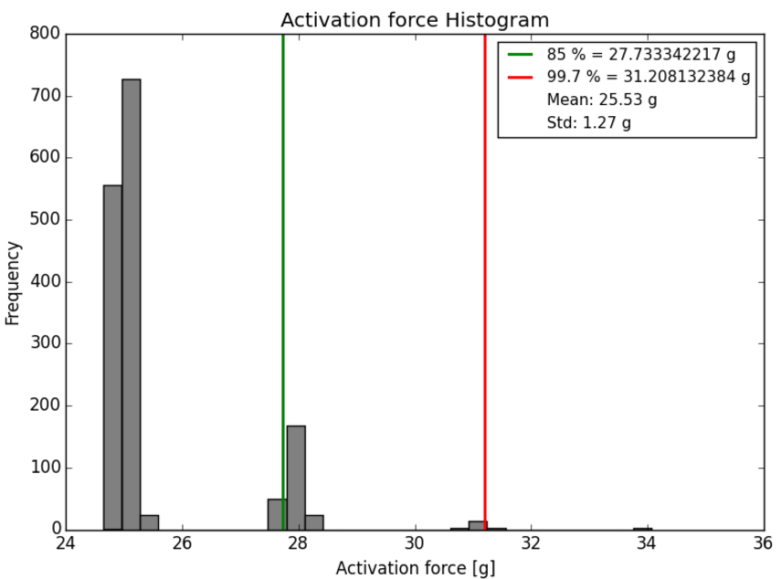

Stylus Angled Height Sensing Test
Stylus angled height sensing test report shows the results of the height sensing test. The height sensing test is used to measure the hover range of the DUT. In this test stylus is lowered step by step until it reaches DUT’s hover range.

Settings
Maximum allowed tilt angle error: Maximum allowed error from tilt angle reported by DUT when compared to tilt angle reported by robot.
Maximum allowed orientation angle error: Maximum allowed error from tilt angle reported by DUT when compared to tilt angle reported by robot.
Minimum allowed height for height sensing: Minimum allowed height for detecting stylus hover. If value is above this level, verdict will be pass, otherwise fail.
Maximum allowed accuracy error: Maximum allowed accuracy error.
Maximum allowed missing inputs: The maximum allowed amount of missing inputs in the test.

Report contents
The report consists of accuracy measurement and height sensing figures.

Preview images
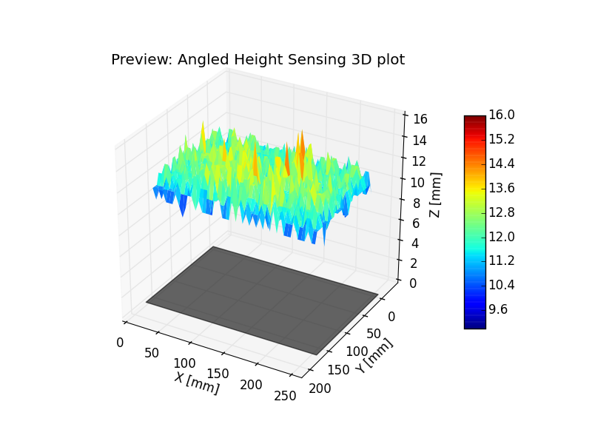

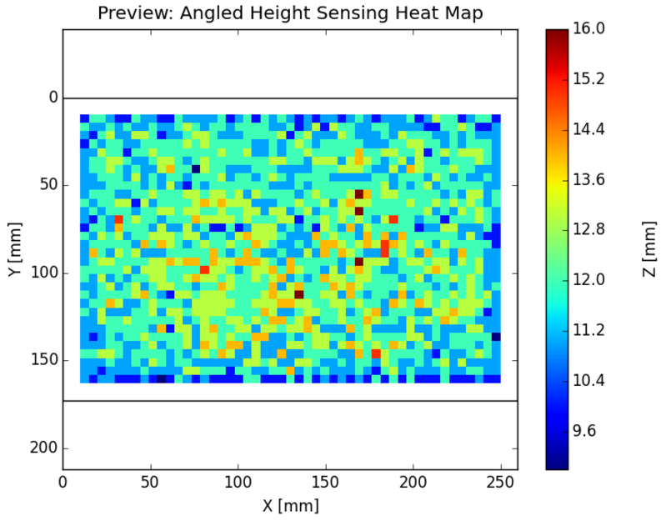
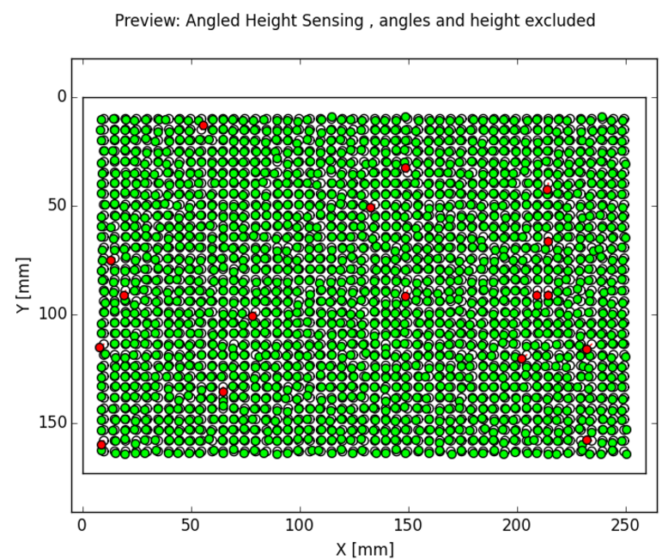
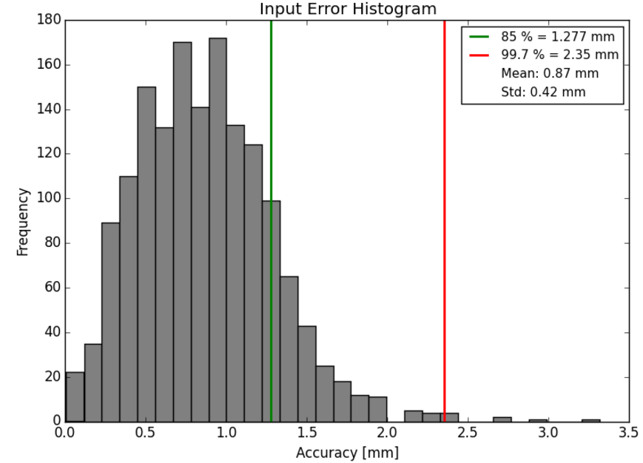
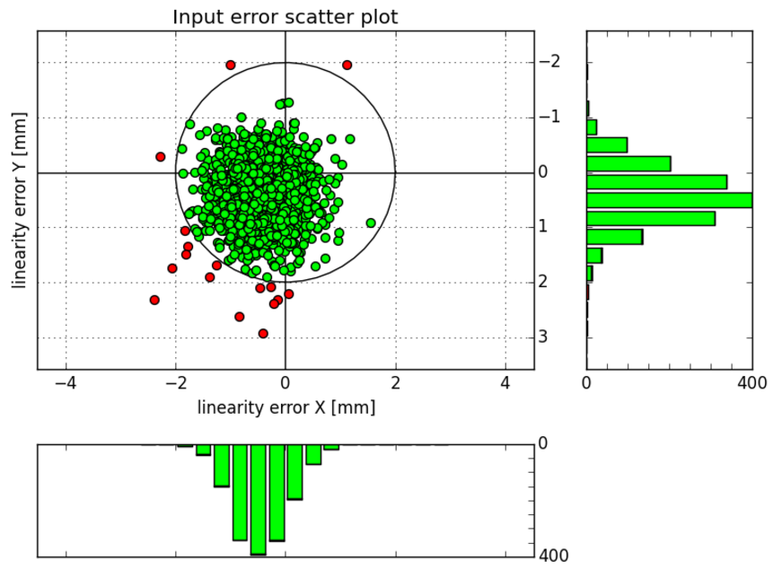

Stylus Angled Swipe Test
Stylus angled swipe test report shows the results of the stylus swipe test. Stylus swipe test is used to measure the accuracy of the DUT, when the stylus is in linear motion.

Settings
Maximum allowed missing swipes in swipe test: A swipe is missing if no points are reported for a single swipe. If the number of missing swipes is more than the maximum amount, the test has failed.
Maximum allowed non stationary jitter: Maximum allowed jitter in a swipe. Jitter is the peak-to-peak maximum movement perpendicular to the swipe line (see Figure 18).
Maximum allowed offset: The maximum allowed offset of swipe point perpendicular to the line that the robot has swiped (see Figure 18 above).
Non stationary jitter search mask: The distance (or window) along the swipe line in which the jitter is calculated.
Maximum allowed tilt angle error: Maximum allowed error from tilt angle reported by DUT when compared to tilt angle reported by robot.
Maximum allowed orientation angle error: Maximum allowed error from tilt angle reported by DUT when compared to tilt angle reported by robot.

Report contents
The report shows the maximum offset measured in the test, maximum jitter and the amount of missing swipes.
The second table shows the offset and jitter values for each swipe. The pass/fail value for the swipe is determined by the offset and jitter values. If no measurement values for a swipe are available the offset and jitter values are ‘N/A’. If there is only one measurement value, the jitter value is ‘N/A’, as jitter calculation requires at least two measurement values.
The third table shows tilt and orientation offset for each swipe if DUT has reported values.

Preview images
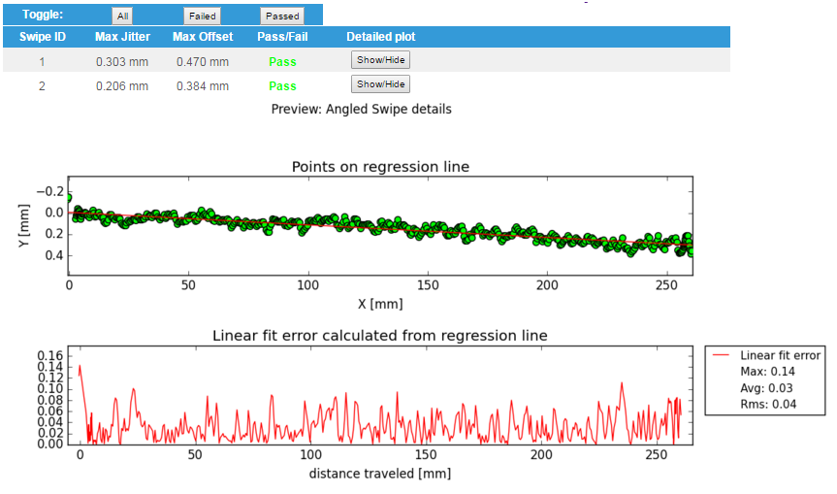
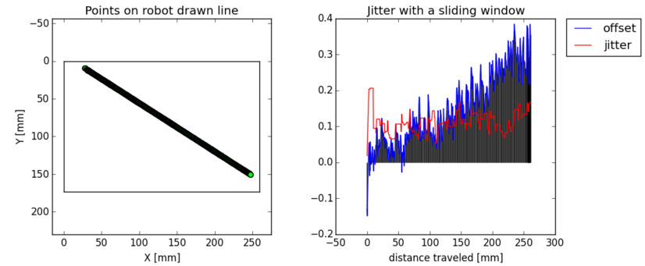
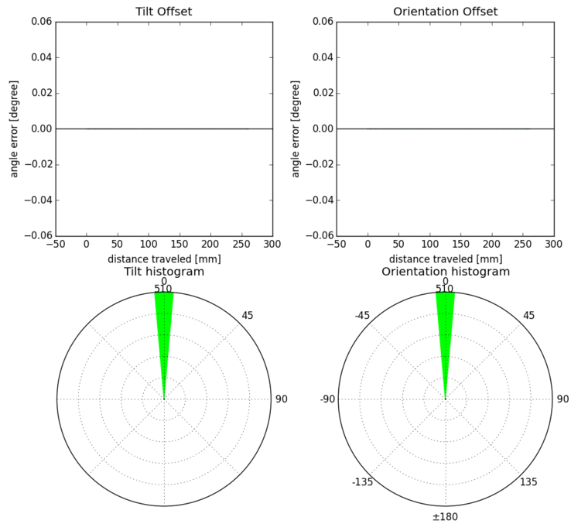

Stylus Angled Tap Test
Stylus Angled Tap Test report shows the results of the stylus tap test. The stylus tap test is used to measure the stylus accuracy performance of the DUT.

Settings
Edge area distance from edge in Tap test: The edge area width. The edge area can have different thresholds than rest of the DUT. If this setting is positive (larger than 0), the edge area analysis is enabled and the two following settings are in use:
Maximum allowed accuracy error in edge area: The maximum allowed positional error if the point that the robot presses resides in the edge area.
Maximum allowed missing edge inputs: The maximum allowed amount of missing inputs in the edge area in addition to the global value. Thus, if the global value is 1 and missing edge inputs value is 2, there can be at most 3 missing inputs in the edge area if none are missing in other parts of the DUT.
Maximum allowed accuracy error: Maximum allowed accuracy error.
Maximum allowed missing inputs: The maximum allowed amount of missing inputs in the test.
Maximum allowed tilt angle error: Maximum allowed error from tilt angle reported by DUT when compared to tilt angle reported by robot.
Maximum allowed orientation angle error: Maximum allowed error from tilt angle reported by DUT when compared to tilt angle reported by robot.

Report contents

Preview images
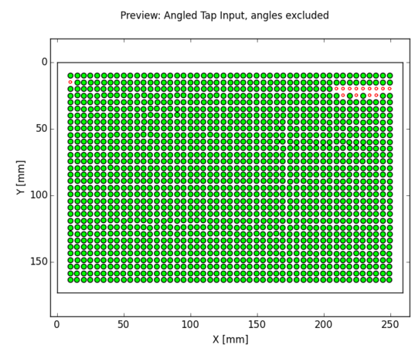

The first preview image shows the overview of the DUT. Circles represent the robot points and the size of the circle is the size of the allowed area given by accuracy error. If the input is missing, the circle is drawn red. If the input is outside the allowed area, the position of the input is shown with red marker, otherwise a green marker is used.
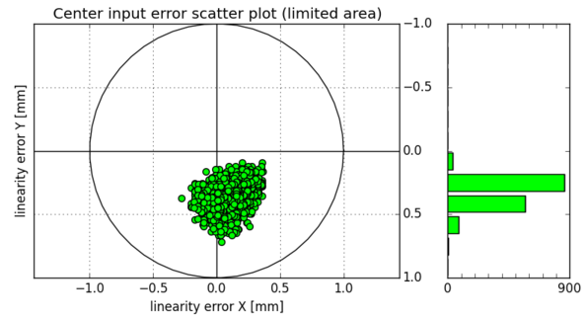

The second image gives the scatter plot. It plots all the measurements in relation with the point that the robot has pressed (reference point). In the image the distribution of the tap error can be observed. The histograms on the sides show the distribution of the points on the axes. The unit in the histogram is one measured event, and the cumulative amount of events in each bar can be read from the scale of the respective histogram. If edge analysis is conducted, two acceptance circles are shown (see above).
Last images show tilt and orientation error. If DUT has reported tilt and orientation they are compared to robot’s tilt and orientation used in this measurement. In detailed table each single point’s tilt and orientation error can be inspected.

Stylus Force Swipe Test
The Stylus force swipe test report shows the results of the force swipe test. The force swipe test is used to measure the accuracy and sensitivity of the DUT, when the touch is in linear motion and constant force is applied.

Settings
Maximum amount of missing swipes: A swipe is missing if no points are reported for a single swipe. If the number of missing swipes is more than the maximum amount, the test has failed.
Maximum allowed offset: The maximum allowed offset of swipe point perpendicular to the line that the robot has swiped (see Figure 18 above).
Non stationary jitter search mask: The distance (or window) along the swipe line in which the jitter is calculated.

Report contents
The first table shows the maximum offset measured in the test, maximum jitter and the amount of missing swipes.
The second table shows the offset and jitter values for each swipe. The pass/fail value for the swipe is determined by the offset and jitter values. If no measurement values for a swipe are available the offset and jitter values are ‘N/A’. If there is only one measurement value, the jitter value is ‘N/A’, as jitter calculation requires at least two measurement values. Applied force and DUT’s reported sensitivity values from the swipe are shown in the detailed view.

Preview images
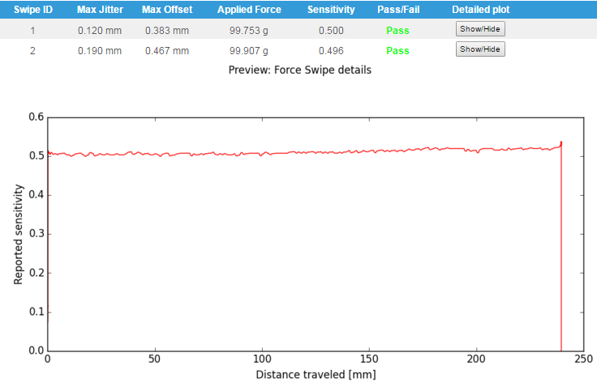

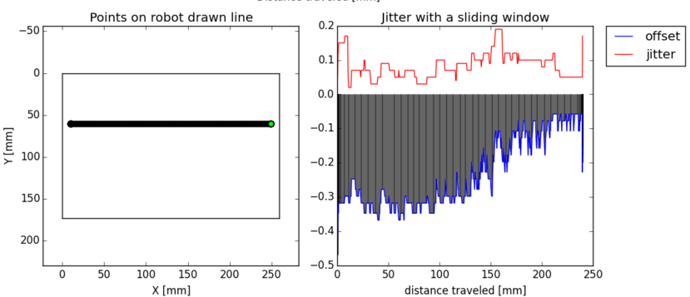
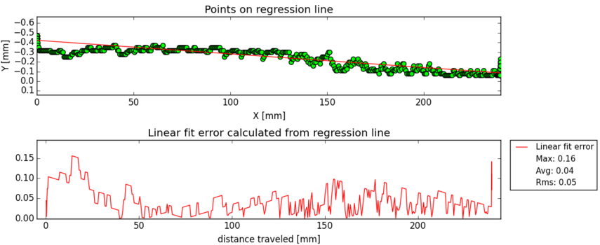

Stylus Hover Angled Tap Test
Stylus Hover Angled Tap Test report shows the results of the hover tap test. The hover tap test is used to measure the hover accuracy performance of the DUT.

Settings
Edge area distance from edge in Tap test: The edge area width. The edge area can have different thresholds than rest of the DUT. If this setting is positive (larger than 0), the edge area analysis is enabled and the two following settings are in use:
Maximum allowed accuracy error in edge area: The maximum allowed positional error if the point that the robot presses resides in the edge area.
Maximum allowed missing edge inputs: The maximum allowed amount of missing inputs in the edge area in addition to the global value. Thus, if the global value is 1 and missing edge inputs value is 2, there can be at most 3 missing inputs in the edge area if none are missing in other parts of the DUT.
Maximum allowed accuracy error: Maximum allowed accuracy error.
Maximum allowed missing inputs: The maximum allowed amount of missing inputs in the test.
Maximum allowed tilt angle error: Maximum allowed error from tilt angle reported by DUT when compared to tilt angle reported by robot.
Maximum allowed orientation angle error: Maximum allowed error from tilt angle reported by DUT when compared to tilt angle reported by robot.

Report contents
Report contents is similar to Stylus Angled Tap test. Report consists of accuracy results from hovering height. Stylus Tilt and Orientation results are calculated if DUT has reported the values.

Preview images
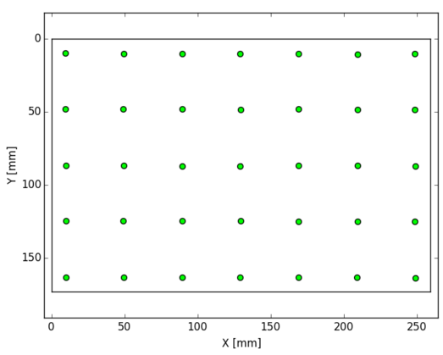

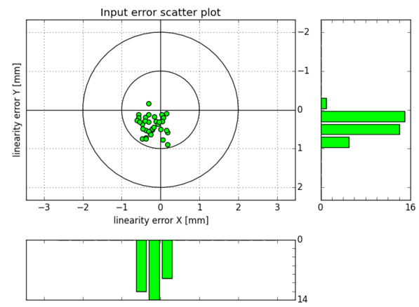

Stylus Hover Stationary Jitter Test
Stylus hover stationary jitter report reports the results of the stylus hover jitter test. It is used to test the performance of the DUT when a single hover point is kept. Optimally the DUT should report a single coordinate consistently.

Settings
Maximum allowed jitter in hover test: The maximum amount of hover jitter allowed for a single point.

Report contents
The hover stationary jitter reports the maximum measured hover stationary jitter in the test. In addition, the results for individual points hovered are measured.
The jitter is calculated from the first coordinate reported by the DUT. The jitter for each successive measurement value is the distance from the first reported point. The jitter reported for an individual tap is the maximum of jitters for individual points.

Preview images
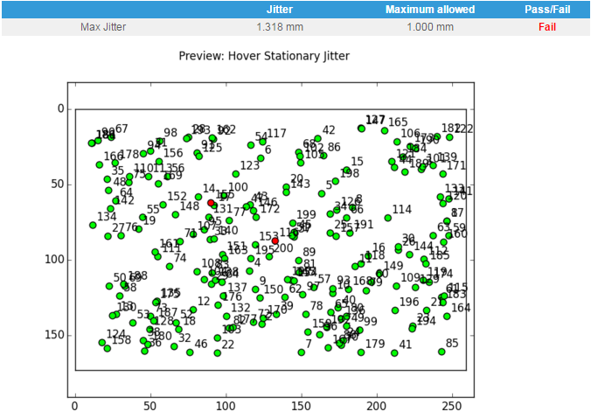
The main preview image shows the different points measured related to the DUT. Passed points (jitter value not exceeding threshold) are marked green, failed points are marked with red color. Note that the passed points are determined by the first input from the panel – the analysis does not take robot touch point into account when determining the pass/failure limits.

Stylus Pressure Sensing Test
Stylus pressure sensing report reports the results of the pressure sensing test. It is used to test the sensitivity performance of the DUT. Optimally the DUT should report same sensitivity value for each point when applied force is constant.

Settings
Target pressure sensitivity value: Target value for sensitivity values reported by DUT.
Note: Relationship between the force value with which the DUT is pressed (in grams) and sensitivity value which the panel reports is only known by the test operator. Set target pressure to match used force in Pressure Sensing Test case.
Max pressure sensitivity error: Maximum error in sensitivity value reported by DUT when comparing to target pressure value.

Report contents
The stylus pressure report shows sensitivity values reported by DUT. The first table shows target, maximum and minimum sensitivity values from the measurement.
3D-plot, heat map and histogram figures show reported sensitivity values measured from DUT.
The detailed table shows maximum force value and measured sensitivity for each individual measurement point. Pass/Fail verdict is given based on target sensitivity value.

Preview images
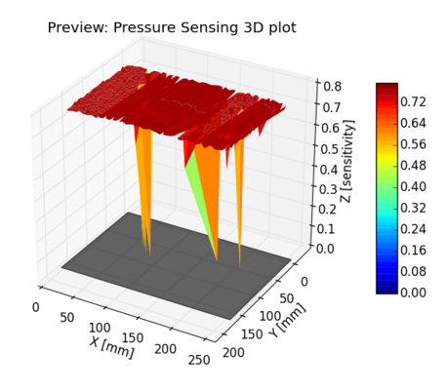
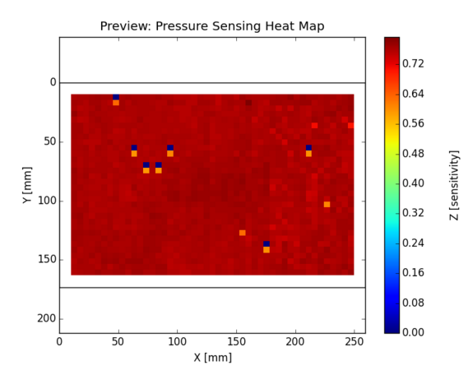
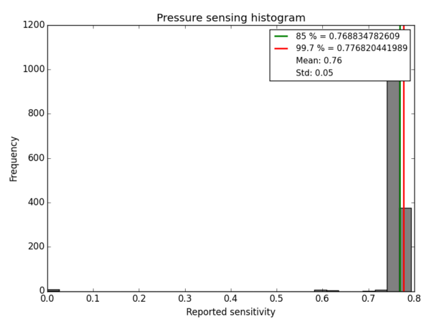

Stylus Stationary Jitter Test
Stylus stationary jitter report reports the results of the stylus stationary jitter test. It is used to test the performance of the DUT when a single point is pressed and hold. Optimally the DUT should report a single coordinate consistently.

Settings
Maximum allowed stationary jitter: The maximum amount of jitter allowed for a single point.

Report contents
The stationary jitter reports the maximum measured stationary jitter in the test. In addition, the results for individual points pressed are measured.
The jitter is calculated from the first coordinate reported by the DUT. The jitter for each successive measurement value is the distance from the first reported point. The jitter reported for an individual tap is the maximum of jitters for individual points.

Preview images
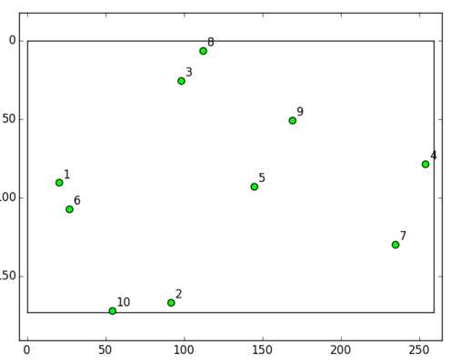
The main preview image shows the different points measured related to the DUT. Passed points (jitter value not exceeding threshold) are marked green, failed points are marked with red color. Note that the passed points are determined by the first input from the panel – the analysis does not take robot touch point into account when determining the pass/failure limits.

Troubleshooting

Trouble | Solution
Analyzing results is slower than before | Use new empty database to store test results. Large databases are slower than small ones.
500 Internal Server Error or other HTTP error | If you get this or any other HTTP error message, please send it to support@optofidelity.com Also send measurement database as attachment if possible.
Web browser cannot display any webpage | Restart analysis SW by first closing web browser and command prompt windows (see 3.2) and then start analysis SW normally (see 3.1).

Change history
Ver. | Status | Date | Author | Remarks
2.0 | Final | 07.05.2014 | JTU
2.1 | Draft | 14.03.2016 | MTO | 2020

