**INTRODUCTION**

A huge number of organization and companies running extremely in huge capacities and operate under surveillance systems CCTV as a prior to a security measure for example banks face the at most challenge of monitoring ,controlling and backing up of the CCTV cameras footage across the branches and offsite ATMS in various locations. One has to move from place to place to execute the processes of monitoring, controlling and backups, usually this incurs various costs and time wastage in compiling all this activities at different time intervals and locations thus low levels of productivity and security threat to the organization leading to inconsistent value for money.

This process can be tedious in most cases as it requires repeated process of recovering video footage, backup storage and even mode of accessing accurate video data.

This problem can therefore be addressed by centralizing all cameras to one control monitoring point system CMS thus centralizing is the processes in which activities of CCTV are retained in the head office and all other offices receive commands from the main office related to security measures.

Control Monitoring System(CMS) on the other hand control and monitoring systems are processes needed to track, review and regulate the progress and performance of CCTV .it also defines areas where changes are required and initiates the required changes

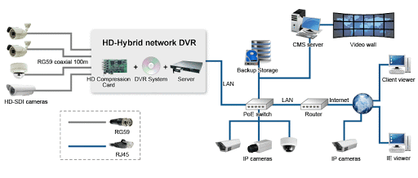

Below are some of the major merits of control monitoring system

* it helps the user to keep truck of over a thousands of all the branch and offsite ATMS cameras simultaneously from a single location
* it increases CCTV footage storage period
* it saves a lot of time as you can access the data from just your PC, without shuffling through other systems
* Also, it is smarter as you can search for a specific video and request instant playback
* improves storage and accessibility
* Can manage all the network connection using your server in multiple cameras.
* Cms posses the capacity to monitor unlimited number of live cameras simultaneously situated at any location

**System Requirement set up**

1. **server**

* A video management system with a video storage board. It can manage up to 128 network cameras for recording ,live view and playback.
* Automatically discover online cameras / DVR.
* advanced system stability
* Alerts system user in case of Camera failure
* database backup and restoration
* Linux operating system, ANR technology and N+1 hot spare system for storage board to enhance reliability.
* Users with related permissions can switch to administrative mode to access the operating system.

2.**Hard Disks**

* A **hard disk drive** (**HDD**),**hard disk**,**hard drive**, or **fixed disk** is an elector-mechanical [data storage device](https://en.wikipedia.org/wiki/Data_storage_device) that uses [manetic storage](https://en.wikipedia.org/wiki/Magnetic_storage) to store and retrieve [digital data](https://en.wikipedia.org/wiki/Digital_data) using one or more rigid rapidly rotating [platters](https://en.wikipedia.org/wiki/Hard_disk_platter) coated with magnetic material.
* All DVRs store their footage on an internal hard drive. Most use a SATA hard drive, this stands for Serial Advanced Technology Attachment and is the method by which the hard drive connects to a device. Computers also use a SATA hard drive but DVRs and computers are different. Unlike a computer your DVR is designed to run 24 hours a day with constant data transfer onto the hard drive. For this reason it is important that you use AV grade drives specifically designed for a DVR rather than standard computer drives which have a tendency to fail prematurely.
* The hard disk will therefore be a main source of storage features within the server as well as backup devices.

In most scenarios, these devices are connected into the DVR to best suite its operations of storage

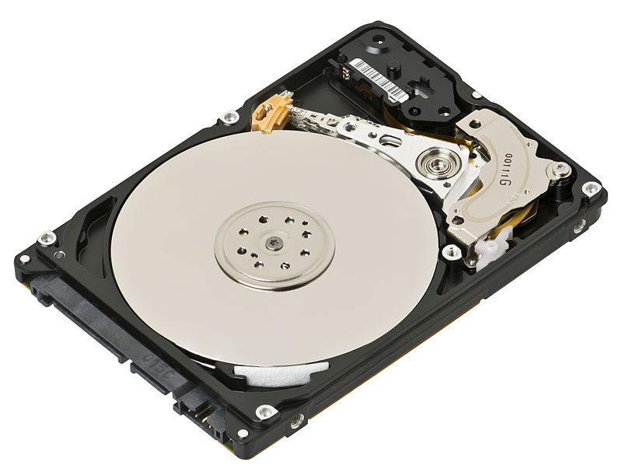

* **Hard drives** come in two basic physical **sizes**: 2.5-inch and 3.5-inch. These **sizes** refer to the **size** of the data platters, not the **size** of the **hard drive** mechanism.
* A **hard disk** hold more data, for example, can store anywhere from 10 to more than 100 gigabytes depending on the storage capacity which is required for the storage capacities for various video footage.

3. **Monitors**

* This can be best described as a device used for observing, checking, or keeping a continuous record of something.

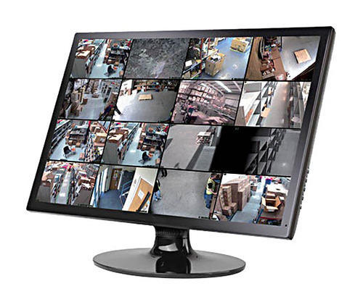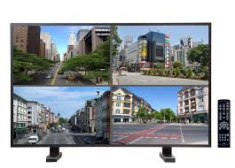

**Main goal of control and monitoring system in CCTV**

* To synchronize video coverage in various branches within the organization.
* To provide continues value for money as far as security is concerned.