1. When i click on the add network submit button the extension goes as small line. If i close and try to open its not opening anymore.  
   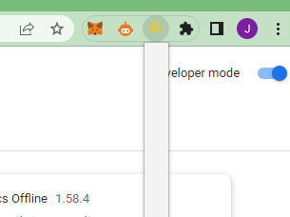  
   Not solved yet
2. On send screen the gas and gas price seems editable i do not think it’s needed to editable  
   Not needed yet
3. Add the swap button or icon only do not work on taht when its click.  
   The icon is chopping form the sides  
   .
4. Add option to expand it like metamask.  
   Not needed yet
5. All the tokens also shown in the assets list and user can also add his own token by importing of contract address.  
   in the right side of the assets list there is send icon so the user click on that and directly send the tokens to the recipient user.
6. Amount and account have confusion in the extension.
7. If we add the network like eth, bnb the coin symbol of ccc shows.
8. The number format of the total coins is wrong its show more than 8 digit in the decimal.
9. After money send there must be some success for the user taht money is debit, also when user click on the send he must get some loading icon so taht he not press multiple times. Once its success its back to the home screen with latest balance.