eHMI Information Transparency and Vehicle Deceleration Interactively Affect Pedestrian Crossing Decisions: A Virtual Reality Study

摘要
Objective: This study examined how eHMIs with different levels of information transparency affect pedestrian crossing decisions, and whether these effects vary with vehicle deceleration, time pressure, and traffic density.
Methods: A virtual reality pedestrian crossing experiment was conducted with 26 participants. A within-subject design was used, including four eHMI conditions (no eHMI, Level 1, Level 2, and Level 3 transparency), two vehicle deceleration rates, two time pressure conditions, and two traffic density conditions. Pedestrian responses were analyzed from behavioral, visual, physiological, and subjective measures.
Results: The presence of an eHMI increased the probability of successful crossing. The mean crossing success probability estimated by the model was approximately 0.95 with an eHMI and 0.55 without one. Higher transparency improved all three subjective ratings. Perceived safety rose with transparency but levelled off between Level 2 and Level 3 (no eHMI < Level 1 < Level 2 ≈ Level 3), while interface comprehensibility and perceived helpfulness continued to rise up to Level 3 (Level 1 < Level 2 < Level 3). Despite these subjective gains, Level 3 showed no advantage over Level 2 in behavioral efficiency.Vehicle deceleration rate interacted with eHMI transparency in crossing delay, F(3,553) = 11.878, p < 0.001. Under high deceleration, crossing delays were shorter with an eHMI than without one. Under low deceleration, crossing delays were longer with an eHMI, and Level 3 produced the longest delay.
Conclusion: eHMIs can support pedestrians in judging the stopping intention of automated vehicles and improve crossing success. However, their effectiveness depends on vehicle motion cues. eHMI design should match the level of information transparency to the vehicle’s deceleration state, rather than increasing the amount of information when motion cues are weak.

关键词：自动驾驶车辆；外部人机界面；信息透明度；行人穿越决策；车辆减速率；虚拟现实

Introduction：
As SAE Level 4 and Level 5 automated vehicles gradually enter urban mixed traffic, interactions between pedestrians and vehicles may no longer follow the patterns seen in conventional traffic. Pedestrians currently rely on cues such as driver eye contact, hand gestures, and vehicle deceleration to decide whether it is safe to cross. In highly automated vehicles, occupants may no longer act as active drivers, and in some cases no clearly identifiable driver may be present. Pedestrians may therefore find it difficult to use eye contact and gestures when interpreting vehicle intentions. This can increase uncertainty about what the vehicle has detected, whether it intends to stop, and how it will move next. Such uncertainty may increase waiting time, reduce traffic efficiency, and lead to misjudgments or risky crossing decisions. Pedestrian interaction with automated vehicles has therefore become an important issue for their introduction into urban traffic (Diels & Thompson, 2018; Nordhoff et al., 2018; Zhou et al., 2022).
External human-machine interfaces (eHMIs) are regarded as an important means of bridging the communication gap between automated vehicles and pedestrians. Most existing eHMIs use visual cues outside the vehicle to communicate vehicle status or intention in pedestrian crossing situations, including anthropomorphic icons, text messages, light signals, and road projections. These visual cues have been examined in different interaction scenarios. For example, Chang et al. (2017) used eye icons to mimic eye contact between drivers and pedestrians, while Eisma et al. (2023) compared the effects of text messages and flashing lights on pedestrian responses and visual attention. Rettenmaier et al. (2020) investigated external displays and road projections in a road narrowing scenario to show how vehicles could communicate their intentions to pedestrians. Beyond the design of visual signals themselves, Dey et al. (2021) and Lau et al. (2024) examined how light signals in eHMIs interact with vehicle movement cues in shaping pedestrians’ crossing decisions. These studies suggest that eHMIs can help pedestrians understand the intentions of automated vehicles. However, existing research has mainly focused on their presence or visual form, while the type and amount of information conveyed often vary simultaneously. This makes it difficult to determine whether pedestrian responses are driven by interface form or by information content. Given the lack of agreement on what information eHMIs should present and how detailed it should be (Alhawiti et al., 2024), further research is needed on how different information levels in eHMIs affect pedestrians’crossing decisions. A further difficulty is that higher information levels are usually conveyed by adding more display elements, so the amount of information and the visual form of the interface tend to change together, which makes their effects hard to separate.
Different information levels in eHMIs correspond to different degrees of information transparency, because they determine how much the vehicle reveals about what it has detected, how it interprets the situation, and how it will respond. In automated systems, transparency refers to the extent to which a system makes its status, reasoning, and future actions understandable to users (Ha et al., 2020; Zang & Jeon, 2025). Chen et al. (2018) further divided transparency into perception, comprehension, and projection levels, suggesting that transparent information should help users understand what the system has perceived, why it acts as it does, and what it is likely to do next. In automated driving, such transparency can reduce uncertainty about system intentions, support more stable expectations of vehicle behavior, and help users form more accurate mental models (Ha et al., 2020; Li et al., 2023).
Following this layered view, eHMI information can range from a basic indication that pedestrians have been detected to a fuller explanation of how the vehicle interprets the crossing situation and how it will respond (Alhawiti et al., 2024). Such information may help pedestrians judge vehicle intentions and form expectations about vehicle behavior. In pedestrian crossing situations, however, the value of transparency depends on whether the information can be used within a short decision window. Pedestrians interact with automated vehicles in open road environments, where the vehicle is still moving and the traffic situation continues to change. They therefore have little opportunity to examine an eHMI in detail, and must combine interface information with vehicle movement cues while deciding whether to cross. If the information is too limited, pedestrians may remain uncertain about the vehicle’s intention to stop. If the information is too detailed, it may require additional attention and interpretation, slowing the decision process and increasing cognitive effort (Li et al., 2023; Oudshoorn et al., 2021; Tran et al., 2024). Higher transparency has been found to improve situation awareness and system understanding, but it may also be accompanied by longer response times or greater cognitive load (Zang & Jeon, 2025). For eHMI design, the question is not how much information to provide, but what level of transparency lets pedestrians read the vehicle’s intention while still deciding quickly.
Pedestrians also judge a vehicle’s intention from its movement, not only from what an eHMI displays. In real traffic situations, pedestrians do not decide whether to cross solely on the basis of external display information. Instead, they continuously observe changes in the vehicle’s approach and use these movement cues to infer whether the vehicle intends to stop for them (Bindschädel et al., 2021; Pekkanen et al., 2022). Previous studies have shown that pedestrians are more likely to recognize a vehicle’s intention to stop when it begins to decelerate earlier (Ackermann et al., 2019). Oliveira et al. (2020) and Oudshoorn et al. (2021) likewise treated vehicle movement as a primary source of information for pedestrians reading the intentions of automated vehicles. Therefore, whether deceleration is timely, noticeable, and stable can directly affect pedestrians’ judgments of vehicle intention and crossing risk.
The role of an eHMI therefore needs to be considered together with the vehicle’s movement. When the information shown by the interface matches the vehicle’s deceleration, the two cues may jointly strengthen pedestrians’ understanding that the vehicle intends to stop, making it easier for them to identify an appropriate crossing moment. In a real vehicle experiment, Dey et al. (2021) found that early and smooth braking, combined with a dynamic eHMI, increased pedestrians’ willingness to cross and their perceived safety. By contrast, late or abrupt braking reduced the positive effect of the eHMI. Lau et al. (2024) similarly showed that an early stopping strategy combined with a dynamic eHMI improved pedestrians’perceived safety and emotional evaluation. However, presenting multiple cues at the same time does not necessarily lead to faster decisions. Bindschädel et al. (2021) found that when an explicit eHMI and vehicle movement cues appeared together, pedestrians’ crossing initiation time could even increase. eHMIs and vehicle movement cues therefore do not simply add up. How they work together may depend on whether the two signals agree, when each one appears, and how well pedestrians can combine them.
Previous studies have often examined stopping behavior and clear deceleration as ways for automated vehicles to indicate their intention to stop for pedestrians. These strategies may help pedestrians feel safer, but they may also reduce traffic efficiency in dense or continuous traffic. Gupta et al. (2019) and Millard-Ball (2018) noted that frequent full stops during pedestrian interactions may disrupt traffic flow and make pedestrians more likely to rely on vehicles stopping before crossing. At the same time, pedestrians in real traffic do not base their crossing decisions only on whether a vehicle has stopped. They also adjust their decisions according to how the vehicle is slowing down and whether the situation appears crossable (Lee et al., 2022; Markkula et al., 2020). For this reason, this study used a movement strategy in which the vehicle first slows to a low speed and then approaches the pedestrian at that constant low speed. This simulates a way for automated vehicles to express an intention to stop while maintaining the continuity of traffic flow. Under this strategy, the vehicle’s deceleration rate serves not only as an important movement cue for pedestrians to judge the vehicle’s intention, but may also affect how they understand and use eHMIs with different levels of transparency. When deceleration is strong, the slowing of the vehicle is easy to notice and already signals an intention to stop, so the eHMI mainly confirms this signal and can work with the motion cue to support a quicker decision. When deceleration is weak, the motion cue is less clear, and the extra information of a higher transparency eHMI is harder to combine with it within a short decision window, which may add to cognitive load and slow the decision rather than ease it. The effect of eHMI transparency may thus differ between the high and low deceleration conditions.
In real crossing situations, pedestrians do not interpret eHMI information and vehicle movement cues in isolation. Their use of these cues is also shaped by the constraints of the crossing context. Time pressure reduces the time available for observation and judgment. It may push pedestrians to start crossing sooner, increase physiological arousal, and make them more willing to accept risk (Almeida et al., 2024; Cœugnet et al., 2019; Dhoke & Choudhary, 2023). Traffic density changes the availability of crossing gaps and the amount of surrounding traffic that pedestrians need to monitor. In denser traffic, pedestrians must make decisions while tracking more vehicle movements, which may increase the difficulty of attention allocation and risk assessment (Bindschädel et al., 2021; Kalantarov et al., 2018). The effects of eHMI transparency and vehicle deceleration may therefore vary with the urgency of the crossing task and the complexity of the traffic environment. Under time pressure, pedestrians have less time to read the interface and may depend more on the vehicle’s movement, so detailed eHMI information may be harder to use. In denser traffic, the added information of a higher transparency eHMI may help pedestrians, but it may also compete for the attention they need to monitor other vehicles.
Both eHMIs and vehicle movement cues can shape pedestrians’ crossing decisions. Yet how the level of information transparency shapes these decisions has received less attention. The relationship between eHMIs and vehicle deceleration also remains unclear, although pedestrians usually need to interpret interface information together with the vehicle’s movement during an ongoing crossing interaction. Moreover, time pressure and traffic density may change how pedestrians attend to and use these cues, but their roles in crossing decisions involving eHMIs have not been sufficiently examined. We therefore conducted a virtual reality pedestrian crossing experiment with a 4 × 2 × 2 × 2 repeated measures design: four levels of eHMI information transparency, two levels of vehicle deceleration rate, two levels of time pressure, and two levels of traffic density. The experiment was evaluated through behavioral, visual, physiological, and subjective measures, so that changes in crossing performance could be considered together with attention allocation, pupil response, and subjective experience.
Based on the above discussion, the following hypotheses were proposed.
H1. eHMI information transparency will affect pedestrians’ crossing decisions and subjective evaluations.
H2. The effect of eHMI information transparency on pedestrians’ crossing decisions will vary with vehicle deceleration rate.
H3. Time pressure and traffic density will affect pedestrians’ crossing strategies and their use of eHMI information.
Methods
Participants
Twenty-six adults were recruited through an online participant recruitment platform. The sample included 10 men and 16 women, aged between 19 and 32 years (M = 23.1, SD = 2.14). All participants had normal or corrected-to-normal vision and normal hearing. Of the participants, 57.69% held a driving license, and 66.67% of these licensed drivers had more than one year of driving experience. Although 50% of the participants reported an interest in automated driving or related study and research, only 15.4% were familiar with the concept of eHMI. Participation was voluntary. All participants provided written informed consent before the experiment.
Apparatus and Virtual Environment
The experiment was conducted using an HTC VIVE Pro Eye headset. A typical urban road environment was built in Unity. The scene consisted of a two-way, two-lane road, with each lane measuring 3.5 m in width. The environment was set in daytime conditions and did not include traffic lights. Participants stood on the near-side pavement from a first-person perspective. The crossing destination was located near the central divider of the road. The starting point and destination were marked by blue squares measuring 0.6 m × 0.6 m.
The experiment was carried out in a 4 m × 4 m laboratory space. Through SteamVR, the virtual scene was mapped onto the physical walking space at a 1:1 scale. The virtual road scene is shown in Figure 1.
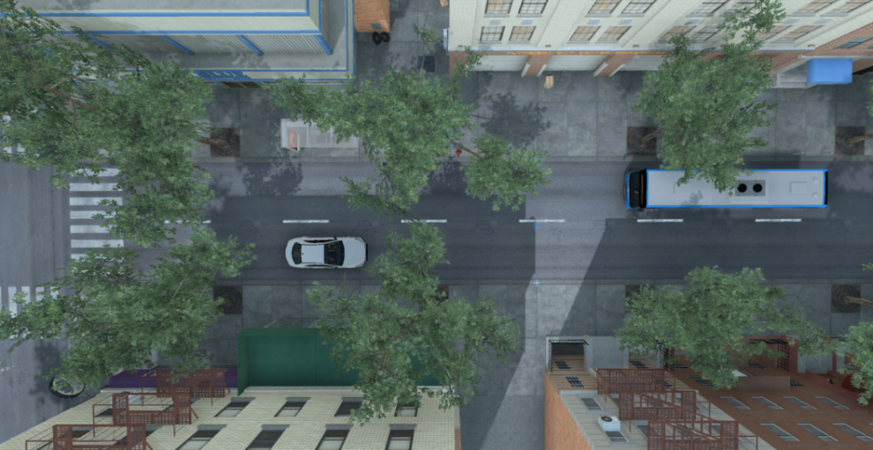
Figure 1. Top view of the VR experimental scene
Experimental Design
The experiment was adapted from the pedestrian crossing paradigm proposed by Lobjois and Cavallo (2007). A 4 × 2 × 2 × 2 repeated measures design was used, with four levels of eHMI information transparency (no eHMI, Level 1, Level 2, and Level 3), two vehicle deceleration rates (1.6 and 3.2 m/s²), two time pressure conditions, and two traffic density conditions. Each participant completed 36 trials, including 32 experimental trials and 4 filler trials. The experimental trials were arranged according to a Latin square. The filler trials were not included in the main statistical analysis and were used to reduce participants’ expectation that the target vehicle would always slow down.
At the beginning of each trial, several filler vehicles passed through the scene at a constant speed of 30 km/h. The target vehicle then appeared in the near lane and followed a deceleration-then-low-speed approach strategy. Specifically, the target vehicle slowed from 30 km/h to 10 km/h and then continued to approach the pedestrian at a constant speed of 10 km/h. In the high deceleration condition, the deceleration rate was 3.2 m/s². In the low deceleration condition, the deceleration rate was 1.6 m/s². The initial distance between the target vehicle and the preceding filler vehicle was fixed at 20 m. In the filler trials, the target vehicle continued at a constant speed and did not slow down. The movement pattern of the target vehicle is illustrated in Figure 2.
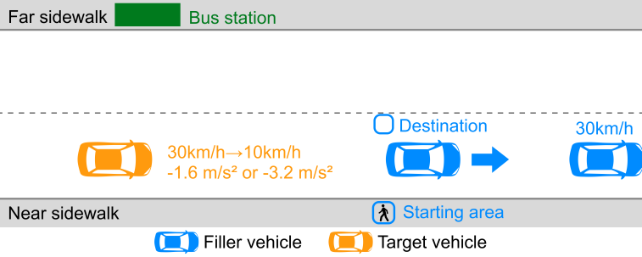
Figure 2. Schematic illustration of the target vehicle movement pattern
In the standard condition, participants were instructed to cross the road as soon as they judged that it was safe to do so. This task was designed to simulate a natural pedestrian response in traffic. The task setup is shown in Figure 3. In the time pressure condition, participants were told to cross as quickly as possible in order to catch a bus that was about to leave on the far side of the road. The time pressure scene is shown in Figure 4. Traffic density was manipulated through the spacing between filler vehicles. In the high density condition, the spacing between filler vehicles was 8 to 11 m. In the low density condition, the spacing was 16 to 19 m. The traffic density manipulation is shown in Figure 5.
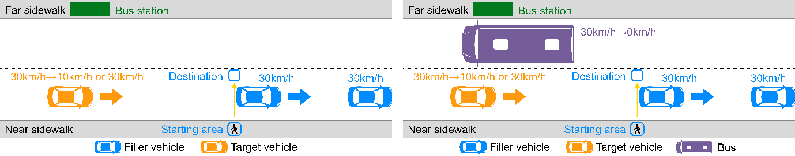
Figure 3. Schematic illustration of the experimental task
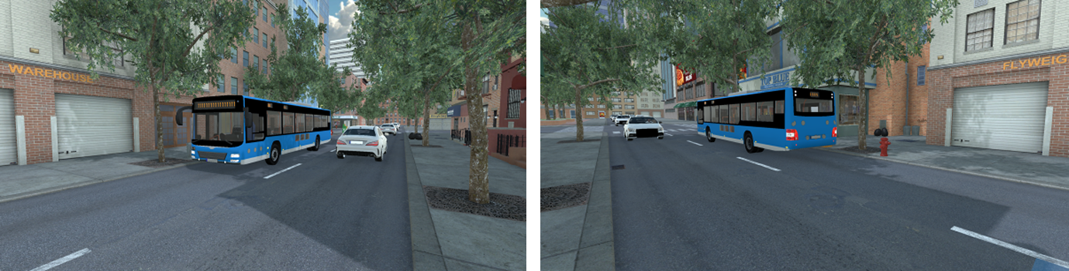
Figure 4. Time pressure scenario in the virtual environment
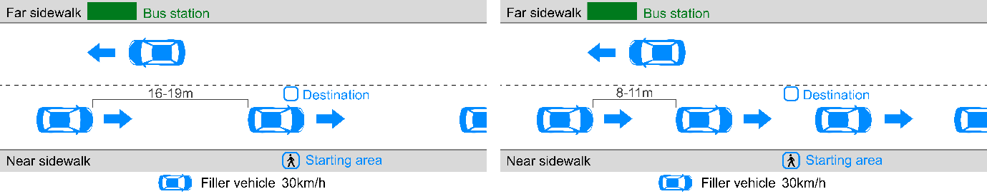
Figure 5. Schematic illustration of filler vehicle density
eHMI Design
The eHMI was designed according to the perception, comprehension, and projection levels in the transparency framework proposed by Chen et al. (2018). Four levels of information transparency were used: a no eHMI condition and three eHMI conditions with progressively more information (Level 1, Level 2, and Level 3). The display was placed at the center of the target vehicle’s front grille, with a size of 40 cm × 90 cm, following previous findings on suitable eHMI locations (Bindschädel et al., 2021; Eisma et al., 2019). In all eHMI conditions, the interface was activated when the target vehicle began to decelerate.
In the no eHMI condition, the display remained off. Level 1 showed a green arrow icon pointing toward the pedestrian to indicate pedestrian detection. Level 2 added the real-time distance between the vehicle and the pedestrian, representing the current spatial relation in the crossing situation. Level 3 further added a remaining time indicator and a circular progress bar to indicate the time window before the vehicle reached the crossing area. As the remaining time decreased, the progress bar shortened and changed from green to yellow and then to red. The four eHMI designs are shown in Figure 6. Before the formal experiment, participants were informed of the meaning of each interface.
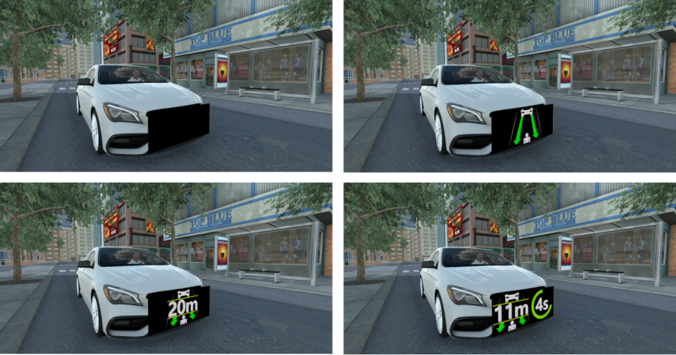
Figure 6. The four eHMI interface designs at different transparency levels
Dependent Measures
The experiment recorded behavioral responses, eye movements, pupil responses, and subjective ratings. The waiting stage was defined as the period from the onset of the crossing window to the moment when the participant left the starting area. The crossing stage was defined as the period from leaving the starting area to reaching the destination area.
Pedestrian crossing behavior was described using crossing success, crossing delay, crossing time, and the time gap at crossing completion. Crossing success indicated whether the participant reached the destination safely. For successful crossings, crossing delay was measured from the opening of the crossing window to the moment the participant left the starting area, while crossing time was measured from leaving the starting area to reaching the destination. The time gap at crossing completion was used to describe the remaining time available after the participant had cleared the travel path of the target vehicle. It was calculated by dividing the longitudinal distance between the vehicle and the pedestrian at that moment by the vehicle’s instantaneous speed, and was expressed in seconds.
Eye movement measures were calculated separately for the waiting and crossing stages. Dynamic areas of interest were used to extract the first fixation duration on the eHMI area and the total fixation duration on the vehicle area.
Pupil measures were also calculated for the two stages separately. These measures included maximum pupil diameter, mean pupil diameter, and pupil diameter change. Pupil diameter change was calculated as the maximum pupil diameter within a stage minus the mean pupil diameter during the first 3 s of that stage.
Subjective ratings were collected after each trial using three seven-point items: perceived safety, interface comprehensibility, and the perceived helpfulness of the eHMI for crossing decisions. Interface comprehensibility and perceived helpfulness were not administered in the no eHMI condition.
Procedure
Before the experiment, participants signed an informed consent form and completed a demographic questionnaire, and the experimenter explained the task, the vehicle's behavior, and the meaning of each eHMI. After the headset was fitted, the eye tracker was calibrated, participants were given time to adapt to the space, and they completed three practice trials. In the formal stage, the experimenter told the participant before each trial whether the time pressure task applied. After each trial, the participant used the hand controller to complete the three rating items on a panel at the destination. A Misery Scale (MISC) was completed after every eight trials (Bos et al., 2010); the experiment would have stopped if the score exceeded 4, but no participant reached this threshold. Each session lasted about 45 minutes, with about 20 minutes for familiarization and practice and about 25 minutes for the formal trials.
Results
Data Overview
Participants completed 832 trials in total (26 participants × 32 trials). Four trials with recording errors were removed, leaving 828 valid trials: 653 successful crossings, 114 trials with no crossing or an incomplete crossing, and 5 collisions. A further 56 trials with early crossing in traffic, in which the participant set off more than 3 s before the crossing window opened, were set aside because the eHMI had not yet appeared and the behavior was highly unsafe. For the crossing delay analysis, trials with a delay below 0 s (n = 59) were also excluded to ensure that the eHMI had been fully displayed. Because of occasional recording failures, the first fixation duration on the eHMI and the pupil data were missing for some trials. In trials with incomplete crossings, long standing times produced abnormally large eye-movement values from the waiting stage, so the eye-movement data from these 114 trials were removed. For the first fixation duration on the eHMI and the total fixation duration on the vehicle, only observations greater than 0 ms were kept.
Data were analyzed in SPSS 27 using generalized linear mixed models (GLMMs). The fixed effects were eHMI transparency, deceleration rate, time pressure, traffic density, and all two-way interactions; participant was entered as a random intercept, with an unstructured covariance and Kenward-Roger degrees of freedom. Post hoc comparisons used a Bonferroni correction. Non-negative continuous measures and the rating scales were modeled with a Gamma distribution and a log link, and post hoc comparisons for crossing success used binary logistic regression. The GLMM main and two-way interaction results for each measure are given in the Appendix. Measures defined only when an eHMI was present, namely the first fixation duration on the eHMI and the comprehensibility and helpfulness ratings (Q2 and Q3), were analyzed across the three eHMI levels only, which is reflected in their degrees of freedom. As a sensitivity check, all continuous outcomes were Winsorized at the 1st and 99th percentiles and re-analyzed. The main and interaction effects kept the same direction and significance before and after Winsorizing, and only a few effects were no longer significant after outlier removal (p > 0.05); only effects that were significant in both the original and the sensitivity analysis are reported below. The inferences in the main text are based on the original, un-Winsorized data, with the Winsorized (99%) data serving as the sensitivity check.
Effects of eHMI Transparency and Deceleration Rate
Main Effect of eHMI Transparency
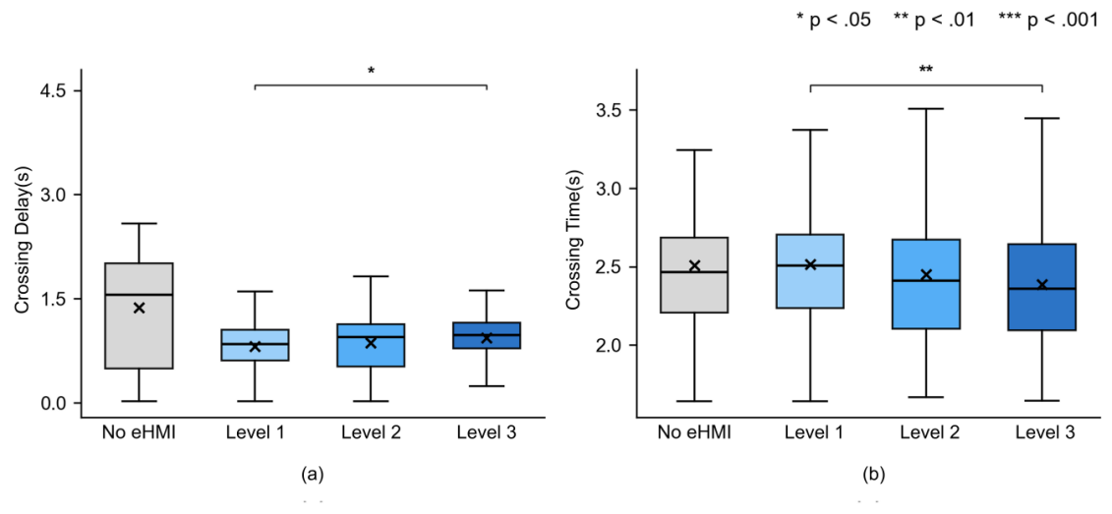
Figure 7. Boxplots of the main effect of eHMI transparency (behavioral measures)
The main effects of eHMI transparency on crossing time and crossing delay are shown in Figure 7. For the behavioral measures, the main effect on crossing delay was significant (F(3, 553) = 3.167, p = 0.024). Post hoc comparisons showed only a difference between Level 3 and Level 1: crossing delay was longer for Level 3 (M = 0.129, SE = 0.044, t(574) = 2.927, p = 0.021). A larger amount of information thus added to the decision initiation cost and delayed the start of crossing. The main effect on crossing time was also significant (F(3, 609) = 4.670, p = 0.003); here crossing time was shorter for Level 3 than for Level 1 (M = −0.109, SE = 0.030, t(619) = −3.635, p = 0.002), as the countdown and progress bar added a sense of urgency and speeded up the movement itself. These two opposing effects suggest that Level 3 prolonged the wait before crossing but accelerated the crossing once initiated, and that the behavioral cost of higher information was confined to the decision stage rather than the movement stage.
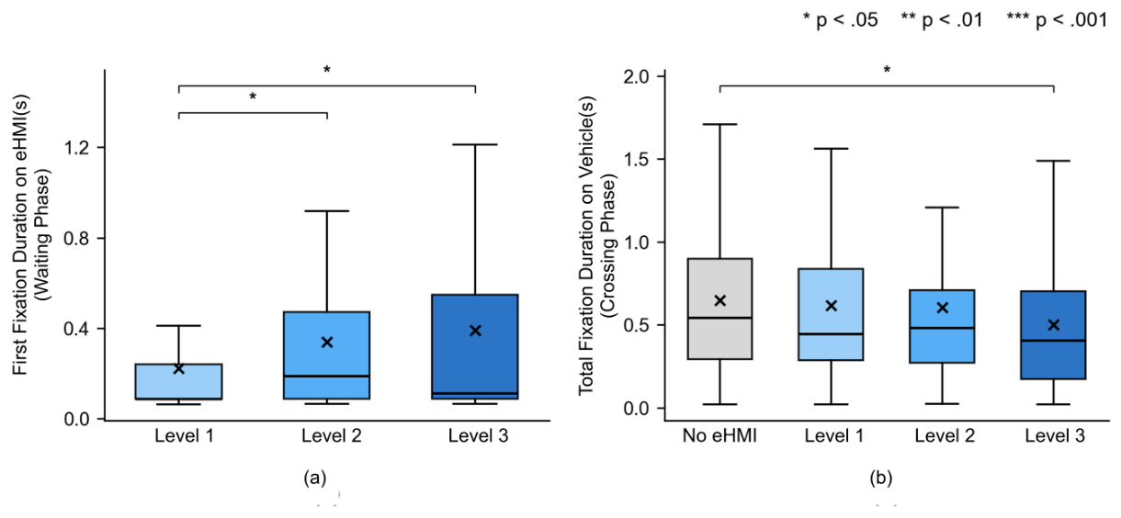
Figure 8. Boxplots of the main effect of eHMI transparency (eye-movement measures)
The main effects of eHMI transparency on the first fixation duration on the eHMI in the waiting stage and the total fixation duration in the crossing stage are shown in Figure 8. The main effect on the first fixation duration on the eHMI in the waiting stage was significant (F(2, 148) = 4.884, p = 0.009); Level 2 (M = 0.107, SE = 0.047, p = 0.047) and Level 3 (M = 0.125, SE = 0.044, p = 0.016) were both longer than Level 1, with no difference between Level 2 and Level 3, as expected when more information has to be processed. The main effect on total fixation duration in the crossing stage was significant (F(3, 412) = 4.540, p = 0.004); Level 3 was shorter than no eHMI (M = −0.229, SE = 0.084, p = 0.042), suggesting that a higher transparency eHMI reduced the need to keep monitoring the environment during crossing (vehicle fixation data were unavailable for the no eHMI condition, so this inference is based on total fixation duration).
For the physiological measures, the main effect on mean pupil diameter in the crossing stage was significant (F(3, 609) = 5.157, p = 0.002); the no eHMI condition was larger than Level 1, Level 2, and Level 3 (all p < 0.05), with no difference among the three transparency levels. An eHMI therefore eased arousal during crossing, but transparency level made no further difference. This absence of a gradient in pupil diameter matches the behavioral pattern: the longer crossing delay at Level 3 likely reflects an increased decision initiation cost rather than sustained higher arousal during the crossing phase itself.
For the subjective ratings, the main effect on perceived safety (Q1) was significant (F(3, 610) = 11.197, p < 0.001); all pairwise comparisons were significant except between Level 2 and Level 3, giving the pattern no eHMI < Level 1 < Level 2 ≈ Level 3. Interface comprehensibility (Q2; F(2, 511) = 76.748, p < 0.001) and perceived helpfulness (Q3; F(2, 511) = 29.841, p < 0.001) both rose in a clear Level 1 < Level 2 < Level 3 pattern. Perceived clarity and support increased with transparency, but this did not carry over to behavior: participants rated higher transparency interfaces as more helpful, yet Level 2 and Level 3 did not differ on the behavioral measures.
Main Effect of Deceleration Rate
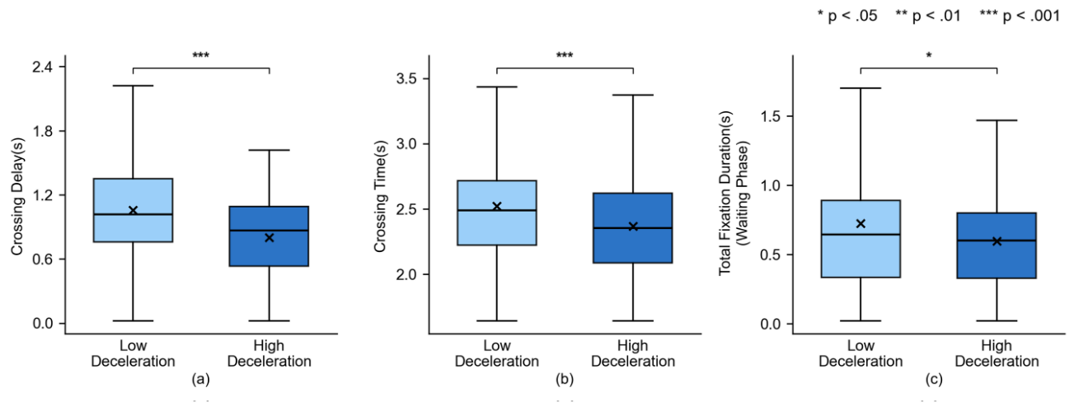
Figure 9. Boxplots of the main effect of deceleration rate
The main effects of deceleration rate are shown in Figure 9. For the behavioral measures, the main effect on crossing delay was significant (F(1, 556) = 40.021, p < 0.001); crossing delay was shorter under low deceleration than under high deceleration (M = −0.283, SE = 0.045, t(411) = −6.311, p < 0.001). The effect on crossing time was significant (F(1, 610) = 24.283, p < 0.001), with shorter crossing time under low deceleration (M = −0.139, SE = 0.028, t(627) = −4.950, p < 0.001). The effect on the time gap was significant (F(1, 610) = 1587.855, p < 0.001), with a smaller time gap under low deceleration (M = −1.476, SE = 0.079,t(25) = −18.788, p < 0.001). Low deceleration carried a more urgent signal and led participants to set off quickly, whereas high deceleration gave a clear stopping signal and a more relaxed crossing. The time gap depends directly on the vehicle's instantaneous speed: under low deceleration the vehicle slows more gradually and is still moving faster when the participant sets off, so part of the difference reflects the physical difference in speed between the two conditions. This effect is reported only as a statistical result and is not interpreted further.
For the eye-movement measures, the main effect on total fixation duration in the waiting stage was significant (F(1, 477) = 5.352, p = 0.021); this duration was shorter under low deceleration (M = −0.100, SE = 0.042, p = 0.017), as participants concentrated on judging the moment to cross. For the physiological measures, the pupil diameter change in the waiting stage (F(1, 557) = 9.170, p = 0.003), the mean pupil diameter in the crossing stage (F(1, 609) = 5.376, p = 0.021), and the pupil diameter change in the crossing stage (F(1, 611) = 7.548, p = 0.006) were all significant. Mean pupil diameter in the crossing stage was larger under low deceleration, pointing to greater cognitive load under time-critical situations; the two pupil diameter change measures were larger under high deceleration, reflecting greater pupil expansion within the stage when the stopping signal was clear.
For the subjective ratings, the main effect on perceived safety (Q1) was significant (F(1, 612) = 43.358, p < 0.001), with lower perceived safety under low deceleration (M = −0.699, SE = 0.106, t(632) = −6.615, p < 0.001). Perceived helpfulness (Q3) was also significant (F(1, 512) = 5.114, p = 0.024), with lower ratings under low deceleration (M = −0.210, SE = 0.093, p = 0.024). The subjective pattern matched the behavioral one.
Interaction of eHMI Transparency and Deceleration Rate
The interaction of eHMI transparency and deceleration rate was significant for five measures: crossing delay and the time gap among the behavioral measures, total fixation duration in the waiting stage and in the crossing stage among the eye-movement measures, and maximum pupil diameter in the crossing stage among the physiological measures. The effect on perceived safety (Q1) was marginal (p = 0.079), and the remaining measures showed no significant interaction (p > 0.05).
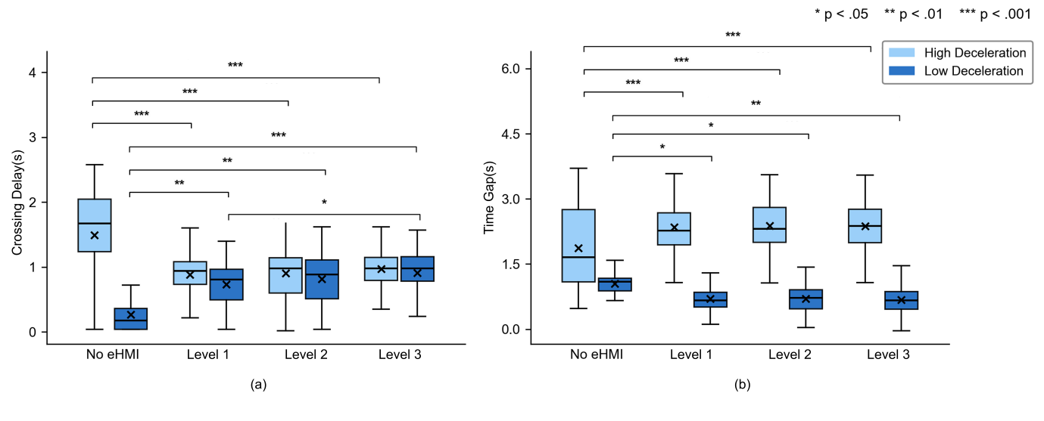
Figure 10. Boxplots of the eHMI transparency × deceleration rate interaction (behavioral measures)
The interaction effects on the behavioral measures are shown in Figure 10. The interaction on crossing delay was significant (F(3, 553) = 11.878, p < 0.001). Under high deceleration, crossing delay was shorter with an eHMI than without one (p < 0.001), with no difference among the transparency levels. Under low deceleration the direction reversed: every eHMI condition had a longer crossing delay than no eHMI (p < 0.01), and Level 3 differed from Level 1, with the longest delay at Level 3 (M = 0.174, SE = 0.062, t(574) = 2.802, p = 0.016). The interaction on the time gap was also significant (F(3, 609) = 15.148, p < 0.001): under high deceleration the time gap for no eHMI was smaller than for Level 1, Level 2, and Level 3 (p < 0.05), with no difference among the eHMI levels; under low deceleration the time gap for no eHMI was larger than for the three eHMI levels (p < 0.05), again with no difference among them. This reversal shows how closely the value of an eHMI depends on the vehicle's movement. Under high deceleration the clear stopping signal and the eHMI reinforced each other, and the eHMI worked as a quick confirmation that helped participants commit to crossing. Under low deceleration, the vehicle's motion provided a weaker and less certain stopping signal. Under these conditions, the eHMI introduced additional information that had to be reconciled with an ambiguous movement cue, increasing the time needed to verify that the interface and the vehicle's actual state were consistent. Level 3 carried the most information and therefore required the most verification time, producing the longest delay.
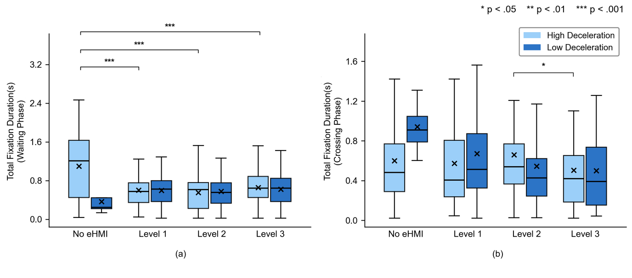
Figure 11. Boxplots of the eHMI transparency × deceleration rate interaction (eye-movement measures)
The interaction effects on fixation duration are shown in Figure 11. The interaction on total fixation duration in the waiting stage was significant (F(3, 473) = 2.764, p = 0.042): only under high deceleration was the duration for no eHMI longer than for Level 3 (M = −0.348, SE = 0.073, p < 0.001), Level 2 (M = −0.413, SE = 0.073, p < 0.001), and Level 1 (M = −0.386, SE = 0.073, p < 0.001), while under low deceleration the eHMI conditions did not differ. Under high deceleration, then, the eHMI lowered the cost of searching the environment. The interaction on total fixation duration in the crossing stage was significant (F(3, 412) = 2.801, p = 0.040): only under high deceleration was the duration for Level 3 shorter than for Level 2 (M = −0.158, SE = 0.057, t(431) = −2.756, p = 0.037), with no difference among the conditions under low deceleration. When deceleration was high and cognitive resources were freer, Level 3 conveyed information more efficiently than Level 2.
For the physiological measures, the interaction on maximum pupil diameter in the crossing stage was significant (F(3, 609) = 3.302, p = 0.020): only under high deceleration was the maximum pupil diameter for no eHMI larger than for Level 3 (M = 0.118, SE = 0.031, p = 0.001) and Level 2 (M = 0.099, SE = 0.031, p = 0.008), with no difference among the conditions under low deceleration. As with the behavioral measures, a higher transparency eHMI eased cognitive load more clearly when the stopping signal from the vehicle's movement was already clear.
Effects of Time Pressure and Traffic Density
Main Effect of Time Pressure
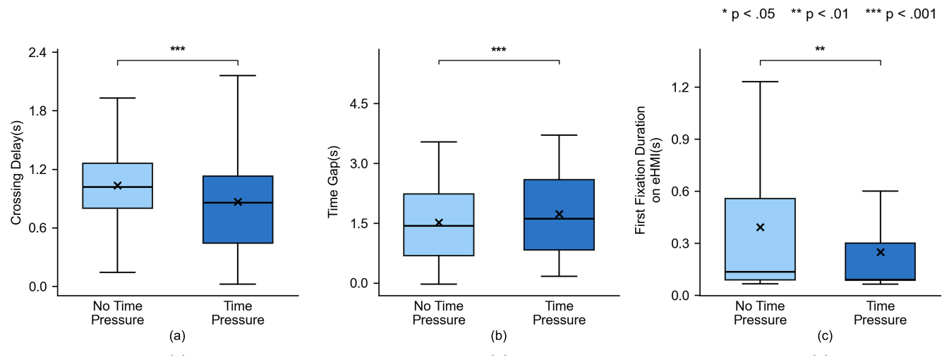
Figure 12. Boxplots of the main effect of time pressure
The main effects of time pressure are shown in Figure 12. For the behavioral measures, the main effect on crossing delay was significant (F(1, 552) = 32.345, p < 0.001); crossing delay was shorter under time pressure than without it (M = −0.195, SE = 0.037, t(505) = −5.292, p < 0.001). The main effect on the time gap was significant (F(1, 608) = 54.485, p < 0.001), with a larger time gap under time pressure (M = 0.221, SE = 0.032, t(549) = 6.980, p < 0.001). Time pressure led participants to decide quickly and set off sooner; because they initiated crossing while the vehicle was still farther away, the time gap at crossing completion was larger, reflecting a strategy of accepting greater risk of crossing ahead of the vehicle rather than waiting for a larger gap.
For the eye-movement measures, the main effect on the first fixation duration on the eHMI in the waiting stage was significant (F(1, 148) = 11.177, p = 0.001); this duration was shorter under time pressure (M = −0.129, SE = 0.041, t(162) = −3.113, p = 0.002), as participants processed the eHMI faster. For the physiological measures, mean pupil diameter was larger under time pressure (F(1, 551) = 24.037, p < 0.001) and the pupil diameter change in the waiting stage was smaller (F(1, 553) = 8.363, p = 0.004); the maximum pupil diameter (F(1, 609) = 4.554, p = 0.033) and mean pupil diameter (F(1, 609) = 11.794, p < 0.001) in the crossing stage were both larger. Time pressure raised arousal throughout the trial, pointing to a decision driven more by emotion.
Main Effect of Traffic Density
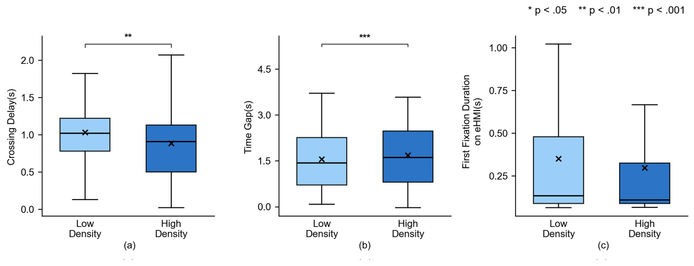
Figure 13. Boxplots of the main effect of traffic density
The main effects of traffic density are shown in Figure 13. The main effect on crossing delay was significant (F(1, 551) = 10.850, p = 0.001); crossing delay was shorter under high density than under low density (M = −0.113, SE = 0.036, t(575) = −3.173, p = 0.002). The main effect on the time gap was significant (F(1, 608) = 10.475, p = 0.001), with a larger time gap under high density (M = 0.097, SE = 0.030, t(629) = 3.212, p = 0.001). Perceived safety (Q1) was also significant (F(1, 609) = 4.924, p = 0.027), with higher ratings under high density (M = 0.200, SE = 0.090, t(616) = 2.219, p = 0.027). Both the behavioral and the subjective results under high density run against the intuition that higher density means higher risk. This may be because the smaller gaps between vehicles in dense traffic make crossable gaps easier to identify, which helps participants pick up the stopping signal quickly .
For the eye-movement measures, the main effect on the first fixation duration on the eHMI in the crossing stage was significant (F(1, 141) = 7.951, p = 0.006); this duration was shorter under high density than under low density (M = −0.243, SE = 0.088, t(143) = −2.756, p = 0.007). Under low density participants needed to read the eHMI to support the decision, whereas under high density the eHMI worked more as a quick confirmation that needed little reading.
Interactions with Time Pressure and Traffic Density
The interaction of eHMI transparency and time pressure was significant for one measure, the pupil diameter change in the waiting stage, and marginal for perceived helpfulness (Q3; p = 0.068). The interaction on the pupil diameter change in the waiting stage was significant (F(3, 552) = 3.695, p = 0.012): only under time pressure was the change for no eHMI smaller than for Level 3 (M = −0.066, SE = 0.022, t(572) = −2.934, p = 0.021) and marginally smaller than for Level 1 (M = −0.056, SE = 0.022, p = 0.057). Under time pressure, then, a higher transparency eHMI gave guiding information that eased a saturated state of attention.
The interaction of eHMI transparency and traffic density was significant for the first fixation duration on the eHMI in the waiting stage (F(2, 150) = 7.173, p = 0.001): only under high density was the duration for Level 3 longer than for Level 1 (M = 0.263, SE = 0.075, t(155) = 3.512, p = 0.002), with no difference among the levels under low density. A higher transparency eHMI was harder to process in dense traffic and called for more initial processing time.
The interactions of deceleration rate with time pressure and with traffic density were both significant for perceived safety (Q1; p < 0.05). In the deceleration × time pressure interaction, low deceleration gave lower perceived safety than high deceleration whether or not there was time pressure, but the gap was larger without time pressure (no pressure: M = −0.949, SE = 0.141, t(631) = −6.707, p < 0.001; with pressure: M = −0.446, SE = 0.134, t(623) = −3.338, p = 0.001); under time pressure participants were more eager to cross and were less sensitive to the risk signalled by urgency. In the deceleration × density interaction, high deceleration gave higher perceived safety than low deceleration at both densities, but the gap was larger under low density (low density: M = −0.912, SE = 0.143, t(633) = −6.371, p < 0.001; high density: M = −0.478, SE = 0.132, t(625) = −3.626, p < 0.001). Under low density the larger gaps between vehicles leave fewer reference cues, so participants relied more on deceleration and gained more perceived safety from high deceleration; under high density the smaller gaps provided extra reference cues that partly replaced deceleration as a source of information. The interaction of time pressure and traffic density was significant for the first fixation duration on the eHMI in the waiting stage (F(1, 153) = 4.558, p = 0.034): under low density the duration was shorter under time pressure than without it (M = −0.244, SE = 0.068, t(150) = −3.601, p < 0.001), with no difference under high density. Under low density participants read the eHMI to support the decision and time pressure speeded up that reading, whereas under high density the eHMI worked as a trigger signal and was little affected by time pressure.
Predictive Model of Crossing Success
After the 56 trials with early crossings in which the eHMI had not appeared were removed, the analysis was based on 772 valid trials. A binary logistic regression tested the effects of eHMI transparency, deceleration rate, time pressure, and traffic density on crossing success. The model fit well (omnibus χ²(6) = 347.421, p < 0.001; Nagelkerke R² = 0.628; Hosmer–Lemeshow χ²(8) = 5.528, p = 0.700). The eHMI factor was significant (Wald = 126.282, p < 0.001); all three eHMI conditions raised the probability of success relative to no eHMI (Exp(B) = 3.627–4.162, p < 0.001), with no difference among them (p > 0.05). Deceleration rate (p < 0.001) and time pressure (p = 0.022) were both significant; traffic density was not (p = 0.449).
Because traffic density had no significant effect on crossing success (note that its significant effects in the GLMM analyses above concerned continuous outcomes such as crossing delay and the time gap, not the binary success outcome) and would add complexity without improving explanatory power, it was dropped, and the three eHMI conditions were combined to build a simpler model (eHMI: 0 = none, 1 = present; deceleration rate: 0 = low, 1 = high; time pressure: 0 = none, 1 = present). The results are given in Table 1.
Table 1. Binary Logistic Regression: Variables in the Equation
Predictor | B | SE | Wald | df | p | Exp(B)
eHMI | 3.889 | 0.346 | 126.537 | 1 | < .001 | 48.869
Deceleration rate | 4.789 | 0.535 | 80.204 | 1 | < .001 | 120.129
Time pressure | 0.710 | 0.311 | 5.217 | 1 | .022 | 2.033
Constant | −2.111 | 0.339 | 38.871 | 1 | < .001 | .121
Note. Variables entered in Step 1: eHMI, deceleration rate, time pressure.
The simpler model fit well overall (χ²(3) = 345.494, p < 0.001), with Nagelkerke R² = 0.626 and a non-significant Hosmer–Lemeshow test (χ²(4) = 2.066, p = 0.724), comparable with the full model. All three predictors were significant: eHMI (B = 3.889, SE = 0.346, Wald = 126.537, p < 0.001, Exp(B) = 48.869), deceleration rate (B = 4.789, SE = 0.535, Wald = 80.204, p < 0.001, Exp(B) = 120.129), and time pressure (B = 0.710, SE = 0.311, Wald = 5.217, p = 0.022, Exp(B) = 2.033). The regression equation was:
P(crossing success) = 1 / (1 + e^−(−2.111 + 3.889 × eHMI + 4.789 × deceleration rate + 0.710 × time pressure))
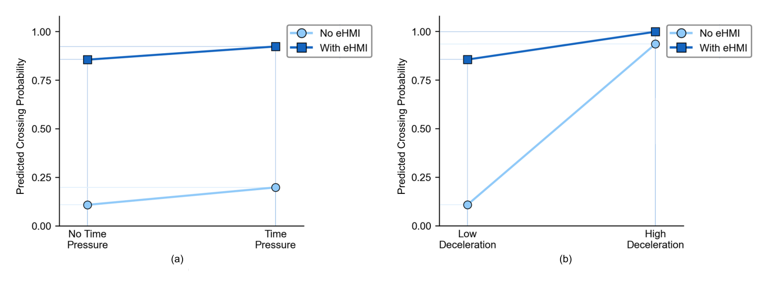
Figure 14. Predictive model of crossing success probability
The model is illustrated in Figure 14. The mean predicted probability of a successful crossing was about 0.95 with an eHMI andabout 0.55 without one. Without an eHMI, the probability rose sharply from low to high deceleration; with an eHMI, it stayed high and rose only slightly across the two deceleration rates, so the eHMI buffered much of the cost of low deceleration. With an eHMI, the probability stayed high under both time pressure conditions; without an eHMI, time pressure had some positive effect on success, but a much weaker one than the eHMI and deceleration rate. The eHMI and deceleration rate were therefore the main factors behind crossing success, with time pressure a secondary one.
Discussion
Effect of eHMI Transparency on Pedestrian Decisions
eHMI transparency affected subjective ratings and crossing behavior, but the two sets of outcomes responded to information depth in different ways. All three subjective ratings increased with transparency. Perceived safety levelled off between Level 2 and Level 3, while interface comprehensibility and perceived helpfulness continued to rise to Level 3. This stepwise pattern matches what the SAT model would predict: presenting perception, comprehension, and projection information in sequence helps pedestrians build a progressively fuller picture of vehicle intent (Chen et al., 2018). The behavioral picture was more constrained. Level 3 lengthened crossing delay relative to Level 1, reflecting the processing cost of a richer display before a decision could be committed to. Once in motion, Level 3 participants crossed faster because the countdown and progress bar created urgency that compressed the movement phase. The behavioral cost of higher transparency was therefore limited to the decision stage and did not carry over into execution. Eye-movement data support this reading: Level 2 and Level 3 attracted longer initial fixations during waiting, reflecting greater processing demand at the start of the trial. Pupil data showed a different pattern: mean pupil diameter during crossing dropped with the presence of any eHMI but did not differ across transparency levels, indicating that the arousal benefit of the interface depended on whether it was present, not on how much information it conveyed. Once an interface provides detection and comprehension cues, adding projection information provides limited further behavioral or physiological benefit, in support of H1.
The gap between subjective and behavioral outcomes is worth examining closely. Comprehensibility and perceived helpfulness rose from Level 1 to Level 3 without interruption, yet behavioral performance levelled off at Level 2. Pedestrians judged Level 3 to be more useful and more understandable than Level 2, but that judgment was not reflected in how they crossed. A similar pattern has been observed in automation research, where greater subjective situation awareness does not reliably produce better behavioral outcomes (Endsley, 1995), and parallels findings in technology acceptance where perceived usefulness outpaces actual behavioral change (Davis, 1989). The practical consequence for eHMI evaluation is that designs assessed through subjective ratings alone will appear more effective than they are at higher transparency levels. Behavioral and physiological measures are necessary to identify where additional information stops improving crossing performance.
The eHMI effects described above were not independent of the vehicle's motion: they were shaped by the deceleration signal that the vehicle provided. Deceleration rate was the strongest predictor of crossing success in the logistic regression (Exp(B) = 120.129), more than twice the effect of eHMI presence (Exp(B) = 48.869), which establishes vehicle kinematics as the primary determinant of whether a crossing attempt succeeds. Under high deceleration, the time gap was large and perceived safety was high, as pedestrians have been shown to read deceleration rate as an informal signal of stopping intent (Ackermann et al., 2019). Under low deceleration, participants set off sooner but with a substantially smaller time gap, and mean pupil diameter during crossing was higher, suggesting a response driven by urgency rather than by confidence in the vehicle's intent. An eHMI always operates against a motion signal that is itself more or less informative, and its contribution to crossing behavior will therefore vary accordingly.
The interaction between transparency and deceleration rate shows that the value of an eHMI is conditional on how clearly the vehicle's motion signals intent. Under high deceleration, any eHMI shortened crossing delay and enlarged the time gap, with no difference among the three transparency levels. The eye-movement and physiological data support a confirmation role: fixation duration in the waiting stage was longer without an eHMI, showing that the interface reduced the need to search the environment; fixation in the crossing stage duration was shorter for Level 3 than for Level 2, suggesting that projection information was used efficiently when cognitive load was low; and maximum pupil diameter during crossing was lower with Level 2 and Level 3 than without any eHMI, indicating reduced arousal when the motion cue was already clear. Under low deceleration, all behavioral effects reversed. Every eHMI condition lengthened crossing delay relative to no eHMI, Level 3 by the largest margin, and the time gap shrank rather than grew. None of the eye-movement or pupil distinctions observed under high deceleration were significant under low deceleration, indicating that the eHMI neither reduced visual search nor eased arousal when the motion cue was ambiguous. The most likely explanation is that when the vehicle's deceleration does not clearly signal intent, the interface information must be evaluated against an uncertain motion referent, a verification process that takes time and grows more costly as information depth increases (Dey et al., 2021). Lee et al. (2022) found that eHMI benefits were smaller under a vehicle approach at low speed, and Song et al. (2024) showed that an eHMI mismatched with vehicle kinematics reduced perceived safety. The present data add to those findings: the cost scales with information depth: the transparency levels were equivalent under high deceleration, but under low deceleration the behavioral penalty grew from Level 1 to Level 3. An eHMI works as a confirmer of clear motion and becomes a source of interference when the motion it is meant to support is itself unclear, which is the pattern H2 predicted.
Time pressure and traffic density shaped the timing and subjective experience of crossing without determining whether a crossing attempt succeeded. Under time pressure, participants initiated crossing sooner and completed it with a larger time gap, reflecting a strategy of crossing while the vehicle was still farther away rather than waiting for it to get closer. Pupil diameter was elevated throughout and the within-stage pupil change during waiting was smaller under time pressure, pointing to a sustained state of high arousal typical of urgency-driven decisions (Almeida et al., 2024; Cœugnet et al., 2019). First fixation duration on the eHMI was shorter under time pressure, indicating that pedestrians extracted interface information more quickly rather than disengaging from the display. Traffic density produced a counterintuitive pattern: under high density, crossing delay was shorter, the time gap was larger, and perceived safety was higher. One possible explanation is that closely spaced vehicles regularize the traffic rhythm and make crossing opportunities more legible, but this account is speculative and would require gap acceptance data to test directly. First fixation duration on the eHMI in the crossing stage was shorter under high density, suggesting that the interface served mainly as a confirmation trigger when the traffic environment was already structured, as Kalantarov et al. (2018) also found. The absence of a density effect on crossing success in the logistic regression (p = 0.449) confirms that density influenced the manner and timing of crossing without affecting the probability of a safe outcome.
The interactions involving time pressure and traffic density reveal two distinct patterns: one concerning how contextual demands change the way pedestrians use the eHMI, and another concerning how those demands alter reliance on the vehicle's motion cue. Regarding eHMI use, under time pressure the no eHMI condition showed a smaller pupil change in the waiting stage than Level 3, suggesting that projection information helped pedestrians manage attentional load when time was short, a benefit that was absent without time pressure. Under high density, Level 3 attracted a longer initial fixation than Level 1 in dense traffic but not in sparse traffic, indicating that projection level content became harder to process when surrounding vehicles competed for attention. The time pressure by density interaction for first fixation duration fits this picture: in sparse traffic, time pressure shortened how long pedestrians read the eHMI, while in dense traffic time pressure made no difference, suggesting the eHMI functioned as an active information source in sparse traffic and as a minimal trigger in dense traffic. Regarding the motion cue, the perceived safety gap between high and low deceleration was wider without time pressure and under low density. Pedestrians were more sensitive to deceleration differences when they had time to observe the vehicle and when fewer surrounding vehicles provided competing reference cues. Time pressure and high density both reduced that sensitivity, suggesting that urgency and a visually demanding environment redirect attention away from the primary motion signal (Dhoke & Choudhary, 2023). Both the eHMI and the vehicle's motion were therefore sensitive to the wider crossing context, as H3 predicted.
Across all conditions, vehicle deceleration set the upper limit on what an eHMI could contribute. When deceleration was strong, any eHMI improved crossing regardless of information depth; when deceleration was weak, the interface made things worse, and more so as information depth increased. The predictive model captures this quantitatively: the deceleration coefficient was more than twice the size of the eHMI coefficient in predicting crossing success. From a design standpoint, the priority should be ensuring that vehicle kinematics communicate stopping intent clearly, through earlier or stronger deceleration, before relying on the interface to close the gap. Where an eHMI is used, a medium transparency design is a reasonable default: it improves on a minimal display across all subjective measures and does not introduce the cost of initiating a decision observed at the highest transparency level. In conditions where the motion cue is weak, time pressure is high, or traffic is dense, the processing cost of richer information increases while the benefit diminishes, so reducing rather than enriching the displayed content is the more appropriate response. The data point toward eHMI systems that adjust their output to match the vehicle's real-time motion and the pedestrian's crossing context, rather than presenting a fixed level of information regardless of conditions.
Conclusion
Whether an eHMI improves pedestrian crossing depends on whether the vehicle's deceleration already signals its intent clearly. Under strong deceleration, any eHMI shortened crossing delay and enlarged the time gap, with physiological arousal lower than in the no eHMI condition. Under weak deceleration, the same interface increased delay and shrank the time gap, and the cost grew as information depth increased. The logistic regression reinforces this ordering: deceleration rate predicted crossing success more than twice as strongly as eHMI presence. Subjective ratings and behavioral outcomes also diverged: pedestrians rated higher transparency interfaces as more comprehensible and more useful, yet crossing behavior levelled off at medium transparency. Studies that assess eHMI effectiveness through subjective ratings alone will therefore overestimate the benefit of richer displays. Time pressure and high traffic density both accelerated crossing initiation without changing the probability of a safe outcome, and both reduced how sensitively pedestrians responded to the vehicle's deceleration. The design implication is that making vehicle deceleration more conspicuous should precede adding interface information, and that display content should be adjusted to how clearly the vehicle's motion communicates intent rather than held constant across conditions.
Several features of the design limit how far the findings extend. The scenario was restricted to a straight urban road in daytime, without intersections, turning vehicles, or simultaneous interactions with multiple automated vehicles; testing on real roads and under varied conditions is needed before the results can be applied broadly. Participants were predominantly young adults, so the results may not apply to older pedestrians or children. The study captured immediate responses to a visual interface and did not examine how exposure over time shapes trust or behavioral adaptation, nor the potential contribution of auditory or tactile cues. Whether adaptive eHMI designs that vary information depth according to real-time vehicle kinematics and traffic conditions produce the benefits this pattern implies remains an open empirical question.
References
Ackermann, C., Beggiato, M., Bluhm, L.-F., Löw, A., & Krems, J. F. (2019). Deceleration parameters and their applicability as informal communication signal between pedestrians and automated vehicles. Transportation Research Part F: Traffic Psychology and Behaviour, 62, 757–768. https://doi.org/10.1016/j.trf.2019.03.006
Alhawiti, A., Kwigizile, V., Oh, J.-S., Asher, Z. D., Hakimi, O., Aljohani, S., & Ayantayo, S. (2024). The effectiveness of eHMI displays on pedestrian–autonomous vehicle interaction in mixed-traffic environments. Sensors, 24(15), Article 15. https://doi.org/10.3390/s24155018
Almeida, R., Sousa, E., Machado, D., Pereira, F., Faria, S., & Freitas, E. (2024). Analysis of the interaction between humans and autonomous vehicles equipped with external human–machine interfaces: The effect of an experimental reward mechanism on pedestrian crossing behavior in a virtual environment. Sustainability, 16(8), 3236. https://doi.org/10.3390/su16083236
Bindschädel, J., Krems, I., & Kiesel, A. (2021). Interaction between pedestrians and automated vehicles: Exploring a motion-based approach for virtual reality experiments. Transportation Research Part F: Traffic Psychology and Behaviour, 82, 316–332. https://doi.org/10.1016/j.trf.2021.08.018
Bos, J. E., De Vries, S. C., Van Emmerik, M. L., & Groen, E. L. (2010). The effect of internal and external fields of view on visually induced motion sickness. Applied Ergonomics, 41(4), 516–521. https://doi.org/10.1016/j.apergo.2009.11.007
Chang, C.-M., Toda, K., Sakamoto, D., & Igarashi, T. (2017). Eyes on a car: An interface design for communication between an autonomous car and a pedestrian. Proceedings of the 9th International Conference on Automotive User Interfaces and Interactive Vehicular Applications, AutomotiveUI '17, 65–73. https://doi.org/10.1145/3122986.3122989
Chen, J. Y. C., Lakhmani, S. G., Stowers, K., Selkowitz, A. R., Wright, J. L., & Barnes, M. (2018). Situation awareness-based agent transparency and human-autonomy teaming effectiveness. Theoretical Issues in Ergonomics Science, 19(3), 259–282. https://doi.org/10.1080/1463922X.2017.1315750
Cœugnet, S., Cahour, B., & Kraiem, S. (2019). Risk-taking, emotions and socio-cognitive dynamics of pedestrian street-crossing decision-making in the city. Transportation Research Part F: Traffic Psychology and Behaviour, 65, 141–157. https://doi.org/10.1016/j.trf.2019.07.011
Dey, D., Matviienko, A., Berger, M., Pfleging, B., Martens, M., & Terken, J. (2021). Communicating the intention of an automated vehicle to pedestrians: The contributions of eHMI and vehicle behavior. It - Information Technology, 63(2), 123–141. https://doi.org/10.1515/itit-2020-0025
Dhoke, A., & Choudhary, P. (2023). Is there a relationship between time pressure and pedestrian non-compliance? A systematic review. Transportation Research Part F: Traffic Psychology and Behaviour, 93, 68–89. https://doi.org/10.1016/j.trf.2023.01.001
Diels, C., & Thompson, S. (2018). Information expectations in highly and fully automated vehicles. In N. A. Stanton (Ed.), Advances in human aspects of transportation (Vol. 597, pp. 742–748). Springer International Publishing. https://doi.org/10.1007/978-3-319-60441-1_71
Eisma, Y. B., Van Bergen, S., Ter Brake, S. M., Hensen, M. T. T., Tempelaar, W. J., & De Winter, J. C. F. (2019). External human–machine interfaces: The effect of display location on crossing intentions and eye movements. Information, 11(1), 13. https://doi.org/10.3390/info11010013
Eisma, Y. B., van Gent, L., & de Winter, J. (2023). Should an external human-machine interface flash or just show text? A study with a gaze-contingent setup. Transportation Research Part F: Traffic Psychology and Behaviour, 97, 140–154. https://doi.org/10.1016/j.trf.2023.07.005
Gupta, S., Vasardani, M., Lohani, B., & Winter, S. (2019). Pedestrian's risk-based negotiation model for self-driving vehicles to get the right of way. Accident Analysis & Prevention, 124, 163–173. https://doi.org/10.1016/j.aap.2019.01.003
Ha, T., Kim, S., Seo, D., & Lee, S. (2020). Effects of explanation types and perceived risk on trust in autonomous vehicles. Transportation Research Part F: Traffic Psychology and Behaviour, 73, 271–280. https://doi.org/10.1016/j.trf.2020.06.021
Kalantarov, S., Riemer, R., & Oron-Gilad, T. (2018). Pedestrians' road crossing decisions and body parts' movements. Transportation Research Part F: Traffic Psychology and Behaviour, 53, 155–171. https://doi.org/10.1016/j.trf.2017.09.012
Lau, M., Nguyen, H. P., Jipp, M., & Oehl, M. (2024). From visions to reality: Investigating the interplay of vehicle kinematics and light-band eHMI in a real vehicle study. Transportation Research Part F: Traffic Psychology and Behaviour, 103, 79–95. https://doi.org/10.1016/j.trf.2024.03.004
Lee, Y. M., Madigan, R., Uzondu, C., Garcia, J., Romano, R., Markkula, G., & Merat, N. (2022). Learning to interpret novel eHMI: The effect of vehicle kinematics and eHMI familiarity on pedestrian's crossing behavior. Journal of Safety Research, 80, 270–280. https://doi.org/10.1016/j.jsr.2021.12.010
Li, C., Wang, Z., Yang, B., Guan, M., Huang, C., & Nakano, K. (2023). The impact of system transparency on passenger's quality of experience in highly automated driving. 2023 IEEE Intelligent Vehicles Symposium (IV), 1–7. https://doi.org/10.1109/IV55152.2023.10186700
Lobjois, R., & Cavallo, V. (2007). Age-related differences in street-crossing decisions: The effects of vehicle speed and time constraints on gap selection in an estimation task. Accident Analysis & Prevention, 39(5), 934–943. https://doi.org/10.1016/j.aap.2006.12.013
Markkula, G., Madigan, R., Nathanael, D., Portouli, E., Lee, Y. M., Dietrich, A., Billington, J., Schieben, A., & Merat, N. (2020). Defining interactions: A conceptual framework for understanding interactive behaviour in human and automated road traffic. Theoretical Issues in Ergonomics Science, 21(6), 728–752. https://doi.org/10.1080/1463922X.2020.1736686
Millard-Ball, A. (2018). Pedestrians, autonomous vehicles, and cities. Journal of Planning Education and Research, 38(1), 6–12. https://doi.org/10.1177/0739456X16675674
Nordhoff, S., De Winter, J., Kyriakidis, M., Van Arem, B., & Happee, R. (2018). Acceptance of driverless vehicles: Results from a large cross-national questionnaire study. Journal of Advanced Transportation, 2018, 1–22. https://doi.org/10.1155/2018/5382192
Oliveira, L., Burns, C., Luton, J., Iyer, S., & Birrell, S. (2020). The influence of system transparency on trust: Evaluating interfaces in a highly automated vehicle. Transportation Research Part F: Traffic Psychology and Behaviour, 72, 280–296. https://doi.org/10.1016/j.trf.2020.06.001
Oudshoorn, M., de Winter, J., Bazilinskyy, P., & Dodou, D. (2021). Bio-inspired intent communication for automated vehicles. Transportation Research Part F: Traffic Psychology and Behaviour, 80, 127–140. https://doi.org/10.1016/j.trf.2021.03.021
Pekkanen, J., Giles, O. T., Lee, Y. M., Madigan, R., Daimon, T., Merat, N., & Markkula, G. (2022). Variable-drift diffusion models of pedestrian road-crossing decisions. Computational Brain & Behavior, 5(1), 60–80. https://doi.org/10.1007/s42113-021-00116-z
Rettenmaier, M., Albers, D., & Bengler, K. (2020). After you?! – Use of external human-machine interfaces in road bottleneck scenarios. Transportation Research Part F: Traffic Psychology and Behaviour, 70, 175–190. https://doi.org/10.1016/j.trf.2020.03.004
Song, Y., Chen, X., Zhang, J., Tian, J., Zhang, L., Ma, G., & Zhuang, X. (2024). Road-crossing behavior and safety of pedestrians facing autonomous vehicles with an acceleration indicator eHMI in VR traffic flow. Transportation Research Part F: Traffic Psychology and Behaviour, 107, 589–606. https://doi.org/10.1016/j.trf.2024.09.023
Taylor, S., Wang, M., & Jeon, M. (2023). Reliable and transparent in-vehicle agents lead to higher behavioral trust in conditionally automated driving systems. Frontiers in Psychology, 14. https://doi.org/10.3389/fpsyg.2023.1121622
Tekkesinoglu, S., Habibovic, A., & Kunze, L. (2024). Advancing explainable autonomous vehicle systems: A comprehensive review and research roadmap (arXiv:2404.00019). arXiv. https://doi.org/10.48550/arXiv.2404.00019
Tran, T. T. M., Parker, C., Hoggenmüller, M., Wang, Y., & Tomitsch, M. (2024). Exploring the impact of interconnected external interfaces in autonomous vehicles on pedestrian safety and experience. Proceedings of the 2024 CHI Conference on Human Factors in Computing Systems, CHI '24, 1–17. https://doi.org/10.1145/3613904.3642118
Zang, J., & Jeon, M. (2025). When more is less: Finding the optimal balance of intelligent agents' transparency in level 3 automated vehicles. International Journal of Human-Computer Studies, 193, 103384. https://doi.org/10.1016/j.ijhcs.2024.103384
Zhou, S., Sun, X., Liu, B., & Burnett, G. (2022). Factors affecting pedestrians' trust in automated vehicles: Literature review and theoretical model. IEEE Transactions on Human-Machine Systems, 52(3), 490–500. https://doi.org/10.1109/THMS.2021.3112956

