Dane Miller

Cole Cooper

Blake Koblitz

**CIS 560 Database System Concepts**

Fall 2012

**Homework 8 of 10: Machine Problem (MP8) /**

**Project Part 2 of 3**

Database GUIs (Front-End), Query Processing

Our GUI is accessed using a web browser, and can be viewed at:

[**http://people.cis.ksu.edu/~colecoop/cis560/cis560_finalProject/index.php**](http://people.cis.ksu.edu/~colecoop/cis560/cis560_finalProject/index.php)

The functions are currently accessed via drop-down menus.

Select a Year:

Select a Commodity:

Sort Output Values From:

Submit: Triggers a Javascript function that collects the values selected in the input fields, converts them into a MySQL function, and submits them to the database. The results are displayed in the chromatic map, as well as the list form below the search tool. We will combine the chromatic map and list views into a single tab-able GUI in later versions.

At the bottom of the page is a link to add a new record. If “Cancel” is selected, the form does nothing and returns to the previous page. If “Save Record” is selected, a PHP form is loaded that processes the data and submits it to the database. We do not currently have any invalid input values, since the Commodity type (and Unit of Measurement) can potentially be almost anything.

[**http://people.cis.ksu.edu/~colecoop/cis560/cis560_finalProject/addRecord.php**](http://people.cis.ksu.edu/~colecoop/cis560/cis560_finalProject/addRecord.php)

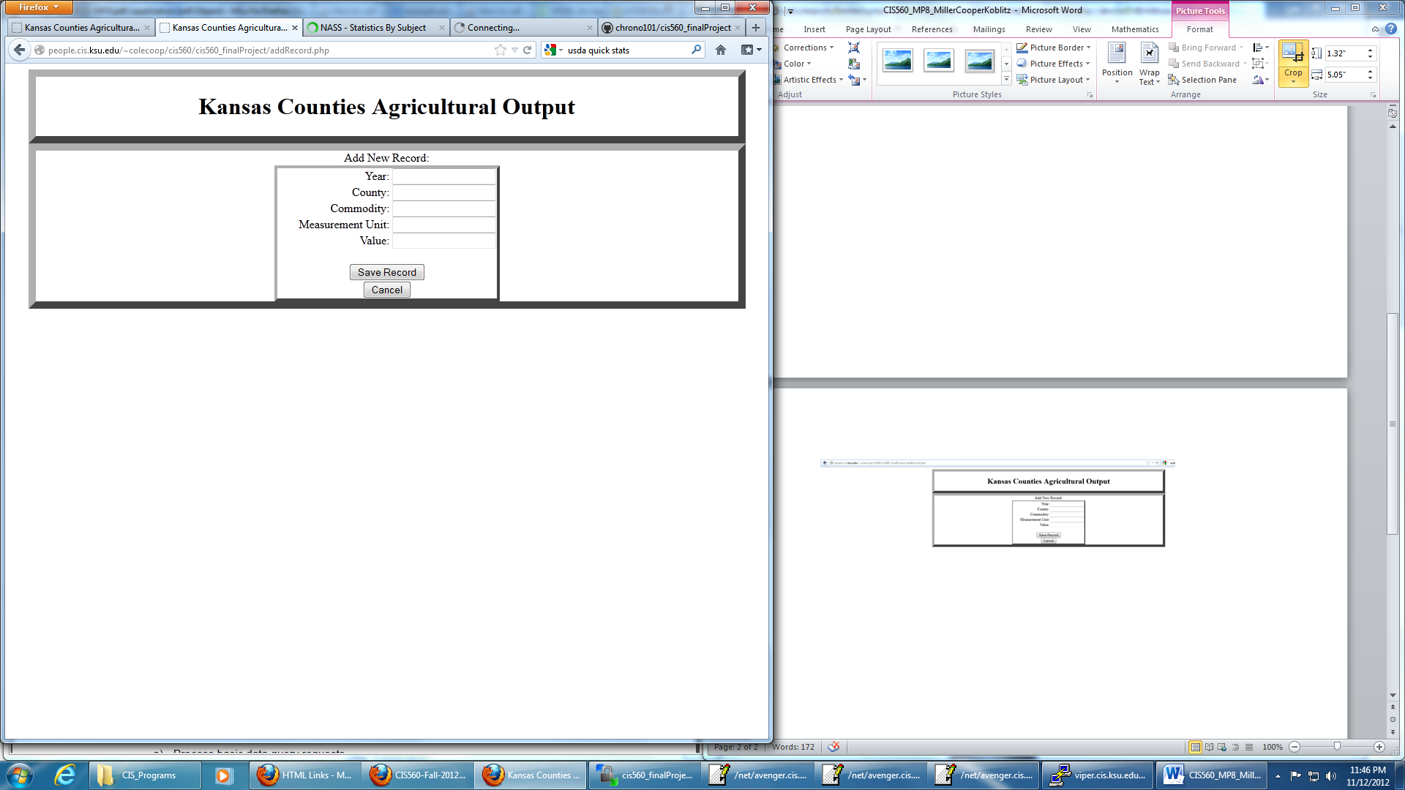

[**http://people.cis.ksu.edu/~colecoop/cis560/cis560_finalProject/index.php**](http://people.cis.ksu.edu/~colecoop/cis560/cis560_finalProject/index.php)

