

[Title of the Revolution, for example: How Denmark Built the World’s Best Cycling Cities]
By [Author Full Name]
[Country or Global] · [Category, for example: Climate, Transit, Health]
[Submission Date]

Fill in the bracketed text above. This title page becomes the credit page for your video and CR write-up. Delete this note before submitting.

Table of Contents
Only needed for a long CR. If your write-up is short, delete this page. Otherwise, right-click the gray box below and choose "Update Field" once your headings are written, and Word will build the list for you automatically.
Summary 1
The Problem 1
The Issue 1
Who It Affects 1
Regional Breakdown 1
The Revolution 2
The Best-Case Example 2
The Solution 2
Closing 3

List of Acronyms
Acronym | Full Term
[WHO] | [World Health Organization]
[EV] | [Electric Vehicle]
[ ] | [ ]

How to Write Your CR
Read this page before you start writing. Delete it, along with the Table of Contents and List of Acronyms pages if you are not using them, before you submit.
Before you write
- Every CR follows the same shape: Summary, then The Problem, then The Revolution (best-case example, solution, closing). Use Heading 1 for these three sections, and Heading 2, 3 and 4 for anything smaller inside them.
- Page numbers start on the Summary page, not on the title page, table of contents or acronym list. That is already set up in this template. Do not add your own page numbers.
Write in plain English
1. Start every paragraph with the point, not the build-up.
Say the conclusion first, then explain it. If a paragraph is about why trees are green, the first sentence should say "Trees are green," not work up to it. See the diagram below for the full pattern.
2. One idea per paragraph.
If you find yourself starting a new idea, start a new paragraph too. Short paragraphs are easier to read on screen.
3. Use simple words.
Write the way you would explain it to a smart friend who does not work in this field. If you need a technical or complicated word, use it, then explain what it means in plain terms right after.
4. Spell out acronyms on first use.
The first time you use an acronym, write it in full with the short form in brackets, for example: World Health Organization (WHO). After that you can just write WHO. Add it to the List of Acronyms page too.
5. Prefer short sentences and active voice.
Example: "The government cut fuel subsidies in 2019" reads better than "Fuel subsidies were cut by the government in 2019."
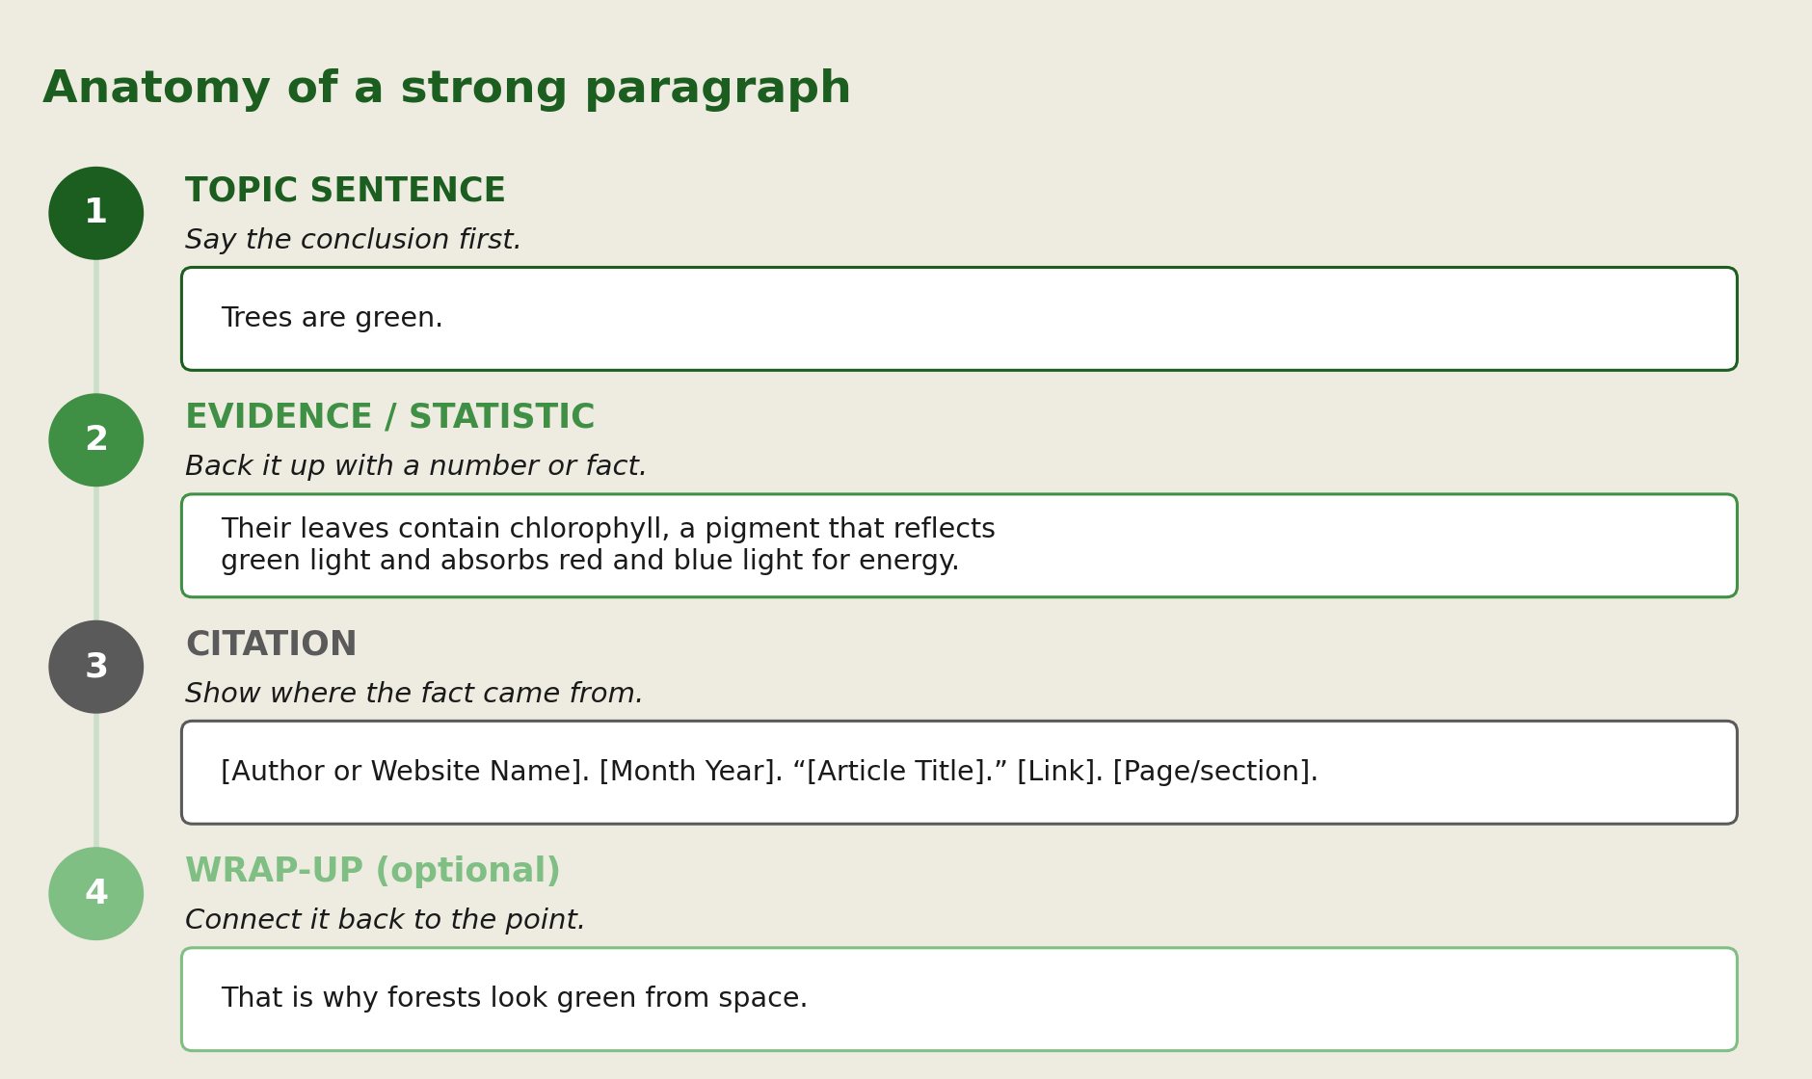
Back up every claim
Use real statistics, not vague statements like "many people." Cite every statistic and every direct claim you did not come up with yourself.
Footnote format
Use Word’s built-in footnotes (References tab, Insert Footnote). Format:
[Author or Website Name]. [Month Year]. “[Title of the Article or Publication].” [Link]. [Page or section number].
For the [Link] part: select the word "Link," right-click, choose Hyperlink, and paste the full web address in. Readers then click the single word "Link" instead of a long, messy web address. A working sample is on the next page, in the first footnote. Always test that your links actually open the right page before you submit.
Formatting checklist
• Every style you need (Heading 1 to 4, Normal, CR Box Heading, CR Box Text, CR Table Text, CR Caption, CR Sources) is already in the Home tab Styles gallery. Select text and click the style.
• Keep tables and figures between the two green lines, with the header row green and every source listed underneath.
• Put case studies in the green boxed format so they stand out from body text.
• A ready-to-copy blank box, table and figure are at the very end of this document.
• Replace every [bracketed] instruction with your own text, then delete the brackets.
• Before you submit: delete this guide page, and delete the Table of Contents and List of Acronyms pages if you did not use them.

Summary
[In 2 to 3 sentences, summarize the issue this CR covers and what the video or write-up will walk through. This is the hook, so make the stakes clear fast.]

The Problem

The Issue
[Describe the problem in depth. What is happening, where, and since when?]

Who It Affects
[Name the countries, regions or groups of people facing this issue and why it matters to them. Back claims with statistics and cite every one.]

Regional Breakdown
[Optional: break the impact down by region or demographic if it varies significantly.]

Key Data Point
[A single striking statistic that anchors the section, for example: X% of Y in Z by 2030.]

Table 1. [Short table title, for example: Emissions by sector, 2025]
[Category] | [Metric] | [Metric]
[Row label] | [Value] | [Value]
[Row label] | [Value] | [Value]
[Row label] | [Value] | [Value]
Sources: [Author or Website Name]. [Month Year]. “[Title of Article or Publication].” [Page or section number].

CASE STUDY: [Short case study title]
[1 to 2 short paragraphs describing a real, specific example of the problem, such as a person, city or event. Cite sources inline as footnotes just like body text.]

The Revolution

The Best-Case Example
[Pick the country or place that has handled this issue best. Explain what they did, how it worked, and why, with data.]

Figure 1. [Short chart title, for example: EV uptake vs. policy timeline]
[Insert chart, graph or photo here]
[If using a chart from an outside source, cite it in Sources below. If it is your own chart built from data, cite the data source instead.]
Sources: [Author or Website Name]. [Month Year]. “[Title of Article or Publication].” [Page or section number].

The Solution
[How can this best-case approach be applied elsewhere, in one country or globally? What would implementation look like, what impact should be expected, and what needs to happen: what pressure on government, what public discussion, what first steps.]

Closing
[Summarize the issue and the solution in 2 to 3 sentences. End by inspiring the reader or viewer to act: what can an individual, a community or a government do right now.]

Reusable blocks: copy and paste as needed
Copy any block below whenever you need an extra box, table or figure.

CASE STUDY : [Case study title]
[Case study text.]

Table : [Table title]
[Column] | [Column] | [Column]
[Row] | [Value] | [Value]
Sources: [Author or Website Name]. [Month Year]. “[Title of Article or Publication].” [Page or section number].

Figure : [Figure title]
[Insert chart, graph or photo here]
[Insert chart, graph or photo here.]
Sources: [Author or Website Name]. [Month Year]. “[Title of Article or Publication].” [Page or section number].

[Author or Website Name]. [Month Year]. “[Title of the Article or Publication].” [Link]. [Page or section number]. For example: UNHCR. June 2025. “Global Trends Report 2025.” Link. p. 12.
[Author or Website Name]. [Month Year]. “[Title of the Article or Publication].” [Link]. [Page or section number]. For example: UNHCR. June 2025. “Global Trends Report 2025.” Link. p. 12.
[Author or Website Name]. [Month Year]. “[Title of the Article or Publication].” [Link]. [Page or section number]. For example: UNHCR. June 2025. “Global Trends Report 2025.” Link. p. 12.

