Asset Management
End User Guide — Step-by-Step Instructions
Version 1.0.0.15 • July 2026

This guide explains how to deploy, configure, and use Asset Management in Microsoft 365 SharePoint Online and Microsoft Teams. UI screenshots are captured from https://chronodat.sharepoint.com/sites/ChronodatProdApps/spfx and stored in docs/user-guide/images/.

Screenshot index
File | Shows
01-dashboard.png | Dashboard — KPI cards and charts
02-all-assets.png | All Assets register with search and filters
03-assigned-to-me.png | Assets assigned to the signed-in user
04-available-assets.png | Assets available for assignment
05-assign-asset.png | Assign Asset operation
06-return-asset.png | Return Asset operation
07-book-asset.png | Book Asset for temporary use
08-request-asset.png | Request a new asset
09-scan-asset.png | Scan barcode or QR label
10-inventory.png | Record physical inventory scans
11-software-licenses.png | Software license tracking
12-maintenance.png | Maintenance records
13-reports.png | Report Builder
14-depreciation.png | Depreciation schedules
15-audit-log.png | Audit trail
16-categories.png | Categories lookup list
17-vendors.png | Vendors lookup list
18-locations.png | Locations lookup list
19-settings-general.png | Settings → General
20-settings-appearance.png | Settings → Appearance
21-settings-forms.png | Settings → Forms
22-settings-tags.png | Settings → Tags
23-settings-subscription.png | Settings → Subscription
24-settings-roles.png | Settings → Roles & Permissions

1. Getting Started
Asset Management is a SharePoint Framework (SPFx) web part for tracking hardware, software licenses, assignments, maintenance, depreciation, and inventory — all within a single modern interface on your SharePoint site.

1.1 Requirements
- Microsoft 365 SharePoint Online
- Modern browser: Edge, Chrome, Firefox, or Safari
- Site owner permission for initial setup and Settings
- Recommended: dedicated subsite so asset lists stay isolated
- Optional: Exchange Online mailbox for notification emails

1.2 Deploy the app (tenant administrator)
- Build or obtain sharepoint/solution/asset-management.sppkg (npm run ship).
- Upload the .sppkg to the SharePoint App Catalog.
- Deploy the package and make it available to sites.
- On the target site, confirm the app appears in Site contents.

1.3 Add the web part to a page
- Create or edit a modern SharePoint page.
- Add the Asset Management web part and publish.
- Open the page while signed in as a site owner.
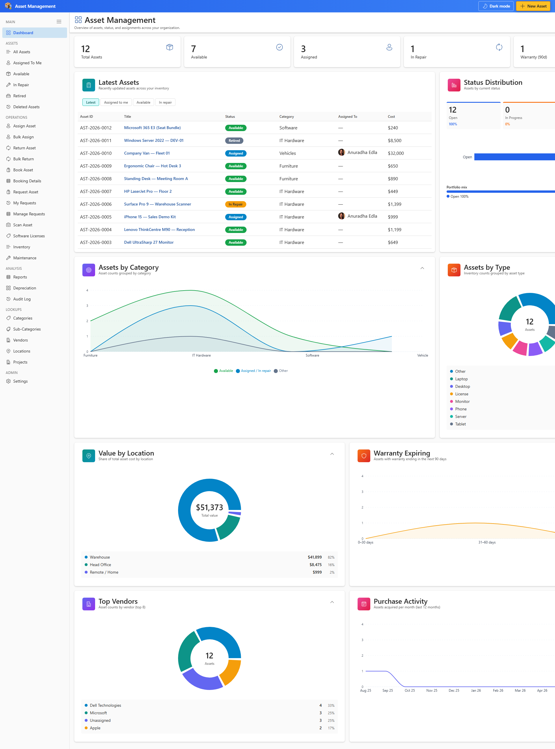
Figure 1 — Asset Management on a SharePoint page

1.4 Run first-time setup
- Click Complete Setup on the banner when the web part loads.
- Wait while lists (AM_Assets, lookups, settings) are created and seed data is applied.
- Confirm the banner shows that lists are ready.
- Open Settings → General to set the app name.
- Open Settings → Appearance to choose theme and colors.

1.5 Roles and permissions
Role | Typical user | Can do | Cannot do
Site owner | SharePoint site collection owner | Run Complete Setup, manage list permissions, open Settings | Approve Graph Mail.Send (tenant admin)
App administrator | IT asset manager added in Settings | Open Settings, manage lookups, workflows, tags, forms | Override SharePoint list security without site owner
Asset manager | Operations lead | Create and edit assets, assign, return, run reports | Open Settings unless granted app administrator
Asset viewer | Staff, auditor | View dashboard, lists, export CSV | Create or edit assets without list permissions

SharePoint list permissions on AM_Assets and lookup lists control create, edit, and delete. Settings → Roles & Permissions controls which pages appear in the UI for each app role.

2. Application Tour

2.1 Top bar
- App name and brand icon (Settings → General)
- Procedure link — optional URL to your asset policy document
- Dark mode toggle — stored per browser
- Create Asset — opens the new asset form
- User profile pill when SharePoint chrome is hidden

2.2 Sidebar navigation
Section | Page | Purpose
MAIN | Dashboard | KPI cards, charts, recent activity
ASSETS | All Assets | Full register with search and export
ASSETS | Assigned To Me / Available / In Repair / Retired | Filtered lifecycle views
OPERATIONS | Assign / Return / Book / Request | Day-to-day asset workflows
OPERATIONS | Scan Asset / Inventory | Barcode and physical inventory
OPERATIONS | Software Licenses / Maintenance | License seats and service records
ANALYSIS | Reports / Depreciation / Audit Log | Reporting and compliance trail
LOOKUPS | Categories / Vendors / Locations / Projects | Master data
ADMIN | Settings | Site owner and app administrator configuration


Figure 2 — Dashboard

3. Managing Assets — Step by Step

3.1 Browse the register
- Open All Assets from the sidebar.
- Use search to find assets by ID, title, serial number, or tag.
- Switch table, list, or card view.
- Filter by status, category, location, or assignee.
- Export filtered results to CSV when available.
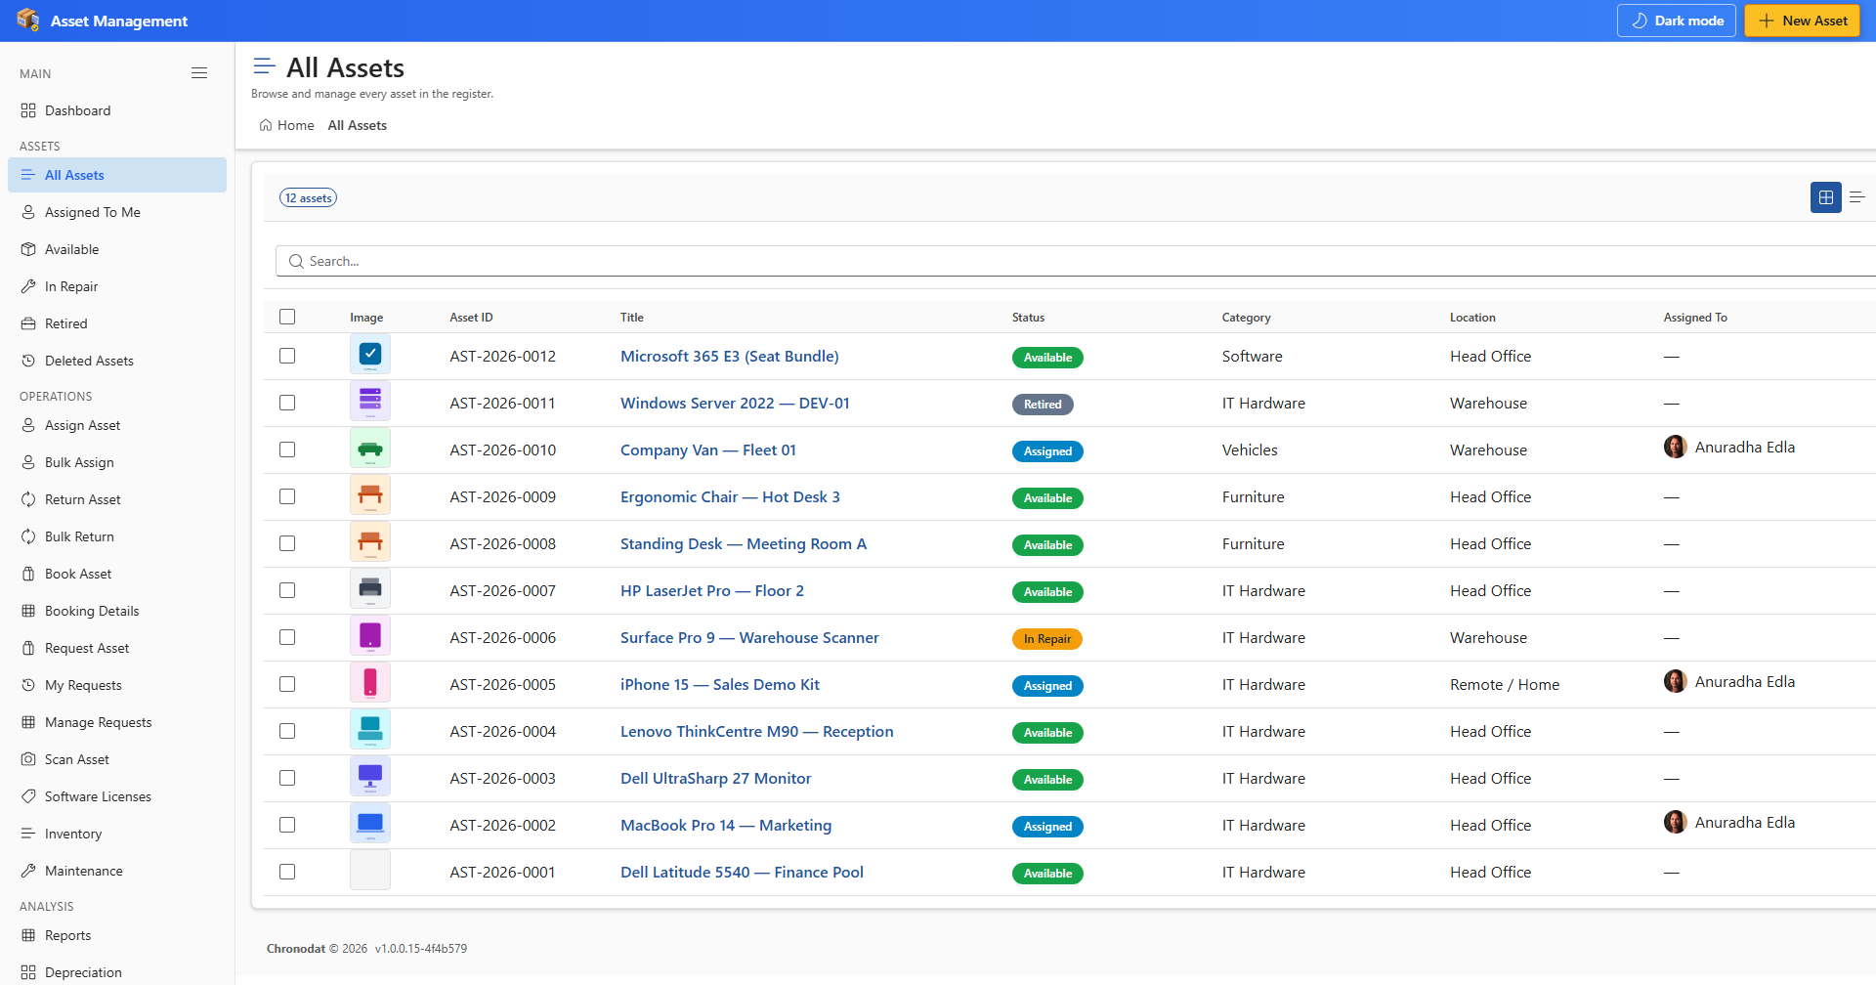
Figure 3 — All Assets

3.2 Create a new asset
- Click Create Asset in the top bar or on the All Assets page.
- On the General tab, enter Title, Category, Status, and required fields.
- Complete Financial, Assignment, and Maintenance tabs as needed.
- If the category has a linked Form Template, complete extra fields below the main tabs.
- Add attachments if needed.
- Click Save. An Asset ID is assigned from Settings → Numbering.

3.3 View, edit, and activity history
- Click an asset title to open the detail panel.
- Click Edit, change fields, then Save.
- Open the Activity tab to view SharePoint version history.
- Use row actions → Delete when you have delete permission.

3.4 Filtered views
- Assigned To Me — assets where you are custodian
- Available — assets ready to assign
- In Repair / Retired / Deleted Assets — lifecycle-specific lists
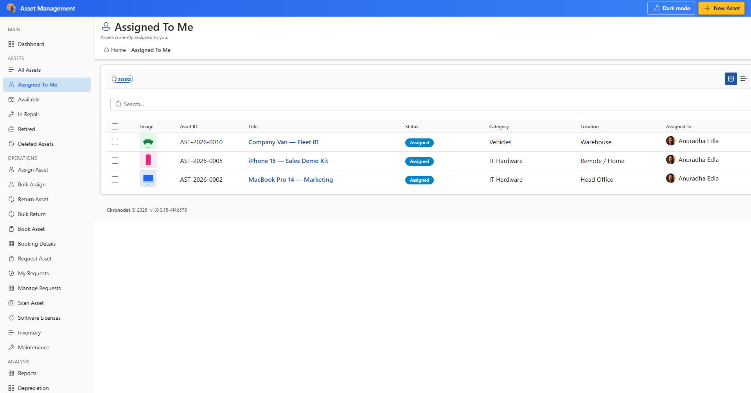
Figure 4 — Assigned To Me

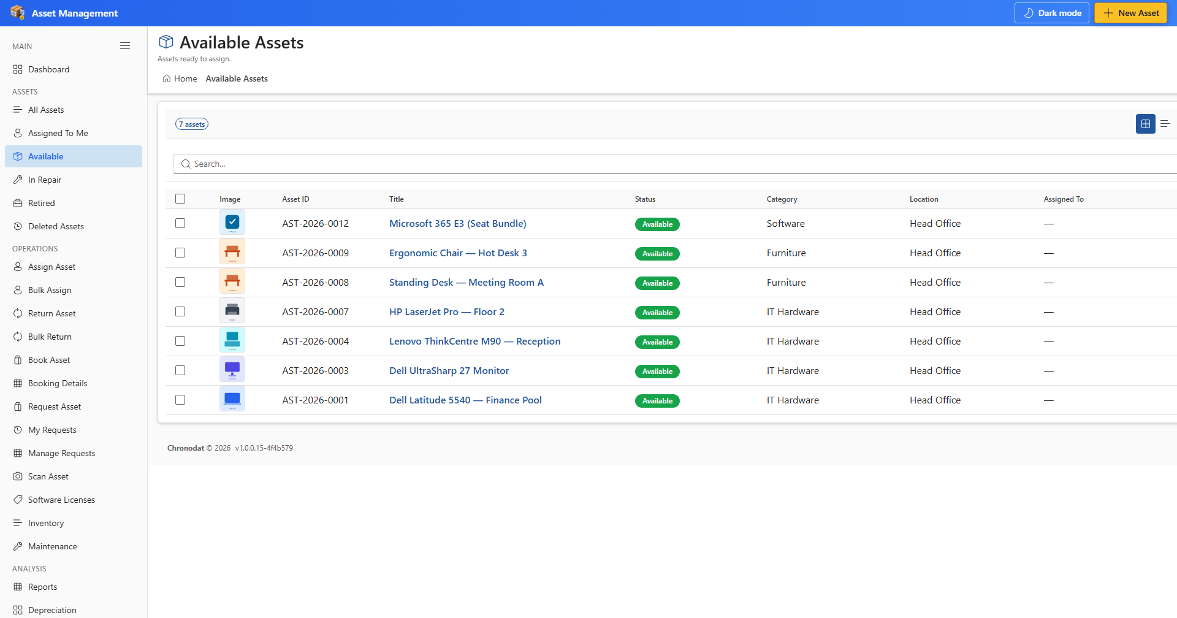
Figure 5 — Available Assets

4. Operations — Step by Step

4.1 Assign an asset
- Open Assign Asset.
- Search for the asset by ID, title, or scan label.
- Select the assignee and optional due date or notes.
- Click Assign.
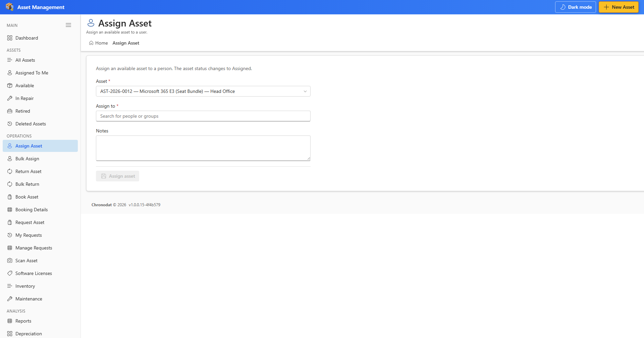
Figure 6 — Assign Asset

4.2 Return an asset
- Open Return Asset.
- Locate the assigned asset.
- Confirm condition and click Return.
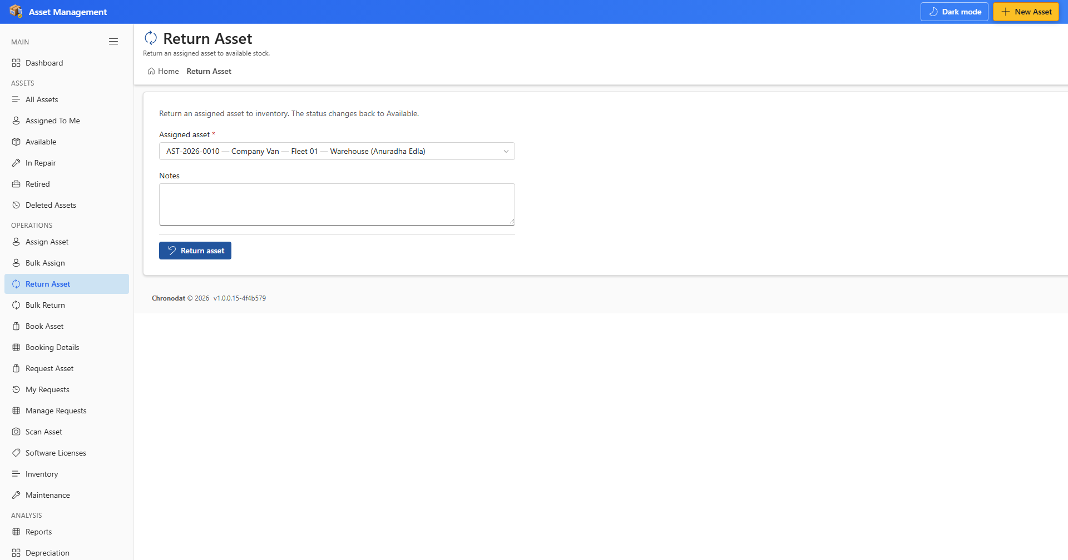
Figure 7 — Return Asset

4.3 Book and request
- Book Asset — reserve an asset for a date range.
- Request Asset — submit a request for equipment.
- My Requests / Manage Requests — track and approve requests.
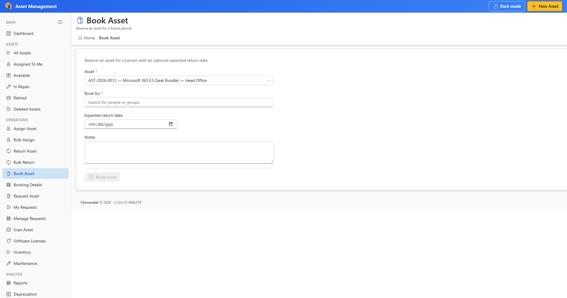
Figure 8 — Book Asset

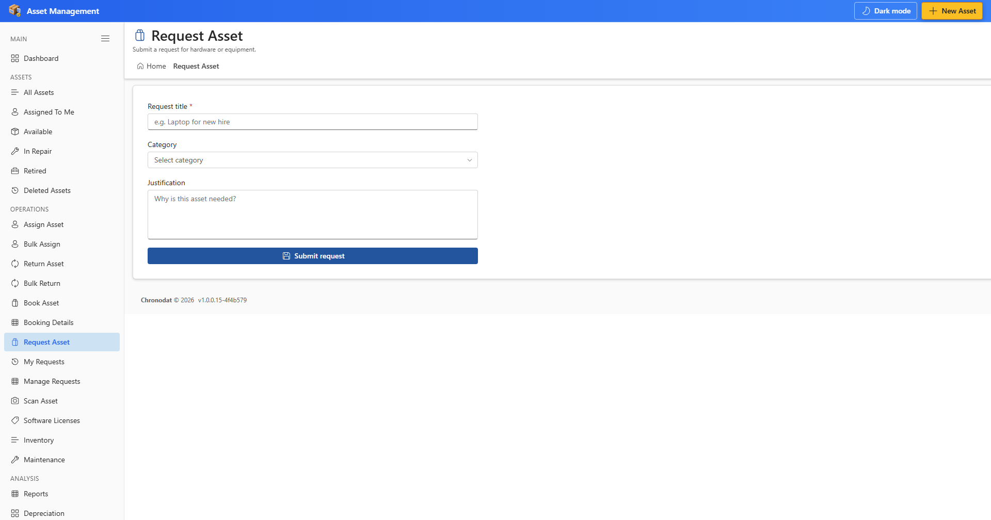
Figure 9 — Request Asset

4.4 Scan and inventory
- Scan Asset — enter or scan a barcode/QR label to open the asset.
- Inventory — record a physical scan during an inventory cycle.
- On Inventory, enter a Scan label before Record scan is enabled.
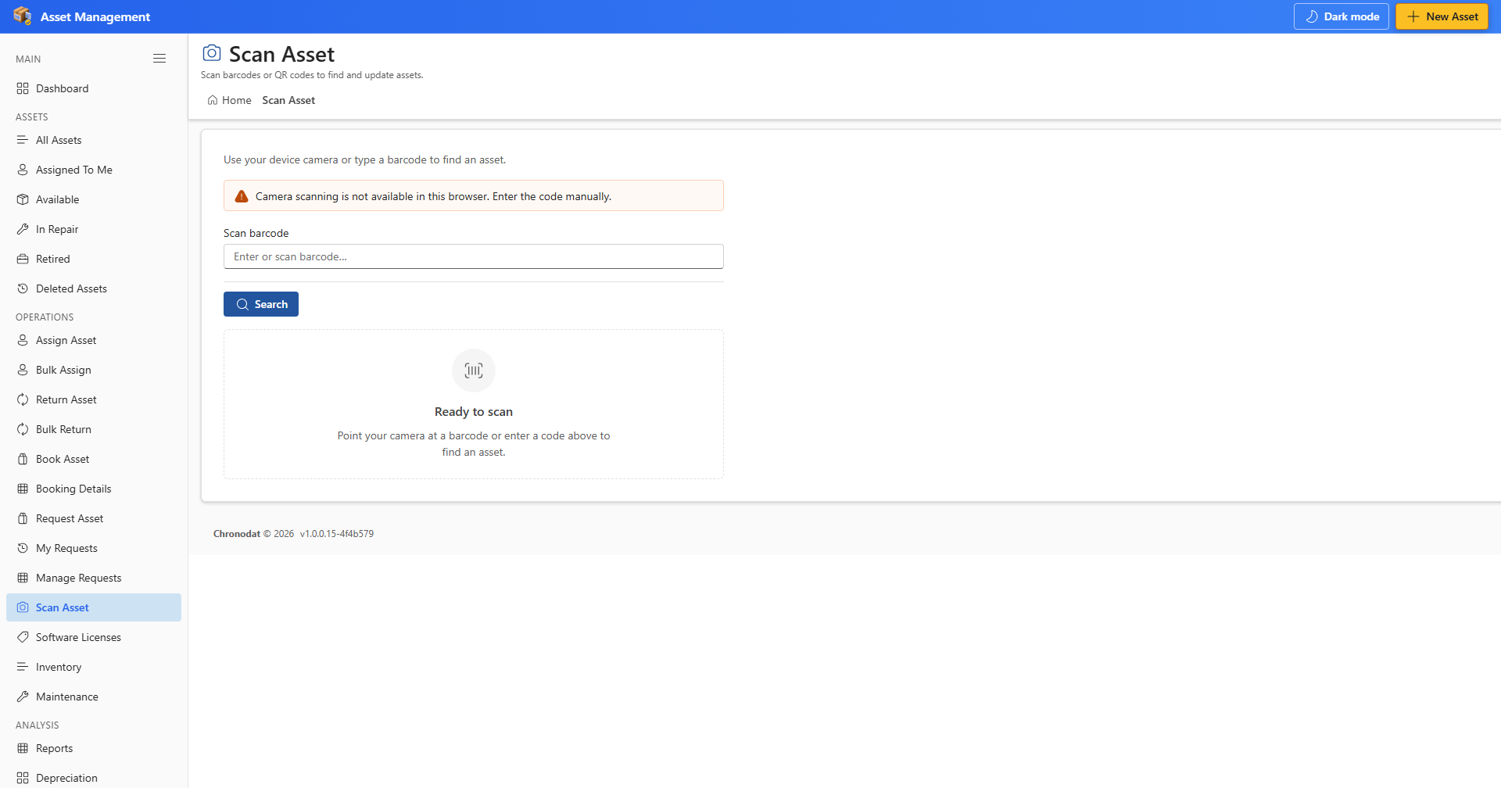
Figure 10 — Scan Asset

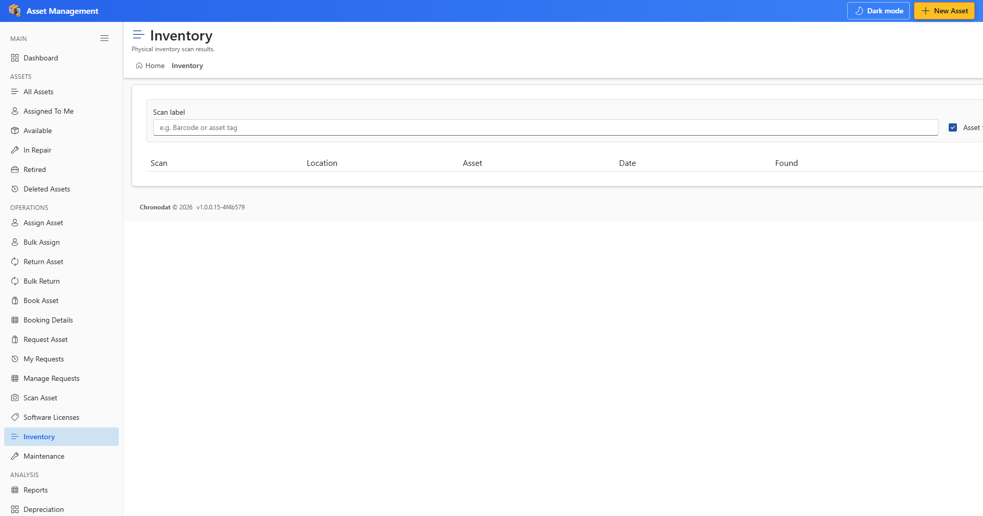
Figure 11 — Inventory

5. Software Licenses & Maintenance

5.1 Software licenses
- Open Software Licenses.
- Add licenses with vendor, seat count, and renewal date.
- Track seat usage against assets or users.
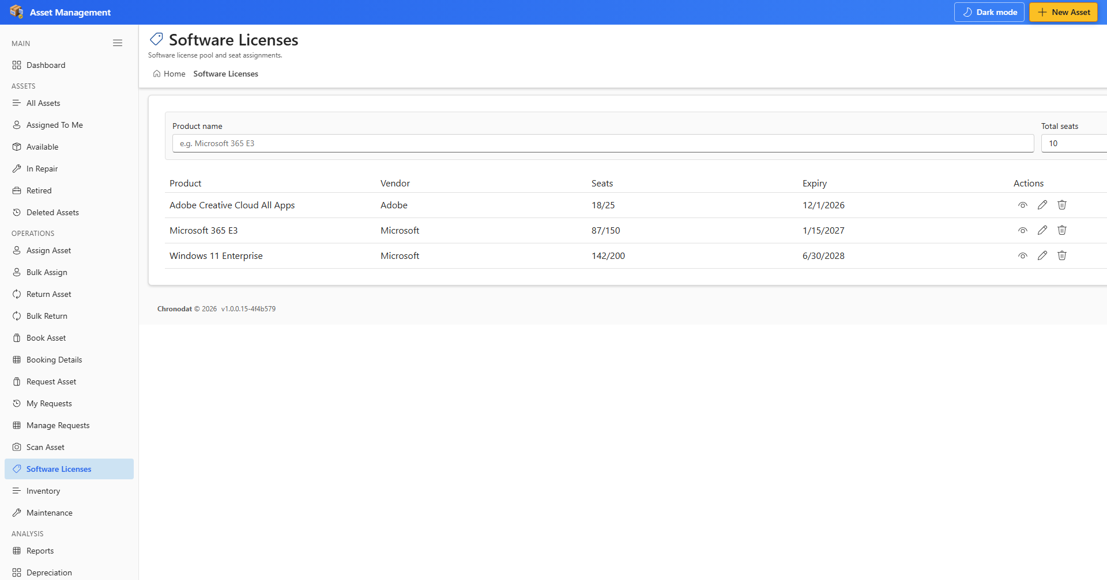
Figure 12 — Software Licenses

5.2 Maintenance
- Open Maintenance.
- Create records for repairs, inspections, or scheduled service.
- Link maintenance entries to assets.
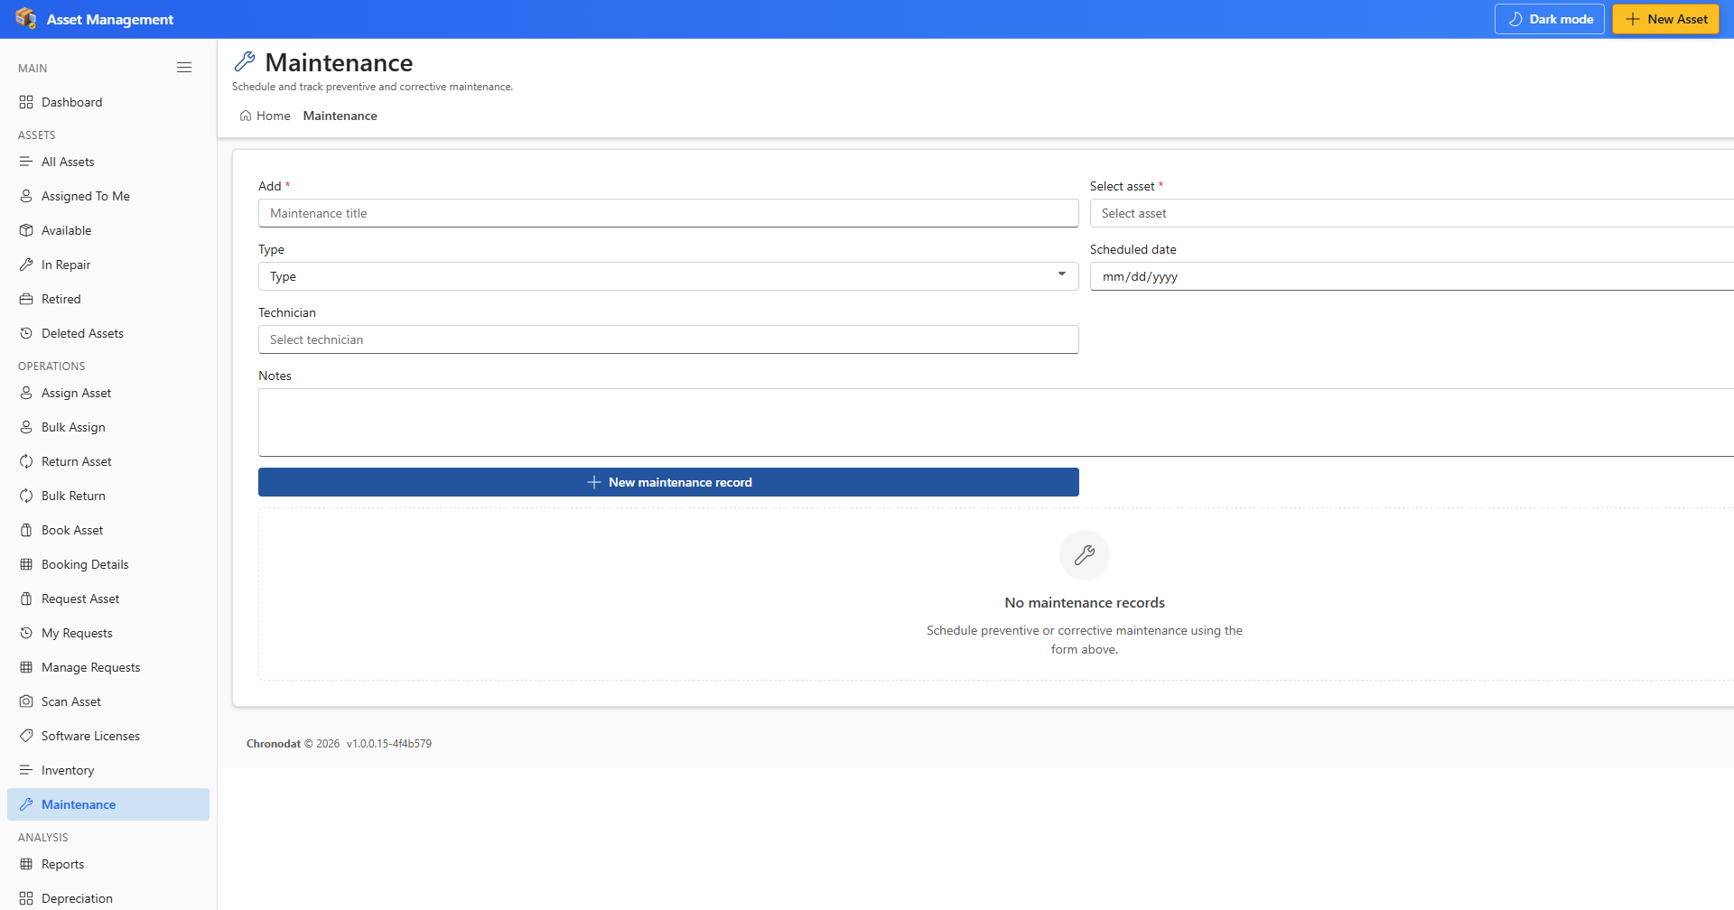
Figure 13 — Maintenance

6. Reports, Depreciation & Audit

6.1 Report Builder
- Open Reports.
- Choose a data source and select columns.
- Add optional filters.
- Generate Report to preview; Download CSV for full export.
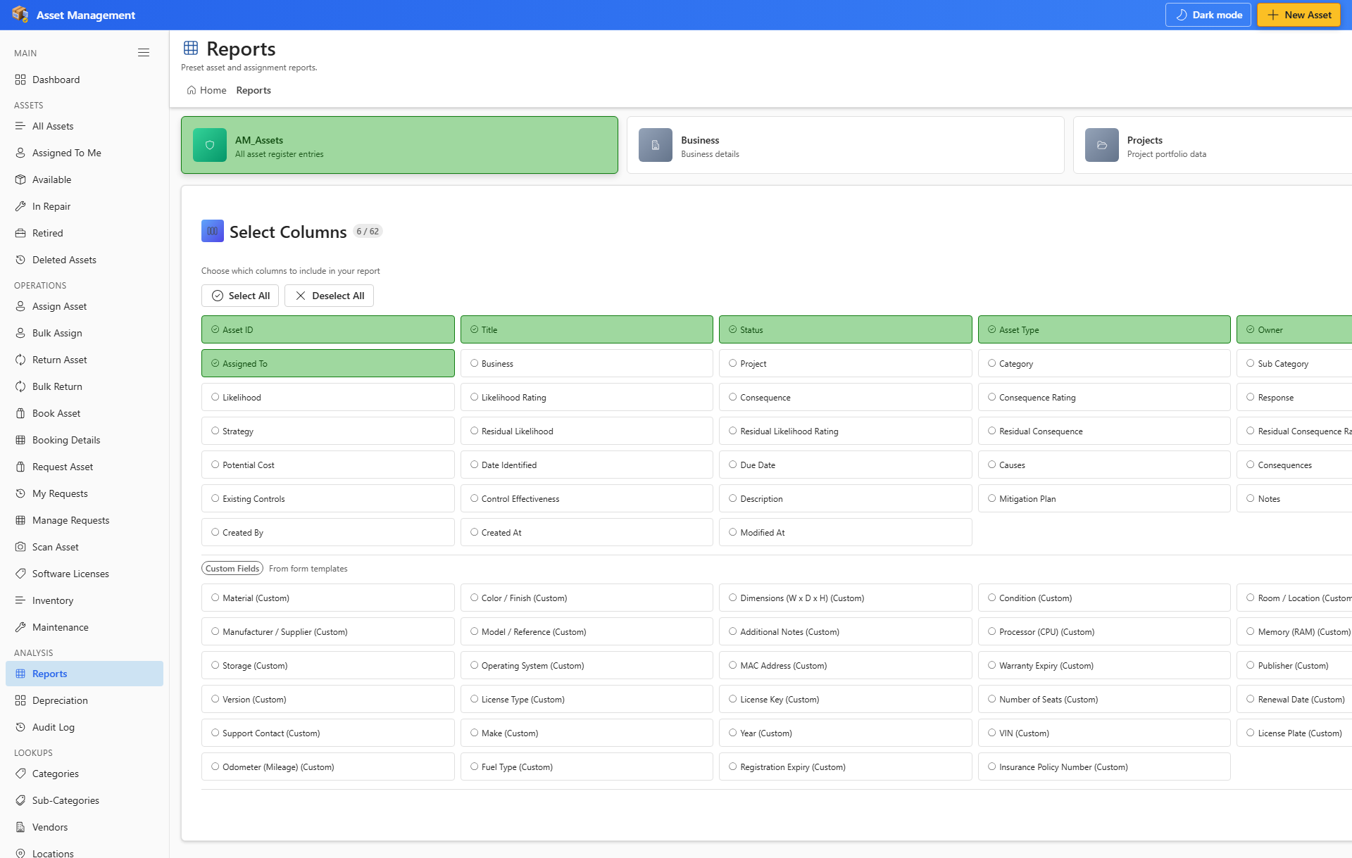
Figure 14 — Report Builder

6.2 Depreciation
Open Depreciation to review schedules for assets with financial data and depreciation method configured.
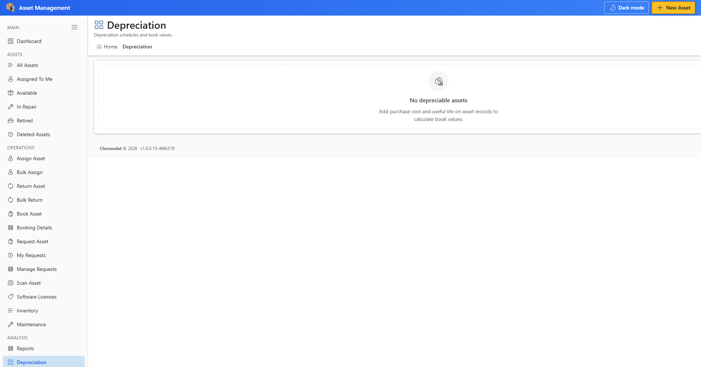
Figure 15 — Depreciation

6.3 Audit Log
Open Audit Log to search create, update, and delete actions. Administrators can also review Settings → Audit Log.
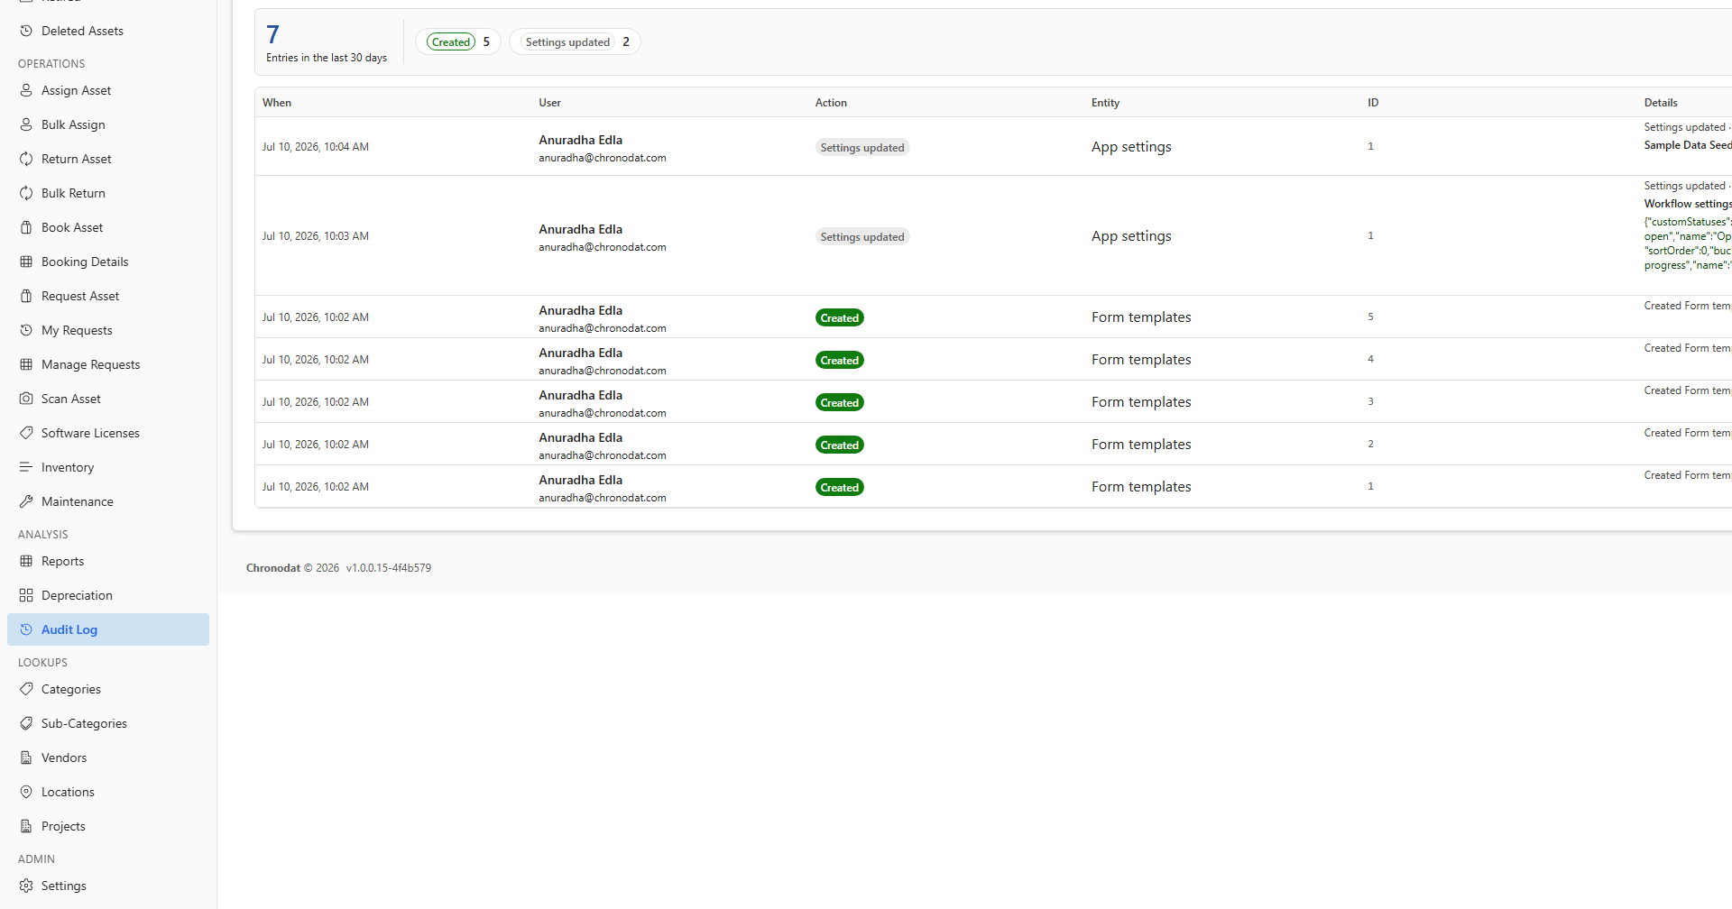
Figure 16 — Audit Log

7. Lookup Lists — Step by Step
- Open Categories, Sub-Categories, Vendors, Locations, or Projects from LOOKUPS.
- Click Add new and complete visible fields.
- Click Save. Values appear in asset forms and filters.
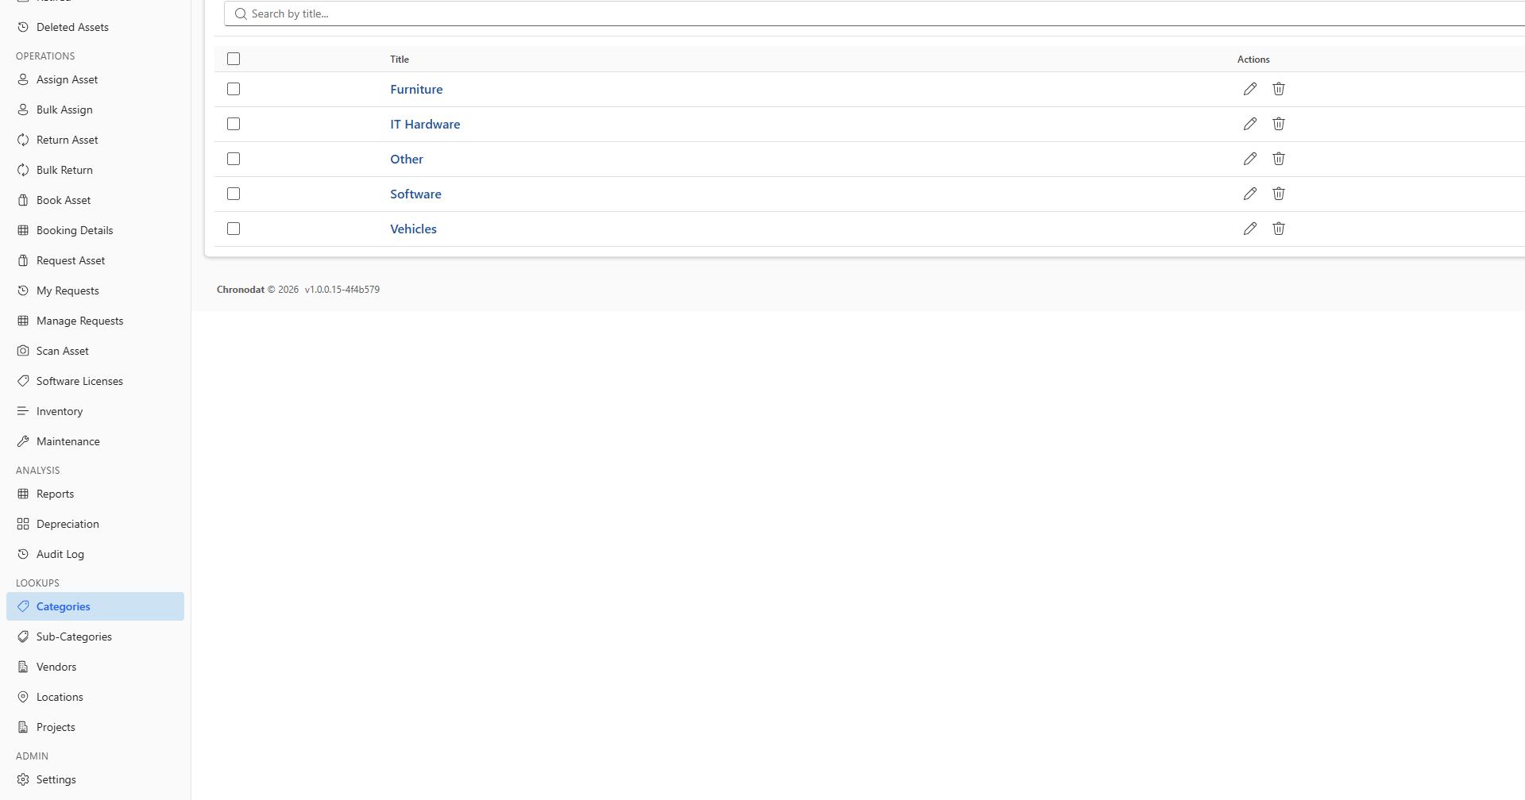
Figure 17 — Categories

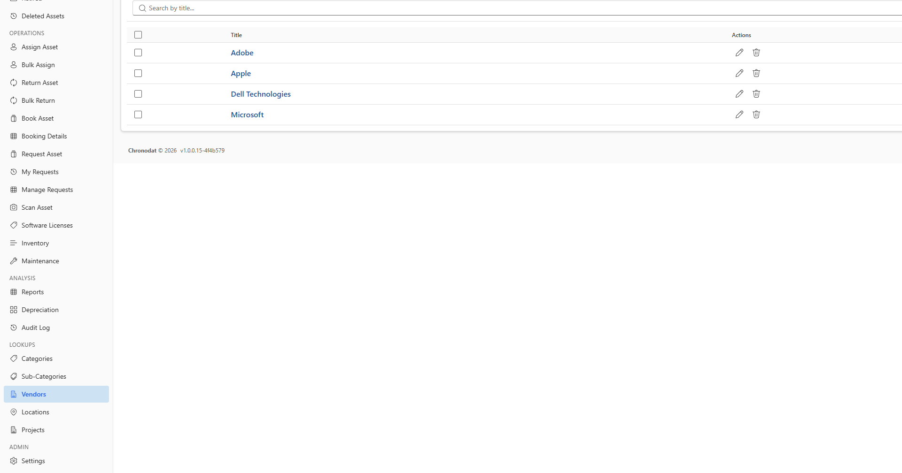
Figure 18 — Vendors

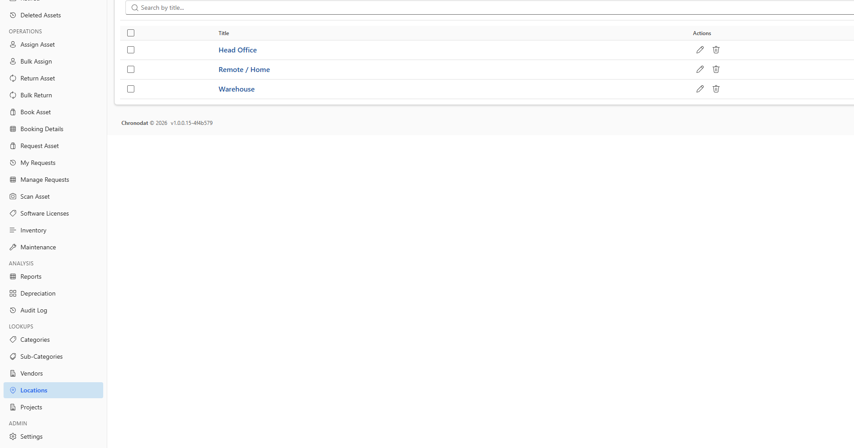
Figure 19 — Locations

8. Settings Reference (Administrators)
Open Admin → Settings. Site owners and app administrators configure the app here.
Setting area | What you configure
General | App name, procedure document URL
Appearance | Theme, colors, layout, hide SharePoint chrome
Dashboard | Dashboard name and summary card behavior
Forms | Field visibility per entity (AM_Assets, AM_Vendors, etc.)
Form Templates | Category-linked extra fields on asset forms
Asset Status | Custom statuses and workflow labels
Subscription | 14-day trial and yearly subscription
App Administrators | Users who can open Settings
Roles & Permissions | App roles and UI page permissions
Tags | Colored tags for asset categorization
Numbering | Auto Asset ID formats
Email Integration | Graph, Power Automate, or Chronodat API delivery
Notification Workflows | Email on create, assign, overdue, etc.
Audit Log | Searchable activity log

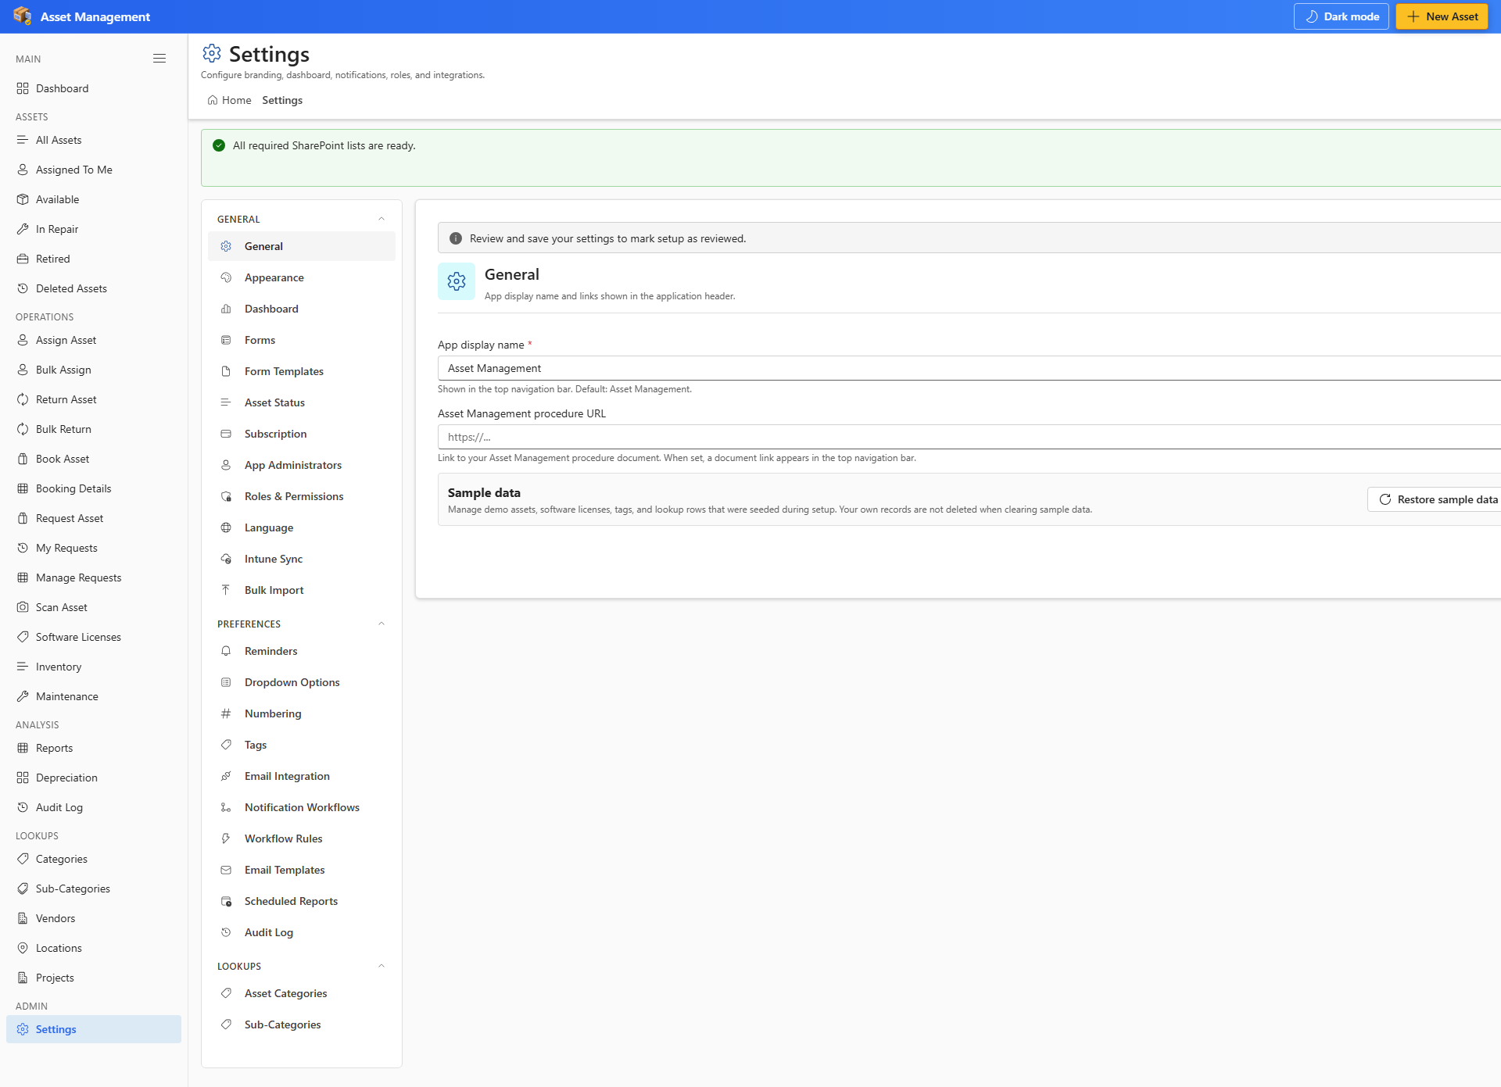
Figure 20 — Settings → General

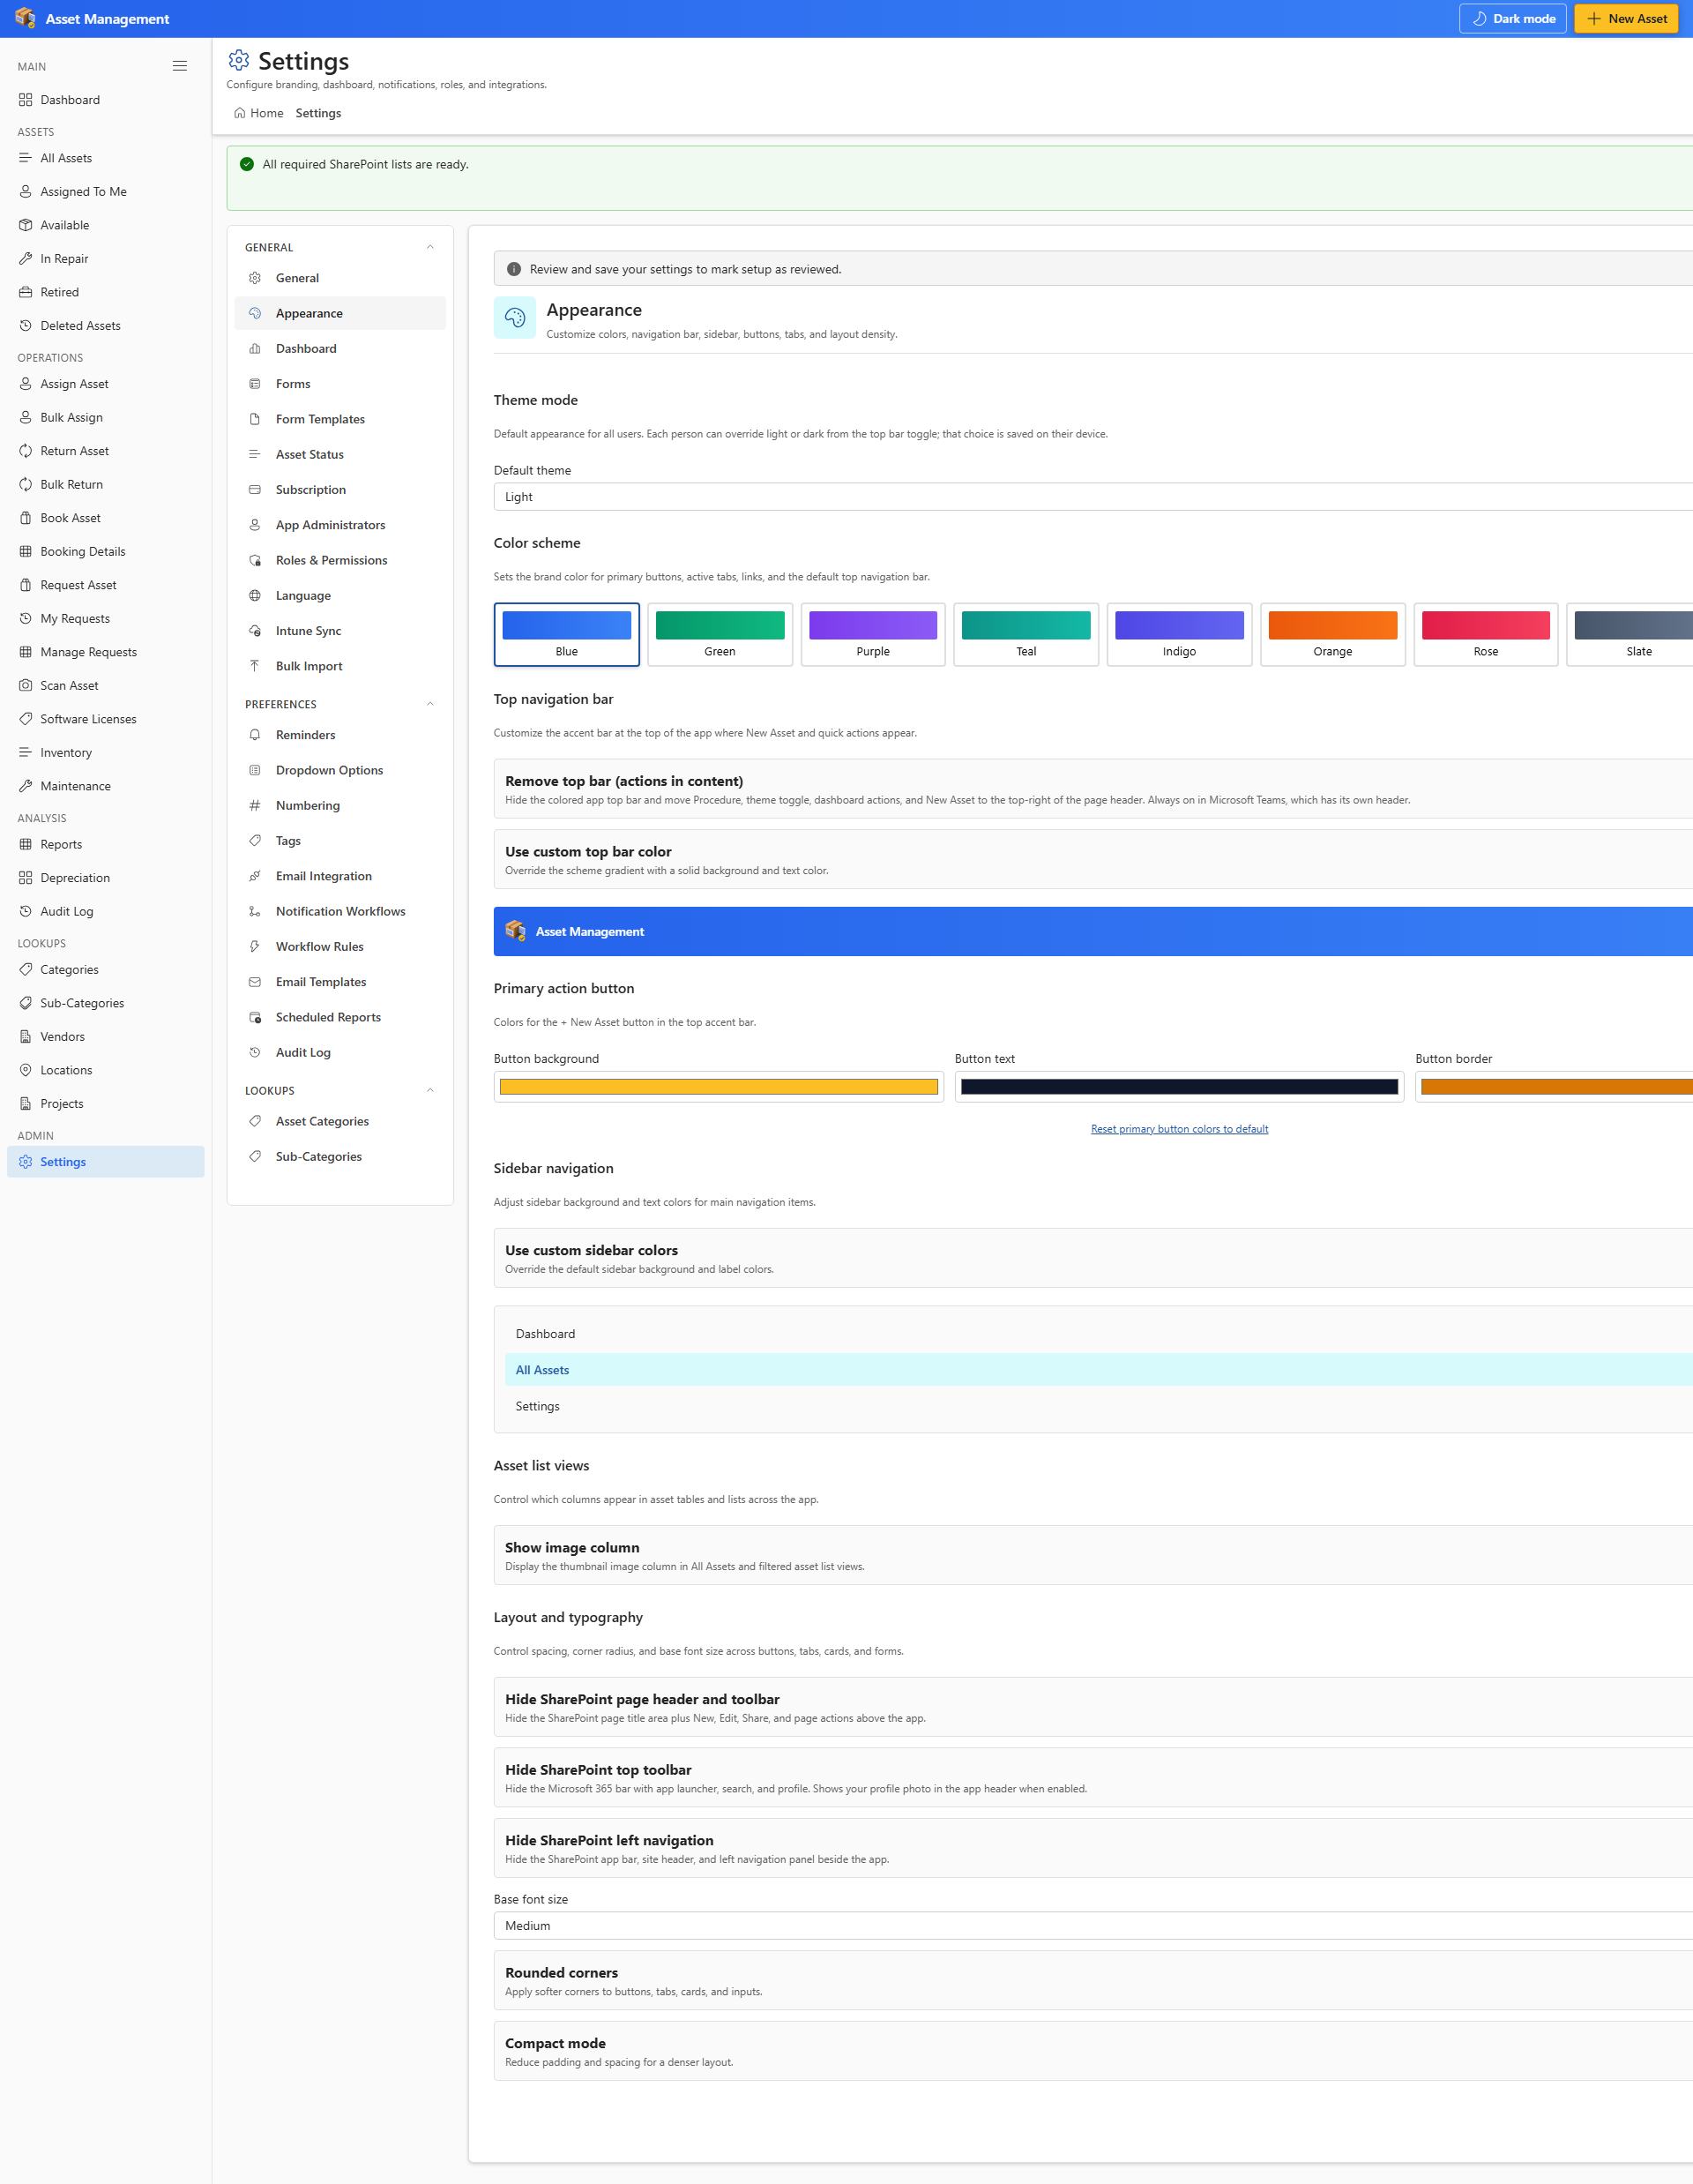
Figure 21 — Settings → Appearance

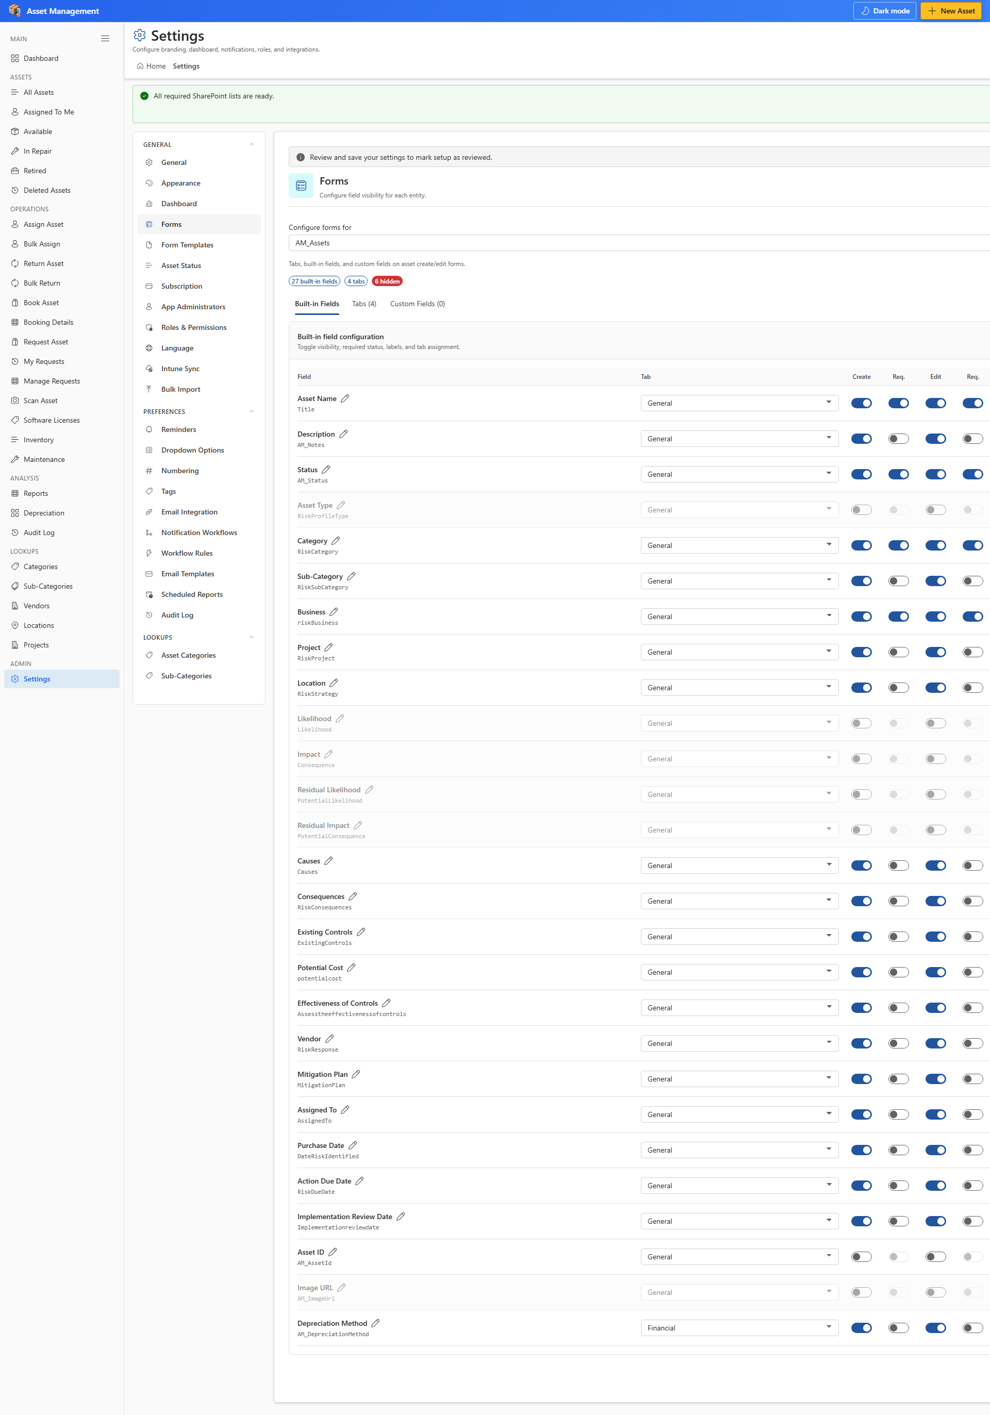
Figure 22 — Settings → Forms

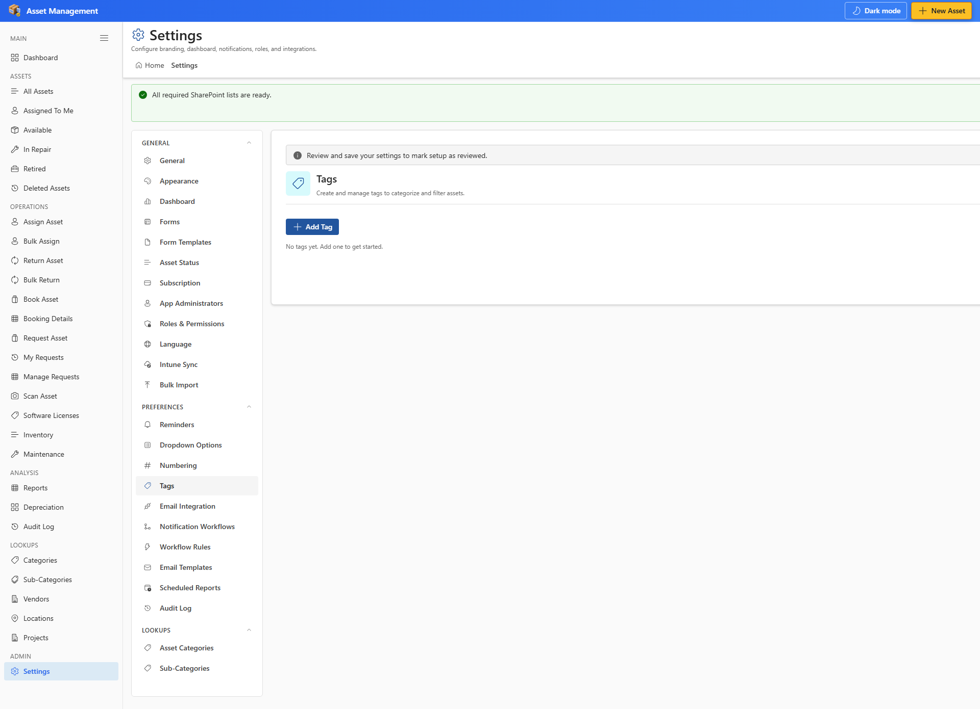
Figure 23 — Settings → Tags

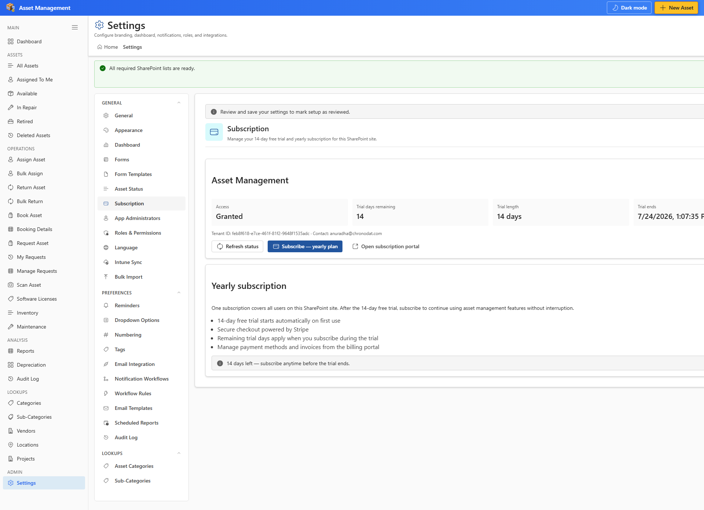
Figure 24 — Settings → Subscription

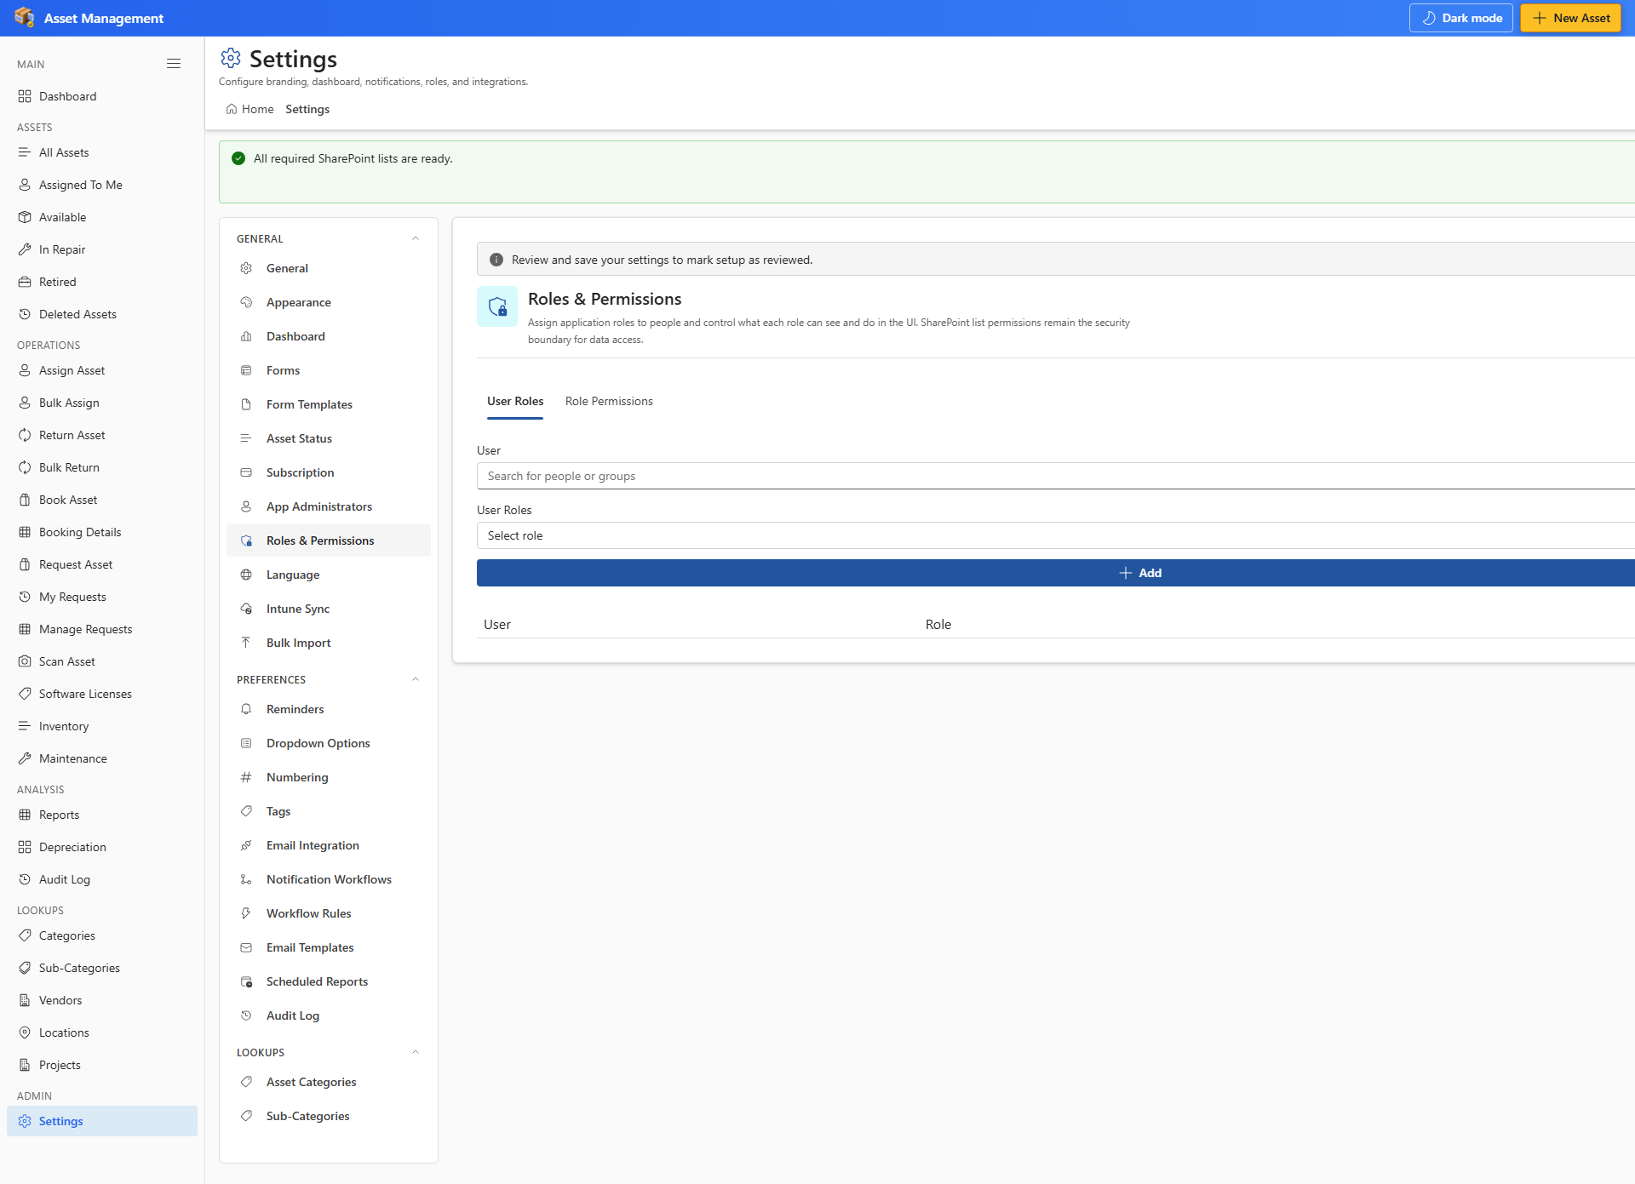
Figure 25 — Settings → Roles & Permissions

9. SharePoint vs Microsoft Teams
Topic | SharePoint page | Teams tab
Data storage | Lists in current SharePoint site | Same — backing SharePoint site
Setup | Run on hosting site | Run on backing SharePoint site
Settings | Full access for site owners / app admins | Same
SharePoint chrome hiding | Available in Appearance | Disabled in Teams

- Deploy the .sppkg to the tenant app catalog.
- Sync to Teams from the catalog entry.
- Add the app as a channel tab or personal app.
- Complete setup on the backing SharePoint site if not already done.

10. Tips & Troubleshooting
Issue | What to try
Setup banner won't go away | Complete Setup as site owner
Can't open Settings | Ask an app administrator to add you
Record scan disabled | Enter a Scan label first on Inventory
Email not sent | Approve Graph Mail.Send; check Email Integration settings
Create Asset disabled | Finish setup; confirm Add on AM_Assets list
Subscription banner | Open Settings → Subscription or contact administrator

10.1 Regenerate this guide
- Set PLAYWRIGHT_BASE_URL to your SharePoint page (example: https://chronodat.sharepoint.com/sites/ChronodatProdApps/spfx).
- Run npm run test:e2e:setup once to create e2e/.auth/user.json.
- Run npm run docs:user-guide:all to capture screenshots and rebuild this document.

Document generated for Asset Management v1.0.0.15. See README.md and docs/ for technical architecture.

