**Labelization guidelines**

Contents

I. 2

II. Introduction 3

III. Data 3

a. Databases 3

b. Data augmentation 3

Method1: Deformation between peaks (length and amplitude) 3

Method2: Deformation of peaks (length and amplitude) 3

Method3: Whole signal deformation (reverse signal, elongate or shorten) 3

Method3 : Addition of noise 4

IV. Peak detection methods 4

a. Pylife 4

b. Neurokit2 and available methods 4

c. Suppression of extra peaks 4

V. Results 4

a. Performance on data from healthy subjects with mild noise 4

b. BPM range limits (simulation data, and 30 bpm and 150 bpm testers + flutter in MITDB) 4

Method Of Evaluation of Peak Validity 4

Results on Neurokit2 Generated Data 4

c. Arrythmia and QRS deformation limits 5

Bibliography 7

1. Introduction

The detection of the quality of ECG data is paramount to be able to computer relevant indicators. Over certain noise levels it gets impossible to detect accurate QT lengths for example. In order to train and test our algorithms of noise level detection, we are making a database of 5s ECG signal Segments. The rules to label those segment are described in this document.

1. Label rules

We will use 5 levels of noise:

* 1 : All phases PQRST of the ECG are visible and clear during the full 5s segment
* 2 : The quality of the signal is good enough to detect QT segment length over the whole segment
* 3: It is possible to detect accurately R waves during the whole segment
* 4: there are some difficulties to detect R waves but we can still guess most of them, can include a part with saturation
* 5 : mostly noise

1. Examples

# Level 1:

PQRST

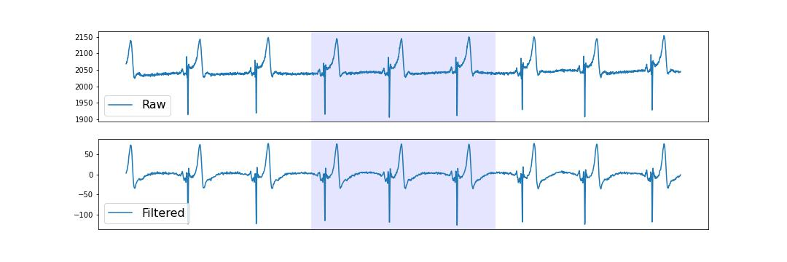

# Level 2 :

We see a step in the raw signal that impact the shape of one of the P waves, however all the QT segments are clear -> level 2

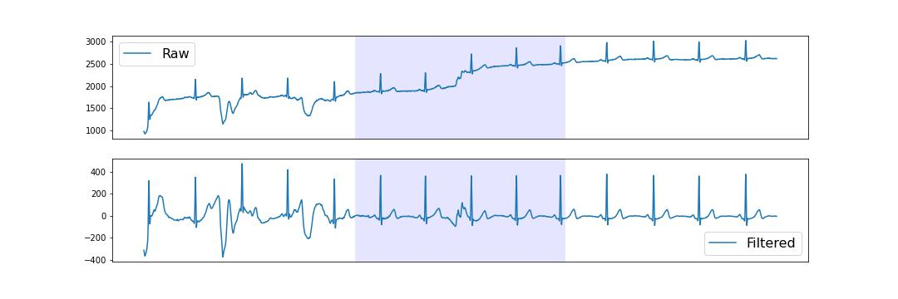

T wave seem okay, P wave visible but with difficulty

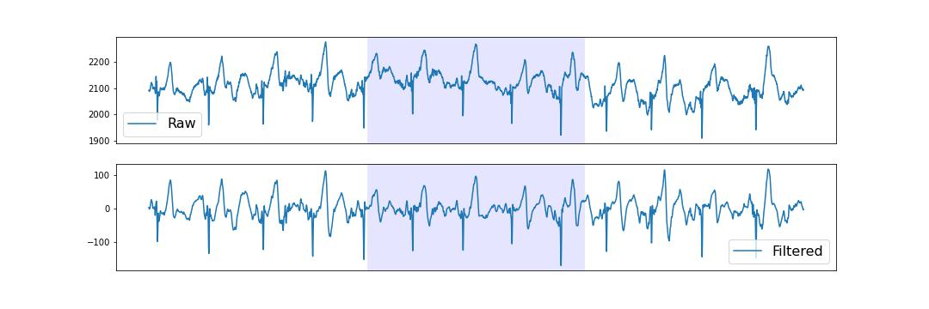

# Level 3 :

No doubt on QRS but deformations of T waves

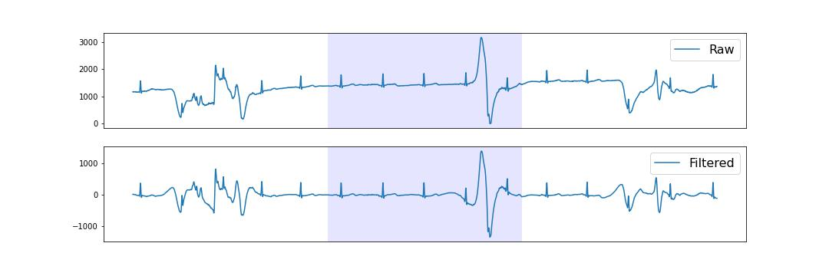

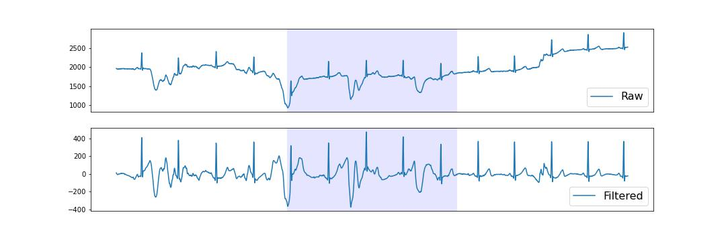

QRS visible in the noise (much narrower and higher gradient than the rest, less error prone)

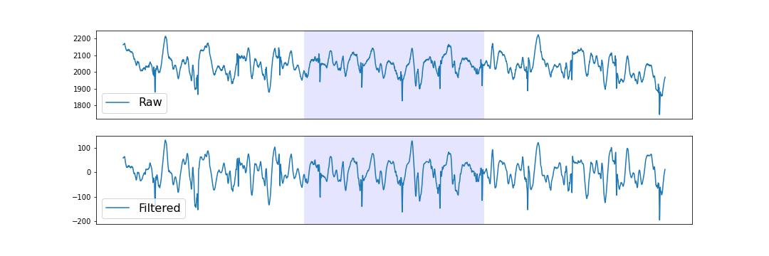

# Level 4 :

Some noise could be interpreted as a QRS

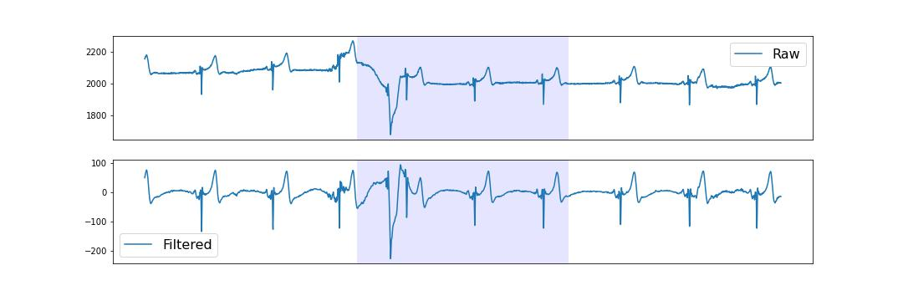

Some saturation make a few QRS disappear, but the other are clearly visible

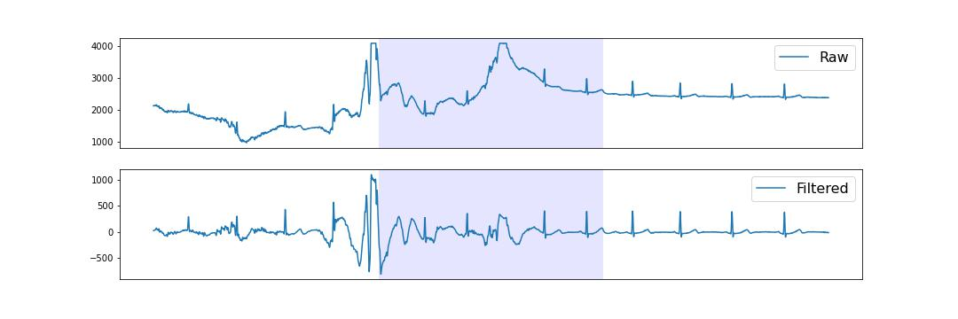

Most QRS are visible but they might be difficulties for the part at the start

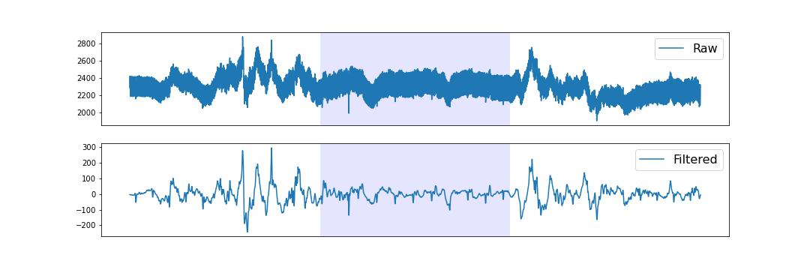

Poor signal but enough visible QRSs

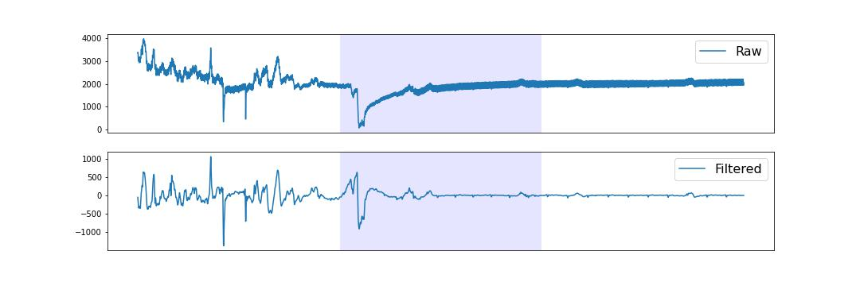

Poor signal, but narrow QRS visibles, although there might be detection errors

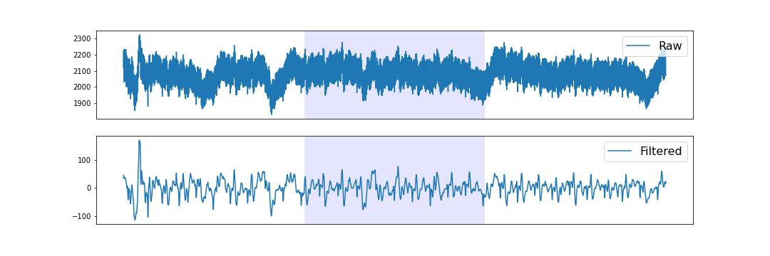

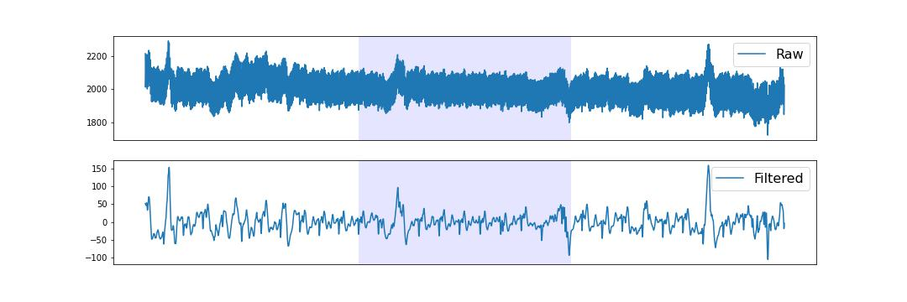

# Level 5

Mostly noise

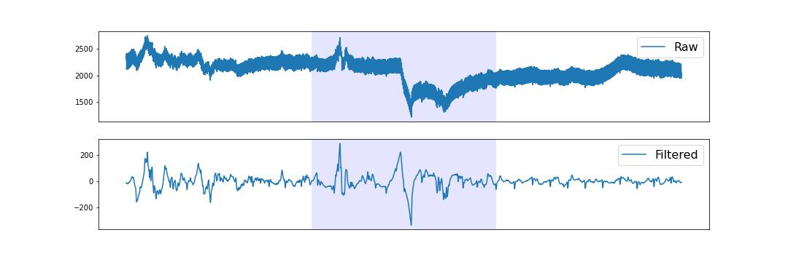

No signal (disconnexion)

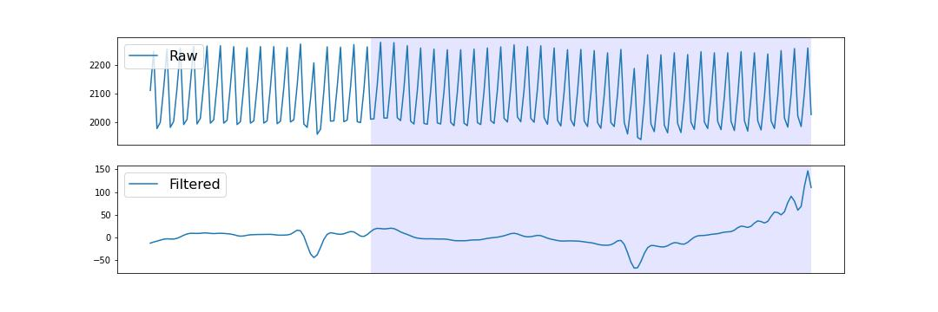

Poor signal

