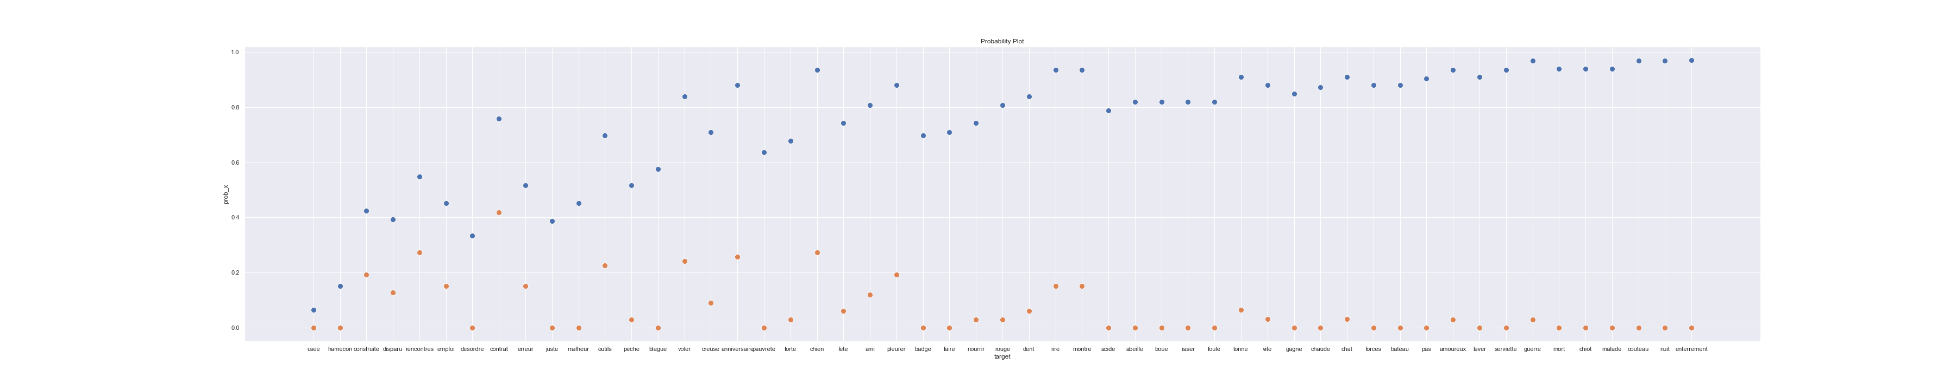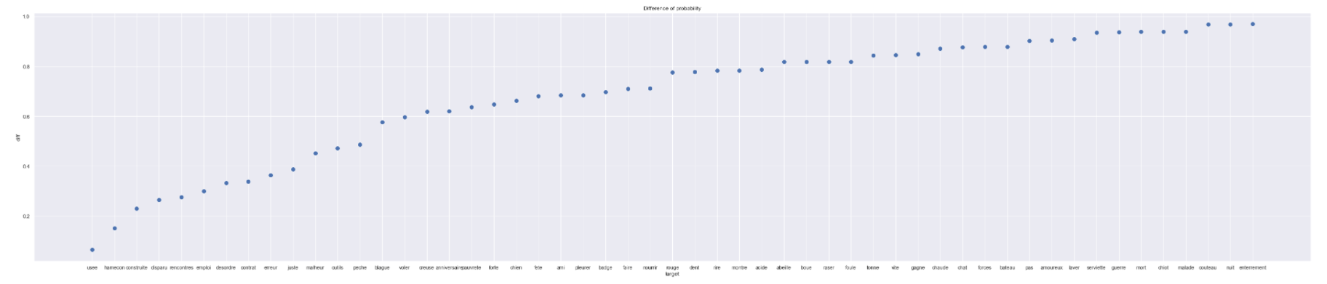

Difference of probability Plot

Probability Plot

