Lab 9 Profiling
Christophe El Chabab | EECE 435L
I compared the supplied scripts with the fast-function optimization given in the handout. Both versions passed the three supplied tests. The measurements below are from the captured terminal runs.

cProfile

Before optimization
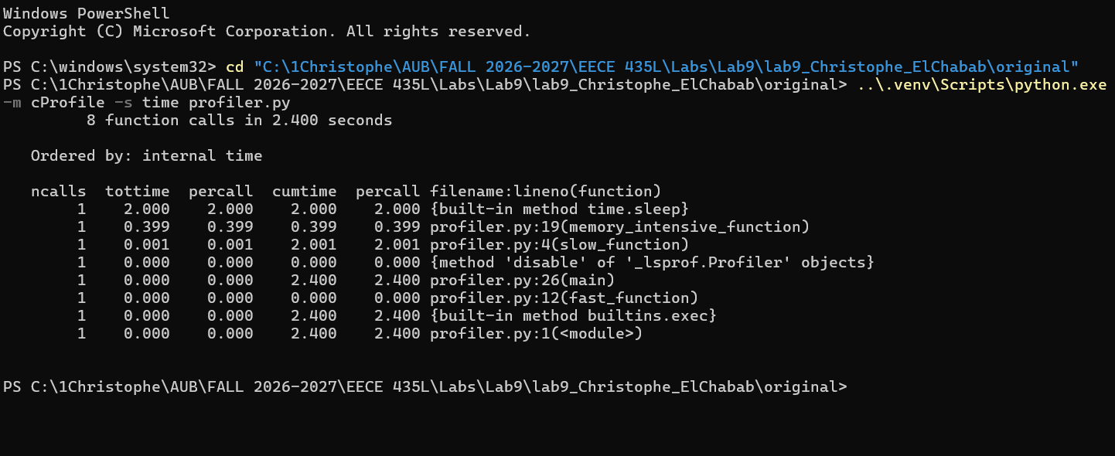

After optimization
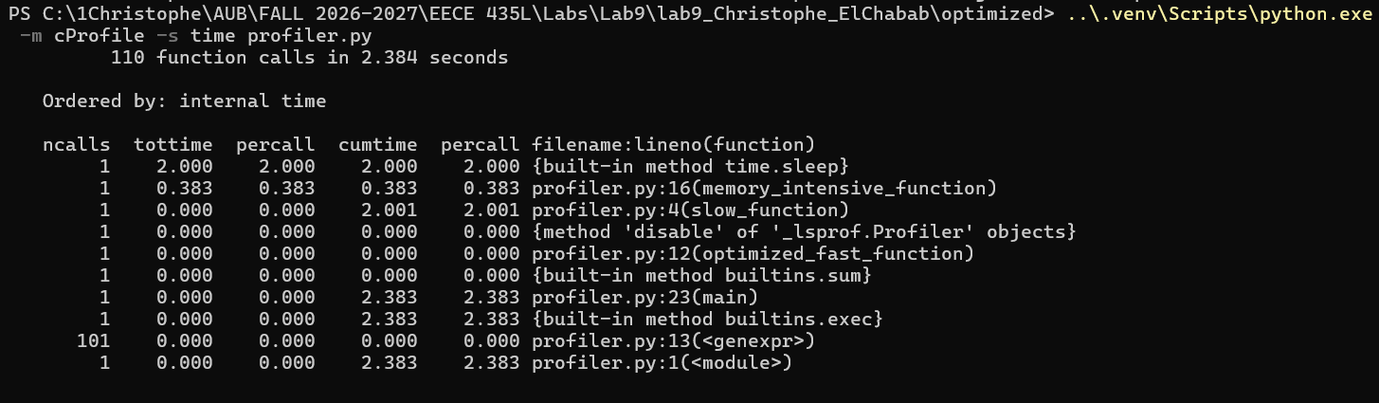
Measurement | Before | After
Total elapsed time | 2.400 s | 2.384 s
time.sleep | 2.000 s | 2.000 s
memory_intensive_function | 0.399 s | 0.383 s
Fast function | 0.000 s | 0.000 s

The sleep dominates elapsed time, and the large loop does most of the computation. Both fast-function times round to 0.000 seconds. The total decreases by 0.016 seconds, but the same decrease appears in the unchanged large loop, so this does not demonstrate a speed improvement from the fast-function change. The optimized report also records 101 generator calls.

Line profiling before optimization
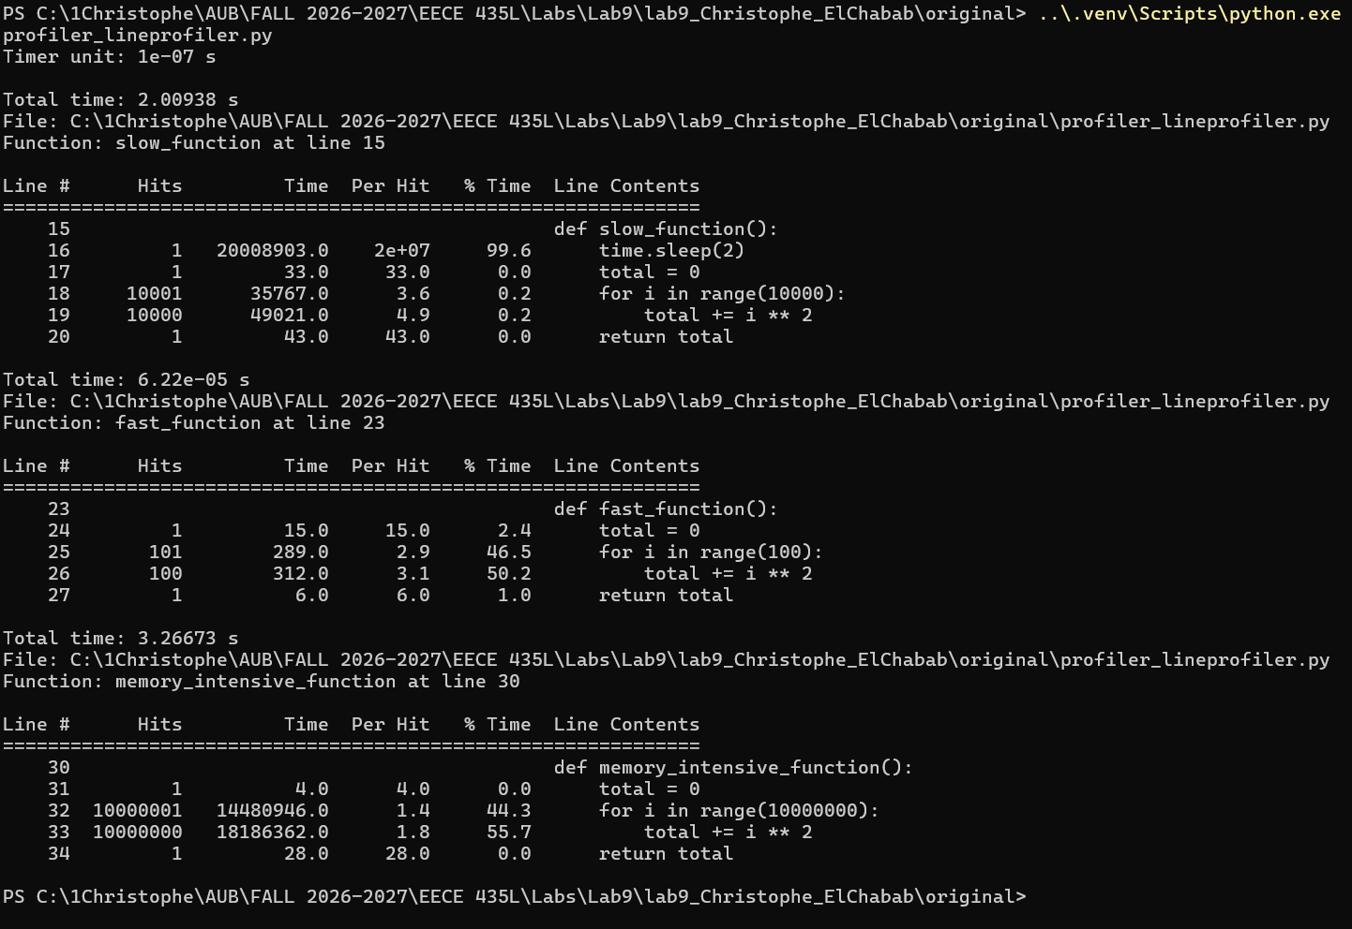
The sleep accounts for 99.6% of slow_function. In the large function, the addition runs ten million times and accounts for 55.7% of its measured time. The loop header takes most of the remaining time. These lines are the main computational cost.
Function | Before | After
slow_function | 2.00938 s | 2.00711 s
Fast function | 62.2 microseconds | 82.0 microseconds
memory_intensive_function | 3.26673 s | 3.77762 s

Line profiling after optimization
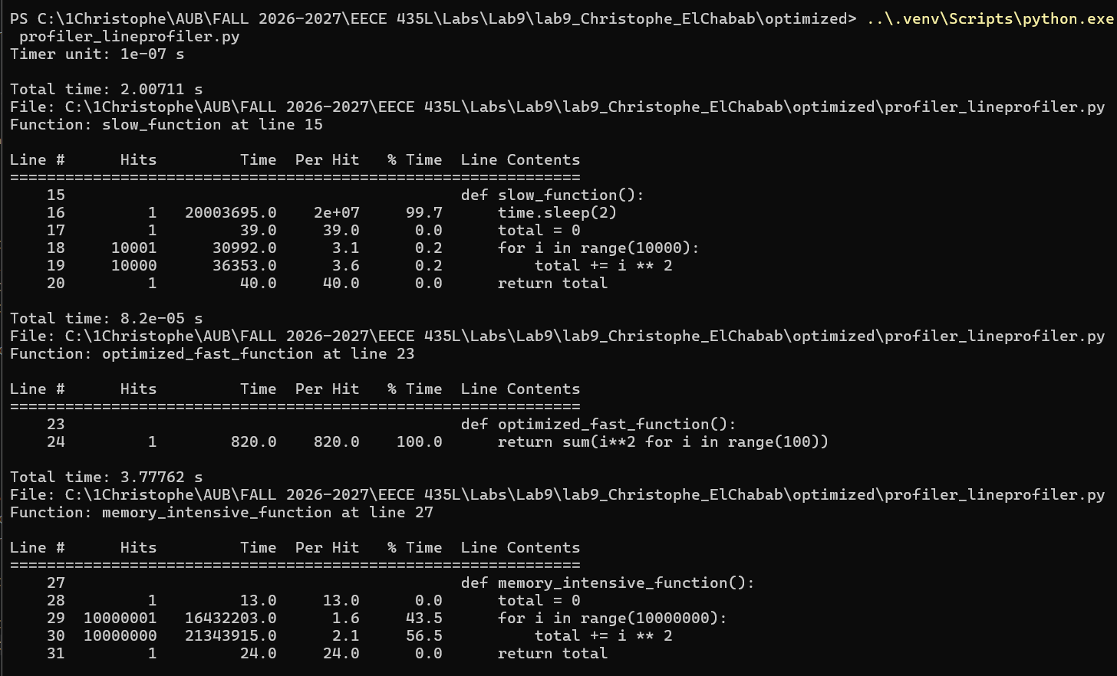
The optimized files call optimized_fast_function in place of fast_function. The function uses the expression given in the handout:
return sum(i**2 for i in range(100))
Both versions return 328350 and calculate the same 100 squares. In this captured run, the sum version takes 82.0 microseconds instead of 62.2 microseconds, about 32% longer. This run therefore does not show a fast-function speed improvement. The code is shorter, but both versions still process the same number of values.
The slow function remains dominated by the two-second sleep, which accounts for 99.7% of its time. The unchanged large loop also takes longer in this run. This shows why a single profiled measurement should not be treated as a guaranteed speedup or slowdown caused by the small code change. The sleep and the large loop were kept as supplied.

Memory profiling before optimization
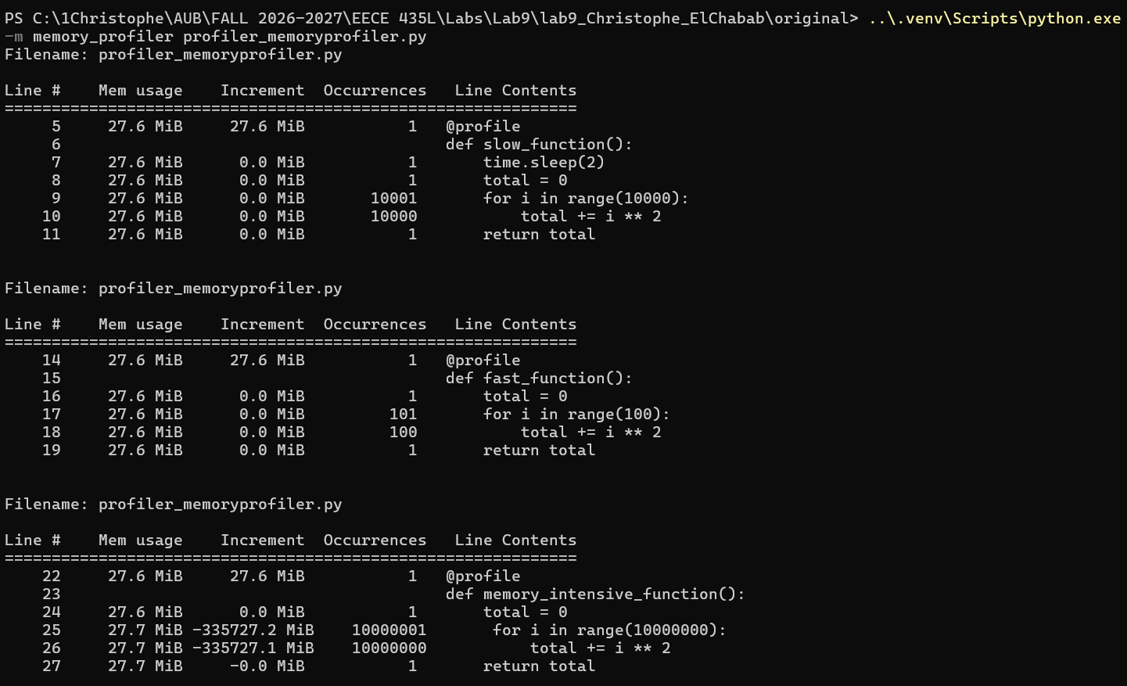
The process uses about 27.6 MiB in the slow and fast functions and reaches about 27.7 MiB in memory_intensive_function. The large function updates one running total rather than storing ten million results, so its memory use stays close to its starting level.
The report records 10000001 loop-header occurrences and 10000000 additions. These counts confirm that the complete loop ran. The memory profiler takes much longer than an ordinary execution because it measures memory repeatedly while tracing the loop.

Memory profiling after optimization
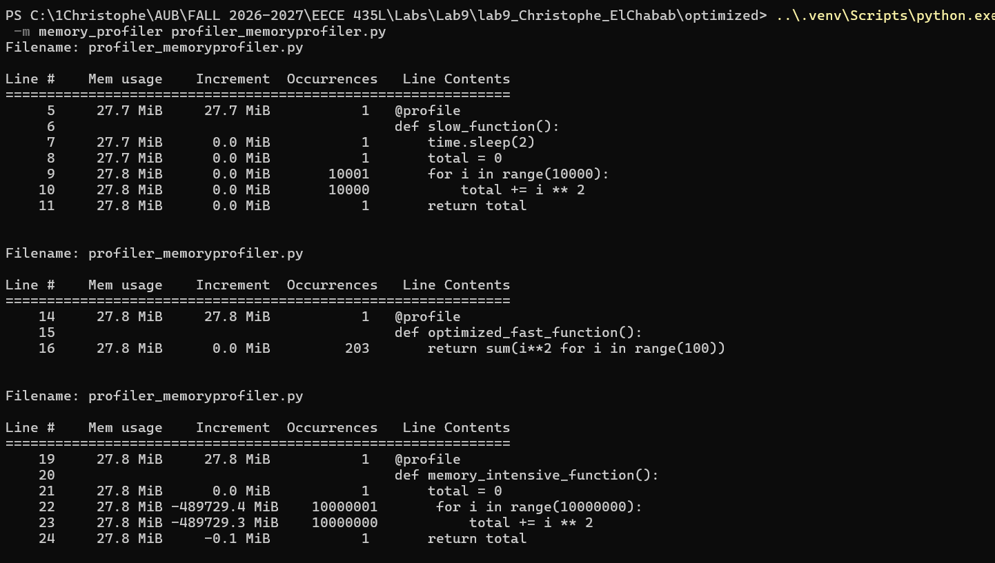
Measurement | Before | After
Highest displayed memory | 27.7 MiB | 27.8 MiB
Fast-function memory | 27.6 MiB | 27.8 MiB
Fast-function line increment | 0.0 MiB | 0.0 MiB
Large-loop additions | 10000000 | 10000000

The measurements do not show a memory saving from the change. The original function keeps one total, and the optimized generator produces values one at a time. Both use little extra memory for this small calculation. The two runs also start at slightly different process-memory levels.
The very large negative Increment entries in both loop reports are accumulated measurements across millions of line executions. The profiler adds differences while retaining maximum readings for previously measured lines, so small fluctuations can build up in this column. They do not represent hundreds of thousands of MiB held or freed at once; the displayed Mem usage stays around 27.7-27.8 MiB.

Tests before and after optimization

Before optimization
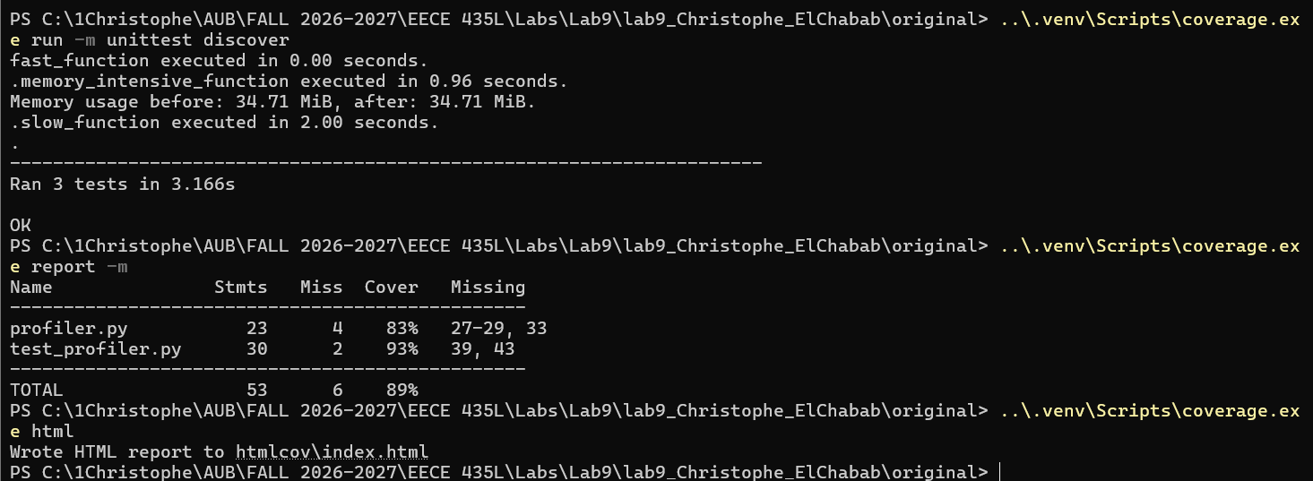

After optimization
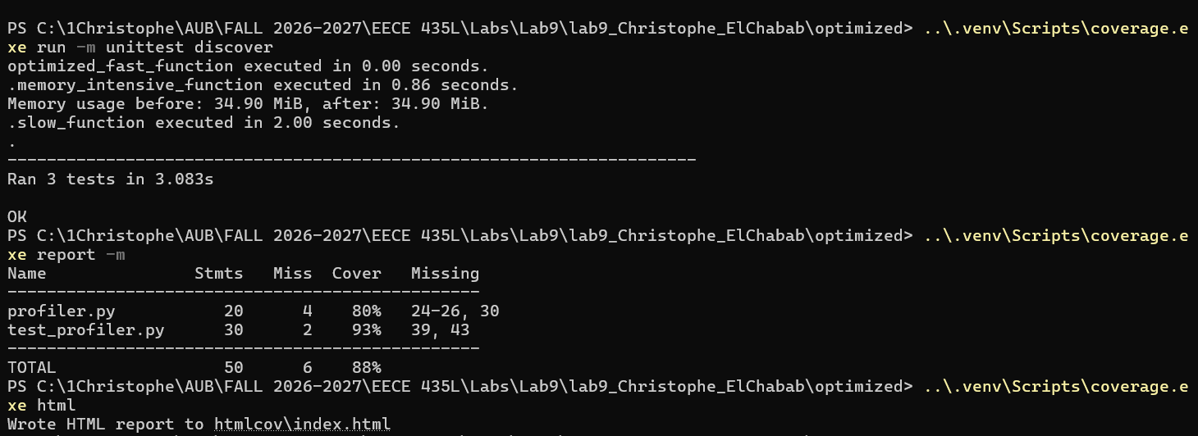
Both runs pass all three tests with the supplied assertions. The suite takes 3.166 seconds before optimization and 3.083 seconds after. The large-function test measures 0.96 seconds before and 0.86 seconds after, both below the five-second limit. The fast-function times print as 0.00 seconds, and the slow-function times print as 2.00 seconds.
The assertions compare unrounded measurements. This explains why the slow-function test passes the greater-than-two-seconds check and the memory test passes the increase check even when the printed values appear equal after rounding.

Coverage analysis
Coverage measurement | Before | After
profiler.py statements | 23 | 20
profiler.py missing statements | 4 | 4
profiler.py coverage | 83% | 80%
test_profiler.py coverage | 93% | 93%
Combined coverage | 89% | 88%

All three computational functions are exercised by the tests. The missing statements are in the main functions and direct-script entry points:
File | Original missing lines | Optimized missing lines
profiler.py | 27-29 and 33 | 24-26 and 30
test_profiler.py | 39 and 43 | 39 and 43

The three missing lines inside profiler.main call the functions, and the final missing line calls main when the script is run directly. unittest discovery imports the module and calls the functions through the test methods instead. In test_profiler.py, the missing lines call unittest.main and invoke that main function for direct execution.
Replacing the fast-function loop removes three statements while the same four main-entry statements remain unexecuted. Coverage of profiler.py therefore changes from 19/23 statements to 16/20 statements. The lower percentage comes from the changed statement count; no computational function loses its test.
The before and after HTML reports are saved in original/htmlcov/index.html and optimized/htmlcov/index.html. Their source pages show the covered function bodies and the missing entry-point lines.

