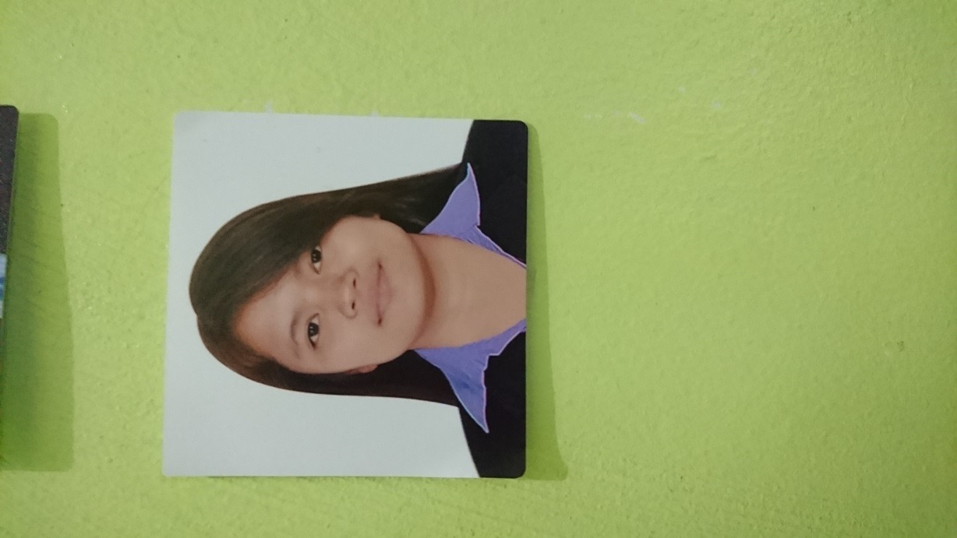

**DAVID, MAY ANGELLIE P.**

**Current Address:** #803 Kalamansi St., Purok 5, BF Homes Parañaque City

**Permanent Address:** #346 Wawa, Pilar, Bataan

**Contact Number:** +639778371118

**Email Address:** [mayangellie.david@gmail.com](mailto:mayangellie.david@gmail.com)

***Summary***

* Almost Seven (7) year experience in programming using RPGLE, CL, SDA, SQL, QUERY and RLU.
* Been exposed to both development and testing/support side and been able to properly accomplished assigned responsibilities and duties.

***IT Work Experience***

* **AEON Credit Service Systems (Philippines) Inc.**

Unit 802, 8TH Floor, Philplans Corporate Center

1012 Triangle Drive corner 10th and 11th Avenue

Bonifacio Global City, Taguig City 1634

**CUSTOMER SUPPORT FOR AEON CREDIT SERVICE (ASIA) CO. LTD.(December 2017-Present)**

**Software Consultant**

**Job Description:**

* Development of new requirements for Credit Card Promotions related to Annual Fee Waive, Bonus Points, Mileage Redemption for HK Express etc.
* Fix program bugs and errors.
* Development of Utility Programs for Files and Menu Clean Up

C**USTOMER SUPPORT FOR AEON CREDIT SERVICE MALAYSIA (October 2016-December 2017)**

**Software Consultant**

**Job Description:**

* Development of new requirements for Credit Card Systems like (E-Money, Maintenance Screens, Bonus Points Automation Programs etc.)
* Fix program bugs and errors.
* System integration testing, QA support, monthly closing support and monitoring of jobs.
* Deployed in Malaysia for 1 year to provide on-site support for on-going projects.

**CUSTOMER SUPPORT FOR AEON CREDIT SERVICE (ASIA) CO. LTD.(June 2013- October 2016)**

**Software Consultant**

**Job Description:**

* Development of new requirements for Credit Card Promotions related to Rebates, Bonus Points, Welcome Offers, and Lucky Draws.
* Enhanced CA Interest module.
* Fix program bugs and errors.
* System integration testing, QA support, monthly closing support and monitoring of jobs.
* Documentation of Unit, Integration and User Acceptance Tests, Programs Specifications, Test Scripts, Post-Production Checklist, etc. based on the Job Request/Incident Reports.
* Deployed in Hong Kong for 6 months to provide on-site support for on-going projects.

**COMMON CREDIT CARD SYSTEM (December 2012 – June 2013)**

**Senior Software Engineer**

**Job Description:**

* Assigned under Common Credit Card System.
* Responsible for As400 coding standards, object reorganization, and decimal control.
* Fix program bugs and errors.

**CREDIT CARD SYSTEM INDONESIA (November 2011 - December 2012)**

**Software Engineer**

**Job Description:**

* Participated in the development and delivery of Credit Card System – Indonesia Project.
* Developed, implemented and maintained credit card system.
* Enhanced programs related to Sales and Payments transactions.
* Enhanced programs for Maintenance Logs/Message Logs.
* Fixed related program bugs and errors
* Documentations of Unit, Integration Tests, Programs Specifications, Test Scripts, Post-Production Checklist, System Operation Procedures, User’s Manuals, etc based on the Job Request/Incident Reports.
* AS400 Training

***Personal Information***

**CITIZENSHIP:** Filipino

**LANGUAGE:** Tagalog, English, Nihongo (Basic)

**Age:** 25 years old

**GENDER:** Female

***Education***

**BACHELOR OF SCIENCE IN COMPUTER SCIENCE Major in Software Development**

Bataan Peninsula State University (Main Campus)

Balanga City, Bataan (2007-2011)

***References***

**Rica Arevalo**

Team Lead

AEON CREDIT SERVICE SYSTEMS (PHILIPPINES)

+639267213401

**Jezavel Dimaculangan**

Senior Software Consultant II

AEON CREDIT SERVICE SYSTEMS (PHILIPPINES)

+639279170031

**Ailyn Terrobias**

Software Consultant

AEON CREDIT SERVICE SYSTEMS (PHILIPPINES)

+639175648683