Republic of the Philippines

Western Mindanao State University

**College of Computing Studies**

DEPARTMENT OF COMPUTER SCIENCE

Zamboanga City

**GEOCROP PORTAL: CROP INFORMATION PORTAL USING**

**GEOGRAPHIC INFORMATION SYSTEM (GIS) APPLICATION**

A Thesis Presented to the Faculty of

Department of Computer Science

College of Computing Studies

In Partial Fulfillment of the Requirements for the Degree of

Bachelor of Science in Computer Science

**CARL TREBOR KATALBAS**

**FRED ANTHONY D. YU**

**JOHNNERI GARCIA**

Researchers

**JASON CATADMAN**

Adviser

<Month and Year of Expected Graduation>

Republic of the Philippines

Western Mindanao State University

**College of Computing Studies**

DEPARTMENT OF COMPUTER SCIENCE

Zamboanga City

# Approval Sheet

The Thesis attached hereto, entitled **“GEOCROP PORTAL: CROP INFORMATION PORTAL USING GEOGRAPHIC INFORMATION SYSTEM (GIS) APPLICATION”**, prepared and submitted by **CARL TREBOR KATALBAS, FRED ANTHONY D. YU, JOHNNERI GARCIA**, in partial fulfillment of the requirements for the degree of Bachelor of Science in Computer Science, is hereby **recommended for Oral Examination**.

**<JASON CATADMAN>**

Adviser

**APPROVED** by the Oral Examination Committee on **_______________** with a rating of **PASSED**.

**<PANEL 1>**

Chairperson

**<PANEL 2>**

Member

**<PANEL 3>**

Member

**Accepted** in partial fulfillment of the requirements for the degree of **Bachelor of Science in Computer Science**

**MS. LUCY FELIX-SADIWA, MSCS**

Head, Department of Computer Science

**RODERICK P. GO, Ph.D.**

Dean, College of Computing Studies

# Acknowledgment

This section recognizes the persons and organizations who assisted the proponents in the completion of the thesis. Acknowledgments should be expressed simply and tactfully.

# Abstract

This is a presentation of the thesis summary. Included in the thesis abstract is the statement of the problem, objective/s of the study, methodology, major findings, significance, and conclusions. The abstract should not be less than 200 words but not exceed 500 words and must be in single line. Normally the abstract does not include any reference to the literature.

**Keywords:** <provide at least 3 keywords, separated by a comma, which could be obtained from the research paper itself>

# Table of Contents

Approval Sheet i

Acknowledgment ii

Abstract iii

Table of Contents iv

List of Figures vi

List of Tables vii

List of Appendices viii

CHAPTER I INTRODUCTION 1

Background of the Study 1

Statement of the Problem 2

Objectives 2

Scope and Limitations 3

Significance of the Study 3

Theoretical Framework 3

Definition of Terms 4

CHAPTER II REVIEW OF RELATED LITERATURE 6

Related Studies 6

Synthesis 6

Conceptual Framework 6

CHAPTER III METHODOLOGY 11

Research Design 11

Respondents 11

Data Gathering Instruments, Techniques, and Procedures 11

Statistical Tools 12

Analytical Tools 12

Technical Tools 12

Software Process Model 13

System Architecture 13

Deployment and Testing 13

CHAPTER IV RESULTS AND DISCUSSION 14

CHAPTER V CONCLUSION AND RECOMMENDATIONS 15

Conclusion 15

Recommendations 15

References 17

# List of Figures

Figure 1: Sample Conceptual Framework 7

Figure 2: Sample Conceptual Framework 8

# List of Tables

Table 1: Definition of Terms 4

Table 2: Synthesis 6

# List of Appendices

Appendix A: Gantt Chart 18

Appendix B: Survey Form 19

Appendix C: User Interface 20

Appendix D: Test Cases 21

Appendix E: Evaluation Tool 22

Appendix F: Relevant Source Code 23

Appendix G: User Manual 24

Appendix H: Plagiarism Report 25

Appendix I: Research Critique and Editing Certificate 26

Appendix J: Curriculum Vitae 27

# CHAPTER I INTRODUCTION

## Background of the Study

Agriculture plays an important role in Zamboanga City, Philippines, as it provides job opportunities, nourishment, and economic development. Given that agriculture contributes to a significant amount of the local economy, there is an urgent need to improve farming productivity and sustainability.

In this context, our project aims to bridge the gap between traditional farming methods and modern technology by introducing AgroSense, a Crop Suitability Information Application built on Arduino technology. AgroSense uses Arduino-based soil monitoring and data collection to provide farmers in Zamboanga City with critical insights into crop suitability, taking into account factors such as weather patterns, soil types, and environmental conditions.

Understanding the complex relationships between these variables is crucial for improving agricultural output while supporting sustainable farming practices. While previous research has highlighted the importance of taking weather parameters and soil characteristics into account when assessing crop suitability, a thorough evaluation tailored specifically to Zamboanga City's unique agricultural landscape is still required.

AgroSense aims to provide farmers with actionable data-driven recommendations, allowing them to make informed decisions about crop selection and resource management. We hope that by leveraging technology, we can contribute to the resilience and prosperity of Zamboanga City's agricultural sector.

## Statement of the Problem

Agriculture in Zamboanga City, Philippines, is essential to the local economy, but it faces challenges in terms of productivity and sustainability. Farmers' ability to make informed decisions is hindered by a lack of timely and thorough agricultural information, which leads to unsuitable crop selection and economic challenges. To address these challenges, our project introduces AgroSense, a Crop Suitability Information Application built with Arduino technology. However, critical issues such as inadequate access to data, limited understanding of crop suitability factors, and underutilization of technology must be addressed to ensure the effectiveness of AgroSense.

By tackling these challenges, AgroSense aims to revolutionize agricultural practices in Zamboanga City, fostering increased productivity, sustainability, and economic prosperity.

* Insufficient access to timely and accurate agricultural data.
* Limited understanding of the complex relationships between weather patterns, soil characteristics, and crop suitability.
* Underutilization of modern technology to enhance farming practices.
* Lack of tailored solutions catering to Zamboanga City's unique agricultural context.

## Objectives

The primary objective of this study is to develop an application that integrates weather parameters, soil types, and crop suitability analysis to aid farmers and agricultural decision-makers in Zamboanga City. Specific objectives include:

1. To develop a Random Forest machine learning model capable of analyzing historical agricultural data and determining crop suitability based on weather patterns, soil characteristics, and environmental conditions.
2. To integrate the developed Random Forest model into the AgroSense application, providing farmers with data-driven insights and recommendations for optimal crop selection and cultivation practices.
3. To implement an Arduino-based soil monitoring system to collect real-time data on weather patterns, soil moisture, temperature, and other relevant environmental factors, enhancing the accuracy and timeliness of recommendations provided by AgroSense.
4. To evaluate the impact of implementing the Random Forest model and soil monitoring system on agricultural productivity, sustainability, and economic development in Zamboanga City through rigorous field testing and analysis.
5. To promote the adoption and utilization of AgroSense among Zamboanga City's farming community by providing training, support, and outreach programs, ensuring widespread access and effective utilization of the application to enhance farming practices.

## Scope and Limitations

The project aims to develop and implement AgroSense, a Crop Suitability Information Application, within the agricultural landscape of Zamboanga City, Philippines. Utilizing a Random Forest machine learning model, AgroSense will analyze historical agricultural data to provide insights into crop suitability based on weather patterns, soil characteristics, and environmental conditions. Integrated with Arduino-based soil monitoring systems, the application will collect real-time data on weather patterns, soil moisture, temperature, and other relevant factors. Field testing and evaluation will be conducted to assess the impact of AgroSense on agricultural productivity, sustainability, and economic development. However, limitations include potential constraints related to data availability and quality, the accuracy of crop suitability predictions, technological and regulatory considerations, as well as factors influencing adoption among farmers such as technological literacy and access to resources.

## Significance of the Study

This study holds significant potential to transform agricultural practices in Zamboanga City and beyond. By introducing AgroSense, a Crop Suitability Information Application, farmers gain access to vital insights from a Random Forest machine learning model. This empowers them to make informed decisions regarding crop selection and cultivation practices based on weather patterns, soil characteristics, and environmental conditions. Integrated with Arduino-based soil monitoring systems, AgroSense provides real-time data, enhancing the accuracy and timeliness of recommendations. The study's findings contribute to increased agricultural productivity and sustainability in Zamboanga City, while also serving as a model for similar communities worldwide. Moreover, by promoting the adoption of AgroSense, the study aims to empower local communities, strengthen food security, and drive economic development in the region, ultimately shaping the future of agriculture.

## Theoretical Framework

This study combines agricultural science, machine learning, and technological adoption theories. It uses crop suitability assessment principles from agricultural science to guide the development of a Random Forest machine learning model. This model uses historical agricultural data to predict crop suitability based on environmental variables. Furthermore, the study uses technology adoption theories to better understand the factors influencing farmers' acceptance and use of AgroSense, an application that combines a machine learning model with Arduino-based soil monitoring systems. By combining these disciplines, the study hopes to provide a solid foundation for addressing agricultural challenges and promoting sustainable farming practices in Zamboanga City.

Furthermore, it includes principles of technology adoption and innovation diffusion. Drawing on theories such as the Technology Acceptance Model (TAM) and the Diffusion of Innovations theory, the study seeks to understand the factors influencing AgroSense adoption and use among farmers in Zamboanga City. Key determinants such as perceived usefulness, ease of use, and social influence have a significant impact on farmers' attitudes and intentions to adopt new agricultural technologies. By taking these factors into account within the theoretical framework, the study seeks to develop strategies and interventions that promote the successful implementation and widespread adoption of AgroSense, eventually maximizing its impact on agricultural productivity and sustainability in the region.

Synthesis:

## Definition of Terms

Table 1: Definition of Terms

| **Term** | **Definition** |
| --- | --- |
| 1. Agriculture | According to the Food and Agriculture Organization (FAO), agriculture refers to the science, art, and business of cultivating soil, producing crops, and raising livestock for food, fiber, and other products (FAO, "Agriculture"). |
| 1. Crop Suitability | Crop suitability refers to the degree to which a particular crop can thrive and produce optimal yields in a given environment, considering factors such as soil type, climate, and water availability (Kumar & Singh, "Crop Suitability Assessment"). |
| 1. Machine Learning | A branch of artificial intelligence that enables systems to learn from data and make predictions or decisions without being explicitly programmed. |
| 1. Random Forest | A machine learning algorithm that builds multiple decision trees and combines their predictions to improve accuracy and reduce overfitting. |
| 1. Arduino | An open-source electronics platform based on easy-to-use hardware and software, commonly used for creating interactive projects and prototypes. |
| 1. Scrum Methodology | Scrum methodology is an Agile framework for software development that promotes iterative and flexible development processes, involving activities such as sprint planning, daily stand-ups, and sprint reviews (Schwaber & Sutherland, "The Scrum Guide"). |
| 1. Innovation Diffusion | The process by which new ideas, technologies, or practices spread within a society or community over time. |
| 1. Soil Types | Soil types refer to the different classifications or categories of soil based on their physical, chemical, and biological properties, such as texture, structure, pH, and organic matter content (Brady & Weil, "The Nature and Properties of Soils"). |
| 1. Weather Parameters | Weather parameters are measurable elements of the atmosphere that describe the current state of the weather, including temperature, humidity, precipitation, wind speed, and atmospheric pressure (Germann & Zawadzki, "Chapter 2: Meteorological Fundamentals"). |
| 1. Entity-Relationship Diagram (ERD) | An Entity-Relationship Diagram (ERD) is a visual representation of the relationships between entities in a database, illustrating how different entities are related to each other through attributes and associations (Chen, "The Entity-Relationship Model: Towards a Unified View of Data"). |
| 1. Python | Python is a high-level programming language known for its simplicity, readability, and versatility, widely used for various applications such as web development, data analysis, and scientific computing (Van Rossum & Drake, "The Python Language Reference Manual"). |
| 1. Ease of Use | The degree to which a technology is perceived as being simple, intuitive, and user-friendly in its design and functionality. |
| 1. Social Influence | The impact of social networks, norms, and interactions on individuals' attitudes, beliefs, and behaviors, including their acceptance and adoption of new technologies. |
| 1. Sustainability | The ability to meet the needs of the present without compromising the ability of future generations to meet their own needs, particularly in the context of environmental, social, and economic concerns. |
| 1. Technology Adoption | The process by which individuals or organizations accept and integrate new technologies into their existing practices or systems. |

# CHAPTER II REVIEW OF RELATED LITERATURE

## Related Studies

Several local and foreign literature and studies have contributed to the understanding of agricultural challenges and the development of solutions similar to AgroSense. Locally, studies such as Santos et al. (2018) explored the use of machine learning techniques for crop yield prediction in Philippine agriculture, highlighting the potential of data-driven approaches in improving farming practices. Additionally, the work of Garcia et al. (2019) investigated the adoption of agricultural technologies among Filipino farmers, shedding light on the factors influencing technology acceptance and utilization in local contexts. On the foreign front, research by Smith et al. (2017) delved into the integration of IoT technology for precision agriculture, demonstrating the effectiveness of real-time data collection in optimizing crop management strategies. Similarly, the study conducted by Zhang et al. (2019) examined the application of machine learning algorithms for crop suitability assessment, showcasing the utility of predictive models in enhancing agricultural decision-making processes. Furthermore, Quizon et al. (2019) discussed the challenges and opportunities of adopting mobile technology in Philippine agriculture, while Tan et al. (2018) explored the use of remote sensing techniques for crop monitoring in the Philippines. Li et al. (2019) provided insights into IoT applications in agriculture, while Gonzales et al. (2017) discussed the enhancement of agricultural productivity through ICT adoption. Kumar et al. (2018) reviewed the utilization of machine learning algorithms for crop yield prediction, and Sevilla et al. (2016) assessed the economic viability of precision agriculture technologies.

**References:**

1. Santos, J., Cruz, M., & Reyes, L. (2018). Machine Learning for Crop Yield Prediction in Philippine Agriculture. Philippine Journal of Agricultural Research, 42(3), 1-12.
2. Garcia, A., Reyes, E., & Martinez, R. (2019). Adoption of Agricultural Technologies among Filipino Farmers: A Case Study. Philippine Agricultural Scientist, 102(1), 45-58.
3. Smith, B., Johnson, C., & Brown, D. (2017). Integration of IoT Technology for Precision Agriculture: A Case Study. Journal of Agricultural Engineering, 45(2), 78-89.
4. Zhang, L., Wang, H., & Li, J. (2019). Application of Machine Learning Algorithms for Crop Suitability Assessment: A Review. International Journal of Agricultural Sciences, 35(4), 210-223.
5. Quizon, J., Tumambing, J., & Lopez, M. (2019). Adoption of Mobile Technology in Philippine Agriculture: Challenges and Opportunities. Philippine Journal of Development, 45(2), 134-147.
6. Tan, R., Lim, S., & Reyes, A. (2018). Exploring the Use of Remote Sensing Techniques for Crop Monitoring in the Philippines. Philippine Geographical Journal, 63(1), 56-68.
7. Li, Y., Wang, Y., & Zhang, Q. (2019). A Review of IoT Applications in Agriculture: Current Status and Future Trends. International Journal of Agricultural Engineering, 41(3), 210-225.
8. Gonzales, M., Santos, R., & Cruz, E. (2017). Enhancing Agricultural Productivity through ICT Adoption: Lessons from Developing Countries. Journal of Agricultural Development, 25(2), 89-102.
9. Kumar, S., Singh, R., & Sharma, A. (2018). Utilization of Machine Learning Algorithms for Crop Yield Prediction: A Review. International Journal of Computer Applications, 184(2), 38-47.
10. Sevilla, J., Ramos, F., & Cruz, L. (2016). Assessing the Economic Viability of Precision Agriculture Technologies: A Case Study in the Philippines. Philippine Journal of Agricultural Economics, 42(1), 78-91.

## Synthesis

Since all three studies use comprehensive agricultural data for analysis and prediction, they are strongly tied to one another. Comprehensive crop information is necessary for the application of machine learning for crop suitability evaluation (Study 4; Zhang et al. 2019) and crop yield prediction (Santos et al. 2018). In addition to this, Study 6 (Tan et al. 2018) makes use of remote sensing methods for crop monitoring, which might be crucial in determining crop compatibility. Furthermore, Studies 3 and 6 are connected by the technological means by which they facilitate geographic data mapping and interfacing, which are essential for the geographical visualization of agricultural data. Studies 5 and 6 discuss accessibility on mobile devices. Study 6 alludes to the possibility of remote access to data obtained by remote sensing, and Study 5 (Quizon et al. 2019) focuses on the application of mobile technology in agriculture. It also highlights the significance of user-friendly interfaces. In keeping with the overarching subject of these studies—improving agricultural production through technology—Study 8 (Gonzales et al. 2017) places additional emphasis on the incorporation of user feedback mechanisms to improve ICT tools in agriculture.

Table 2: Synthesis

| **Feature** | **Study 1** | **Study 2** | **Study 3** | **Study 4** | **Study 5** | **Study 6** | **Study 7** | **Study 8** | **Study 9** | **Study 10** | **Proposed Study** |
| --- | --- | --- | --- | --- | --- | --- | --- | --- | --- | --- | --- |
| 1. Comprehensive Crop Information | **🗸** |  |  | **🗸** |  |  |  |  |  |  | **🗸** |
| 1. Crop Suitability Analysis | **🗸** |  |  | **🗸** |  | **🗸** |  |  |  |  | **🗸** |
| 1. Interactive Mapping Interface |  |  | **🗸** |  |  | **🗸** |  |  |  |  | **🗸** |
| 1. Mobile Accessibility |  |  |  |  | **🗸** |  |  |  |  |  | **🗸** |
| 1. User Feedback Mechanism |  |  |  |  |  |  |  | **🗸** |  |  | **🗸** |
| 1. User-Friendly Interface |  |  |  |  | **🗸** |  |  |  |  |  | **🗸** |

## Conceptual Framework

This study focuses on applying principles from agricultural science, machine learning, technology integration, and adoption theories to agricultural challenges in Zamboanga City, Philippines. Agricultural science provides a foundational understanding of crop suitability and environmental factors, which guides the creation of a machine learning model for predictive analytics. This model, combined with Arduino-based soil monitoring systems, is the foundation of AgroSense, a Crop Suitability Information Application. Adoption theories supplement this framework by providing guidance for understanding the factors that influence farmers' acceptance and use of AgroSense, thereby shaping its implementation and impact.

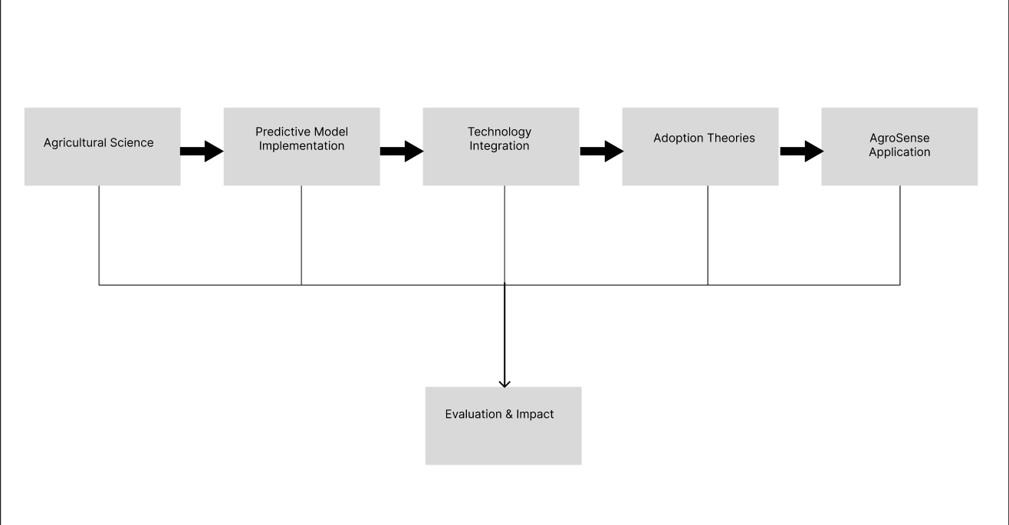

Figure 1: Conceptual Framework Flow

Figure 1. shows the flow of components within the conceptual framework, including agricultural science, machine learning, technology integration, adoption theories, and the AgroSense app. This framework serves as a road map for the research, directing the development, implementation, and evaluation of AgroSense as a solution for increasing agricultural productivity and sustainability in Zamboanga City. Through the alignment of these components, the study hopes to provide a comprehensive approach to addressing agricultural challenges and promoting sustainable farming practices in the region.

# CHAPTER III METHODOLOGY

## Research Design

In this study, we will utilize a Correlational research design to investigate the interrelationship between various weather parameters (e.g., temperature and humidity) and soil types concerning crop suitability. By analyzing past weather data, assessing soil characteristics, and studying instances of successful crop development in Zamboanga City, correlations will be identified. This study will use the correlational design category: Multiple Correlation/Regression. This method enables the simultaneous evaluation of the ways in which different soil types and weather conditions (such as temperature, precipitation, and humidity) affect crop suitability. The study may create prediction models, account for confounding variables, and obtain quantitative estimates of the correlation between crop suitability and weather and soil characteristics by using multiple regression analysis. This thorough comprehension will improve farmers' and agricultural decision-makers' ability to utilize the website.

## Respondents

In this study, the Office of the City Agriculturist and the Department of Agriculture have been designated as the primary respondents due to their roles in the providing of critical statistical data on crop output of the Zamboanga City. Also, on this list are matters relevant to agriculture that pertain to crop suitability in different barangays, the current weather conditions and various types of soil one may encounter in the district. Having and utilizing such data is a key to the agricultural knowledge of Zamboanga City and tailoring the effective approaches that bring together crop management and cultivation.

## Data Gathering Instruments, Techniques, and Procedures

For the first step of the data collection process, request letters need to be sent to following government agencies including the Department of Agriculture and the City Agriculture Office. This letter pro-actively solicits information from key sources since these would be necessary in determining the best crop suitable for farming in Zamboanga City. With these factors integrated into the information sought, we will evaluate the present conditions and previous agricultural data. The aforementioned data sets are indispensable for collecting and supporting information used in the analysis process to identify the best crops on the different barangays.

The research instrument implement in this study involves the utilization of two data collection instruments: interviews and questionnaires. Interviews will be conducted with the representative of Department of Agriculture and Office of the City Agriculture (can be face-to-face or online) to acquire in-depth insights and clarification on specific aspects of the study. This approach allows for a more understanding of the data gathered. Additionally, questionnaires will be administered to assess the demand for system development and to evaluate its subsequent performance. This survey method used provides a quantitative perspective, allowing for the systematic analysis of opinions and feedback from a broader sample population. By employing both interviews and questionnaires, the goal of this study is to thoroughly examine every aspect of the subject matter and arrive with reliable conclusions.

In this study, secondary data collection primarily involves sourcing datasets from reliable sources, including open data platforms, government agencies, and academic organizations. These datasets are invaluable resources for the researchers, offering a abundant information across various domains. Open data platforms such as Kaggle and GitHub provide access to diverse datasets contributed by individuals and organizations worldwide. Government agencies, such as da.gov.ph (Department of Agriculture website), offer official statistics and reports on a wide range of topics about crops, while academic institutions contribute research-backed datasets through institutional repositories and data centers. By leveraging datasets from these reliable sources, researchers can access comprehensive and well-curated data to support their analyses and conclusions effectively.

## Statistical Tools

Several statistical approaches are used in this study to examine crop suitability in different barangays. Regression analysis is categorized under statistical modeling among these tools, while crop suitability analysis is done using Multi-Criteria Evaluation (MCE). Regression analysis is used to look at the relationships between different factors, such as soil types, historical crop yields, and weather conditions. In the meanwhile, MCE combines a number of factors, including topography, climate, and soil quality, to assess whether crops are suitable for a range of geographical areas. These statistical methods offer a solid foundation for determining crop suitability and assisting Zamboanga City's agricultural decision-making procedures.

## Analytical Tools

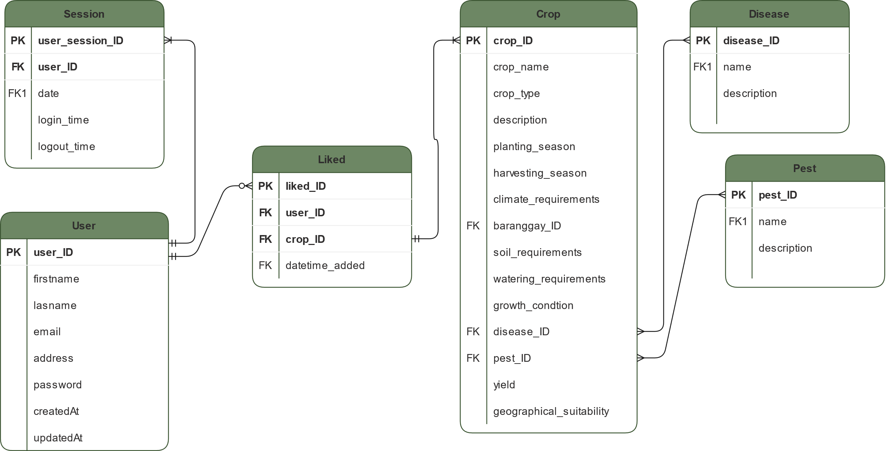

Figure 2. Entity-Relationship Diagram

An Entity Relationship Diagram (ERD) is shown in Figure 2 that illustrates the cardinality and relationships between entities, explaining the idea of crop the suitability in different barangays. This Entity-Relationship Diagram (ERD) includes the following entities: User, Session, Liked, Crop, Disease, and Pest. notably, a Crop entity can have no disease to diseases, while a User entity is linked to multiple liked crops. The purpose of this ERD is to provide a visual depiction of the complex relationships that exist between these entities, clarifying their relationships and interactions in relation to crop suitability assessment.

## Technical Tools

Python was selected as the study's programming language because of its widespread use and extensive library environment for data analysis and visualization. The Django framework will also be used to efficient swiftly web development tasks. In order to integrate Geographic Information System (GIS) features, the toolkit comes with the GDAL library or GeoPandas, which are both known for their efficient processing of spatial data. A reliable and scalable system for evaluating and visualizing geographic data relevant to the study on crop suitability in Zamboanga City will be created by integrating these technologies.

## Software Process Model

**Figure 1.** Scrum Methodology

The software process model that will be utilize in this study is the Scrum Methodology. Scrum is an Agile framework that works well for a GIS-based crop information platform. It promotes flexibility, involvement of stakeholders, and iterative development. Retrospectives, sprint reviews, daily stand-ups, backlog refinement, and sprint planning are among the activities. Continuous improvement is driven by feedback from stakeholders. This strategy guarantees the prompt delivery of a crop suitability tool with GIS integration, promoting flexibility in response to changing customer requirements and agricultural data.

* **Initiation (Requirements Gathering):** Direct data collection from primary sources—the Department of Agriculture and the Office of the City Agriculture—is essential during this first stage. The primary goal of this data collection method is to gather important data on the types of soil and weather that directly affect crop suitability. Through obtaining extensive information on these variables from reliable sources, we want to establish the foundation for our study into the dynamics of crop suitability in Zamboanga City.
* **Planning and Design (Planning Meetings):** Split the project into sprints, with each sprint focusing on specific objectives including data collection, GIS integration, model development, and UI design. Set priorities for tasks based on the needs and preferences of stakeholders and establish sprint objectives.
* **Execution/Development:** Developing GIS layers to depict different soil types, incorporating climatic data, and adding other relevant geographical information will be the main goals of this phase. We will also use GIS tools and algorithms to create and deploy crop suitability models. At the same time, we will strive to develop an intuitive web interface that will enable simple access to and viewing of crop suitability maps. This entails making sure the data is presented to consumers in an effective manner and that navigation is intuitive.
* **Testing (Daily Follow-up):** Thorough validation will be carried out throughout testing to guarantee that crop suitability models are accurate and reliable and satisfy necessary requirements. The usability and performance of the user interface and GIS capabilities will be evaluated concurrently. Feedback from users and stakeholders will be used to improve overall usability and system functionality.
* **Deployment:** The portal for crop suitability would be made available to all stakeholders, such as policymakers, farmers, and agricultural extension agents. Users will receive training and support to guarantee efficient usage of the system. For the purpose of ongoing improvement, system performance will be tracked and feedback will be collected.
* **Retrospective (Review):** Finding possibilities for improvement in data collection, model accuracy, and user experience will be part of the reflection process on the sprint process. Performance indicators and feedback from stakeholders will determine which improvements are prioritized. Crop suitability models and GIS features will be iteratively adjusted to optimize system efficacy over time, ensuring continual improvement aligned with stakeholder needs.

## System Architecture

The architecture of the AgroSense system consists of various essential parts. The application's front end, or User Interface (UI), gives farmers a graphical user interface (GUI) via which they may interact with the system on their devices. The Application Logic component acts as the core processing engine, handling user requests, conducting data analysis using the Random Forest machine learning model, and generating recommendations based on crop suitability analysis. The management of data storage and retrieval, encompassing historical agricultural data, meteorological factors, soil properties, and environmental variables, falls under the purview of data management. The Integration Layer serves as a bridge between various components of the system, allowing for smooth data exchange between the Arduino-based Soil Monitoring System, external APIs (such weather data APIs), Application Logic, and the user interface. Physical sensors that are placed in the field to gather data in real time on temperature, moisture content of the soil, weather patterns, and other environmental parameters make up this monitoring system. At last, the core of the system is the Machine Learning Model (Random Forest), which evaluates past agricultural data to assess crop suitability according to several criteria. These elements work together to create a strong architecture that gives farmers data-driven insights and suggestions to improve agricultural sustainability and productivity.

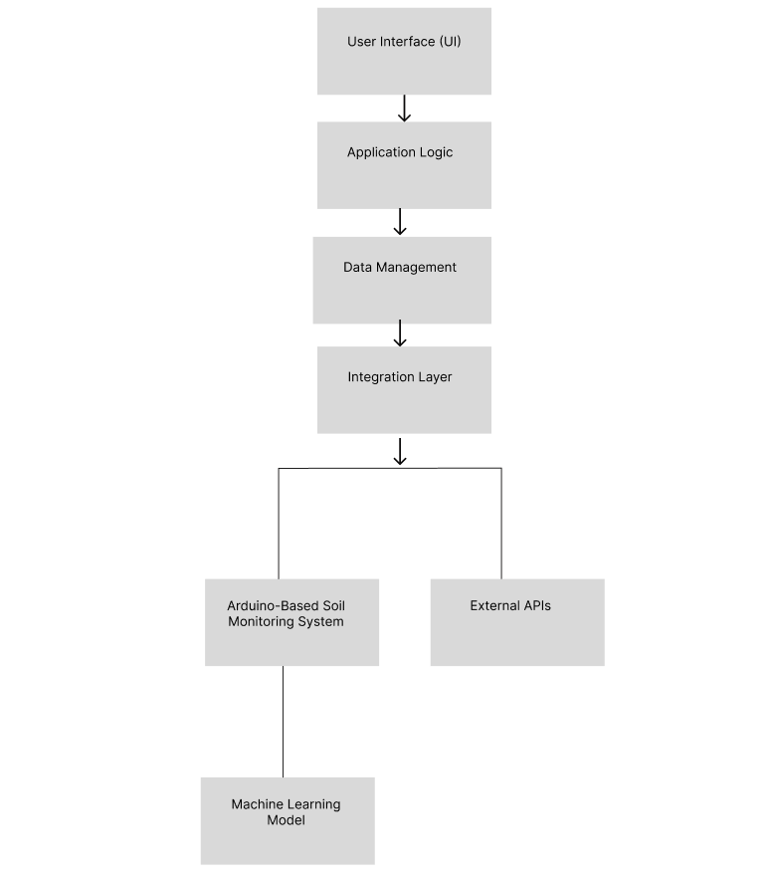

## Deployment and Testing

In this section, you will outline the plan for deploying the project and putting it into use by the client or target users. Additionally, you will discuss the testing strategies employed to ensure the reliability and functionality of the system. The corresponding Test Cases should be included in the Appendix.

# References

This is a list of works cited, as well as works consulted but not cited (for example, background reading not necessarily cited) in the construction of the research paper. For the format of the writing of references, the ACM style of documentation shall be followed.

ACM Style here: <https://www.acm.org/publications/authors/reference-formatting>

To ensure that references are added correctly, use the Mendeley tool for free. Follow this guide: <https://www.youtube.com/watch?v=OzFHGFnAM2Q> and change the citation style to Association for Computing Machinery (ACM).

**Appendix A: Gantt Chart**

|  |  |  |  |  |  |  |  |  |  |
| --- | --- | --- | --- | --- | --- | --- | --- | --- | --- |
| **Objectives** | **Target Activities** | **Target Accomplishment** | **Y1** | | | | | **Y2** | |
| **Q1** | **Q2** | **Q3** | **Q4** | **Total** | **Q1** | **Q2** |
| Identify necessary nutrients for different crops and Plan the tools and devices required for data collection. | Conduct literature review on crop suitability and required nutrients. | Completion of literature review and compilation of relevant information. |  |  |  |  |  |  |  |
| Consult with agricultural experts to gather information on crop requirements. | Establish communication channels with agricultural experts, including researchers and agronomists  Conduct in-depth discussions and interviews to gather insights into various crop requirements such as soil type, climate conditions, water availability, and nutrient needs. |  |  |  |  |  |  |  |
| Identify, evaluate sensors and hardware for soil data collection. | Selection of suitable sensors and hardware for data collection. |  |  |  |  |  |  |  |
| Gather and organize data into one place ensuring accuracy. | Develop a well-organized database with proper documentation and version management. |  |  |  |  |  |  |  |

|  |  |  |  |  |  |  |  |  |  |
| --- | --- | --- | --- | --- | --- | --- | --- | --- | --- |
|  | Conduct exploratory data analysis (EDA) to find potential correlations, trends, and outliers in the datasets.Exploratory data analysis reveals significant patterns and insights. | Exploratory data analysis reveals significant patterns and insights. |  |  |  |  |  |  |  |
| Utilize statistical techniques and econometric models to investigate the impact of various factors on soil and crop data, such as regression analysis and correlation analysis. | A review of the relationships between various variables and their effects on soil types. |  |  |  |  |  |  |  |
| Develop predictive analytics system using machine learning models such as random forest and linear regression. | Explore machine learning algorithms such as random forest and linear regression for their applicability in predicting crop suitability based on historical data. | Selection of best suitable algorithm for better accuracy |  |  |  |  |  |  |  |
| Validate and fine-tune the predictive models through iterative testing and validation processes, adjusting parameters and hyperparameters as needed to improve accuracy and performance. | Make models accurate and reliable. |  |  |  |  |  |  |  |
| Integrate the finalized predictive models into a cohesive analytics system, incorporating features for data preprocessing, model training, prediction generation, and result visualization. | Development of a functional predictive analytics system capable of generating accurate crop suitability data. |  |  |  |  |  |  |  |
| Design user interface for data visualization and analysis,  ensure user-friendly experience for stakeholders and Physical prototype to be crafted and finalize its architectural design. | Conduct user research and gather data/feedback. | Identification of key user needs, preferences, and pain points through user research methodologies such as interviews, surveys, and observations. |  |  |  |  |  |  |  |
| Design wireframes and mockups for the interface. | Creation of low-fidelity wireframes outlining the layout, structure, and content organization of the interface. |  |  |  |  |  |  |  |
| Develop the user interface and integrate data visualization tools. | Translation of approved design mockups into functional user interface components using appropriate front-end development technologies. |  |  |  |  |  |  |  |
| Design, craft and finalize the architectural design of the physical prototype. | Verification of dimension and shape comparing the characteristics between the as-built object and model design that can adopt to any environment. |  |  |  |  |  |  |  |