Homework 2
Chris Lee

Problem 1

Problem Statement
For this problem, I simulated the regular spiking neuron using the Izhikevich model with varying currents, and recorded plots for voltage vs. time and spike rate vs. current.

Results
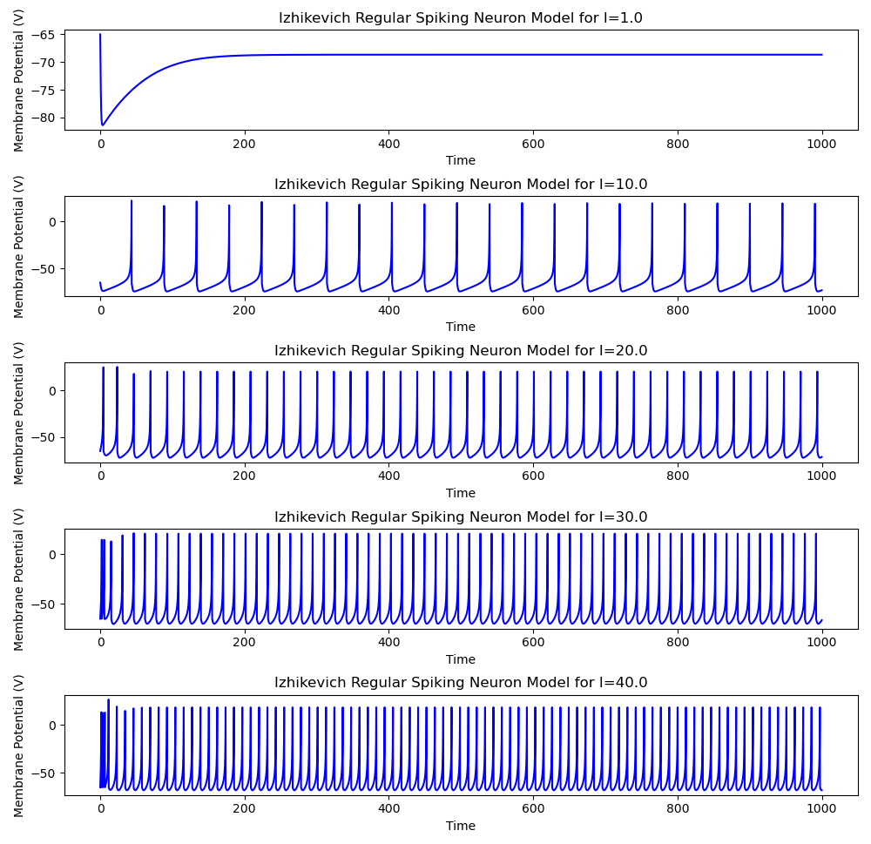
Figure 1.1. The plots of membrane potential as a function of time and input current for several simulations of the regular spiking neuron.
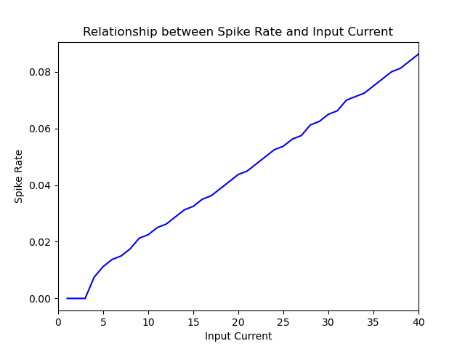
Figure 1.2. Plot of mean firing rate as a function of input current. The relationship is relatively linear.

Discussion
The relationship between input current and the number of spikes recorded in the simulation appears to be somewhat linear. For the regular spiking neuron, the threshold to start producing spikes seems to be between 3 and 4 current units, as in Figure 1.2, the rate of spikes is zero between 1-3 current units. In addition, the regular spiking neuron will initially have a higher frequency of spikes before dropping to a more constant level. This is demonstrated in Figure 1.1, where the simulations for 30 and 40 current units show a cluster of spikes. It appears that given only the output, the fast spiking rate at the beginning could be used to tell when a high input current started being applied, and the spiking rate roughly shows the level of excitation of the neuron.

Problem 2

Problem Statement
For this problem, I simulated the fast spiking neuron using the Izhikevich model with varying currents, and recorded plots for voltage vs. time and spike rate vs. current. In addition, I compare the spike rate vs. current between the fast spiking neuron model and the regular spiking neuron model.

Results
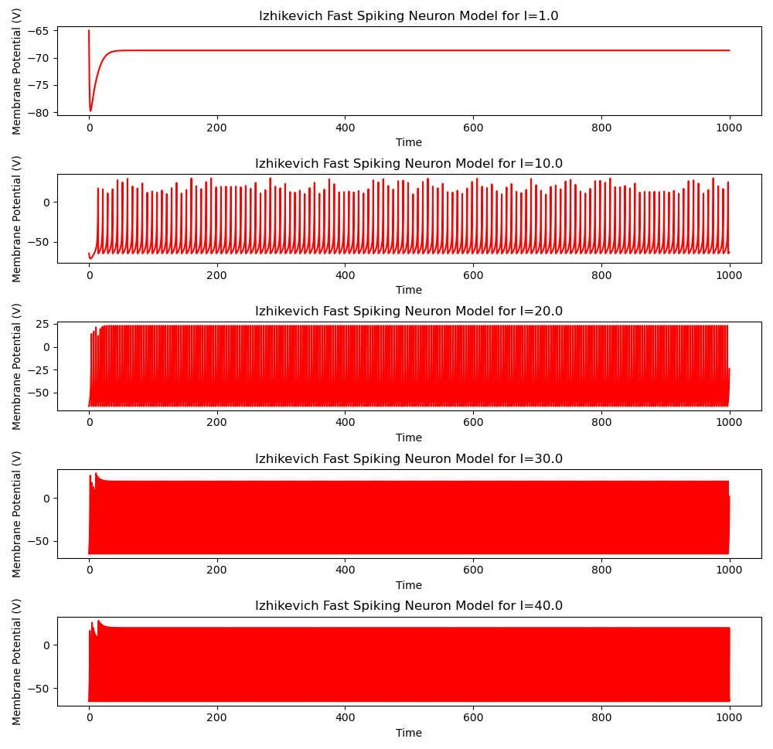
Figure 2.1. The plots of membrane potential as a function of time and input current for several simulations of the fast spiking neuron. The frequency of spikes is much higher than the regular spiking model.
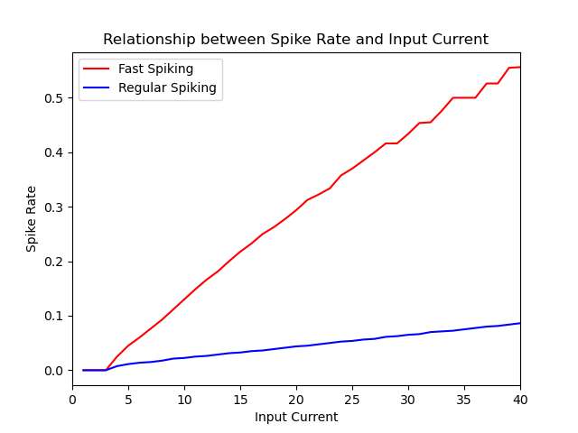
Figure 2.2. A comparison of mean spike rate as a function of input current between fast spiking and regular spiking neuron models. They both share a relatively linear relationship with current, although the fast spiking neuron’s mean spike rate grows much faster.

Discussion
The fast spiking neuron model has similar behavior to the regular spiking neuron model: 1-3 volts is insufficient to cause a spike during the simulation time, and the spikes at the beginning of the simulation appear to be more clustered together than the rest of the simulation, which can be seen in Figure 2.1. The mean spike rate of the fast spiking neuron appears to have more variability, which presents as the line being more jagged than the line for the regular spiking mean spike rate in Figure 2.2.

Problem 3

Methods
I used ChatGPT 3.5. My prompt was “generate the code for simulating a regular spiking Izhikevich neuron that runs for 1000 time-steps with inputs of I from 0 to 40 in steps of 1, then plots the spiking rate vs. I using the last 800 time-steps to calculate the spiking rate”, and I used this prompt because I summarized the Problem 3 requirements as a command.

Result
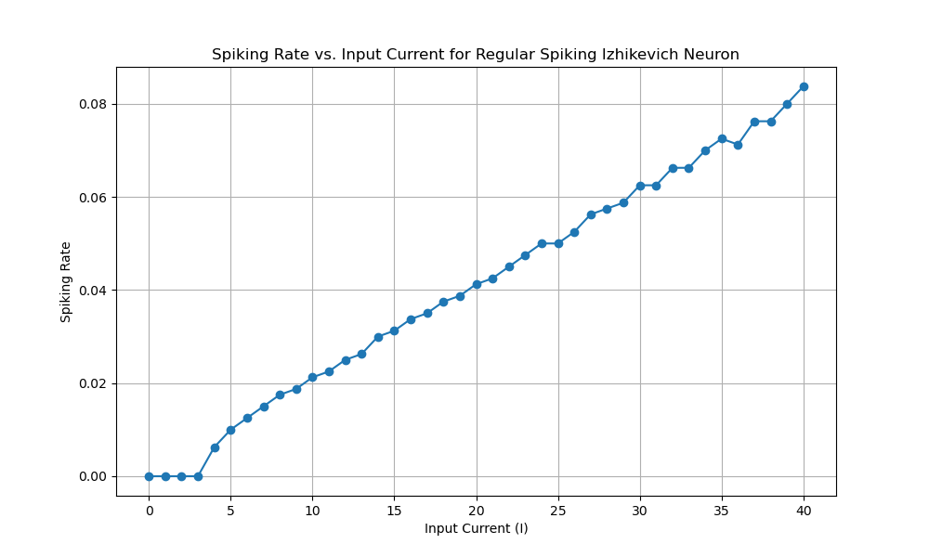
Figure 3.1. The plot of mean spike rate vs. input current created using ChatGPT-generated code.

Discussion
The code ran successfully without any modifications, although required a minor modification. The spike rate was incorrectly calculated because it used spikes from all 1000 time-steps and then divided by 800. I think “last 800 time-steps to calculate the spiking rate” did not explicitly state to only use spikes from the last 800 time-steps. As a result, each non-zero data point was slightly inflated. I fixed it by only incrementing the spike count if t > 200.
After fixing the error, the plot produced as shown in Figure 3.1 is nearly if not identical to Figure 1.2 outside of aesthetic choices.

Transcript
