Homework 3
Chris Lee

Problem 1
System Specification
For the parameters of my perceptron, I used 15 epochs with an eta of 0.001. I chose this because I wanted to have the data visualize more nicely even though it would converge faster with similar results using an eta of 0.005 and fewer epochs. It also created a lower error fraction than the other combinations I tried. My weights were randomized using np.random.rand (and divided by 2 to have all initial weights between [0, 0.5)), and I seeded it at 7 for consistent weights.

Results

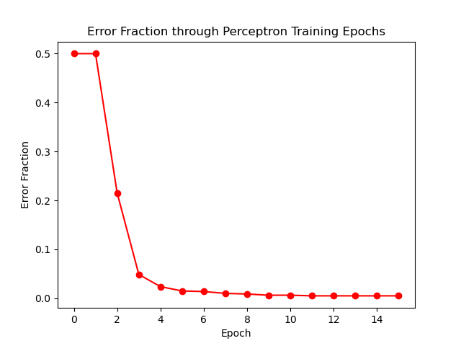
Figure 1.1: The error fraction rapidly drops to nearly zero after just five passes through the training set, but very slowly approaches zero for the remaining epochs.

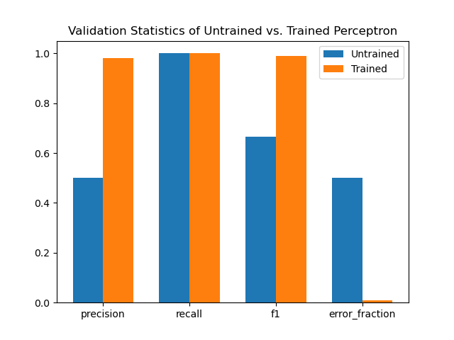
Figure 1.2: The precision, recall, F1 score, and error fractions before and after training. The precision is the biggest improvement after training.
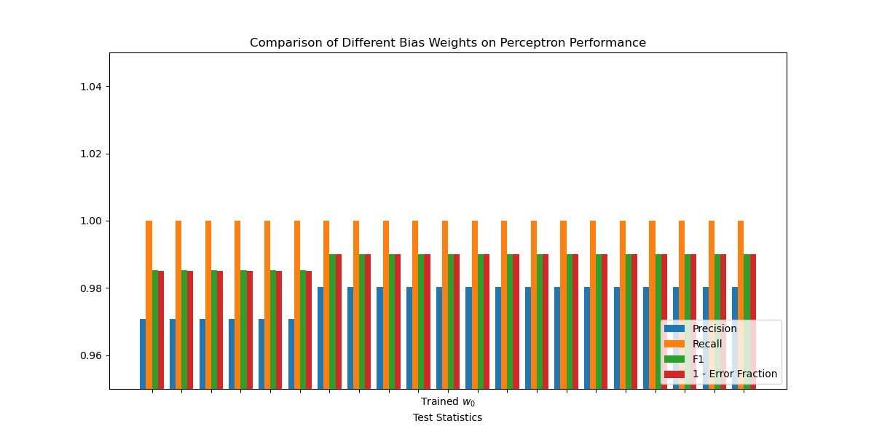
Figure 1.3: A measurement of test statistics after using a range of different bias weights, with the original bias weight statistics in the middle as reference.
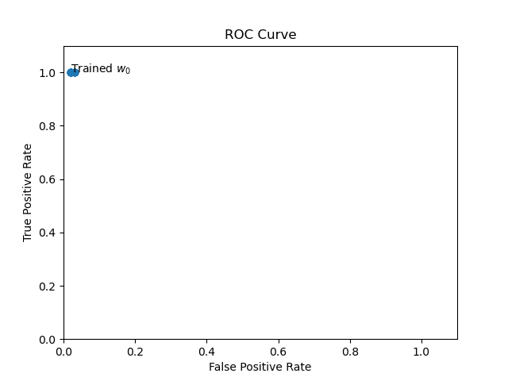
Figure 1.4: The ROC curve for the range of bias weights. Their performances are extremely similar.

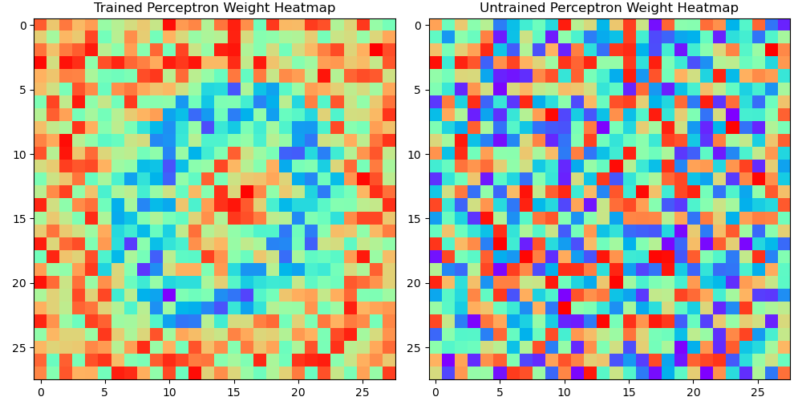
Figure 1.5: A comparison of heatmaps of the weights for an untrained and trained perceptron. Deep blue indicates negative weights for the trained heatmap but zero weight on the untrained heatmap.

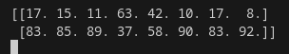
Figure 1.6: A table of values. The rows correspond to how many were classified as 0 or 1 out of a sample of 100, and the columns correspond to the 8 digits from 2 to 9.

Based on Figure 1.3., it appears that variation from the bias weight only negatively impacts performance when the bias weight is multiplied by a factor smaller than around 0.9. Otherwise, it does not impact the performance of the perceptron.

Analysis of Results
The untrained test statistics initially surprised me. However, it makes sense because all of the weights were random numbers in the interval [0, 0.5). Since there’s no input that causes inhibition, any picture that wasn’t completely black would almost definitely register as a 1 by the untrained perceptron. This means that there would never be a false negative, so the recall would be perfect, and all of the zeros would be false positives, so the precision would be ½.

Secondly, the results shown in Figure 1.6. are only a little surprising. Any digit that has a vertical line or a strong “presence” in its middle would strongly excite the perceptron, which explains the results for 2, 3, 4, 7, 8 and 9. However, any digit with a round shape would also strongly inhibit the perceptron. This would explain why a lot of 5s and 6s were interpreted as 0s; the only part of their shape in the middle is a horizontal line. However, most of the digits share some characteristics of the shapes of both 0 and 1, so there exists some ambiguity.

