Supplementary material to ‘Phyllostomid bats distribution and richness gradient in a subtropical Brazilian state’

**Appendix S1. List of studies consulted in the survey of records and their respective locations.**

|  |  |  |
| --- | --- | --- |
| **Reference** | **Country** | **Locality / Region** |
| Althoff, 2007 | Brazil | Blumenau, SC |
| Althoff et al., 2017 | Brazil | Northern SC |
| Barquez et al., 1999 | Argentina | Missiones Province |
| Bôlla et al., 2017 | Brazil | Southern SC |
| Cirignoli et al., 2011 | Argentina | Missiones Province |
| Carvalho et al., 2013 | Brazil | Pedras Grandes, SC |
| Cherem et al., 2004 | Brazil | SC |
| Cherem et al., 2011 | Brazil | P. E. Serra do Tabuleiro, SC |
| Gonçalves et al., 2018 | Brazil, Argentina | Atlantic Forest |
| Gruener et al., 2012 | Brazil | Blumenau, SC |
| Miretzki, 2003 | Brazil | PR |
| Muylaert et al., 2017 | Brazil, Argentina | Atlantic Forest |
| Noronha, 2016 | Brazil | RS |
| Reus, 2009 | Brazil | RS and SC |
| Sekiama et al., 2001 | Brazil | Parque Nacional do Iguaçu, Paraná |
| Sipinski and Reis, 1995 | Brazil | Itapoá, SC |

Legend: SC = Santa Catarina state, RS = Rio Grande do Sul state, PR = Paraná state

**Appendix S2. Correlations of WorldClim bioclimatic variables with the first four axes of the Principal Component Analysis (PCA). “Variance accounted” indicates how much of the unique variation in the bioclimatic variables set is accounted for by that particular PC. "Cumulative Proportion" shows the accumulated value of the variation accounted for by the first four axes.**

|  |  |  |  |  |
| --- | --- | --- | --- | --- |
| Bioclimatic variable | PC1 | PC2 | PC3 | PC4 |
| bio1 - Annual Mean Temperature | 0.10 | 0.38 | 0.18 | -0.05 |
| bio2 - Mean Diurnal Range | 0.29 | -0.09 | -0.01 | -0.51 |
| bio3 - Isothermality | 0.03 | -0.24 | -0.16 | -0.52 |
| bio4 - Temperature Seasonality | 0.34 | 0.12 | 0.21 | -0.01 |
| bio5 - Max Temperature of Warmest Month | 0.20 | 0.32 | 0.19 | -0.18 |
| bio6 - Min Temperature of Coldest Month | -0.14 | 0.36 | 0.13 | 0.19 |
| bio7 - Temperature Annual Range | 0.35 | 0.00 | 0.08 | -0.37 |
| bio10 - Mean Temperature of Warmest Quarter | 0.14 | 0.36 | 0.20 | -0.03 |
| bio11 - Mean Temperature of Coldest Quarter | 0.03 | 0.40 | 0.15 | -0.04 |
| bio12 - Annual Precipitation | 0.26 | 0.12 | -0.39 | 0.11 |
| bio13 - Precipitation of Wettest Month | 0.00 | 0.27 | -0.42 | -0.10 |
| bio14 - Precipitation of Driest Month | 0.37 | -0.04 | -0.14 | 0.23 |
| bio15 - Precipitation Seasonality | -0.32 | 0.18 | -0.14 | -0.28 |
| bio16 - Precipitation of Wettest Quarter | -0.06 | 0.26 | -0.43 | -0.04 |
| bio17 - Precipitation of Driest Quarter | 0.37 | -0.04 | -0.19 | 0.17 |
| bio18 - Precipitation of Warmest Quarter | -0.12 | 0.25 | -0.41 | -0.07 |
| bio19 - Precipitation of Coldest Quarter | 0.35 | -0.08 | -0.16 | 0.27 |
| **Variance Accounted (%)** | **0.34** | **0.34** | **0.18** | **0.11** |
| **Cumulative Proportion (%)** | **0.34** | **0.68** | **0.86** | **0.97** |

**Appendix S3. Average performance of the models of each species in the geographically structured cross-validation procedure, according to Area Under Curve of the Receiver Operating Characteristic (AUC) and Continuous Boyce Index (CBI).**

|  |  |  |
| --- | --- | --- |
| **Species** | **AUC** | **CBI** |
| *Anoura caudifer* | 0.793 | 0.598 |
| *Anoura geoffroyi* | 0.822 | 0.425 |
| *Artibeus fimbriatus* | 0.725 | 0.602 |
| *Artibeus lituratus* | 0.733 | 0.869 |
| *Artibeus obscurus* | 0.754 | 0.522 |
| *Artibeus planirostris* | 0.829 | 0.496 |
| *Carollia perspicillata* | 0.762 | 0.853 |
| *Chiroderma doriae* | 0.968 | 0.864 |
| *Chrotopterus auritus* | 0.702 | 0.668 |
| *Desmodus rotundus* | 0.712 | 0.628 |
| *Diphylla ecaudata* | 0.846 | 0.886 |
| *Glossophaga soricina* | 0.813 | 0.412 |
| *Micronycteris megalotis* | 0.785 | 0.860 |
| *Mimon bennettii* | 0.740 | 0.840 |
| *Platyrrhinus lineatus* | 0.695 | 0.701 |
| *Platyrrhinus recifinus* | 0.831 | 0.907 |
| *Pygoderma bilabiatum* | 0.775 | 0.801 |
| *Sturnira lilium* | 0.752 | 0.906 |
| *Sturnira tildae* | 0.813 | 0.809 |
| *Vampyressa pusilla* | 0.820 | 0.841 |
| **Mean** | **0.783** | **0.725** |
| **Standard deviation** | **0.06** | **0.17** |

**Appendix S4. Forest remnants present in Santa Catarina state.**

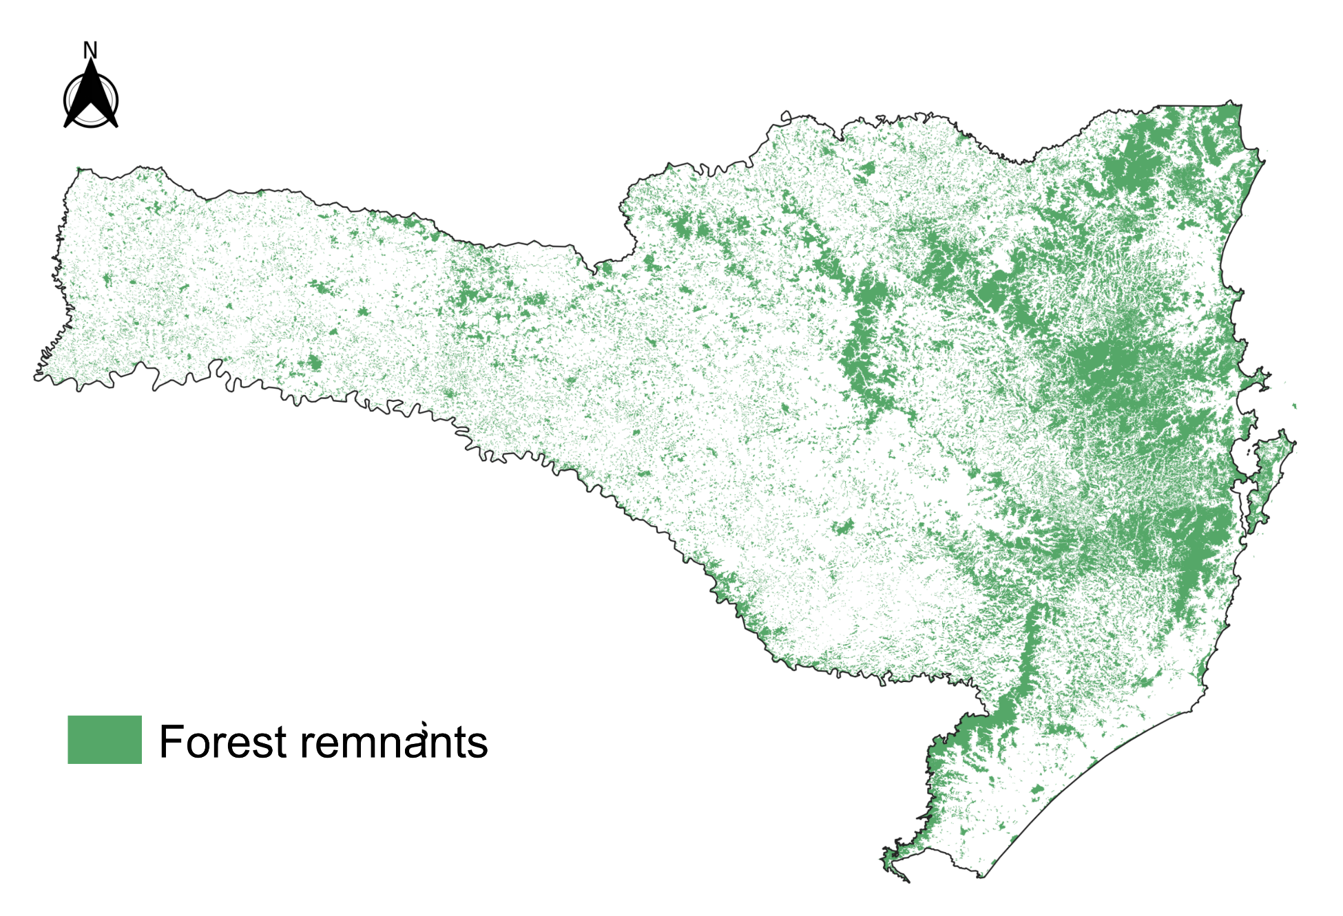

**References**

Althoff, S.L. 2007. *A Comunidade de quirópteros, sua biologia e ecologia no Parque Natural Municipal Nascentes do Garcia, Estado de Santa Catarina, Brasil* (Doctoral Thesis). Universidade Federal do Rio Grande do Sul. Porto Alegre.

Althoff, S.L.; Tribess, B.; Reinert, M.J.; Ferreira, M.A.R. & Carvalho, F. 2017. Expansion of the southern limit of *Vampyrodes caraccioli* Thomas, 1889 (Chiroptera, Phyllostomidae) and first record for Santa catarina state, southern Brazil. *Check List,* 13: 871–877.

Barquez, R.M.; Mares, M.A.; Braun, J.K. 1999. *The bats of Argentina*. Special Publications. Museum of Texas Tech University, 42: 1-275.

Bôlla, D.A.S.; Ceron, K.; Carvalho, F. et al. 2017. Mastofauna Terrestre Do Sul De Santa Catarina: Mamíferos De Médio E Grande Porte E Voadores. *Tecnol. e Ambient,* 3: 61-78.

Carvalho, F.; Fabián, M. E. & Menegheti, J. O. 2013. Vertical structure of an assemblage of bats (Mammalia: Chiroptera) in a fragment of Atlantic Forest in Southern Brazil. *Zoologia*, 30: 491–498.

Cherem, J. J.; Graipel, M. E.; Tortato, M. A. et al. 2011. Mastofauna terrestre do Parque Estadual da Serra do Tabuleiro, Estado de Santa Catarina, sul do Brasil. *Biotemas,* 24: 73-84.

Cherem, J. J.; Simões-Lopes, P. C.; Althoff S. L. & Graipel, M. E. 2004. Lista dos mamíferos do estado de Santa Catarina, sul do Brasil. *Mastozoología Neotrop.,* 11:151–184.

Cirignoli, S.; Galliari, C. A.; Pardiñas, U. F. J.; Podestá, D. H. & Abramson, R., 2011. Mamíferos De La Reserva Valle Del Cuña Pirú, Misiones, Argentina. *25 Mastozoología Neotrop.,* 18: 25–43.

Gonçalves, F.; Bovendorp, R. S.; Beca, G. et al. 2018. ATLANTIC MAMMAL TRAITS: a data set of morphological traits of mammals in the Atlantic Forest of South America. *Ecology*, 99: 498-498.

Gruener, C. G.; Dallacorte, F.; Althoff, S. L. & Sevegnani L. 2012. Efeito da fragmentação florestal sobre as comunidades de morcegos (Mammalia, Chiroptera) do município de Blumenau, Santa Catarina, Brasil. *Rev. Estud. Ambient.,* 14: 6-19.

Miretzki, M. 2003. Morcegos do Estado do Paraná, Brasil (Mammalia, Chiroptera): riqueza de espécies, distribuição e síntese do conhecimento atual. *Papeis Avulsos de Zoologia,* 43: 101–138.

Muylaert, R. d. L.; Stevens, R. D.; Esbérard C. E. L. et al. 2017. ATLANTIC BATS: a data set of bat communities from the Atlantic Forests of South America. *Ecology,* 98: 3227-3227.

Noronha, B. T. 2016. *Análise dos registros de Chiroptera no Rio Grande do Sul: métodos empregados e distribuição de espécies por municípios, com ênfase em áreas de parques eólicos* (TCC). Universidade Federal do Rio Grande do Sul. Porto Alegre.

Reus, C. L., 2009. *Aspectos bio-ecológicos e análise da diversidade e composição de quirópteros (Mammalia, Chiroptera) em área de influência da Usina Hidrelétrica Barra Grande, SC/RS, Brasil* (Masters Dissertation). Universidade Federal do Rio Grande do Sul. Porto Alegre.

Sekiama, M. L.; Reis, N. R. dos; Peracchi, A. L. & Rocha V. J. 2001. Morcegos do Parque Nacional do Iguaçu, Paraná (Chiroptera, Mammalia). *Rev. Bras. Zool.,* 18: 749–754.

Sipinski, E. A. B. & Reis N. R.1995. Dados ecológicos dos quirópteros da Reserva Volta Velha, Itapoá, Santa Catarina, Brasil. *Rev. Bras. Zool.,* 12: 519–528.