**STEPS TO EXECUTE THIS APPLICATION SUCCESSFULLY**

**(NOTE: THIS INSTRUCTION WAS USED ON WINDOWS SERVER)**

1. There are two folders that make up this project (crud-app and backend), the crus-app is located inside the crud-app.zip file.
2. Install the backend first because the crud-app depends on it.
3. Download and install xampp, node and composer
4. Start up the Xamp, open CMD and navigate to the **“backend”** folder
5. Start the server with Laravel Artisan command “**php artisan serve**”
6. Install **Node JS**
7. Install the Angular CLI using “**npm install -g @angular/cli”**
8. Install JSON Server using this command on power shell **“npm install -g json-server”**
9. Unzip the **“crud-app.zip”** , you should have a folder with the name **crud-app**.
10. Open the **crud-app** folder on Visual Studio code
11. Go to terminal menu, create a new terminal

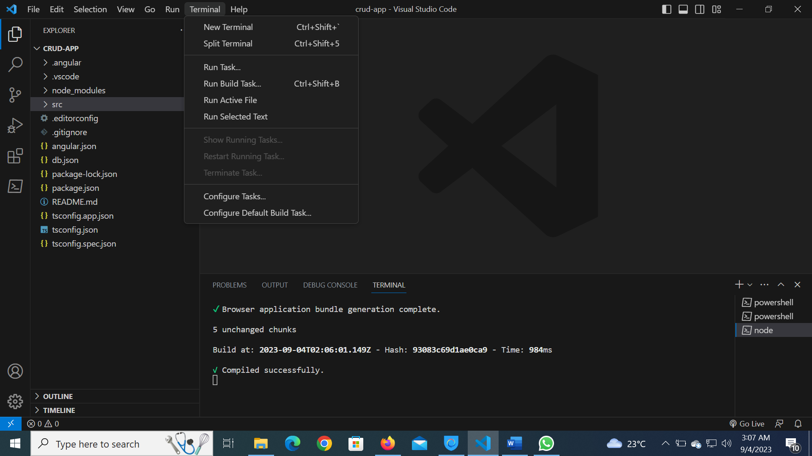

1. In the new terminal, launch the application by typing the command below:

**“ng serve -o”**

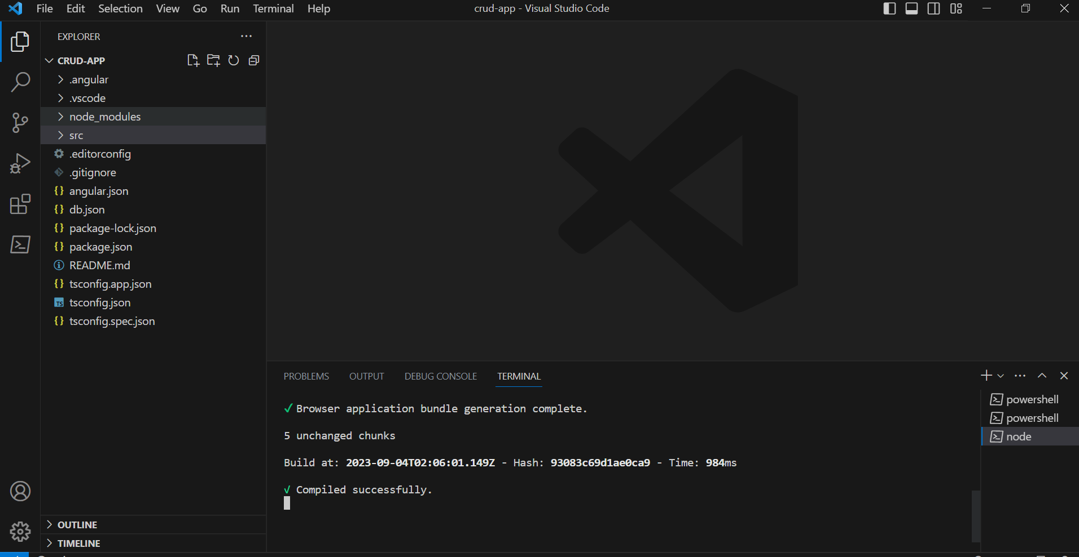

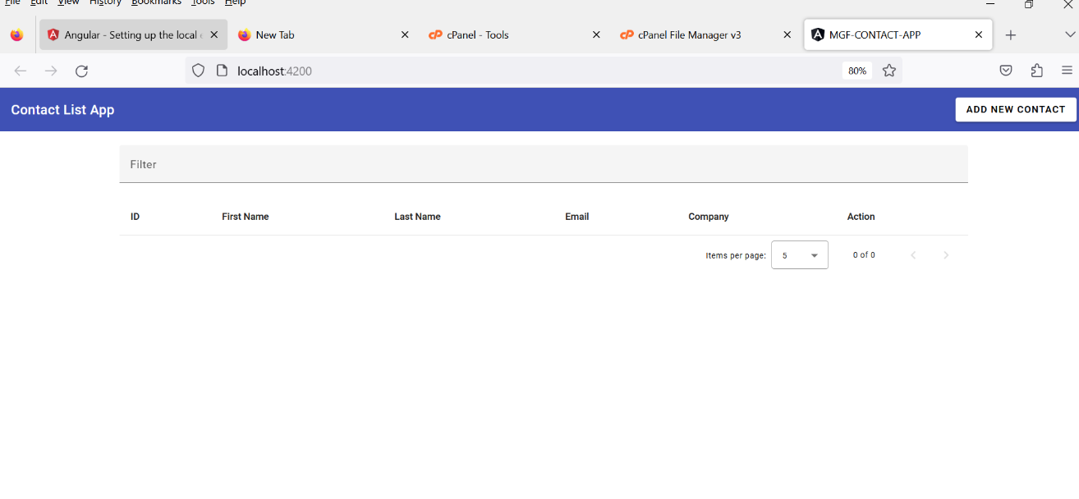 14.The application launches but without the data

1. Open a new terminal and run the following command to start the JSON data server

**“JSON-server --watch db.json”**

**Unit Testing Interfaces**

1. This is the displayed contact

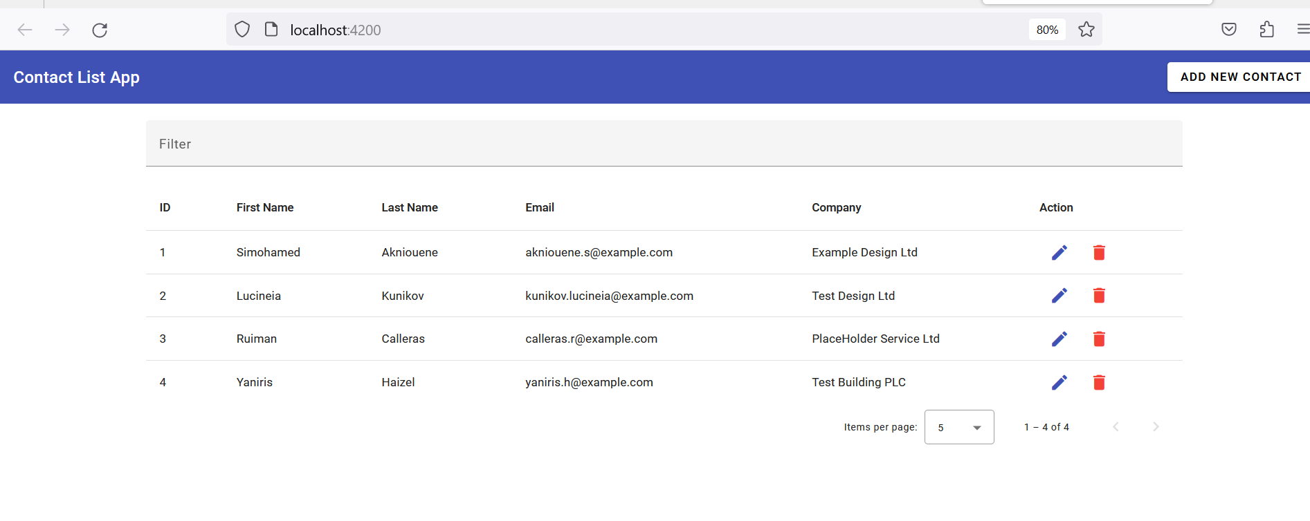

1. **Here is a view that indicates that sorting and Filtering was implemented**

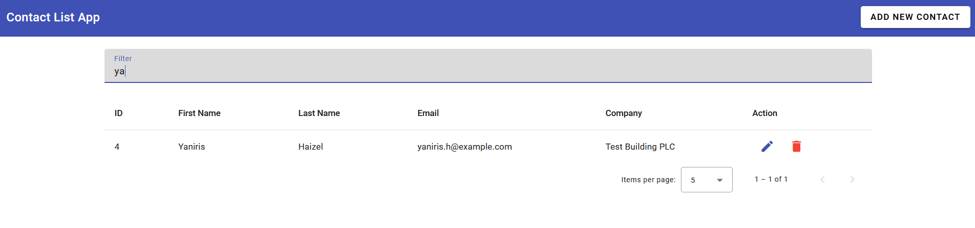

1. **A Form to add a new contact**

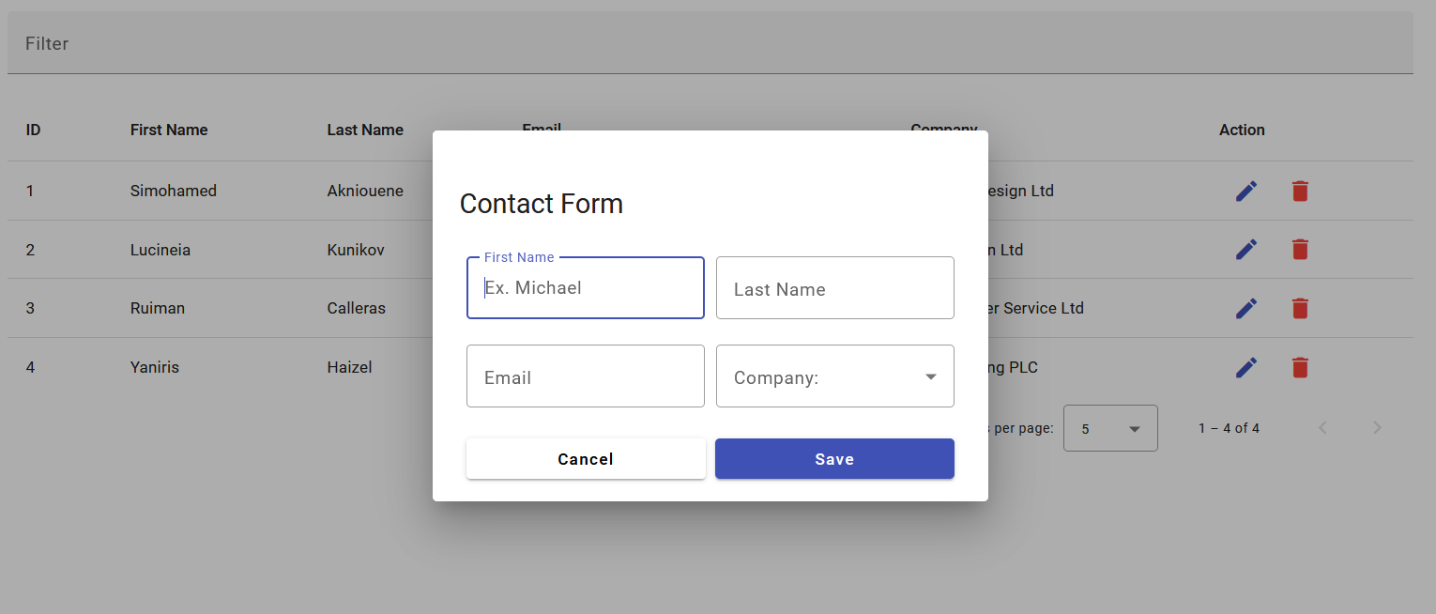

1. **A form to edit an existing contact**

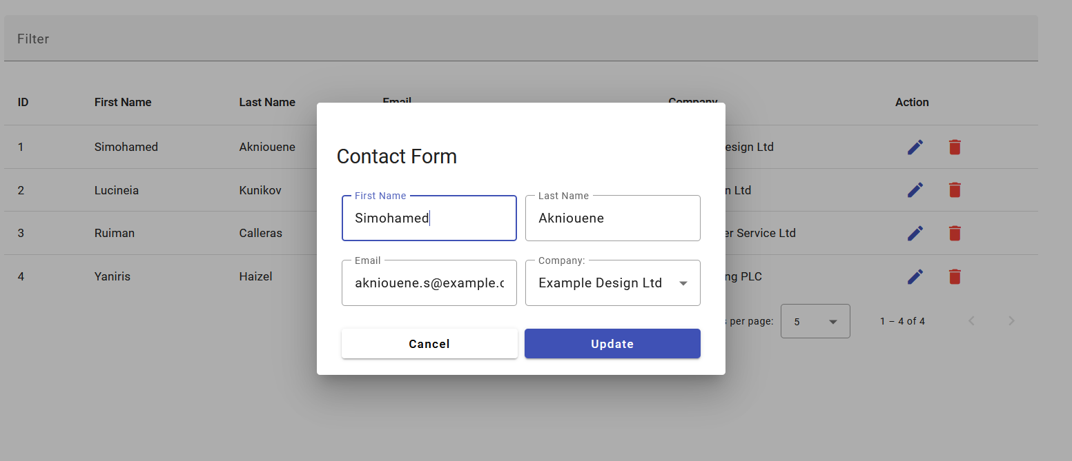

1. Ability to soft delete a contact

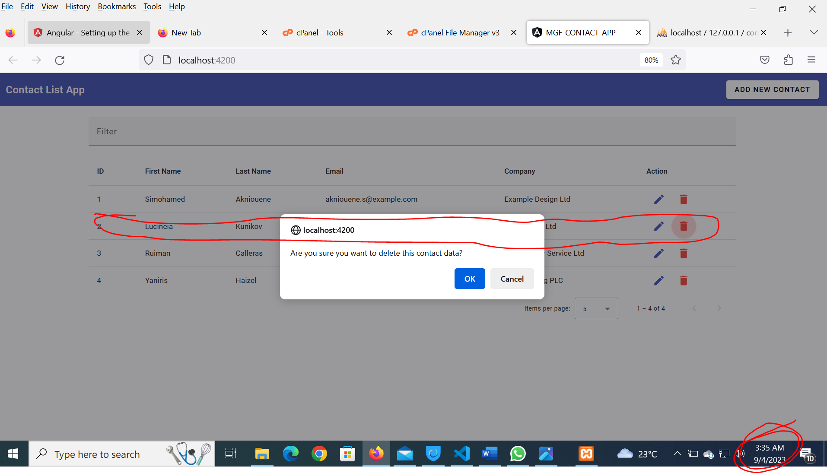

This record was deleted by 09/04/2023 3:36:00 am. Confirm from the Operating time system as marked read.

After deleting it shows here in the interface, it persists in the database

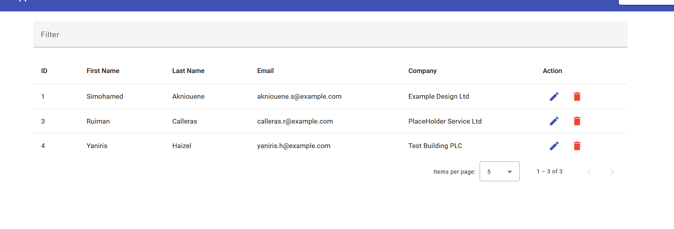

It is deleted from the interface but remain in the database

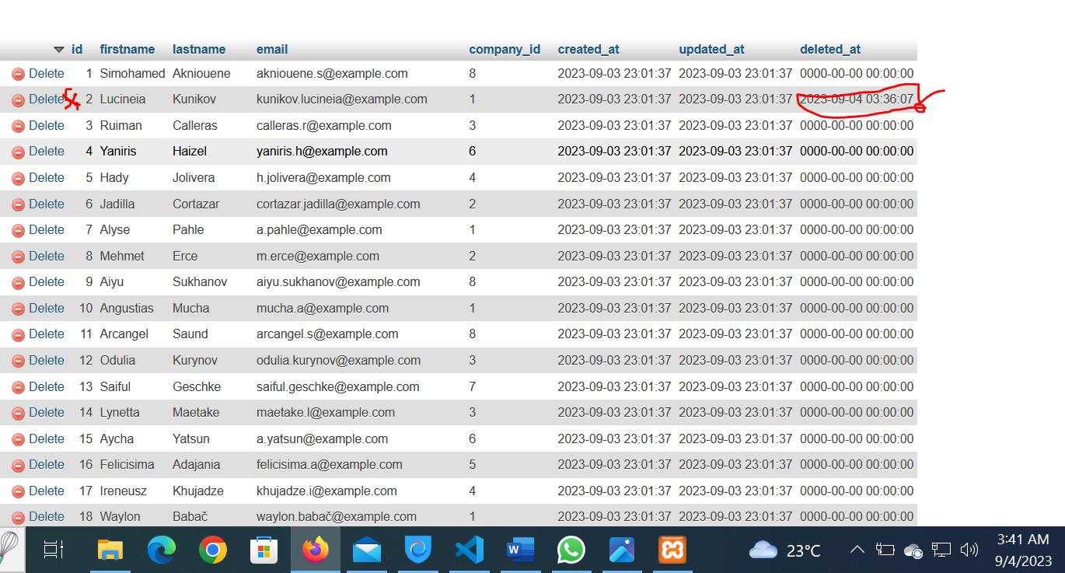

1. A report to show the number of contacts

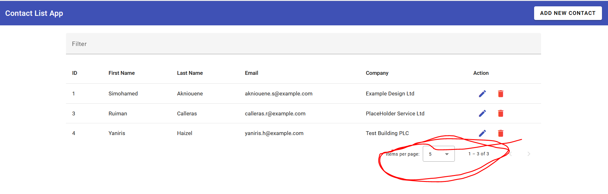

The pagination Module serves as he report