MegaMart Retail Store Sales Analysis Report
10-july-2026.

Executive Summary
This report analyses the key factors influencing the overall Business performance of the MegaMart retail store, with a focus on sales, profit, customers, products and discounts.

Aims & Objectives
- Identify which categories and products that drive sales and profit the most.
- Identify sales trend over time (month, year & quarter).
- Identify which store and region perform best.
- Identify how customer demographics (age, city & city) influence sales.
- Identify average order value (AOV and customer lifetime value (CLV).
- Identify how discounts affect revenue.

Data Overview
Tables:
Sales transactions
Customer information
Product information
Store information
Source: Kaggle datasets.
Other Information:
Customer age was derived from birth year and latest transaction year to support demographic analysis.
Customer age band was derived by grouping customers according to age groups.
Customer lifespan was derived from join date and current transaction date to support customer analysis.
Discount band was derived by grouping different levels of discount to further simplify discount analysis.

Key Findings
The following questions were the focus of this analysis:
- Which products and categories drive the most sales and profit?
Findings:
MegaMart’s product portfolio is divided into three major categories: Electronics, Fashion and Groceries. Analysis shows that Fashion is the best performing category, generating $6.23 million in sales, $1.66m in profits and 7,015 units sold. Within this category, Accessories are leading in the product segment, contributing $1.92m in sales, $431.99k in profits from 1612 units sold. These findings indicate that customer demand is strongest for Fashion products, especially Accessories, making them a key driver of company’s overall financial performance, an area for their continued investment.

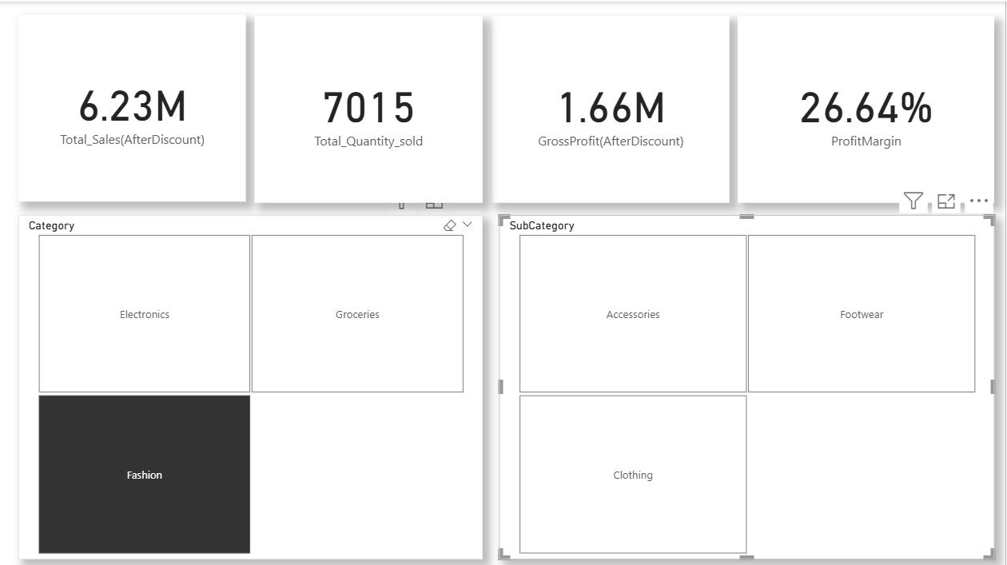
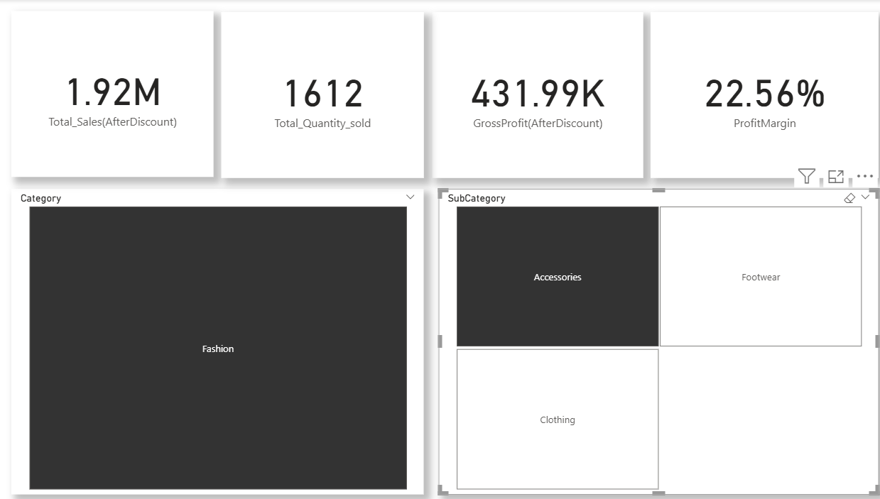

- What is the trend of sales over time (monthly, quarterly and yearly)?
Findings:
The MegaMart’s sales transaction spans across three years, from September 2023 to September 2025. Yearly analysis shows that sales increased steadily from 2023 to 2024 then experienced a slight decline in 2025. Quarterly analysis further shows that the 4th quarter contributed the most to the business performance in 2024. Overall, the trend shows that sales consistently decline during the 2nd and 3rd quarters of the year. Monthly analysis reveals that there is a consistent peak in sales from November to December and an all-time low in February. This pattern indicates that the business experiences strong seasonal demand towards the end of each year.
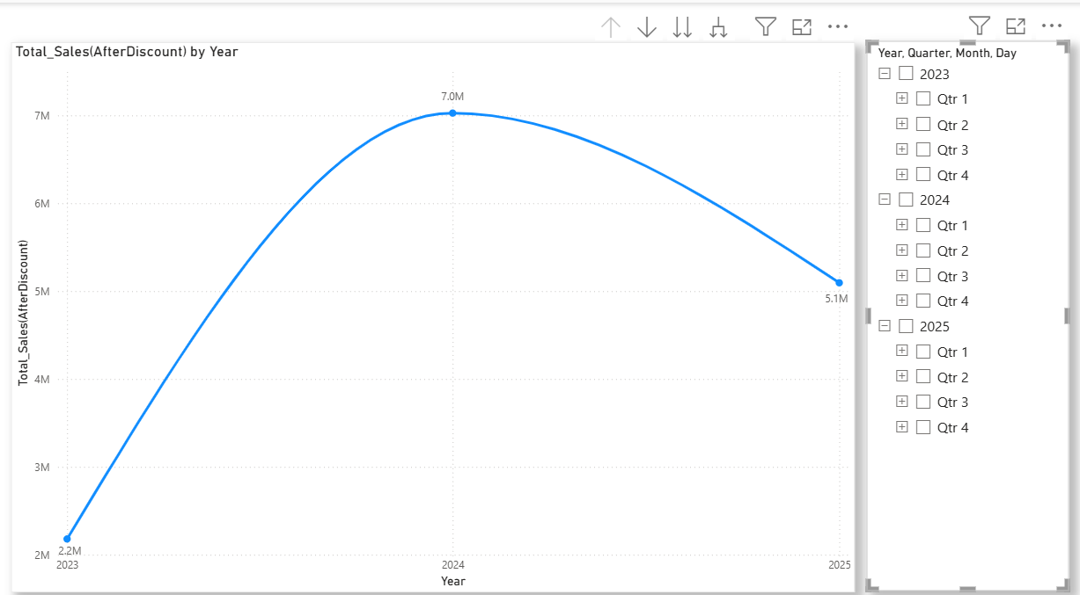

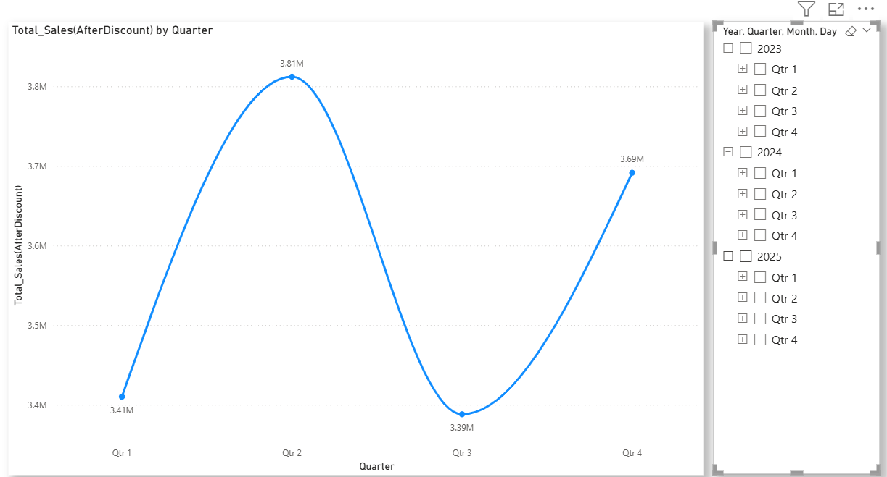
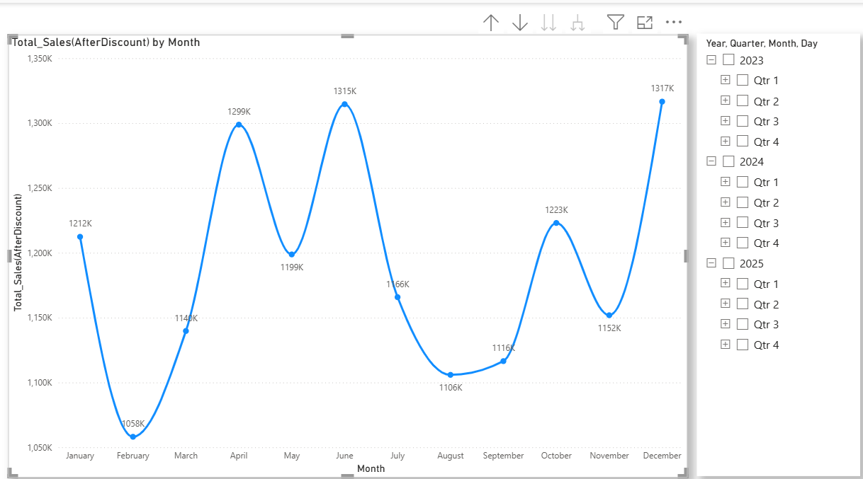

- Which stores and region performs best?
Findings:
MegaMart has five branches across the East, South, North and West regions, with the East region having two branches. Analysis shows that the East region delivers the strongest overall business performance, generating total sales of $5.60 million, a profit of $1.50 million from 5834 units sold, driven by the combined performance of its two branches.
However, analysis further shows that the best-performing individual branch is the MegaMart New Michele, located in the west region. The branch generated total sales of $2.92 million, a gross profit of $804.01 thousand and a profit margin of 27.53% from 3036 units sold. This implies that for every dollar in sales, 27.53 cents was retained as gross profit, indicating high operational efficiency than the MegaMart Jimenezborough in the south region which sold 3061 units but recorded a lower overall business performance: total sales of $2.88 million, a gross profit of $753.86 thousand and a profit margin of 26.17%.
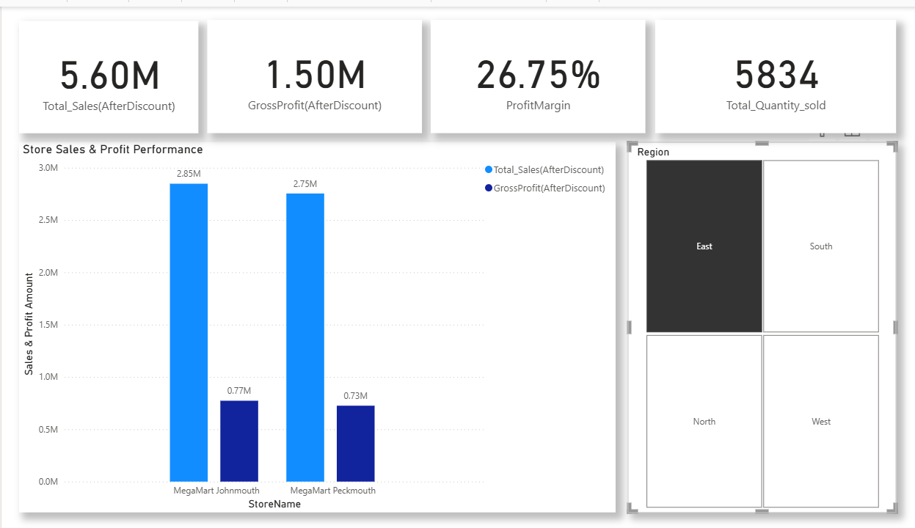

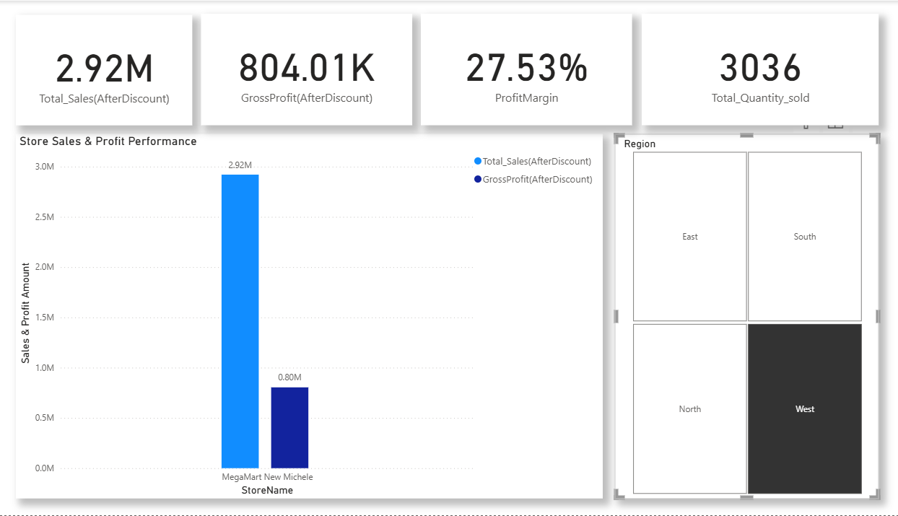

- How do customer demographics (age, gender and city) influence sales?
Findings:
Analysis shows that customers in their forties have the greatest influence on sales, generating total sales of $1.23 million, a gross profit of $322.44 thousand with 444 units purchased by this group.
Gender analysis shows that the male customers Purchase more than female customers, generating total sales of $8.07 million, a gross profit of $2.17 million with a total purchasing 2810 units.
Further analysis reveal that the highest sales were recorded in the city of Lake Dawn, generating total sales of $117.09 thousand, a gross profit of $28.43 thousand from 32 units sold.
These findings suggest that middle-aged customers, particularly males, contribute most to sales performance, while Lake Dawn represents the strongest-performing customer market among the cities.
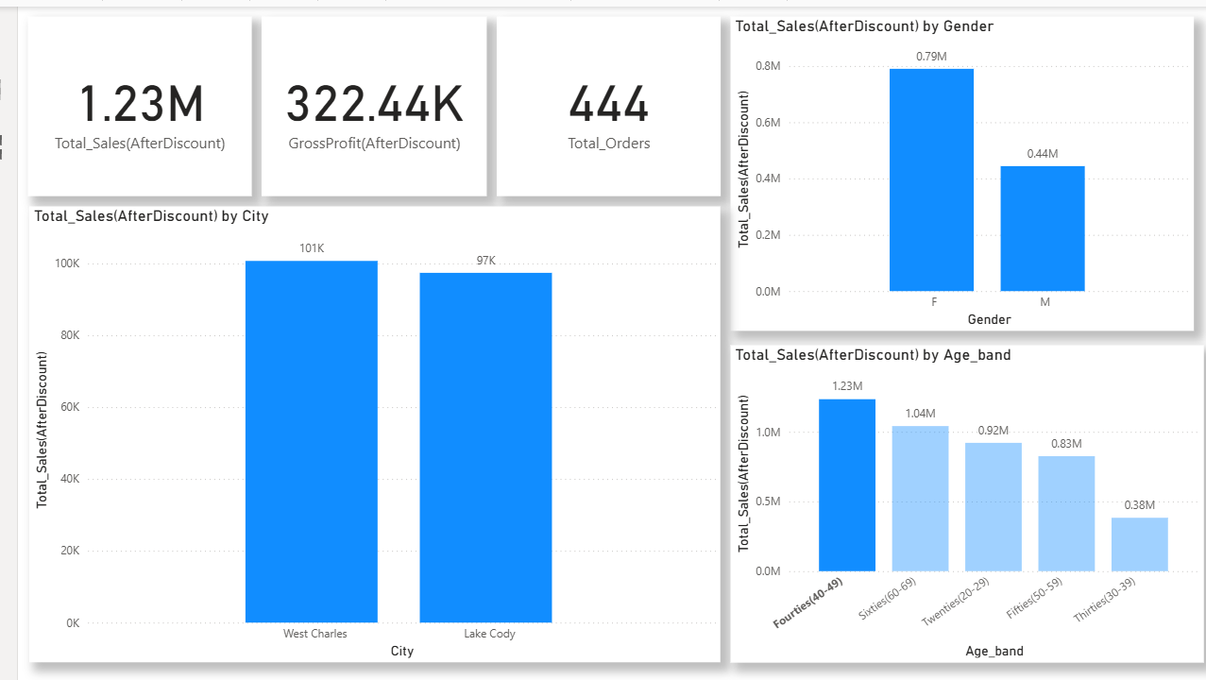
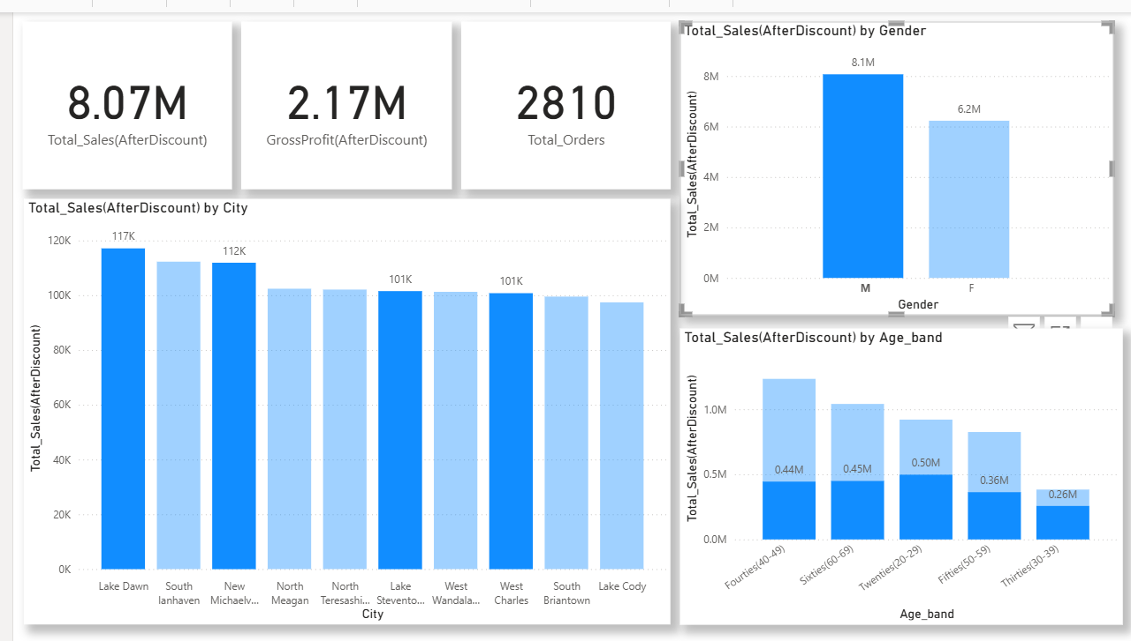
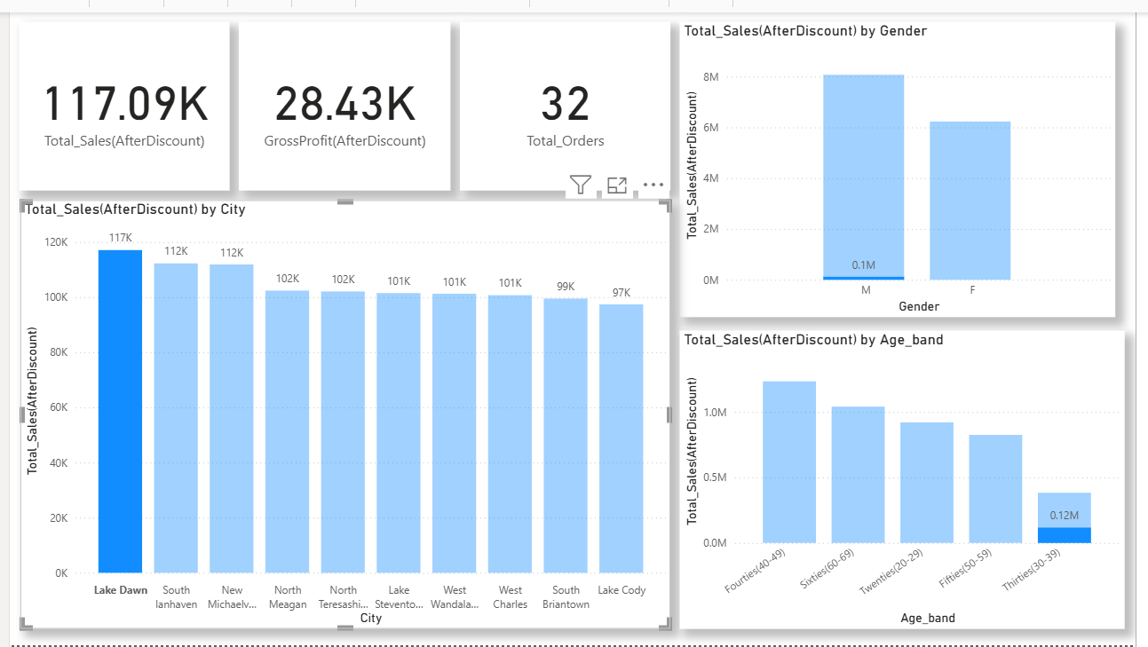

- What is the average order value and customer lifetime value?
Findings:
Analysis shows, that the average order value is $2.86 thousand. This means that on an average, every order placed by customers is worth $2.86 thousand.
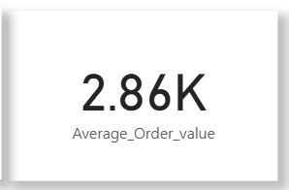
Customer analysis shows that, customer lifetime value (CLV) represents the total sales generated by a customer. Further analysis shows that CLV is strongly influenced by average order value, purchase frequency (the rate at which a customer places orders) and customer lifespan. This relationship is evident from the analysis of Brittany Green who recorded the highest CLV of $143.367 thousand despite having an average CLV of $71.68 thousand, which is lower than that of many top customers. Her high CLV was primarily driven by her customer lifespan of eight years, making her the longest-serving customer in the dataset. This suggests that although Brittany green generated the highest lifetime sales, she placed smaller orders on average and purchased less frequently than many other top customers. Her long customer relationship was the key factor driving her high CLV.
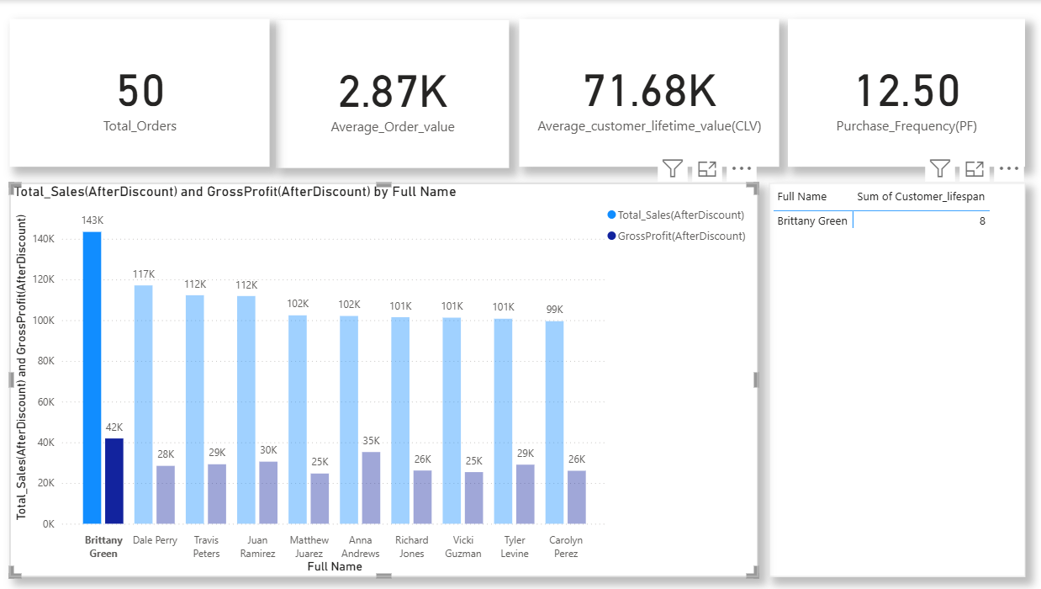
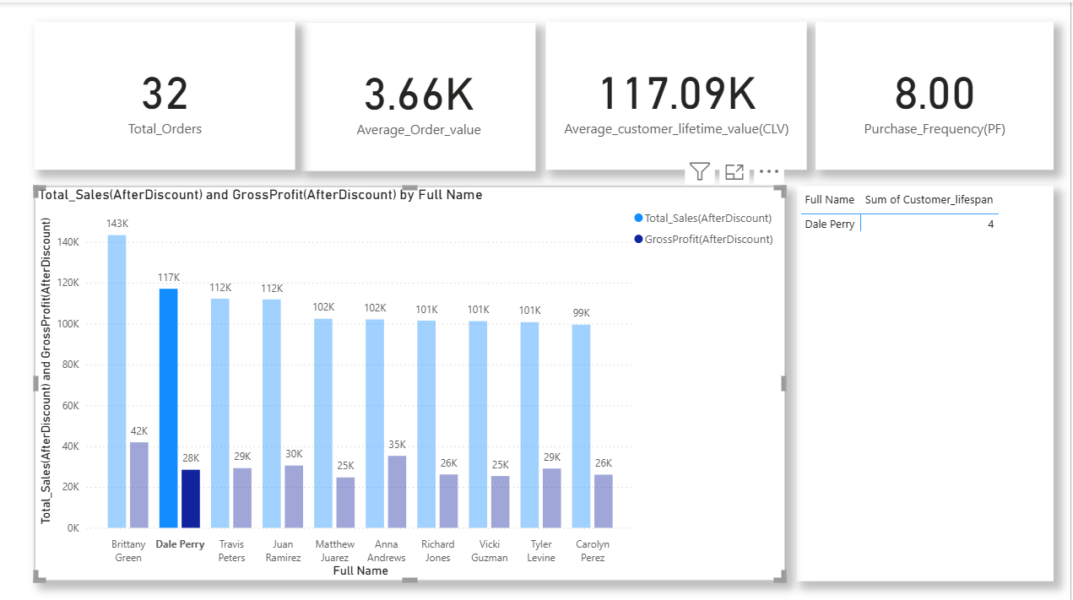
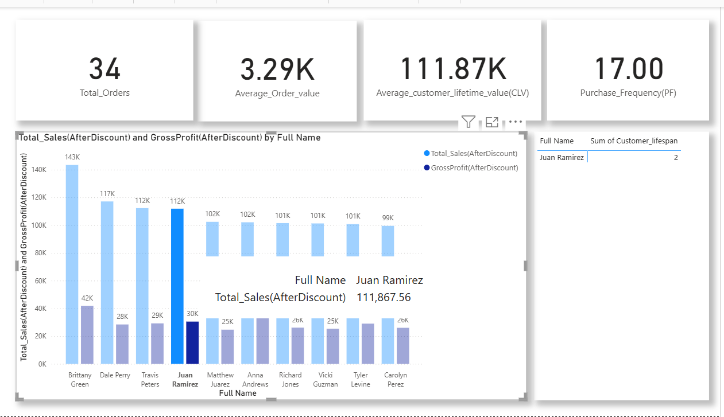

- How do discounts affect revenue?
Findings:
Discount analysis shows that products sold with low discounts (1-10%) generated the highest revenue, producing total sales of $7.01 million, a gross profit of $1.88 million from 2433 transactions and 7261 units sold with 7.46% discount impact on revenue.
Products sold without discounts generated total sales of $3.85 million, gross profit of $1.24 million from 1243 transactions and 3732 units sold.
Meanwhile, products sold with medium discounts (11-20%) generated total sales of $3.44 million, a gross profit of $707.79 thousand from 1324 transactions and 3956 units sold, with a 15% discount impact on revenue.
These findings indicate that products discounted between 1% and 10% generated approximately 50% of total revenue. Although these discounts reduced potential revenue by 7.46%, it served as a great encouragement for customers to purchase more resulting in the highest sales and a strong gross profit $1.88 million, suggesting that customers purchased more products at this discount rate compared to products sold without discounts.
By comparison discounts between 11% and 20% produced lower sales and profitability, with a 15% impact on revenue, suggesting that higher discounts reduced business performance. Generally, these findings suggest that maintaining discounts within the range of 1% and 10% is best for attracting customers, maximizing profit while also protecting the revenue.
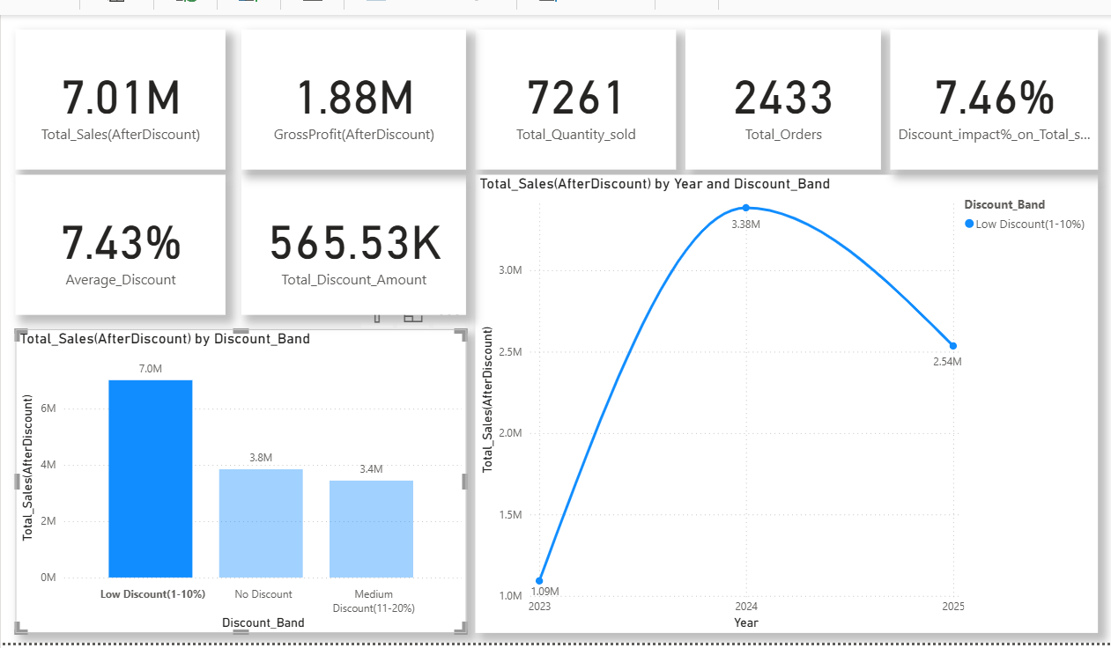
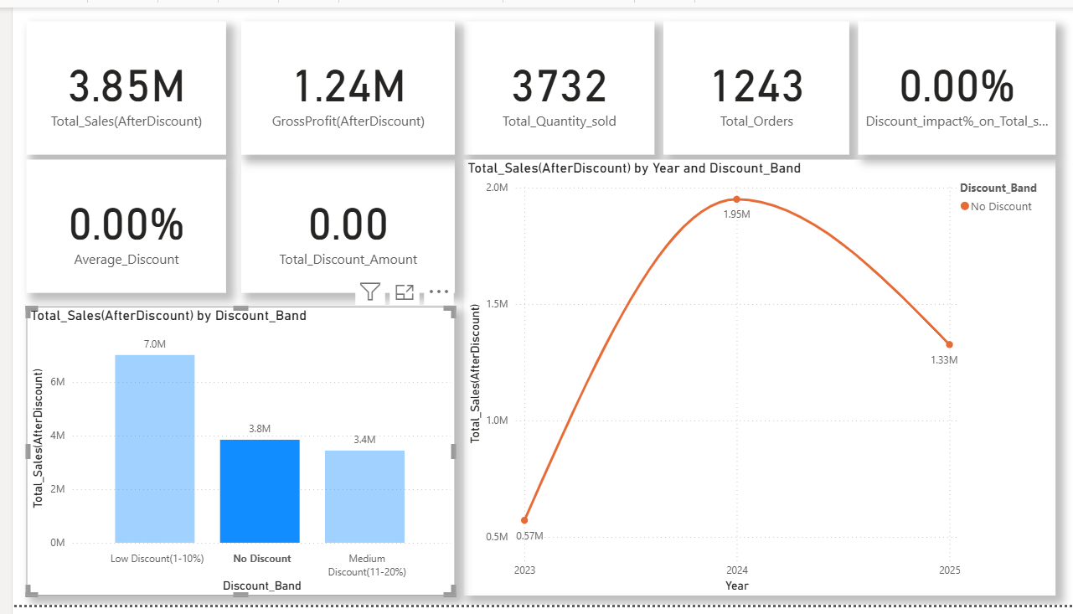
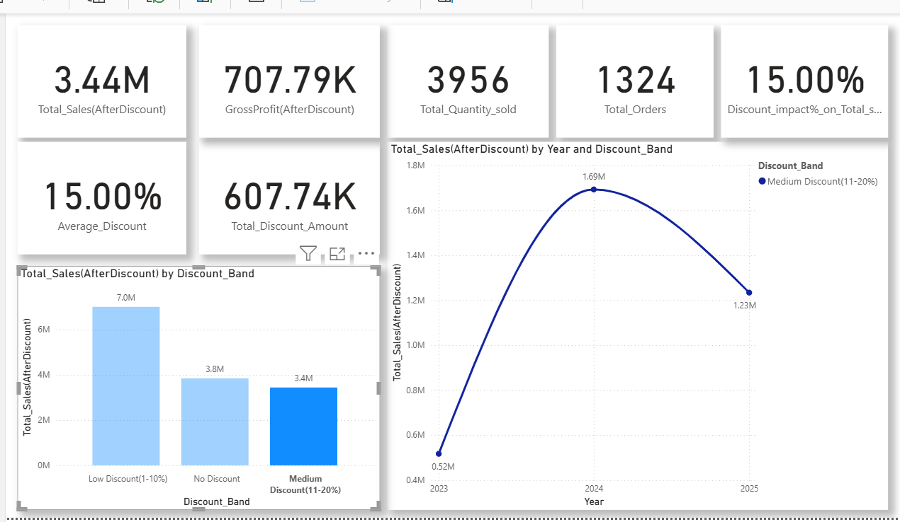

Recommendations
Based on the findings of this analysis, the following recommendations are proposed to improve sales performance, profitability and overall business growth.
- Although not central to the business question, analysis also showed that the Groceries category had the highest profit margin of 30.44%, suggesting high efficiency and profitability. The business should therefore increase focus and increase investment in this category by increasing its product range and ensuring consistent stock availability.
- The business should ensure the consistent availability of stocks especially during end-of-year period, as analysis shows that there is a consistent seasonal demand during this time.
- Investigations should be carried out in the south region, where MegaMart Jimenezborough is located, to determine why it recorded a higher sales volume but a lower overall business performance compared with MegaMart New Michele.
- The analysis identified high-value customers who contribute significantly to sales and profitability. VIP Loyalty programs should be introduced to reward these customers and also customers who contribute significantly to sales and profitability over a specified period, based on criteria established by the business.

Conclusion
This analysis provided valuable insights into the factors influencing MegaMart’s sales and profitability, including sales performance, sales trends, regional and store performance, customer behavior, customer lifetime value and the impact of discounts. The findings highlight key opportunities for improving business performance, while the recommendations provide practical actions to support sustainable growth, increased profitability, and informed decision-making.

