2.5.1

mmu/base/mmu_cut_tip.cfg内

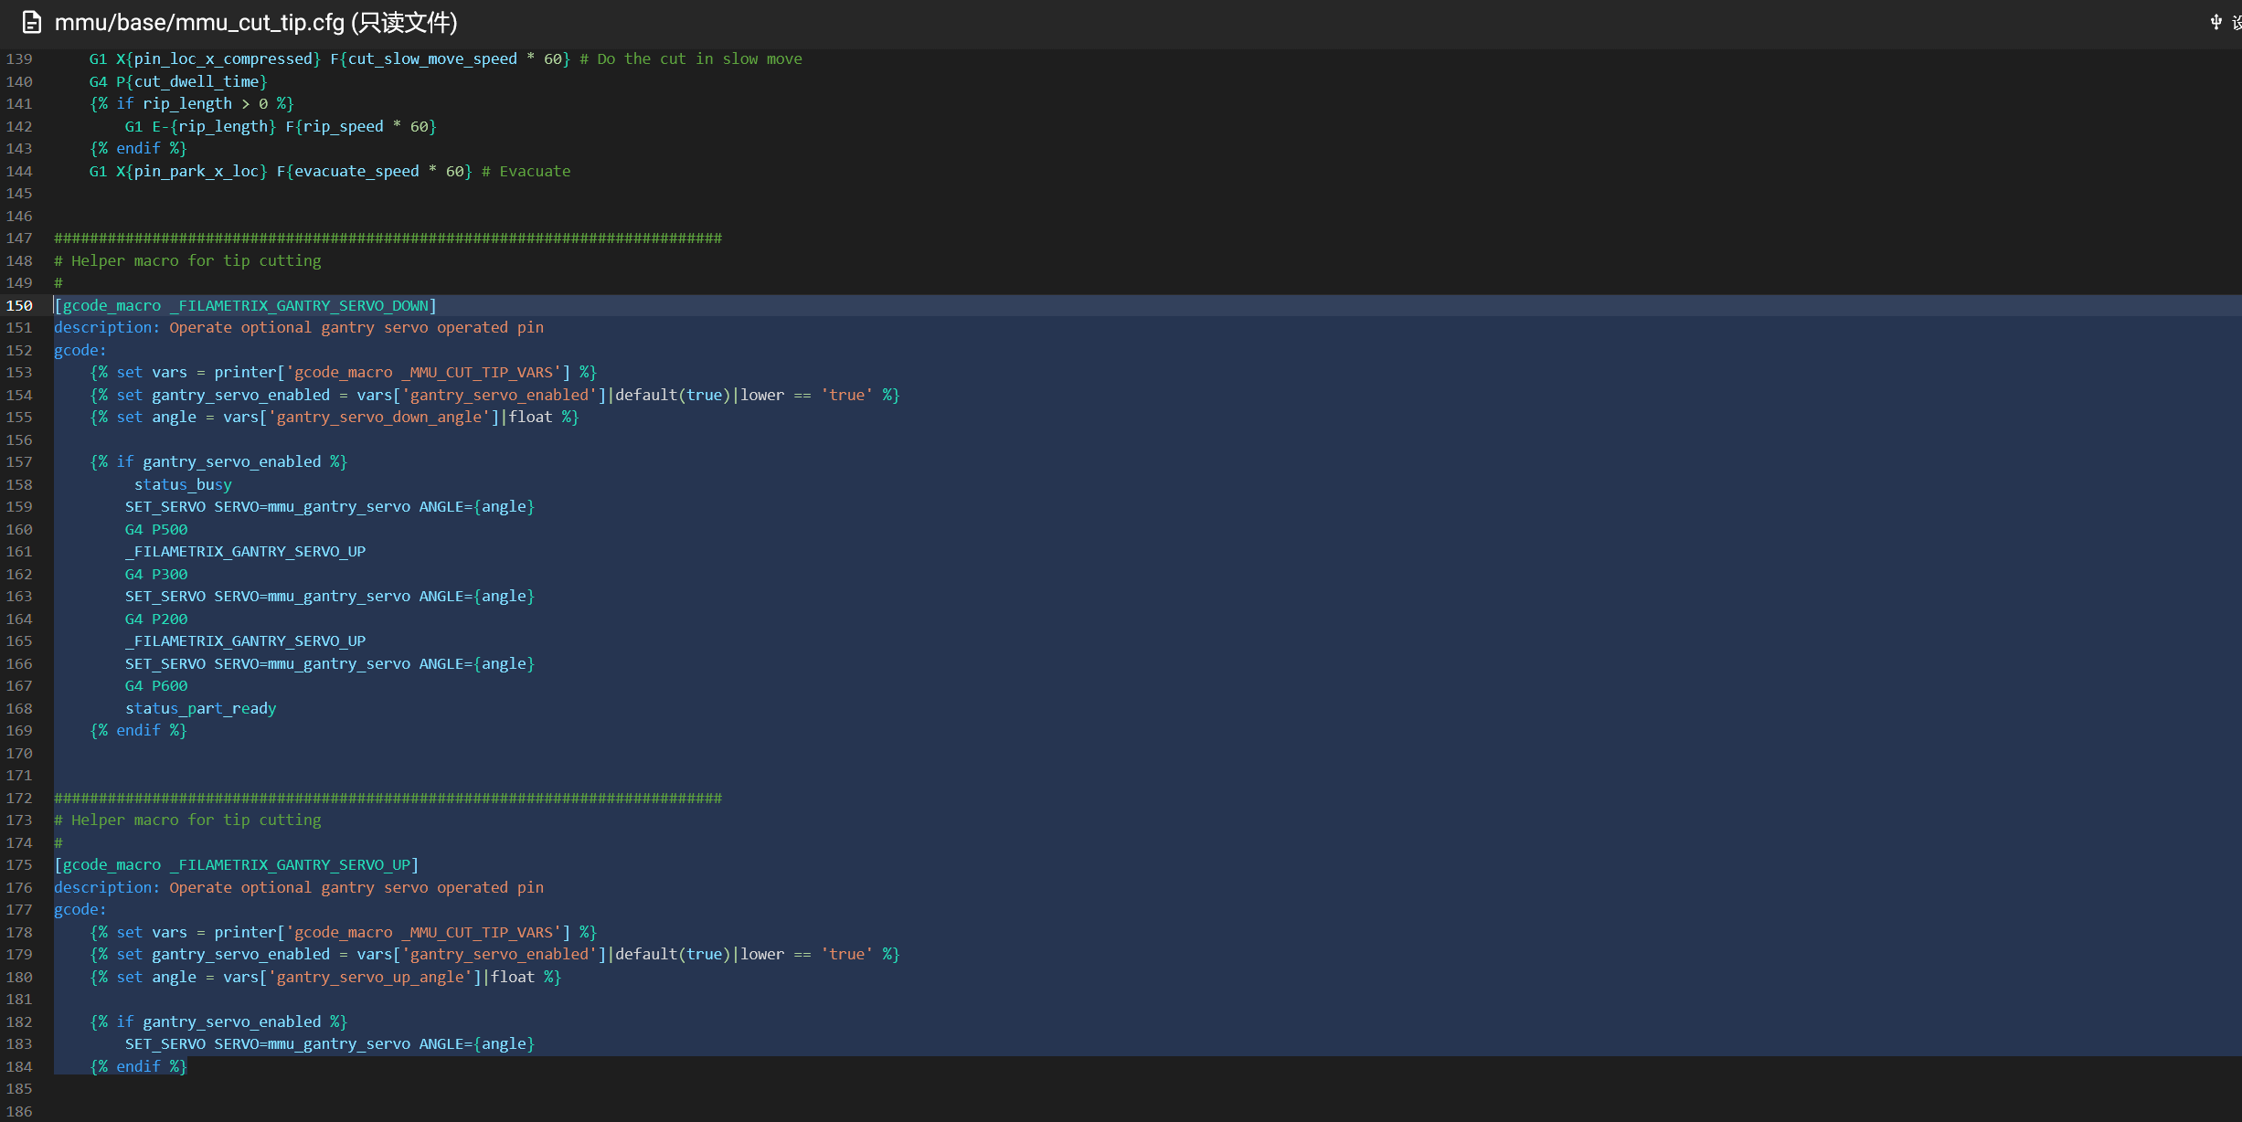

[gcode_macro _FILAMETRIX_GANTRY_SERVO_DOWN]

description: Operate optional gantry servo operated pin

gcode:

{% set vars = printer['gcode_macro _MMU_CUT_TIP_VARS'] %}

{% set gantry_servo_enabled = vars['gantry_servo_enabled']|default(true)|lower == 'true' %}

{% set angle = vars['gantry_servo_down_angle']|float %}

{% if gantry_servo_enabled %}

status_busy

SET_SERVO SERVO=mmu_gantry_servo ANGLE={angle}

G4 P500

_FILAMETRIX_GANTRY_SERVO_UP

G4 P300

SET_SERVO SERVO=mmu_gantry_servo ANGLE={angle}

G4 P200

_FILAMETRIX_GANTRY_SERVO_UP

SET_SERVO SERVO=mmu_gantry_servo ANGLE={angle}

G4 P600

status_part_ready

{% endif %}

###########################################################################

# Helper macro for tip cutting

#

[gcode_macro _FILAMETRIX_GANTRY_SERVO_UP]

description: Operate optional gantry servo operated pin

gcode:

{% set vars = printer['gcode_macro _MMU_CUT_TIP_VARS'] %}

{% set gantry_servo_enabled = vars['gantry_servo_enabled']|default(true)|lower == 'true' %}

{% set angle = vars['gantry_servo_up_angle']|float %}

{% if gantry_servo_enabled %}

SET_SERVO SERVO=mmu_gantry_servo ANGLE={angle}

{% endif %}

mmu/base/mmu_hardware.cfg内

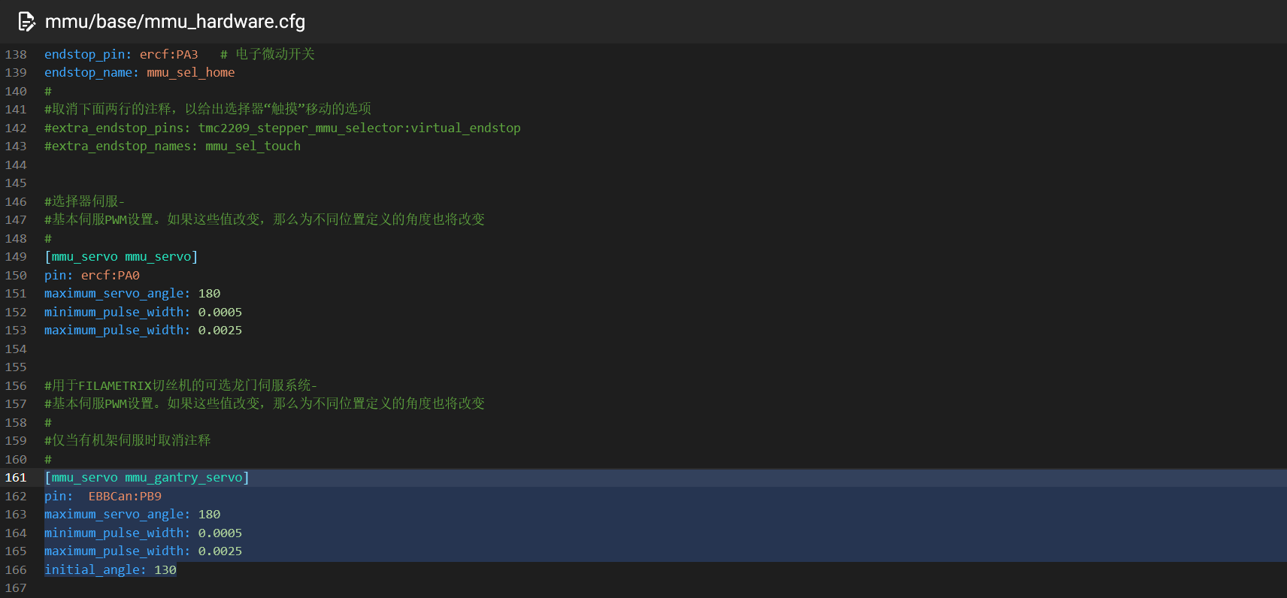

[mmu_servo mmu_gantry_servo]

pin: EBBCan:PB9 #按照自己舵机切刀引脚进行配置

maximum_servo_angle: 180

minimum_pulse_width: 0.0005

maximum_pulse_width: 0.0025

initial_angle: 130

mmu/base/mmu_parameters.cfg内

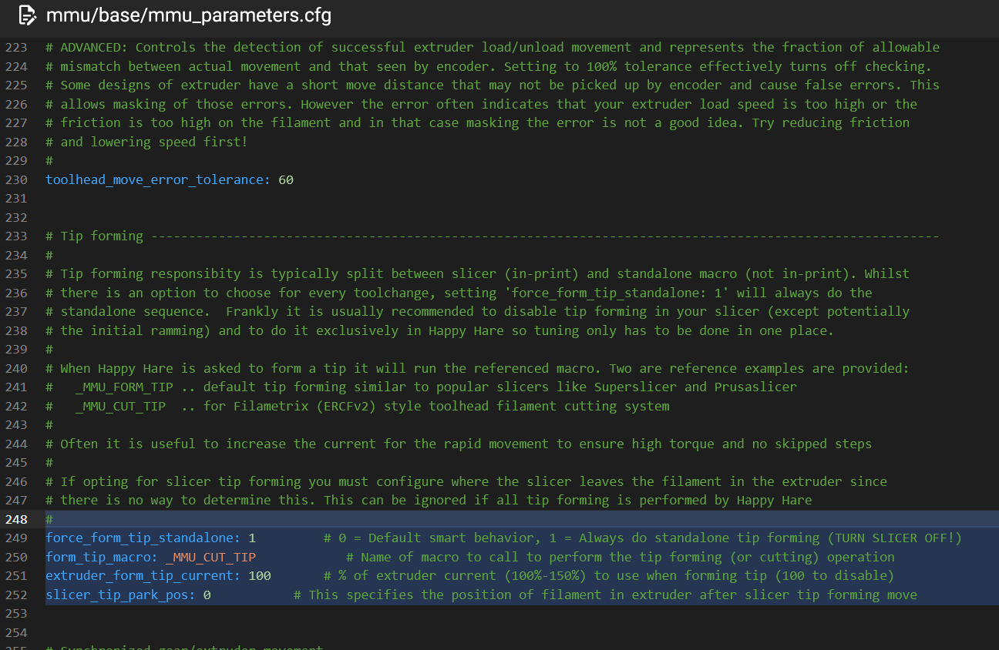

#

force_form_tip_standalone: 1 # 0 = Default smart behavior, 1 = Always do standalone tip forming (TURN SLICER OFF!)

form_tip_macro: _MMU_CUT_TIP # Name of macro to call to perform the tip forming (or cutting) operation

extruder_form_tip_current: 100 # % of extruder current (100%-150%) to use when forming tip (100 to disable)

slicer_tip_park_pos: 0 # This specifies the position of filament in extruder after slicer tip forming move

mmu/base/mmu_macro_vars.cfg内根据自己机器配置[gcode_macro _MMU_CUT_TIP_VARS]

参考：

[gcode_macro _MMU_CUT_TIP_VARS]

description: Happy Hare toolhead tip cutting macro configuration variables

gcode: # Leave empty

# Whether the toolhead tip cutting macro will return toolhead to initial

# position (usually wipetower) after the cut is complete. If using parking

# logic you may want to disable this and set 'park_after_form_tip: True'

variable_restore_position : True ; True = return to initial position, False = don't return

# Distance from the internal nozzle tip to the cutting blade. This dimension

# is based on your toolhead and should not be used for tuning

variable_blade_pos : 37.5 ; Distance in mm from internal nozzle tip

# Distance to retract prior to making the cut, this reduces wasted filament

# (left behind in extruder) but might cause clog if set too large and/or if

# there are gaps in the hotend assembly. This must be less than 'blade_pos'

variable_retract_length : 31.5 ; (5mm less than 'blade_pos' is a good starting point)

# Whether to perform a simple tip forming move after the initial retraction

# Enabling this adds some time to the cutting but gives some additional cooling

# time of molten filament and avoids potential clogging on some hotends

variable_simple_tip_forming : 1 ; True = Perform simple tip forming, False = skip

# This should be the position of the toolhead where the cutter arm just

# lightly touches the depressor pin

variable_pin_loc_xy : 280, 304 ; x,y coordinates of depressor pin

# This distance is added to 'pin_loc_x' to determine the starting position

# and to create a small saftely distance that aids in generating momentum

variable_pin_park_x_dist : 0 ; Distance in mm

# Position of the toolhead when the cutter is fully compressed. Should leave

# a small headroom (should be a bit larger than 0, or whatever xmin is) to

# avoid banging the toolhead or gantry

variable_pin_loc_x_compressed : 280 ; x coordinate

# Retract length and speed after the cut so that the cutter blade doesn't

# get stuck on return to origin position

variable_rip_length : 1 ; Distance in mm to retract to aid lever decompression (>= 0)

variable_rip_speed : 12 ; Speed mm/s

# Pushback of the remaining tip from the cold end into the hotend. This does

# not have to push back all the way, just sufficient to ensure filament

# fragment stays in hot end. Cannot be larger than 'retract_length'

variable_pushback_length : 10 ; Distance in mm

variable_pushback_dwell_time : 0 ; Time in ms to dwell after the pushback

# Speed related settings for tip cutting

# Note that if the cut speed is too fast, the steppers can lose steps.

# Therefore, for a cut:

# - We first make a fast move to accumulate some momentum and get the cut

# blade to the initial contact with the filament

# - We then make a slow move for the actual cut to happen

variable_travel_speed : 166 ; Speed mm/s

variable_cut_fast_move_speed : 33 ; Speed mm/s

variable_cut_slow_move_speed : 8 ; Speed mm/s

variable_evacuate_speed : 166 ; Speed mm/s

variable_cut_dwell_time : 50 ; Time in ms to dwell at the cut point

variable_cut_fast_move_fraction : 1.0 ; Fraction of the move that uses fast move

variable_extruder_move_speed : 50 ; Speed mm/s for all extruder movement

# Safety margin for fast vs slow travel. When traveling to the pin location

# we make a safer but longer move if we are closer to the pin than this

# specified margin. Usually setting these to the size of the toolhead

# (plus a small margin) should be good enough

variable_safe_margin_xy : 0, 0 ; Approx toolhead width +5mm, height +5mm)

# If gantry servo option is installed, enable the servo and set up and down

# angle positions

variable_gantry_servo_enabled : True ; True = enabled, False = disabled

variable_gantry_servo_down_angle: -5 ; Angle for when pin is deployed

variable_gantry_servo_up_angle : 130 ; Angle for when pin is retracted