Project Plan: Hotel Reservation System

Authors:
Project Team:
Chrystal Jovel Cator – Project Manager, Database Designer
Ana Isabel M. Estrella – Software Developer, Analyst
Michael Johnson Gendrala – Software Developer, Database Designer
Diann Marie L. Bie – Documentation, QA
Louella Javier – Documentation, QA

1.0 Executive Overview

1.1 Purpose:

The purpose of this project is to help a Hotel Management to organize their room reservations. This project shows the status of each room changes its status if it is reserved or occupied, helps employees with planning and allocating customers in each room and satisfies customers with fast and accurate transactions.

1.2 Objectives:

The objective of this project is to create a Hotel Reservation system by using Visual Basic as the main programming language in a span of 2 months.

1.3 Scope:

The scope of the project is to create a system where employees can log-in, check room status, add reservations and add room updates to help optimize the time the employees can respond to the reservation requests of customers.
The limitations that the group will have are to simply create the system through the use of Visual Basic Software, and to test their quality if the system would meet the groups’ expectations and make the system correctly.

Software:
- Microsoft Visual Basic .Net 2008/Visual Studio 2010
- PostgreSQL/MySQL
- GitHub

Tasks to do:
  - Analyze the requirements of an inventory system
  - Plan a simple design on what the system should look like
  - Create the design using visual basic according to the design planned
  - Start encoding the functions based on the requirements.

Use Cases:
User (Registration)
- Will click the register button
- Input all of the fields which are the information for the user.
- User will press the button “Complete Registration”

User (Reservation and Booking)
- User will first log in
- User will check which room is available and what class
- User will choose the available room
- User will enter the information of the customer which will be booking or reserving the room
- User will either press the “Booked” button or “Reserved” button to finish.

User (Booking Reserved Room or Book a room regularly)
- User will log in
- User will check the rooms available and which class it belongs it is, and the rooms reserved beforehand
- User will enter customer information if the customer will be booking a room immediately; otherwise skip to next step if the user chose a reserved room.
- User will press the “Booked” button to finish.

1.4 Assumptions and Constraints

Table 1.0 Assumptions and Constraints

 | ASSUMPTIONS | CONSTRAINTS | IMPACTS
PEOPLE | The developers will do their best to accomplished the project, the members of this group will participate for the good and proper deliverables of this project | The People might be pressured by the lack of time but It will not stop the group to find some alternatives to make the project completed in time. | The Project will not be on time to complete and might have a problem in its functionalities.
PROCESS | The Process of the group will be scheduled and must be accurate to the completion of this project. | The process of working in this project might not be followed in the declared scheduled due to the other errands of some members of the group. | The project will be delayed.
TECHNOLOGY | Project Developers will use Visual Basic .Net 2008 to create the system | None | None.

1.5 Project Deliverables

Table 2.0 Project Deliverables
WBS | TASK | DELIVERABLE | DUE DATE | POINT OF CONTACT*
1 | Concept | Project Scope  Project Plan | February 23, 2011 | Project Manager
2 | Project Analysis, Concept, and Design | Infrastructure Specifications | March 3, 2011 | Project Manager
3 | Project Development and Integration | Prototype and Database | March 24, 2011 | Integration Manager
4 | Testing | Test Plan Reviews  Test Report | March 31, 2011 | Quality Assurance
5 | Finalizing | Final System | April 7, 2011 | Project Manager

1.6 Schedule and Budget Summary

Table 3.0 Schedule and Budget Summary
 |  | SCHEDULE
WBS | TASK | DURATION (in man days) | START | FINISH
1 | Concept | 5 | February 7, 2011 | February 23, 2011
2 | Project Analysis, Concept, and Design | 3 | February 24, 2011 | March 3, 2011
3 | Project Development and Integration | 6 | March 4, 2011 | March 24, 2011
4 | Testing | 4 | March 25, 2011 | April 4, 2011
5 | Finalizing | 3 | April 4, 2011 | April 11, 2011
ESTIMATED TOTAL DAYS:21

2.0 Project Organization

Project Manager
Project Developer
Quality Assurance
Documenter
Database Designer
Software Developer

Figure 1.0 PR0JECT’S ORGANIZATION STRUCTURE

Table 4.0 Roles & Responsibilities of Internal Structure
MAIN ROLES | RESPONSIBILITIES
Database Designer | - Design the database for the system.  - Administers the database for Hotel Reservation System
Documenter | - Prepare the following documents  - User Manual  - Technical Manual  - Database Manual  - Project Plan
Project Manager | - The one who leads the project.  - The project manager is responsible for:  - Scope Development  - Review all the data given by the documenter
Quality Assurance (QA) | - Helping the system analysts in reviewing the specification he/she gathers.  - Test the Quality of the system
Software Developers | - Design the layout of the system  - Codes Polishing  - Create functions of system

System Analysts | - Responsible for gathering inputs and information for the system development.  - Identify the Specifications for the Systems

3.0 Managerial Process Plans

3.1. Start-up Plan

3.1.1 Estimates

Factors considered in the schedule estimates included the following:
1. The entire project will take 21 working days.
2. Start of Work is February 7, 2011
- Work schedule is Mondays and Thursdays 4:15 pm to 5:30 pm during Software Quality Assurance Class
- The Project will be completed by April 11, 2011

3.2 Work Plan

3.2. 1 Work Breakdown Structure

Table 5.0 Work Breakdown Structure
WBS | TASK NAME | PREDE-CESSOR | SUCCES-SOR | DURATION  (in Days) | DELIVERABLE | MAIN ROLES
1 | Program Management |  |  | 5 | Project Scope
1.1 | Determine Project Scope |  | 1.4 | 1 |  | P
1.2 | Develop Project Timeline | 1.2 |  | 1 |  | P, L
1.3 | Scope Presentation | 1.1, 1.2 |  | 1 |  | P
1.4 | Scope Revision and Updates from the presentation |  |  | 1 |  | P
1.5 | Completion of Project Plan |  |  | 2 | Project Plan | P
2 | Project Analysis, Concept, and Design | 1 | 3 | 3
2.1 | Identify strengths and weaknesses of the system |  | 2.2 | 1 |  | A
2.2. | Interface and Functionality Requirements | 2.1 | 2.3 | 1 |  | A,Q
2.3 | Infrastructure Requirements and Specifications | 2.2 |  | 1 | Infrastructure Specifications | A
2.3.1 | Operating System |  |  | 1 |  | A
2.3.2 | Layout Customization |  |  | 2 |  | S
3 | Project Development and Integration | 2 | 4 | 6
3.1 | Assign Development Staff |  | 3.2 | 1 |  | P
3.2 | Prepare Preliminary Design | 3.1 | 3.3, 3.4 | 1 |  | P
3.3 | Development of Database | 3.2 |  | 2 |  | D
3.4 | Develop Layout / Code | 3.2 |  | 3 |  | S
3.5 | Developer Testing | 3.3, 3.4 | 3.6 | 1 |  | Q
3.6 | Presentation of Prototype and Database | 3.5 |  | 1 | Prototype and Database | P,L
4 | Testing | 3 | 5 | 4
4.1 | Review Test Plans |  | 4.2 | 1 | Test Plan Reviews | Q
4.2 | Do Actual Testing | 4.1 | 4.3 | 1 |  | Q
4.3 | Test Report | 4.2 | 4.4 | 2 | Test Reports | Q
5 | Finalizing |  |  | 3
5.1 | Polishing of Codes / Setup of Server and Databases |  |  | 2 |  | Q
5.2 | Updates from Testing |  |  | 1 | Final System, Source Code | Q
* Legend:
P – Project Manager A – Analysts
D – Database Manager Q – Quality Control / Quality Assurance
S – Web Developer L – Documentation Lead

3.3.4 Quality Control / Quality Assurance

QUALITY CONTROL

FIGURE 6.0 QC PROCESS
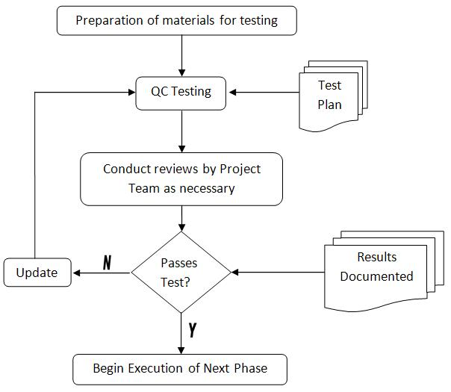

FIGURE 7.0 TESTING IN SYSTEMS DEVELOPMENT LIFE CYCLE USING RUP
Testing will involve functional and non-functional testing. Each testing will performed both in developer and user sides.

ELABORATION
Project Analysis, Concept, and Design

INCEPTION
Project Management
CONSTRUCTION
Project Development and Integration
TRANSITION
Testing and Implementation

Table 6.0 Types of Tests to be Performed

Non-Functional Testing
User Acceptance Testing | This is where the QA/QC Specialist, together with the Analyst, prepares criteria for formal acceptance of the website code. The QA/QC defines the tests that the website code must meet in order for the website to be considered complete.
User Testing | Users and stakeholders will be asked to explore the website functionalities and its features.  The website will be presented formally to the sponsors/clients’ meeting.  Training will be conducted for free after the website project is formally accepted by the sponsors/clients.
Functional Testing
Database Testing | To test if the site and its database has a strong communication. And to test the speed of fetching of data from database.
Server Testing | Test if the website does have a strong connection to the server.
Bandwidth Testing | Test the minimum and maximum bandwidth for website efficiency.
Validation Testing | Test if certain required fields have validation.
Alphanumeric Testing | To test the website for fields that are case sensitive.
Usability Testing | To measure the site’s friendliness to user thru its interface and navigations.
Performance Testing | To measure website resource usage to the machine and server request handling.
Security Testing | Testing of the site and web server to eliminate possible security loopholes.
Stress Testing | To measure the steadiness of the system after an update to codes is made.
Integration Testing | To be performed after a function or modules is added to the existing set of codes.
Browser Compatibility Testing | To test website performance in different web browsers and how pages are displayed in different users in different machines.
Accessibility Testing | To measure how well the site’s interfaces and contents respond to users with disabilities and limitations.

QUALITY ASSURANCE

FIGURE 8.0 QA PROCESS

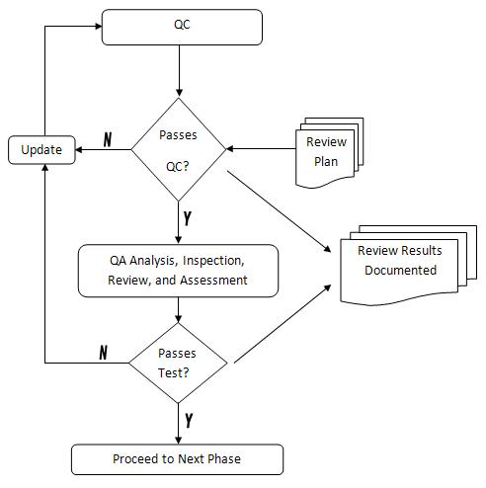

Main Criteria for Quality Assurance

Main criteria for QA:
- Features Usability
- User Experience Factors
- User Support Communication
- User Comments
- Tools Used
- Processes of Data Posting
- Redesigning

Project Startup Checklist

 | Item | Status | Location | Comments/  Plan to Resolve
1 | Planning
1.1 | Is the project statement -- scope, definition and objectives -- the same as agreed to in the Project Statement process
1.2 | Has the Project Statement been reviewed as part of the baseline process?
1.3 | Is there a baseline plan against which to measure progress?
1.4 | Does the baseline plan address or include the following areas:
1.4.1 | Project Scope, deliverables, and milestones
1.4.2 | Work Breakdown Structure with task dependencies
1.4.3 | Task plans, estimates, resource assignments
1.4.4 | Project Schedule with milestone dates
1.4.5 | Project progress tracking
1.4.6 | Issue Resolution and Change Management
1.4.7 | Quality Plan
1.4.8 | Risk Management Plan
1.4.9 | Project Organization
 | Other Plans as needed:
1.4.10 | Facilities Plan
1.4.11 | Documentation Plan
1.4.12 | Materials Plan
1.4.13 | Training Plan
1.4.14 | Back-up and Recovery Plan
1.4.15 | Contingency Plan
1.4.16 | Cut Over or Transition Plan
1.4.17 | Warranty Plan
1.4.18 | Others:
1.5 | Is the plan for project resources adequate?
1.6 | Are the original project schedule and budget realistic?
1.7 | Is the organization plan adequate?
1.8 | Are there adequate project controls?
1.9 | Is there an information system for the project?
1.10 | Were key project stakeholders brought into project plan?
1.11 | Were potential users involved early in the planning process?
1.12 | Was planning completed before the project was initiated?
1.13 | Is the plan under configuration management?
1.14 | If there are vendors, have they signed off on the project plan?
1.15 | If there is an independent oversight contractor, have they signed off on the project plan?
2 | Organization
2.1 | Is the Project Manager qualified and experienced in Project Management?
2.2 | Have roles and responsibilities of the team been documented and clearly communicated to the team, customer, and stakeholders?
2.3 | Is the organization structure appropriate for the project’s size and complexity?
2.4 | Is there an identified role of a technical leader (i.e., Project Lead, Team Lead, Solution Architect)?
2.5 | Is the quality audit function identified and assigned?
2.6 | Does the Project Manager have adequate administration and technical support?
2.7 | Is there a Change Control Manager?
2.8 | Have the configuration management functions been assigned?
2.9 | Are there backup strategies for key members of the project?
2.10 | Other Organization items:
3 | Tracking & Monitoring
3.1 | Are the various types of reports, their contents, frequency, and audience defined and communicated to the project team?
3.2 | Are the input requirements from the team members clearly documented and communicated?
3.3 | Have the reports to be produced, distributed, and filed been defined?
3.4 | Has the format for tracking and monitoring schedules and costs been defined?
4 | Reviewing
4.1 | Have the various meetings, the purpose, context, frequency, and participants been defined and communicated?
4.2 | Have the meeting materials been defined?
4.3 | Are the meetings set up to have assigned notes takers that will add action items/issues to the issue list?
5 | Issue Management
5.1 | Is an Issue Management Process documented?
5.2 | Is this process communicated to the customer and team members?
5.3 | Will an issue form be in use?
5.4 | Will all project issues be unconditionally tracked through the issue resolution process?
5.5 | Will all tasks resulting from issues be entered into the project plan and tracked through the plan?
5.6 | Are there processes for unresolved issues to be escalated and resolved within a reasonable timeframe?
6 | Configuration Management (Change Control)
6.1 | Will there be a Change Control Process in place?
6.2 | Is the Change Control Process documented and on file?
6.3 | Has this process been communicated to the customer and project team?
6.4 | Will there be a change request form in use?
6.5 | Will all project deliverable and software configuration management be changed only through the change control process?
6.6 | Will all change requests be unconditionally tracked through this process?
6.7 | Will all change requests and current status be logged?
6.8 | Will all tasks resulting from approved changes be entered into the project plan and tracked through the plan?
6.9 | Will new change requests be acknowledged in a timely manner?
6.10 | Has a method and process for requirement tracking been developed?
7 | Risk Management
7.1 | Will the project risks being managed be according to the project’s risk management process?
7.2 | Will the Risk Worksheet be updated on a regular and frequent basis?
7.3 | Will the Risk Status be reported to management on a regular and frequent basis?
7.4 | Will there be documented contingency plans for the top 5-10 risks?
7.5 | Will the Preventive Plans for the top 5 risks be identified, included in the project plan, and implemented?
8 | Quality Assurance
8.1 | Is there a Quality Assurance Plan documented?
8.2 | Are the quality assurance functions and related roles and responsibilities clearly defined?
8.3 | Are completion/verification criteria defined for each task producing an output?
8.4 | Is there a process (test plans, inspections, reviews) defined for verifying outputs for each task?
8.5 | Will tasks be marked “complete” only after internal QA has been successfully completed?
8.6 | Will there be a formal process for submitting, logging, tracking, and reporting of items undergoing QA throughout the submit-test-rework-resubmit-retest cycle?
8.7 | Will statistics related to QA be collected and problems raised as issues?
8.8 | Will the QA related information be reported regularly as part of the Status Reporting mechanisms?

Appendices A- System Design

Login(For Employees)

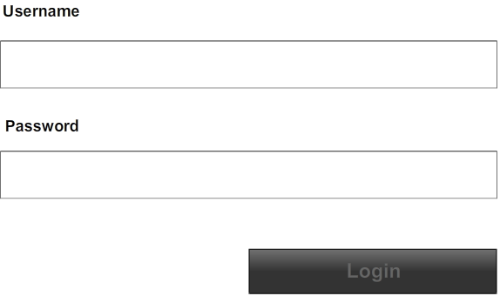

Employee's Registration
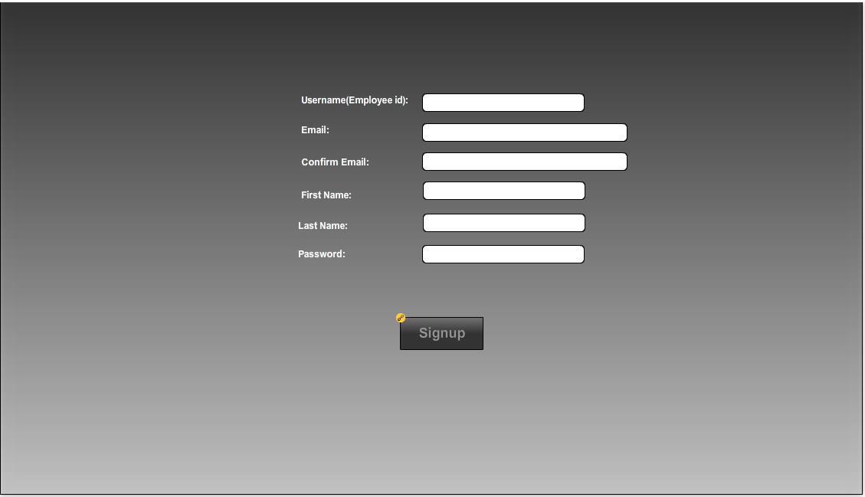

Booking System
