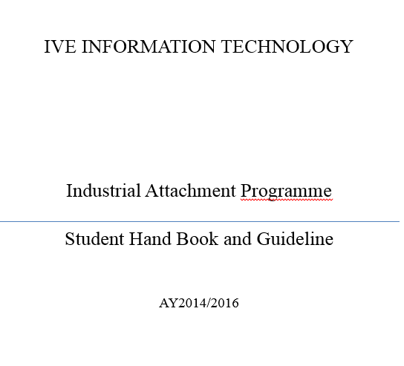

Programme      /     /     .

**1 Industrial Attachment Programme**

Industrial Attachment (IA) is a “work-based experience programme” providing a real-life organizational context for students to develop specific or generic skills, valuable to their professional development.  
  
Students can apply and enhance their skills in reality, contribute to the organization, and, at the same time, obtain invaluable guidance from their company mentors. They can also identify their own strengths and weaknesses through their self-evaluation and feedback from the mentors.

**1.1 Programme Structure**

The cumulative total duration of the attachment should be no shorter than 90 hours, which can be taken place during term-time or summer vacation (i.e. July-August). Work related to a small project, as well as specific tasks such as research, production, administration, or day-to-day operation are excellent opportunities.  
  
All participating students will be assigned a Company Mentor who provides supervision and feedback to the students. A pre-assigned IVE IA Supervisor will keep close contact with the student and the company mentor during the attachment period. The overall assessment shall be done by IVE IA Supervisor based on the evaluation and feedback from the company mentor.

**2 Responsibilities of Participating Parties**

2.1 Participating Company/Organization

* To provide training and/or working opportunities for the student
* To assign a company mentor for the student on attachment
* To provide a safe working environment and on-the-job safety instruction for the student
* To allow the IVE IA Supervisor to visit the student at least once during the attachment period

2.2 Participating Company/Organization Mentor

* To provide advice and ongoing feedback on student performance.
* To keep in close contact with the IVE IA Supervisor to provide feedback on student work, progress and performance throughout the attachment period
* To inform IVE IA Supervisor at once of a student’s absence of any 2 consecutive half-days.
* To immediately inform the IVE IA Supervisor concerned of any accidents or injuries that involve the student during the attachment

2.3 IVE

* To provide guidance to the student on working attitudes, workplace safety and relevant Key Skills before the attachment
* To ensure that each student on attachment is covered by a Group Personal Accident Insurance Policy
* To assign an IVE IA Supervisor to liaise with the company to set up attachment visit(s) to meet with the student / company mentor concerned

2.4 IVE IA Supervisor

* To provide guidance, monitor, and document the progress of the student during the attachment period
* To keep in close contact with the company mentor throughout the attachment period and act on / follow up any areas of concern with the student and/or the company
* To provide ongoing feedback to the company mentor and the student to foster effective communication and establish supportive relationships before, during and after the attachment period

2.5 Student

* To observe the rules and regulations (in particular, those relating to safety and security) of the company
* To comply with the instructions and orders of their IA Supervisor (s), company mentor(s) and such staff members of the company, as the job requires
* To observe the office hours of the company and be punctual
* To behave appropriately (as advised by the IA Supervisor and company) as a representative of IVE in the important role of attachment student at the company
* To observe and comply with the legal laws where the attachment takes place
* To take care of herself/himself during and after work hours and not to leave the factory building or dormitory at night if the attachment is outside Hong Kong
* To notify the company mentor before s/he leaves the factory or dormitory if it is located outside Hong Kong
* To report any unsafe working conditions or other concerns to the company mentor and/or the IA Supervisor / Coordinator
* Not to take unapproved leave during the attachment period

**3 Assessment**

Both the company mentor and IVE IA Supervisor shall keep close contact with the student and each other, and provide necessary support and assessment for the student during the attachment period. Assessment shall include but not limited to interview, periodic and final review. Company mentor should complete the final report at the end of the attachment. <Refer to Appendix 6>

During the industrial attachment, students are required to:

* Follow the schedule and complete the attachment as agreed in the Statement of Understanding.
* Log what they have learnt and experienced in the workplace as frequent as possible
* Complete the monthly report and seek endorsement from the company/organization mentor <Refer to Appendix 4>
* Report to IVE IA Supervisor during the visit

Either PASS or FAIL will be given to student with indication in the student report.

**4 Periodic Review by IVE Industrial Attachment Supervisor**

IVE IA Supervisor will keep a close monitoring of student progress in the workplace and make a visit as an interim review. During the visit, the IVE IA Supervisor will meet with student and company mentor, review what the student has learnt, prepare the coming work plan, give advices and provide assistance if necessary. <Refer to Appendix 5>

**5 Student’s Evaluation on Industrial Attachment**

After the completion of an industrial attachment, each student is required to complete an evaluation report to consolidate his/her own advancement and experience gained. The report has to be submitted within one month after the completion of the industrial attachment. <Refer to Appendix 7>

**6 Insurance Coverage**

The VTC Group Personal Accident Insurance provides insurance cover to students while they are participating in the industrial attachment. Students are advised and encouraged to, if they prefer, take out additional/supplementary insurance coverage on their own for personal accidents, medical, travel, and/or third party liabilities. <Refer to Appendix 3>

**7 Appendices:**

Appendix 1 : Student Information (Student)

Appendix 2.1 : Industrial Attachment Form (Organization)

Appendix 2.2 : Statement of Understanding (Organization)

Appendix 3 : Insurance Coverage for Students (Parent/Guardian) (Optional)

Appendix 4 : Monthly Report (Student)

Appendix 5 : Visiting Report (IA Supervisor) (Optional)

Appendix 6 : Final Report (Organization)

Appendix 7 : Evaluation Report (Student)

Appendix 8 : Industrial Attachment Certificate (Template) (Departmental IA Coordinator)