

**Program 2: Write a shell script that accepts a file name,starting and ending line numbers  
as arguments and display all the lines between the given line numbers.**  
echo "enter file name"  
read f  
echo 'enter starting position'  
read st  
echo 'enter ending position'  
read end  
echo 'The lines between' $st 'and' $end 'from' $f  
if [ $st -lt $end ]  
then  
n1=`expr $st + 1`  
n2=`expr $end - 1`  
sed -n "$n1,$n2 p" $f  
elif [ $st -gt $end ]  
then  
n3=`expr $st - 1`  
n4=`expr $end + 1`  
sed -n "$n4,$n3 p" $f  
fi  
**Output:**

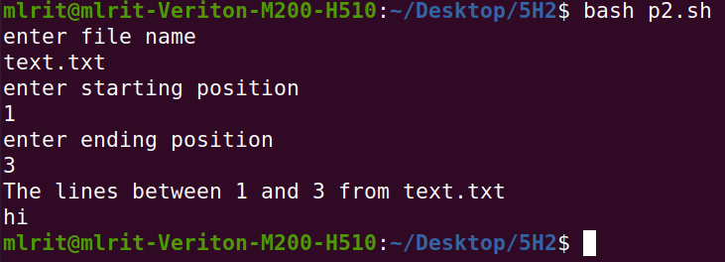asdAS



**Program 3: Write a shell script that deletes all lines containing a specified word in one or more files supplied as arguments to it.**  
echo 'enter a word to be deleted'  
read word  
echo 'enter file name'  
read fname  
echo 'lines in' $fname 'after deleting the word' $word ':'  
sed "/$word/d" $fname

**Output**

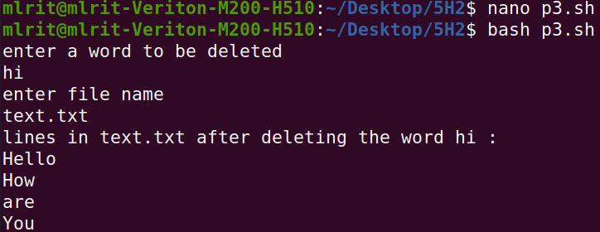



**Program 4: Write a shell script that displays a list of all the files in the current directory to which the user has read,write and execute permissions.**  
for i in *  
do  
if [ -r $i -a -w $i -a -x $i ]  
then

21  
echo $i  
fi  
done

**Output**







**Program 5: Write a shell script that receives any number of file names as arguments checks if every argument supplied is a file or directory and reports accordingly.whenever the argument is a file,the number of lines on it is also reported.**  
for fname in $*  
do  
if [ -f $fname ]  
then  
echo $fname 'is a file'  
echo 'no.of lines in' $fname ':'  
wc -l $fname  
elif [ -d $fname ]  
then  
echo $fname 'is a directory'  
else  
echo 'Does not exist'  
fi  
done  
**Output:**

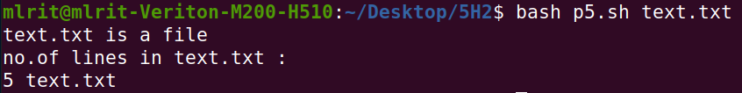



**Program 6**: **Write a shell script that accepts a file names as its arguments,counts and reports the occurrence of each word that is present in the file argument file in other argument files.**

if [ $# -eq 0 ]

then

echo "no arguments"

else

tr " " "\n" < $1 > temp

shift

for i in $*

do

tr " " "\n" < $i > temp1

y=`wc -l < temp`

j=1

while [ $j -le $y ]

do

x=`head -n $j temp | tail -1`

c=`grep -c "$x" temp1`

echo $x $c

j=`expr $j + 1`

done

done

fi

**Output:**

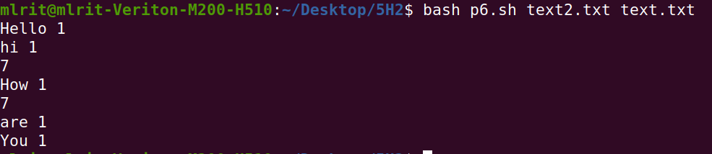



**Program 7: Write a shell script to all of the directory files in a directory.**

echo 'enter a directory name'

read dname

echo 'The list of directory files in the directory' $dname 'are'

cd $dname

ls -l | grep '^d'

**Output:**

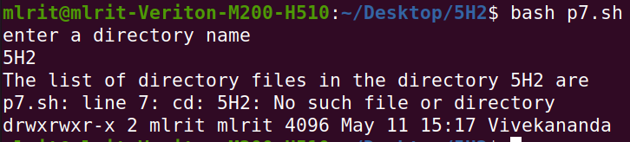



**Program 8**: **Write a awk script to count the number of lines in a file that do not contain vowels.**

echo 'enter a file name'

read fn

awk '$0 !~/[aeiou]/ { c=c+1 }

END { print("The no.of lines that do not contain vowels:",c) }' $fn

**Output:**

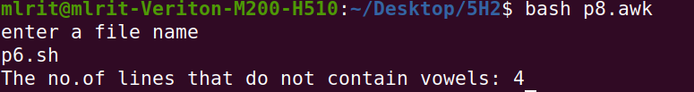



**Program 9** : **Write a awk script to find the number of characters,words and lines in a file.**

echo "enter a file name"

read fn

awk '{ w=w+NF

c=c+length($0)

}

END { print("No.of lines:",NR)

print("No.of words:",w)

print("No.of characters:",c)

}' $fn

**Output:**

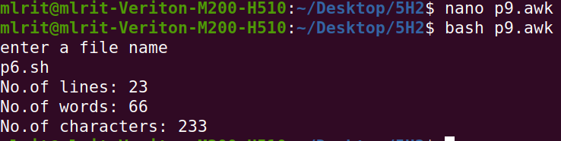



**Program 10**: **Write a C program that makes a copy of a file using standard I/O and system calls.**

#include<stdio.h>

#include<unistd.h>

#include<fcntl.h>

#define MAX_SIZE 1000

void main()

{

int fd1,fd2,r1,w1;

char buffer[MAX_SIZE];

char sourceName[100],destName[100]; printf("enter the source file\n"); scanf("%s",sourceName); printf("enter a new file name"); scanf("%s",destName); fd1=open(sourceName,O_RDONLY);

r1=read(fd1,buffer,MAX_SIZE);

fd2=open(destName,O_CREAT|O_RDWR,0600);

w1=write(fd2,buffer,r1);

}**O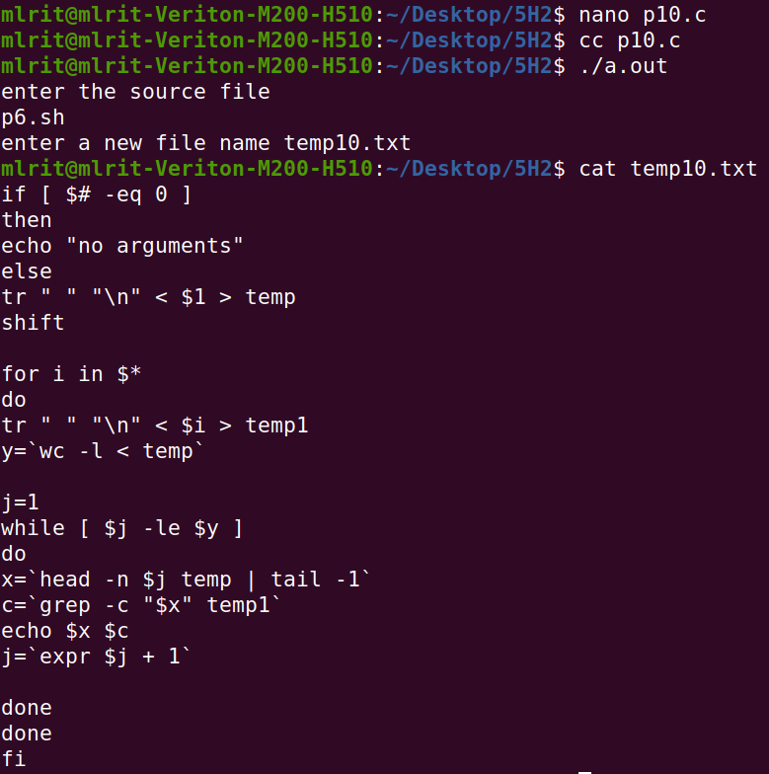utput:**



**Program 11:.Implement in C the following Unix commands using system calls.**

1. **cat command**

#include<fcntl.h>

#include<stdlib.h>

#include<stdio.h>

#include<string.h>

#include<unistd.h>

#define MAX_SIZE 500

int main()

{

int fd1,n;

char buf[MAX_SIZE],fname[20]; printf("enter a file name\n"); scanf("%s",fname); fd1=open(fname,O_RDONLY); if(fd1==-1)

printf("the file does not exist");

else

{

printf("The contents of file %s are:\n",fname); n=read(fd1,buf,MAX_SIZE); write(1,buf,n);

}

}

**Output:**

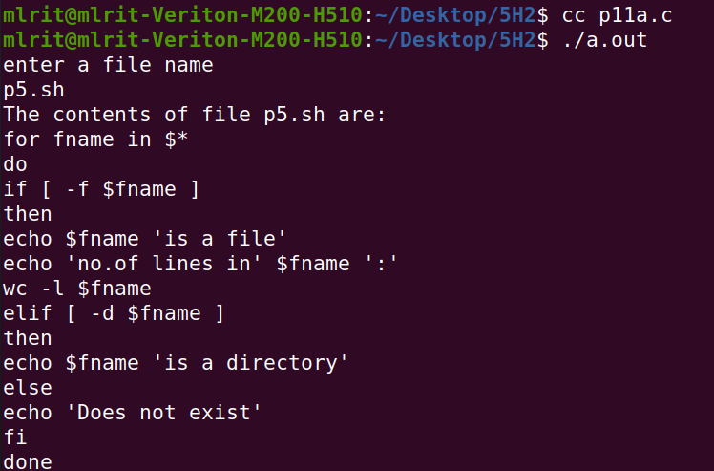



**11b)mv command**

#include<fcntl.h>

#include<stdlib.h>

#include<stdio.h>

#include<string.h>

#include<unistd.h>

int main(int argc,char *argv[])

{

open(argv[1],O_RDONLY);

creat(argv[2],S_IWUSR);

rename(argv[1],argv[2]);

unlink(argv[1]);

}

**Output:**

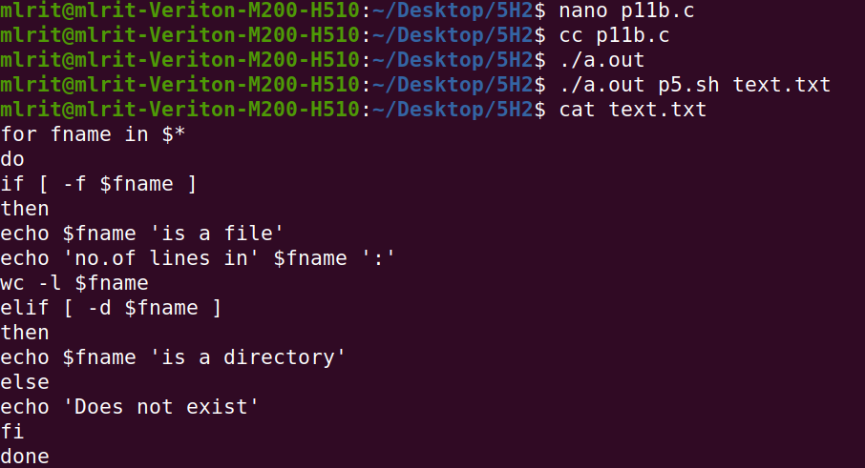



**Program 12: Write a C program to list for every file in a directory,its inode number in a given directory**

#include<stdlib.h>  
#include<stdio.h>  
#include<string.h>  
int main(int argc,char *argv[])  
{  
char d[50];  
if(argc==2)  
{  
bzero(d,sizeof(d));  
strcat(d,"ls ");  
strcat(d,"-i ");  
strcat(d,argv[1]);  
system(d);  
}  
else  
printf("\nInvalid no.of inputs");  
}

**Output:**

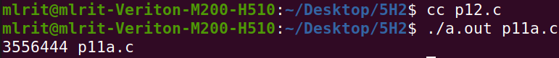



**Program 13: Write a C program to create a child process and allow the parent to display “parent” and the child to display “child ” on the screen.**

#include<stdio.h>

#include<stdlib.h>

#include<unistd.h>

#include<fcntl.h>

int main()

{

pid_t pid;

pid=fork();

if(pid==-1)

printf("failed to fork");

else if(pid==0)

printf("child process:%d\n",getpid());

else

printf("parent process:%d",getpid());

}

**Output:**





**Program 14: Write a C program to create a Zombie process**

#include<stdio.h>

#include<stdlib.h>

#include<unistd.h>

#include<fcntl.h>

void main()

{

int pid;

pid=fork();

if(0==pid)

{

printf("child process %d \n",getpid());

exit(0);

}

else

{

wait(0);

sleep(10);

printf("parent process %d \n", getppid());

}

}

**Output:**

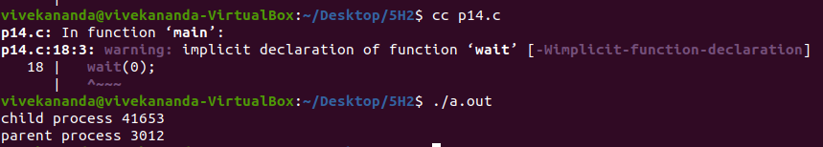



**Program 15: Write a C program that illustrates how an orphan is created.**

1. **Orphan process** #include<stdio.h>

#include<stdlib.h>

#include<unistd.h>

#include<fcntl.h> void main()

{

int pid; pid=fork(); if(pid==0)

{

printf("I am the child process with PID:%d and my parent id is:%d\n\n",getpid(),getppid());

sleep(15);

printf("I am the child process with PID:%d and my parent id:%d\n",getpid(),getppid());

}

else

{

printf("I am the parent process with PID:%d\n \n",getpid()); printf("My child's PID is:%d\n\n",pid); sleep(1);

}

printf("PID %d terminates \n",getpid()); /*Both processes execute this*/}

**Output:**

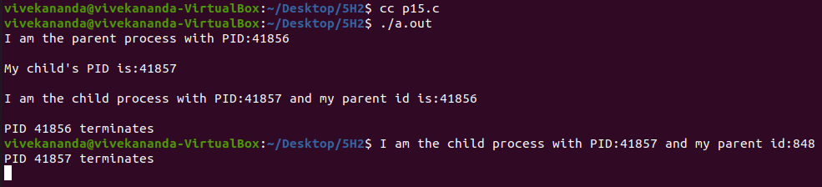

**ii)Orphan process** #include<stdio.h>

#include<stdlib.h>

#include<unistd.h>

#include<fcntl.h>

void main()

{

int pid; pid=fork(); if(0==pid)

{

printf("%d\n",getpid());

sleep(5);

printf("%d\n",getpid());

}

else

{

printf("%d\n",getpid());

printf("bye from parent\n");

exit(0);

}

**}**

**Output:**

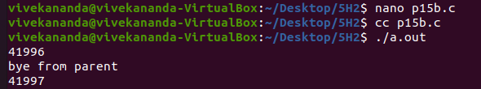



**Program 16: Write a C program that illustrates communication between two unrelated process using named pipe(FIFO).**

//read write

#include <stdio.h>

#include <string.h>

#include <fcntl.h>

#include <sys/stat.h>

#include <sys/types.h>

#include <unistd.h>

int main()

{

int fd1;

// FIFO file path

char * myfifo = "/tmp/myfifo";

// Creating the named file(FIFO)

// mkfifo(<pathname>,<permission>)

mkfifo(myfifo, 0666);

char str1[80], str2[80];

while (1)

{

// First open in read only and read

fd1 = open(myfifo,O_RDONLY);

read(fd1, str1, 80);

// Print the read string and close

printf("User1: %s\n", str1);

close(fd1);

// Now open in write mode and write

// string taken from user.

fd1 = open(myfifo,O_WRONLY);

fgets(str2, 80, stdin);

write(fd1, str2, strlen(str2)+1);

close(fd1);

}

return 0;

}

**output:**

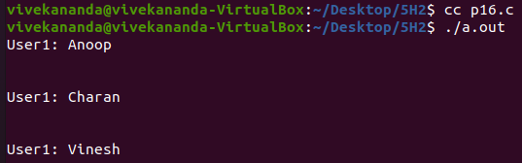

/fifo write read// C program to implement one side of FIFO

// This side writes first, then reads

#include <stdio.h>

#include <string.h>

#include <fcntl.h>

#include <sys/stat.h>

#include <sys/types.h>

#include <unistd.h>

int main()

{

int fd;

// FIFO file path

char * myfifo = "/tmp/myfifo";

// Creating the named file(FIFO)

// mkfifo(<pathname>, <permission>)

mkfifo(myfifo, 0666);

char arr1[80], arr2[80];

while (1)

{

// Open FIFO for write only

fd = open(myfifo, O_WRONLY);

// Take an input arr2ing from user.

// 80 is maximum length

fgets(arr2, 80, stdin);

// Write the input arr2ing on FIFO

// and close it

write(fd, arr2, strlen(arr2)+1);

close(fd);

// Open FIFO for Read only

fd = open(myfifo, O_RDONLY);

// Read from FIFO

read(fd, arr1, sizeof(arr1));

// Print the read message

printf("User2: %s\n", arr1);

close(fd);

}

return 0;

**}**

**Output:**

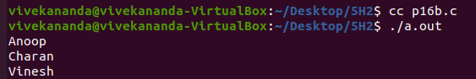



**Program 17:write a C program(sender.c) to create a message queue with read and write permissions to wrte 3 messages to it with different priority numbers.**

#include<sys/types.h>

#include<sys/ipc.h>

#include<sys/msg.h>

#include<stdio.h>

#include<string.h>

#include<stdlib.h>

int main(){

int qid, len,i;

char s[15];

struct

{

long mtype;

char mtext[15];

} message,buff;

qid = msgget(1000,IPC_CREAT|0666);

if(qid==-1)

{

perror("message queue create failed");

exit(1);

}

for(i=1;i<=3;i++){

printf("enter the msg to send \n");

scanf("%s",s);

strcpy(message.mtext,s);

message.mtype=i;

len=strlen(message.mtext);

if(msgsnd(qid,&message,len+1,0)==-1)

{

perror("message failed\n");

exit(1);

}

}

}

**Output:**

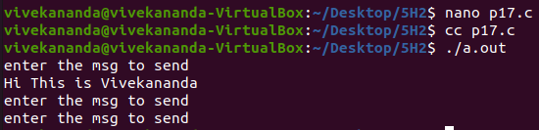



**Program 18:write a C program(receiver.c) that receives the messages from sender and displays them.**

#include<sys/types.h>

#include<sys/ipc.h>

#include<sys/msg.h>

#include<stdio.h>

#include<string.h>

#include<stdlib.h>

int main(){

int qid, len,i;

char s[15];

struct

{

long mtype;

char mtext[15];

} buff;

qid = msgget(1000,IPC_CREAT|0666);

if(qid==-1)

{

perror("message queue create failed");

exit(1);

}

for(i=1;i<=3;i++){

if(msgrcv(qid,&buff,15,i,0)==-1)

{

perror("message failed\n");

exit(1);

}

printf("message received from sender is %s\n",buff.mtext);

}

}

**Output:**

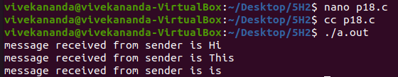



**Program 19:write client and server programs(using c) for interaction between server and client processes using Unix Domain Sockets.**

**a)unix domain sockets(interaction between server and client)**

**(server)**

#include <sys/types.h>

#include <sys/socket.h>

#include <sys/un.h>

#include <stdio.h>

#define NSTRS 3

#define ADDRESS "mysocket"

/* no. of strings */

//"mysocket" /* addr to connect */

/*

• Strings we send to the client. */

char *strs[NSTRS] = {

"This is the first string from the server.\n",

"This is the second string from the server.\n",

"This is the third string from the server.\n"

};

main()

{

char c;

FILE *fp;

int fromlen;

register int i, s, ns, len;

struct sockaddr_un saun, fsaun;

/*

• Get a socket to work with. This socket will

• be in the UNIX domain, and will be a

• stream socket.

*/

if ((s = socket(AF_UNIX, SOCK_STREAM, 0)) < 0) { perror("server: socket");

exit(1);

}

/*

• Create the address we will be binding to. */

saun.sun_family = AF_UNIX;

strcpy(saun.sun_path, ADDRESS);

/*

* Try to bind the address to the socket. We

• unlink the name first so that the bind won't

• fail.

*

• The third argument indicates the "length" of

• the structure, not just the length of the

• socket name.

*/

unlink(ADDRESS);

len = sizeof(saun.sun_family) + strlen(saun.sun_path);

if (bind(s, &saun, len) < 0) {

perror("server: bind");

exit(1);

}

/*

• Listen on the socket. */

if (listen(s, 5) < 0) {

perror("server: listen");

exit(1);

}

/*

• Accept connections. When we accept one, ns

• will be connected to the client. fsaun will

• contain the address of the client.

*/

if ((ns = accept(s, &fsaun, &fromlen)) < 0) {

perror("server: accept");

exit(1);

}

/*

• We'll use stdio for reading the socket. */

fp = fdopen(ns, "r");

/*

• First we send some strings to the client. */

for (i = 0; i < NSTRS; i++)

send(ns, strs[i], strlen(strs[i]), 0);

/*

* Then we read some strings from the client and

• print them out. */

for (i = 0; i < NSTRS; i++) {

while ((c = fgetc(fp)) != EOF) {

putchar(c);

if (c == '\n')

break;

}

}

/*

• We can simply use close() to terminate the

• connection, since we're done with both sides. */

close(s);

exit(0);

}

**Output:**

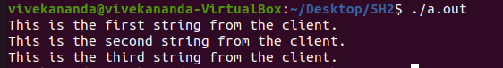



**20 unix domain sockets(interaction between server and client)**

**Client.c**

#include <sys/types.h>

#include <sys/socket.h>

#include <sys/un.h>

#include <stdio.h>

#define NSTRS 3

#define ADDRESS "mysocket"

/* no. of strings */

/* addr to connect */

/*

• Strings we send to the server. */

char *strs[NSTRS] = {

"This is the first string from the client.\n",

"This is the second string from the client.\n",

"This is the third string from the client.\n"

};

void main(){

char c;

FILE *fp;

register int i, s, len;

struct sockaddr_un saun;

/*

• Get a socket to work with. This socket will

• be in the UNIX domain, and will be a

• stream socket.

*/

if ((s = socket(AF_UNIX, SOCK_STREAM, 0)) < 0) { perror("client: socket");

exit(1);

}

/*

• Create the address we will be connecting to. */

saun.sun_family = AF_UNIX;

strcpy(saun.sun_path, ADDRESS);

/*

• Try to connect to the address. For this to

• succeed, the server must already have bound

• this address, and must have issued a listen()

• request.

*

• The third argument indicates the "length" of

• the structure, not just the length of the

• socket name.

*/

len = sizeof(saun.sun_family) + strlen(saun.sun_path);

if (connect(s, &saun, len) < 0) {

perror("client: connect");

exit(1);

}

/*

• We'll use stdio for reading

• the socket.

*/

fp = fdopen(s, "r");

/*

• First we read some strings from the server

• and print them out.

*/

for (i = 0; i < NSTRS; i++) {

while ((c = fgetc(fp)) != EOF) {

putchar(c);

if (c == '\n')

break;

}

}

/*

• Now we send some strings to the server. */

for (i = 0; i < NSTRS; i++)

send(s, strs[i], strlen(strs[i]), 0);

/*

• We can simply use close() to terminate the

• connection, since we're done with both sides. */

close(s);

exit(0);

}

**Output:**

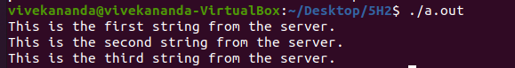



**21. internet sockets**

**a) server1.c**

#include<netinet/in.h> //structure for storing address information

#include<stdio.h>

#include<stdlib.h>

#include<sys/socket.h> //for socket APIs

#include<sys/types.h>

int main(int argc, char const* argv[])

{

// create server socket similar to what was done in

// client program

int servSockD = socket(AF_INET, SOCK_STREAM, 0);

// string store data to send to client

char serMsg[255] = "Message from the server to the client";

// define server address

struct sockaddr_in servAddr;

servAddr.sin_family = AF_INET;

servAddr.sin_port = htons(9001);

servAddr.sin_addr.s_addr = INADDR_ANY;

// bind socket to the specified IP and port

bind(servSockD, (struct sockaddr*)&servAddr,

sizeof(servAddr));

// listen for connections

listen(servSockD, 1);

// integer to hold client socket.

int clientSocket = accept(servSockD, NULL, NULL);

// send's messages to client socket

send(clientSocket, serMsg, sizeof(serMsg), 0);

return 0;

**}**

**Output:**





**b)client.c**

#include<netinet/in.h> //structure for storing address information

#include<stdio.h>

#include<stdlib.h>

#include<sys/socket.h> //for socket APIs

#include<sys/types.h>

int main(int argc, char const* argv[])

{

int sockD = socket(AF_INET, SOCK_STREAM, 0);

struct sockaddr_in servAddr;

servAddr.sin_family = AF_INET;

servAddr.sin_port = htons(9001); // use some unused port number

servAddr.sin_addr.s_addr = INADDR_ANY;

int connectStatus = connect(sockD, (struct sockaddr*)&servAddr, sizeof(servAddr));

if (connectStatus == -1) {

printf("Error...\n");

}

else {

char strData[255];

recv(sockD, strData, sizeof(strData), 0);

printf("Message: %s\n", strData);

}

return 0;

}

**output:**

