MSc DevSecOps Project

Week # 4: Continuous Integration Screenshot of Successful CI Run
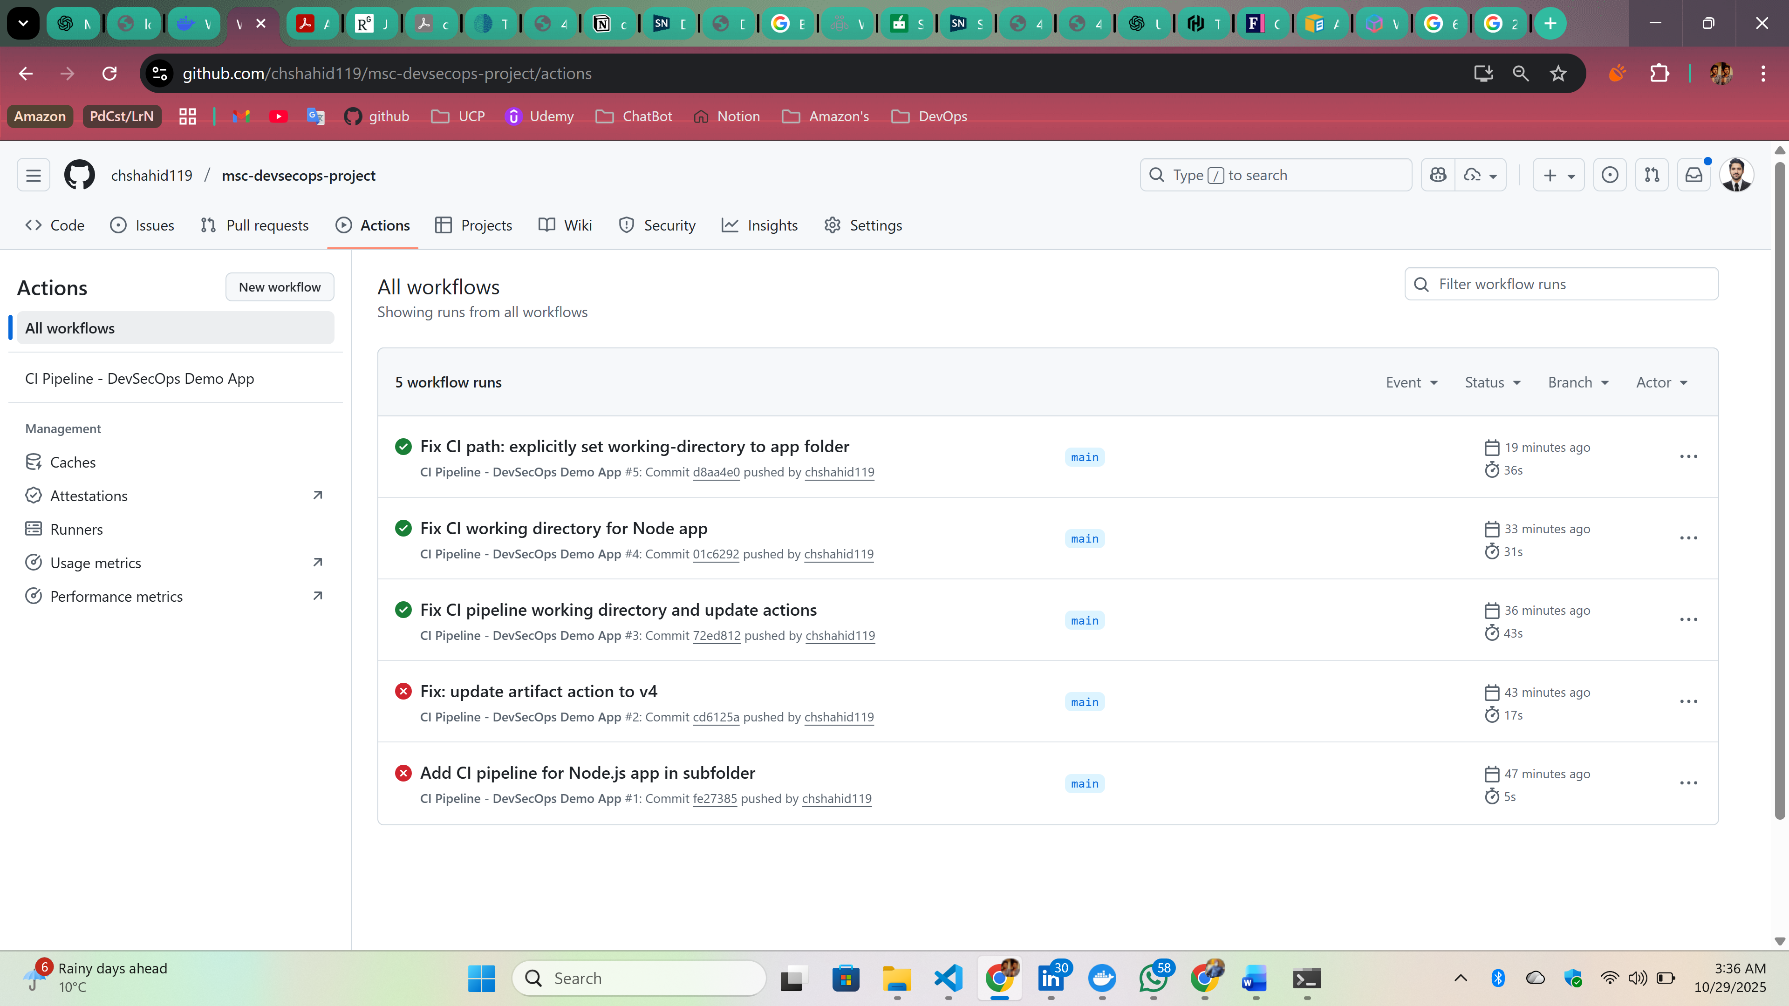
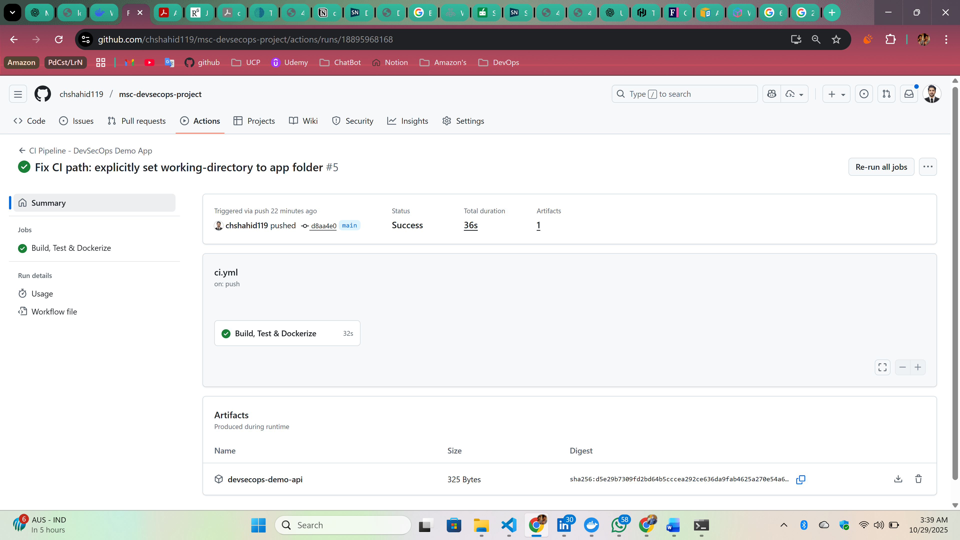

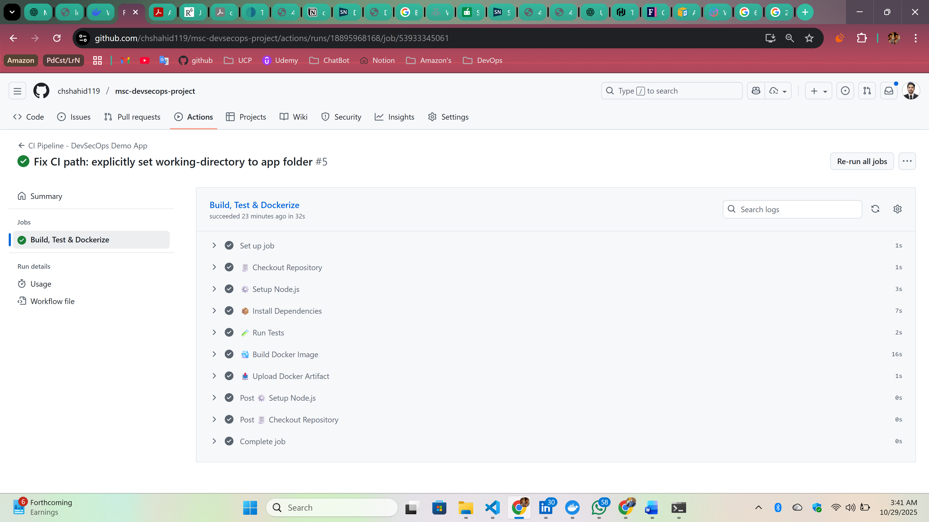

So Total Cl Time for all those process takes = 36 seconds

