Transformation of the Rio Grande Delta after One Hundred Years of Human Intervention

Abstract

The Rio Grande has been an emblematic feature and a source of life for the region. Since Pre-Historic times it has provided the resources that allowed waves of humans to migrate inland from the coast, and communities to thrive in a land where water is scarce. Large scale anthropogenic activities including, river diversions and dam construction have negatively impacted the river. Twenty-three major dams and many small ones built on the main channel and many of its tributaries in the last century, have drastically reduced water discharge and eliminated sediment delivery to the delta. This study explores how the channel sinuosity (degree of how meandering the channel is) of the river, in the delta plain, has changed. We test the hypothesis that under a significantly reduced water discharge and a much smaller suspended sediment load, the river has reduced the sinuosity of its channel to achieve equilibrium with the new conditions. Jupyter lab will be the main processing tool use in this project to analyze discharge, sediment, and sinuosity data collected for this research. The processing power of jupyter will help us able to figure out if the delta reach of the Rio Grande has suffered a reduction in sinuosity as a result of human activity.

1.- Introduction

*1.1.- The basin*

The Rio Grande is the twentieth longest river in the world and the fifth longest in North America (Schmidth and Dilworth, 2019). With a basin area of 924,300 km² that extends over the United States and Mexican territories, the Rio Grande has its headwaters at 3,837m above sea level in the San Juan Mountains in Colorado (Metz, 2010) and travels 3,060 km to its outlet in South Texas, where it reaches the Gulf of Mexico. On its way to the gulf, the river runs through the states of Colorado, New Mexico, and Texas in the United States and the states of Chihuahua, Coahuila, Nuevo Leon, and Tamaulipas in Mexico. Once it reaches Texas, the river becomes the international boundary between Mexico and the United States, for 2,054 km to the Gulf of Mexico, the longest river border between two countries in the world (Schmandt, 2002).

*1.2.- The Delta*

The Rio Grande formed a sizable delta of around 7,770 km² that spans from Southeast Texas to Northeast Tamaulipas with a shoreline length of approximately 300 km, and begins near the city of Harlingen, 70 km from shore, (Ewing and Gonzalez, 2016) (Figure 1). Mostly rural region with a sub-tropical climate with an average precipitation of 1.6 mm in 2020, according National Oceanic and Atmospheric Administration. The major urban hubs within the confines of this area are Brownsville, Texas (population 182,781) and Matamoros, Tamaulipas (population 520,367). Like all modern deltas, the Rio Grande delta is thought to have formed due to the slowdown in the rate of sea-level rise between 8500- and 6500-years BP that A picture containing text, nature
allowed the accumulation of sediment in coastal areas (Stanley and Warne, 1994).

Figure 3. The Rio Grande delta. The Rio Grande and the delta shoreline are delineated in red. Falcon Dam is seen in the right up corner (Google Earth, 2021).

1.3.- Human activity on the Rio Grande

Nowadays, fifteen major dams and diversions, and many more minor structures, have been built in the last 100 years. Two of these major deltas are located within the Lower Rio Grande reach; these dams are Amistad dam and Falcon dam, which are located at 546 km and 212 km from the mouth of the river, respectively. Vast human intervention has resulted in a drastic reduction of water discharge and have effectively terminated bed and suspended sediment loads delivered to the delta. The drastic reduction, and in some instances the complete loss, of discharge and sediment load have the potential to get the Rio Grande system out of equilibrium. A river reaches equilibrium once it finds the gradient that allows its water discharge to flow and transport its sediment load (Nanson and Huang, 2018). Anthropogenic actions are now considered a major force shaping delta landform (Kondolf et al., 2014; Rogers and Overeem., 2017; Higgins et al., 2018). Coastal erosion, the increase of relative sea level rise rates, sediment depletion, land subsidence, and human pressure on delta land are expected to negatively affect the efficiency of conventional approaches currently use to protect delta environments (Schmitt et al., 2017). It is important for local communities such as the Rio Grande Valley to understand the changes that are happening in the Rio Grande system.

1.4.- Sinuosity

Sinuosity is a common concept use in geomorphology to represent the ratio between river length and valley length. It is calculated by dividing the river length from point a to point b by the valley length (straight line) from the same point a to point b (Figure 2). A sinuosity of 1 means that the distance traveled in the river would be the same to the distance travel in the valley. On the other hand, a sinuosity of 2 means that the distance traveled in the river is double to the distance traveled in the valley.

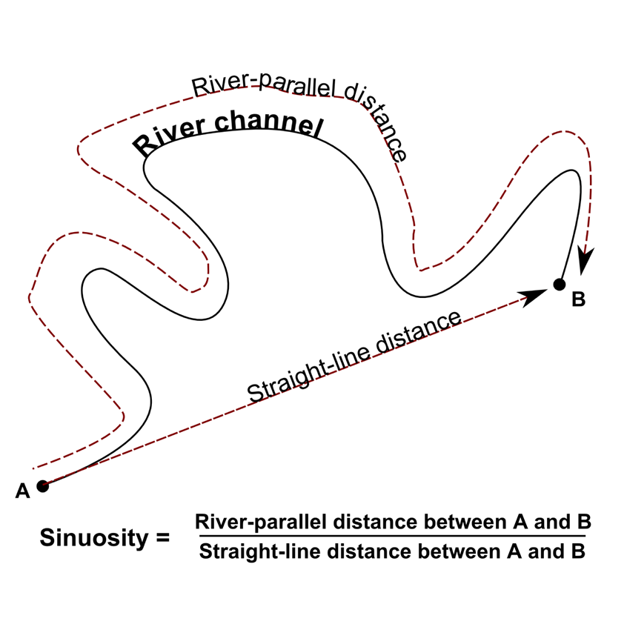Figure 2. Sinuosity. River length indicates the distance travelled through the river. Valley length indicates the distance travel through the valley parallel to the river (Sorsby, 2018).

2.- Objective

The objective of this research was to look and quantify the effects that one hundred years of human activity have had on the delta reach of the Rio Grande. GIS will be used to track the path of the Rio Grande in the delta from publicly available aerial imagery from 2014 and maps from 2012 to measure sinuosity. Government data on flow discharge and sediment load will be examined as well. The data collected will be processed to search for any meaningful change that can be related to human activity.

This research intends to answer the following questions: Has human activity changed the delta section of the Rio Grande? Can sinuosity, flow, and sediment data provide enough data to proof that human activity has affected the river? If change is detected, can it be related to human activity?

2.1.- Hypothesis

This study will test the hypothesis that as result of the significant decline of water discharge, and the almost complete elimination of suspended sediment to the coast, over the last one hundred years, the river has adjusted its channel in the delta region by reducing its sinuosity.

3.- Methods

3.1.- Research Area

This study focuses on the delta portion of the Rio Grande, which begins at the Cameron and Hidalgo county line and extends to the mouth of the at Boca Chica Beach; a stretch of 70 Km of river channel. This area will be divided into four sections to isolate any disturbances affecting our overall measurement

3.2.- Rio Grande 1912 through 2014

Data from 1912 was obtained from 11 maps published by then International Boundary Commission in 1913. The maps are the oldest and high-quality record available of the Lower Rio Grande before major human interference at any sector of its channel and offers the possibility of getting a sinuosity that is representative to the river before major anthropogenic impacts.

Aerial imagery for the year 2014 was obtained from the Texas Natural Resources Information System (TNRIS) website. Even though more recent aerial images have been published by TNRIS, only those released in 2014 show the research area.

3.3.- ArcGIS

ArcMap 10.7.1 has been selected to be use for this research to prepare and manage the datasets. It provides the tools necessary for georeferencing processes, creating models of the Rio Grande in 1912 and 2012, measuring valley length and river length, and other processes that were necessary in this research.

3.4.- Jupyter Lab

Jupyter Lab will be used to obtain the sinuosity ratio for the Rio Grande and analyze discharge and sediment data. The processing power of Jupyter lab will serve to find any drastic changes in any of these variables. Analyzing these data can help quantify the harm that anthropogenic factors have caused on the delta reach of the Rio Grande.

3.5.- Expected Timeline

1. Processing and analyzing 1912 and 2014 maps – April 5th, 2021 to April 7th, 2021
2. Collecting and organizing discharge and sediment data – April 7th to April 9th, 2021
3. Processing data using Jupyter – April 10th, 2021 to April 11th, 2021

References

Ewing, Thomas, and Juan Gonzalez. “The Late Quaternary Rio Grande Delta - A Distinctive, Underappreciated Geologic System.” *Gulf Coast Association of Geologic Societies Transactions*, vol. 66, 2016, pp. 169–80.

Metz, Leon C. “Rio Grande.” *Handbook of Texas Online*, June 2020.

Schmandt, Jurgen. “Bi-National Water Issues in the Rio Grande/Rio Bravo Basin.” *Water Policy*, vol. 4, 2002, pp. 137–55.

Schmidt, Robert H., and Donald Dilworth Brand. *Rio Grande*. Encyclopedia Britannica, 20 Nov. 2019.

Schmitt, R. J. P., et al. “Losing Ground - Scenarios of Land Loss as Consequence of Shifting Sediment Budgets in the Mekong Delta.” *Geomorphology*, vol. 294, Oct. 2017, pp. 58–69, doi:<https://doi.org/10.1016/j.geomorph.2017.04.029>.

Sorsby, Skyler. “Sinuosity.” *Geomorphology and GRASS GIS*.

Stanley, Daniel Jean, and Andrew G. Warne. “Worldwide Initiation of Holocene Marine Deltas by Deceleration of Sea-Level Rise.” *Science*, vol. 265, no. 5169, July 1991, pp. 228–31, doi:[10.1126/science.265.5169.228](https://doi.org/10.1126/science.265.5169.228).