## Cover Crop Seed preferences among harvester ants in the Lower Rio Grande Valley

Lilly Elliott, UTRGV

MARS-5170-90L

04/04/2021

1. Abstract

Harvester ants (Genus Pogonomyrmex) are known to forage seeds up to 25m away from the colony to store in their underground granaries. Though quick, harvester ants can be fastidious in their seed selection for consumption – and will collect as many favored seeds possible. This study aims to determine if local red harvester ants prefer specific varieties of cover crop seeds commonly used in the Lower Rio Grande Valley. If there is a strong preference by the Harvester Ants for a commonly used cover crop seed, it could prove detrimental to farmers that are trying to prevent topsoil erosion. To determine this, red harvester ant colonies around UTRGV with no prior exposure to cover crop seeds were chosen as test subjects. Trials were run with groups of 9 colonies (minimum of 10m apart) for a cafeteria study where several seed varieties were tested, wheatgrass and radish being preferred among the rest. To collect data on which seeds they were taking, we categorized 10 seeds of each variety into Petri dishes placed 2m from the entrance of the colony along a foraging trail. All Petri dishes were placed within a wire cage to protect the seeds from vertebrates that could interfere with data collection.

2. Background

Pogonomyrmex ants, measuring up to a centimeter in length and part of the New World genus, are common inhibitors of the arid to semiarid regions in the United States. Seed feeders and occasional corpse scavengers, these ants are most notably known for the bare disks surrounding the entrance to their colony of ~10,000 individuals, a relatively small number in comparison to other ant species. They remove vegetation from the entrance to warm their colony. In comparison with grass, bare soil absorbs much more heat. With hairs protruding on the underside of their head, these ants use these “beards” to excavate tunnels from 1 to 10 meters in diameter with a depth of as much as 5m into the dry soil (Reed & Landolt, 2019). Harvester ant wise, south Texas would likely attract harvester ant species of *Po. rugosus* and *Po. barbatus*, who are attracted to soils of higher clay contents likely due to a longer-lasting moisture availability after rains. Moisture is very important to ants and aids in anywhere from colony foundation to nuptial flights (Johnson, 2001). What comes as a requirement also can be detrimental if too much. Though moist soil is a necessity, like all things, too much of a good thing is bad. Harvester ants can drown if the soil moisture content is high especially since they’re prone to arid/semi-arid regions. This might be a reason as to why they have been observed to avoid areas of UTRGV with a high density of sprinklers and instead concentrate in open grass areas that aren’t prone to having a large sprinkler system in place.

3. Importance

In Texas, there is one major predator of harvester ants: the Texas Horned Lizard, *Phrynosoma cornutum*. Of insects and spiders, 65% of the threatened Texas horned lizards’ diet consists of Pogonomyrmex ants. Their numbers are declining due to food and habitat loss (Davis & Parks, 2012). To protect themselves from predation the ants cease foraging activities and hide in the colony until the lizard moves on, sometimes even plugging up the entrance to the colony (Johnson, 2001). Protection of this lizard requires protection of its food source as well, and with pesticides eradicating harvester populations in agricultural areas, as well as invasive species there’s no surprise of the population’s decline. Harvester ants aren’t only targeted in agricultural settings, but in urban areas as well. The bare disks that result from their presence interfere with the popular ‘clean lawn’ homeowners prefer, causing them to specifically be targeted. If not specifically targeted, generic insecticides that suburban residents use against fire ants also kill off harvester ant. This population decline in harvester ants in both urban and agricultural settings can directly affect the population of Texas Horned Lizards through urbanization and lack of prey due to harvesters’ ongoing competition with invasive fire ants (Henke & Fair, 2019).

The relationship between Harvester ants and Invasive Fire Ants in Texas would be competitive (Davis & Parks, 2012). Fire ants are opportunistic omnivores like Harvester ants and are known to consume seeds and affect local seed assemblages through seed transport. They consume germinating seeds, fruits, and roots. This overlap in consumption preferences makes them deadly competition for Harvester Ants. They’re very aggressive and attack any intruders in comparison to the slower moving, tamer Harvester ant (Reed & Landolt, 2019). In fact, according to a study conducted by Hook and Porter, of 5 red harvester ant colonies targeted by invasive fire ants only 1 survived (Hook & Porter, 1990).

Harvester ants can also do good for their surrounding ecosystem. They partake in group foraging and together form trails extending from their colony up to 60m away in high colony dense areas to food sources to sustain their underground granaries (Reed & Landolt, 2019).  This movement causes a lot of displacement of seeds and loss of potential vegetation growth, in turn bringing the seeds to the colony for consumption and returning to the soil via feces. They also increase soil health by aeration via tunnels, increase total N, and decrease pH in their colony over time. Roots of vegetation outside the disk can absorb the available nutrients in the soil and enhance plant growth. These disturbances within the soil also increase microbial diversity due to the relocation of settled microorganisms and making space for new ones. Though they play a small impact in their surrounding environment, they’re still a valid food source for a Texas species and should be studied more to ethically push them out of agricultural areas and towards native brushlands they can thrive in without disturbance.

4. What are your research questions?

Harvester ants can be heavily driven by preference if given a choice. They do not hesitate to empty already full seed depots if there is a sudden abundance of a preferred seed. In this experiment, we are looking at preventing harvester ant predation in agricultural areas. Knowing preference types within a pool of cover crop seeds. Removal of these cover crop seeds removes the protective barrier grown in the form of above ground biomass and below ground root systems. These are to protect nutritious topsoil from external forces like erosion in the forms of wind and water.

Do harvester ants have significant preferences between different seed types? How will a survival analysis properly compare preferences between different types of seeds if there is any?

A survival analysis demonstrates length until ‘death’, though mostly used in life or death scenarios including ill patients and their mortality rate, we can apply this same principle to cover crop seeds and count their ‘death’ as an ant taking it into the colony for consumption. In figure 1, the graph demonstrates a visually similar curve depicting average mortality of vetch seeds over time. The final data will include other seed varieties, error bars, and comparisons of significances of differences over time.

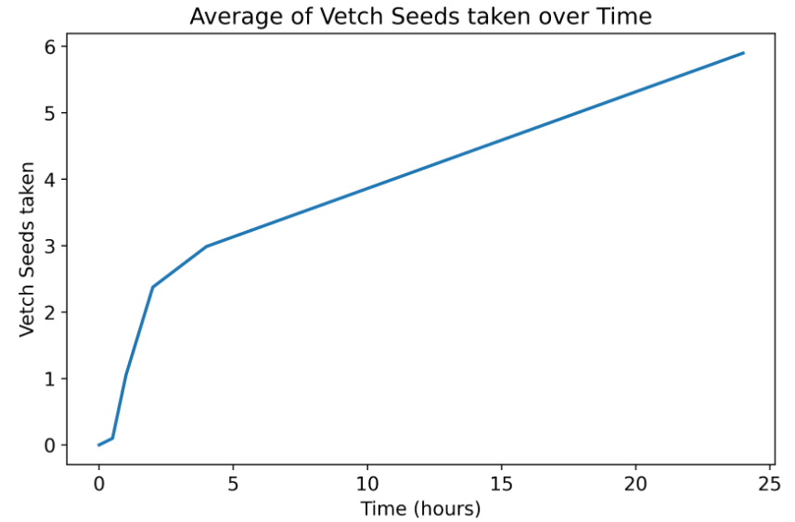

Figure 1. Similar formatting example of survival analysis with one of the five seed varieties.

5. Broader Impacts?

If these preferences trials prove successful, more studies can be conducted by comparing ‘disliked’ seeds with common native seeds to see where the preferences lie in that instance. If native seeds prove to be preferred, this disliked seed could be the standard recommendation to Valley farmer’s who are looking to turn to alternative methods of avoiding harvester ant predation (this will serve well for organic farms who cannot use pesticides against pests ).

6. Methodology

Survival analysis is a time-to-event analysis where time it takes for an event to occur is recorded. In this scenario, time will be documented to see how long until harvester ants remove a seed variety of their choice from the dish. We will see which seed varieties have the highest probability of survival for cover crop recommendation.

The lifelines package on Python will allow us to A Kaplan-Meier plot and a Cox-Proportional Hazards regression are going to be made to see the effect of seed type on survival. We will be able to see comparison of survival rates between the different seeds. Some cages/dishes were compromised in the process of the study during certain trials. Under these circumstances, since the ‘event’ had not yet occurred we will censor (right censoring) that colony within that trial. This censoring is just a confirmation that the removal of the seeds was not due to the event or lack of, just no opportunity to reach that.

Before beginning, the necessary library imports are numPY, pandas, matplotlib.pyplot, and Kaplan-Meier-Fitter (KMF) from lifelines. Excel sheet will be adjustment for ease of use (i.e. convert time to An object is then to be created for the KMF and create a new column named ‘dead’ where 0 = alive and 1 = dead. Every time a seed is taken it will be noted equal to one within that column. Next is to see how long these seeds survived before being taken by ants by seeing how long it took for the dead column to convert from 0 to 1. We will use the KMF.fit(), KMF.predict(), print kmf.survival_function_, and then plot the data using KMF.plot and matplotlib.pyplot. Then obtain the confidence intervals to add to the plots and properly compare seed type survivability to one another. As for the Cox proportional hazards model is similar but instead apply all of the related columns (so seed varieties, time, and dead column) and create an object equal to CoxPHFitter(), then apply .fit, .print_summary, and .predict_survival_function().plot.

7. Timeline

April 4th - 9th, 2021: Complete and submit proposal. Search for aid in using Jupyter Notebook to run analysis. Write down methodology to run a survival analysis using Python via the lifelines package.

April 12th -16th, 2021: Begin analysis with current preference data on hand, organize to ease process of survival analysis.

April 19th- 23rd, 2021: Complete draft figures and evidence to support or disprove hypothesis. Begin first draft of analysis explanation and its effects.

April 26th- 29th, 2021: Complete final figures, ensure written portion is done properly, insert graphs and reference them properly through out the text.

7. Citations

Davis, J. M., & Parks, T. (n.d.). *Management of the Red Harvester Ant*. 9.

Henke, S. E., & Fair, W. S. (n.d.). *MANAGEMENT OF TEXAS HORNED LIZARDS*. 8.

Hook, A. W., & Porter, S. D. (1990). Destruction of Harvester Ant Colonies by Invading Fire Ants in South-Central Texas (Hymenoptera: Formicidae). *The Southwestern Naturalist*, *35*(4), 477–478. https://doi.org/10.2307/3672056

Johnson, R. A. (2001). Biogeography and Community Structure of North American Seed-Harvester Ants. *Annual Review of Entomology*, *46*(1), 1–29. https://doi.org/10.1146/annurev.ento.46.1.1

Reed, H. C., & Landolt, P. J. (2019). Chapter 22—Ants, Wasps, and Bees (Hymenoptera). In G. R. Mullen & L. A. Durden (Eds.), *Medical and Veterinary Entomology (Third Edition)* (pp. 459–488). Academic Press. https://doi.org/10.1016/B978-0-12-814043-7.00022-4

TR;, S. (n.d.). Survival analysis and interpretation Of TIME-TO-EVENT data: The tortoise and the hare. Retrieved April 12, 2021, from https://pubmed.ncbi.nlm.nih.gov/30015653/

Team, T. (2021, March 16). Survival analysis with python tutorial - how, what, when, and why. Retrieved April 12, 2021, from https://pub.towardsai.net/survival-analysis-with-python-tutorial-how-what-when-and-why-19a5cfb3c312?source=friends_link&sk=65c086e2b02ac43b2d577e02141fd56a