**An exploratory analysis of temperature and precipitation trends of the Lower Rio Grande Valley, Texas**

**Paola Granados**

Abstract

Global climate change anticipates the increase in frequency and duration of extreme weather events. Although several models have been proposed to study global climate change, no studies have been performed to evaluate whether significant changes in temperature and precipitation have occurred in the Lower Rio Grande Valley. This study aims to analyze precipitation and temperature trends in McAllen, TX and Brownsville, TX using statistical analysis in Python and weather date from NOAA weather stations. Future projections of temperature and precipitation will be performed, as well as analysis of frequency of extreme weather events. Results of this study will provide information to regional city officials to better mitigate for future extreme weather events.

Background

While there has been numerous amounts of research done to model, quantify, and visualize temperature and precipitation changes due to global climate change, there is limited information and analysis done on how these climate changes are occurring at the local level. In addition, due to global climate change there is an expected increase in the amount and frequency of extreme weather events. Temperature extremes pose a greater ecological risk to many species than mean warming, and can impact human systems through impacts on health as well as energy consumption (Sheridan & Lee, 2018).

Understanding the extent to which the Rio Grande Valley region will see changes in weather and extreme events is critical to better prepare for these events. A study analyzing temperature and precipitation trends in Southeastern US states forecasted Texas to have the greatest decrease in precipitation from states studied (Liu et al., 2012). Changes in temperature and precipitation trends further affect hydrological regimes, regional energy demands, health of humans, agricultural systems, and flooding events. Information gathered by analyzing temperature and precipitation trends can primarily inform local and regional policymakers on local climate change and can help develop strategies to mitigate effects of extreme weather.

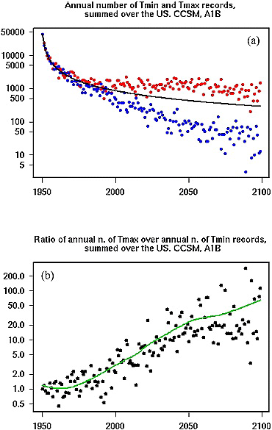

**Figure 1. a) Projected annual numbers of record highs and lows and b) their ratios in the US. observations show that warm extremes are increasing more rapidly than cold extremes, and the ratio of these record high maximum to record low minimum temperatures is projected to increase** (Meehl et al., 2009)

Research Question

In this study, temperature and precipitation data for two sites in the Rio Grande Valley, McAllen, TX and Brownsville, TX, will be analyzed to understand current climate trends and predict future climatological events.

* Does historical precipitation and temperature data for McAllen and Brownsville show an increase?
* Is there an increase in extreme temperature and weather events?

Proposed Methods

Temperature data will be obtained from the National Weather Service (NWS) data portal from which mean monthly temperature data will be downloaded. Daily weather summaries will be downloaded from NOAA’s Climate Data Portal, including average, minimum, maximum temperatures and precipitation data.

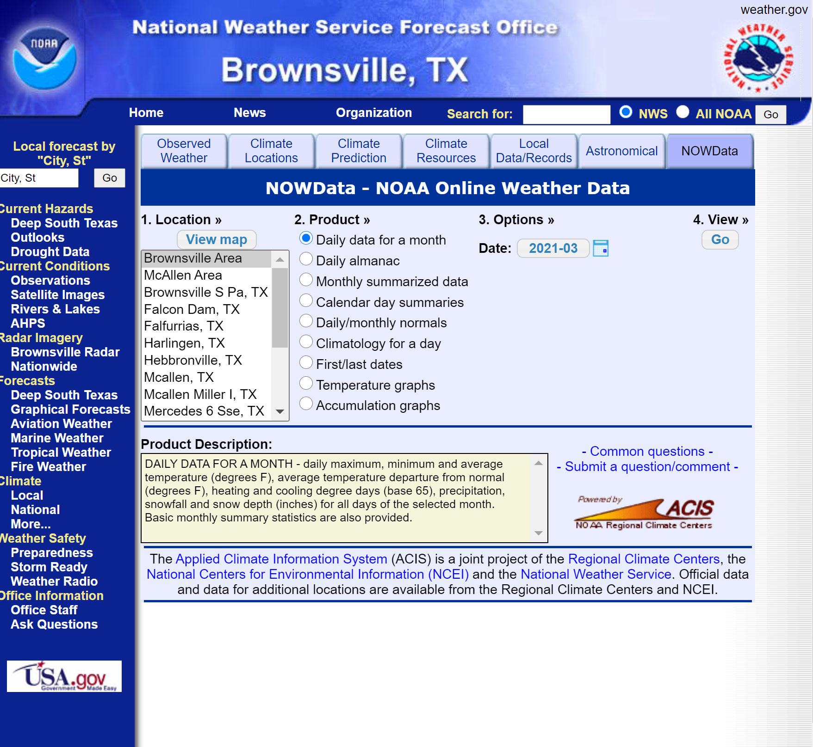

**Figure 2. National Weather Service’s NOW Data Portal**

Analysis of temperature data will include determining if there has been a change in average temperatures over time and further studying this trend. The temperature trend found from observational data will then be used to project likely temperature records for future years using the FB Prophet package in Python. Extreme temperature events will be graphed and fitted to regression models to study the frequency of extreme events. A similar procedure will also be followed for precipitation data.

Timeline

**Table 1. Proposed timeline for research project**

|  |  |  |  |  |  |  |  |  |  |
| --- | --- | --- | --- | --- | --- | --- | --- | --- | --- |
| **Task** | **4/5** | **4/7** | **4/12** | **4/14** | **4/19** | **4/21** | **4/26** | **4/28** | **5/3** |
| Project proposal presentation |  |  |  |  |  |  |  |  |  |
| Download data |  |  |  |  |  |  |  |  |  |
| Data analysis: trends and projections |  |  |  |  |  |  |  |  |  |
| Data analysis: extreme weather events analysis |  |  |  |  |  |  |  |  |  |
| Write final paper |  |  |  |  |  |  |  |  |  |
| Final project presentation |  |  |  |  |  |  |  |  |  |

References

Liu, L., Hong, Y., Hocker, J. E., Shafer, M. A., Carter, L. M., Gourley, J. J., Bednarczyk, C. N., Yong, B., & Adhikari, P. (2012). Analyzing projected changes and trends of temperature and precipitation in the southern USA from 16 downscaled global climate models. *Theoretical and Applied Climatology*, *109*(3), 345–360. https://doi.org/10.1007/s00704-011-0567-9

Meehl, G. A., Tebaldi, C., Walton, G., Easterling, D., & McDaniel, L. (2009). Relative increase of record high maximum temperatures compared to record low minimum temperatures in the U.S. *Geophysical Research Letters*, *36*(23). https://doi.org/10.1029/2009GL040736

Sheridan, S. C., & Lee, C. C. (2018). Temporal Trends in Absolute and Relative Extreme Temperature Events Across North America. *Journal of Geophysical Research: Atmospheres*, *123*(21), 11,889-11,898. https://doi.org/10.1029/2018JD029150