Low Level Design (SEARCH EXPENSE cODE MODULE)

|  |  |
| --- | --- |
| **Project Code** | Group 3 |
| **Project Name** | Expense Management System |

|  |  |  |
| --- | --- | --- |
| **Prepared/Modified by** | **Role** | **Date of Preparation** |
| Group 3 | Senior Analysts | 31/10/2019 |
| **Reviewed by** | **Role** | **Date of Review** |
|  |  |  |
| **Approved by** | **Role** | **Date of Approval** |
|  |  |  |
| **Circulation List** |  | **Version Number of the template:1.0** |
| **Version Number** | 1.0 |  |

Table of Contents

1. Description Of The Unit 3

2. References 4

3. Dependencies / Assumptions 5

4. Class Diagrams 6

5. Sequence Diagrams 7

6. Design Components 8

6.1 List Of UI Components 8

6.2 List Of Design Classes 8

7. Re-Usable Routines/Components 9

8. Messages 10

9. Configuration Files 11

10. Crud Matrix Table 12

11. Data Mapping Matrix 13

12. Action Flow Matrix 14

13. Stored Procedures 15

14. Program Specification / Pseudo Code 16

REVISION HISTORY OF THE WORK PRODUCT 17

# Description Of The Unit

The search module is used by users to get the expense details. The user can be an employee. This module searches for the expenses and displays it on the main screen.

# References

| **Reference** | **Description** |
| --- | --- |
| Repository reference | https://github.com/chshekhar13/spring-plp-with-service.git |
| Class Diagram |  |
| URS |  |
| UTP |  |
| DB Design | ExpenseCodeModule/src/main/resources/MySQL Script |

# Dependencies / Assumptions

**Assumptions:**

Database should have the details of that expense stored in it.

Expense Code is auto incremented on adding of new expense.

# Class Diagrams

[Class Diagram](../../HLD/Class%20Diagrams/Class%20Diagrams)

# Sequence Diagrams

|  |
| --- |
| **Sequence Diagram** |
| NA |

# Design Components

## List Of UI Components

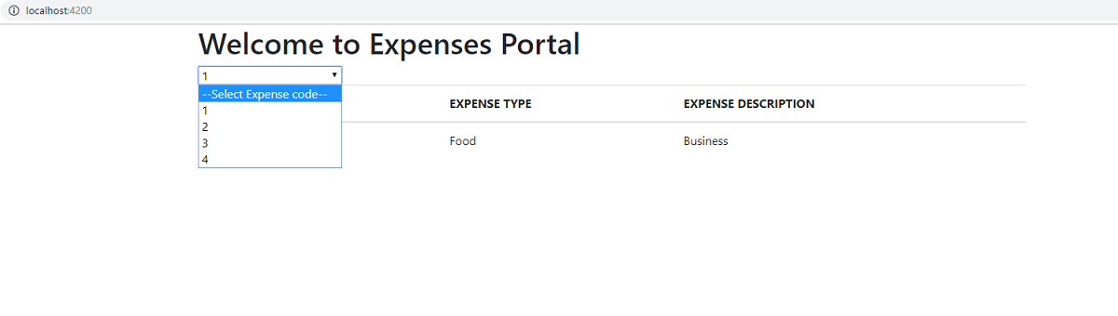

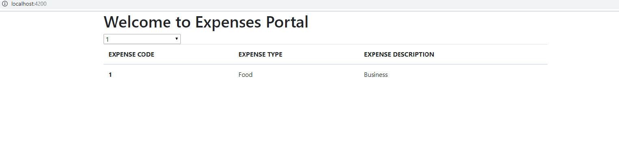

## List Of Design Classes

|  |  |  |  |  |
| --- | --- | --- | --- | --- |
| **Sr. No.** | **LLD Name** | **Class Name** | **Method Name** | **Method Description** |
| 1 | Search Module | ExpenseCodeModule (Java Bean) | Appropriate getters and setters methods | Getters retrieve the property values and setters set the property values |
| 2 | Search Module | ExpensesController | displayById(@PathVariable("id") int id)  : Optional<ExpenseCodeModule> | Searches the details of expense code entered in a text box. |
| 4 | Search Module | ExpenseCodeModuleServiceImpl | displayById(int id)  : Optional<ExpenseCodeModule> | Gets expense details and returns it to controller |
| 5 | Search Module | ExpenseDao extends CrudRepository | findById(id)  : Optional<ExpenseCodeModule> | Gets expense details and returns it to service |

# Re-Usable Routines/Components

Re-Usable Routines/Components

* DataAccessException class : ExpenseDetailsNotFound
* Database properties files

# Messages

|  |  |  |
| --- | --- | --- |
| **#.** | **Type** | **Message Text** |
| NA | NA | NA |

# Configuration Files

|  |  |  |
| --- | --- | --- |
| File Name | Path | Description |
| application.properties | ExpenseCodeModule/src/main/resources/application.properties | To configure database connection. |
| pom.xml | ExpenseCodeModule/pom.xml | To configure the dependancies. |

# Crud Matrix Table

|  |  |  |  |  |  |
| --- | --- | --- | --- | --- | --- |
| **#** | **Table Name** | **Create** | **Read** | **Update** | **Delete** |
| 1 | expense_details | N | Y | N | N |

# Data Mapping Matrix

|  |  |  |  |  |  |  |  |
| --- | --- | --- | --- | --- | --- | --- | --- |
| Sr. No. | Screen Label | Field Source | Field Type | Data Type | Max Length | Data Flow | Mandatory |
| 1 | Search | expense_code | Drop Down List | Varchar2 | 50 | D->UI | NA |

**Legend**

D 🡪 UI (Database to User Interface)

UI 🡪 D (User Interface to Database)

UI (User Interface Only)

# Action Flow Matrix

|  |  |  |  |
| --- | --- | --- | --- |
| **Sr. No.** | **Action** | **Description** | **Process** |
| 1 | On click of  a particular drop down option | Displays expense details | Details of expense of the selected drop down option are displayed on the screen. |

# Stored Procedures

|  |  |  |  |  |
| --- | --- | --- | --- | --- |
| **#** | **Stored Procedure Name**  **(with Description)** | **Input/Out Parameters** | **Type** | **Size** |
| 1. | NA | NA | NA | NA |

# Program Specification / Pseudo Code

**14.1 <ACTION: SEARCH_CLICK>**

**Pseudo Code:**

1. **Client Side Scripting:**

None

1. **Server Side Scripting:**

None

**BEGIN**

Call displayById(@PathVariable("id") int id) in ExpensesController class in Presentation Layer

**BEGIN**

Call findById() in CrudRepository class.

**END**

Return to Presentation Layer

**END**

REVISION HISTORY OF THE WORK PRODUCT

|  |  |  |  |  |  |
| --- | --- | --- | --- | --- | --- |
| # | Date | Version # | Section Changed | Details of changes made | Approved By |
| 1 | 31/10//2019 | 1.0 | NA | NA |  |
| 2 | 01/11/2019 | 1.1 | Controller | Added @CrossOrigin("http://localhost:4200") annotation in controller for angular UI |  |
| 3 | 04/11/2019 | 1.2 | Angular  (Front End). | Search box changed to drop down menu. |  |