=======================================================================

/etc/yum.repos.d/cloudera-manager.repo

=======================================================================

[cloudera-manager]

name = Cloudera Manager, Version 5.8.2

baseurl = https://archive.cloudera.com/cm5/redhat/7/x86_64/cm/5.8.2/

gpgkey = https://archive.cloudera.com/redhat/cdh/RPM-GPG-KEY-cloudera

gpgcheck = 1

=======================================================================

SCM_PREPARE_DATABASE.SH

=======================================================================

sudo /usr/share/cmf/schema/scm_prepare_database.sh mysql amon amon 'ZAQ!zaq112'

sudo /usr/share/cmf/schema/scm_prepare_database.sh mysql rman rman 'ZAQ!zaq112'

sudo /usr/share/cmf/schema/scm_prepare_database.sh mysql metastore hive 'ZAQ!zaq112'

sudo /usr/share/cmf/schema/scm_prepare_database.sh mysql sentry sentry 'ZAQ!zaq112'

sudo /usr/share/cmf/schema/scm_prepare_database.sh mysql nav nav 'ZAQ!zaq112'

sudo /usr/share/cmf/schema/scm_prepare_database.sh mysql navms navms 'ZAQ!zaq112'

mysql> show grants for amon;

+------------------------------------------------+

| Grants for amon@% |

+------------------------------------------------+

| GRANT USAGE ON *.* TO 'amon'@'%' |

| GRANT ALL PRIVILEGES ON `amon`.* TO 'amon'@'%' |

+------------------------------------------------+

2 rows in set (0.00 sec)

mysql> show grants for rman;

+------------------------------------------------+

| Grants for rman@% |

+------------------------------------------------+

| GRANT USAGE ON *.* TO 'rman'@'%' |

| GRANT ALL PRIVILEGES ON `rman`.* TO 'rman'@'%' |

+------------------------------------------------+

2 rows in set (0.00 sec)

mysql> show grants for hive;

+-----------------------------------------------------+

| Grants for hive@% |

+-----------------------------------------------------+

| GRANT USAGE ON *.* TO 'hive'@'%' |

| GRANT ALL PRIVILEGES ON `metastore`.* TO 'hive'@'%' |

+-----------------------------------------------------+

2 rows in set (0.00 sec)

mysql> show grants for sentry;

+----------------------------------------------------+

| Grants for sentry@% |

+----------------------------------------------------+

| GRANT USAGE ON *.* TO 'sentry'@'%' |

| GRANT ALL PRIVILEGES ON `sentry`.* TO 'sentry'@'%' |

+----------------------------------------------------+

2 rows in set (0.00 sec)

mysql> show grants for nav;

+----------------------------------------------+

| Grants for nav@% |

+----------------------------------------------+

| GRANT USAGE ON *.* TO 'nav'@'%' |

| GRANT ALL PRIVILEGES ON `nav`.* TO 'nav'@'%' |

+----------------------------------------------+

2 rows in set (0.00 sec)

mysql> show grants for navms;

+--------------------------------------------------+

| Grants for navms@% |

+--------------------------------------------------+

| GRANT USAGE ON *.* TO 'navms'@'%' |

| GRANT ALL PRIVILEGES ON `navms`.* TO 'navms'@'%' |

+--------------------------------------------------+

2 rows in set (0.01 sec)

=======================================================================

HADOOP CORE

=======================================================================

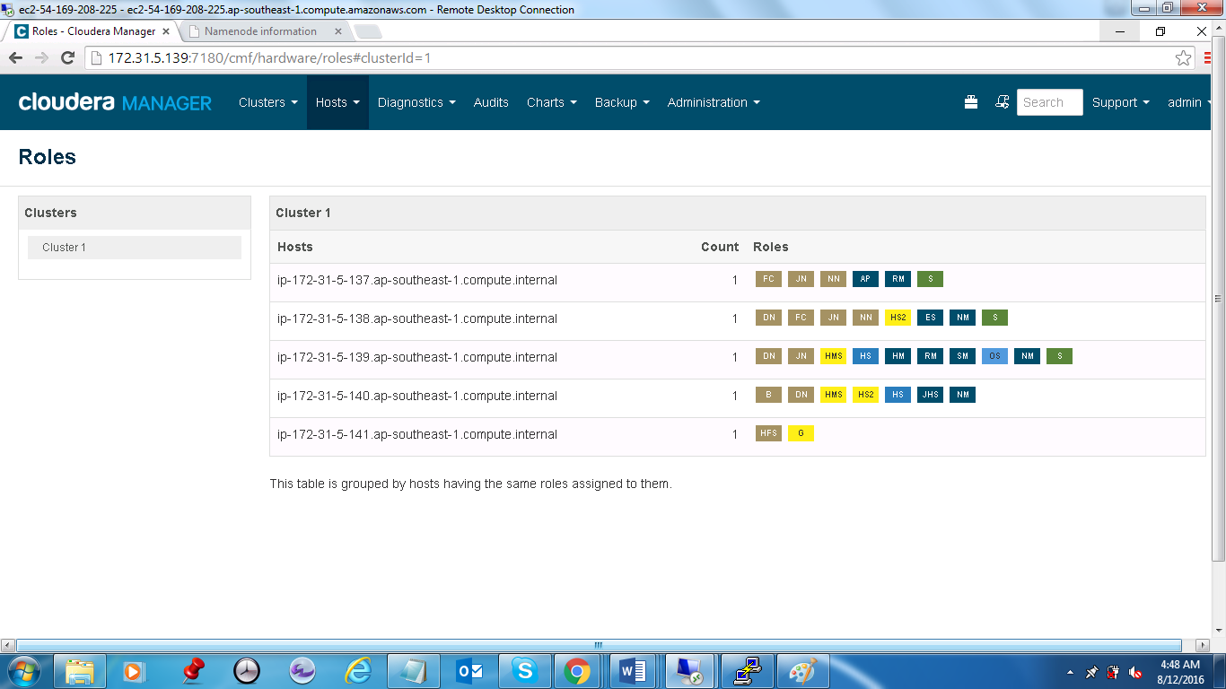

=======================================================================

HADOOP CORE

=======================================================================

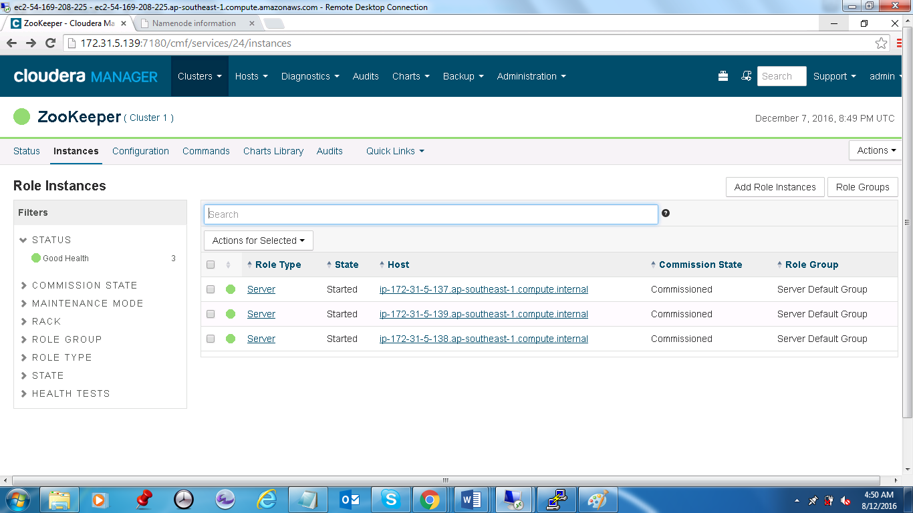

=======================================================================

CLOUDERA IS HEALTHY

=======================================================================

