Suhwan Choi

Advisor: Hongjing Lu, Yujia Peng

June 14, Spring 2019

**The effects of causality on Time perception**

Our causal belief can influence our perception of time (Buehner & Humphreys, 2009). The study by Buehner and Humphreys (2009) used stimulus-anticipation tasks to study the effects of causality on time perception. During the tasks, participants heard two tones, with specific time intervals between them, and participants learned to make responses corresponding to each tone. In causal-control group, making the first response caused the second tone. In the baseline group, the second tones were simply followed by the first tones after the time intervals, so there was no causality involved in the baseline group. The study found that the responses for the second tones were significantly faster in the causal-control group than in the baseline group. According to Buehner and Humphreys (2009), the faster responses of the causal-control group indicated a shortened experience of the time intervals in the case of target stimuli participants themselves had generated. In other words, people perceived an event to be shorter if the event was directly caused by them. Accordingly, causality tested by Buehner and Humphreys was “direct” causal experience, in which participants were directly involved in causing an event. However, the present study explores whether the conclusion of Buehner and Humphreys can generalize to a different kind of causality, by using “indirect” casual experience to study time perception. In fact, by making participants observe causality in videos, the present study showed that indirect causal experience lengthens the experience of time, seemingly in direct contrast to the study by Buehner and Humphreys.

**Method**

**Participant**

Thirty participants were recruited from the Department of Psychology subject pool at the University of California, Los Angeles. Ages of the 30 participants ranged from 17 to 27 (*M* = 20.7, *SD* = 1.97). Twenty four participants were female, and six participants were male. Participants received a participation credit for their psychology courses. The exclusion criterion was that participants had to have normal or corrected-to-normal vision: no participant was excluded.

**Materials**

The present study used action videos filmed with a camera in a gym with a temporal resolution of 30 frames per second (fps). Each video presented a pair of agents performing one of the three throwing-catching actions: bounce pass, chest pass, or underhand throw. In total, there were six action categories, two categories (only male or female agents) for each throwing-catching action. Each action category had two versions: causal and non-causal. The causal version represented causal action: an agent throws a ball to another agent who is facing the thrower. The causal version reflected the natural causal relationship between a thrower and a receiver. The other version represented non-causal action: an agent throws a ball to another agent who is facing away from the thrower. For each video, action category was chosen at random.

Each participant completed 360 test trials. Each trial showed one causal action video and one non-causal action video, with a short time interval between them. Also, for each trial, one video was chosen as a reference video, which was always 1033ms long. Three levels were used in video selection: video-order level, video-reference level, and video-length level. The video-order level had two conditions: causal-first condition (causal videos presented first) and non-causal-first condition (non-causal video presented first). Half of the total trials were randomly assigned to the causal-first condition, and the other half to the non-causal-first condition. The video-reference level had two conditions: causal-reference condition (causal video is a reference) and non-causal-reference condition (non-causal video is a reference). Half of the trials in each video-order level condition were randomly assigned to the causal-reference condition, and the other half were assigned to the non-causal-reference condition (see figure 1). As a result, there were 90 trials for each order-reference combination (see figure 1). The video-length level had nine conditions: from 633ms to 1433ms, increasing by 100ms. The nine video-length conditions were equally distributed among 90 trials in each order-reference combination: there were 10 non-reference videos for each video length. There were 12 practice trials with the random conditions described above.

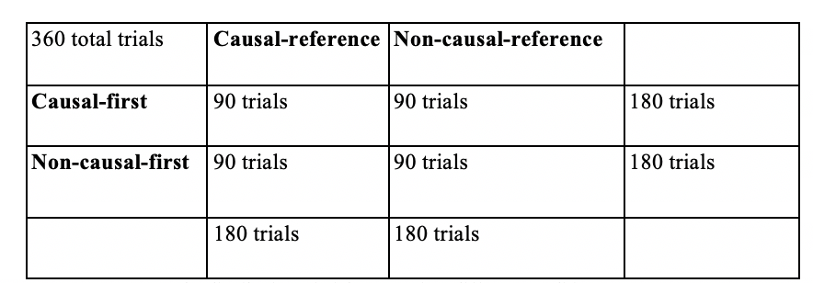

*Figure 1*. The distribution of trials across four different conditions.

**Procedure**

Participants were seated in front of a computer screen in a dark experiment room. They first read the instruction message informing that they would see two videos for each session and that they must choose which video was longer after seeing two videos. In each trial, before first videos, the text “Video 1” was presented on the screen. Likewise, before second videos, the text “Video 2” was presented on the screen. At the end of each trial, after two videos were presented, the instruction message asked, “Which video was longer?”, instructing participants to press a left arrow key if the first video was longer and a right arrow key if the second video was longer. In the practice trials, “correct” or “wrong” message provided immediate feedbacks on the participants’ responses. During the practice trials, experimenters stood next to the participants to check whether the participants understood the instruction correctly. Before the test trials, the participants were instructed to wear a headphone to block out noise.

**Results**

Since there were nine possible video lengths, there were nine conditions for video-length differences between causal and non-causal videos: from -400 ms to 400 ms, increasing by 100 ms (see x-axis on Figure 2). For example, -400 ms indicated that causal videos were 400 ms shorter than non-causal videos. For each video-length difference condition, the proportion of causal videos perceived as longer was calculated. Logistic regression of the proportion on video-length differences provided the point of subjective equality (PSE) (black circle in Figure 2). PSE corresponds to the point at which we perceive causal and non-causal video to be equally long (50 percent chance).

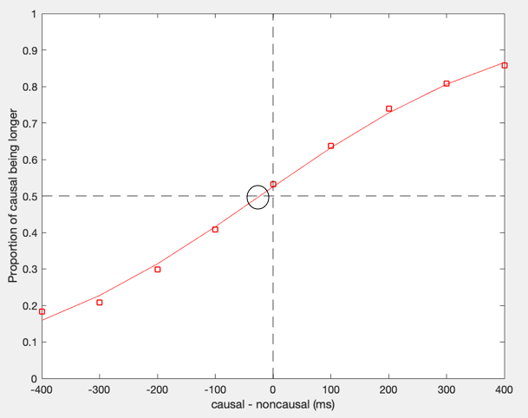

*Figure 2*. The proportion of causal videos perceived as longer at each video-length difference, across all 30 participants. The red line indicates the prediction generated by the regression. The black circle indicates PSE, which corresponds to the point at which the prediction generated by the regression meets the proportion of 0.5. The figure shows the PSE of -25.78ms.

The null hypothesis in the present study was that causality in videos would have no effect on the perceived temporal duration (PSE = 0). One sample t-test was conducted to test the effect of casualty against the null hypothesis. The result showed that the main effect of causal video condition was significant: the obtained PSE values (*M* = -25.78, *SD* = 43.281) were significantly lower than PSE expected from the null hypothesis; *t*(29) = 0.46, *p* = 0.003. When causal videos were on average 25.78ms shorter than non-causal videos, participants perceived causal and non-causal videos as equally long. In other words, when causal and non-causal videos were equally long, causal videos were perceived as longer. Thus, given the significant *p* value (*p* = 0.003), it is reasonable to accept the hypothesis that people are more likely to perceive causal videos as longer than non-causal videos.

**Discussion**

The present study found that causal videos were perceived to be significantly longer than non-causal videos: “time dilation.” The result is seemingly contradictory to the finding of Buehner and Humphreys (2009) that causal experience shortens the experience of time: “time compression.” Highlighting that the nature of causal experience has drastically different effects on time perception, the seemingly contradictory results are consistent with other findings. According to Faro and Hastie (2013), the perception of causality shortens the perceived temporal duration: if an action has caused a subsequent event, the interval between the action and the event is perceived as shorter. The “time compression” might originate from the way we infer causal relations: we are more likely to perceive temporally proximate agents/events as causally related (Faro & Hastie, 2013). However, the experiments reviewed by Faro and Hastie (2013) involved very direct causal experience (e.g. pushing a button causing an object to move), just like the experiment by Buehner and Humphreys (2009). In contrast, the study by Wang and Jiang (2012) demonstrated “time dilation” by generating indirect causal experience. Wang and Jiang (2012) compared participants’ perceived duration of the three different types of stimuli: 1) biological motion of point-light walkers, 2) static point-light walkers, and 3) scrambled version of the biological motion. The biological motion of point-light walkers is causally related motion because movements of individual dots are causally related to one another in terms of biomechanics causally related motion. As a result, they showed that causally related motion lengthened the perceived temporal duration. Yet, it is still not clear what component of causal experience contributes to the difference in time perception.

The two components of causal experience are likely responsible for the difference in time perception: causality and experience. First of all, causality in “time compression” and “time dilation” differs qualitatively. Causality in “time compression” involved very straightforward, obvious representations of cause and effect (e.g. a button press causes specific sound), whereas causality in “time dilation” involved more abstract representation of cause and effect (e.g. moving dots in of point-light walkers and the relationship between a ball thrower and a receiver). Likewise, the quality of experience in “time compression” and “time dilation” differs significantly. In “time compression,” participants are active agents causing an event, so they directly and personally experience causality. In “time dilation,” participants indirectly experience causality by observing causality in videos. Thus, future studies may control the quality of causality and experience to single out the component responsible for the difference in time perception.

Wang and Jiang (2012) used neural energy hypothesis to explain the temporal dilation phenomenon. According to the neural energy hypothesis, subjective temporal duration of external stimuli is correlated with the amount of neural energy encoding the stimuli, especially in the posterior superior temporal sulcus (Wang & Jiang, 2012). In other words, compared to non-causal videos, causal videos might be more “intense” stimuli, producing more neural activities. Using the same videos, the previous study by Yujia Peng showed that causal relations in human actions can induce illusory motion perception. Participants were more likely to perceive causal actions as smooth actions, even when there was a sudden change in receiving actions. In other words, when participants saw causal videos, prior knowledge of causality might fill in the perceptual gaps between image frames, such that the participants subjectively “saw” more image frames than the actual number of frames in causal videos. Thus, according to the neural energy hypothesis and illusory motion perception, seeing causal videos might produce “time dilation” because filling in the perceptual gaps would demand a greater amount of neural energy.

References

Buehner, M. J., & Humphreys, G. R. (2009). Causal binding of actions to their effects.*Psychological Science, 20*(10), 1221-1228. doi:http://dx.doi.org/10.1111/j.1467-9280.2009.02435.x

Chen, Y., & Scholl, B. J. (2016). The perception of history: Seeing causal history in static

shapes induces illusory motion perception. *Psychological Science, 27*(6), 923-930. doi:<http://dx.doi.org/10.1177/0956797616628525>

Faro, D., McGill, A. L., & Hastie, R. (2013). The influence of perceived causation on

judgments of time: an integrative review and implications for decision-making. *Frontiers in psychology*, *4*, 217. doi:10.3389/fpsyg.2013.00217

Wang, L., & Jiang, Y. (2012). Life motion signals lengthen perceived temporal duration.

*PNAS Proceedings of the National Academy of Sciences of the United States of America, 109*(11), e673-e677. doi:<http://dx.doi.org/10.1073/pnas.1115515109>