Suhwan Choi

Research Apprenticeship Report

Advisor: Hongjing Lu, Yujia Peng

March 22, Winter 2019

**Perception of Continuous Movements from Causal Actions**

We can infer causality from what we perceive without conscious efforts. For example, we tend to perceive a bitten cookie as a whole cookie that was bitten (Chen & Scholl, 2016). Moreover, our prior knowledge of causality can exert top-down influence on perception, as Chen and Scholl (2016) showed that causal history from static shapes could generate illusory motion perception. Furthermore, using videos of two agents throwing and receiving a ball, the previous study by Yujia Peng showed that causal relations in human actions can also induce illusory motion perception. If an agent throws a ball to another agent facing the thrower, their action is causally related (causal video). In contrast, if an agent throws a ball to another agent facing away from the thrower, their action is not causally related (non-causal video). According to the study by Yujia Peng, people were more likely to perceive causal actions as smooth actions, even when there was a sudden change in receiving actions. In other words, prior knowledge of causality filled the gaps in motion perception, as if it added the missing image frames in the receiving actions. In fact, if prior knowledge of causality filled the gaps in motion perception like adding more image frames in a video, our prior knowledge of causality may influence time perception. Using causal and non-causal videos from Yujia Peng’s previous experiment, the present study explored the effect of causal relations on time perception.

According to Faro and Hastie (2013), the perception of causality shortens the perceived temporal duration: if an action has caused a subsequent event, the interval between the action and the event is perceived as shorter. The “time compression” might originate from the way we infer causal relations: we are more likely to perceive temporally proximate agents/events as causally related (Faro & Hastie, 2013). However, Wang and Jiang (2012) presented possibly contradictory results. The study by Wang and Jiang (2012) compared participants’ perceived duration of the stimuli: 1) biological motion of point-light walkers, 2) static point-light walkers, and 3) scrambled version of the biological motion. They showed that causally related motion lengthened the perceived temporal duration. The biological motion of point-light walkers is causally related motion because movements of individual dots are causally related to one another in terms of biomechanics. Although the study by Faro and Hastie (2013) was more directly related to causality, the study by Wang and Jiang (2012) might generalize better to the present study. The various studies reviewed by Faro and Hastie (2013) focused on the temporal duration between cause and effect, whereas the study by Wang and Jiang (2012) and the present study focused on the temporal duration of stimuli featuring causal relations. In addition, the studies described by Faro and Hastie (2013) involved obvious, straightforward causality (e.g. pushing a button causing an object to move), whereas the study by Wang and Jiang (2012) and the present study involved prior knowledge of causality (relationship between a thrower and a receiver). Thus, if the study by Wang and Jiang (2012) could generalize to the present study, people would more likely perceive causal videos as longer than non-causal videos.

**Method**

**Participant**

Thirty participants were recruited from the Department of Psychology subject pool at the University of California, Los Angeles. Ages of the 30 participants ranged from 17 to 27 (*M* = 20.7, *SD* = 1.97). Twenty four participants were female, and six participants were male. Participants received a participation credit for their psychology courses. The exclusion criterion was that participants had to have normal or corrected-to-normal vision: no participant was excluded.

**Materials**

The present study used action videos filmed with a camera in a gym with a temporal resolution of 30 frames per second (fps). Each video presented a pair of agents performing one of the three throwing-catching actions: bounce pass, chest pass, or underhand throw. In total, there were six action categories, two categories (only male or female agents) for each throwing-catching action. Each action category had two versions: causal and non-causal. The causal version represented causal action: an agent throws a ball to another agent who is facing the thrower. The causal version reflected the natural causal relationship between a thrower and a receiver. The other version represented non-causal action: an agent throws a ball to another agent who is facing away from the thrower. For each video, action category was chosen at random.

Each participant completed 360 test trials. Each trial showed one causal action video and one non-causal action video, with a short time interval between them. Also, for each trial, one video was chosen as a reference video, which was always 18-frames long. Three levels were used in video selection: video-order level, video-reference level, and frame-number level. The video-order level had two conditions: causal-first condition (causal videos presented first) and non-causal-first condition (non-causal video presented first). Half of the total trials were randomly assigned to the causal-first condition, and the other half to the non-causal-first condition. The video-reference level had two conditions: causal-reference condition (causal video is a reference) and non-causal-reference condition (non-causal video is a reference). Half of the trials in each video-order level condition were randomly assigned to the causal-reference condition, and the other half were assigned to the non-causal-reference condition (see figure 1). The frame-number level had nine conditions: from 6 frames to 30 frames, each condition increasing by 3 frames. There were 90 trials for each order-reference combination (see figure 1). The nine frame-number conditions were equally distributed among 90 trials in each order-reference combination. There were 12 practice trials with the random conditions described above.

|  |  |  |  |
| --- | --- | --- | --- |
| 360 total trials | **Causal-reference** | **Non-causal-reference** |  |
| **Causal-first** | 90 trials | 90 trials | 180 trials |
| **Non-causal-first** | 90 trials | 90 trials | 180 trials |
|  | 180 trials | 180 trials |  |

*Figure 1*. The distribution of trials across four different conditions.

**Procedure**

Participants were seated in front of a computer screen in a dark experiment room. They first read the instruction message informing that they would see two videos for each session and that they must choose which video was longer after seeing two videos. In each trial, before first videos, the text “Video 1” was presented on the screen. Likewise, before second videos, the text “Video 2” was presented on the screen. At the end of each trial, after two videos were presented, the instruction message asked, “Which video was longer?”, instructing participants to press a left arrow key if the first video was longer and a right arrow key if the second video was longer. In the practice trials, “correct” or “wrong” message provided immediate feedbacks on the participants’ responses. During the practice trials, experimenters stood next to the participants to check whether the participants understood the instruction correctly. Before the test trials, the participants were instructed to wear a headphone to block out noise.

Since there were nine possible video frames, there were nine conditions for video-length differences between causal and non-causal videos: from -400 ms to 400 ms, increasing by 100 ms (see x-axis on Figure 2). For example, -400 ms indicated that causal videos were 400 ms shorter than non-causal videos. For each video-length difference condition, the proportion of causal videos perceived as longer was calculated. The regression of the proportion on video-length differences provided the point of subjective equality (PSE) (see Figure 2). At the video-length difference corresponding to PSE, it expected that perceived temporal durations for causal and non-causal videos are subjectively equal.

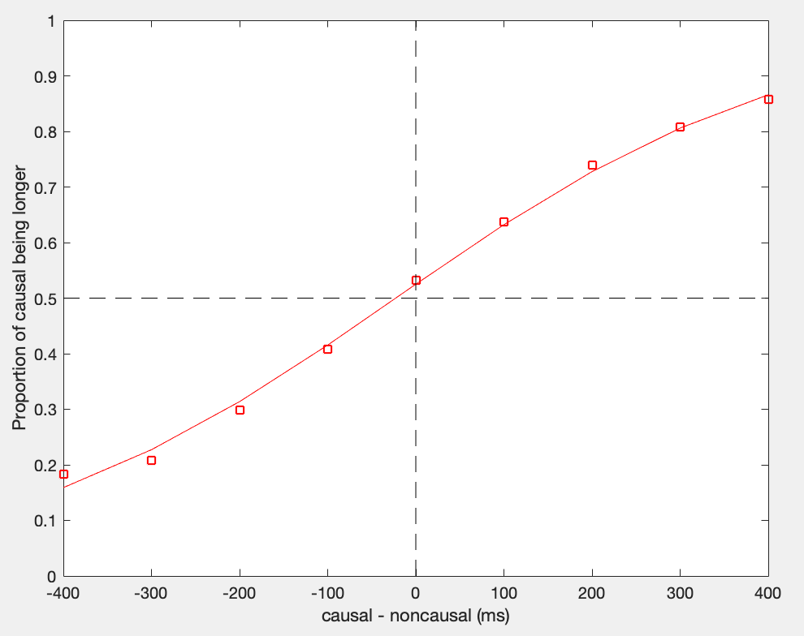

*Figure 2*. The proportion of causal videos perceived as longer at each video-length difference, across all 30 participants. The red line indicates the prediction generated by the regression. PSE corresponds to the point at which the prediction generated by the regression meets the proportion of 0.5.

**Results**

The null hypothesis in the present study was that causality in videos would have no effect on the perceived temporal duration (PSE = 0). One sample t-test was conducted to test the effect of casualty against the null hypothesis. The result showed that the main effect of causal video condition was significant: the obtained PSE values (*M* = -25.78, *SD* = 43.281) were significantly lower than PSE expected from the null hypothesis; *t*(29) = 0.46, *p* = 0.003. When causal videos were on average 25.78 ms shorter than non-causal videos, participants perceived causal and non-causal videos as equally long. In other words, when causal and non-causal videos were equally long, causal videos were perceived as longer. Thus, given the significant *p* value (*p* = 0.003), it is reasonable to accept the hypothesis that people are more likely to perceive causal videos as longer than non-causal videos.

Moreover, to explore the effects of video-order and video-reference levels on PSE, paired-samples t-tests were conducted to 1) compare PSE in causal-first and non-causal-first conditions and 2) compare PSE in causal-reference and non-causal-reference conditions. There was no significant difference in the PSE for causal-first (*M* = -9.288, *SD* = 76.034) and non-causal-first (*M* = -45.711, *SD* = 92.345) conditions; *t*(29) = 1.400, *p* = 0.172. Thus, the result suggests that the presentation order did not have any significant effect on perceived temporal duration. On the other hand, there was a significant difference in the PSE for causal-reference (*M* = -72.095, *SD* = 45.884) and non-causal-reference (*M* = 17.660, *SD* = 68.658) conditions; *t*(29) = -6.141, *p* <.001. The result suggests that the type of reference videos had a significant effect on perceived temporal duration. Specifically, when causal videos were references, causal videos were on average perceived as longer than non-causal videos.

**Discussion**

Consistent with the study by Wang and Jiang (2012), the present study found that causal videos were perceived as significantly longer than non-causal videos. Wang and Jiang (2012) used neural energy hypothesis to explain such temporal dilation phenomenon. According to the neural energy hypothesis, subjective temporal duration of external stimuli is correlated with the amount of neural energy encoding the stimuli, especially in the posterior superior temporal sulcus (Wang & Jiang, 2012). In other words, compared to non-causal videos, causal videos might be more “intense” stimuli, producing more neural activities. As the previous study by Yujia Peng has shown, prior knowledge of causality can fill in perceptual gaps in motion perception. It is possible that cognitive processes of filling in perceptual gaps also applied to the present study. In other words, when participants saw causal videos, prior knowledge of causality might fill in the perceptual gaps between image frames, such that the participants subjectively “saw” more image frames than the actual number of frames in causal videos (given that mental frame-reading rate was constant). Thus, because filling in the perceptual gaps would demand a greater amount of neural energy, seeing causal videos would produce increased perceived temporal duration.

However, the significant main effect (*p* <.001) of the causal-reference condition might be applying bias to the main effect (*p* = 0.003) of the causal video condition. Because all reference videos were 18-frames long, all PSE were measured with respect to only 18 frames. It is possible that different reference frame-numbers can produce significantly different PSE. Accordingly, future studies can use all nine frame-numbers (from 6 frames to 30 frames) as reference frame-numbers, in order to obtain PSE from video-length differences calculated at different references. Introducing multiple reference frame-numbers will reduce possible bias of 18-frames reference videos and more accurately demonstrate the effect of causal videos on 4PSE.

References

Chen, Y., & Scholl, B. J. (2016). The perception of history: Seeing causal history in static

shapes induces illusory motion perception. *Psychological Science, 27*(6), 923-930. doi:<http://dx.doi.org/10.1177/0956797616628525>

Faro, D., McGill, A. L., & Hastie, R. (2013). The influence of perceived causation on

judgments of time: an integrative review and implications for decision-making. *Frontiers in psychology*, *4*, 217. doi:10.3389/fpsyg.2013.00217

Wang, L., & Jiang, Y. (2012). Life motion signals lengthen perceived temporal duration.

*PNAS Proceedings of the National Academy of Sciences of the United States of America, 109*(11), e673-e677. doi:<http://dx.doi.org/10.1073/pnas.1115515109>