Task 1a
Inputs
- Month to search for
Processes
- Calculate the total number of orders collected and delivered
- Work out which customer gave the 1st 5 star rating

Task 1b
2. IN Orders()
3. IN Position

Task 1d
Month searched | Nov

orderNum | position | If current month is equal to searched month and current rating is 5
Ord165 | -1 | False
Ord166 | -1 | False
Ord167 | -1 | False
Ord168 | 3 | True

Task 1e
My program used a single function to count deliveries and collection. However, you could return both values from a single function and only run the function once, saving on traversing the array twice.
The array would need to be increased in size and all of the loops adjusted to either take account of the new length. The number of enties could be calculated when the file is read and passed to the other parts of the program.

Task 2

Task 2a
A query to calculate the total value of the comics featuring a specific main character
A query to calculate the average value of the comics

Task 2b
One comic would have many characters, so this would be needed to stop data duplication.

Task 2c
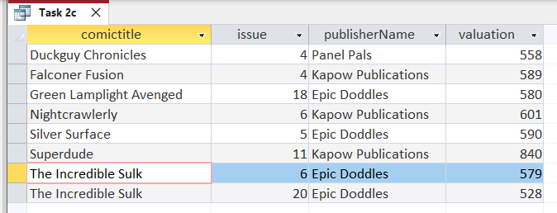
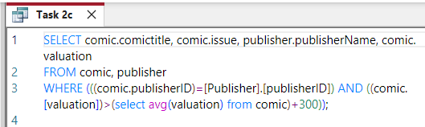
New version of Access changed the code when I accidently clicked on design.

Access version used for next tasks


Task 2d
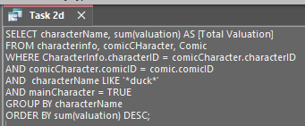
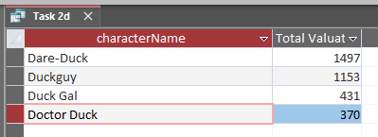

Task 2e
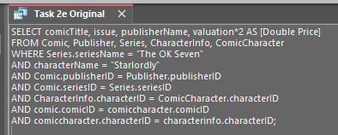
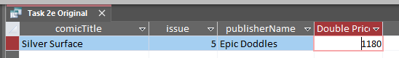

Task 2fi
- A query to calculate how much a comic has increased in value since it was purchased

Task 2fii
You would need to store the purchase price of the comic, this could be added to the comic table

Task 3

Task 3a
- A form to allow entry of an enquiry
- Javascript to allow the hiding and showing of the correct record score

Task 3b

