1. How to use include, exclude methods, parallel attribute?

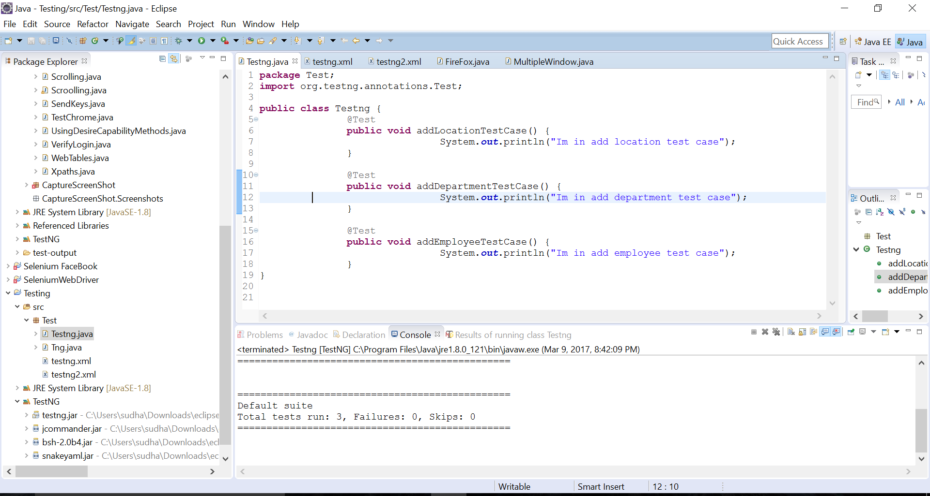

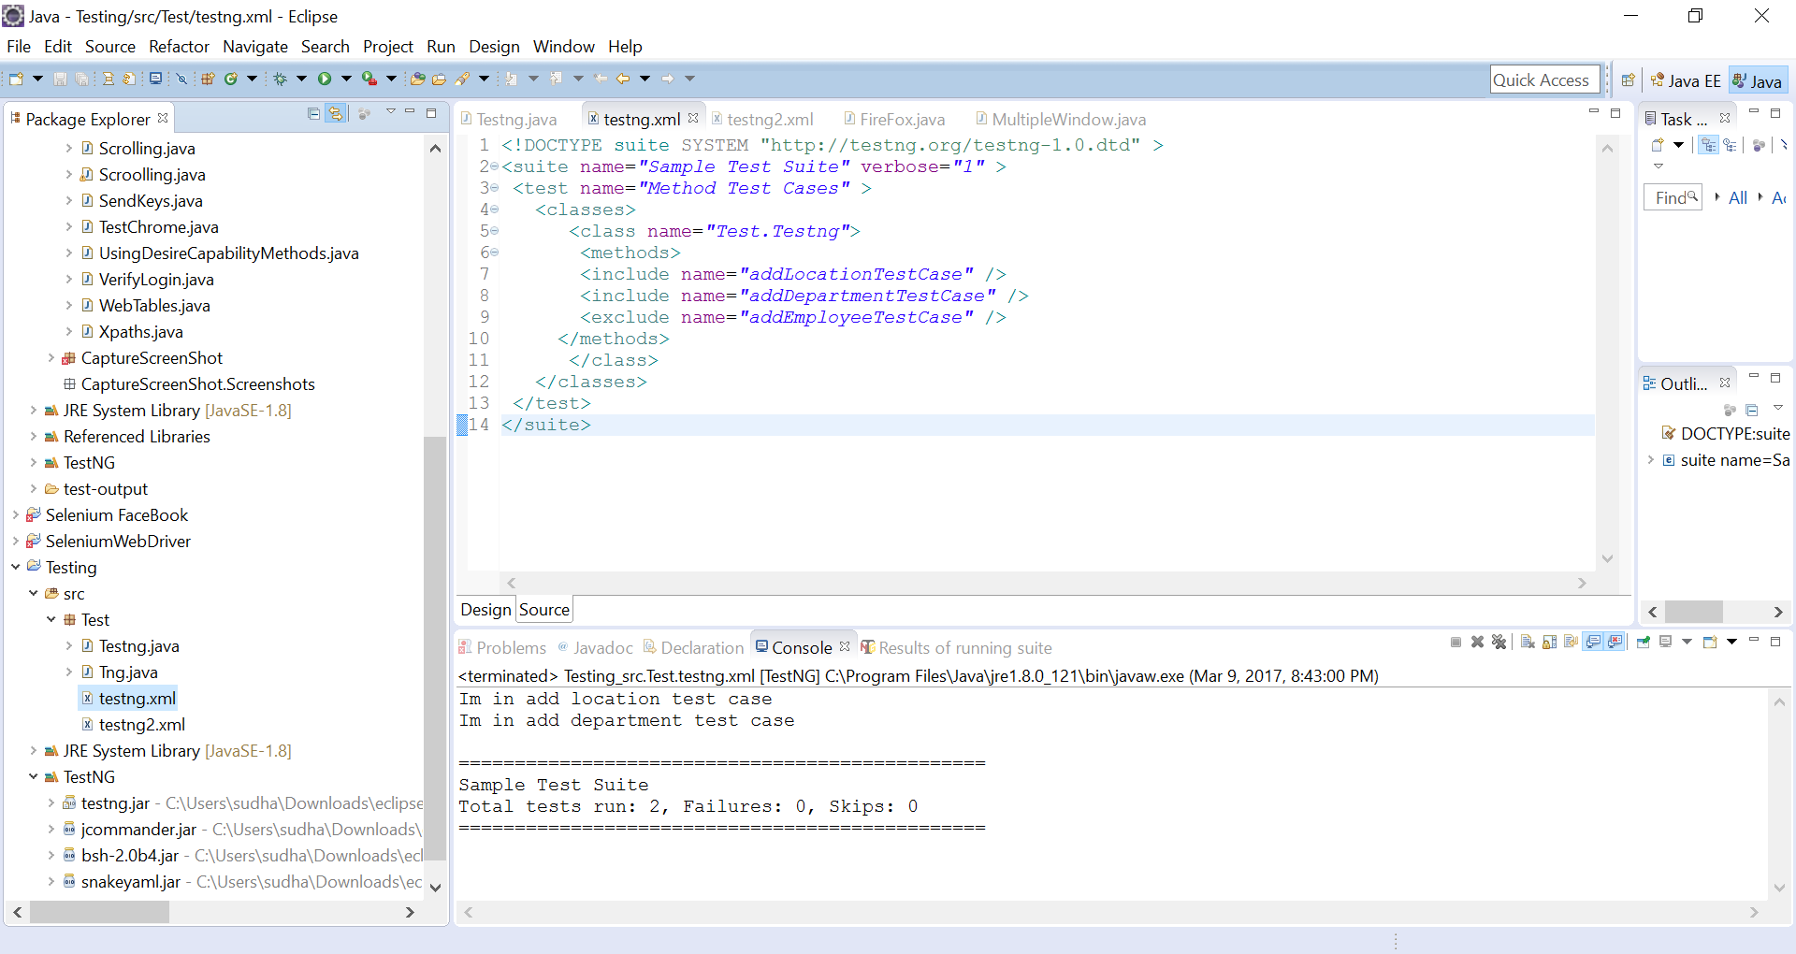

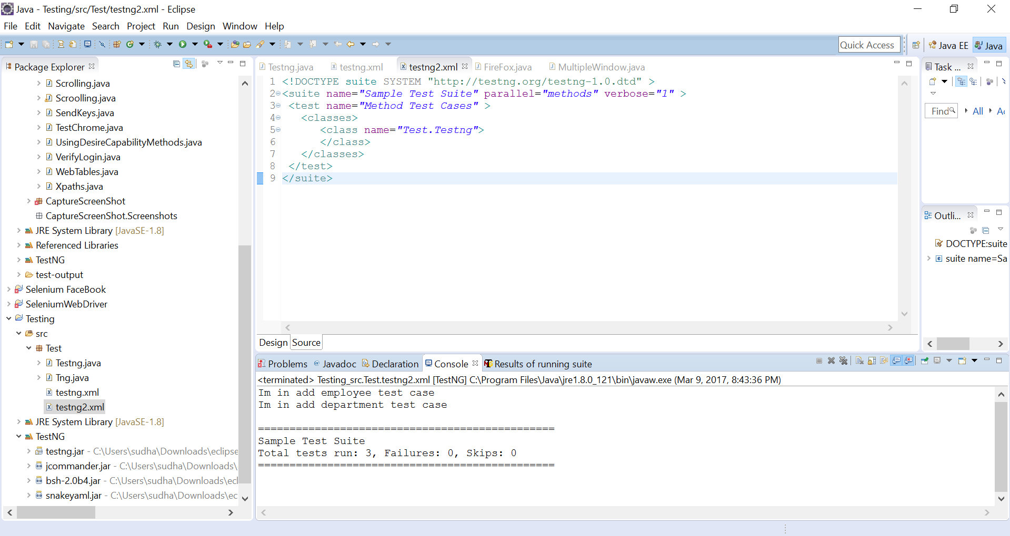

1. Configure Testng in eclipse

In Eclipse go to help -> Click on Eclipse market place -> Go to find-> Type “TestNG”->click on Go->Install

1. Beforeclass, Beforetest, Test, Dataprovider, afterclass, aftertest, beforesuite, aftersuite, parameters

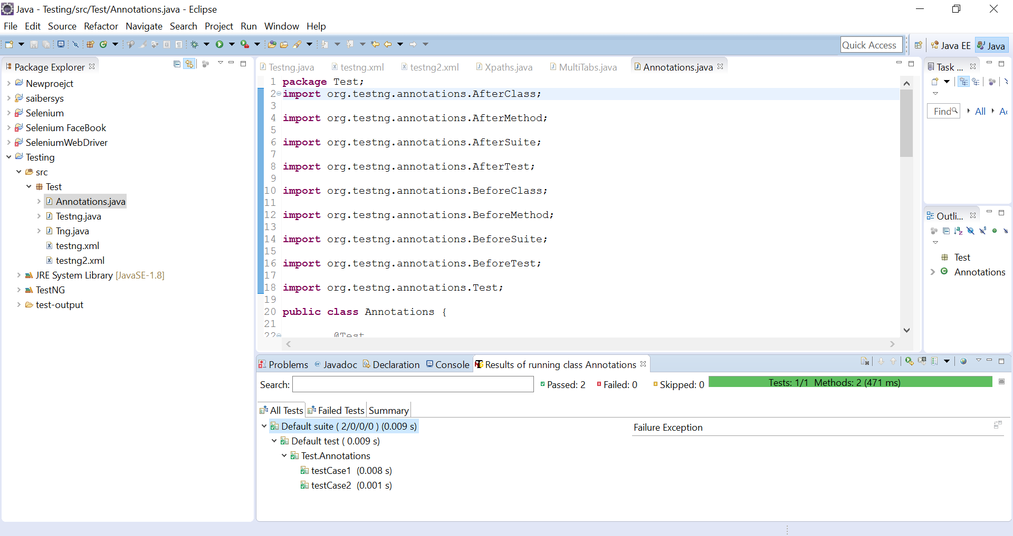

**package** Test;

**import** org.testng.annotations.AfterClass;

**import** org.testng.annotations.AfterMethod;

**import** org.testng.annotations.AfterSuite;

**import** org.testng.annotations.AfterTest;

**import** org.testng.annotations.BeforeClass;

**import** org.testng.annotations.BeforeMethod;

**import** org.testng.annotations.BeforeSuite;

**import** org.testng.annotations.BeforeTest;

**import** org.testng.annotations.Test;

**public** **class** Annotations {

@Test

**public** **void** testCase1() {

System.***out***.println("This is the Test Case 1");

}

@Test

**public** **void** testCase2() {

System.***out***.println("This is the Test Case 2");

}

@BeforeMethod

**public** **void** beforeMethod() {

System.***out***.println("This will execute before every Method");

}

@AfterMethod

**public** **void** afterMethod() {

System.***out***.println("This will execute after every Method");

}

@BeforeClass

**public** **void** beforeClass() {

System.***out***.println("This will execute before the Class");

}

@AfterClass

**public** **void** afterClass() {

System.***out***.println("This will execute after the Class");

}

@BeforeTest

**public** **void** beforeTest() {

System.***out***.println("This will execute before the Test");

}

@AfterTest

**public** **void** afterTest() {

System.***out***.println("This will execute after the Test");

}

@BeforeSuite

**public** **void** beforeSuite() {

System.***out***.println("This will execute before the Test Suite");

}

@AfterSuite

**public** **void** afterSuite() {

System.***out***.println("This will execute after the Test Suite");

}

}

1. Configure testng.xml for creating test suites, specifying test classes, parameters,

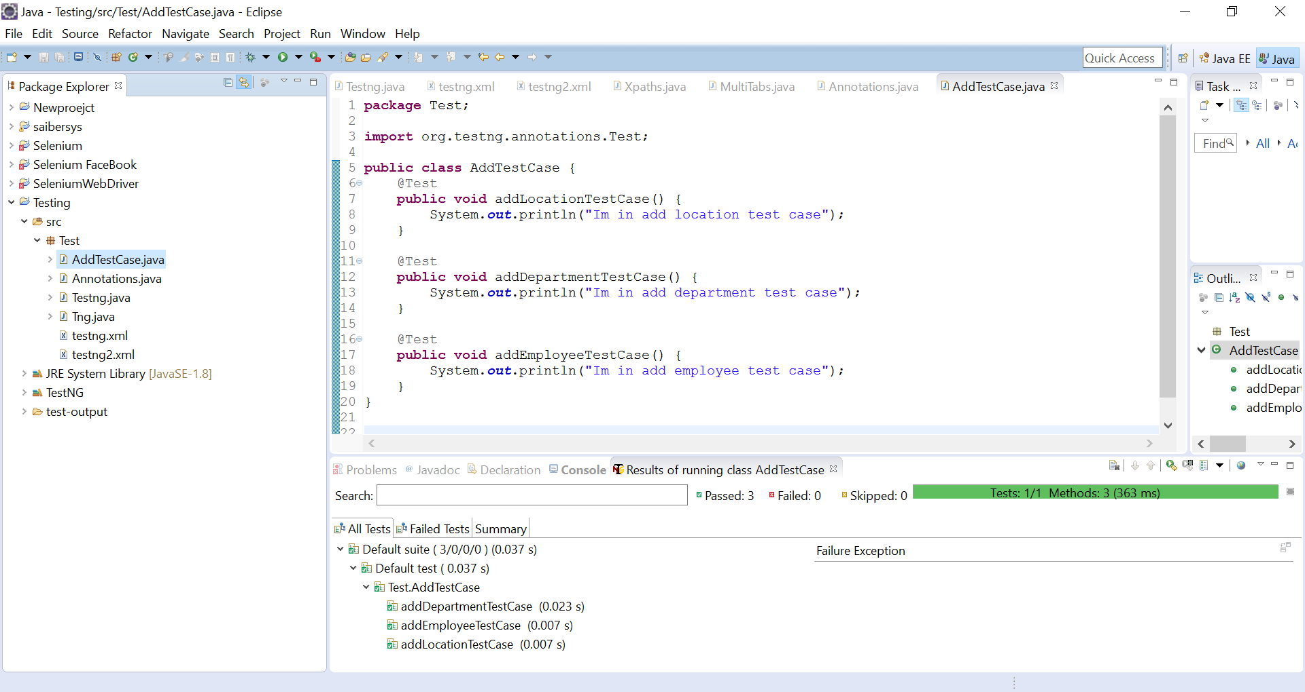

**package** Test;

**import** org.testng.annotations.Test;

**public** **class** AddTestCase {

@Test

**public** **void** addLocationTestCase() {

System.***out***.println("Im in add location test case");

}

@Test

**public** **void** addDepartmentTestCase() {

System.***out***.println("Im in add department test case");

}

@Test

**public** **void** addEmployeeTestCase() {

System.***out***.println("Im in add employee test case");

}

}

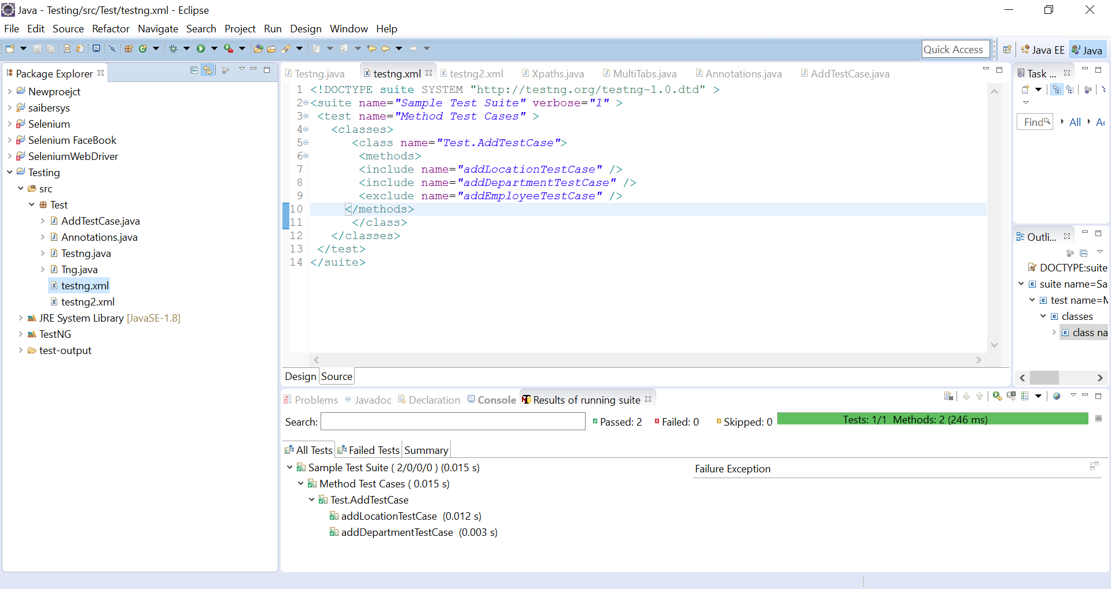

1. Testng reports generation

I have created test reports for the above program. Below are console report and html reports.

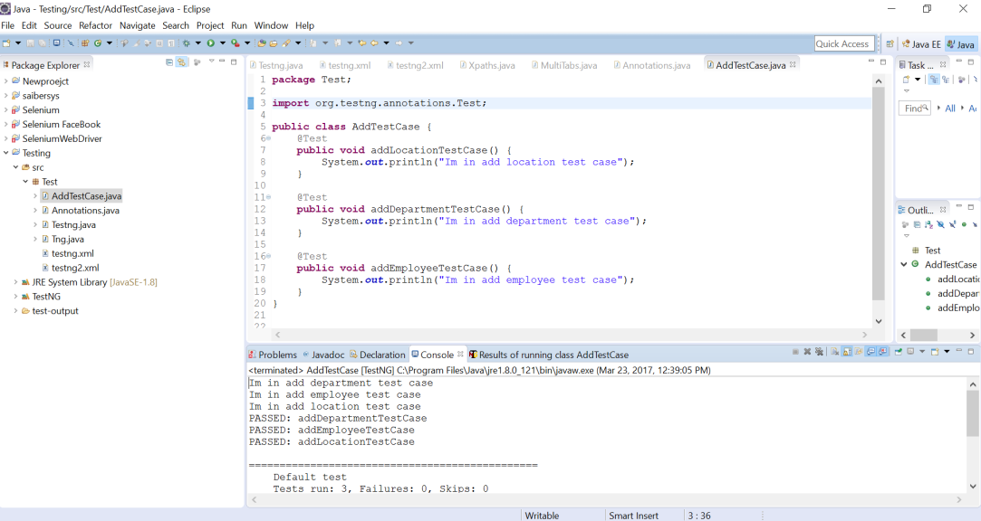

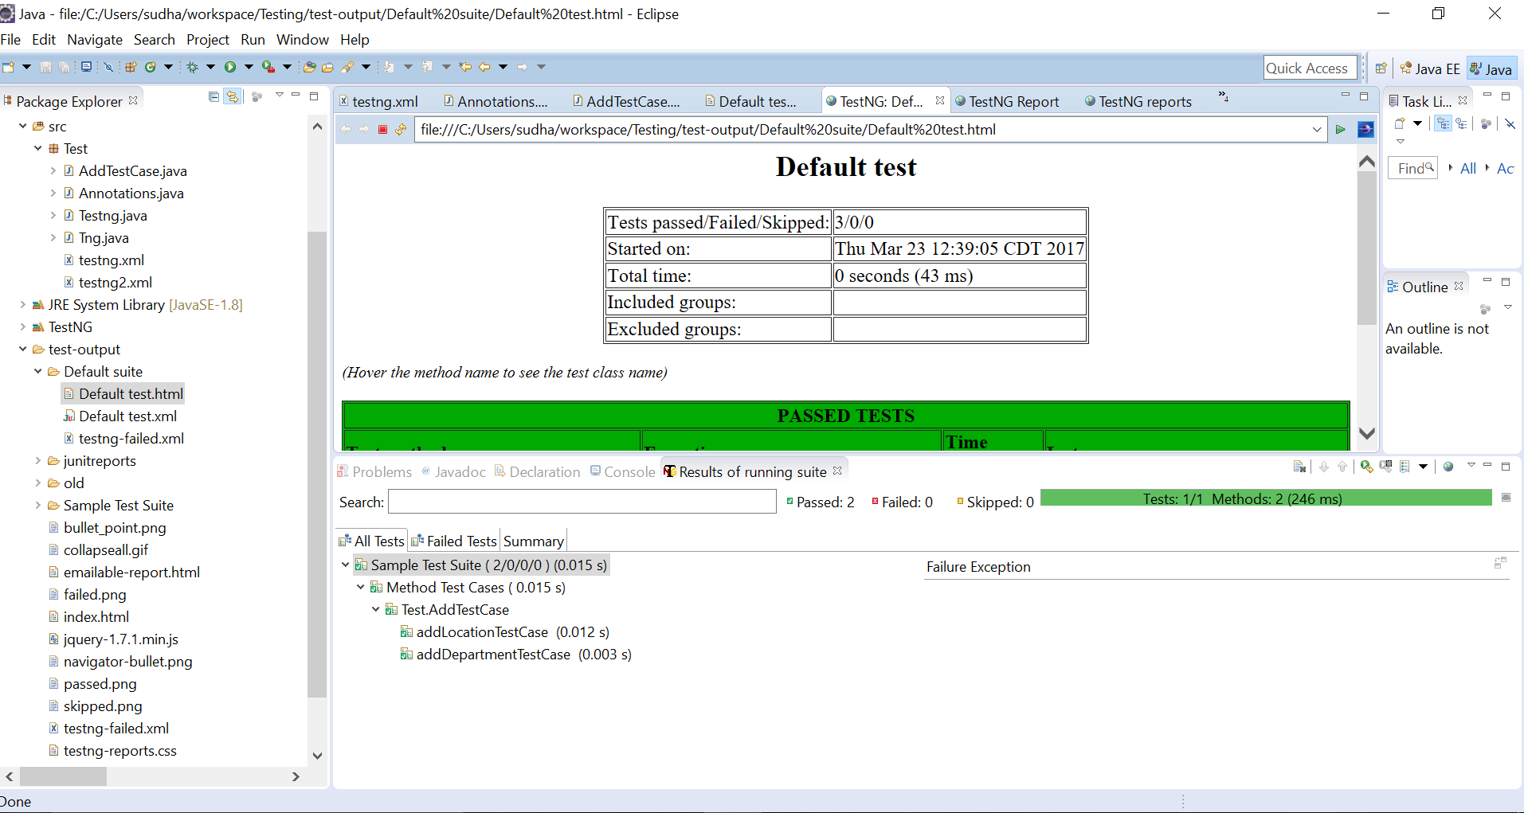

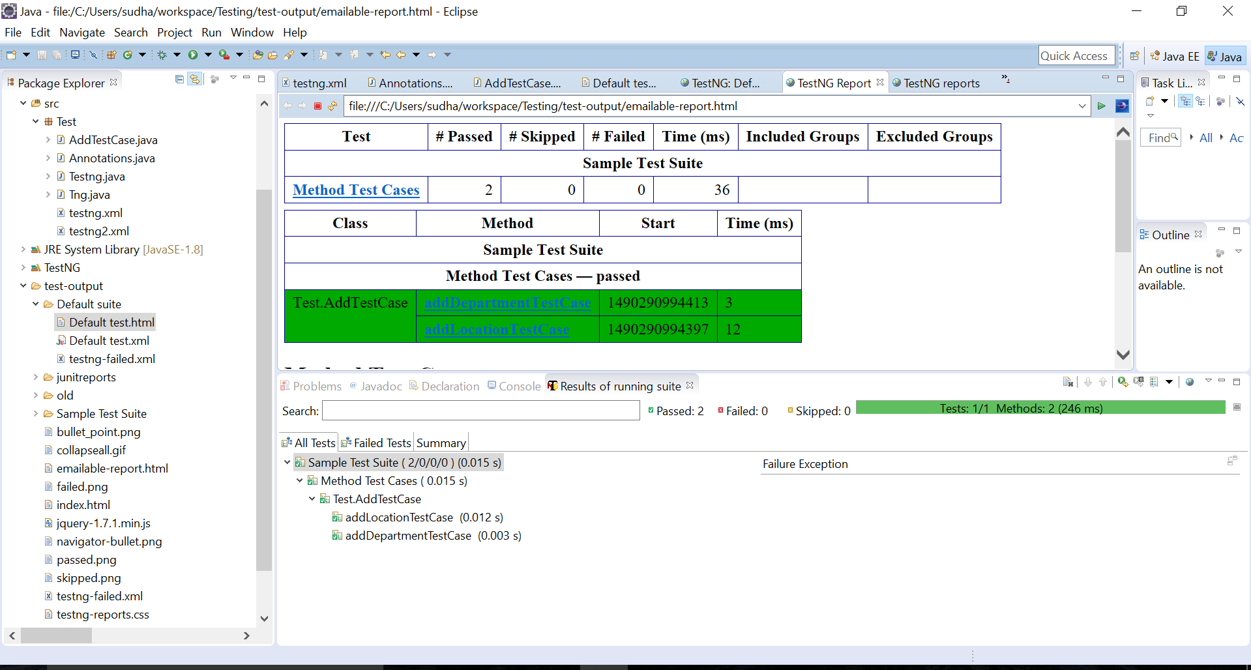

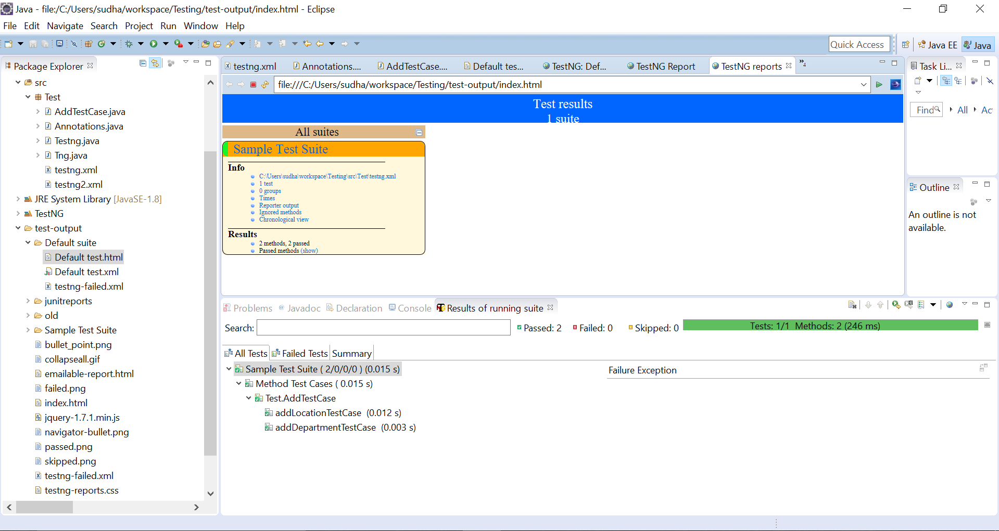

1. Using Listeners for report generation (itestlistener, isuitelistener)

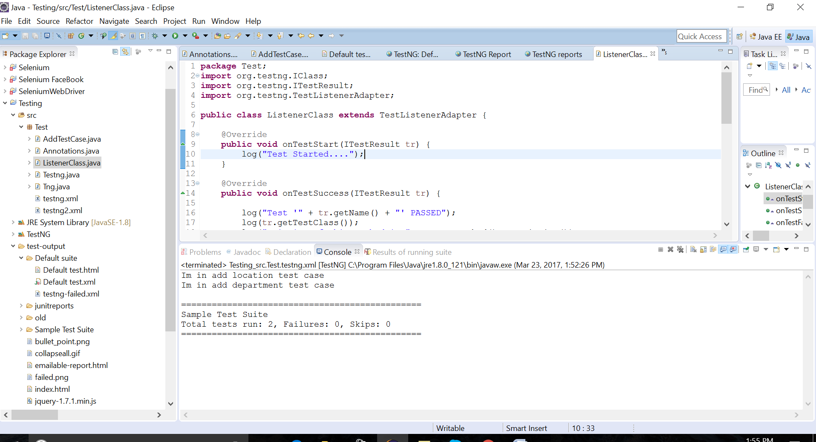

**package** Test;

**import** org.testng.IClass;

**import** org.testng.ITestResult;

**import** org.testng.TestListenerAdapter;

**public** **class** ListenerClass **extends** TestListenerAdapter {

@Override

**public** **void** onTestStart(ITestResult tr) {

log("Test Started....");

}

@Override

**public** **void** onTestSuccess(ITestResult tr) {

log("Test '" + tr.getName() + "' PASSED");

log(tr.getTestClass());

log("Priority of this method is " + tr.getMethod().getPriority());

System.***out***.println(".....");

}

@Override

**public** **void** onTestFailure(ITestResult tr) {

log("Test '" + tr.getName() + "' FAILED");

log("Priority of this method is " + tr.getMethod().getPriority());

System.***out***.println(".....");

}

@Override

**public** **void** onTestSkipped(ITestResult tr) {

log("Test '" + tr.getName() + "' SKIPPED");

System.***out***.println(".....");

}

**private** **void** log(String methodName) {

System.***out***.println(methodName);

}

**private** **void** log(IClass testClass) {

System.***out***.println(testClass);

}

}

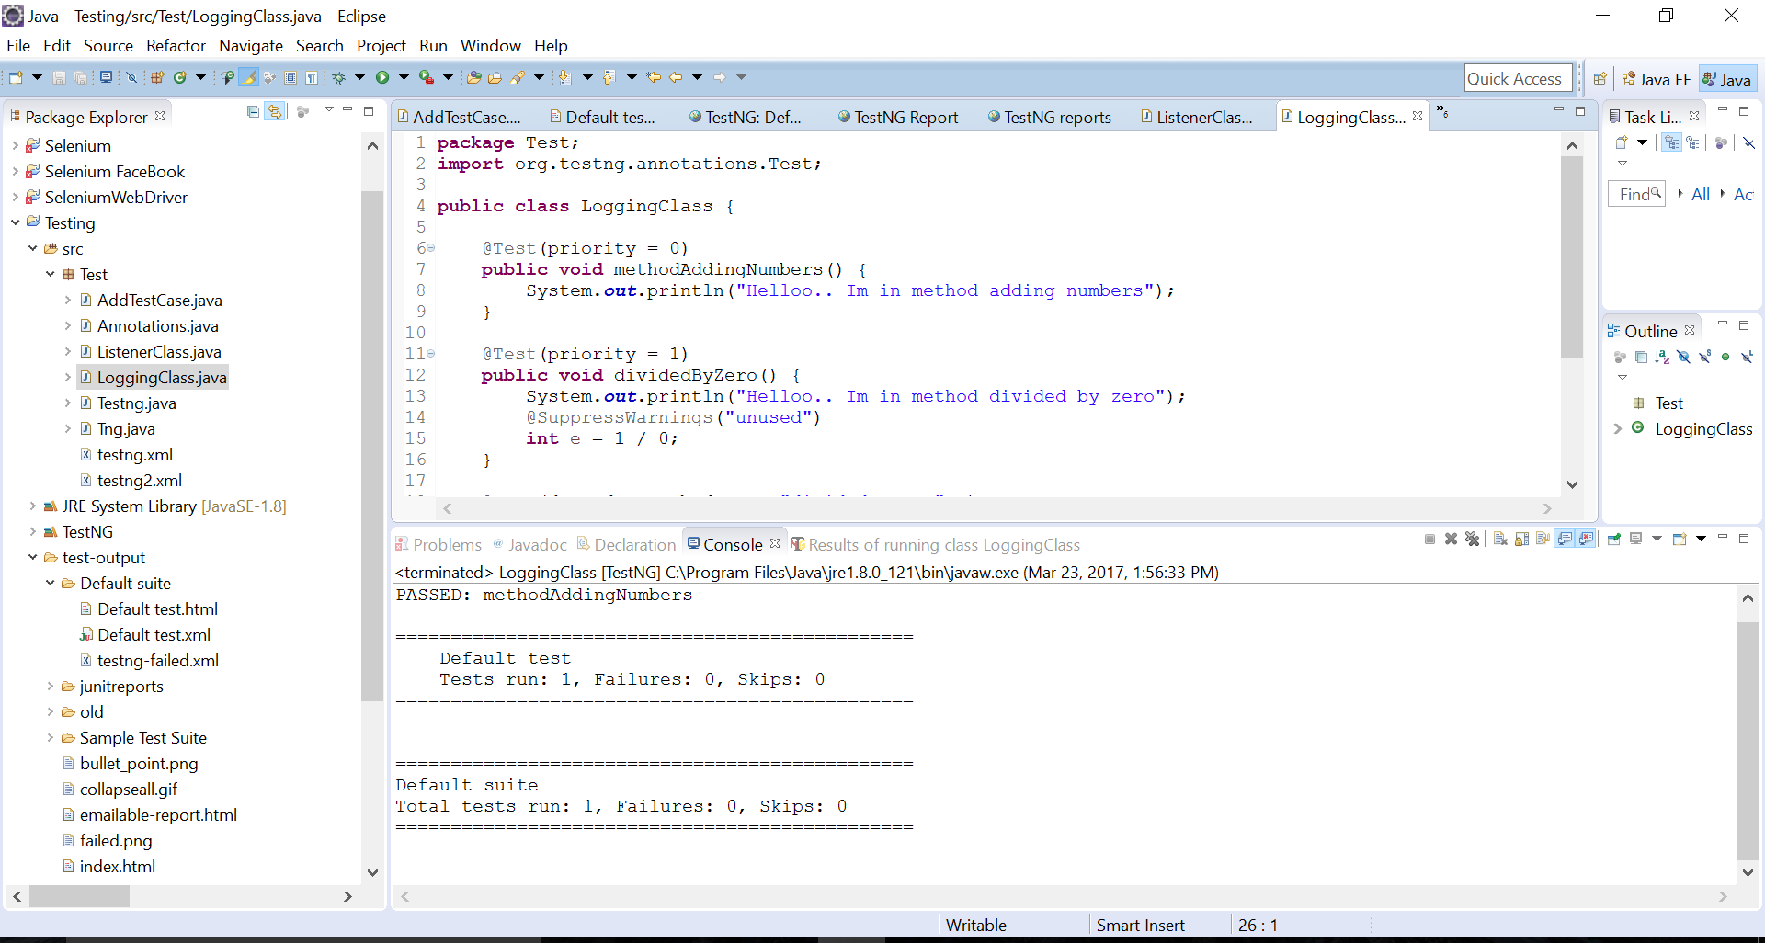

**package** Test;

**import** org.testng.annotations.Test;

**public** **class** LoggingClass {

@Test(priority = 0)

**public** **void** methodAddingNumbers() {

System.***out***.println("Helloo.. Im in method adding numbers");

}

@Test(priority = 1)

**public** **void** dividedByZero() {

System.***out***.println("Helloo.. Im in method divided by zero");

@SuppressWarnings("unused")

**int** e = 1 / 0;

}

@Test(dependsOnMethods = { "dividedByZero" })

**public** **void** methodSkip() {

System.***out***.println("Helloo.. Im in method skip");

}

}

<!DOCTYPE suite SYSTEM "http://testng.org/testng-1.0.dtd" >

<suite name=*"Log Suite Example"* verbose=*"1"*>

<listeners>

<listener class-name=*"Test.ListenerClass"* />

</listeners>

<test name=*"TestNG logs sample"* preserve-order=*"true"*>

<classes>

<class name=*"Test.LoggingClass"*>

<methods>

<include name=*"methodAddingNumbers"* />

<include name=*"dividedByZero"* />

<include name=*"methodSkip"* />

</methods>

</class>

</classes>

</test>

</suite>

1. Page factory

**package** Test;

**import** org.openqa.selenium.WebElement;

**public** **class** GoogleSearchPage {

**private** WebElement q;

**public** **void** searchFor(String text) {

q.sendKeys(text);

q.submit();

}

}

**package** Test;

**import** org.openqa.selenium.WebDriver;

**import** org.openqa.selenium.chrome.ChromeDriver;

**import** org.openqa.selenium.support.PageFactory;

**public** **class** UsingGoogleSearchPage {

**public** **static** **void** main(String[] args) {

// Create an instance of a driver

System.*setProperty*("webdriver.chrome.driver","C:\\Selenium\\chromedriver.exe");

WebDriver driver = **new** ChromeDriver();

// Navigate to the right place

driver.get("http://www.google.com/");

GoogleSearchPage page = PageFactory.initElements(driver, GoogleSearchPage.**class**);

// And now do the search.

page.searchFor("Hello");

}

}

1. Create Maven Project

Configuring Maven in Eclipse:

Open eclipse -> Go to Help -> Click on install new software -> Available software

Window gets opened -> Give the path -> ADD -> Click on finish.

Open Eclipse-> Go to file -> open new -> go to new project -> go to ther -> select new maven project -> click on finish.

1. Include class for reading data from excel file under proper package.

**import** java.io.File;

**import** java.io.FileInputStream;

**import** java.io.FileNotFoundException;

**import** java.io.IOException;

**import** java.util.concurrent.TimeUnit;

**import** org.apache.poi.xssf.usermodel.XSSFSheet;

**import** org.apache.poi.xssf.usermodel.XSSFWorkbook;

**import** org.openqa.selenium.By;

**import** org.openqa.selenium.WebDriver;

**import** org.openqa.selenium.WebElement;

**import** org.openqa.selenium.chrome.ChromeDriver;

**public** **class** TestCase3 {

**public** **static** **void** main(String[] args) {

System.*setProperty*("webdriver.chrome.driver","C:\\Selenium\\chromedriver.exe");

WebDriver driver = **new** ChromeDriver();

driver.manage().window().maximize();

driver.get("http://www.google.com");

WebElement searchbox = driver.findElement(By.name("q"));

**try**{

FileInputStream file = **new** FileInputStream(**new** File("C:\\Users\\User\\Desktop\\input.xlsx"));

XSSFWorkbook workbook = **new** XSSFWorkbook(file);

XSSFSheet sheet = workbook.getSheetAt(0);

**for**(**int** i=0; i<= sheet.getLastRowNum(); i++){

String keyword = sheet.getRow(i).getCell(0).getStringCellValue();

searchbox.sendKeys(keyword);

searchbox.submit();

driver.manage().timeouts().implicitlyWait(10000, TimeUnit.***MILLISECONDS***);

}

workbook.close();

file.close();

}

**catch**(FileNotFoundException fnfe){

fnfe.printStackTrace();

}

**catch** (IOException ioe) {

ioe.printStackTrace();

}

}

}

1. Multiple tabs

import java.util.concurrent.TimeUnit;

import org.openqa.selenium.By;

import org.openqa.selenium.WebDriver;

import org.openqa.selenium.firefox.FirefoxDriver;

public class MultiTabs {

public static void main(String[] args) throws InterruptedException {

System.setProperty("webdriver.gecko.driver", "C:\\geckodriver\\geckodriver.exe");

WebDriver driver = new FirefoxDriver();

driver.get("http://www.seleniumpoint.com/testwebsite.php");

driver.manage().timeouts().implicitlyWait(40, TimeUnit.SECONDS);

Thread.sleep(3000);

driver.findElement(By.id("remail")).sendKeys("test@seleniumpoint.com");

driver.findElement(By.id("rpassword")).sendKeys("test@123");

driver.findElement(By.id("rsubmit")).click();

Thread.sleep(3000);

//handle new tab

String parentWindowHandle =driver.getWindowHandle();

System.out.println("parentWindowHandle" +parentWindowHandle);

driver.findElement(By.xpath("//div[@class='product2View']//a")).click();

Thread.sleep(4000);

System.out.println(driver.getTitle());

for(String childTab:driver.getWindowHandles())

{

driver.switchTo().window(childTab);

}

Thread.sleep(3000);

System.out.println(driver.getTitle());

driver.findElement(By.xpath("//button")).click();

}

}

