**Docker Compose** is an orchestration tool that makes spinning up multi-container applications effortless.

We need to define the file with name “docker-compose.ym” in you project directory.

1. First, you define your app’s environment with a **Dockerfile** so it can run anywhere:
2. define the components that make up your app in **docker-compose.yml** so they can be run together in an isolated environment.
3. Run **docker-compose up** and Compose will start and run your entire app, determining the right order to start everything in, and building and pulling any images as necessary.

Let us build an **Ruby on Rail** application using Docker compose

**Docker Swarm**

Docker Swarm is native clustering for Docker. It turns a pool of Docker hosts into a single, virtual Docker host. Because Docker Swarm serves the standard Docker API, any tool that already communicates with a Docker daemon can use Swarm to transparently scale to multiple hosts.

1. creating a Swarm cluster on your network is to pull the Docker Swarm image.
2. configure the Swarm manager and all the nodes to run Docker Swarm.
   1. open a TCP port on each node for communication with the Swarm manager
   2. install Docker on each node
   3. create and manage TLS certificates to secure your cluster

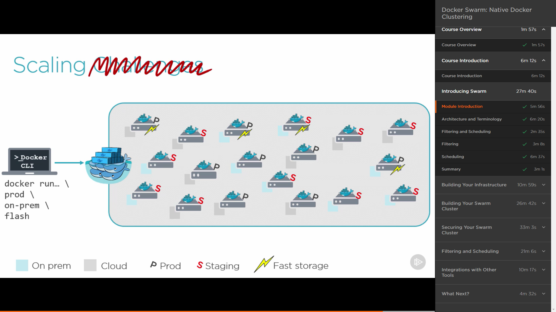

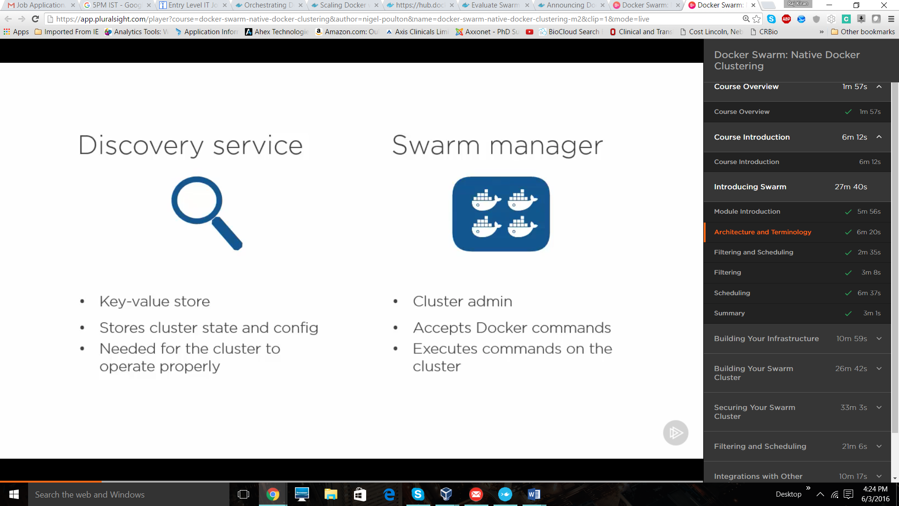

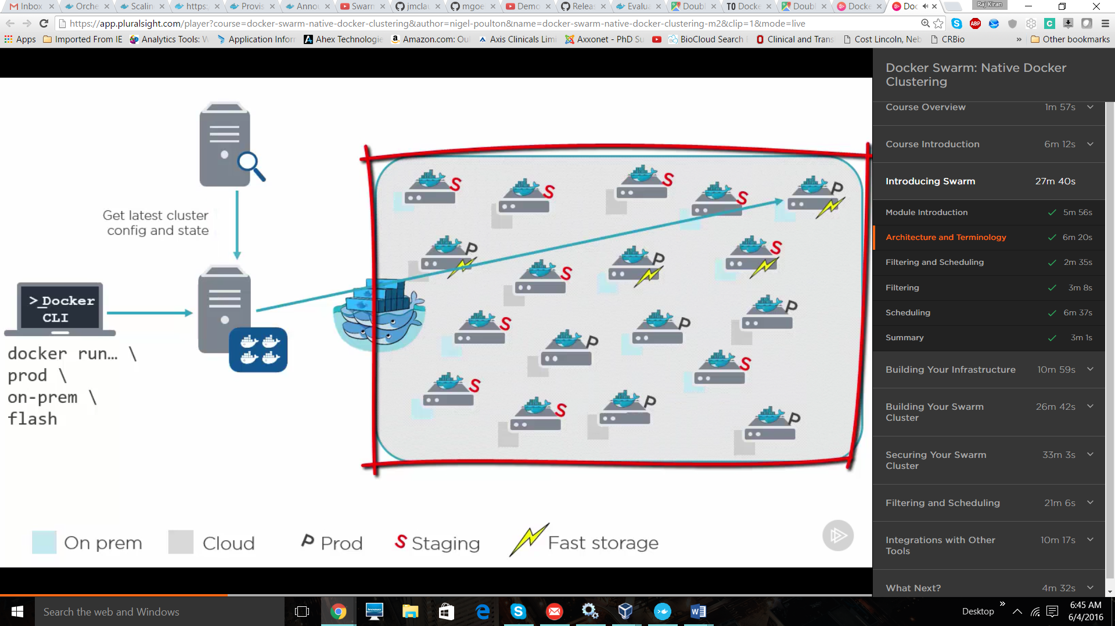

Lets build it. Go to <https://docs.docker.com/swarm/install-w-machine/>

Steps

1. Create manager and number of node you needed.
2. Create a Swarm Discovery tocken. As we are creating small cluster we are using discovery tocken to register our swarm contain or backend as a member of the cluster. But when we are using for production environment we will go with Discovery Backend. By using swarm manage **we can list to assign tasks** to the nodes.

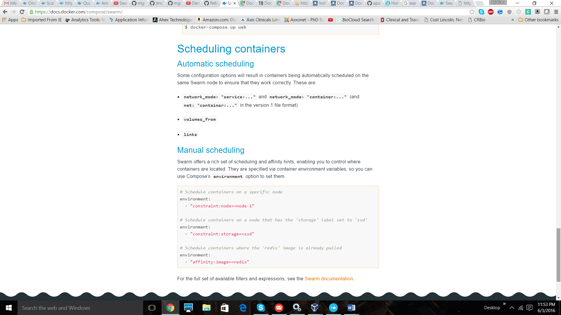

The resources that I followed are

<https://www.youtube.com/watch?v=WgQWndFPMpg>

<https://www.youtube.com/watch?v=zTKGfPfhg78>

You can find all commands in above given videos. Please do follow those videos and implement them.

Thank you,

Raj Kiran