maven生命周期

三套生命周期
Maven拥有三套相互独立的生命周期，它们分别为clean，default和site，它们的意义分别是：
- clean：清理项目
- default：构建项目
- site：建立项目站点
每个生命周期包含一些阶段(phase)，这些生命周期中的phase是有顺序的，并且后面的phase依赖于前面的phase。
较之于生命周期阶段的前后依赖关系，三套生命周期确是相互独立的，用户可以仅仅调用clean生命周期的某个阶段，或者仅仅调用default生命周期的某个阶段，而不会对其他生命周期产生任何影响。例如，当用户调用clean生命周期的clean阶段的时候，不会触发default生命周期的任何阶段。
用户和Maven最直接的交互方式就是调用这些生命周期阶段。

生命周期-clean
clean生命周期的目的是清理项目，包含以下三个阶段：
- pre-clean:执行一些清理前需要完成的工作
- clean:清理上一次构建生成的文件
- post-clean:执行一些清理后需要完成的工作

在PATH=maven-core-3.2.1.jar /META-INF/plexus/components.xml中定义了该生命周期，并绑定了一些默认plugin的goal：
<component>
<role>org.apache.maven.lifecycle.Lifecycle</role>
<implementation>org.apache.maven.lifecycle.Lifecycle</implementation>
<role-hint>clean</role-hint>
<configuration>
<id>clean</id>
<phases>
<phase>pre-clean</phase>
<phase>clean</phase>
<phase>post-clean</phase>
</phases>
<default-phases>
<clean>
org.apache.maven.plugins:maven-clean-plugin:2.5:clean
</clean>
</default-phases>
</configuration>
</component>

生命周期-site
site生命周期的目的是建立和发布项目站点，Maven能够基于POM所包含的信息，自动生成一个友好的站点，方便团队交流和发布项目信息。包含如下阶段:
- pre-site:执行一些在生成项目站点之前需要完成的工作
- site:生成项目站点文档
- post-site:执行一些在生成项目站点之后需要完成的工作
- site-deploy:将生成的项目站点发布到服务器上
在PATH=maven-core-3.2.1.jar /META-INF/plexus/components.xml中定义了该生命周期，并绑定了一些默认plugin的goal：
<component>
<role>org.apache.maven.lifecycle.Lifecycle</role>
<implementation>org.apache.maven.lifecycle.Lifecycle</implementation>
<role-hint>site</role-hint>
<configuration>
<id>site</id>
<phases>
<phase>pre-site</phase>
<phase>site</phase>
<phase>post-site</phase>
<phase>site-deploy</phase>
</phases>
<default-phases>
<site>
org.apache.maven.plugins:maven-site-plugin:3.3:site
</site>
<site-deploy>
org.apache.maven.plugins:maven-site-plugin:3.3:deploy
</site-deploy>
</default-phases>

</configuration>
</component>

生命周期-default
default生命周期定义了真正构建时需要执行的所有步骤，它是所有生命周期中最核心的部分：
- validate：validate the project is correct and all necessary information is available
- initialize: initialize build state, e.g. set properties or create directories
- generate-sources: generate any source code for inclusion in compilation.
- process-sources: process the source code, for example to filter any values.
- generate-resources: generate resources for inclusion in the package.
- process-resources: copy and process the resources into the destination directory, ready for packaging.
- compile: compile the source code of the project.
- process-classes: post-process the generated files from compilation, for example to do bytecode enhancement on Java classes.
- generate-test-sources: generate any test source code for inclusion in compilation.
- process-test-sources: process the test source code, for example to filter any values.
- generate-test-resources: create resources for testing.
- process-test-resources: copy and process the resources into the test destination directory.
- test-compile: compile the test source code into the test destination directory
- process-test-classes: post-process the generated files from test compilation, for example to do bytecode enhancement on Java classes. For Maven 2.0.5 and above.
- test: run tests using a suitable unit testing framework. These tests should not require the code be packaged or deployed.
- prepare-package: perform any operations necessary to prepare a package before the actual packaging. This often results in an unpacked, processed version of the package. (Maven 2.1 and above)
- package: take the compiled code and package it in its distributable format, such as a JAR.
- pre-integration-test: perform actions required before integration tests are executed. This may involve things such as setting up the required environment.
- integration-test: process and deploy the package if necessary into an environment where integration tests can be run.
- post-integration-test: perform actions required after integration tests have been executed. This may including cleaning up the environment.
- verify: run any checks to verify the package is valid and meets quality criteria.
- install: install the package into the local repository, for use as a dependency in other projects locally.
- deploy: done in an integration or release environment, copies the final package to the remote repository for sharing with other developers and projects.
部分翻译如下：
- process-sources:处理项目主资源文件，一般而言，是对src/main/resources目录的内容进行变量替换等工作后，复制到项目输出的主classpath目录中
- compile:编译项目的主源码。一般而言，是将src/main/java目录下的Java文件编译并输出到主classpath目录中
- process-test-sources:处理项目测试资源文件。一般而言，是处理src/test/resources目录下的资源文件然后复制输出到测试classpath中
- test-compile:编译测试代码。一般而言，是将src/test/java目录下的Java代码编译并输出至测试classpath目录中
- test:使用单元测试框架运行测试，测试代码不会被打包或者部署
- package:接受编译好的代码，打包成可发布的格式，如jar，war等
- install:将包安装到Maven本地仓库，供本地其它Maven项目使用
- deploy:将最终的包赋值到远程仓库，供其它开发人员和Maven项目使用
在PATH=maven-core-3.2.1.jar /META-INF/plexus/components.xml中定义了该生命周期：
<component>
<role>org.apache.maven.lifecycle.Lifecycle</role>
<implementation>org.apache.maven.lifecycle.Lifecycle</implementation>
<role-hint>default</role-hint>
<configuration>
<id>default</id>
<phases>
<phase>validate</phase>
<phase>initialize</phase>
<phase>generate-sources</phase>
<phase>process-sources</phase>
<phase>generate-resources</phase>
<phase>process-resources</phase>
<phase>compile</phase>
<phase>process-classes</phase>
<phase>generate-test-sources</phase>
<phase>process-test-sources</phase>
<phase>generate-test-resources</phase>
<phase>process-test-resources</phase>
<phase>test-compile</phase>
<phase>process-test-classes</phase>
<phase>test</phase>
<phase>prepare-package</phase>
<phase>package</phase>
<phase>pre-integration-test</phase>
<phase>integration-test</phase>
<phase>post-integration-test</phase>
<phase>verify</phase>
<phase>install</phase>
<phase>deploy</phase>
</phases>
</configuration>
</component>
比对clean、site生命周期，我们发现default生命周期没有给其phase绑定任何默认plugin的 goal，原因是由于packageing type有许多（如 war、jar、pom、ejb等），它们差异比较大，所以需单独对这些packageing type 的lifecycle进行单独配置，例如如下的packageing type=war格式的lifecycle声明：
<component>
<role>org.apache.maven.lifecycle.mapping.LifecycleMapping</role>
<role-hint>war</role-hint>
<implementation>org.apache.maven.lifecycle.mapping.DefaultLifecycleMapping</implementation>
<configuration>
<lifecycles>
<lifecycle>
<id>default</id>
<phases>
<process-resources>
org.apache.maven.plugins:maven-resources-plugin:2.6:resources
</process-resources>
<compile>
org.apache.maven.plugins:maven-compiler-plugin:2.5.1:compile
</compile>
<process-test-resources>
org.apache.maven.plugins:maven-resources-plugin:2.6:testResources
</process-test-resources>
<test-compile>
org.apache.maven.plugins:maven-compiler-plugin:2.5.1:testCompile
</test-compile>
<test>
org.apache.maven.plugins:maven-surefire-plugin:2.12.4:test
</test>
<package>
org.apache.maven.plugins:maven-war-plugin:2.2:war
</package>
<install>
org.apache.maven.plugins:maven-install-plugin:2.4:install
</install>
<deploy>
org.apache.maven.plugins:maven-deploy-plugin:2.7:deploy
</deploy>
</phases>
</lifecycle>
</lifecycles>
</configuration>
</component>
1.1.3.1、1.1.3.2将对default生命周期针对不同packageing type进行一些补充说明。

packaging type
摘自某项目pom.xml：
<groupId>com.wdlt.service</groupId>
<artifactId>server</artifactId>
<packaging>war</packaging>
<version>1.0.0</version>

执行命令mvn package,console的输出：
[INFO] Scanning for projects...
[INFO]
[INFO] Using the builder org.apache.maven.lifecycle.internal.builder.singlethreaded.SingleThreadedBuilder with a thread count of 1
[INFO]
[INFO] ------------------------------------------------------------------------
[INFO] Building server 1.0.0
[INFO] ------------------------------------------------------------------------
[INFO]
[INFO] --- maven-resources-plugin:2.6:resources (default-resources) @ server ---
[INFO] Using 'UTF-8' encoding to copy filtered resources.
[INFO] Copying 21 resources
[INFO]
[INFO] --- maven-compiler-plugin:2.5.1:compile (default-compile) @ server ---
[INFO] Nothing to compile - all classes are up to date
[INFO]
[INFO] --- maven-resources-plugin:2.6:testResources (default-testResources) @ server ---
[INFO] Using 'UTF-8' encoding to copy filtered resources.
[INFO] Copying 0 resource
[INFO]
[INFO] --- maven-compiler-plugin:2.5.1:testCompile (default-testCompile) @ server ---
[INFO] Nothing to compile - all classes are up to date
[INFO]
[INFO] --- maven-surefire-plugin:2.12.4:test (default-test) @ server ---
[INFO]
[INFO] --- maven-war-plugin:2.4:war (default-war) @ server ---
[INFO] Packaging webapp
[INFO] Assembling webapp [server] in [/home/smart/Documents/workspace-eclipse-4.4/server/target/server]
[INFO] Processing war project
[INFO] Copying webapp resources [/home/smart/Documents/workspace-eclipse-4.4/server/src/main/webapp]
[INFO] Webapp assembled in [539 msecs]
[INFO] Building war: /home/smart/Documents/workspace-eclipse-4.4/server/target/server-1.0.0.war
[INFO] ------------------------------------------------------------------------
[INFO] BUILD SUCCESS
[INFO] ------------------------------------------------------------------------
[INFO] Total time: 2.610 s
[INFO] Finished at: 2016-01-23T14:02:14+08:00
[INFO] Final Memory: 13M/210M
[INFO] ------------------------------------------------------------------------

结论：我们发现它执行了这些gola： resources、 compile、 testResources、 testCompile、 test、 war
他们对应的phase： process-resources、compile、process-test-resources、test-compile、test、 package

为什么会执行这些插件的gogal呢？
在PATH=maven-core-3.2.1.jar /META-INF/plexus/components.xml中我们发现以下配置片段：
<component>
<role>org.apache.maven.lifecycle.mapping.LifecycleMapping</role>
<role-hint>war</role-hint>
<implementation>org.apache.maven.lifecycle.mapping.DefaultLifecycleMapping</implementation>
<configuration>
<lifecycles>
<lifecycle>
<id>default</id>
<phases>
<process-resources>
org.apache.maven.plugins:maven-resources-plugin:2.6:resources
</process-resources>
<compile>
org.apache.maven.plugins:maven-compiler-plugin:2.5.1:compile
</compile>
<process-test-resources>
org.apache.maven.plugins:maven-resources-plugin:2.6:testResources
</process-test-resources>
<test-compile>
org.apache.maven.plugins:maven-compiler-plugin:2.5.1:testCompile
</test-compile>
<test>
org.apache.maven.plugins:maven-surefire-plugin:2.12.4:test
</test>
<package>
org.apache.maven.plugins:maven-war-plugin:2.2:war
</package>
<install>
org.apache.maven.plugins:maven-install-plugin:2.4:install
</install>
<deploy>
org.apache.maven.plugins:maven-deploy-plugin:2.7:deploy
</deploy>
</phases>

</lifecycle>
</lifecycles>
</configuration>
</component>
注:
<role>的值为org.apache.maven.lifecycle.mapping.LifecycleMapping，表示这是为该packaging进行的lifecycle绑定。
<role-hint>的值是packaging type的 值。
<implementation> 指LifecycleMapping具体绑定实现者。
<configuration>里是为这个新定义的packaging type设置默认被绑定的phases list。列表中的每一个phase都会被绑定到一个goal上。请注意goal设置必须是"fully qualified"的（格式为：groupId:artifactId:goal or groupId:artifactId:version:goal）。
摘自某项目的pom.xml:
<modelVersion>4.0.0</modelVersion>
<groupId>com.travel.common</groupId>
<artifactId>travel-common</artifactId>
<version>0.0.1</version>
<packaging>jar</packaging>
<name>travel-common</name>

执行命令mvn package,console的输出：
[INFO] Scanning for projects...
[INFO]
[INFO] Using the builder org.apache.maven.lifecycle.internal.builder.singlethreaded.SingleThreadedBuilder with a thread count of 1
[INFO]
[INFO] ------------------------------------------------------------------------
[INFO] Building travel-common 0.0.1
[INFO] ------------------------------------------------------------------------
[INFO]
[INFO] --- maven-resources-plugin:2.6:resources (default-resources) @ travel-common ---
[INFO] Using 'UTF-8' encoding to copy filtered resources.
[INFO] Copying 0 resource
[INFO]
[INFO] --- maven-compiler-plugin:2.5.1:compile (default-compile) @ travel-common ---
[INFO] Nothing to compile - all classes are up to date
[INFO]
[INFO] --- maven-resources-plugin:2.6:testResources (default-testResources) @ travel-common ---
[INFO] Using 'UTF-8' encoding to copy filtered resources.
[INFO] Copying 0 resource
[INFO]
[INFO] --- maven-compiler-plugin:2.5.1:testCompile (default-testCompile) @ travel-common ---
[INFO] Nothing to compile - all classes are up to date
[INFO]
[INFO] --- maven-surefire-plugin:2.12.4:test (default-test) @ travel-common ---
[INFO]
[INFO] --- maven-jar-plugin:2.6:jar (default-jar) @ travel-common ---
[INFO] Building jar: /home/smart/Documents/workspace-eclipse-4.4/travel-common/target/travel-common-0.0.1.jar
[INFO]
[INFO] ------------------------------------------------------------------------
[INFO] BUILD SUCCESS
[INFO] ------------------------------------------------------------------------
[INFO] Total time: 1.999 s
[INFO] Finished at: 2016-01-23T11:51:24+08:00
[INFO] Final Memory: 12M/210M
[INFO] ------------------------------------------------------------------------

结论：我们发现它执行了这些gola： resources、 compile、 testResources、 testCompile、 test、 jar
他们对应的phase： process-resources、compile、process-test-resources、test-compile、test、 package

为什么会执行这些插件的gogal呢？
在PATH=maven-core-3.2.1.jar /META-INF/plexus/components.xml中我们发现以下配置片段：
<component>
<role>org.apache.maven.lifecycle.mapping.LifecycleMapping</role>
<role-hint>jar</role-hint>
<implementation>org.apache.maven.lifecycle.mapping.DefaultLifecycleMapping</implementation>
<configuration>
<lifecycles>
<lifecycle>
<id>default</id>
<phases>
<process-resources>
org.apache.maven.plugins:maven-resources-plugin:2.6:resources
</process-resources>
<compile>
org.apache.maven.plugins:maven-compiler-plugin:2.5.1:compile
</compile>
<process-test-resources>
org.apache.maven.plugins:maven-resources-plugin:2.6:testResources
</process-test-resources>
<test-compile>
org.apache.maven.plugins:maven-compiler-plugin:2.5.1:testCompile
</test-compile>
<test>
org.apache.maven.plugins:maven-surefire-plugin:2.12.4:test
</test>
<package>
org.apache.maven.plugins:maven-jar-plugin:2.4:jar
</package>
<install>
org.apache.maven.plugins:maven-install-plugin:2.4:install
</install>
<deploy>
org.apache.maven.plugins:maven-deploy-plugin:2.7:deploy
</deploy>
</phases>

</lifecycle>
</lifecycles>
</configuration>
</component>

注:
<role>的值为org.apache.maven.lifecycle.mapping.LifecycleMapping，表示这是为该packaging进行的lifecycle绑定。
<role-hint>的值是packaging type的 值。
<implementation> 指LifecycleMapping具体绑定实现者。
<configuration>里是为这个新定义的packaging type设置默认被绑定的phases list。列表中的每一个phase都会被绑定到一个goal上。请注意goal设置必须是"fully qualified"的（格式为：groupId:artifactId:goal or groupId:artifactId:version:goal）。

摘自某项目pom.xml:
<modelVersion>4.0.0</modelVersion>
<groupId>com.travel.my</groupId>
<artifactId>travel-my</artifactId>
<version>0.0.1-SNAPSHOT</version>
<packaging>pom</packaging>

执行命令mvn package,console的输出：

[INFO] Scanning for projects...
[INFO]
[INFO] ------------------------------------------------------------------------
[INFO] Building travel-my 1.0-SNAPSHOT
[INFO] ------------------------------------------------------------------------
[INFO] BUILD SUCCESS
[INFO] ------------------------------------------------------------------------
[INFO] Total time: 6.977 s
[INFO] Finished at: 2016-01-23T14:05:15+08:00
[INFO] Final Memory: 20M/210M
[INFO] ------------------------------------------------------------------------

结论：我们发现它执行了这些gogla： no.
他们对应的phase： no.

为什么会任何插件的goal都没执行呢？
在PATH=maven-core-3.2.1.jar /META-INF/plexus/components.xml中我们发现以下配置片段：
<component>
<role>org.apache.maven.lifecycle.mapping.LifecycleMapping</role>
<role-hint>pom</role-hint>
<implementation>org.apache.maven.lifecycle.mapping.DefaultLifecycleMapping</implementation>
<configuration>
<lifecycles>
<lifecycle>
<id>default</id>
<phases>
<install>
org.apache.maven.plugins:maven-install-plugin:2.4:install
</install>
<deploy>
org.apache.maven.plugins:maven-deploy-plugin:2.7:deploy
</deploy>
</phases>
</lifecycle>
</lifecycles>
</configuration>
</component>

注:
<role>的值为org.apache.maven.lifecycle.mapping.LifecycleMapping，表示这是为该packaging进行的lifecycle绑定。
<role-hint>的值是packaging type的 值。
<implementation> 指LifecycleMapping具体绑定实现者。
<configuration>里是为这个新定义的packaging type设置默认被绑定的phases list。列表中的每一个phase都会被绑定到一个goal上。请注意goal设置必须是"fully qualified"的（格式为：groupId:artifactId:goal or groupId:artifactId:version:goal）。

以上三个示例声明了三种packaging（war,jar,pom）type，实际上还有一些其他的packaging type(例如ejb、ear等)。这些packaging type都定义在PATH=maven-core-3.2.1.jar /META-INF/plexus/components.xml中，而且这些pacagking type都给一些phase绑定了一些默认的插件（这也是当project中为什么没有任何插件声明，我们也能执行maven default生命周期的phase进行正常工作的原因）。

什么是Artifact Handler
直译为：artifact 处理；artifact是产品、制品的意思，放到java世界里就是module名，例如spring由许多project，每个project可能含有许多module，其中spring framework project就含有很多module，例如：spring-core module、spring-beans module。Artifact Handler的意思就是如何处理这些artifact的：例如artifact 打包后的后缀，artifact使用的什么语言等。artifact handler和packaging type有什么关系呢？一个 Artifact最终必定属于某种packaging type，但只能为其一；他们的关系就像是接口实现与接口的关系。
下面是从PATH=maven-core-3.2.1.jar /META-INF/plexus/components.xml摘录的部分Artifact Handler声明：
<component>
<role>org.apache.maven.artifact.handler.ArtifactHandler</role>
<role-hint>pom</role-hint>
<implementation>org.apache.maven.artifact.handler.DefaultArtifactHandler</implementation>
<configuration>
<type>pom</type>
</configuration>
</component>
<component>
<role>org.apache.maven.artifact.handler.ArtifactHandler</role>
<role-hint>jar</role-hint>
<implementation>org.apache.maven.artifact.handler.DefaultArtifactHandler</implementation>
<configuration>
<type>jar</type>
<language>java</language>
<addedToClasspath>true</addedToClasspath>
</configuration>
</component>
<component>
<role>org.apache.maven.artifact.handler.ArtifactHandler</role>
<role-hint>war</role-hint>
<implementation>org.apache.maven.artifact.handler.DefaultArtifactHandler</implementation>
<configuration>
<type>war</type>
<includesDependencies>true</includesDependencies>
<language>java</language>
<addedToClasspath>false</addedToClasspath>
</configuration>
</component><

maven插件

插件目标
Maven plugin简单的来说就是“根据输入/输出参数配置来完成‘某个/些’目标（goal）/任务（task）/咒语（mojo）/功能（func）”。
有些插件通常可以完成多个“目标（goal）/任务（task）/咒语（mojo）/功能（func）”，之所以让插件完成多个“目标（goal）/任务（task）/咒语（mojo）/功能（func）”，是因为这些“目标（goal）/任务（task）/咒语（mojo）/功能（func）”中有许多代码可以复用。
例如，maven-dependency-plugin插件有十多个目标，每个目标对应了一个功能，下面就是其几个功能对应的目标：
- dependency:analyze
- dependency:tree
- dependency:list

同时有些插件的有些gogal/task/mojo/func在开发时已经默认指定了bind到maven生命周期的那个phase上，这也是在pom.xml中仅声明插件的goal或goal、phase都不声明，mavan在执行命令时仍能执行插件的goal的原因。

查看插件该如何配置
help:describe -Dplugin=groupId:artifactId:version -Ddetail
如：
[smart@localhost jyl-backstage]$ mvn help:describe -Dplugin=org.apache.maven.plugins:maven-compiler-plugin:2.5.1 -Ddetail

插件绑定
插件的goal必须绑定到生命周期的phase才能起作用。

内置绑定
maven 的三大lifecycle进行了一些默认绑定。
Clean 生命周期的默认绑定：
<component>
<role>org.apache.maven.lifecycle.Lifecycle</role>
<implementation>org.apache.maven.lifecycle.Lifecycle</implementation>
<role-hint>clean</role-hint>
<configuration>
<id>clean</id>
<phases>
<phase>pre-clean</phase>
<phase>clean</phase>
<phase>post-clean</phase>
</phases>
<default-phases>
<clean>
org.apache.maven.plugins:maven-clean-plugin:2.5:clean
</clean>
</default-phases>
</configuration>
</component>
Site 声明周期的默认绑定：
<component>
<role>org.apache.maven.lifecycle.Lifecycle</role>
<implementation>org.apache.maven.lifecycle.Lifecycle</implementation>
<role-hint>site</role-hint>
<configuration>
<id>site</id>
<phases>
<phase>pre-site</phase>
<phase>site</phase>
<phase>post-site</phase>
<phase>site-deploy</phase>
</phases>
<default-phases>
<site>
org.apache.maven.plugins:maven-site-plugin:3.3:site
</site>
<site-deploy>
org.apache.maven.plugins:maven-site-plugin:3.3:deploy
</site-deploy>
</default-phases>

</configuration>
</component>

default声明周期，不同的packaging type有不同的绑定：
Packaging type=war的内置绑定：
<component>
<role>org.apache.maven.lifecycle.mapping.LifecycleMapping</role>
<role-hint>war</role-hint>
<implementation>org.apache.maven.lifecycle.mapping.DefaultLifecycleMapping</implementation>
<configuration>
<lifecycles>
<lifecycle>
<id>default</id>
<phases>
<process-resources>
org.apache.maven.plugins:maven-resources-plugin:2.6:resources
</process-resources>
<compile>
org.apache.maven.plugins:maven-compiler-plugin:2.5.1:compile
</compile>
<process-test-resources>
org.apache.maven.plugins:maven-resources-plugin:2.6:testResources
</process-test-resources>
<test-compile>
org.apache.maven.plugins:maven-compiler-plugin:2.5.1:testCompile
</test-compile>
<test>
org.apache.maven.plugins:maven-surefire-plugin:2.12.4:test
</test>
<package>
org.apache.maven.plugins:maven-war-plugin:2.2:war
</package>
<install>
org.apache.maven.plugins:maven-install-plugin:2.4:install
</install>
<deploy>
org.apache.maven.plugins:maven-deploy-plugin:2.7:deploy
</deploy>
</phases>
</lifecycle>
</lifecycles>
</configuration>
</component>
Packaging type=jar的内置绑定：
<component>
<role>org.apache.maven.lifecycle.mapping.LifecycleMapping</role>
<role-hint>jar</role-hint>
<implementation>org.apache.maven.lifecycle.mapping.DefaultLifecycleMapping</implementation>
<configuration>
<lifecycles>
<lifecycle>
<id>default</id>
<phases>
<process-resources>
org.apache.maven.plugins:maven-resources-plugin:2.6:resources
</process-resources>
<compile>
org.apache.maven.plugins:maven-compiler-plugin:2.5.1:compile
</compile>
<process-test-resources>
org.apache.maven.plugins:maven-resources-plugin:2.6:testResources
</process-test-resources>
<test-compile>
org.apache.maven.plugins:maven-compiler-plugin:2.5.1:testCompile
</test-compile>
<test>
org.apache.maven.plugins:maven-surefire-plugin:2.12.4:test
</test>
<package>
org.apache.maven.plugins:maven-jar-plugin:2.4:jar
</package>
<install>
org.apache.maven.plugins:maven-install-plugin:2.4:install
</install>
<deploy>
org.apache.maven.plugins:maven-deploy-plugin:2.7:deploy
</deploy>
</phases>

</lifecycle>
</lifecycles>
</configuration>
</component>
Packaging type=pom的内置绑定：
<component>
<role>org.apache.maven.lifecycle.mapping.LifecycleMapping</role>
<role-hint>pom</role-hint>
<implementation>org.apache.maven.lifecycle.mapping.DefaultLifecycleMapping</implementation>
<configuration>
<lifecycles>
<lifecycle>
<id>default</id>
<phases>
<install>
org.apache.maven.plugins:maven-install-plugin:2.4:install
</install>
<deploy>
org.apache.maven.plugins:maven-deploy-plugin:2.7:deploy
</deploy>
</phases>
</lifecycle>
</lifecycles>
</configuration>
</component>
...

绑定一个goal到一个特定的phase上
<plugin>
<groupId>org.apache.maven.plugins</groupId>
<artifactId>maven-war-plugin</artifactId>
<version>2.4</version>
<configuration>
<packagingExcludes>
</packagingExcludes>
<warSourceExcludes>
</warSourceExcludes>
<webappDirectory></webappDirectory>
<warName></warName>
</configuration>
<executions>
<execution>
<id>default-war</id>
<configuration></configuration>
<phase>package</phase>
<goals>
<goal>war</goal>
</goals>
</execution>
</executions>
</plugin>
说明：
- 全局的configuration针对插件的所有goal的配置
- execution#configuration是针对当前excution的配置，
- execution#id，是给excution起个唯一id，这里需谨慎，例如这里我们声明id=default-war，run mvn packaging后你会在控制台发现运行了一次打包操作；如果你修改这里的名字为abc，run mvn packaging后你会在控制胎发现运行了两次打包操作；原因是packaging type对应的package phase 默认绑定了一个插件的gogal，它的excution#id=default-war[格式为default-plugin#gogal],与设定的excution#id=abc不同，所以它会运行两次。
- execution#phase绑定到那个phase，有时可忽略，原因是plugin的gogal有默认bind。
- execution#gogals#gogal，可以多个，当前phase绑定那些gogal。

这种绑定是最常见的，也是我们经常使用的，使用这种绑定我们可以完成以下工作：
- 修改内置绑定的默认行为：例如对于packaging type=war，可使用packagingExcludes排除一些那些无用的文件；例如可以更换内置绑定插件的版本；...。
- 扩展内置绑定，例如“创建项目的源码jar包”内置绑定并没有涉及这一任务，因此我们可以进行如下配置
<plugin>
<groupId>org.apache.maven.plugins</groupId>
<artifactId>maven-source-plugin</artifactId>
<version>2.1.1</version>
<executions>
<execution>
<id>attach-sources</id>
<phase>verify</phase>
<goals>
<goal>jar-no-fork</goal>
</goals>
</execution>
</executions>
</plugin>

使用maven-source-plugin来完成这个任务，它的jar-no-fork目标能够将项目的主代码打包成jar文件，可以将其绑定到default生命周期的verify阶段(集成测试之后，install之前的一个阶段)：

有时候，我们仅声明了插件，但没有声明goal和phase间的相互绑定也是可行的，原因是，这些插件的一些goal 默认指定了绑定到那些phase；
例如在某pom.xml中我们这样声明插件：
...
<plugin>
<groupId>org.apache.maven.plugins</groupId>
<artifactId>maven-war-plugin</artifactId>
<version>2.4</version>
<configuration>
<packagingExcludes>
</packagingExcludes>
<warSourceExcludes>
</warSourceExcludes>
<webappDirectory></webappDirectory>
<warName></warName>
</configuration>
</plugin>
...
consle 对phase 的输出为：
[INFO] --- maven-war-plugin:2.4:war (default-war) @ server ---
[INFO] Packaging webapp
[INFO] Assembling webapp [server] in [/home/smart/Documents/workspace-eclipse-4.4/server/target/server]
[INFO] Processing war project
[INFO] Copying webapp resources [/home/smart/Documents/workspace-eclipse-4.4/server/src/main/webapp]
[INFO] Webapp assembled in [115 msecs]
[INFO] Building war: /home/smart/Documents/workspace-eclipse-4.4/server/target/server-1.0.0.war

说明 没有指定 excution#id 采用默认，内置绑定采用的也是默认，所以执行一次；

例如在某pom.xml中我们这样声明插件：
...
<plugin>
<groupId>org.apache.maven.plugins</groupId>
<artifactId>maven-war-plugin</artifactId>
<version>2.4</version>
<configuration>
<packagingExcludes>
</packagingExcludes>
<warSourceExcludes>
</warSourceExcludes>
<webappDirectory></webappDirectory>
<warName></warName>
</configuration>
</plugin>
<plugin>
<groupId>org.apache.maven.plugins</groupId>
<artifactId>maven-war-plugin</artifactId>
<version>2.4</version>
<configuration>
<packagingExcludes>
</packagingExcludes>
<warSourceExcludes>
</warSourceExcludes>
<webappDirectory></webappDirectory>
<warName></warName>
</configuration>
<executions>
<execution>
<id>default-yyy</id>
<phase>package</phase>
<goals>
<goal>war</goal>
</goals>
</execution>
</executions>
</plugin>

…

consle 对phase 的输出为：
[INFO] --- maven-war-plugin:2.4:war (default-war) @ server ---
[INFO] Packaging webapp
[INFO] Assembling webapp [server] in [/home/smart/Documents/workspace-eclipse-4.4/server/target/server]
[INFO] Processing war project
[INFO] Copying webapp resources [/home/smart/Documents/workspace-eclipse-4.4/server/src/main/webapp]
[INFO] Webapp assembled in [115 msecs]
[INFO] Building war: /home/smart/Documents/workspace-eclipse-4.4/server/target/server-1.0.0.war

[INFO] --- maven-war-plugin:2.4:war (default-yyy) @ server ---
[INFO] Packaging webapp
[INFO] Assembling webapp [server] in [/home/smart/Documents/workspace-eclipse-4.4/server/target/server]
[INFO] Processing war project
[INFO] Copying webapp resources [/home/smart/Documents/workspace-eclipse-4.4/server/src/main/webapp]
[INFO] Webapp assembled in [73 msecs]
[INFO] Building war: /home/smart/Documents/workspace-eclipse-4.4/server/target/server-1.0.0.war
[INFO]

说明 第一个配置没有指定 excution#id 采用默认，内置绑定采用的也是默认，所以他们仅执行一次，而且覆盖优先；

第二个由于采用了新的excution#id ，所以maven认为他们是不一样的，所以又执行了一次。

如果多个goal被绑定到同一个phase，那么这些插件声明的先后顺序决定了goal的执行顺序。

定义一个packaging type
定义一个新的packaging type，直白的说就是定义一个pom.xml中<packaging>的值，
如果你想提供一个特别的packaging type，也就是提供一个特别的<packaging>值，那么你不仅需要提供default#package phase goal的插件绑定，还需要提供其他default lifecycle phases与goals的绑定。
定义packaging type的配置文件必须放置在plugin jar的META-INF/plexus/components.xml里，以下是定义packaging type 示例：
<component-set>
<components>
<component>
<role>org.apache.maven.lifecycle.mapping.LifecycleMapping</role>
<role-hint>plexus-application</role-hint>
<implementation>org.apache.maven.lifecycle.mapping.DefaultLifecycleMapping</implementation>
<configuration>
<phases>
<process-resources>org.apache.maven.plugins:maven-resources-plugin:resources</process-resources>
<compile>org.apache.maven.plugins:maven-compiler-plugin:compile</compile>
<process-test-resources>org.apache.maven.plugins:maven-resources-plugin:testResources</process-test-resources>
<test-compile>org.apache.maven.plugins:maven-compiler-plugin:testCompile</test-compile>
<test>org.apache.maven.plugins:maven-surefire-plugin:test</test>
<package>org.codehaus.plexus:plexus-maven-plugin:app</package>
<install>org.apache.maven.plugins:maven-install-plugin:install</install>
<deploy>org.apache.maven.plugins:maven-deploy-plugin:deploy</deploy>
</phases>
</configuration>
</component>
</components>
</component-set>

在上面的代码中:
<role>的值为org.apache.maven.lifecycle.mapping.LifecycleMapping，表示这是为packaging进行的lifecycle绑定。
<role-hint>的值是新定义的packaging type 值。
<implementation> 指LifecycleMapping具体绑定实现者。
<configuration> element里是为这个新定义的packaging type设置被绑定的phases list。列表中的每一个phase都会被绑定到一个goal上。请注意goal设置必须是"fully qualified"的（格式为：groupId:artifactId:goal or groupId:artifactId:version:goal）。
值得留意的是：上述代码只是把package phase绑定到自定义plugin的app goal上，其他phase还是绑定到缺省的goal上。

在项目中使用自定义的packaging type：
在project 的pom.xml中进行如下声明：
...
<packaging>plexus-application</packaging>
...
<plugin>
<groupId>org.codehaus.plexus</groupId>
<artifactId>plexus-maven-plugin</artifactId>
</plugin>
...

如上声明你的project，打包后的包名后缀是xxx.plexus-application，这是因为maven使用了默认的artifact handler：org.apache.maven.artifact.handler.DefaultArtifactHandler（在maven-core-3.2.1.jar /META-INF/plexus/components.xml中），
<component>
<role>org.apache.maven.artifact.handler.ArtifactHandler</role>
<role-hint>default</role-hint>
<implementation>org.apache.maven.artifact.handler.DefaultArtifactHandler</implementation>
<description />
<isolated-realm>false</isolated-realm>
</component>

如果我们想自定义，可进行如下声明（同样必须放置在plugin jar的META-INF/plexus/components.xml里）：
<component>
<role>org.apache.maven.artifact.handler.ArtifactHandler</role>
<role-hint>plexus-application </role-hint> <!-- 约定是plexus-application ，但是你可以随便起名字，例如“abc” -->
<implementation>org.apache.maven.artifact.handler.DefaultArtifactHandler</implementation>
<configuration>
<type>plexus-application</type>
<language>java</language>
<addedToClasspath>true</addedToClasspath>
</configuration>
</component>
然后在project的pom.xml插件声明中增加<extensions>true</extensions>，如：
...
<packaging>plexus-application</packaging>
...
<plugin>
<groupId>org.codehaus.plexus</groupId>
<artifactId>plexus-maven-plugin</artifactId>
<extensions>true</extensions>
</plugin>
...

forking a parallel lifecycle
Forking a Parallel Lifecycle
While lots of mojos will participate in the standard lifecycle, there are just as many that are used in other scenarios. These are mojos that are executed standalone from the command line (such as idea:idea ), or individual reports in the site building process.
However, sometimes these goals require that a particular task has already been performed - for instance, the IDEA plugin must ensure sources have been generated to properly construct its module files. If the goal were participating in the lifecycle, it would easily do this by ensuring it occurred after the phase it depended on having run. Since this isn't the case, it must have a way to first execute that task.
Additionally, even goals participating in the build lifecycle might need to perform a task with different parameters to what was already used, and does not want the output to affect the current build (for example, running clover:check to run tests with modified sources and fail if a certain coverage ratio is not achieved).
For these reasons, mojos are capable of forking a new lifecycle. The lifecycle will be a normal build lifecycle, a clone of the one currently being used (including any additional bindings from the POM), executed up until the point specified by the mojo.
For example, the idea:idea mojo specifies the following in the mojo level declarations to call the source generation:
@execute phase="generate-sources"
But what happens if generate-sources has already been run in this build? In the current version of Maven, there is no way to tell if the previous execution used the same input and outputs as the current mojo requires, so the task (and any preceding ones if from the lifecycle) must be run again.
For this reason, it is important that if your plugin does any intensive work, you should first check whether it is necessary to perform the tasks again, perhaps by using timestamp checking or a similar technique. As an example, the compiler plugin will only recompile changed source files so can very efficiently be run multiple times in a build if necessary.
When the lifecycle is forked, the project object being used is also cloned. In this way, modifications made to the project as part of the execution, such as the addition of a new source root, will not affect the original build. When the lifecycle finishes executing and control is passed to the original mojo, it can access that project using the expression $executedProject . For example:
/**
* @parameter expression="${executedProject}"
*/
private MavenProject executedProject;
This project instance can be used by the mojo to obtain results, and propogate any changes it sees fit into the original build.
Finally, when forking the new lifecycle, it is possible to augment it on top of the changes already made by the packaging and the plugins in the POM.
For example, consider the Clover plugin. If clover:check were to be run from the command line, the plugin would need to fork the lifecycle, executing the test phase. But, it would also need to add some configuration and bind the clover:compiler goal to thegenerate-sources phase.
This can be achieved by including the following file as META-INF/maven/lifecycle.xml in the plugin JAR:
<lifecycles>
<lifecycle>
<id>clover</id>
<phases>
<phase>
<id>generate-sources</id>
<executions>
<execution>
<configuration>
<debug>true</debug>
</configuration>
<goals>
<goal>compiler</goal>
</goals>
</execution>
</executions>
</phase>
</phases>
</lifecycle>
</lifecycles>
Here, the executions element is present in a similar way to a plugin declaration in the POM. This can be used to bind a goal one or more times to a particular phase, as well as specifying configuration. Note that configuration already provided in the POM to that plugin that is not part of a specific execution will also be applied.
The lifecycle ID given here (clover ) can then be used in the mojo to specify what to overlay on the forked lifecycle when executing it, using the following mojo level declaration:
@execute phase="test" lifecycle="clover"

一些其他插件

eclipse 插件

idea 插件

scm插件

realease 插件

maven 安装
Maven是 Apache 下的一个项目。

下载
http://mirrors.cnnic.cn/apache/maven/binaries/
Windows
http://www.apache.org/dyn/closer.cgi/maven/binaries/apache-maven-3.2.1-zip
linux
http://www.apache.org/dyn/closer.cgi/maven/binaries/apache-maven-3.2.1-bin.tar.gz

安装
Windows:
unzip apache-maven-3.2.1-bin.zip
linux：
[smart@bogon ~]$ cd /usr/local
[smart@bogon ~]$ mkdir maven-3.2.1
[smart@bogon ~]$ cp /tmp/apache-maven-3.2.1-bin.tar.gz ./maven-3.2.1
[smart@bogon ~]$ cd maven-3.2.1
[smart@bogon ~]$ chmod 755 apache-maven-3.2.1-bin.tar.gz
[smart@bogon ~]$ tar -zvxf apache-maven-3.2.1-bin.tar.gz

环境变量
windows：

系统变量：MAVEN_HOME = D:\Development\apache-maven-3.0.4
系统变量：path = %MAVEN_HOME%\bin
Linxu

[smart@bogon ~]$ vi /etc/profile //在打开的profile 尾部追加以下内容
“
# maven
export M2_HOME=/usr/local/maven-3.2.1/apache-maven-3.2.1
export PATH=$M2_HOME/bin:$PATH
”
[smart@bogon ~]$ source /etc/profile //...
[smart@bogon ~]$ mvn -v //验证

配置

修改本地仓库地址：
<!-- localRepository
| The path to the local repository maven will use to store artifacts.
|
| Default: ${user.home}/.m2/repository -->
<localRepository>/usr/local/maven-3.2.1/repository</localRepository>

maven 私服搭建

download
地址：http://www.sonatype.org/nexus/thank-you-for-downloading/
windows请下载zip，linux请下载tar.gz。

安装

Windows:
unzip nexus-2.4-bundle.zip
linux：
[smart@bogon ~]$ cd /usr/local
[smart@bogon ~]$ mkdir nexus
[smart@bogon ~]$ cp /tmp/nexus-2.4-bundle.tar.gz ./nexus
[smart@bogon ~]$ cd nexus
[smart@bogon ~]$ chmod 755 nexus-2.4-bundle.tar.gz
[smart@bogon ~]$ tar -zvxf nexus-2.4-bundle.tar.gz

启动
Windows
双击 bin/nexus.bat即可启动
Linux
[smart@bogon ~]$ cd /usr/local/nexus/nexus-2.4.0-09/bin
[smart@bogon ~]$ ./nuxus start

浏览器中输入http://locahost:8081/nexus/
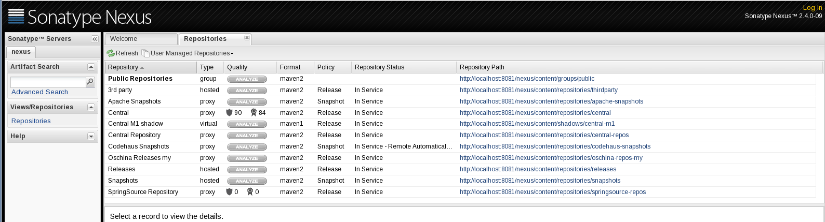
8081为nexus的端口号，要修改端口号可进入nexus-2.4.0-09/bin/conf/下打开nexus.properties文件，修改application-port属性值就可以了。
默认的用户名和密码：admin/admin123，登录后看到如下图所示：
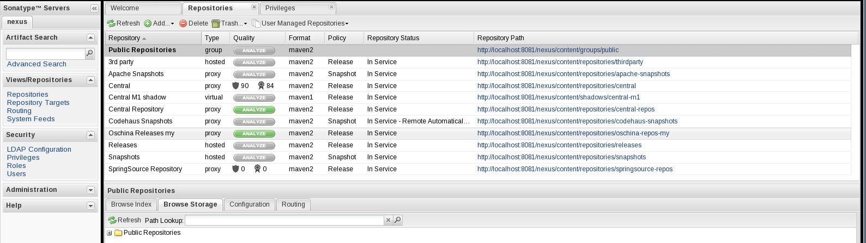

nexus仓库分类
nexus的仓库类型分为以下四种：group: 仓库组、hosted：宿主、proxy：代理、virtual：虚拟；
首次登陆nexus后可以看到以下一个仓库组和多个仓库：
- PublicRepositories: 仓库组
- 3rd party: 无法从公共仓库获得的第三方发布版本的构件仓库
- Apache Snapshots: 用了代理ApacheMaven仓库快照版本的构件仓库
- Central: 用来代理maven中央仓库中发布版本构件的仓库
- Central M1 shadow: 用于提供中央仓库中M1格式的发布版本的构件镜像仓库
- Codehaus Snapshots: 用来代理CodehausMaven 仓库的快照版本构件的仓库
- Releases: 用来部署管理内部的发布版本构件的宿主类型仓库
- Snapshots:用来部署管理内部的快照版本构件的宿主类型仓库

nexus仓库说明
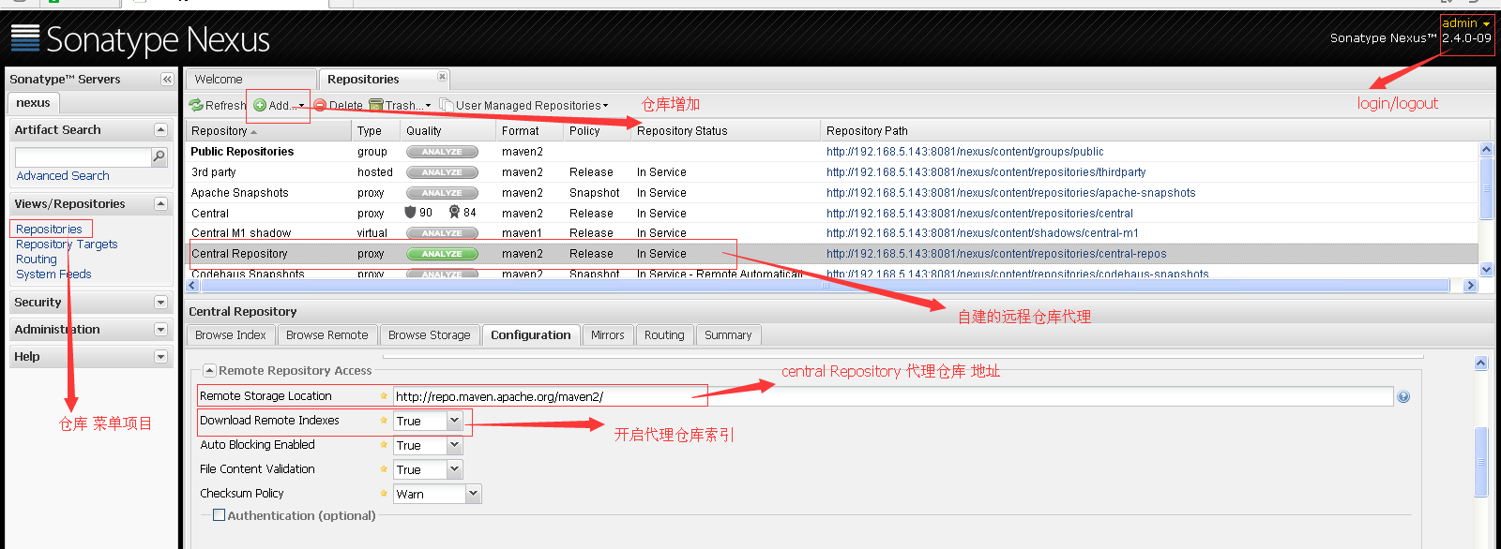
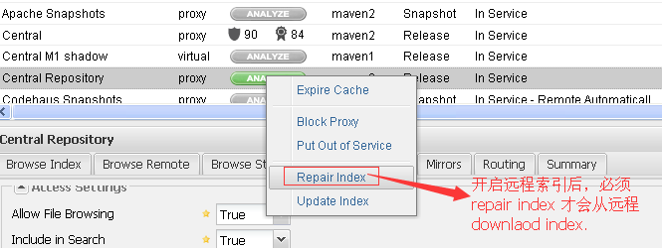
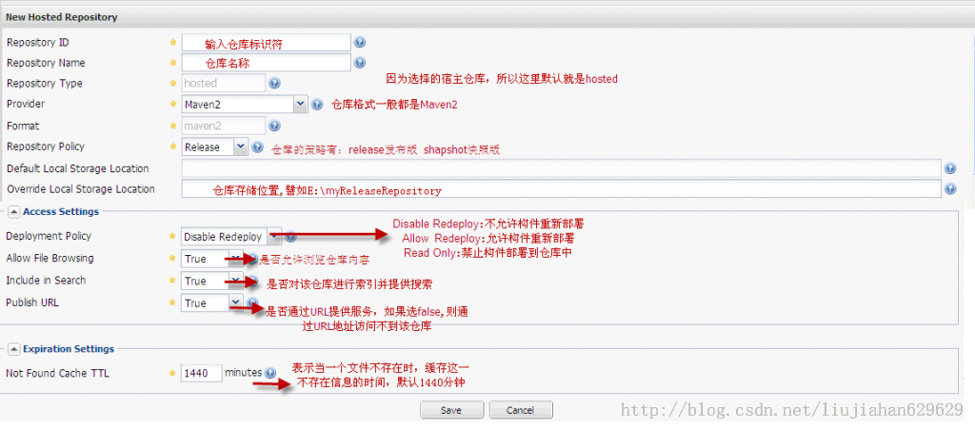

使用nexus仓库
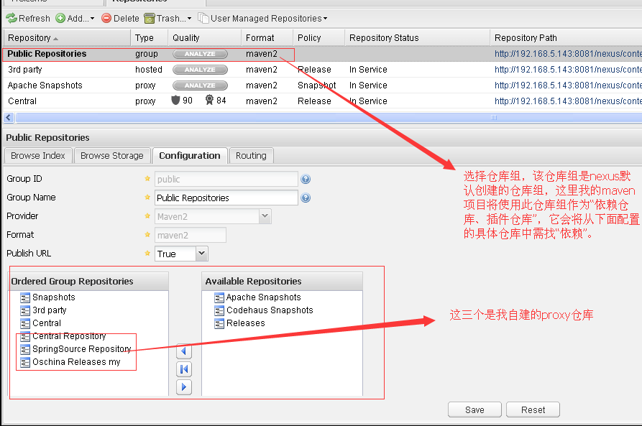

代理所有远程仓库

1、当pom.xml中 没有配置仓库地址（包括依赖仓库和插件仓库），maven会使用“本地仓库”、“默认的远程仓库（http://repo.maven.apache.org/maven2）”。
2、当pom.xml中 配置有仓库地址，maven会同时使用“本地仓库”、“默认的远程仓库地址”、“pom配置的仓库地址”。
如何让maven在使用“远程仓库时始终使用代理仓库（nexus 的仓库组仓库），而不是繁琐的在pom中或settings.xml中配置多个远程仓库”？仅需在 /usr/local/maven-3.2.1/apache-maven-3.2.1/conf/settings.xml增加如下配置片段：
<mirrors>
<!-- mirror
| Specifies a repository mirror site to use instead of a given repository. The repository that
| this mirror serves has an ID that matches the mirrorOf element of this mirror. IDs are used
| for inheritance and direct lookup purposes, and must be unique across the set of mirrors.
|
<mirror>
<id>mirrorId</id>
<mirrorOf>repositoryId</mirrorOf>
<name>Human Readable Name for this Mirror.</name>
<url>http://my.repository.com/repo/path</url>
</mirror>
-->

<mirror>
<id>public</id>
<mirrorOf>*</mirrorOf>
<name>central-mirror</name>
<url>http://192.168.5.143:8081/nexus/content/groups/public/</url>
</mirror>

</mirrors>
当我们项目中需要使用新的远程仓库时，仅需给nexus pulic仓库组 add 该远程仓库，而无需修改我们的项目任何文件即可。

发布本地的Snapshots和realeases到nexus
打开/usr/local/maven-3.2.1/apache-maven-3.2.1/conf/settings.xml，增加：
<server>
<id>Releases</id>
<username>admin</username>
<password>admin123</password>
</server>
<server>
<id>Snapshots</id>
<username>admin</username>
<password>admin123</password>
</server>
pom.xml中增加：
<!-- deploy cht nexus -->
<distributionManagement>
<repository>
<id>Releases</id>
<url>http://192.168.5.143:8081/nexus/content/repositories/releases</url>
</repository>
<snapshotRepository>
<id>Snapshots</id>
<url>http://192.168.5.143:8081/nexus/content/repositories/snapshots/</url>
</snapshotRepository>
</distributionManagement>

maven 命令
常用的命令不在细说，这里说以下我认为重要但易被忽视的命令

