Project Overview
This project is a portfolio website showcasing my profile, skills, projects included with a contact form for users to submit enquiries. The project page is implemented with crud to allow users to create read updates and delete the projects. This project was developed using Flask, HTML5, CSS, Jinjia2 and SQLite.

Description of Implemented features
Home page – I included my profile picture with a profile picture and an about me paragraph. The navigation bar allows users to visit other respective pages, home, skills, projects and the contact form.
Skills page – This page shows my technical and software skills with my personal strengths. I used flexbox in CSS to arrange each skill into a skill card with a responsive layout.
Projects page – This page takes the projects from the SQLite database under the projects table and displays them each in a card. Each card has a project title, image and a description. I also implemented CRUD operations with an edit, delete and a add project button. Projects that are edited, added or deleted will be synced and updated to the database.
Contact page – This page features a form to allows users to submit their name, email, phone number and a message. Both Client side and Server-side validation is used to ensure the form inputs are not empty and appropriate before storing the information in the table contacts in the database. For client-side validation, I used the required function in the html form code and for server-side validation I checked if the email contains the ‘@’symbol and the message is not empty.
Media Queries – I used CSS media queries to ensure the website remains user-friendly on smaller screens by resizing the content to fit a smaller layout.
Database Structure
The database consists of 2 tables, contacts and projects.
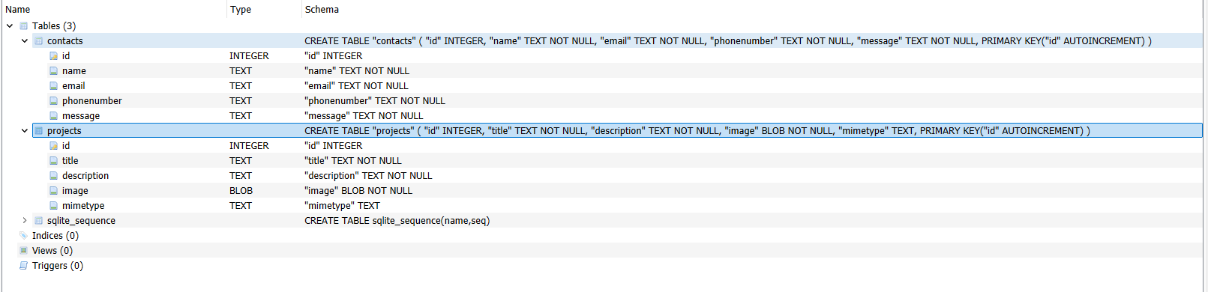

References
https://www.w3schools.com/sql/sql_datatypes.asp
https://www.w3schools.com/css/css_display.asp
https://stackoverflow.com/questions/71284939/read-img-file-from-db-using-flask-and-render-it-to-html?
I learned about blob and implemented this in my project. BLOB stands for Binary Large Object data types. BLOB is used to store images, videos and other files as binary data. This is done using the code image.read() which reads the image and converts it into binary data. The code mimetype = image.mimetype allows you to identify which type of image is it like JPEG, PNG and then store it in the database under the projects table. Flask retrieves this blob data and returns it to the browser using the response library.
I also learned about other CSS features such as flex end which aligns item to the right side of container and display: block which makes the element occupy one whole line.

