Studio 2

ChiaChi Huang:29432006

Self-Evaluation :

|  |  |  |  |  |  |
| --- | --- | --- | --- | --- | --- |
| Need Help | Work in Progress | Pass | Credit | Distinction | High Distinction |

Tutor Evaluation :

|  |  |  |  |  |  |
| --- | --- | --- | --- | --- | --- |
| Incomplete | Needs improvement | Pass | Credit | Distinction | High Distinction |

Task 1.1:

1. Screenshot of “Step 9” in the instructions

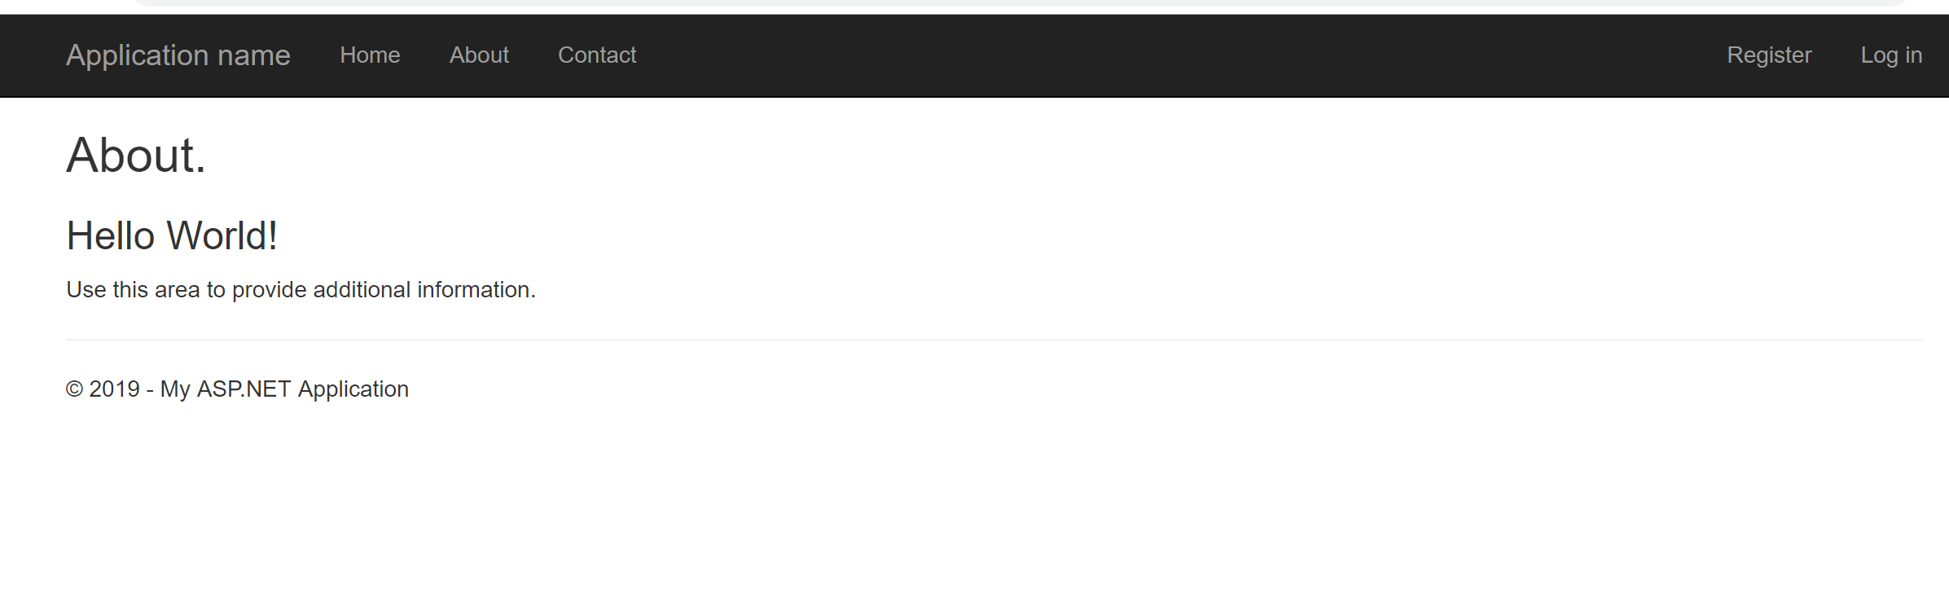

1. Project zipped and submitted on eFolio under Week03

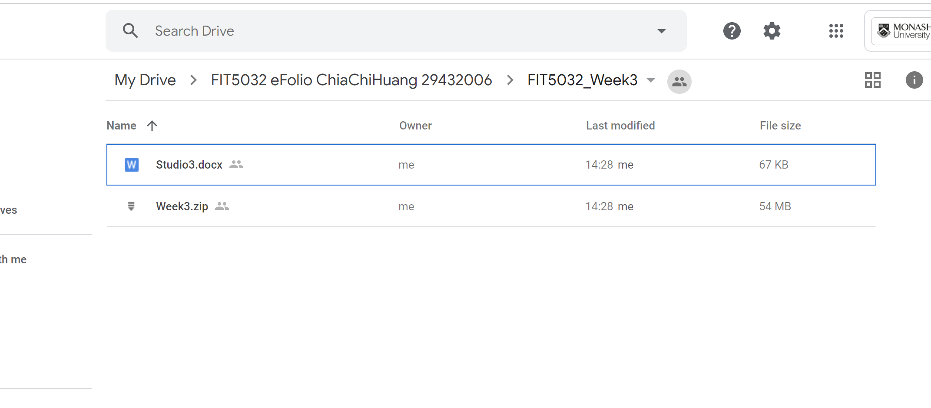

Task 1.2: