
College of Engineering, Construction, and Living Sciences
Bachelor of Information Technology (BIT)
Checkpoint-1, Semester 2, 2025
Automation of User, Process, and Permission Management in a Computing System
ID616001 Operating Systems Concepts
Level 6, Credits 15
Version 1.0

General Instructions
This checkpoint contributes 10% to your total course grade.
- All solutions must be your own original work. If you reference any external resources (online or offline), provide appropriate citations and credit.
- You may use online tools or websites (e.g., Google) to assist your work; however, all sources used must be properly acknowledged.
- This checkpoint will be conducted during class time under the supervision of your tutor.
- This is an open-book assessment.
- Collaboration is strictly prohibited. All tasks must be completed independently.

Submission Instructions
- Save your answer document using the following naming convention: <username>_checkpoint1_s22025.docx.
- Complete all tasks using the virtual machine (VM) assigned to you on the Azure cloud platform.
- Do not use any other VM.
- Record and document all steps taken during task execution. Include:
  - Screenshots of commands and outputs.
  - Any scripts or configuration files used.
  - Descriptive captions explaining each screenshot or script.
- Place your answers and supporting evidence in the designated response area for each question.
- Submit your completed document, along with all necessary files (scripts, screenshots, etc.), via the Assessment section of the Microsoft Teams course channel.

Learning Outcomes
• Perform automated user and permissions management in a computing system.

Assessment Objectives
You will be assessed on your ability to demonstrate the following competencies:
- Managing Linux user accounts, group memberships, home directories, and file permissions according to best practices.
- Parsing and analyzing system log files to identify critical issues and extract meaningful insights.
- Applying key Bash scripting constructs such as conditionals, loops, functions, and text-processing utilities (grep, awk, cut, sort, etc.) to solve real-world problems.

Task 1: Connect to Your Azure Virtual Machine Using PuTTY [15 Marks]
- Retrieve your VM Public IP Address [2 marks]
  - Log into your Azure account to retrieve the public IP address of your assigned VM.
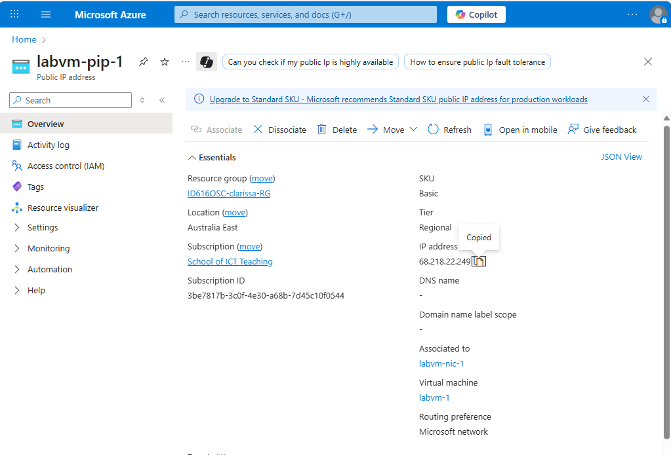
- Connect using PuTTY [5 marks]
  - Use the public IP address to connect remotely to the VM using PuTTY.
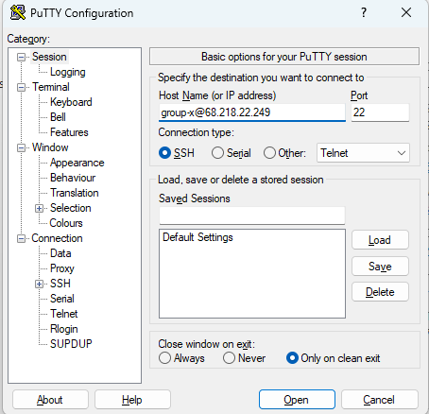
  - Log in using the initial username and password assigned to you (similar to what was used in labs). 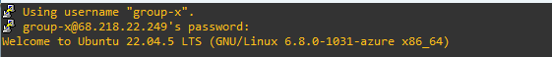3. Change the account username [5 marks]
  - Use appropriate Linux commands to change the current username to your actual student username
Added a new user named tempadmin -> sudo adduser username
Verify that it has been added -> id username
Log in into tempadmin, change the username
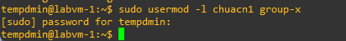
Change the username -> sudo usermod -1 <new> <old>
  - Ensure that all references (home directory, group name, ownership) are updated accordingly.
4. Change the password [3 marks]
- Set a new secure password for your user account using appropriate commands.
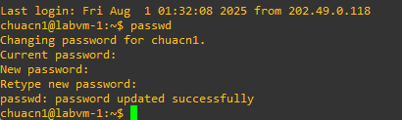
Used the passwd command to change the password
- Important: Do not use your institutional or school account password. Use a different secure password that you can remember for the duration of this lab.
Submission for Task 1:
Submit clear screenshots demonstrating each step of the task, each accompanied by a brief description explaining what the screenshot shows. Your submission must include:
- A successful SSH connection to the VM using PuTTY.
- The command(s) used to rename the user and modify associated directories/groups.
- Evidence of a successful password change (do not show the actual password).
Note: Screenshots submitted without accompanying explanations will not be awarded full marks.
Requirements for Task 2 and Task 3
To complete Task 2 and Task 3, you will need to retrieve required files from a GitHub repository. Follow the instructions below:
- GitHub Repository: https://github.com/OlayinkaOP/checkpoint1-files.git
- Cloning the Repository: Use the following command in your terminal to clone the repository: git clone https://github.com/OlayinkaOP/checkpoint1-files.git
- Ensure the repository is cloned successfully and the relevant files are accessible before proceeding.
Task Scenario
You have recently joined an Operations (Ops) team as an Intern System Administrator. Your team frequently onboards new users and monitors system logs for potential issues. As part of your duties, you are to automate both user management and system log analysis using Bash scripting.

Task 2: User On-boarding Automation [40 Marks]
Write a shell script named onboard_users.sh to automate the user onboarding process based on the data provided in a CSV file (users.csv). Each line in the file contains information in the format: username,groupname,shell.
Your script must handle user account creation, group assignment, directory setup, and logging, all with appropriate documentation.
Functional Requirements:
- Read and parse users.csv [5 marks]
    - Correctly open and loop through each line of users.csv.
    - Use IFS, read, or cut to extract fields (username, groupname, shell).

The terminal output is showing the content of the users.csv with their timestamp for viewing it
- Check and manage user accounts [5 marks]
    - Check if the user already exists.

    - If user exists, update their login shell to the specified shell in the CSV.
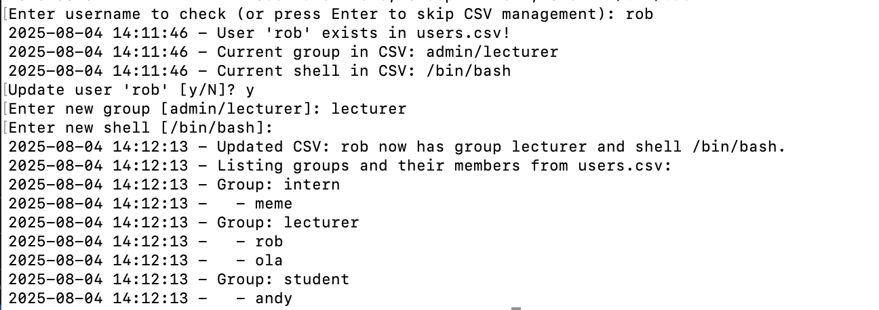
The terminal output shows that it successfully able to read that rob exist in the csv file and is able to update their shell and group
    - If the user does not exist, create the user with the specified shell.
- 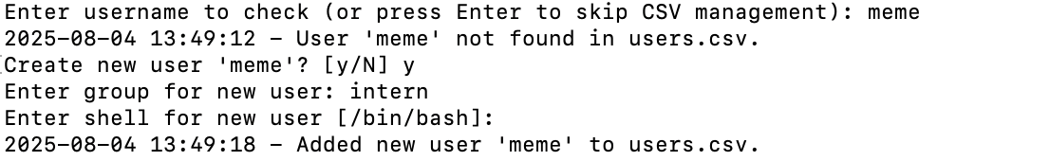
This terminal output is prompting user to enter a username to check if it exist in the csv file
If it doesn’t, it creates a new user, group and shell, press enter to keep it as [/bin/bash]

- Verify and manage group membership [5 marks]
    - Check if the specified group exists; if not, create it.
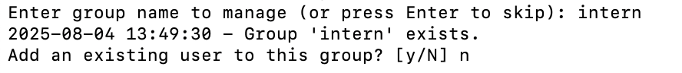
    - Ensure the user is added to the group.
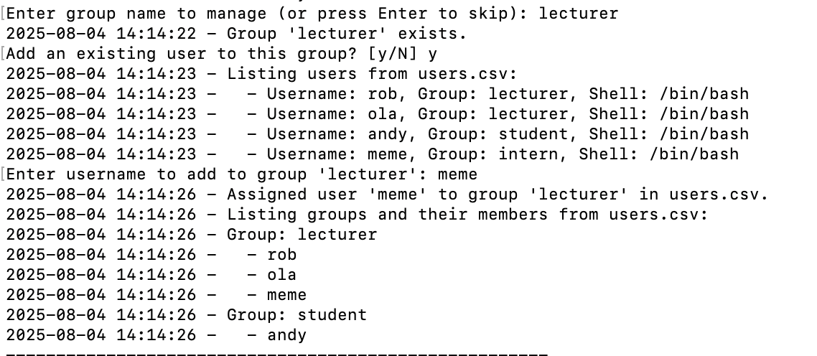
The terminal output shows that it recognises the existing group name and successfully enable user to add new user into the the group
- Setup home directory [5 marks]
    - Ensure that the user’s home directory is created with 700 permissions.
    - If it already exists, correct its permissions and ownership if needed.
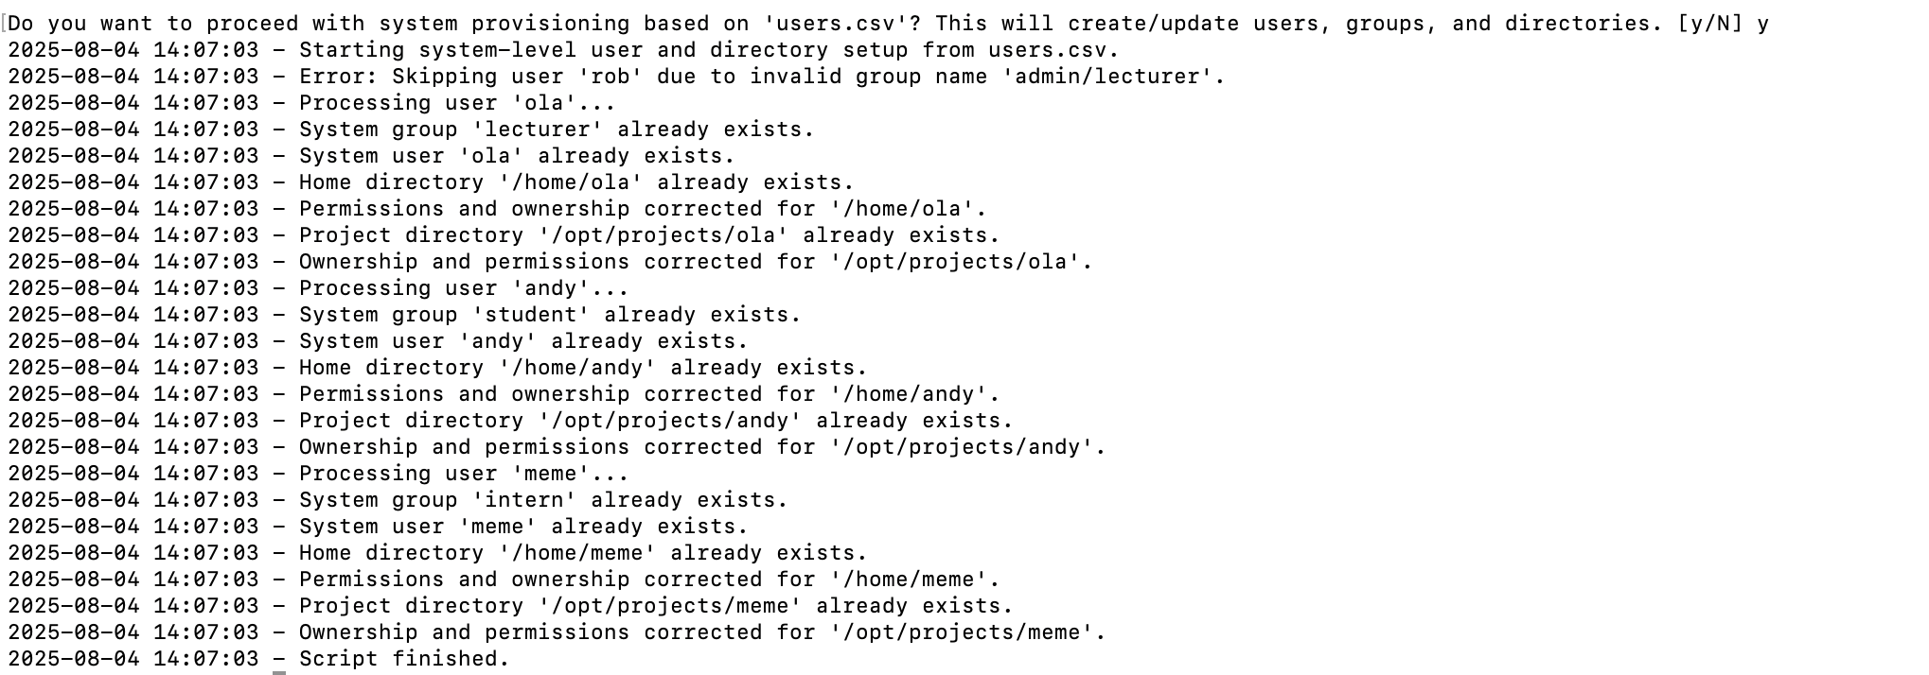
The terminal output successfully identifying the group and user and home directory exist
It failed for user rob du to invalid groupnaame, admin/lecturer
- Create a project directory for the user [5 marks] • Create a directory at /opt/projects/<username>.
    - Set ownership to <username>:<groupname>.
    - Set permissions to 750.

- Log actions to /var/log/user_onboarding_audit.log [5 marks]
    - Log every significant action (user creation, group addition, directory setup).
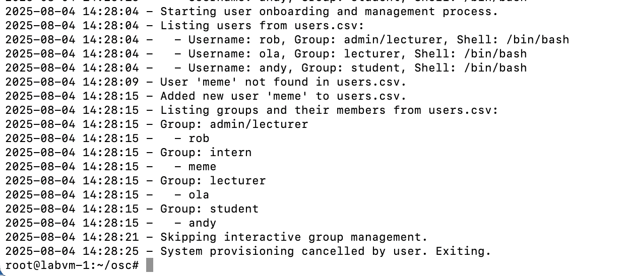
    - Include timestamps and clear messages.
- Implement error handling and input validation [5 marks]
    - Ensure the script continues processing other users if one entry fails.
    - Include checks for missing fields or invalid characters in usernames/groups.
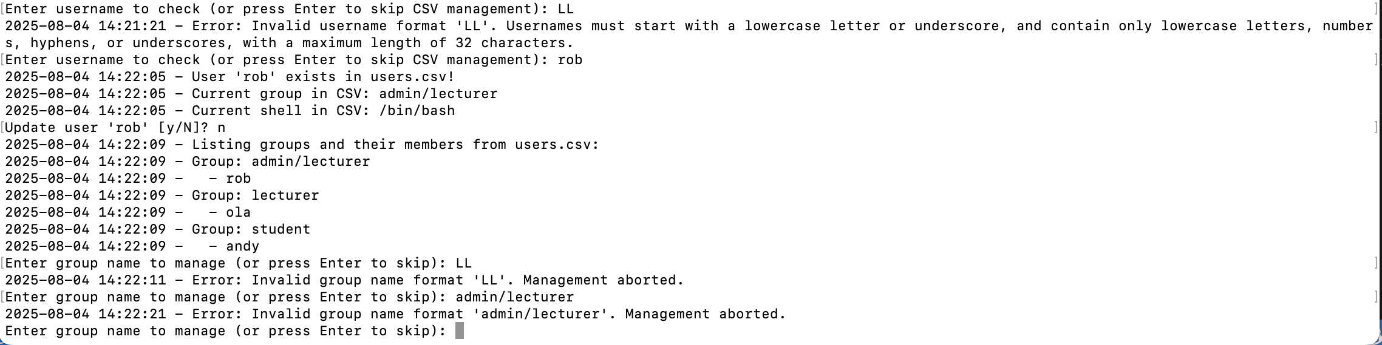
The terminal output shows that the script continues ask the user to try again after inputting invalid characters
User have to update user rob to either admin or lecturer in order for it to be valid
- Add inline comments to explain the logic [5 marks]
  - Provide clear, concise comments describing each major code block or decision.
Submission Instructions:
  - Submit the completed onboard_users.sh script.
  - Include screenshots showing:
    - Terminal output from running the script.
    - The contents of /var/log/user_onboarding_audit.log.
• All screenshots must include descriptive captions.

Task 3: Critical Log Analysis [20 Marks]
Script Name: critical_log_analysis.sh
This task requires you to develop a Bash script that processes and analyzes log data to identify and summarize critical system events. A log file called sys_log˙txt is included in the git repository. Follow the step-by-step instructions and perform the task associated below:
- Filter critical logs using keywords [5 marks]
    - Search the log file and extract only the lines containing ERROR, CRITICAL, FATAL log keywords.
    - Ensure the keyword matching is case-insensitive.
    - Use tools such as grep -i for pattern matching.
- Tokenize filtered logs into individual words [5 marks]
    - Convert the filtered log lines into individual tokens/words for further analysis.
    - Use utilities such as tr, awk, or sed to tokenize the text.
- Count frequency and Sort Word Frequencies [5 marks]
    - Compute the frequency of each token and sort them in descending order to identify the most frequent ones.
    - Your script should display the top 10 most frequent tokens.
    - Use tools like sort, uniq -c, and head.
- Save top 10 results (tokens) to a file named top10_critical.txt [5 marks]
  - Store the result of your top 10 frequent tokens into a file named top10_critical.txt.
Submission Requirements for Task 2:
  - critical_log_analysis.sh (your analysis script)
  - top10_critical.txt (output file of top 10 tokens)
  - Screenshot of terminal displaying the result of the top 10 tokens
  - 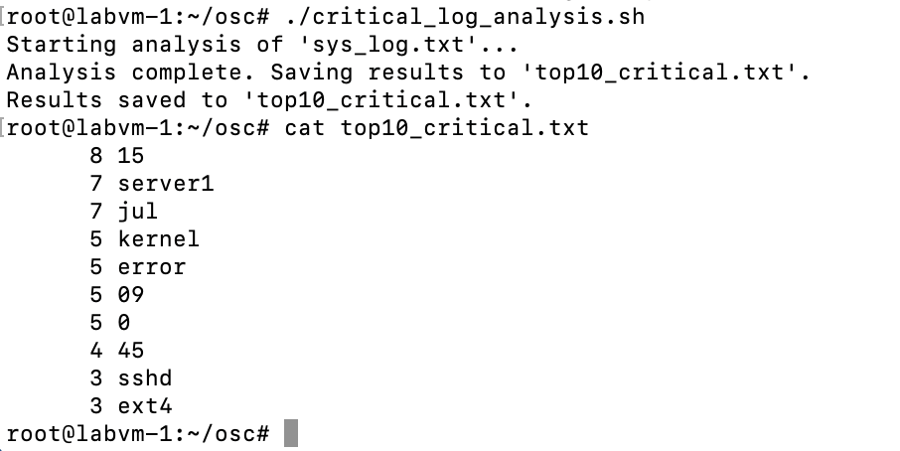

Code Defense Instructions and Key Requirements [25 Marks]
You must defend your code through a walkthrough. This includes:
- Explaining how your script works.
- Justifying your design and implementation decisions.
- Demonstrating awareness of error handling and validation.
- Responding to questions related to output interpretation and logic.

Final Submission Instructions
- Clone the GitHub repository and complete your work inside it.
- Your final submission must include:
  - onboard_users.sh
  - critical_log_analysis.sh
  - top10_critical.txt
  - <username>_checkpoint1_s22025.docx
  - All screenshots with descriptive captions ( integrate them into your report)
- Push your changes to your GitHub repository.
- Submit a clone of your GitHub repository through the MS Teams Assignment Channel.

Course Regulations
Refer to the course directive for full details on:
- Late Submission Penalties
- Referencing Style
- Plagiarism Policy
- Other Assessment Guidelines
Make sure you are familiar with and adhere to all course regulations.

Rubric Marking Sheet
Criteria | Max Marks | Marks Awarded
Task 1: VM Connection and User Setup [15 Marks]
Retrieve VM Public IP Address | 2
Connect to VM using PuTTY | 5
Change the account username | 5
Change the password | 3
Task 2: User Onboarding Automation [40 Marks]
Parse users.csv file correctly | 5
User account management (exist/create/update) | 5
Group creation and membership validation | 5
Home directory setup with permissions | 5
Project directory creation and permission setup | 5
Log significant actions with timestamps | 5
Error handling and input validation | 5
Inline comments and script readability | 5
Task 3: Critical Log Analysis [20 Marks]
Filter critical logs using keywords | 5
Tokenize filtered logs into individual words | 5
Count frequency and sort top 10 tokens | 5
Output written to top10_critical.txt | 5
Code Defense Presentation [25 Marks]
Clarity of explanation and walkthrough | 5
Justification of implementation choices | 5
Understanding of logic and flow | 5
Awareness of error handling/validation | 5
Responses to questions (completeness/confidence) | 5
Total | 100
Assessor’s Comments:

Assessor Name: Signature: Date:

