INTRODUCTION

The program is written to monitor the stock levels of a warehouse. The following information for a stock is monitored: product code, quantity on hand, reorder level, reorder quantity, supplier number, supplier address.

For each stock, the data to be stored is separated into 3 different files. See “File design details” section for how the data is separated.

File design details

The data monitored is stored into 3 different files, PRODUCT.DAT, SUPPLIER.DAT and ADDRESS.DAT.

File | Data stored | Field name: Field Type | Actual code
PRODUCT.DAT | Product Code  Quantity on hand,  Reorder level,  Reorder quantity | ProductCode: string[5]  QuantityOnHand: Integer  ReorderLevel: Integer  ReorderQuantity: Integer | record  ProductCode: TProducTCode;  QuantityOnHand,  ReorderLevel,  ReorderQuantity: Integer;  end;
SUPPLIER.DAT | Product Code  Supplier No | ProductCode: string[5]  SupplierNo: Integer | record  ProductCode: TProductCode  SupplierNo,  Reserved1, Reserved2: Integer;  end;
ADDRESS.DAT | Supplier No  Address | SupplierNo: Integer  Address: string[100] | record  SupplierNo: Integer;  Address: string[100];  end;

Each file is an array of buckets. Each bucket contains 50 records. Each record contains data as specified above.

As the program is written using Object Oriented (OO), the design of the file may not be seen directly from the code.

Record Creation Methods

There is a requirement to generate 2000 random product codes, conforming to the format NmmXX, where N is from 1 to 9, nn from 00 to 99, and X is A to J. So XX will produce the range from AA to JJ.

See the codes listed in the table below to see how each code is generated

Code used to generated Product Code.
Field | Code used to generate | Comments
N | Random(9) | Number from 0 to 8 is generated, so, +1 to get 1 to 9. Next, add the ordinal value of character ‘0’ to the generated number. This will give the numbers from ‘1’ to ‘9’
m | Random(10) | Number from 0 to 9 is generated. This code is run twice to get two numbers. Next, add the ordinal value of character ‘0’ to the generated number. This will give the numbers from ‘0’ to ‘9’
X | Random(11) | Generates a number from 0 to 10. Hence, to get A, B, C, D...J, just add the ordinal value of the character ‘A’ to the generated number. This code is run twice to get two alphabets.

Code used to generate supplier number.
Field | Code used to generate | Comments
SupplierNo | Random(32767)+1 | Generates a number from 0 to 32766. Adding 1 will guarantee that the generated numbers is from 1 to 32767.

Codu used to generated supplier address.
Field | Code used to generate | Comments
Address | Random(32767) | Generates a number from 0 to 32766. The program uses this for the address, by consolidating “ADDRESS ” followed by the number generated. So, for example, if 22057 is generated, the address for the supplier is “ADDRESS 22057”.

Hashing Index Design Details

In designing the storage of the data files, a simple hashing method is used. Each data that will be stored is uniquely identified by an index. So, for the Products, the product code will be used as the index, wherelse for the Supplier and the Supplier Address, the supplier number will be used as the index number.

Each file has a fixed number of buckets. In the design, 50 is used. To find the location where the data will be stored, a calculated is used (Index mod NumberOfBuckets). This calculation gives a value from 0 to 49. The location is then read, using a combination of Seek and BlockRead. If the location is occupied, the program then goes to the overflow area (which starts from location 50 onwards) and repeatedly looks for an unused location, it then stores the data there.

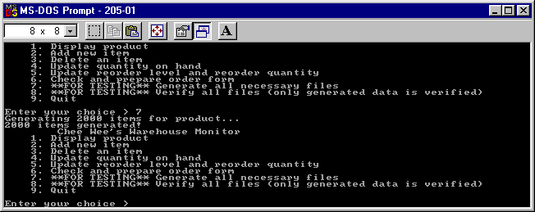
Results of File Processing
This screen capture shows the result after the products list is generated.

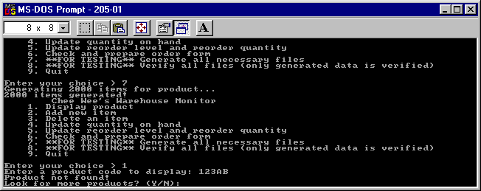
A search for a non-existent product.

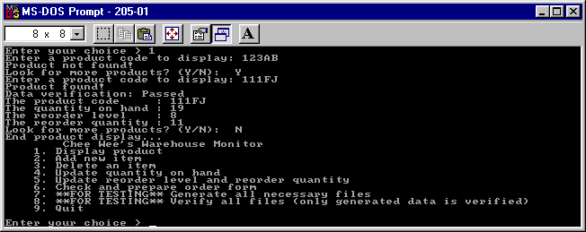
A search for a listed product.

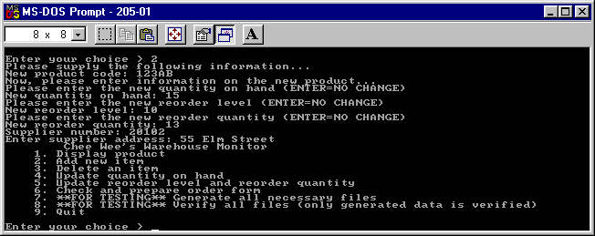
Adding a new product item

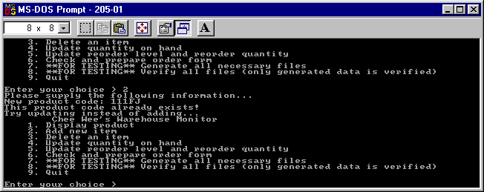
Adding a new item, that already exists...

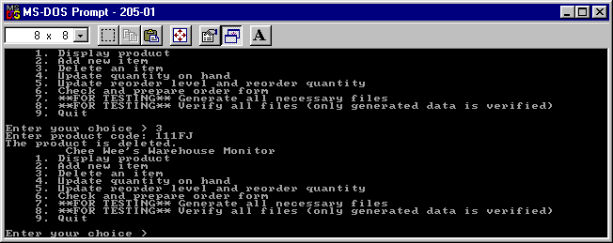
Deleting a product.

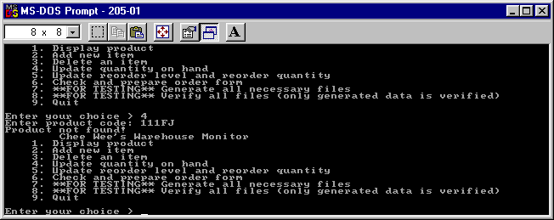
Updating a product which is non-existent.
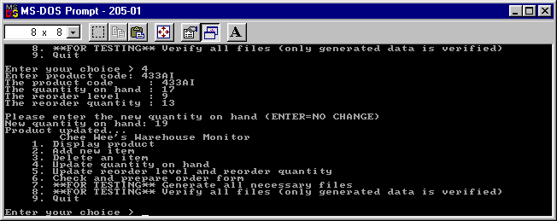
Updating a product.

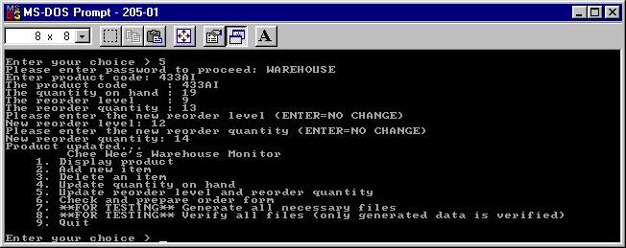
Updating a product’s reorder level and reorder quantity. The password used is WAREHOUSE

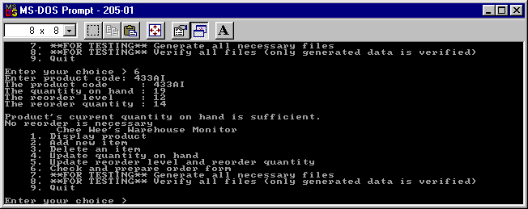
Checking a product’s levels to see if quantity is sufficient. (In this case, it is sufficient)

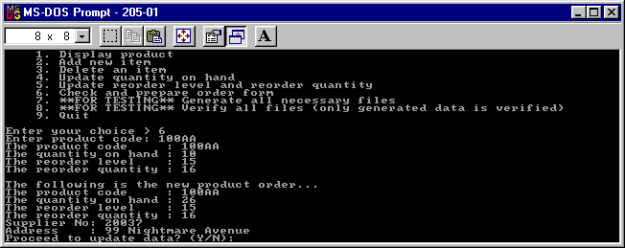
Checking a product which have insufficient levels.

Limitations

Due to the fact that the SUPPLIER.DAT file is indexed on the PRODUCT CODE, hence different manufacturers cannot have the same PRODUCT CODE.

Program Listing

UNIT FILE: BUCKETS.PAS
(contains the implementation for the object TbucketHashTable)

{ Chua Chee Wee
U/96/0237638
CIS205 Assignment 1
}
unit Buckets;
interface

const
BucketArraySize = 40;
UNUSED = 0;
type
TBucketResult =
(bktInserted, bktFound, bktNotFound, bktDeleted, bktUpdated);

{
A Bucket hashing object that works with any data size...
To use the bucket, call CreateTable.

CreateTable requires a filename, the number of buckets and the size
of a single bucket.

Any data should be declared as such...

TDataRecord = record
Fields...
end

BucketArray = array [0..BucketSize-1] of TDataRecord
One bucket contains many records...

hence, when creating the bucket, you go...
New(PSomethingBucket, CreateTable('FILENAME.DAT', NumberOfBucketsToCreate,
SizeOf(BucketArray));

}
TBucketHashTable = object
private
NumBuckets: Integer; { # of normal buckets }
MaxOverflow: Integer; { Index of last overflow Bucket }
CurrentBucket: Pointer; { A single Bucket }
Filename: string;
DataFile: file;
BucketSize: Integer;

procedure GetBucket(num: Longint);
procedure PutBucket(num: Longint);
procedure NewOverflow(var BucketProbes, ItemProbes: Integer);

public

destructor Done; virtual;

{ To override by descendants!!! }
function GetBucketDataStatus(ABucket: Pointer;
Index: Integer): Longint; virtual;

{ Gets the index for a record }
function DecodeBucketDataIndex(ABucketData: Pointer): Longint; virtual;

{ Sets a record inside a bucket status to unused... }
procedure ClearBucketData(ABucket: Pointer; Index: Integer); virtual;

{ Gets a record out of a bucket }
procedure GetBucketData(ACurrentBucket: Pointer; Index: Integer;
DestinationData: Pointer); virtual;

{ Copies a record from elsewhere into a bucket }
procedure SetBucketData(ABucket: Pointer; Index: Integer;
ABucketData: Pointer); virtual;

{
ABucketSize is the size in bytes, of each Bucket.
A Bucket consists of many items of items...
}
constructor CreateTable(AFilename: string;
ANumBuckets, ABucketSize: Integer);

constructor OpenTable(AFilename: string;
ANumBuckets, ABucketSize: Integer);

function InsertItem(BucketData: Pointer;
var BucketProbes,
ItemProbes: Integer): TBucketResult;

function FindItem(BucketData, TransferData: Pointer;
var BucketProbes,
ItemProbes: Integer): TBucketResult;

function DeleteItem(BucketData: Pointer;
var BucketProbes,
ItemProbes: Integer): TBucketResult;

function UpdateItem(BucketData: Pointer;
var BucketProbes,
ItemProbes: Integer): TBucketResult;

end;

implementation

{ Close the file if it is open }
destructor TBucketHashTable.Done;
begin
if (NumBuckets > 0) then Close(DataFile);
FreeMem(CurrentBucket, BucketSize);
end;

constructor TBucketHashTable.OpenTable(AFilename: string;
ANumBuckets, ABucketSize: Integer);
begin
Filename := AFilename; BucketSize := ABucketSize;
NumBuckets := ANumBuckets;
Assign(DataFile, Filename);
{$I-} Reset(DataFile, BucketSize); {$I+}
if IOResult=2 then {file not found}
Fail;
GetMem(CurrentBucket, BucketSize);
{ Provided the Record Size given is correct, this is how the max overflow
is calculated ... }
MaxOverflow := FileSize(DataFile)-1;
end;

{ Create a new hash table }
constructor TBucketHashTable.CreateTable(AFilename: string;
ANumBuckets, ABucketSize: Integer);
var
I: Integer;
begin
BucketSize := ABucketSize;
NumBuckets := ANumBuckets;
MaxOverflow := NumBuckets - 1;

{ Create the file }
Filename := AFilename;
Assign(DataFile, Filename);
Rewrite(DataFile, BucketSize);

GetMem(CurrentBucket, BucketSize);

{ For debugging purposes... The line below can be removed without harm... }
FillChar(CurrentBucket^, BucketSize, $FF);

{ Clear CurrentBucket }
for I := 0 to BucketArraySize - 1 do
ClearBucketData(CurrentBucket, I);

{ Write the empty buckets into the file }
for I := 0 to NumBuckets - 1 do
BlockWrite(DataFile, CurrentBucket^, 1);
end;

{ Converts a record into it's corresponding index }
function TBucketHashTable.DecodeBucketDataIndex(ABucketData: Pointer): Longint;
begin
{ Override!!! }
end;

{ Clears a record inside a bucket }
procedure TBucketHashTable.ClearBucketData(ABucket: Pointer; Index: Integer);
begin
{ Override!!! }
end;

{
Descendants actually do this...
Returns
DecodeBucketDataIndex(PSomeBucketDefinition(ABucket)^[Index]) as
the result of this function...
}
function TBucketHashTable.GetBucketDataStatus(ABucket: Pointer;
Index: Integer): Longint;
begin
{ Override!!! }
end;

{ Copies a record into a bucket
Index is the position of the record inside the bucket }
procedure TBucketHashTable.SetBucketData(ABucket: Pointer; Index: Integer;
ABucketData: Pointer);
begin
{ Override!!! }
end;

{
Copies a record out of a bucket
Index is the position of the record inside the bucket
}
procedure TBucketHashTable.GetBucketData(ACurrentBucket: Pointer;
Index: Integer;
DestinationData: Pointer);
begin
{ Override!!! }
end;

{ Insert an item in a hash table. Return bktFound if the
item is already in the table, bktInserted otherwise. }
function TBucketHashTable.InsertItem(BucketData: Pointer;
var BucketProbes,
ItemProbes: Integer): TBucketResult;
var
BucketPos, Pos: Integer;
BucketFull: Boolean;
BucketIndex: Longint;
begin
BucketProbes := 0;
ItemProbes := 0;

{ See if the item is already present. }
if (FindItem(BucketData, nil, BucketProbes, ItemProbes) =
bktFound) then
begin
InsertItem := bktFound;
exit;
end;

{ Get the Bucket where the item should be }
BucketIndex := abs(DecodeBucketDataIndex(BucketData));
BucketPos := (BucketIndex mod NumBuckets);
BucketProbes := BucketProbes + 1;
GetBucket(BucketPos);

{ See if the last position in the Bucket is used. }
ItemProbes := ItemProbes + 1;
BucketFull := GetBucketDataStatus(CurrentBucket, BucketArraySize - 1) <> UNUSED;

{ If the Bucket is full, use the last overflow Bucket. }
if (BucketFull) then
begin
BucketPos := MaxOverflow;
if (BucketPos < NumBuckets) then
begin
BucketFull := True
end else
begin
BucketProbes := BucketProbes + 1;
GetBucket(BucketPos);
BucketFull := GetBucketDataStatus(CurrentBucket, BucketArraySize - 1) <>
UNUSED;
end;
end;

{ If the overflow buckets are full, make a new one }
if (BucketFull) then
begin
NewOverflow(BucketProbes, ItemProbes);
BucketPos := MaxOverflow;
end;

{ At this point BucketPos gives the index of a Bucket
with at least one unused entry. Find the first
unused entry and use it. }
for Pos := 0 to BucketArraySize - 1 do
begin
ItemProbes := ItemProbes + 1;
if GetBucketDataStatus(CurrentBucket, Pos) = UNUSED then Break;
end;

{ Insert the item. }
SetBucketData(CurrentBucket, Pos, BucketData);

{ Update the data file. }
BucketProbes := BucketProbes + 1;
PutBucket(BucketPos);

InsertItem := bktInserted;
end;

{ Get a Bucket. }
procedure TBucketHashTable.GetBucket(num: Longint);
begin
Seek(DataFile, num);
BlockRead(DataFile, CurrentBucket^, 1);
end;

{ Save a Bucket to file. }
procedure TBucketHashTable.PutBucket(num: Longint);
begin
Seek(DataFile, num);
BlockWrite(DataFile, CurrentBucket^, 1);
end;

{ Create a new overflow Bucket. }
procedure TBucketHashTable.NewOverflow(var BucketProbes, ItemProbes: Integer);
var
i: Integer;
begin
{ Clear CurrentBucket. }
for i := 0 to BucketArraySize - 1 do
ClearBucketData(CurrentBucket, i);
ItemProbes := ItemProbes + BucketArraySize;

{ Write the new Bucket to disk. }
MaxOverflow := MaxOverflow + 1;
BucketProbes := BucketProbes + 1;
PutBucket(MaxOverflow);
end;

{ Locates an item in a hash table.
Optionally, copies the located item into another location, as indicated
by TransferData }
function TBucketHashTable.FindItem(BucketData: Pointer;
TransferData: Pointer;
var BucketProbes,
ItemProbes: Integer): TBucketResult;
var
BucketPos, Pos: Integer;
BucketIndex: Longint;
begin
BucketProbes := 0;
ItemProbes := 0;

{ Get the Bucket it belongs in. }
BucketIndex := abs(DecodeBucketDataIndex(BucketData));
BucketPos := (BucketIndex mod NumBuckets);
BucketProbes := BucketProbes + 1;
GetBucket(BucketPos);

{ Look for the item or an unused position. }
for Pos := 0 to BucketArraySize - 1 do
begin
ItemProbes := ItemProbes + 1;
if GetBucketDataStatus(CurrentBucket, Pos) = UNUSED then
begin
FindItem := bktNotFound; { not here }
exit;
end;
if GetBucketDataStatus(CurrentBucket, Pos) = BucketIndex then
begin
if TransferData<>nil then
GetBucketData(CurrentBucket, Pos, TransferData);
FindItem := bktFound; { found it. }
exit;
end;
end;

{ If we haven't found it, check the overflow buckets. }
for BucketPos := NumBuckets to MaxOverflow do
begin
BucketProbes := BucketProbes + 1;
GetBucket(BucketPos);

for Pos := 0 to BucketArraySize - 1 do
begin
ItemProbes := ItemProbes + 1;
if GetBucketDataStatus(CurrentBucket, Pos) = UNUSED then
begin
FindItem := bktNotFound; { It's not here. }
exit;
end;
if GetBucketDataStatus(CurrentBucket, Pos) = BucketIndex then
begin
if TransferData<>nil then
GetBucketData(CurrentBucket, Pos, TransferData);
FindItem := bktFound; { We found it. }
exit;
end;
end;
end;

{ If we still haven't found it, it's not here. }
FindItem := bktNotFound;
end;

{
Given a record, convert it into it's index, then based on that index,
try and locate the record in the bucket file. If located, clears
the record in the bucket file away... Doesn't actually delete the record in
the bucket. Just marked it unused...
}
function TBucketHashTable.DeleteItem(BucketData: Pointer;
var BucketProbes,
ItemProbes: Integer): TBucketResult;
var
BucketPos, Pos: Integer;
BucketIndex: Longint;
begin
BucketProbes := 0;
ItemProbes := 0;

{ Get the Bucket it belongs in. }
BucketIndex := abs(DecodeBucketDataIndex(BucketData));
BucketPos := (BucketIndex mod NumBuckets);
BucketProbes := BucketProbes + 1;
GetBucket(BucketPos);

{ Look for the item or an unused position. }
for Pos := 0 to BucketArraySize - 1 do
begin
ItemProbes := ItemProbes + 1;
if GetBucketDataStatus(CurrentBucket, Pos) = UNUSED then
begin
DeleteItem := bktNotFound; { not here }
exit;
end;
if GetBucketDataStatus(CurrentBucket, Pos) = BucketIndex then
begin
ClearBucketData(CurrentBucket, Pos);
PutBucket(BucketPos);
DeleteItem := bktDeleted; { Delete it! }
exit;
end;
end;

{ If we haven't found it, check the overflow buckets. }
for BucketPos := NumBuckets to MaxOverflow do
begin
BucketProbes := BucketProbes + 1;
GetBucket(BucketPos);

for Pos := 0 to BucketArraySize - 1 do
begin
ItemProbes := ItemProbes + 1;
if GetBucketDataStatus(CurrentBucket, Pos) = UNUSED then
begin
DeleteItem := bktNotFound; { It's not here. }
exit;
end;
if GetBucketDataStatus(CurrentBucket, Pos) = BucketIndex then
begin
ClearBucketData(CurrentBucket, Pos);
PutBucket(BucketPos);
DeleteItem := bktDeleted; { Deleted it! }
exit;
end;
end;
end;

{ If we still haven't found it, it's not here. }
DeleteItem := bktNotFound;
end;

{ Works by generating a BucketIndex from the data
pointed to by BucketData. Then, using the data pointed
to by BucketData, updates the item.

Same implementation as InsertItem, except that returns
different results...
}
function TBucketHashTable.UpdateItem(BucketData: Pointer;
var BucketProbes,
ItemProbes: Integer): TBucketResult;
var
BucketPos, Pos: Integer;
BucketIndex: Longint;
begin
BucketProbes := 0;
ItemProbes := 0;

{ Get the Bucket it belongs in. }
BucketIndex := abs(DecodeBucketDataIndex(BucketData));
BucketPos := (BucketIndex mod NumBuckets);
BucketProbes := BucketProbes + 1;
GetBucket(BucketPos);

{ Look for the item or an unused position. }
for Pos := 0 to BucketArraySize - 1 do
begin
ItemProbes := ItemProbes + 1;
if GetBucketDataStatus(CurrentBucket, Pos) = UNUSED then
begin
UpdateItem := bktNotFound; { not here }
exit;
end;
if GetBucketDataStatus(CurrentBucket, Pos) = BucketIndex then
begin
SetBucketData(CurrentBucket, Pos, BucketData);
PutBucket(BucketPos);
UpdateItem := bktUpdated; { Updated it! }
exit;
end;
end;

{ If we haven't found it, check the overflow buckets. }
for BucketPos := NumBuckets to MaxOverflow do
begin
BucketProbes := BucketProbes + 1;
GetBucket(BucketPos);

for Pos := 0 to BucketArraySize - 1 do
begin
ItemProbes := ItemProbes + 1;
if GetBucketDataStatus(CurrentBucket, Pos) = UNUSED then
begin
UpdateItem := bktNotFound; { It's not here. }
exit;
end;
if GetBucketDataStatus(CurrentBucket, Pos) = BucketIndex then
begin
SetBucketData(CurrentBucket, Pos, BucketData);
PutBucket(BucketPos);
UpdateItem := bktUpdated; { Updated it! }
exit;
end;
end;
end;

{ If we still haven't found it, it's not here. }
UpdateItem := bktNotFound;
end;

end.

Main program file

{ Chua Chee Wee
CIS205 Assignment 1
U/96/0237638
Warehouse Monitor v1.0
Needs TP/BP 7.0 or later version...

WARNING! DO NOT RUN ON PENTIUM II 233 or later...
CRT's Delay fails... when run on PII-233+
}
program Warehouse_Monitor;
uses Crt, Buckets;

const
NumberOfBuckets = 50;

type

TProductCode = string[5];
PProductData = ^TProductData;
TProductData = record
ProductCode: TProductCode; { key }
QuantityOnHand,
ReorderLevel,
ReorderQuantity: Integer;
end;

PSupplier = ^TSupplier;
TSupplier = record { Current key is ProductCode }
ProductCode: TProductCode;
SupplierNo,
Reserved1, Reserved2: Integer;
end;

PSupplierAddress = ^TSupplierAddress;
TSupplierAddress = record
SupplierNo: Integer; { key }
Address: string[30];
end;

PProductBucket = ^TProductBucket;
TProductBucket = array [0..BucketArraySize - 1] of TProductData;

PSupplierBucket = ^TSupplierBucket;
TSupplierBucket = array [0..BucketArraySize - 1] of TSupplier;

PSupplierAddressBucket = ^TSupplierAddressBucket;
TSupplierAddressBucket = array [0..BucketArraySize - 1] of TSupplierAddress;

{ See BUCKET.PAS for these virtual/overide methods }
PProductHashTable = ^TProductHashTable;
TProductHashTable = object(TBucketHashTable)
procedure ClearBucketData(ABucket: Pointer; Index: Integer); virtual;
function GetBucketDataStatus(ABucket: Pointer; Index: Integer): Longint; virtual;
function DecodeBucketDataIndex(ABucketData: Pointer): Longint; virtual;
procedure SetBucketData(ABucket: Pointer; Pos: Integer; ABucketData: Pointer); virtual;
procedure GetBucketData(ACurrentBucket: Pointer; Index: Integer;
DestinationData: Pointer); virtual;
end;

PSupplierTable = ^TSupplierTable;
TSupplierTable = object(TBucketHashTable)
procedure ClearBucketData(ABucket: Pointer; Index: Integer); virtual;
function GetBucketDataStatus(ABucket: Pointer; Index: Integer): Longint; virtual;
function DecodeBucketDataIndex(ABucketData: Pointer): Longint; virtual;
procedure SetBucketData(ABucket: Pointer; Pos: Integer; ABucketData: Pointer); virtual;
procedure GetBucketData(ACurrentBucket: Pointer; Index: Integer;
DestinationData: Pointer); virtual;
end;

PSupplierAddressTable = ^TSupplierAddressTable;
TSupplierAddressTable = object(TBucketHashTable)
procedure ClearBucketData(ABucket: Pointer; Index: Integer); virtual;
function GetBucketDataStatus(ABucket: Pointer; Index: Integer): Longint; virtual;
function DecodeBucketDataIndex(ABucketData: Pointer): Longint; virtual;
procedure SetBucketData(ABucket: Pointer; Pos: Integer; ABucketData: Pointer); virtual;
procedure GetBucketData(ACurrentBucket: Pointer; Index: Integer;
DestinationData: Pointer); virtual;
end;

{
Input: string s
Output: s is converted into all caps
}
procedure UpStr(var s: OpenString);
var
I: Integer;
begin
for I := 1 to Length(s) do s[I] := UpCase(s[I]);
end;

{
Input: TProductData Data
Output: Displays various fields of Data on screen
}
procedure ShowProductData(var Data: TProductData);
begin
with Data do
begin
WriteLn('The product code : ', ProductCode);
WriteLn('The quantity on hand : ', QuantityOnHand);
WriteLn('The reorder level : ', ReorderLevel);
WriteLn('The reorder quantity : ', ReorderQuantity);
end;
end;

{ Convert a product code into it's index }
function ProductCodeToIndex(ProductCode: TProductCode): Longint;
var
I, J, K, L, M: Integer;
begin
if ProductCode<>'' then
begin
I := Ord(ProductCode[1])-Ord('0');
J := Ord(ProductCode[2])-Ord('0');
K := Ord(ProductCode[3])-Ord('0');
L := Ord(ProductCode[4])-Ord('A');
M := Ord(ProductCode[5])-Ord('A');
ProductCodeToIndex := Longint(I)*10000+J*1000+K*100+L*10+M;
end else
ProductCodeToIndex := UNUSED;
end;

{ Verify that a product code is in the format
xYYAA
where x is 1-9,
YY is 00..99
AA is AA..JJ
}
function VerifyProductCode(var ProductData: TProductData): Boolean;
begin
with ProductData do
VerifyProductCode := (ProductCode[1] in ['1'..'9']) and
(ProductCode[2] in ['0'..'9']) and
(ProductCode[3] in ['0'..'9']) and
(ProductCode[4] in ['A'..'J']) and
(ProductCode[5] in ['A'..'J']);

end;

procedure UpdateInteger(Fieldname: string; var UpdateInteger: Integer);
var
sNewInteger: string[5];
Error, NewInteger: Integer;
begin
WriteLn('Please enter the new ', Fieldname, ' (ENTER=NO CHANGE)');
Write('New ', Fieldname,': ');
ReadLn(sNewInteger);
Val(sNewInteger, NewInteger, Error);
if Error=0 then
UpdateInteger := NewInteger;
end;

procedure UpdateProductData(var ProductData: TProductData;
UpdateQuantityOnHand,
UpdateReorderLevel,
UpdateReorderQuantity: Boolean);
begin
if UpdateQuantityOnHand then
UpdateInteger('quantity on hand', ProductData.QuantityOnHand);
if UpdateReorderLevel then
UpdateInteger('reorder level', ProductData.ReorderLevel);
if UpdateReorderQuantity then
UpdateInteger('reorder quantity', ProductData.ReorderQuantity);
end;

function PromptYesNo(Prompt: string): Char;
var
Ch: Char;
begin
Write(Prompt, '? (Y/N): ');
repeat
Ch := UpCase(ReadKey)
until Ch in ['Y', 'N'];
WriteLn(Ch);
PromptYesNo := Ch;
end;

function ProductValuesChanged(var ProductData,
NewProductData: TProductData): Boolean;
begin
ProductValuesChanged :=
(ProductData.QuantityOnHand <> NewProductData.QuantityOnHand) or
(ProductData.ReorderLevel <> NewProductData.ReorderLevel) or
(ProductData.ReorderQuantity <> NewProductData.ReorderQuantity);

end;

procedure TProductHashTable.ClearBucketData(ABucket: Pointer; Index: Integer);
begin
PProductBucket(ABucket)^[Index].ProductCode := '';
end;

function TProductHashTable.GetBucketDataStatus(ABucket: Pointer; Index: Integer): Longint;
begin
GetBucketDataStatus := DecodeBucketDataIndex(@PProductBucket(ABucket)^[Index]);
end;

procedure TProductHashTable.SetBucketData(ABucket: Pointer; Pos: Integer; ABucketData: Pointer);
begin
PProductBucket(ABucket)^[Pos] := PProductData(ABucketData)^;
end;

function TProductHashTable.DecodeBucketDataIndex(ABucketData: Pointer): Longint;
begin
with PProductData(ABucketData)^ do
DecodeBucketDataIndex := ProductCodeToIndex(ProductCode);
end;

procedure TProductHashTable.GetBucketData(ACurrentBucket: Pointer;
Index: Integer;
DestinationData: Pointer);
begin
PProductData(DestinationData)^ := PProductBucket(ACurrentBucket)^[Index];
end;

{ New... }
procedure TSupplierTable.ClearBucketData(ABucket: Pointer; Index: Integer);
begin
with PSupplierBucket(ABucket)^[Index] do
begin
{ SupplierNo:= UNUSED; }
ProductCode := '';
end;
end;

function TSupplierTable.GetBucketDataStatus(ABucket: Pointer; Index: Integer): Longint;
begin
GetBucketDataStatus := DecodeBucketDataIndex(@PSupplierBucket(ABucket)^[Index]);
end;

procedure TSupplierTable.SetBucketData(ABucket: Pointer; Pos: Integer; ABucketData: Pointer);
begin
PSupplierBucket(ABucket)^[Pos] := PSupplier(ABucketData)^;
end;

function TSupplierTable.DecodeBucketDataIndex(ABucketData: Pointer): Longint;
begin
with PSupplier(ABucketData)^ do
DecodeBucketDataIndex := {Longint(SupplierNo)*100000+}
ProductCodeToIndex(ProductCode);
end;

{ Copy a record into the bucket }
procedure TSupplierTable.GetBucketData(ACurrentBucket: Pointer;
Index: Integer;
DestinationData: Pointer);
begin
PSupplier(DestinationData)^ := PSupplierBucket(ACurrentBucket)^[Index];
end;

{ Set a record's status as UNUSED. This record is inside a bucket }
procedure TSupplierAddressTable.ClearBucketData(ABucket: Pointer; Index: Integer);
begin
PSupplierAddressBucket(ABucket)^[Index].SupplierNo := UNUSED;
end;

{ Get a record's index or status }
function TSupplierAddressTable.GetBucketDataStatus(ABucket: Pointer; Index: Integer): Longint;
begin
GetBucketDataStatus := DecodeBucketDataIndex(@PSupplierAddressBucket(ABucket)^[Index]);
end;

{ Copy a record into a bucket }
procedure TSupplierAddressTable.SetBucketData(ABucket: Pointer; Pos: Integer; ABucketData: Pointer);
begin
PSupplierAddressBucket(ABucket)^[Pos] := PSupplierAddress(ABucketData)^;
end;

function TSupplierAddressTable.DecodeBucketDataIndex(ABucketData: Pointer): Longint;
begin
with PSupplierAddress(ABucketData)^ do
DecodeBucketDataIndex := SupplierNo;
end;

procedure TSupplierAddressTable.GetBucketData(ACurrentBucket: Pointer;
Index: Integer;
DestinationData: Pointer);
begin
PSupplierAddress(DestinationData)^ :=
PSupplierAddressBucket(ACurrentBucket)^[Index];
end;

function GenerateProductCode: TProductCode;
var
I, J, K, A1, A2: Integer;
s1, s2, s3, s4, s5: string[1];
begin
I := Random(9)+1; { Guarantee greater than zero by +1}
J := Random(10); { Generate from 0 to 9}
K := Random(10);
A1 := Random(11); { Generate from 0 to 10 ie... A to J }
A2 := Random(11);
s1 := Chr(I+Ord('0'));
s2 := Chr(J+Ord('0'));
s3 := Chr(K+Ord('0'));
s4 := Chr(Ord(A1)+Ord('A'));
s5 := Chr(Ord(A2)+Ord('A'));
GenerateProductCode := s1+s2+s3+s4+s5;
end;

procedure GenerateSupplierNo(var Supplier: TSupplier);
var
I: Integer;
begin
I := Random(32767)+1;
Supplier.SupplierNo := I;
end;

procedure GenerateSupplierAddress(var SupplierAddress: TSupplierAddress);
var
s: string[20];
I: Longint;
begin
I := Random(32767);
Str(I, s);
FillChar(SupplierAddress.Address, SizeOf(SupplierAddress.Address), 0);
SupplierAddress.Address := 'ADDRESS '+s;
end;

procedure GenerateProductData(var ProductData: TProductData);
begin
with ProductData do
begin
ProductCode := GenerateProductCode;
ReorderLevel := 7+Random(3)+1;
QuantityOnHand := 15+Random(5)+1;
ReorderQuantity := 10+Random(5)+1;
end;
end;

var
ProductTable: PProductHashTable;
SupplierTable: PSupplierTable;
SupplierAddressTable: PSupplierAddressTable;

function ProductDisplay: Boolean; far;
const
sVerifyData: array[Boolean] of string[6]=('Failed', 'Passed');
var
FoundProductData, ProductData: TProductData;
s: TProductCode;
ProductTable: PProductHashTable;
Quit: Boolean;
BucketProbes, ItemProbes: Integer;
begin
ProductDisplay := False;
ProductTable := New(PProductHashTable, OpenTable('PRODUCT.DAT',
NumberOfBuckets, SizeOf(TProductBucket)));
repeat
Write('Enter a product code to display: ');
ReadLn(s);
UpStr(s);
ProductData.ProductCode := s;
if ProductTable^.FindItem(@ProductData, @FoundProductData, BucketProbes,
ItemProbes)=bktFound then
begin
WriteLn('Product found!');
WriteLn('Data verification: ',
sVerifyData[VerifyProductCode(ProductData)]);
ShowProductData(FoundProductData);
end else
begin
WriteLn('Product not found!');
end;
Quit := PromptYesNo('Look for more products')='N';
until Quit;
WriteLn('End product display...');
Dispose(ProductTable, Done);
end;

function ProductAdd: Boolean; far;
var
ProductData: TProductData;
Supplier: TSupplier;
SupplierAddress: TSupplierAddress;
BucketProbes, ItemProbes: Integer;
SupplierResult: TBucketResult;
begin
ProductAdd := False;
WriteLn('Please supply the following information...');
Write('New product code: '); ReadLn(ProductData.ProductCode);
UpStr(ProductData.ProductCode);
if ProductTable^.FindItem(@ProductData, @ProductData, BucketProbes,
ItemProbes)=bktFound then
begin
WriteLn('This product code already exists!');
WriteLn('Try updating instead of adding...');
exit;
end else
begin
WriteLn('Now, please enter information on the new product...');
{ Update all values on product data }
UpdateProductData(ProductData, True, True, True);
ProductTable^.InsertItem(@ProductData, BucketProbes, ItemProbes);
end;
Write('Supplier number: '); ReadLn(Supplier.SupplierNo);
Supplier.ProductCode := ProductData.ProductCode;
SupplierResult := SupplierTable^.InsertItem(@Supplier, BucketProbes,
ItemProbes);
if SupplierResult<>bktInserted then
WriteLn('The supplier already supplies this product!!!') else
begin
Write('Enter supplier address: ');
ReadLn(SupplierAddress.Address);
SupplierAddress.SupplierNo := Supplier.SupplierNo;
{ The following should succeed, since the supplier doesn't exist... }
SupplierAddressTable^.InsertItem(@SupplierAddress, BucketProbes,
ItemProbes);
end;
end;

function ProductDelete: Boolean; far;
var
ProductData: TProductData;
s: string;
BucketProbes, ItemProbes: Integer;
begin
ProductDelete := False;
Write('Enter product code: ');
ReadLn(s); UpStr(s);
ProductData.ProductCode := s;
if ProductTable^.DeleteItem(@ProductData, BucketProbes,
ItemProbes)<>bktDeleted then
WriteLn('The product doesn''t exist!') else
WriteLn('The product is deleted.');
end;

function ProductUpdateQuantity: Boolean; far;
var
ProductCode: TProductCode;
ProductData, FoundProductData: TProductData;
BucketProbes, ItemProbes: Integer;
begin
ProductUpdateQuantity := False;
Write('Enter product code: ');
Readln(ProductCode); UpStr(ProductCode);
ProductData.ProductCode := ProductCode;
if ProductTable^.FindItem(@ProductData, @FoundProductData, BucketProbes,
ItemProbes)=bktFound then
begin
ShowProductData(FoundProductData);
WriteLn;
ProductData := FoundProductData;
UpdateProductData(ProductData, True, False, False);
{FoundProductData will contain the old data if ProductData changed,
hence ProductValuesChanged do a compare on both, so as to check...}
if ProductValuesChanged(ProductData, FoundProductData) then
ProductTable^.UpdateItem(@ProductData, BucketProbes, ItemProbes);
WriteLn('Product updated...');
end else
begin
WriteLn('Product not found!');
end;
end;

function ProductUpdateReorder: Boolean; far;
var
Password: string;
ProductCode: TProductCode;
ProductData, FoundProductData: TProductData;
BucketProbes, ItemProbes: Integer;
begin
ProductUpdateReorder := False;
Write('Please enter password to proceed: ');
ReadLn(Password);
if Password='WAREHOUSE' then
begin
Write('Enter product code: ');
Readln(ProductCode); UpStr(ProductCode);
ProductData.ProductCode := ProductCode;
if ProductTable^.FindItem(@ProductData, @FoundProductData, BucketProbes,
ItemProbes)=bktFound then
begin
ShowProductData(FoundProductData);
ProductData := FoundProductData;
UpdateProductData(ProductData, False, True, True);
if ProductValuesChanged(ProductData, FoundProductData) then
ProductTable^.UpdateItem(@ProductData, BucketProbes, ItemProbes);
WriteLn('Product updated...');
end else
begin
WriteLn('Product not found!');
end;
end else
begin
WriteLn('Password wrong!');
WriteLn('Access denied...');
end;
end;

function ProductOrderForm: Boolean; far;
var
ProductCode: TProductCode;
ProductData, FoundProductData: TProductData;
FoundSupplier, Supplier: TSupplier;
FoundSupplierAddress, SupplierAddress: TSupplierAddress;
BucketProbes, ItemProbes: Integer;
begin
ProductOrderForm := False;
Write('Enter product code: ');
Readln(ProductCode); UpStr(ProductCode);
ProductData.ProductCode := ProductCode;
if ProductTable^.FindItem(@ProductData, @FoundProductData, BucketProbes,
ItemProbes)=bktFound then
begin
ShowProductData(FoundProductData);
WriteLn;
ProductData := FoundProductData;
with ProductData do
begin
if QuantityOnHand<=ReorderLevel then
Inc(QuantityOnHand, ReorderQuantity) else
begin
WriteLn('Product''s current quantity on hand is sufficient.');
WriteLn('No reorder is necessary');
exit;
end;
end;
WriteLn('The following is the new product order...');
ShowProductData(ProductData);
Supplier.ProductCode := ProductData.ProductCode;
if SupplierTable^.FindItem(@Supplier, @FoundSupplier, BucketProbes,
ItemProbes)<>bktFound then
begin
WriteLn('Supplier is expected to be found, but is missing.');
WriteLn('Unable to continue...');
exit;
end;
SupplierAddress.SupplierNo := FoundSupplier.SupplierNo;
SupplierAddressTable^.FindItem(@SupplierAddress, @FoundSupplierAddress,
BucketProbes, ItemProbes);
WriteLn('Supplier No: ', FoundSupplier.SupplierNo);
WriteLn('Address : ', FoundSupplierAddress.Address);
{ UpdateProductData(ProductData, True, False, False); }
{ if ProductValuesChanged(ProductData, FoundProductData) then }
if PromptYesNo('Proceed to update data')='Y' then
begin
ProductTable^.UpdateItem(@ProductData, BucketProbes, ItemProbes);
WriteLn('Product updated...');
end else
WriteLn('Product not updated...');
end else
begin
WriteLn('Product not found!');
end;
end;

function ProductGenerate: Boolean; far;
var
ProductData: TProductData;
Supplier: TSupplier;
SupplierAddress: TSupplierAddress;
ProductsGenerated, SuppliersGenerated: Integer;
InsertResult: TBucketResult;
AddressFile, CodeFile, SupplierNoFile: Text;
BucketProbes, ItemProbes: Integer;
begin
ProductGenerate := False;
if SupplierAddressTable<>nil then Dispose(SupplierAddressTable, Done);
if SupplierTable<>nil then Dispose(SupplierTable, Done);
if ProductTable<>nil then Dispose(ProductTable, Done);
ProductTable := New(PProductHashTable, CreateTable('PRODUCT.DAT',
NumberOfBuckets, SizeOf(TProductBucket)));
SupplierTable:= New(PSupplierTable, CreateTable('SUPPLIER.DAT',
NumberOfBuckets, SizeOf(TSupplierBucket)));
SupplierAddressTable:= New(PSupplierAddressTable, CreateTable('ADDRESS.DAT',
NumberOfBuckets, SizeOf(TSupplierAddressBucket)));
SuppliersGenerated := 0; Supplier.SupplierNo := 0;
Assign(CodeFile, 'CODES.TXT');
Rewrite(CodeFile);
Assign(SupplierNoFile, 'SUPPLIER.TXT');
Rewrite(SupplierNoFile);
Assign(AddressFile, 'ADDRESS.TXT');
Rewrite(AddressFile);
Randomize;
WriteLn('Generating 2000 items for product...');
for ProductsGenerated := 0 to 1999 do
begin
if ProductsGenerated mod 66=0 then { Generate 30 suppliers }
begin
Inc(SuppliersGenerated);
if SuppliersGenerated<=30 then
begin
GenerateSupplierNo(Supplier);
SupplierAddress.SupplierNo := Supplier.SupplierNo;
GenerateSupplierAddress(SupplierAddress);
WriteLn(AddressFile, Supplier.SupplierNo, ' ',SupplierAddress.Address);
InsertResult := SupplierAddressTable^.InsertItem(@SupplierAddress,
BucketProbes, ItemProbes);
end;
end;
Write('Generating item ', ProductsGenerated+1:4, #13);
repeat
GenerateProductData(ProductData);
InsertResult := ProductTable^.InsertItem(@ProductData, BucketProbes,
ItemProbes);
until InsertResult=bktInserted;
WriteLn(CodeFile, ProductData.ProductCode);
Supplier.ProductCode := ProductData.ProductCode;
WriteLn(SupplierNoFile, Supplier.SupplierNo:5, ' ', Supplier.ProductCode);
InsertResult := SupplierTable^.InsertItem(@Supplier, BucketProbes,
ItemProbes);
end;
WriteLn(ProductsGenerated+1, ' items generated!');
Close(AddressFile);
Close(SupplierNoFile);
Close(CodeFile);
end;

function ProductVerify: Boolean; far;
var
ProductData: TProductData; SupplierAddress: TSupplierAddress;
s: string;
ProductTable: PProductHashTable;
SupplierAddressTable: PSupplierAddressTable;
BucketProbes, ItemProbes: Integer;
Found, J, I, Error: Integer;
f: Text;
begin
ProductVerify := False;
Assign(f, 'CODES.TXT');
{$I-} Reset(f); {$I+}
if IOResult=2 then
begin
WriteLn('You must generate all files first!!!');
exit;
end;
ProductTable := New(PProductHashTable, OpenTable('PRODUCT.DAT',
NumberOfBuckets, SizeOf(TProductBucket)));
Found := 0; J := 0;
while not eof(f) do
begin
Readln(f, s);
Inc(J);
UpStr(s);
ProductData.ProductCode := s;
if ProductTable^.FindItem(@ProductData, nil, BucketProbes,
ItemProbes)=bktFound then
begin
Inc(Found);
end;
Write('Verifying for product item ', J: 4, ': ', s, ' found: ', Found: 4, #13);
end;
WriteLn;
WriteLn('Verifying products done!');
SupplierAddressTable:= New(PSupplierAddressTable, OpenTable('ADDRESS.DAT',
NumberOfBuckets, SizeOf(TSupplierAddressBucket)));
Close(f);
Assign(f, 'ADDRESS.TXT');
Reset(f);
Found := 0; J := 0;
while not eof(f) do
begin
Readln(f, s);
I := Pos(' ',s);
Delete(s, I, Length(s));
Val(s, I, Error);
SupplierAddress.SupplierNo := I;
Inc(J);
if SupplierAddressTable^.FindItem(@SupplierAddress, nil, BucketProbes,
ItemProbes)=bktFound then
begin
Inc(Found);
end;
Write('Verifying for address item ', J, ': ', s, ' found: ', Found, #13);
end;
WriteLn;
WriteLn('Verifying addresses done!');
Dispose(SupplierAddressTable, Done);
Dispose(ProductTable, Done);
end;

function QuitWarehouse: Boolean; far;
begin
QuitWarehouse := True;
end;

{
Tries and open each table...
PRODUCT - 1st file
SUPPLIER - 2nd file
ADDRESS - 3rd file

If the open fails, then creates the file...
}
procedure Init;
begin
ProductTable := New(PProductHashTable, OpenTable('PRODUCT.DAT',
NumberOfBuckets, SizeOf(TProductBucket)));
SupplierTable:= New(PSupplierTable, OpenTable('SUPPLIER.DAT',
NumberOfBuckets, SizeOf(TSupplierBucket)));
SupplierAddressTable:= New(PSupplierAddressTable, OpenTable('ADDRESS.DAT',
NumberOfBuckets, SizeOf(TSupplierAddressBucket)));
if ProductTable=nil then
ProductTable := New(PProductHashTable, CreateTable('PRODUCT.DAT',
NumberOfBuckets, SizeOf(TProductBucket)));
if SupplierTable=nil then
SupplierTable:= New(PSupplierTable, CreateTable('SUPPLIER.DAT',
NumberOfBuckets, SizeOf(TSupplierBucket)));
if SupplierAddressTable=nil then
SupplierAddressTable:= New(PSupplierAddressTable, CreateTable('ADDRESS.DAT',
NumberOfBuckets, SizeOf(TSupplierAddressBucket)));
end;

procedure Run;

type
TMenuChoice = (tmDisplayProduct, tmAdd,
tmDelete, tmUpdateQuantity,
tmUpdateReorder, tmOrderForm,
tmGenerate,
tmVerify,
tmQuit);
TWarehouseFunc = function: Boolean;

{
Pre: Menu options displayed
Post: Selected function to execute
}
function getchoice: TMenuChoice;
const
SelectionLow = 1;
SelectionHigh = 9;
SelLowChar = Chr(SelectionLow+Ord('0'));
SelHighChar = Chr(SelectionHigh+Ord('0'));
displaytext: array[SelectionLow..SelectionHigh] of string = (
'Display product',
'Add new item',
'Delete an item',
'Update quantity on hand',
'Update reorder level and reorder quantity',
'Check and prepare order form',
'**FOR TESTING** Generate all necessary files',
'**FOR TESTING** Verify all files (only generated data is verified)',
'Quit'
);
var
X, i: Integer;
ch: Char;
begin
WriteLn(' Chee Wee''s Warehouse Monitor');
for i := SelectionLow to SelectionHigh do
begin
Writeln(' ', i,'. ', displaytext[i]);
end;
WriteLn;
Write('Enter your choice > ');
repeat
ch := ReadKey;
if not (ch in [SelLowChar..SelHighChar]) then
begin
X := WhereX;
Write('Invalid Choice...');
Write(^G);
Delay(1000);
GotoXY(X, WhereY);
ClrEol;
end;
until ch in [SelLowChar..SelHighChar];
WriteLn(ch);
getchoice := TMenuChoice(Ord(ch)-ord(SelLowChar));
end;

const
WarehouseFunc: array[TMenuChoice] of TWarehouseFunc = (
ProductDisplay,
ProductAdd,
ProductDelete,
ProductUpdateQuantity,
ProductUpdateReorder,
ProductOrderForm,
ProductGenerate,
ProductVerify,
QuitWarehouse
);

var
quit: Boolean;
choice: TMenuChoice;
begin
quit := False;
repeat
choice := GetChoice;
quit := WarehouseFunc[choice];
until quit;
end;

procedure Done;
begin
Dispose(SupplierAddressTable, Done);
Dispose(SupplierTable, Done);
Dispose(ProductTable, Done);
end;

begin
Init; { Initialises the program }
Run; { Run!!! }
Done; { Cleans up the program... }
end.

