SECTION 3A

- 99-U-F-S-0001-M

The underlined code should be separated into different attributes.
- There are many disadvantages in such information-bearing codes. For example, if the student changes his status of studying from part time to full time or full time to part time, the code would have to be changed. Also, if the student changes from one faculty to another, the code would have to be updated too. Another situation of change of code is when the student goes from undergraduate to a graduate. In this case, the identifying code would have to be changed also. Next, a SQL query based on the information stored in the code would take much longer than if the codes were separated.
- Possible disadvantage of creating other attributes to store information stored in the information-bearing code is data redundancy. Any change in status will cause a change in the attributes. Also, this will affect the information-bearing code as it will have to be updated too.

SECTION 3B
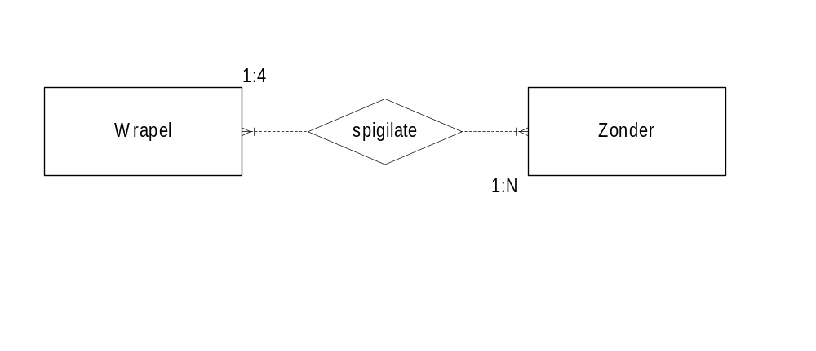
- E/R diagram

Normalized relationships

A | B | C | H
a | 3 | 1 | 8
a | 3 | 6 | 2
a | 4 | 1 | 6
b | 3 | 1 | 8
b | 4 | 2 | 0
c | 2 | 2 | 0
c | 2 | 4 | 2
R1 (A, B, C, H)

B | D
3 | k
4 | t
2 | p
R2 (B, D)

D | F | G
k | 12 | x
t | 23 | y
p | 10 | z
R3 (D, F, G)

A | E
a | 5
b | 7
c | 2
R4 (A, E)

SECTION 3C
- 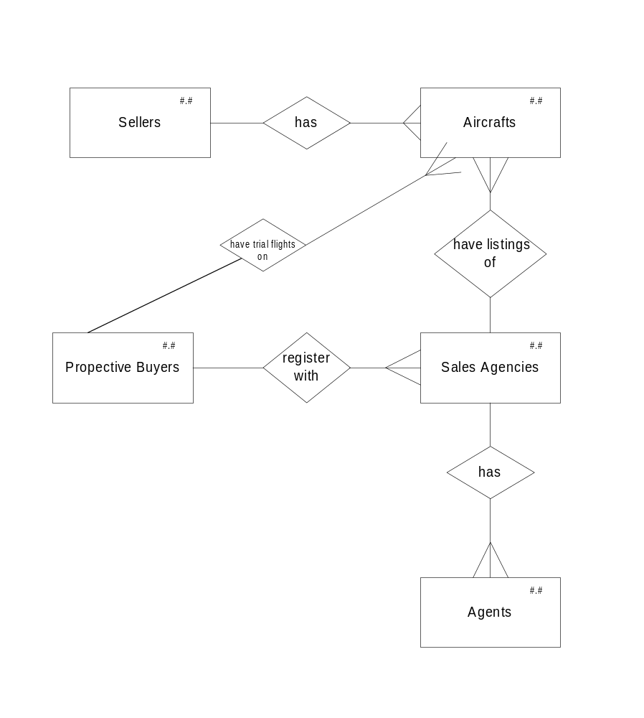

- Relationship

OWNED_BY (REG-ENUM, CUST-ID)
LISTING (CUST-ID, SCODE)
EMPLOYED_BY (ENUM, SCODE)
OFFER (CUST-ID, ENUM, REG-ENUM, AMOUNT)
TRIAL (REG-ENUM, ENUM, CUST-ID, DATE)

SECTION 3D

1 | F | 2 | T | 3 | F | 4 | F | 5 | T
6 | F | 7 | T | 8 | T | 9 | T | 10 | T
11 | T | 12 | F | 13 | T | 14 | T | 15 | F
16 | T | 17 | T | 18 | F | 19 | F | 20 | F

  - R1 lists all the programmers, eliminating any duplicates.
  - R3 lists all programmers who know WIN95.
  - R6 lists all programmers who know WIN95 or UNIX.
  - R7 lists all programmers who know WIN95 and UNIX.
  - R8 lists all programmers who know WIN95 and not UNIX.
  - R10 lists all programmers who do not know WIN95.
  - R11 lists all programmers who do not know WIN95.
  - R14 lists all programmers who know the operating system of AAA Autofix.
  - R15 lists all programmers who know WIN95 only.

  - R1 = PROJECT OS-SKILLS OVER SYSTEM
R2 = NATURAL JOIN R1(SYSTEM)=CUST-SYS(SYSTEM)
  - R3 = PROJECT CUST-SYS OVER SYSTEM
R4 = NATURAL JOIN R3(SYSTEM)=CUST-SYS(SYSTEM)
  - R5 = DIFFERENCE R4,R2

