ANALYSIS

The Huffman compression algorithm compresses a message into a bit string of minimal length by using an elegant way to compute a tree of frequencies. Once the tree is constructed, the message can be encoded by replacing the frequencies at the bottom nodes with the associated letters and then viewing the tree as an encoding tree, with “left” corresponding to a code bit of 0 and “right” corresponding to a code bit of 1.

Building the Huffman Code

The first step in building the Huffman code is to count the frequency of each character within the message to be encoded. The following code fills in an array FrequencyCount with the frequency counts for a message.

procedure GetFrequencyCount;

var

Loop: Longint;

begin

for Loop := 0 to 511 do

FrequencyCount[Loop] := 0;

for Loop := 1 to DataSize do

Inc(FrequencyCount[GetData]);
end;
The next step is to build the coding tree from the bottom up according to the frequencies. In building the tree, it will be viewed as a binary tree with frequencies stored in the nodes: after it has been built, it will be view as a tree for coding.

First, a tree node is created for each nonzero frequency. Then, the two nodes with the smallest frequencies are found, and a new node is created with those two nodes as children and with frequency value the sum of the values of the children. Then the two nodes with smallest frequency in that forest are found, and a new node is created in the same way. Continuing in this way, larger and larger subtrees are built, at the same time, reducing the number of trees in the forest by one at each step (remove two, add one). Ultimately, all the nodes are combined into a single tree. In order to find the nodes with the smallest frequencies, the heap sort is used. It is guaranteed to sort N elements in about N log N steps. There is no “worse-case” input that will make heap sort run slower.
procedure BuildInitialHeap;
var
Loop: Word;
begin

HeapLength := 0;

for Loop := 0 to 255 do
if FrequencyCount[Loop]>0 then
begin
Inc(HeapLength);
Heap[HeapLength] := Loop;
end;

for Loop := HeapLength downto 1 do
Reheap (Loop);
end;

procedure Reheap (HeapEntry: Word);
var
index: Word;
HeapValue: Longint;
begin

HeapValue := Heap[HeapEntry];

while HeapEntry <= HeapLength div 2 do
begin
Index := HeapEntry+HeapEntry;

if Index < HeapLength then
if FrequencyCount[Heap[Index]] >= FrequencyCount[Heap[Index+1]] then
Inc(Index);

if (FrequencyCount[HeapValue] < FrequencyCount[Heap[Index]]) then
Break;

Heap[HeapEntry] := Heap[Index];
HeapEntry := Index;
end;

Heap[HeapEntry] := HeapValue;
end;
The construction of the tree of frequencies (BuildInitialHeap) involves the general process of removing the smallest from a set of unordered elements. The heap is built by first initializing the Heap array to point to the non-zero frequency counts and then using the Reheap procedure as above to construct the tree.
while HeapLength <> 1 do
begin
HeapValue := Heap[1];
Heap[1] := Heap[HeapLength];
Dec(HeapLength);

Reheap (1);
findex := HeapLength + 255;

FrequencyCount[findex] := FrequencyCount[Heap[1]] + FrequencyCount[HeapValue];
Father[HeapValue] := findex;
Father[Heap[1]] := -findex;
Heap[1] := findex;

Reheap (1);
end;

Father[256] := 0;

The first two lines of the “while” loop removes the first element (and largest member) of the heap and violates the heap condition by moving the last element (and smallest member) of the heap to the top (or the root). This raises the priority, whcich necessitates a call to Reheap to restore order in the heap. The tree itself is represented as an array of “parent” links. Father[HeapValue] is the index of the parent of the node whose weight is in FrequencyCount[HeapValue]. The sign of Father[HeapValue] indicates whether the node is a left (-) or a right (+) child of it’s parent.

Computational complexity analysis

The program

Program, Procedures and Functions
General routines
No | Routine | Description
 | DataSize | Returns the length of the orginal message
 | GetData | Returns the next character in the original message
 | ResetDataIndex | Initialises an index to point to the next character to rettrieve when GetData is called.
 | WriteData | Buffers the data to be written in blocks of 4K. Used only by Testing.
 | FlushData | Used when there is still data to be written, but the data has not reached the required size of 4K.
 | Testing | Reads the file HUFFMAN.PAS and compresses it into HUFFMAN.2. Then, reads the compressed file, HUFFMAN.2 to produce HUFFMAN.3. The files HUFFMAN.3 and HUFFMAN.PAS should contain the same data
 | Reheap | Checks the heap for any violation and rebuilds the heap, so that smaller elements are at the top of the heap, and larger elements are at the bottom.
 | CompressImage | Used by Testing. Compresses the original message.
 | GenerateCodeTable | Creates a code table that contains the bit strings of each character.
 | BuildCodeTree | Builds the Huffman coding tree.
 | GetFrequencyCount | Builds a table of frequencies of characters in the message.
 | Initialise | Initialises the program
 | Deinitialise | Deinitialises the program.
 | Binary | Returns the Huffman bit string of each character

Tests Done

The program is tested modularly. The following are the tests done, sequentially. The following screens are results of screen capture from Windows. Tests done are each menu option.

Shows initial screen (For Menu Option 7 later)
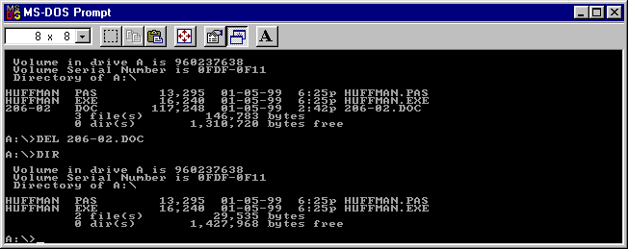

Menu option 1
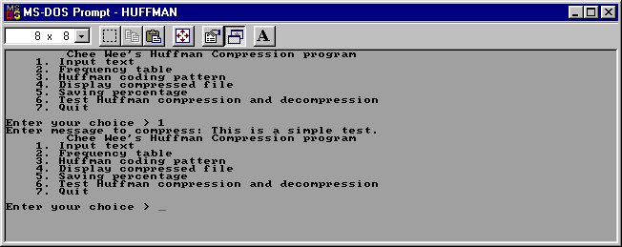
Menu option 2
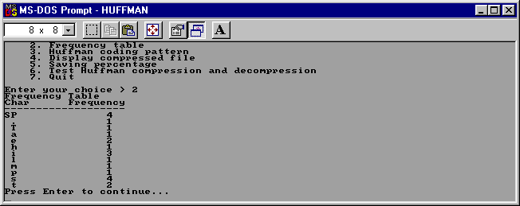
Menu option 3
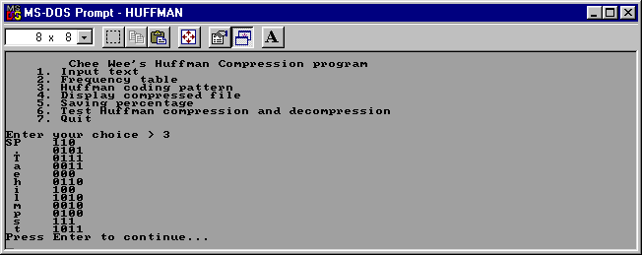
Menu option 4
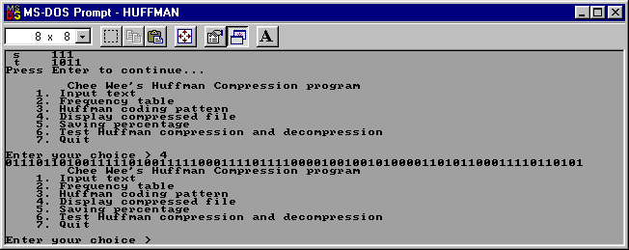

Menu option 5
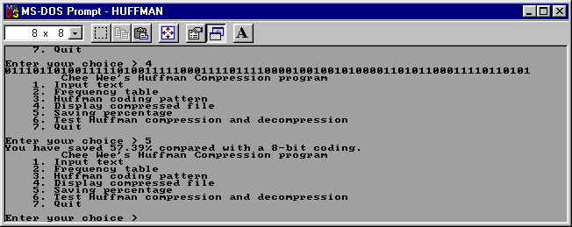
Menu option 6
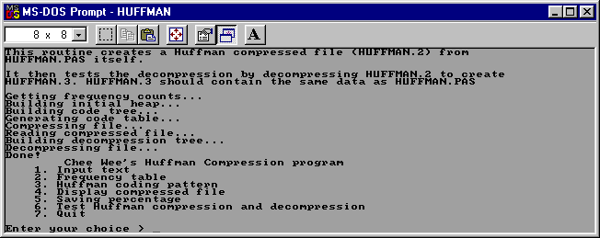
Menu option 7
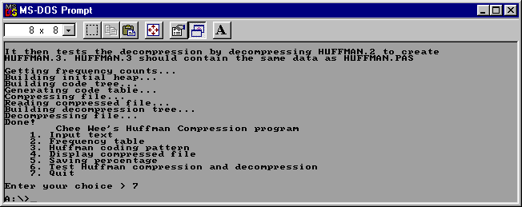
A directory command shows that files generated are HUFFMAN.2 and HUFFMAN.3. Note that HUFFMAN.3 is the same size as HUFFMAN.PAS, hence confirming that the Huffman encoding works.
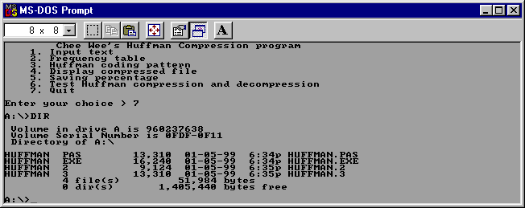

Limitations

The program can only compress messages with frequencies of each character having the maximum of 65535 occurances. This translates into a maximum file size of 16MB.

When running Menu Option 6 stands by itself, it does not work in conjunction with the other Menu Options.

Sources

Robert Sedgewick, Algorithms, Second Edition, Addison Wesley, Princeton University, 1988.

Program Listing

{ Chua Chee Wee
CIS 206 Assignment 2
U/96/0237638
}
program Huffman;
uses CRT;
type
TBinary = string[8];
var
{ Structures used for building code tree }
Father: array[0..511] of Integer;
Code: array[0..255] of Word;
HeapLength: Word;
CompressCharCount, FileLength: Longint;
Heap: array[0..256] of Word;
CodeLength: array[0..255] of Byte;
FrequencyCount: array[0..511] of Longint;
Message: string;

InFile, OutFile: File;
OutDataIndex, InDataIndex: Longint;
InData, OutData: array[1..4096] of Byte;
SizeRead: Word;
Dirty: Boolean; { Keeps track of whether data has been written }

function DataSize: Longint;
begin
if Length(Message)>0 then
DataSize := Length(Message) else
DataSize := FileSize(InFile);
end;

function GetData: Byte;
begin
if Length(Message)>0 then
begin
GetData := Ord(Message[InDataIndex]);
end else
begin
if (InDataIndex=0) or (InDataIndex>SizeRead) then
begin
BlockRead(InFile, InData, SizeOf(InData), SizeRead);
InDataIndex := 1;
end;
GetData := InData[InDataIndex];
end;
Inc(InDataIndex);
end;

procedure ResetDataIndex;
begin
if Length(Message)>0 then
InDataIndex := 1 else
begin
InDataIndex := 0;
Seek(InFile, 0);
end;
end;

procedure WriteData(Ch: Byte);
begin
Inc(OutDataIndex);
if OutDataIndex>SizeOf(OutData) then
begin
BlockWrite(OutFile, OutData, SizeOf(OutData));
OutDataIndex := 1;
Dirty := False;
end;
OutData[OutDataIndex] := Ch;
Dirty := True;
end;

procedure FlushData;
begin
if Dirty then
BlockWrite(OutFile, OutData, OutDataIndex);
end;

procedure Reheap (HeapEntry: Word);
var
index: Word;
HeapValue: Longint;
begin

HeapValue := Heap[HeapEntry];

while HeapEntry <= HeapLength div 2 do
begin
Index := HeapEntry+HeapEntry;

if Index < HeapLength then
if FrequencyCount[Heap[Index]] >= FrequencyCount[Heap[Index+1]] then
Inc(Index);

if (FrequencyCount[HeapValue] < FrequencyCount[Heap[Index]]) then
Break;

Heap[HeapEntry] := Heap[Index];
HeapEntry := Index;
end;

Heap[HeapEntry] := HeapValue;
end;

procedure CompressImage;
var
CurrBit, CurrentLength, dvalue, Loop1: Integer;
CurrentCode: Word;
CurrByte, Loop: Longint;
TheByte: Word;
begin
CurrBit := 7; CurrByte := 0; TheByte := 0;

for Loop := 1 to DataSize do
begin
dvalue := GetData;
CurrentCode := Code[dvalue];
CurrentLength := CodeLength[dvalue];

for Loop1 := CurrentLength-1 downto 0 do
begin
if ((CurrentCode shr Loop1) and 1)<>0 then
thebyte := thebyte or (1 shl CurrBit);

Dec(CurrBit);
if (CurrBit < 0) then
begin
WriteData(thebyte);
TheByte := 0;
Inc(CurrByte);
CurrBit := 7;
end;
end;
end;
WriteData(thebyte);
Inc(CurrByte);
CompressCharCount := CurrByte;
end;

function GenerateCodeTable: Boolean;
var
BitCode,
Loop,
CurrentLength,
CurrentBit: Word;

Parent: Integer;

begin
for Loop := 0 to 255 do
if FrequencyCount[Loop]>0 then
begin
CurrentLength := 0;
BitCode := 0;
CurrentBit := 1;
Parent := Father[Loop];

while (Parent<>0) do
begin
if (Parent < 0) then
begin
Inc(BitCode, CurrentBit);
Parent := -Parent;
end;
Parent := Father[Parent];
CurrentBit := CurrentBit*2;
Inc(CurrentLength);
end;

Code[Loop] := BitCode;

if CurrentLength > 16 then
GenerateCodeTable := False
else
CodeLength[Loop] := CurrentLength;
end else
begin
Code[Loop] := 0;
CodeLength[Loop] := 0;
end;
GenerateCodeTable := True;
end;

procedure BuildCodeTree;
var
findex: Word;
HeapValue: Longint;
begin

while HeapLength <> 1 do
begin
HeapValue := Heap[1];
Heap[1] := Heap[HeapLength];
Dec(HeapLength);

Reheap (1);
findex := HeapLength + 255;

FrequencyCount[findex] := FrequencyCount[Heap[1]] +
FrequencyCount[HeapValue];
Father[HeapValue] := findex;
Father[Heap[1]] := -findex;
Heap[1] := findex;

Reheap (1);
end;

Father[256] := 0;
end;

procedure BuildInitialHeap;
var
Loop: Word;
begin

HeapLength := 0;

for Loop := 0 to 255 do
if FrequencyCount[Loop]>0 then
begin
Inc(HeapLength);
Heap[HeapLength] := Loop;
end;

for Loop := HeapLength downto 1 do
Reheap (Loop);
end;

procedure GetFrequencyCount;
var
Loop: Longint;
begin

for Loop := 0 to 511 do
FrequencyCount[Loop] := 0;

for Loop := 1 to DataSize do
Inc(FrequencyCount[GetData]);
end;

procedure Initialise;
begin
ResetDataIndex;
OutDataIndex := 0;
Dirty := False;
end;

procedure Deinitialise;
begin
FlushData;
Close(OutFile);
if Length(Message)=0 then
begin
Close(InFile);
end;
end;

var
DecompTree: array[0..511] of Integer;

procedure BuildDecompTree;
var
CurrentNode, Loop, Loop1, CurrentIndex: Word;
begin

CurrentNode := 1;
DecompTree[1] := 1;

for Loop := 0 to 255 do
begin
if CodeLength[loop]<>0 then
begin
CurrentIndex := 1;
for Loop1 := CodeLength[Loop] - 1 downto 1 do
begin
CurrentIndex := (DecompTree[CurrentIndex] shl 1) +
((Code[Loop] shr Loop1) and 1);
if DecompTree[CurrentIndex]=0 then
begin
Inc(CurrentNode);
DecompTree[CurrentIndex] := CurrentNode;
end;
end;
DecompTree[(DecompTree[CurrentIndex] shl 1) +
(Code[Loop] and 1)] := -Loop;
end;
end;
end;

procedure DecompressImage;
var
CurrChar: Byte;
BitShift: Integer;
cindex: Word;
CharCount: Longint;
begin
cindex := 1;
CharCount := 0;

while CharCount < FileLength do
begin
CurrChar := GetData;

for BitShift := 7 downto 0 do
begin
cindex := (cindex shl 1) + ((CurrChar shr BitShift) and 1);

if (DecompTree[cindex] <= 0) then
begin
WriteData(-DecompTree[cindex]);
Inc(CharCount);
if CharCount = FileLength then
bitshift := 0
else
cindex := 1;
end
else
cindex := DecompTree[cindex];
end;
end;
end;

function GetInputText: Boolean; far;
begin
GetInputText := False;
repeat
Write('Enter message to compress: ');
ReadLn(Message);
if Length(Message)=0 then
begin
WriteLn('You must enter a message to encode!!!');
WriteLn;
end;
until Length(Message)>0;
Initialise;
GetFrequencyCount;
BuildInitialHeap;
BuildCodeTree;
if not GenerateCodeTable then
begin
WriteLn('Failure in building code table!!!');
WriteLn('Only maximum of 65535 occurances of each character is allowed.');
WriteLn('Program failure...');
WriteLn('Quitting...');
Halt;
end;
end;

function Binary(B: Byte; Len: Integer): TBinary;
var
S: string[8];
I: Integer;
begin
S := '';
for I := Len-1 downto 0 do
S := S+Chr(((B shr I) and 1)+Ord('0'));
Binary := S;
end;

function DisplayFrequencyTable: Boolean; far;
var
I: Integer;
begin
DisplayFrequencyTable := False;
WriteLn('Frequency Table');
WriteLn('Char Frequency');
WriteLn('-------------------');
for I := 0 to 255 do
if FrequencyCount[I]<>0 then
begin
if I=Ord(' ') then
Write('SP') else
Write(Chr(I):2);
WriteLn('':14, FrequencyCount[I]);
end;
WriteLn('Press Enter to continue...');
ReadLn;
end;

function DisplayHuffmanCodingPattern: Boolean; far;
var
I: Integer;
begin
ResetDataIndex;
CompressImage;
DisplayHuffmanCodingPattern := False;
for I := 0 to 255 do
if CodeLength[I]>0 then
begin
if I=Ord(' ') then
Write('SP') else
Write(Chr(I):2);
WriteLn('':4, Binary(Code[I], CodeLength[I]));
end;
WriteLn('Press Enter to continue...');
ReadLn;
end;

function DisplayCompressedFile: Boolean; far;
var
I: Integer;
Data: Byte;
begin
DisplayCompressedFile := False;
ResetDataIndex;
for I := 1 to DataSize do
begin
Data := GetData;
Write(Binary(Code[Data], CodeLength[Data]));
end;
WriteLn;
end;

function ComputeSavings: Boolean; far;
var
TotalBits, HuffmanBits: Longint;
I: Integer;
begin
ComputeSavings := False;
HuffmanBits := 0;
for I := 0 to 255 do
Inc(HuffmanBits, FrequencyCount[I]*CodeLength[I]);
TotalBits := 8*DataSize;
Write('You have saved ', (TotalBits-HuffmanBits)/TotalBits*100:0:2);
WriteLn('% compared with a 8-bit coding.');
end;

function QuitHuffman: Boolean; far;
begin
QuitHuffman := True;
end;

function Testing: Boolean; far;

procedure ClearError;
var Error: Integer;
begin
Error := IOResult;
end;
var I: Integer;
begin
WriteLn('This routine creates a Huffman compressed file (HUFFMAN.2) from');
WriteLn('HUFFMAN.PAS itself.');
WriteLn;
WriteLn('It then tests the decompression by decompressing HUFFMAN.2 to create');
WriteLn('HUFFMAN.3. HUFFMAN.3 should contain the same data as HUFFMAN.PAS');
WriteLn;
Testing := False; Message := '';
Assign(InFile, 'HUFFMAN.PAS');
Reset(InFile, 1);
Initialise;

WriteLn('Getting frequency counts...');
GetFrequencyCount;

WriteLn('Building initial heap...');
BuildInitialHeap;

WriteLn('Building code tree...');
BuildCodeTree;

WriteLn('Generating code table...');
if not GenerateCodeTable then
begin
WriteLn('Failure in building code table!!!');
WriteLn('Only maximum of 65535 occurances of each character is allowed.');
WriteLn('Program failure...');
WriteLn('Quitting...');
Halt;
end;

FileLength := DataSize;
Assign(OutFile, 'HUFFMAN.2');
Rewrite(OutFile, 1);
BlockWrite(OutFile, Code, SizeOf(Code));
BlockWrite(OutFile, FileLength, SizeOf(FileLength));
BlockWrite(OutFile, CodeLength, SizeOf(CodeLength));

ResetDataIndex;

WriteLn('Compressing file...');
CompressImage;

Deinitialise;
Assign(OutFile, 'HUFFMAN.3');
{$I-} Erase(OutFile); {$I+}
ClearError;
(* Assign(OutFile, 'HUFFMAN.2');
{$I-}Rename(OutFile, 'HUFFMAN.3');{$I+}*)

WriteLn('Reading compressed file...');
Assign(InFile, 'HUFFMAN.2');
Reset(InFile, 1);
BlockRead(InFile, Code, SizeOf(Code));
BlockRead(InFile, FileLength, SizeOf(FileLength));
BlockRead(InFile, CodeLength, SizeOf(CodeLength));

Initialise;
Assign(OutFile, 'HUFFMAN.3');
Rewrite(OutFile, 1);
for I := 1 to SizeOf(Code)+SizeOf(FileLength)+SizeOf(CodeLength) do
GetData;

WriteLn('Building decompression tree...');
BuildDecompTree;

WriteLn('Decompressing file...');
DecompressImage;
Deinitialise;
WriteLn('Done!');
end;

procedure Run;

type
TMenuChoice = (
tmGetInputText,
tmDisplayFrequencyTable,
tmDisplayHuffmanCodingPattern,
tmDisplayCompressedFile,
tmComputeSavings,
tmTesting,
tmQuitHuffman
);
THuffmanFunc = function: Boolean;

{
Pre: Menu options displayed
Post: Selected function to execute
}
function getchoice: TMenuChoice;
const
SelectionLow = 1;
SelectionHigh = 7;
SelLowChar = Chr(SelectionLow+Ord('0'));
SelHighChar = Chr(SelectionHigh+Ord('0'));
displaytext: array[SelectionLow..SelectionHigh] of string = (
'Input text',
'Frequency table',
'Huffman coding pattern',
'Display compressed file',
'Saving percentage',
'Test Huffman compression and decompression',
'Quit'
);
var
X, i: Integer;
ch: Char;
begin
WriteLn(' Chee Wee''s Huffman Compression program');
for i := SelectionLow to SelectionHigh do
begin
Writeln(' ', i,'. ', displaytext[i]);
end;
WriteLn;
Write('Enter your choice > ');
repeat
ch := ReadKey;
if not (ch in [SelLowChar..SelHighChar]) then
begin
X := WhereX;
Write('Invalid Choice...');
Write(^G);
Delay(1000);
GotoXY(X, WhereY);
ClrEol;
end;
until ch in [SelLowChar..SelHighChar];
WriteLn(ch);
getchoice := TMenuChoice(Ord(ch)-ord(SelLowChar));
end;

const
HuffmanFunc: array[TMenuChoice] of THuffmanFunc = (
GetInputText,
DisplayFrequencyTable,
DisplayHuffmanCodingPattern,
DisplayCompressedFile,
ComputeSavings,
Testing,
QuitHuffman
);

var
quit: Boolean;
choice: TMenuChoice;
begin
Textbackground(White); {For printing, save ink}
TextColor(Black);
Clrscr;
quit := False;
repeat
choice := GetChoice;
quit := HuffmanFunc[choice];
until quit;
end;

begin
Run;
end.

